Report on Visit of School Students at K R Mangalam University
Date: 17th February 2025
Venue: K. R. Mangalam University
Event Type: Visit
Mode of Activity: Offline
Target Group: School students (9th to 12th students)
Coordinator: Dr. Neeraj Kumari (NSS Program Coordinator), Mr. Amit Kumar Yadav (NSS Program Officer) and Dr Vicky Kapoor (NSS Member)

Organized by: NSS, K R Mangalam University
Participants during the event: More than 44 school students and 31 NSS volunteers
Introduction:
K.R. Mangalam University organized a visit for school students (9th to 12th students) of Govt. Sr. Sec. School, Abheypur, Sohna,on 17th February 2025 to provide the experience of higher education facilities and scientific laboratories. The visit aimed to introduce young learners to various academic disciplines and encourage them to explore the diverse opportunities available in higher education. The students visited key facilities, including Chemistry, Physics, Pharmacy, and Physiotherapy Laboratories, as well as the Central Library. The visit was designed to inspire students by offering hands-on exposure to laboratory experiments and modern educational resources.
2. Objectives
The primary objectives of this visit were to provide school students with practical exposure to higher education and research facilities and introduce fundamental scientific concepts through interactive demonstrations in the laboratories.
Contents:
The visit began at the School of Physiotherapy and Rehabilitation Sciences (SPRS), where students explored various physiotherapy techniques and therapies in the lab.
The tour continued to the laboratories of the School of Basic and Applied Sciences, including Physics, Chemistry, and Forensic Science. Here, students gained insights into fundamental

scientific principles in chemistry and physics. In the Forensic Science laboratory, they engaged in hands-on experiences such as fingerprint analysis and crime scene investigation techniques, including examining areas where fatalities occurred.
Additionally, students visited the laboratories of the School of Medical and Allied Sciences, where they learned about the scientific principles behind the formulation of medicines, including both allopathic and Ayurvedic approaches. The visit concluded with a tour of the university library, where students explored various academic resources.
Conclusion and Outcomes:
The visit provided an enriching and interactive learning experience, enhancing students' understanding of various scientific disciplines. Through practical exposure, they developed a deeper appreciation for the applications of science in different fields. The event successfully ignited curiosity among the students and inspired them to explore career opportunities in science and healthcare-related domains.
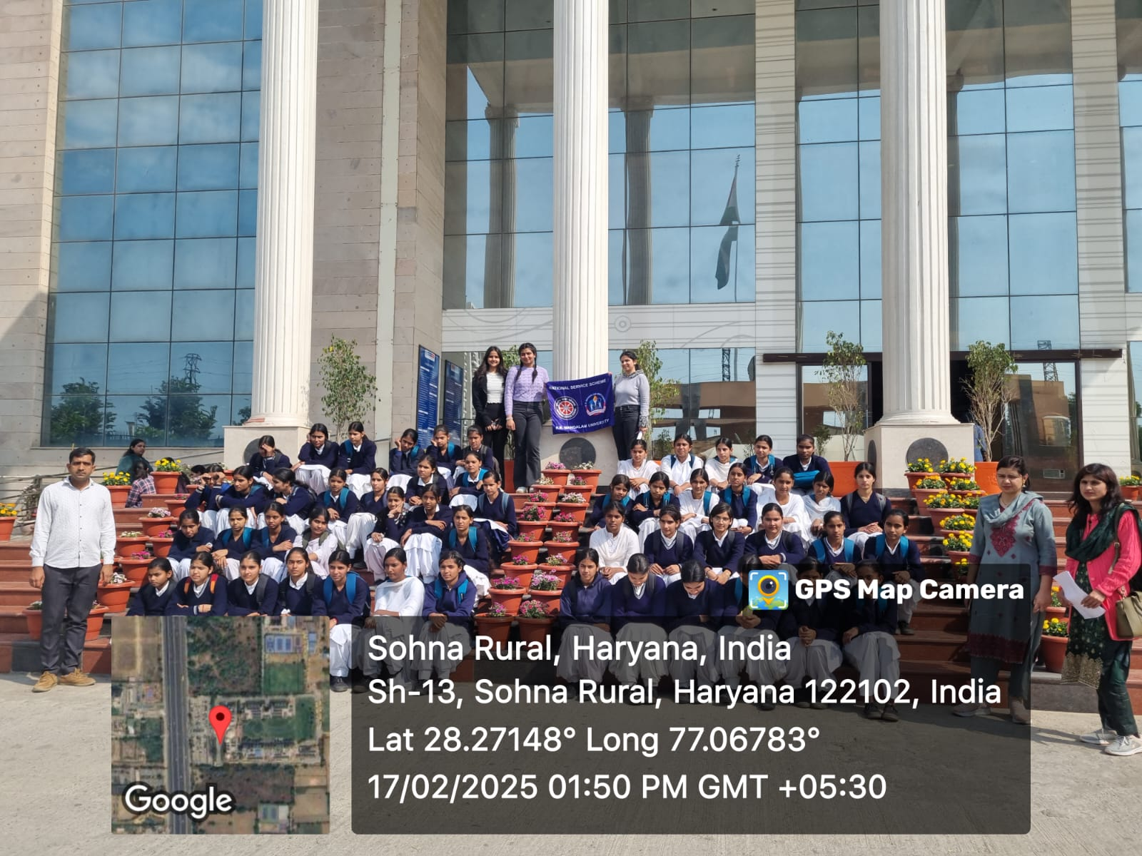

Photo 1: A group photograph of students and NSS volunteers

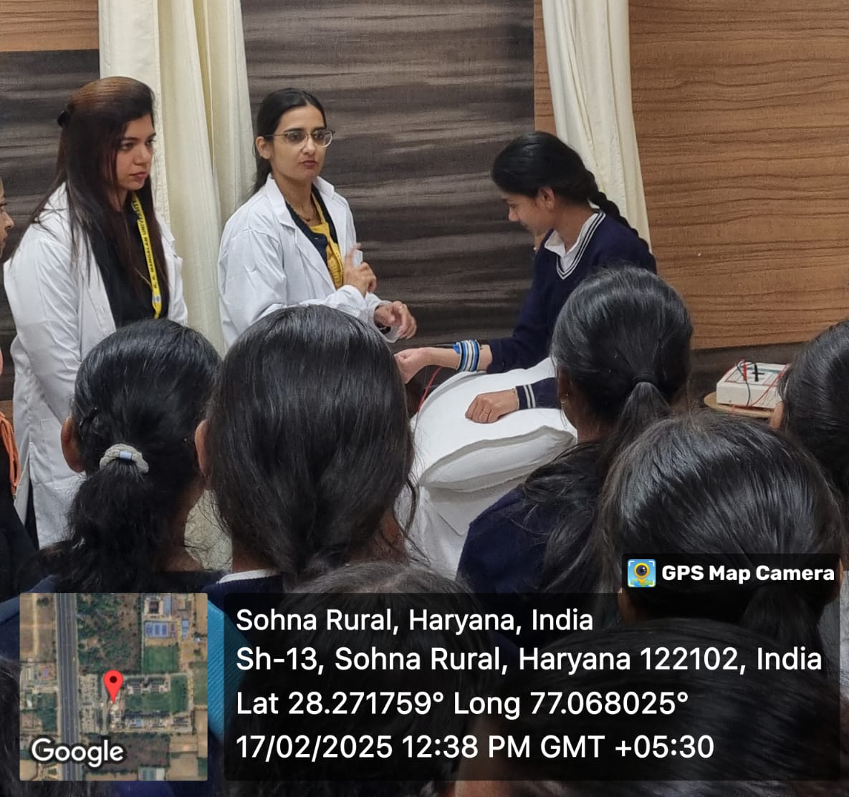

Photo 2: Students in Physiotherapy lab
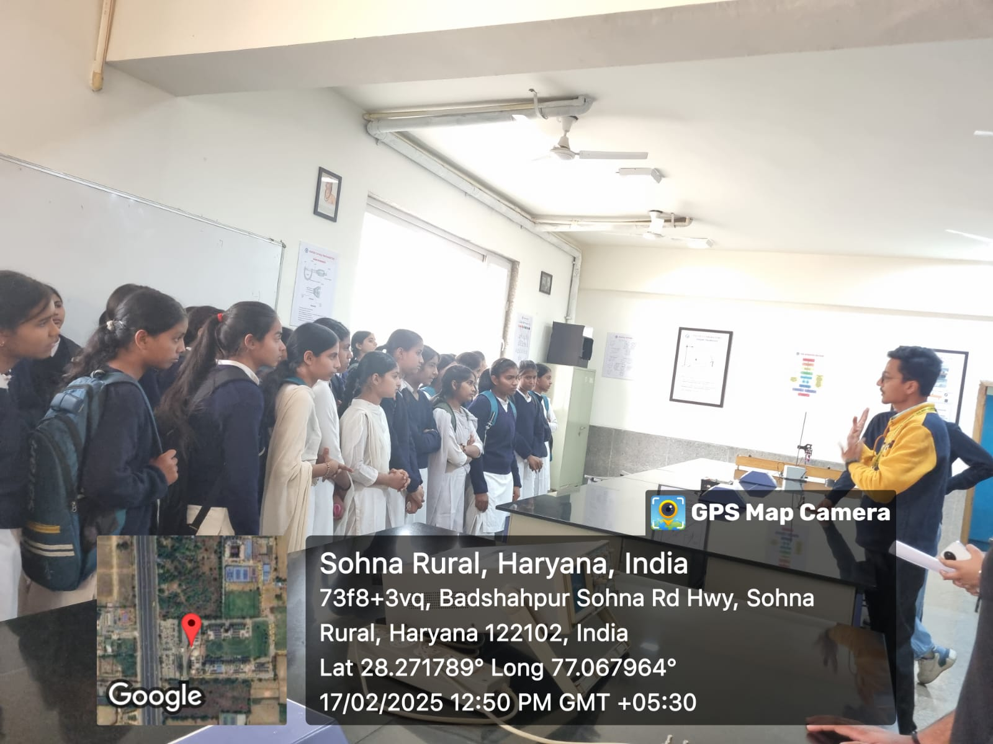

Photo 3: Dr. Vicky Kapoor explained about basic physics

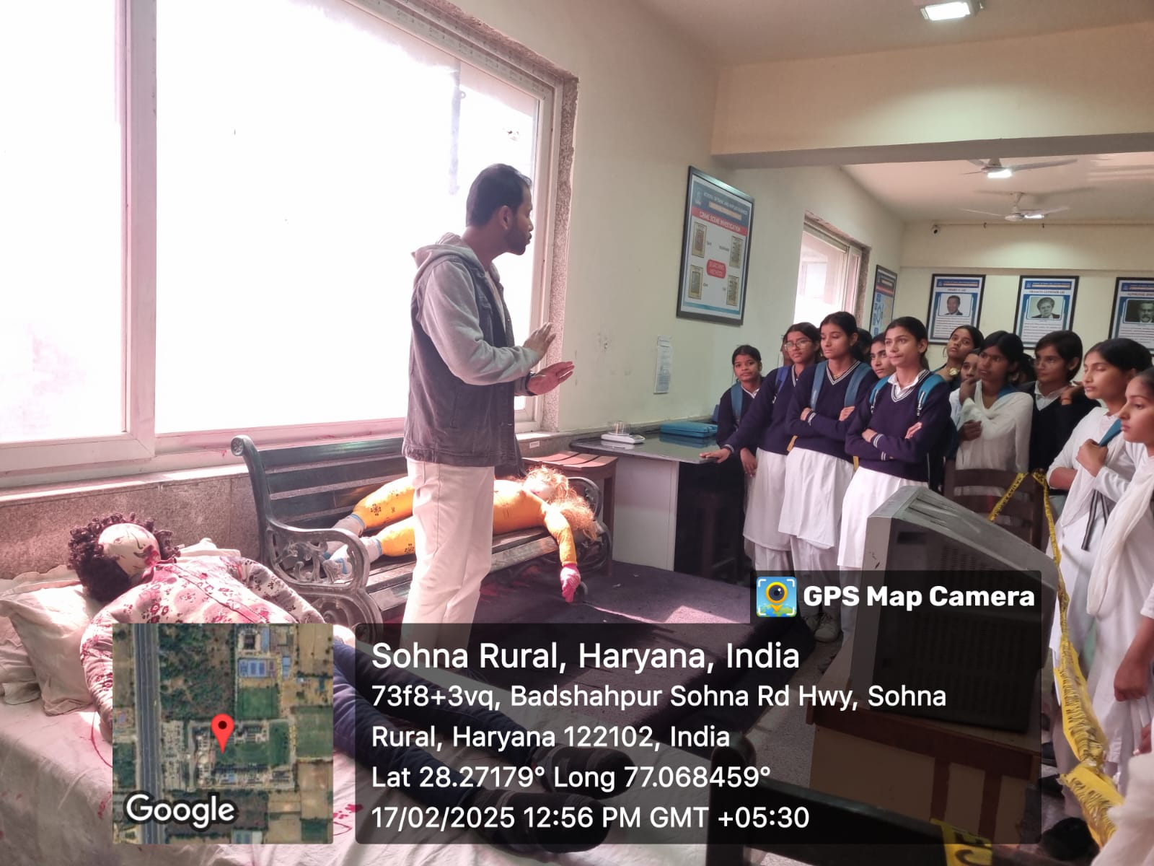

Photo 4: Students experienced investigation of the crime scene

Report Prepared by | Dr Neeraj Kumari, NSS Program Coordinator
Report Verified by IQAC Coordinator | Dr Shikha Dutt Sharma

