Report on Self Defense Training Workshop
Date: 24th January 2025
Venue: Daulah village, Sohna
Event Type: Workshop(Extension Activity)
Mode of Activity: Offline
Target Group: School students (9th to 12th students) and NSS volunteers
Coordinator: Dr. Neeraj Kumari (NSS Program Coordinator) and Mr. Thomas Monteiro (NSS Program Officer)

Organized by: NSS, K R Mangalam University with Urban Games Federation of India (UGFI)
Resource Person: Ms Naveen Chaudhary, President of UGFI and Mr Harsh Dahiya, General Secretary, UGFI
Participants during the event: More than 44 school students and 31 NSS volunteers
Introduction:
National Girl Child Day, observed annually on January 24 in India, is a pivotal occasion dedicated to promoting the rights, education, and well-being of girls. Established in 2008 by the Ministry of Women and Child Development, the day seeks to raise awareness about the need to empower girls and foster an environment free from gender-based discrimination, enabling them to thrive. Therefore, in view of this, NSS-K R Mangalam University in collaboration with the Urban Games Federation of India (UGFI), New Delhi, organized a self-defense training workshop at Govt. Sr. Sec. School, Daulah.
Objectives:
The main objective of conducting the workshop was to empower young students by giving them training in some basic self-defense skills to boost their confidence and ensure their safety.

Contents:
The event was started by Mr Rohtash Singh, Lecturer of English, Govt. Sr. Sec. School, Daulah. He welcomed all the guests and NSS-KRMU team with the permission of Principal, Govt. Sr. Sec. School, Daulah. He described the motive to observe National Girl Child Day and organization of workshop. The workshop was preceded by Ms Muskan, the expert of self-defense skills and martial arts. She demonstrated some practical techniques such as blocking, escaping holds using their hands and legs, and remaining vigilant in unfamiliar environments. Mr. Dahiya emphasized the importance of awareness, quick reflexes, and maintaining composure in critical situations. A self-defense performance was also showcased by the participants, including schoolgirls and NSS volunteers, under the guidance of the expert trainers.
Conclusions:
The event successfully instilled a sense of self-reliance and courage among the participants. As a token of gratitude, Dr. Neeraj Kumari, NSS Program Coordinator, and Mr Thomas Monteiro, NSS Program Officer, presented mementos to Ms. Naveen Choudhary and the Principal of Govt. School, Daulah. The program concluded with a heartfelt vote of thanks extended by Dr. Neeraj Kumari, expressing appreciation for the trainers, school staff, and students for their enthusiastic participation in this meaningful initiative.
Event outcomes:
The self-defense workshop conducted on National Girl Child Day successfully empowered participants with practical techniques and strategies to ensure personal safety. School girls and NSS volunteers actively engaged in the training sessions, gaining hands-on experience under expert guidance.

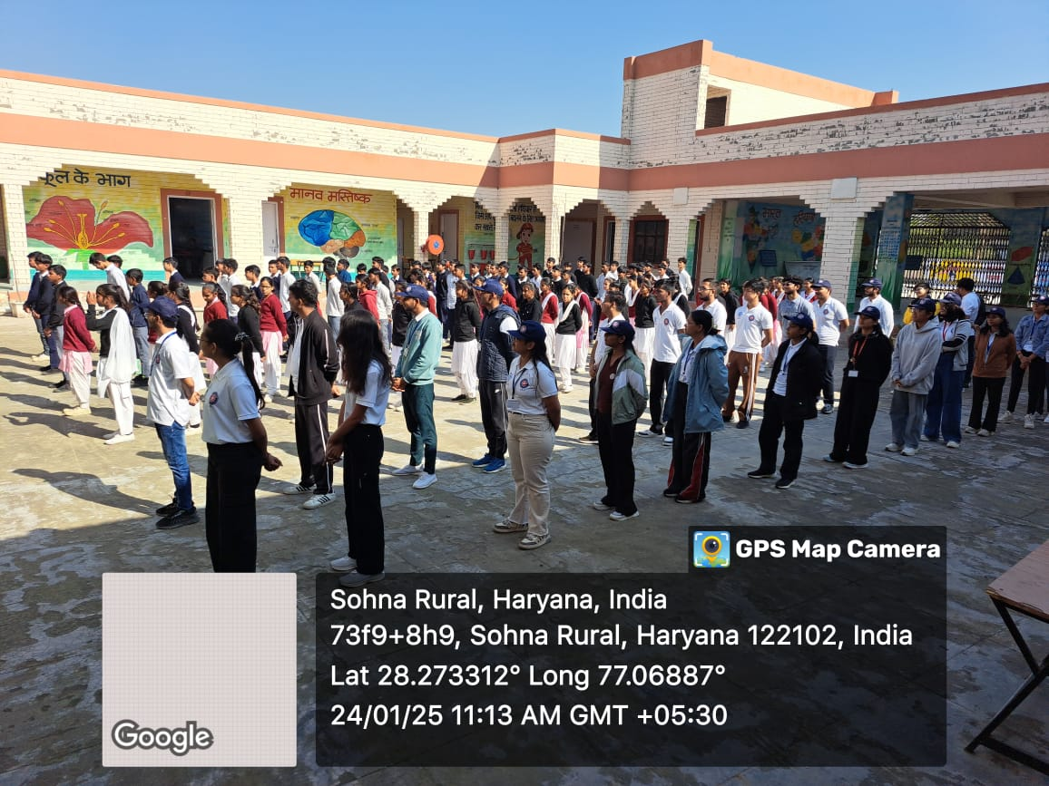

Photo 1: NSS volunteers during delf defense training
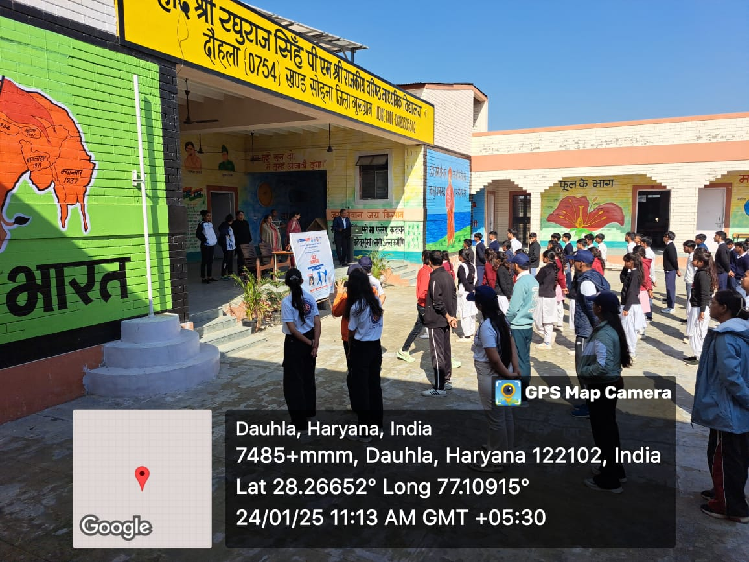

Photo 2: Mr Rohtash Singh welcomed all the guests

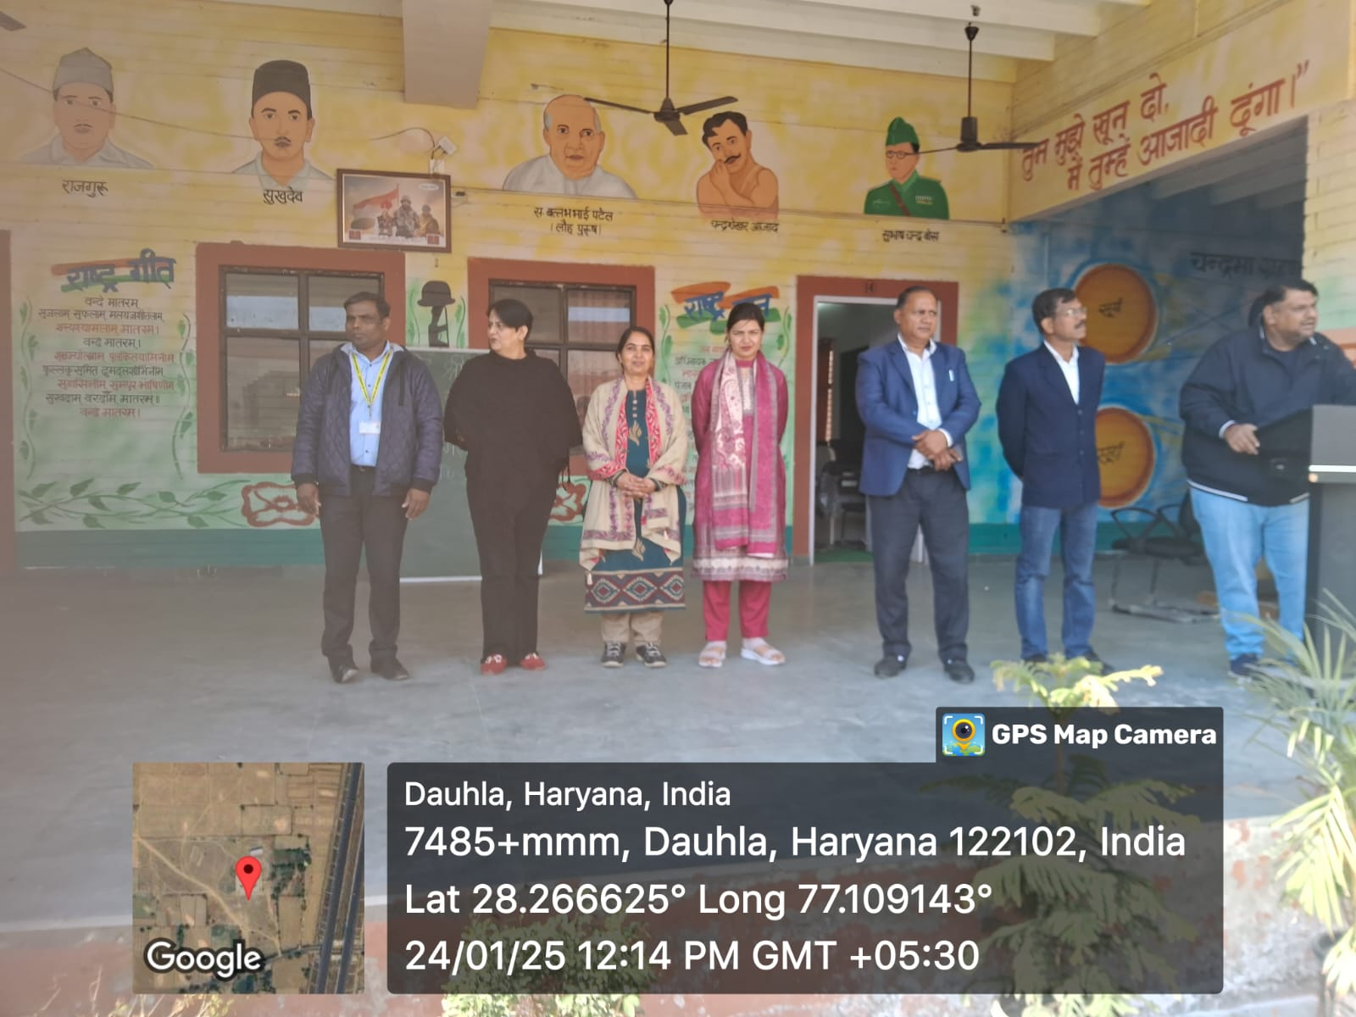

Photo 3: Mr Harsh Dahiya addressed the participants about the importance of self defense
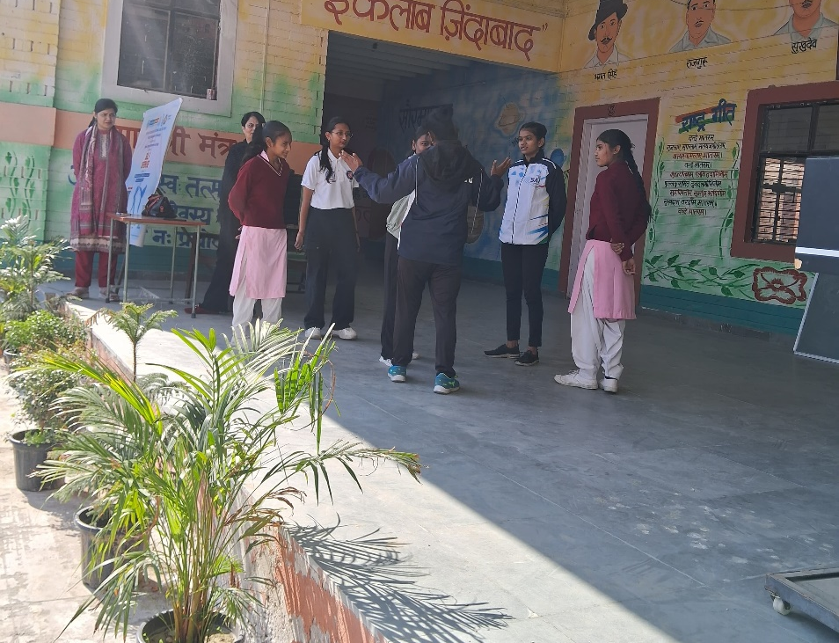

Photo 4: Experts learned some basic techniques of self defense

Report Prepared by | Dr Neeraj Kumari, NSS Program Coordinator
Report Verified by IQAC Coordinator | Dr Shikha Dutt Sharma

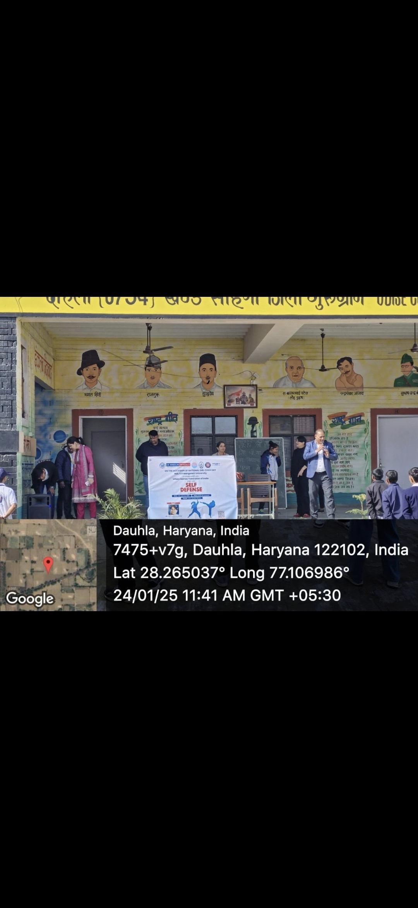

Glimpse of the workshop

