Report on Menstrual Health Awareness Session
Date: 07th April 2025
Venue: Berka Village, Gurgaon
Event Type: Awareness Session (Extension Activity)
Mode of Activity: Offline
Target Group: Rural Women
Coordinator: Dr. Neeraj Kumari (NSS Program Coordinator) and Dr. Sapna Rana (NSS member)
Organized by: NSS, K.R. Mangalam University
Participants during the event: More than 24 women Rural women of Berka Village and 32 NSS volunteers
Introduction:
World Health Day, observed annually on April 7, focuses on increasing awareness about key health concerns affecting global communities. In alignment with the Sustainable Development Goals (SDG 3: Good Health and Well-Being and SDG 5: Gender Equality), NSS K.R. Mangalam University organized an awareness session on Menstrual Health in Berka Village, Gurgaon. This initiative aimed to sensitize and educate rural women on the importance of menstrual hygiene, thereby fostering health, dignity, and empowerment.
Objectives:
The primary objective of this awareness session was to educate women about the biological aspects of menstruation, discredit myths, and promote hygienic practices by encouraging the use of sanitary pads. The session also aimed to build a supportive community where menstruation is discussed freely and without stigma.
Contents:
The event commenced with an insightful introduction by Dr. Neeraj Kumari, NSS Program Coordinator, who highlighted the historical evolution of sanitary pads and elaborated on the biological processes behind the menstrual cycle. She explained in simple language the science of menstruation, making it accessible and relatable to the rural audience.

The session was further led by two dedicated NSS volunteers, Ms. Anushri and Ms. Riya. They emphasized the importance of using clean and safe sanitary products, the recommended frequency for changing pads, managing menstrual cramps, and precautions to be taken during periods. They also addressed common myths and taboos associated with menstruation, encouraging open dialogue among the women.
The session was interactive, with participants sharing their experiences and clarifying doubts, which fostered a sense of community and understanding. At the end of the session, sanitary pads were distributed among all participants to support healthy menstrual practices.
Conclusions:
The awareness session effectively met its objective by fostering understanding and initiating open discussion on menstrual hygiene. It helped break the silence and stigma associated with menstruation and empowered rural women with knowledge and resources to manage their menstrual health with dignity.
Dr. Sapna Rana, the event coordinator, concluded the session with a heartfelt vote of thanks, expressing gratitude to all participants and volunteers for making the event impactful.
Event Outcomes:
The session led to increased awareness among rural women regarding the significance of menstrual hygiene. Many participants expressed their intent to adopt hygienic practices and educate their daughters and peers. The sanitary pad distribution further enabled immediate implementation of the knowledge shared during the session.
Future Prospects:
Following the success of this awareness drive, NSS K.R. Mangalam University plans to conduct similar sessions in other nearby villages. Future initiatives may include workshops on reusable sanitary products, health check-ups, and the establishment of regular menstrual health education in rural outreach programs.

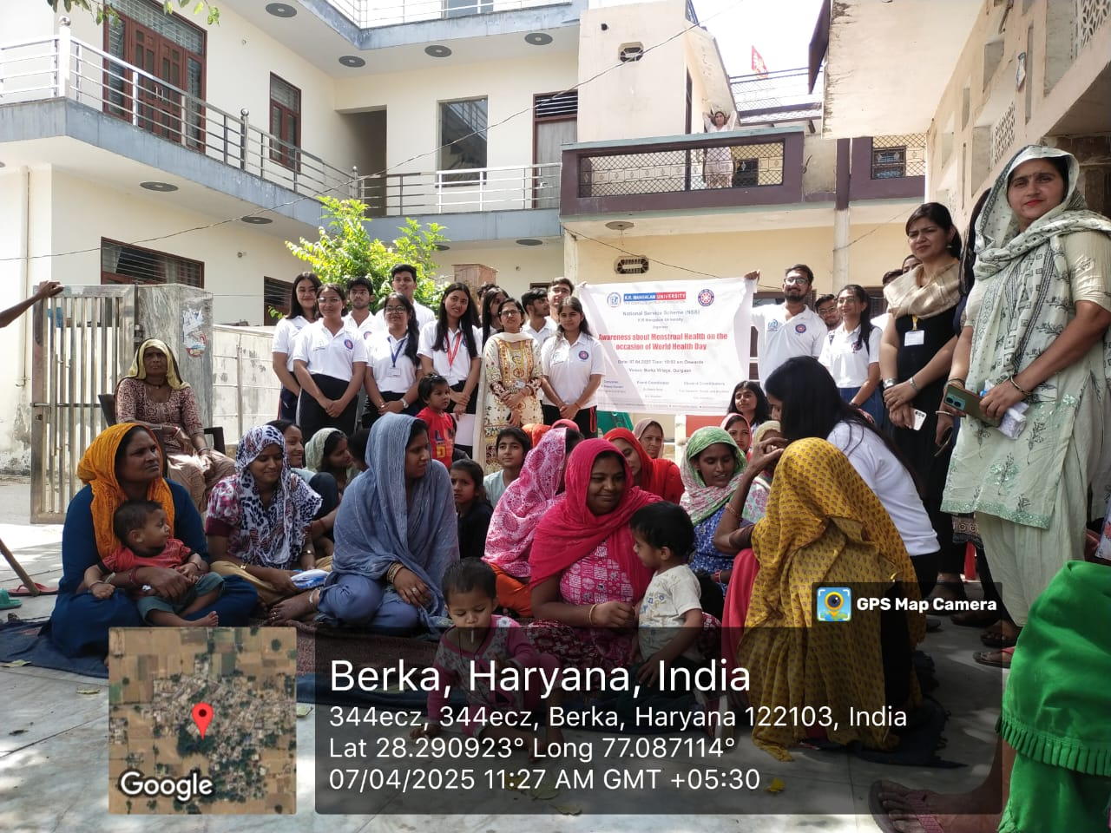

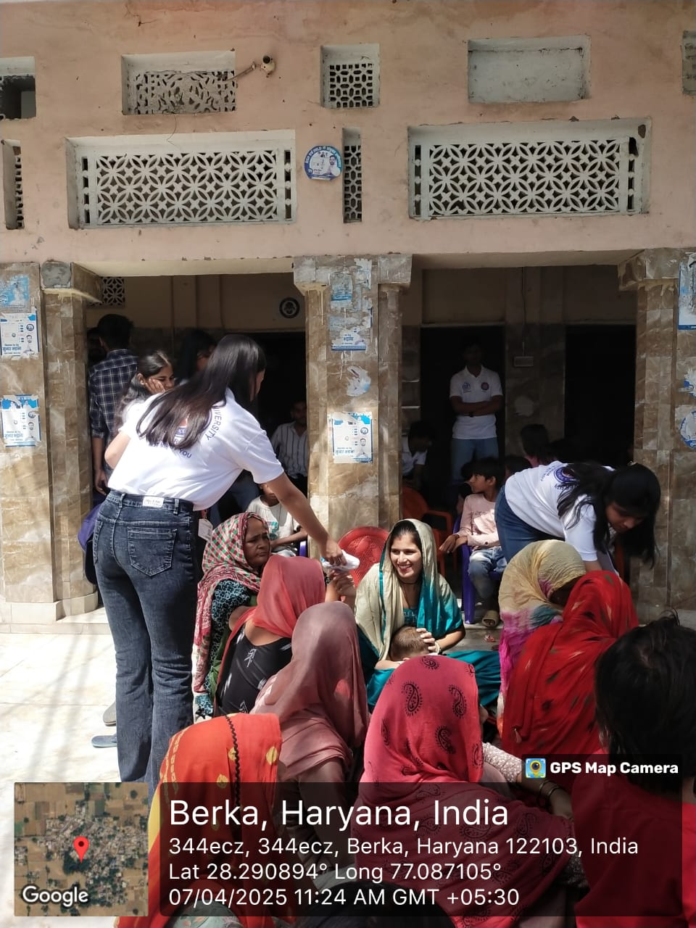
Photo 1: A group photograph of NSS volunteers and rural women

Photo 2: NSS volunteers distributed sanitary napkins to rural women
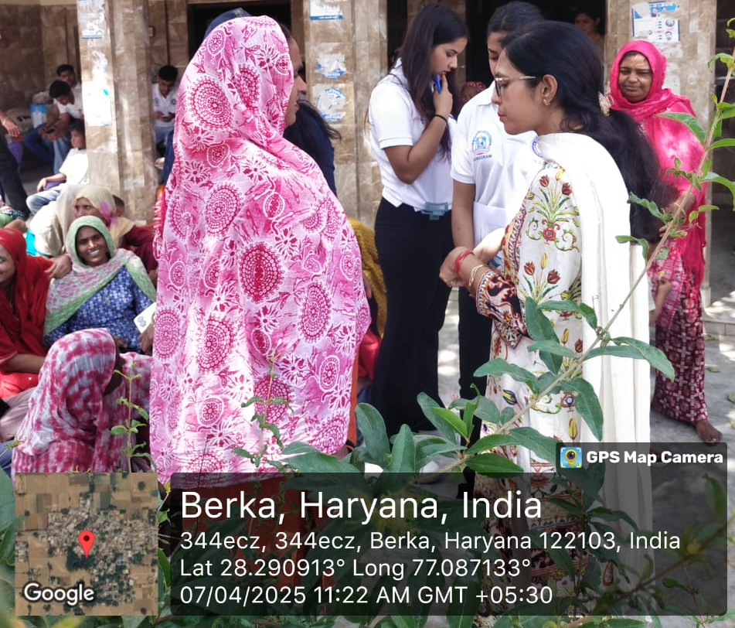

Photo 3: Dr. Sapna discussing about the myth related to Menstrual cycle
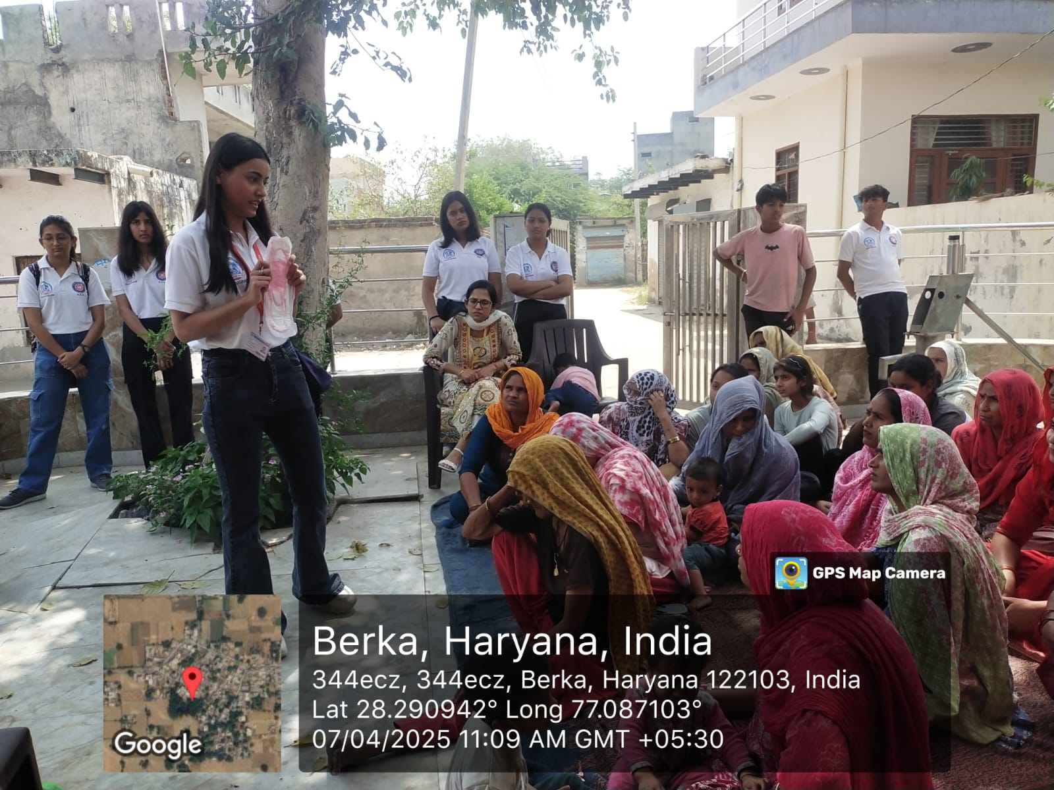

Photo 4: Ms Riya explained the use of sanitary napkin

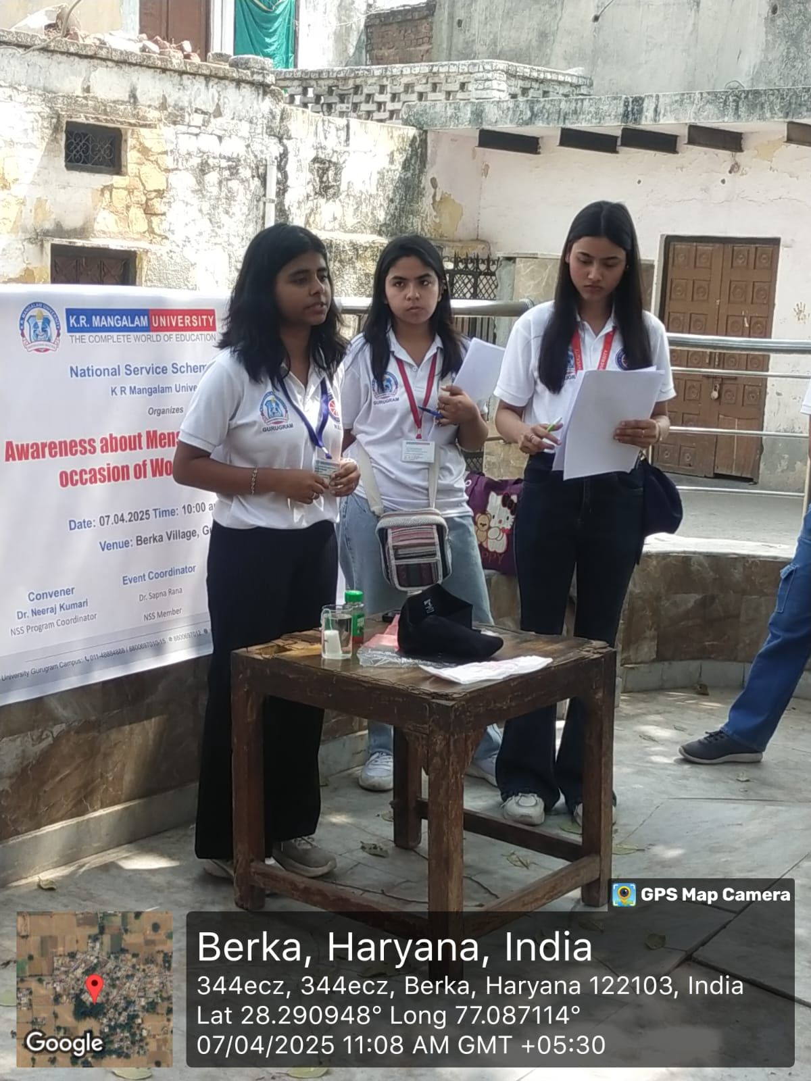

Report Prepared by | Dr Neeraj Kumari, NSS Program Coordinator
Report Verified by IQAC Coordinator | Dr Shikha Dutt Sharma

Photo 5: Ms Anushri explained the proper use of sanitary napkin

