Report on “Shiksha Uday: A One-Day Literacy Camp”
Date: 4th March 2025
Venue: Dream Girls Foundation, Sector-9, Gurugram
Event Type: One-Day Camp (Extension Activity)
Mode of Activity: Offline
Target Group: Underprivileged children (ages 1–10)
Coordinators: Dr. Neeraj Kumari (NSS Program Coordinator) and Mr. Thomas Monteiro (NSS Program Officer)
Organized by: NSS Unit, K.R. Mangalam University, Gurugram
Participants during the event: More than 72 children and 44 NSS volunteers
Introduction:
The NSS Unit of K.R. Mangalam University, Gurugram, organized "Shiksha Uday: A One-Day Literacy Camp" on March 4, 2025, at Dream Girls Foundation, Sector-9, Gurugram. The camp was conducted under the guidance of Dr. Neeraj Kumari and Mr. Thomas Monteiro to extend basic literacy education to underprivileged children from labor-class families. This initiative aligned with the spirit of National Service Scheme to serve the community and promote education for all.
Objectives:
The primary objective of this literacy camp was to spread awareness about the importance of education and spark a desire for learning among marginalized children. The event also aimed to foster social responsibility and empathy among NSS volunteers by providing them with an opportunity to contribute meaningfully to society.
Contents:
The event featured a series of engaging, educational, and creative activities designed specifically for children aged 1 to 10. Volunteers taught the children basic literacy concepts such as the alphabet, numbers, and rhymes through playful interaction. Storytelling sessions, educational

games, drawing and craft activities were also conducted to boost the children's cognitive skills and imagination. In addition to academic engagement, recreational activities like group songs, dance, and games made the environment lively and joyful. NSS volunteers ensured that each child received personalized attention, encouragement, and motivation. To support their learning journey, stationery items, books, and refreshments were distributed to all children.
Event Outcomes:
The camp successfully created a nurturing and cheerful learning environment for the children. The NSS volunteers also demonstrated commendable commitment, leadership, and teamwork in managing and conducting the activities. The event strengthened the values of community service, empathy, and educational outreach.
This initiative directly supported the United Nations Sustainable Development Goals (SDGs) including:
- SDG 4 – Quality Education: Promoting inclusive and equitable quality education and lifelong learning opportunities for all.
- SDG 10 – Reduced Inequalities: Bridging educational gaps for marginalized children.
- SDG 17 – Partnerships for the Goals: Collaboration with NGOs like Dream Girls Foundation for social impact.
Future Prospects:
Following the encouraging response and visible impact, the NSS unit plans to organize similar literacy camps on a regular basis. There is also a proposal to initiate a long-term volunteer tutoring program in collaboration with local NGOs to ensure continuity in education for these children.

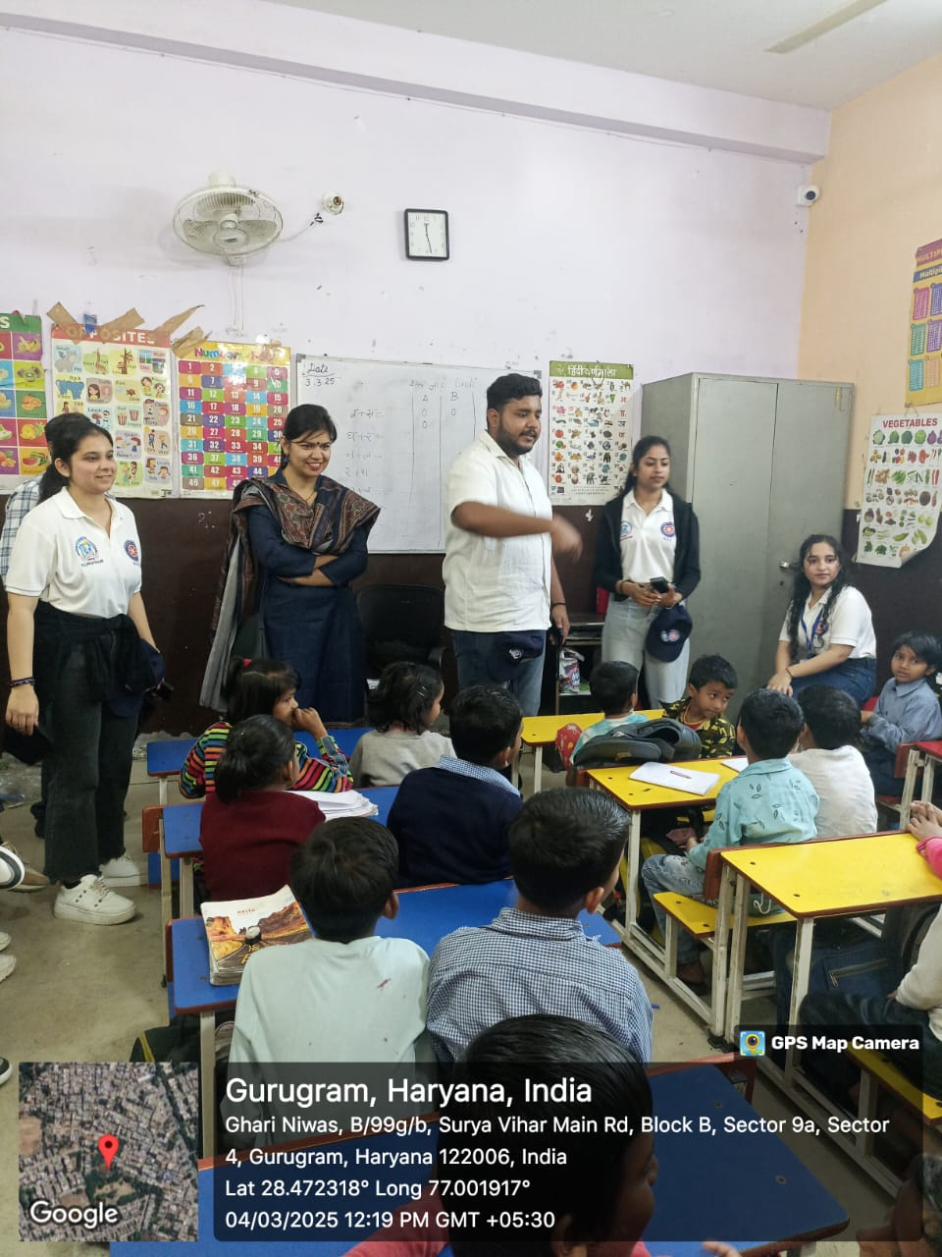

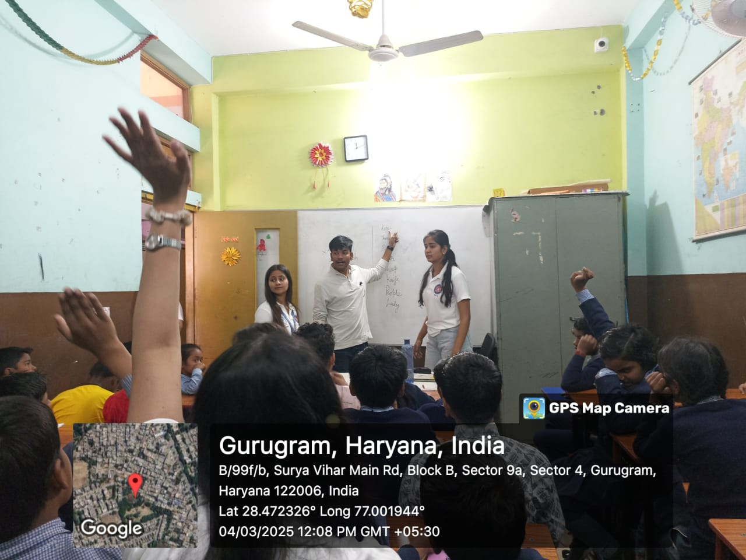
Photo 1: NSS volunteers with foundation children

Photo 2: NSS volunteers teaching the foundation children

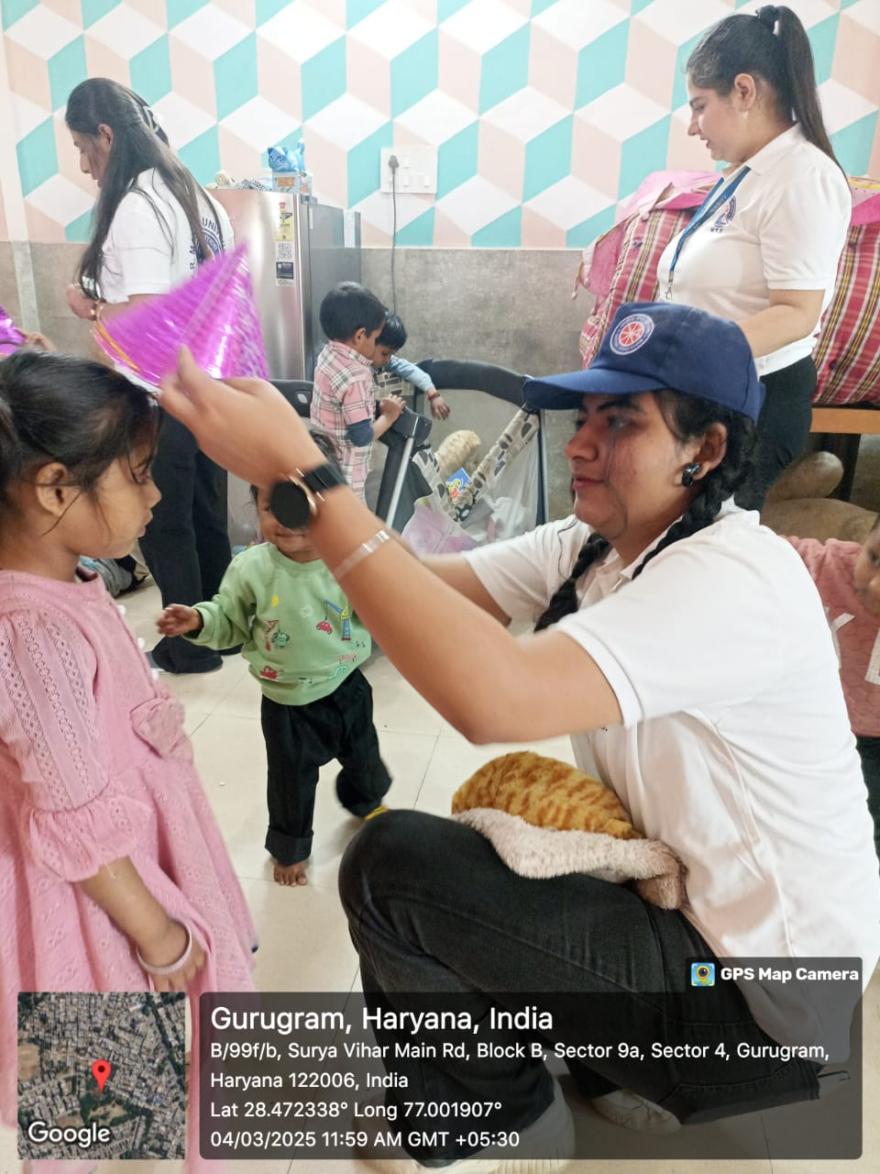

Photo 3: NSS volunteers spending time with foundation children

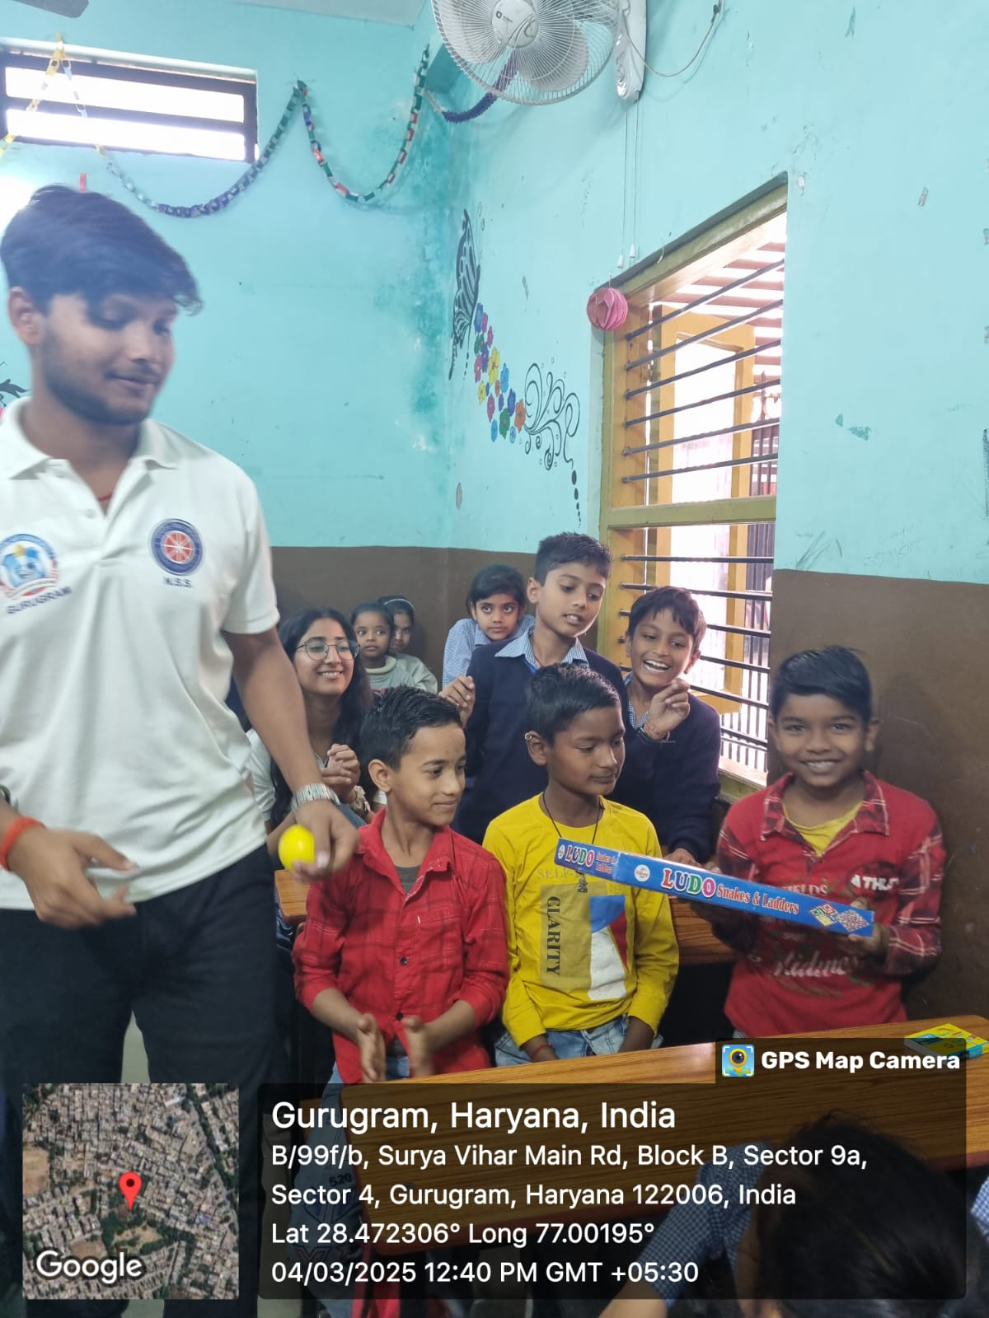

Photo 4: NSS volunteers distributed the games and study materials to children

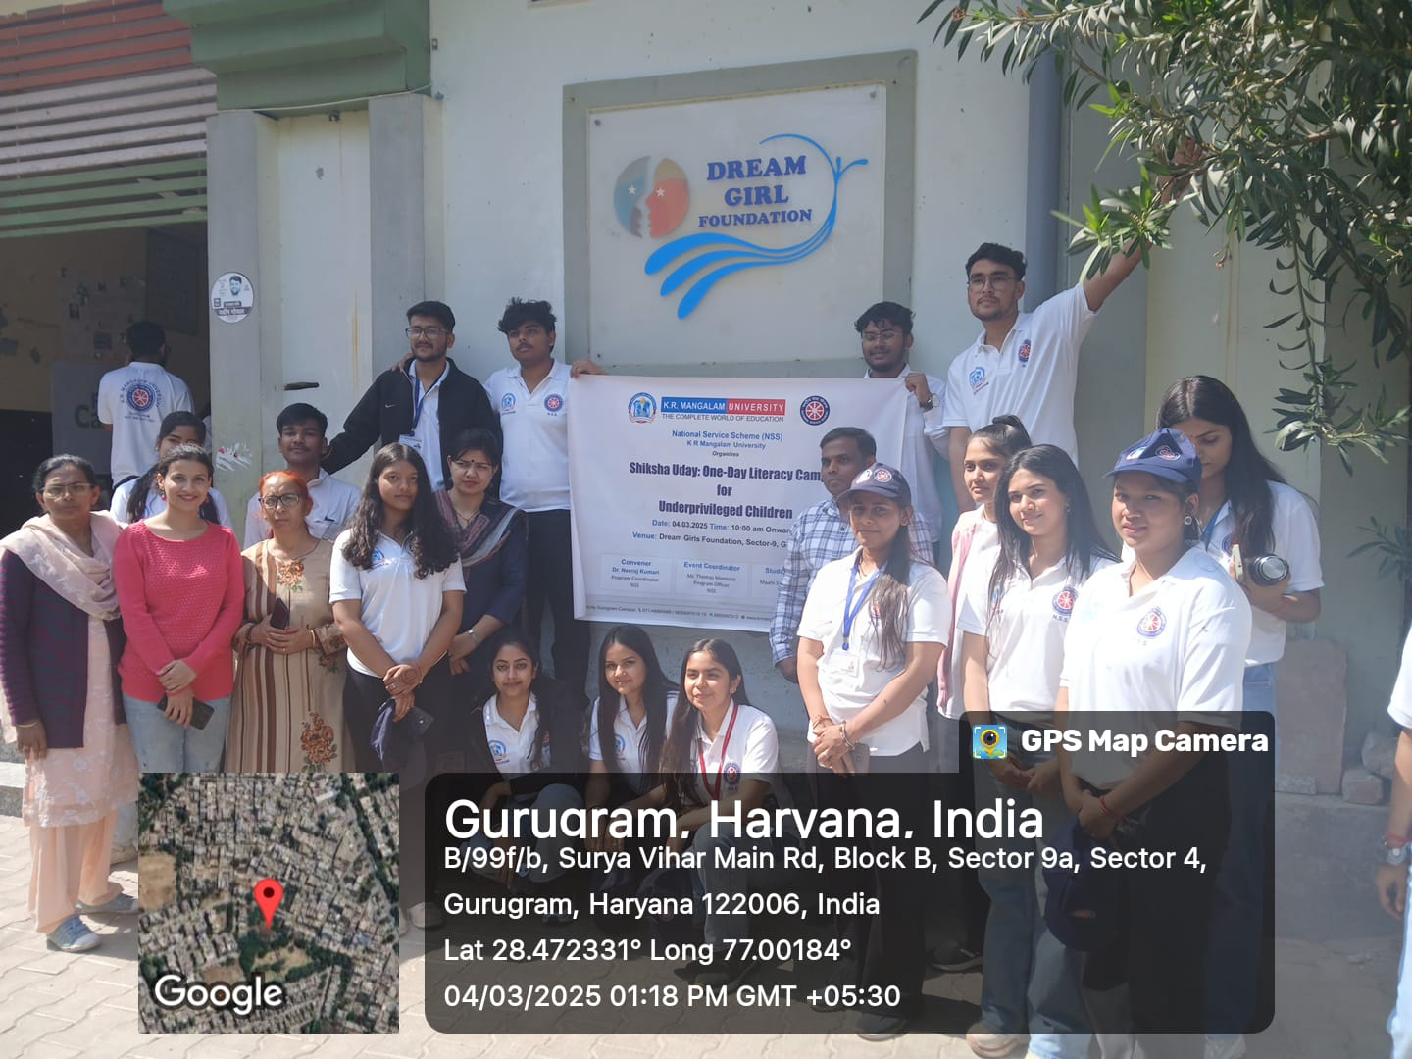

Photo 5: A group photograph with NSS volunteers and staff of the foundation

Report Prepared by | Dr Neeraj Kumari, NSS Program Coordinator
Report Verified by IQAC Coordinator | Dr Shikha Dutt Sharma

