Report on Health Checkup Camp
Date: 15th April 2025
Venue: Daulah Village, Sohna Block
Event Type: One-Day Health Camp (Extension Activity)
Mode of Activity: Offline
Target Group: Rural residents (all age groups)
Coordinators: Mr. Amit Kumar (NSS Program Officer)
Organized by: NSS Unit, K.R. Mangalam University, Gurugram in collaboration with School of Physiotherapy and Rehabilitation Sciences (SPRS)
Participants during the event: 31 NSS volunteers and more than 34 villagers
Introduction:
The NSS, K.R. Mangalam University, in collaboration with the School of Physical Rehabilitation Sciences (SPRS), organized a community-based Health Camp on 15th April 2025 at Daulah village in Sohna Block. The initiative aimed to extend essential healthcare and physiotherapy services to the rural population, addressing common musculoskeletal and general health issues. This outreach program was conducted under the expert guidance of Dr. Ankita Samuel and Dr. Hemant Kumar, and it aligned with the Sustainable Development Goals (SDGs) 3, Good Health and Well-being and ensure healthy lives by promoting well-being for all at all ages.
Objectives:
- To provide accessible physiotherapy and healthcare support to underserved rural communities.
- To educate villagers on health, hygiene, and preventive care.
- To give hands-on learning experiences to SPRS students, strengthening their clinical skills and social responsibility.
Contents:
The health camp witnessed enthusiastic participation from the community, with more than 34 villagers availing themselves of free check-ups and physiotherapy treatments. A dedicated team

of 10 student volunteers from SPRS, K.R. Mangalam University along with NSS volunteers participated in the diagnosis and treatment of patients, under the supervision of experienced faculty members. The camp focused on addressing common issues such as joint pain, backaches, and mobility-related problems.
Therapeutic interventions and health awareness counseling were provided on-site, ensuring comprehensive support for attendees. The local village representatives, including the Sarpanch, extended their cooperation, making the event well-organized and widely accepted by the community. The program not only addressed the immediate health needs of the people but also educated them about preventive practices and healthy lifestyle habits.
Conclusion:
Through this initiative, essential medical and physiotherapy services were successfully delivered to underserved populations, addressing their immediate health concerns and raising awareness on preventive care. The collaborative efforts of students, faculty, and local authorities not only brought tangible benefits to the community but also enriched the students with practical knowledge and civic responsibility.
Event Outcomes:
The event had a meaningful impact on the community and the participating students. The villagers appreciated the initiative, which brought medical assistance to their doorstep. The students gained real-time experience in handling patients and understanding community healthcare challenges, thereby reinforcing their academic training with practical exposure.
The event fostered a spirit of service and empathy among the student volunteers and strengthened K.R. Mangalam University’s commitment to community engagement and nation-building through the NSS platform.
Future Prospects:
Inspired by the positive outcomes, the NSS Unit and SPRS plan to organize periodic health camps in other rural locations, further integrating academic learning with social commitment. Plans are also underway to initiate follow-up visits and chronic care support for patients in need.
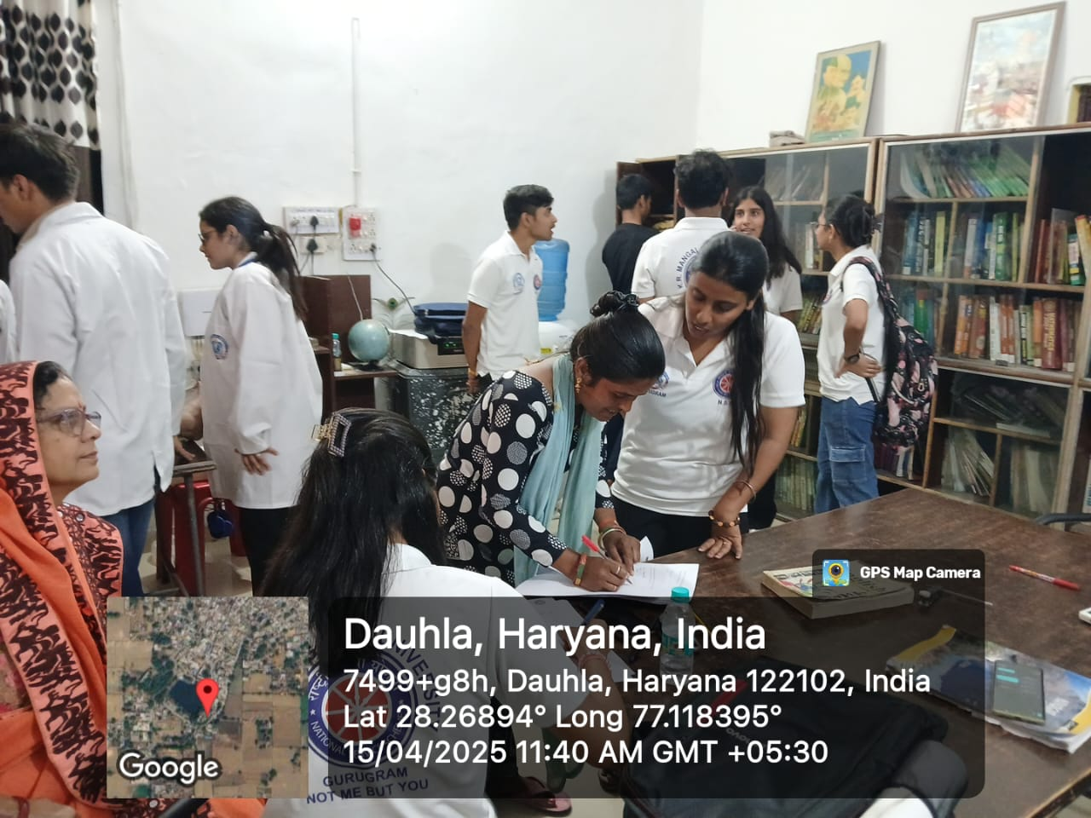

Photo 1: NSs volunteers during the health check up
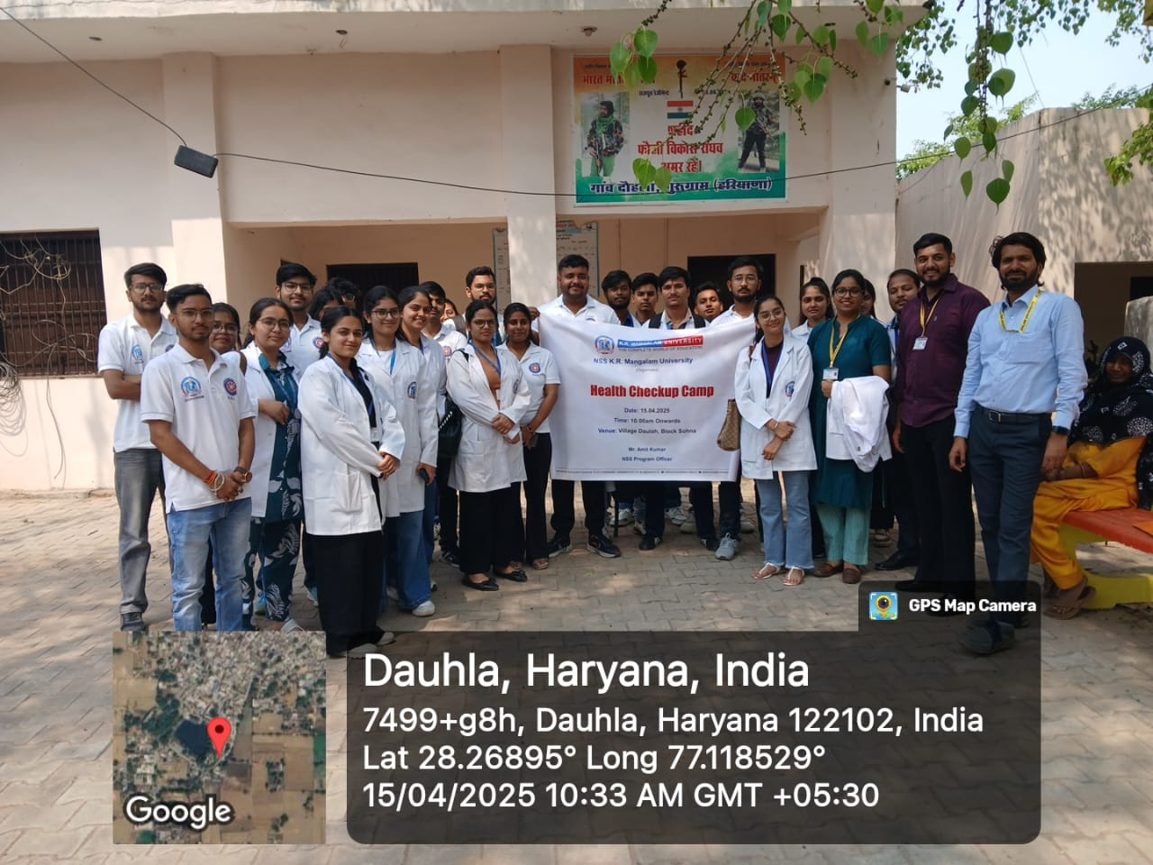

Photo 2: A group photograph of NSS volunteers, SPRS students and faculties

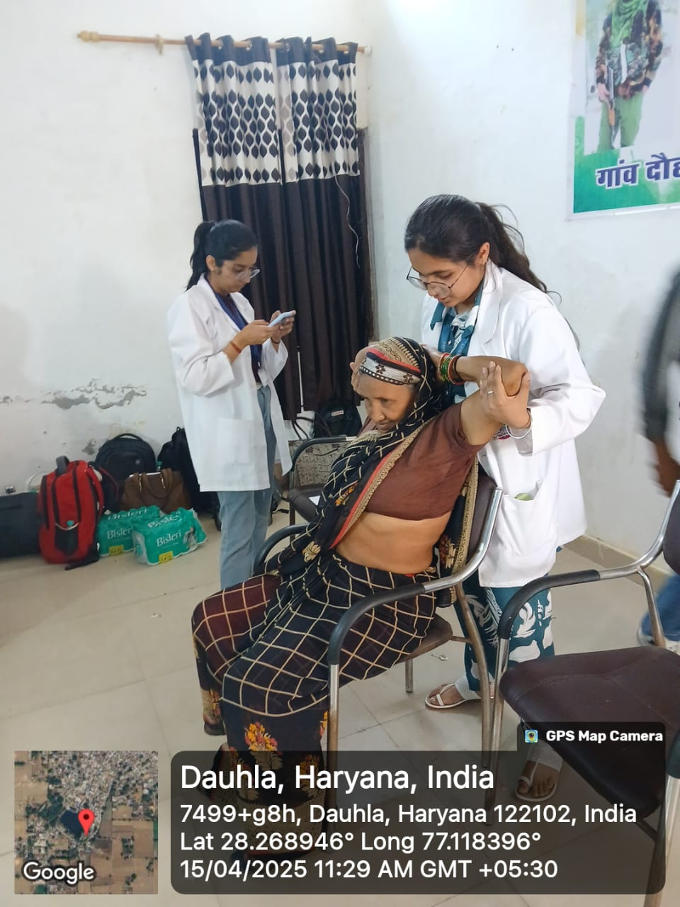

Photo 3: Volunteers taking physiotherapy session of villagers

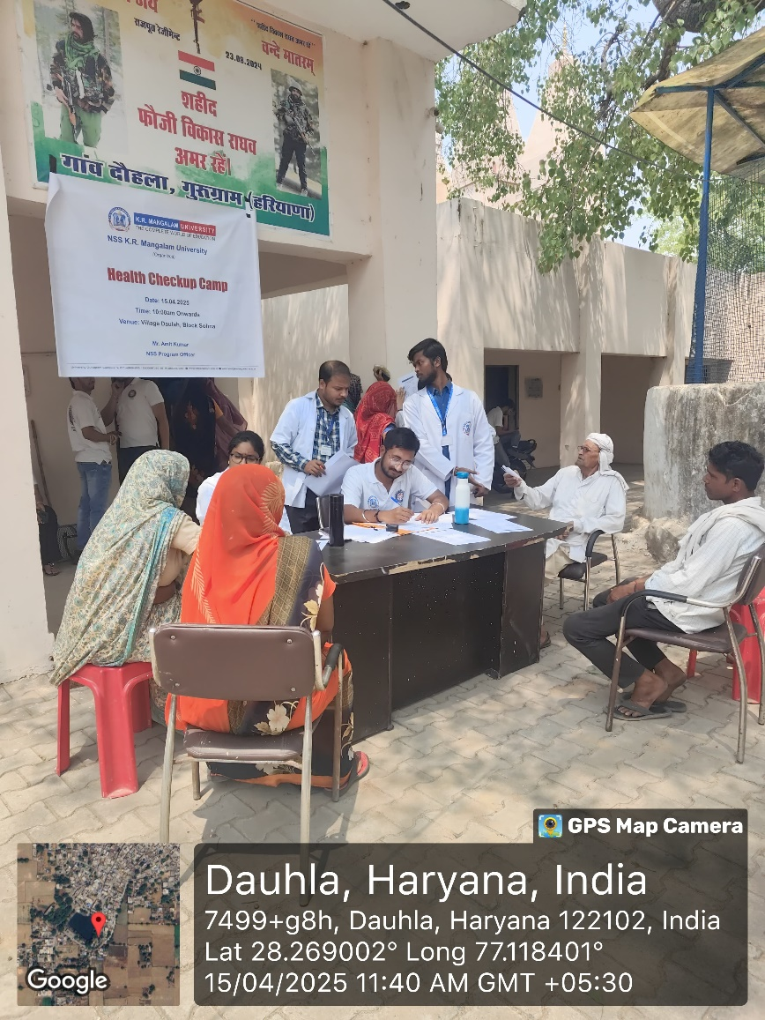

Photo 4: NSS volunteers during the registration of villagers
Report Prepared by | Dr Neeraj Kumari, NSS Program Coordinator
Report Verified by IQAC Coordinator | Dr Shikha Dutt Sharma

