Report on Donation Drive and Visit to Old Age Home
Date: 11th February 2025
Venue: Earth Saviour Foundation, Bandhwari
Event Type: Visit and Donation
Mode of Activity: Offline
Target Group: Residents of Earth Saviour Foundation and NSS volunteers
Coordinator: Dr. Neeraj Kumari (NSS Program Coordinator) and Dr. Sapna Rana (NSS Member)

Organized by: NSS, K R Mangalam University
Participants during the event: More than 31 residences of foundation and 44 NSS volunteers
Introduction:
National Service Scheme (NSS) of K.R. Mangalam University consistently endeavors to inculcate the values of selfless service, empathy, and social responsibility among students. In line with these objectives, a donation drive was organized on 11th February 2025 to support the underprivileged residents of the Earth Saviours Foundation, a shelter home located in Bandhwari village, Faridabad.
Objectives:
The key objectives of the donation drive were:
- To foster the spirit of service and compassion among students.
- To collect and distribute essential resources to the needy residents of the Earth Saviours Foundation.
- To provide NSS volunteers with an opportunity to engage meaningfully with the underprivileged and understand their challenges.
- To promote empathy, volunteerism, and community participation in social welfare initiatives.

Contents:
Collection cartons were placed across the university campus (Aryabhata and Bhaskracharya block) to collect clothes, food items and other necessary things. The university community, including faculty, staff, and students, contributed generously for the donation. The collected items were segregated separately by NSS volunteers. On 11th February 2025, NSS volunteers, accompanied by Dr. Neeraj Kumari and Dr. Sapna Rana (Event Coordinator), visited the Earth Saviours Foundation. The team delivered the collected donations and spent quality time with the residents.
The volunteers engaged in heartfelt conversations with the residents, learning about their struggles and life experiences. Volunteers distributed dry food items and personally served lunch, creating a warm and inclusive atmosphere.
Conclusions:
The donation drive turned out to be a deeply emotional and transformative experience for all involved. The humble act of giving was met with heartfelt gratitude from the residents, many of whom described the foundation as a sacred space that feels like home. The experience highlighted the critical importance of social engagement and reinforced the NSS motto — “Not Me, But You.” Event outcomes:
The donation drive witnessed overwhelming participation from the entire university community, reflecting a collective spirit of service and empathy. The initiative led to the successful collection and distribution of essential items including clothes, food, and spiritual books to the residents of the Earth Saviours Foundation. NSS volunteers had meaningful and heartfelt interactions with the residents, offering not just material support but also emotional connection. The visit left a lasting impact on the students, enhancing their understanding of empathy, compassion, and various social issues. The positive feedback from the residents and foundation caretakers served as a testimony to the success of the event.

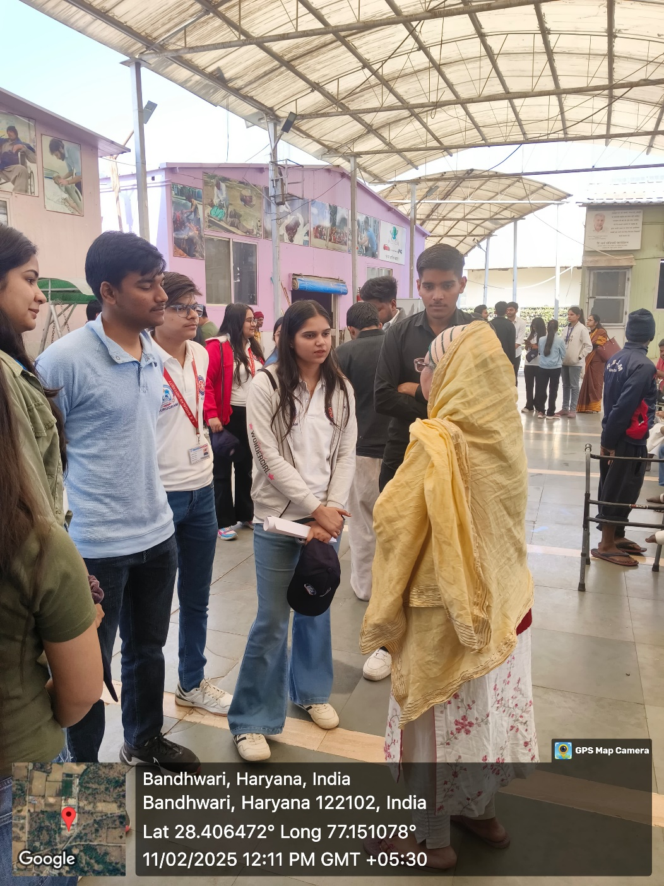

Photo 1: NSS volunteers during interaction with residences

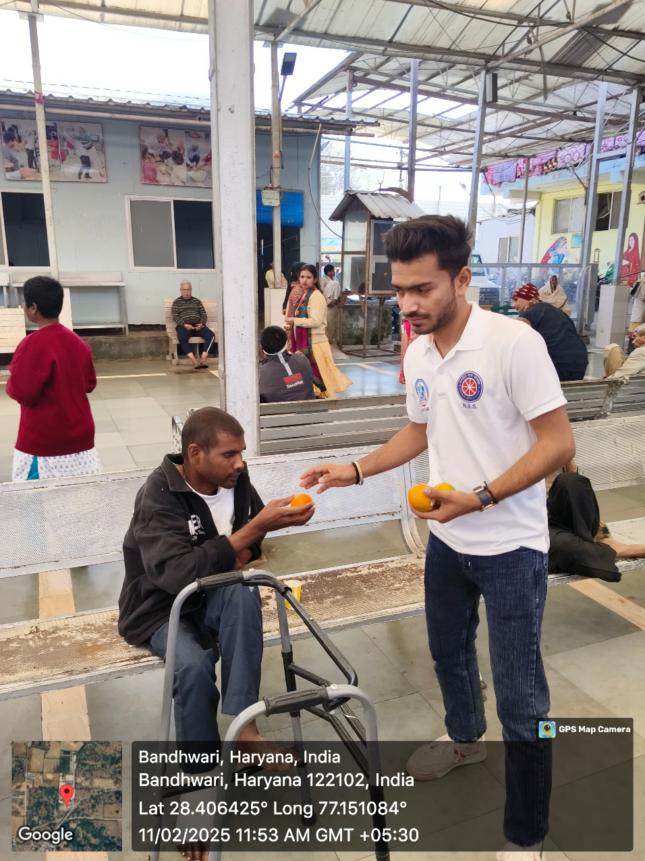

Photo 2: Mr Rohtash Singh welcomed all the guests

Photo 2: NSS volunteers during distribution of food items

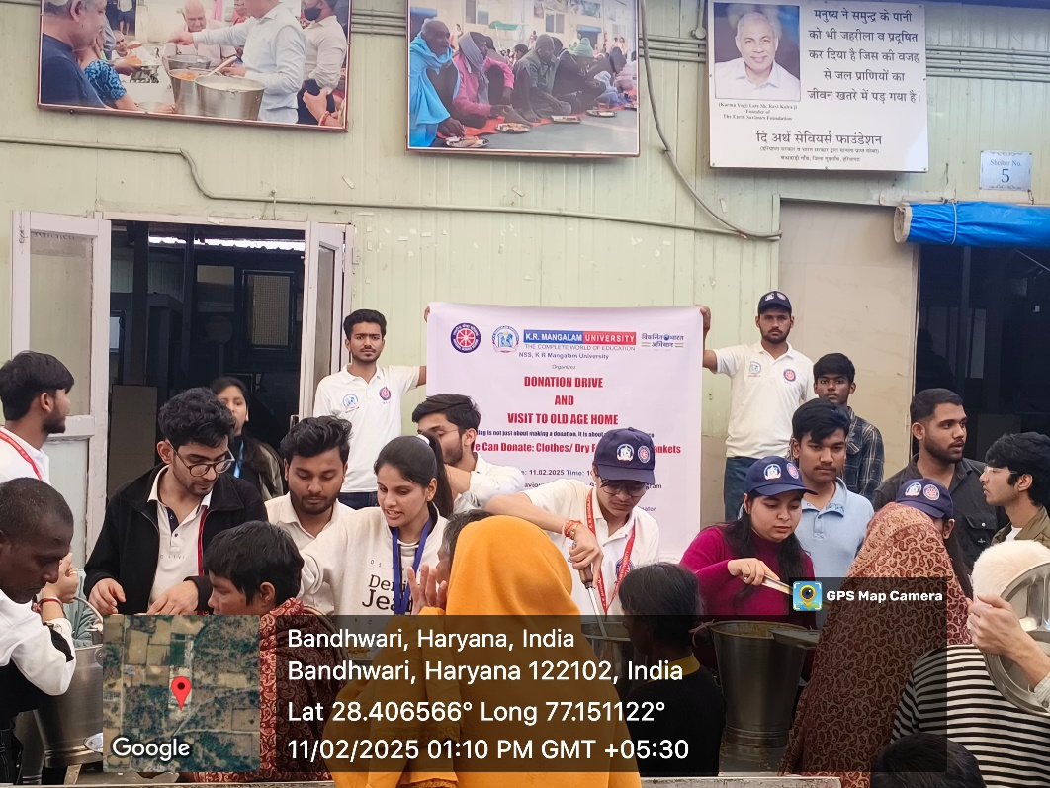

Photo 3: NSS volunteers during distribution of lunch to the residences
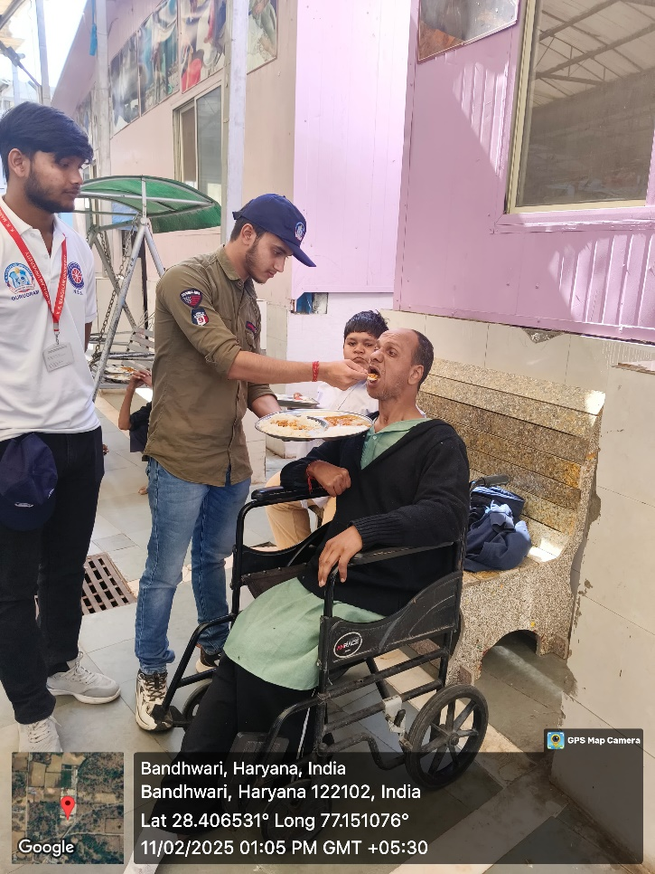

Photo 4: NSS volunteers during feeding the lunch
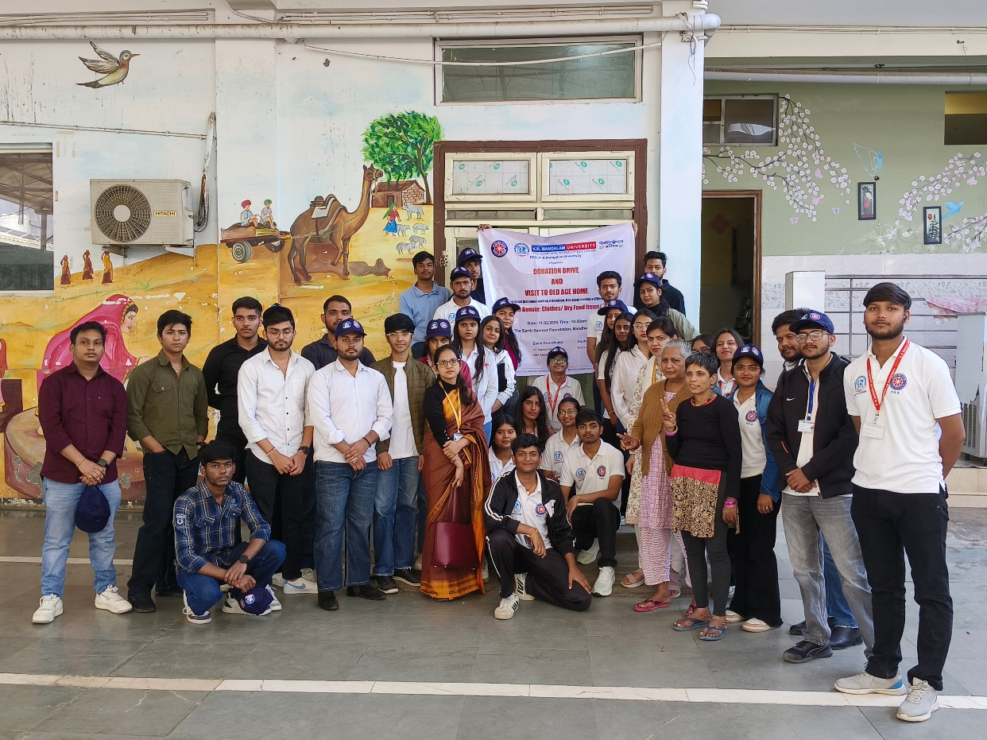

Report Prepared by | Dr Neeraj Kumari, NSS Program Coordinator
Report Verified by IQAC Coordinator | Dr Shikha Dutt Sharma

Photo 5: A group photograph with NSS volunteers and residence of the foundation

Glimpse of the workshop

