Report on Viksit Bharat district Youth Parliament
Date: 22-23 March 2025
Venue: K. R. Mangalam University
Event Type: Youth Parliament
Activity: Offline
Target Group: Students from different educational institute
Coordinator: Dr. Neeraj Kumari (NSS Program Coordinator), Dr. Thomas Monteiro (NSS Program Officer), Mr. Amit Kumar (NSS Program Officer), Dr. Vicky Kapoor and Dr. Sapna Rana (NSS member)
Organized by: NSS, K.R. Mangalam University
Participants during the event: 65 students from different educational institutes of Rewari, Faridabad and Gurgaon districts
Resource Persons: Mr. Karan Choudhary (Advocate), Sr. Advocate Tezpal Yadav, Mr. Man Singh Yadav (Ex. Assistant Director ED), Dr. Anjali Sekhwat (Associate Professor, School of Law, Sushant University, Gurgaon), Mr. Naveen Garg (Advocate), Mr. Shivam Arora (Advocate)
Introduction:
The Viksit Bharat Youth District Youth Parliament (DYP) 2025 was a successful and impactful event organized by the National Service Scheme (NSS) unit of K.R. Mangalam University. Held on 22nd and 23rd March 2025, the event provided a platform for students to engage in deliberative discussions, hone their leadership skills, and showcase their awareness about pressing social and national issues. The event saw enthusiastic participation from students across three districts—Rewari, Faridabad, and Gurugram—and was coordinated by NSS key officials and volunteers, highlighting the effective leadership and organizational skills of the NSS team.
Objectives:
The primary objective of DYP was to create an interactive and productive forum for students to engage in parliamentary-style discussions. The event aimed to foster leadership skills, increase awareness about key national and societal issues, and promote democratic values among the youth. By encouraging students to deliberate on various contemporary issues, the DYP also sought to cultivate a sense of civic responsibility and active participation in shaping societal progress.
Contents:
A total of 200 students registered for the event through the MY Bharat portal, and after a thorough screening process, 150 students from the districts of Rewari, Faridabad, and Gurugram were selected to participate. The event was graced by distinguished dignitaries, including:
- Mr. Narendra Ahuja Vivek (Ex-State Drug Controller)
- Mr. T.R. Khem (Former UGC Secretary)
- Mr. Naveen Gulia (District Youth Officer)
- Prof. Mehraj-uddin Mir (Motilal Nehru Chair)
- Dr. Rahul Sharma (Registrar, K.R. Mangalam University)
These esteemed personalities, along with five jury members, added value to the event, providing valuable insights during the deliberations.
The event was divided into two days of intense discussions and competitions. On Day 1, the students from Gurugram participated with great enthusiasm, presenting well-researched arguments and actively participating in the debate. The session concluded at 4:00 PM with a formal closure.
Day 2 started with the competition, where students from Rewari and Faridabad districts showcased their skills. The lively discussions and debates carried on until 1:00 PM, after which the NSS students from K.R. Mangalam University presented vibrant cultural performances, adding an artistic touch to the event.
Conclusions:
The event was concluded with the jury announcing the winners. A total of 10 participants were awarded certificates of achievement, marking the successful completion of the DYP. The District Youth Parliament 2025 successfully provided a platform for students to showcase their public speaking and leadership abilities while engaging in meaningful debates. The active participation and excellent conduct of the event reflected the growing enthusiasm and commitment of the youth

towards national issues. The presence of prominent dignitaries and the vibrant cultural performances added to the event’s success, leaving a lasting impact on all participants.

NAME | POSITION | DISTRICT
Pinki | I | GURUGRAM
Tamanna Dalal | II | GURUGRAM
Charan Singh | III | GURUGRAM
Tushar Kalra | IV | GURUGRAM
Abhimanyu Yadav | V | GURUGRAM
Priya | VI | GURUGRAM
Tarun Sharma | VII | FARIDABAD
Vishnu Mishra | VIII | GURUGRAM
Saatwick Mukherjee | IX | GURUGRAM
Divyanshi Shekhawat | X | GURUGRAM

Event Outcomes:
DYP 2025 achieved its goal of fostering awareness, leadership, and democratic values among the youth. The competitive sessions were an excellent learning opportunity for the participants, who not only gained insights into important national issues but also developed essential skills for effective public speaking and debate. The winners, who were felicitated with certificates, were also inspired to continue their journey of leadership and community engagement.
Future Prospects:
The success of DYP 2025 sets the stage for similar events in the future, aiming to involve a wider student base and address more diverse issues. The event has paved the way for increased collaboration between educational institutions and government bodies, providing a platform for students to contribute to national discourse. Moving forward, the NSS unit at K.R. Mangalam

University plans to expand the event’s scope, involving students from more districts, and incorporating additional activities such as workshops, mentorship programs, and community engagement initiatives to further enhance its impact.

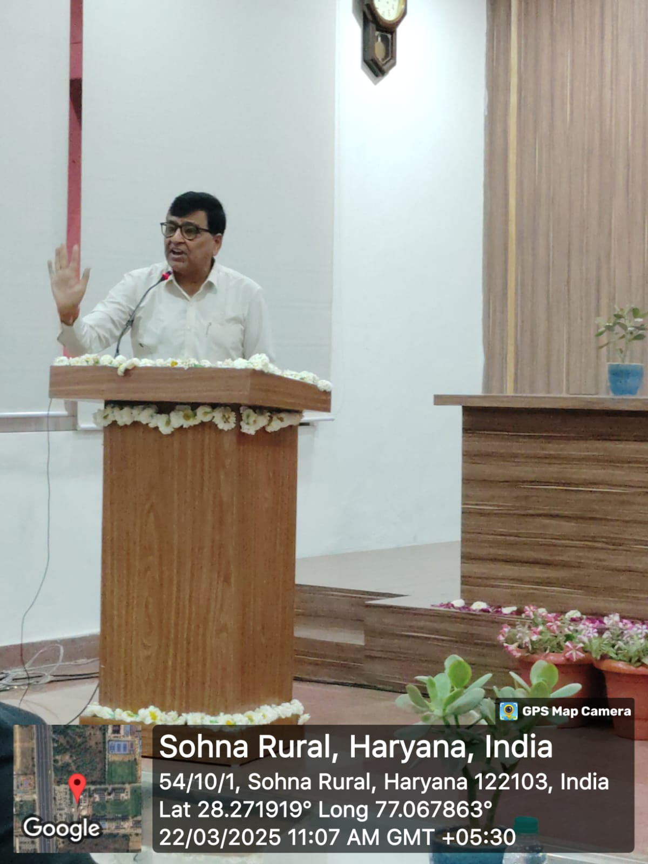

Photo 1: Chief guest Mr. Narendar Ahuja Vivek addressed the auidence

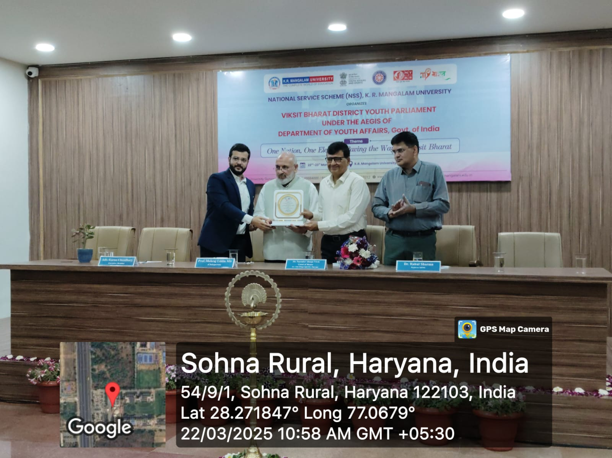

Photo 2: Prof. Mehraj Uddin Mir, Dr. Rahul Sharma and Jury member Mr. Karan Chaudhary facilitated the guest with guest of honour

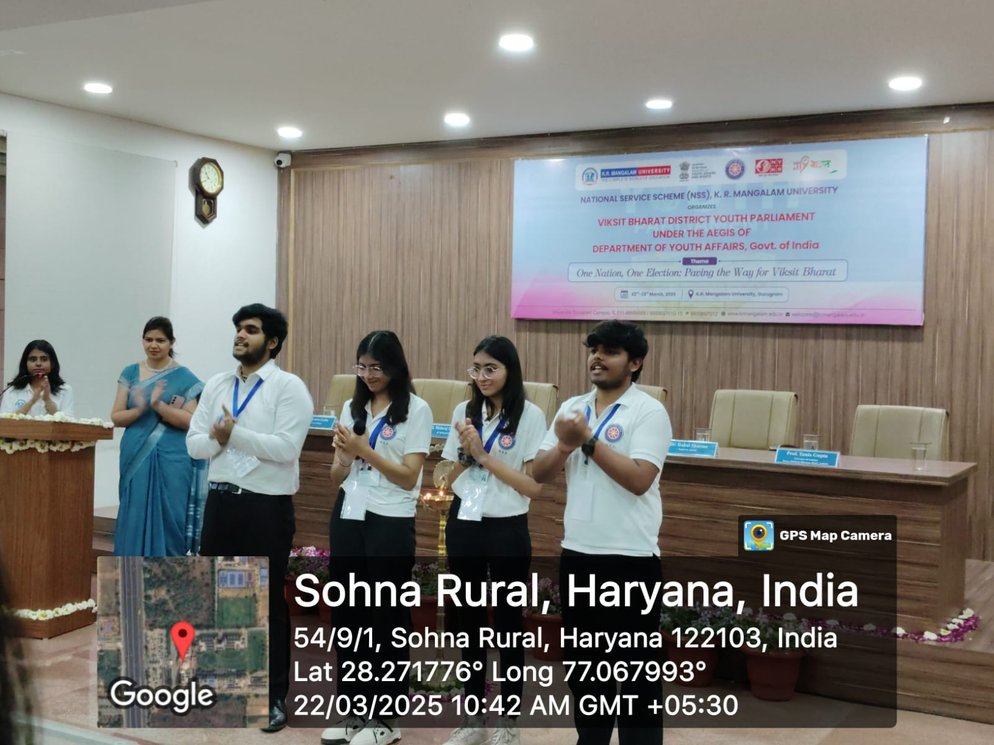

Photo 3: NSS volunteers performed NSS geet and NSS clap during inauguration of DYP
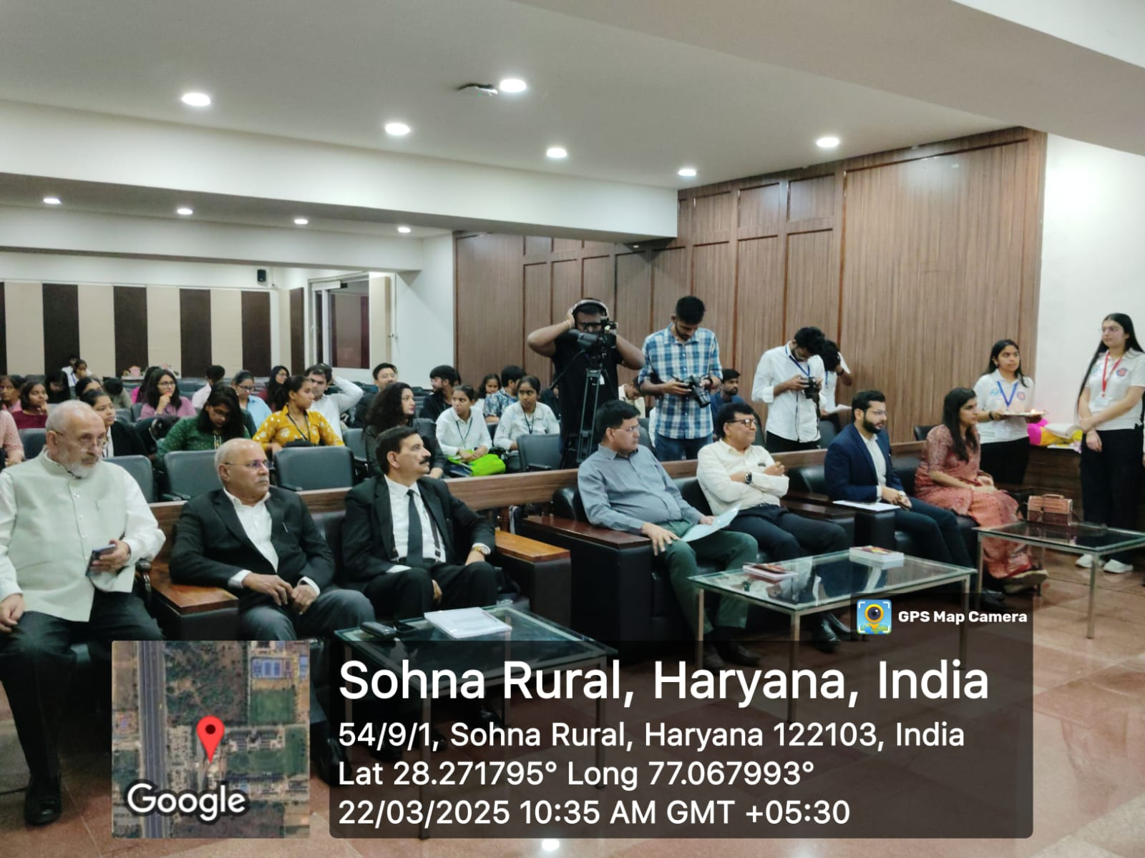

Photo 4: participants and Guests during the inauguration ceremony

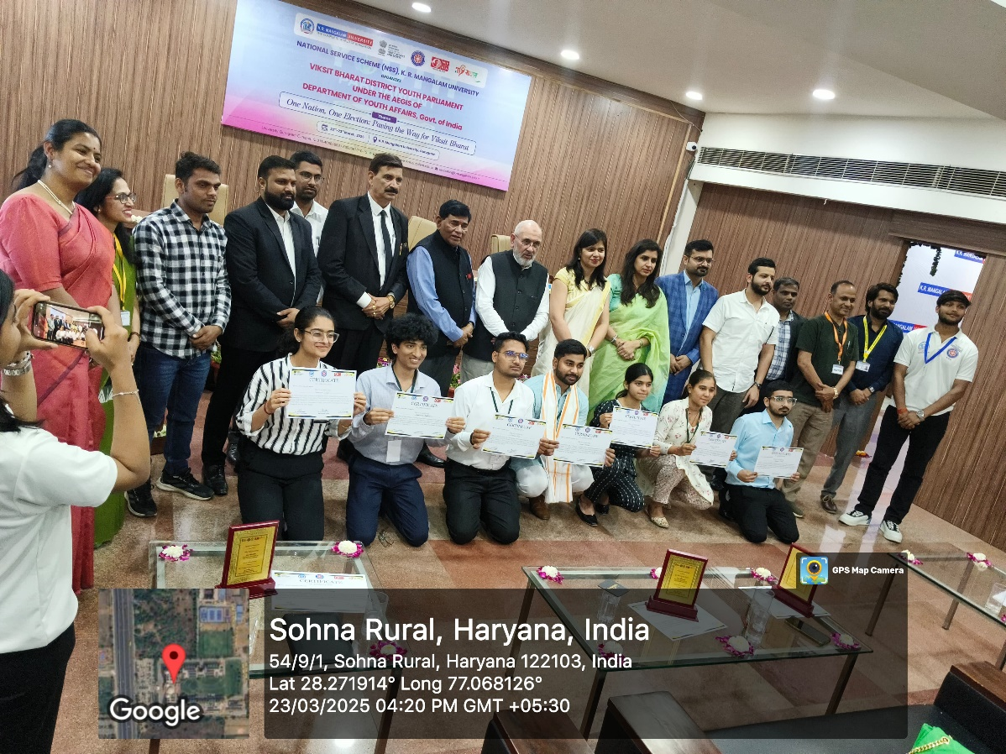

Photo 5: A group photograph with all winner of DYP
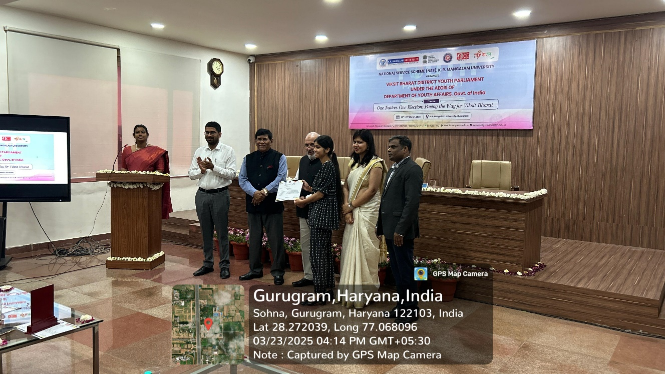

Photo 6: Certificate distribution to winner

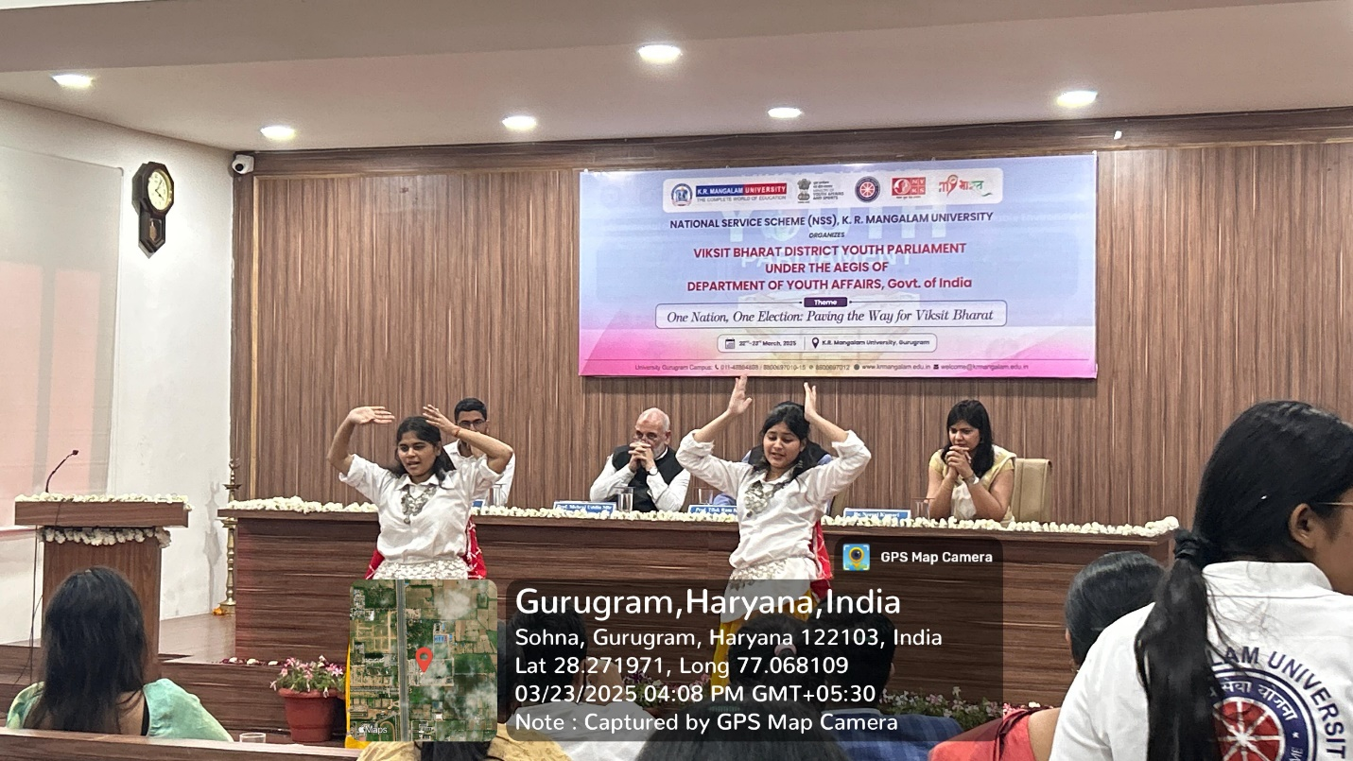

Photo 7: Cultural performance by NSS volunteers
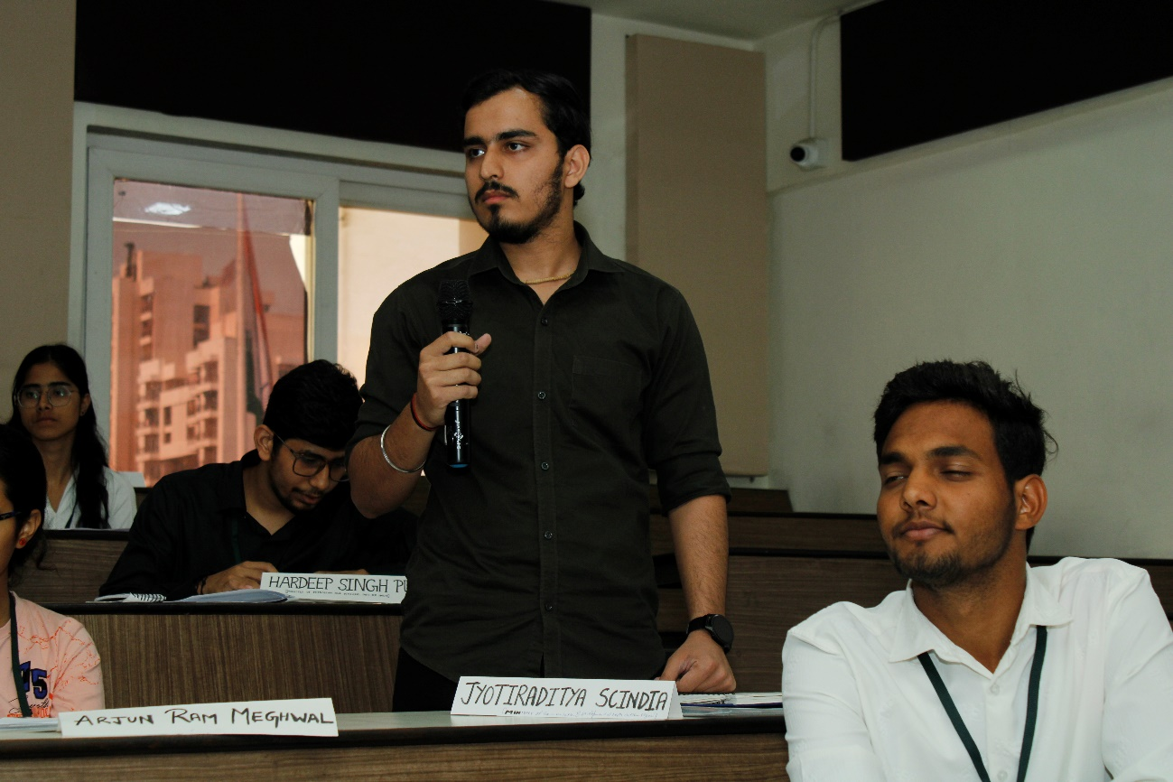

Photo 8: Participants from various districts during DYP

Report Prepared by | Dr Neeraj Kumari, NSS Program Coordinator
Report Verified by IQAC Coordinator | Dr Shikha Dutt Sharma

