Report on a visit to Ayushman Hospital

Date: 22nd October 2024
Venue: C-2, Palma Vihar, Gurgaon
Event Type: Visit
Mode of Activity: Offline
Target Group: NSS volunteers
Coordinator: Dr. Neeraj Kumari (NSS Program Coordinator) and Mr. Thomas Monteiro (NSS Program Officer)

Organized by: NSS, K R Mangalam University, Gurugram
Participants during event: 24 NSS volunteers
Introduction:
Ayushman Hospitals, a part of Ayushman Bharat scheme which is also known as Pradhan Mantri Jan Arogya Yojana (PM-JAY), is a government funded projecwhich provides free treatment at public places. Therefore, to provide exposure about traditional systems of medicine, including Ayurveda, Yoga, Naturopathy, and Homeopathy, NSS K R Mangalam University organized a visit to Ayush Wing, a center of Ayushman department on 22nd October 2024.
Contents:
The visit was organized under the guidance of Dr. Neeraj Kumari and Mr. Thomas Moneiro. The team was warmly welcomed by Mr. Bhudev, a Yoga expert, Dr. Anupriya, an expert in Ayurveda, and Dr. Geetanjli, a specialist in Panchakarma. During the visit, the volunteers had the opportunity to explore the principles and treatments of Panchakarma, an ancient Ayurvedic detoxification process aimed at balancing the body and mind. They were introduced to the various methods used in Panchakarma and learned about its health benefits. The volunteers also participated in a yoga session led by Mr. Bhudev, where they experienced different asanas and breathing techniques that promote physical and mental well-being. This hands-on experience deepened their understanding

of the holistic health practices central to the AYUSH (Ayurveda, Yoga & Naturopathy, Unani, Siddha, and Homeopathy) system. Through interactions with the experts, the volunteers gained valuable insights into the Ayurvedic approach to healthcare, focusing on natural remedies, preventive care, and lifestyle modifications for overall health improvement.
Conclusions:
The visit was both educational and enriching, providing the volunteers with practical knowledge and inspiration to adopt a healthier lifestyle. The session concluded with a discussion on the importance of empathy and ethics in healthcare, encouraging students to consider future engagements in the healthcare field.
Event outcomes:
Participants left with a deeper appreciation for the complexities of hospital management and patient care, as well as the role of ayurveda in improving healthcare outcomes.
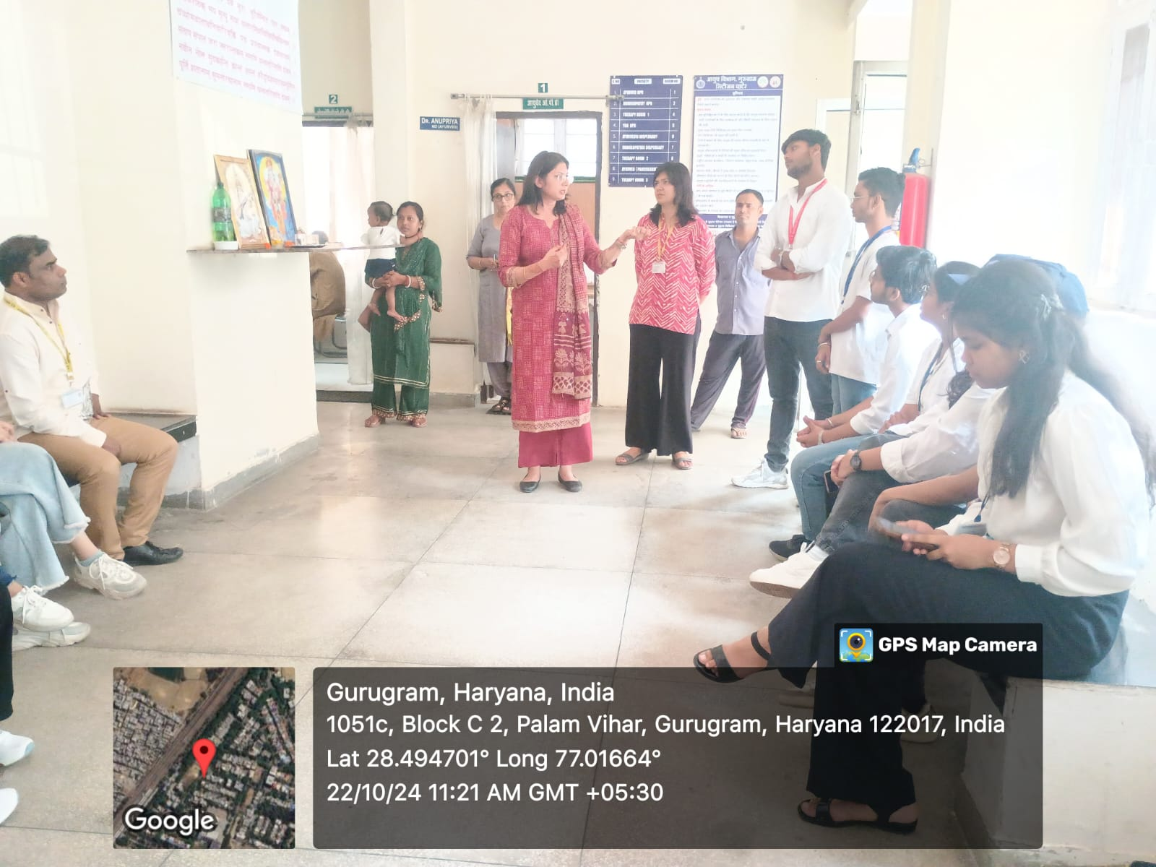

Photo 1: Dr. Anupriya, Head of Ayush Wing welcomed the volunteers at their center

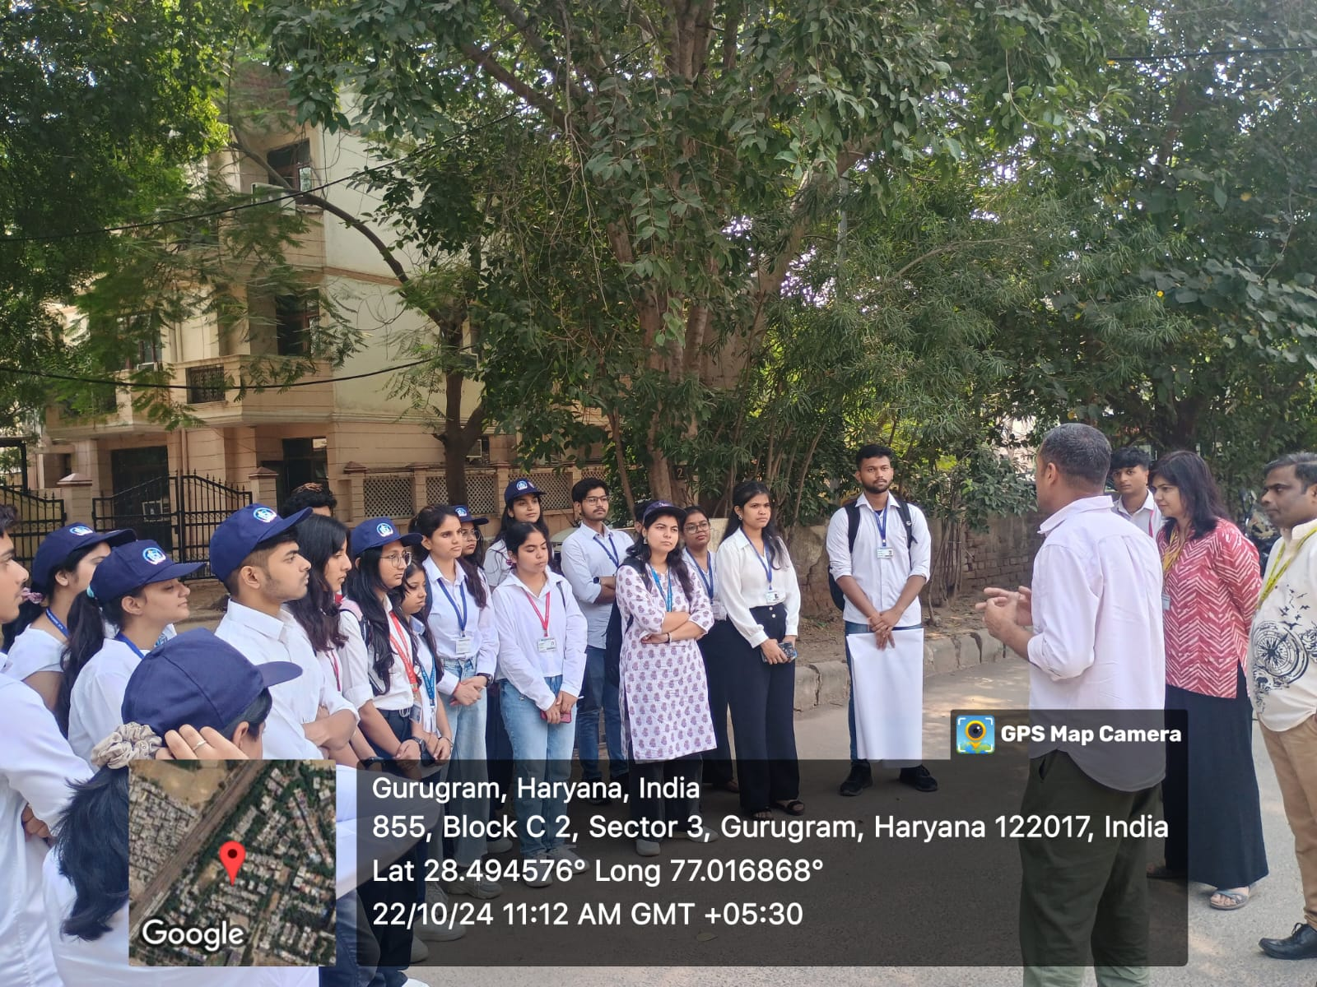

Photo 2: Mr Bhudev, Yoga Expert verified about Ayushman Hospital
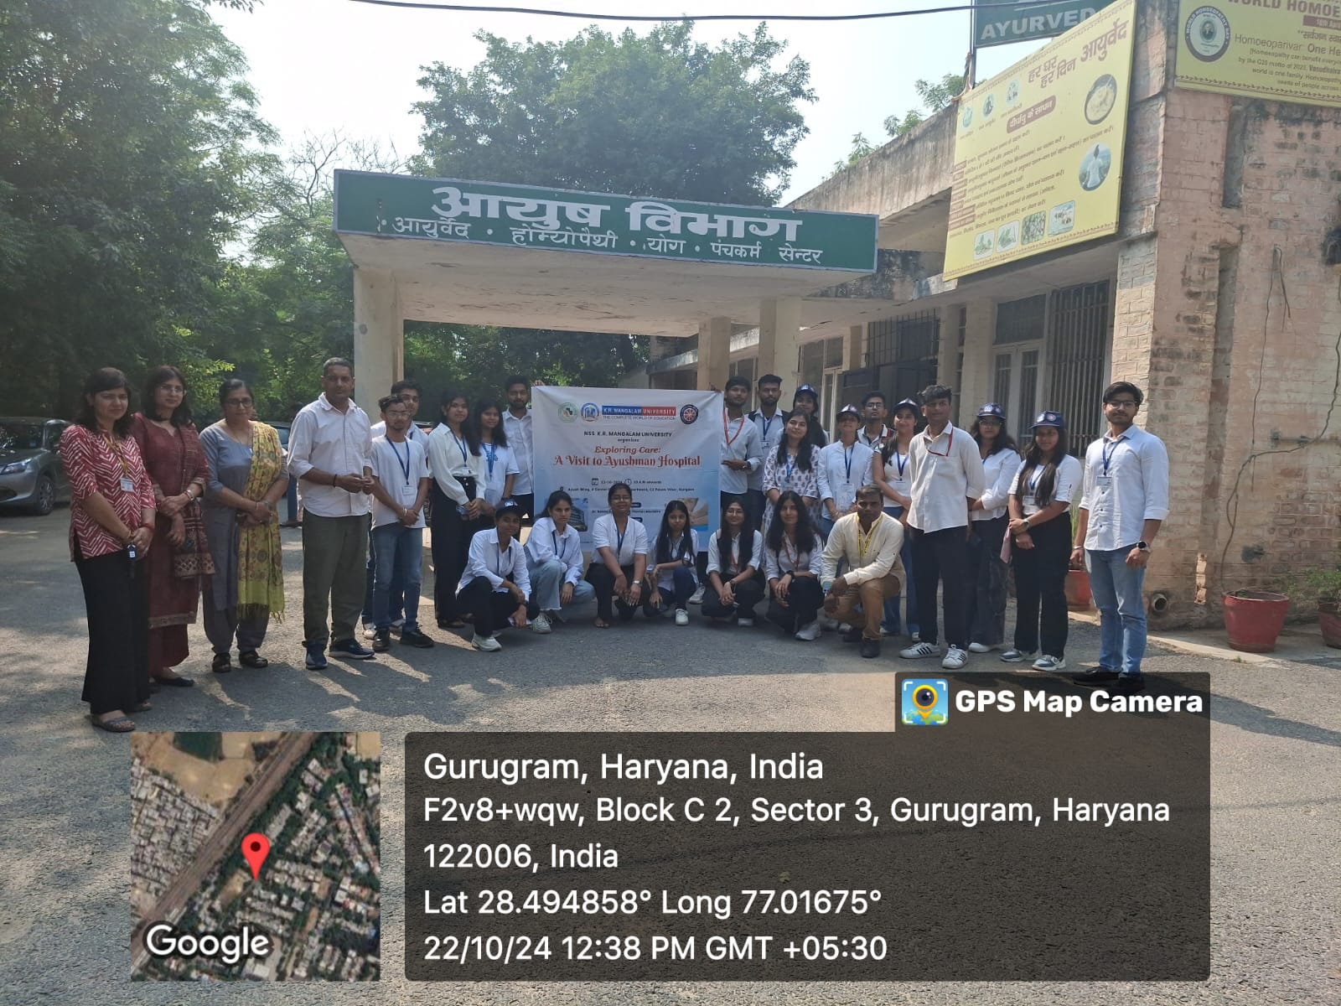

Photo 3: A group photograph with the staff of hospital

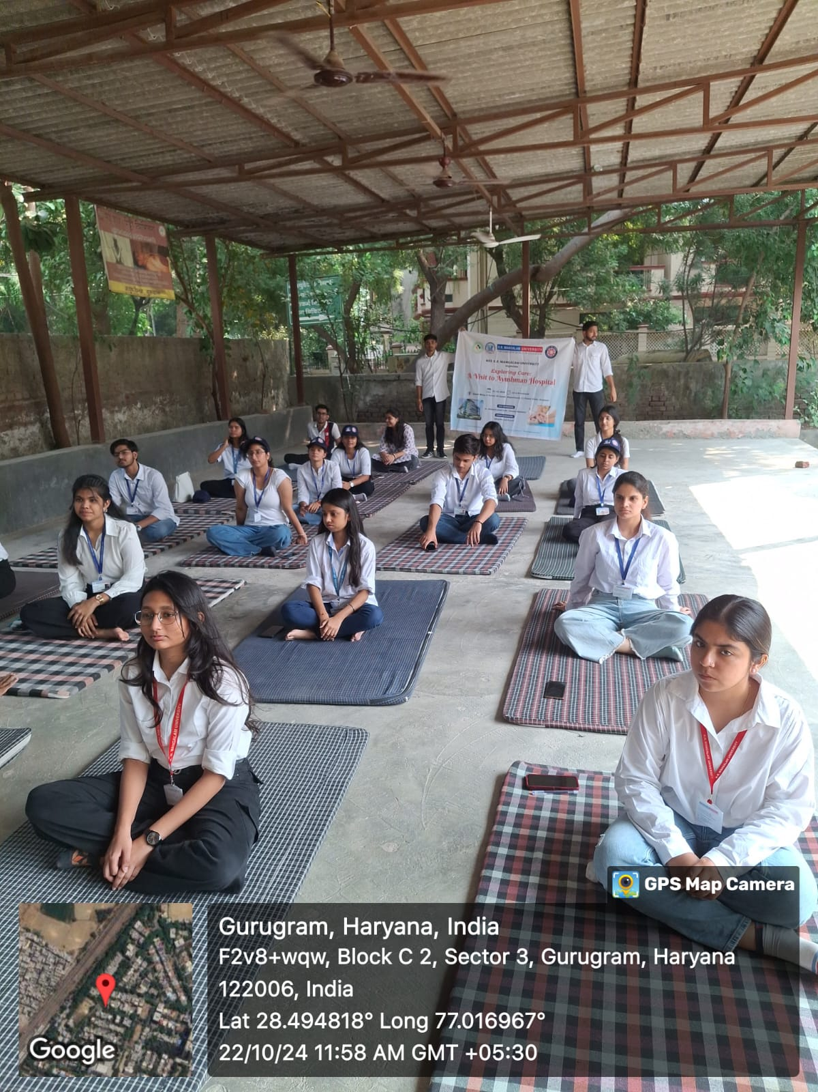

Photo 4: Volunteers during Yoga session
Report Prepared by | Dr Neeraj Kumari, NSS Program Coordinator
Report Verified by IQAC Coordinator | Dr Shikha Dutt Sharma

