Report on
A Visit to the Aravalli Biodiversity Park and Field Project on
“Exploring Biodiversity Conservation Strategies at Aravalli Biodiversity Park: A Study on Ecological Sustainability and Community Engagement”

29 November 2024

Date: November 29, 2024
Venue: Aravalli Biodiversity Park, Vasant Vihar, New Delhi
Event Type: Field Visit
Mode of Activity: Offline
Target Group: Student-teachers of B.El.Ed. Semester 3 and 5
Organized by: School of Education, K. R. Mangalam University
Number of Participants: 43 student-teachers
Faculty Coordinators: Prof. P. C. Jena, Professor, School of Education and Dr. Anshul Saluja, Assistant Professor, School of Education

Introduction
The field visit to Aravalli Biodiversity Park (ABP) was organized by the School of Education, K. R. Mangalam University, as an experiential learning activity to foster ecological awareness and environmental stewardship among student-teachers. The ABP, a model of ecological restoration, offers a platform for understanding biodiversity conservation and sustainable development. The visit focused on evaluating conservation strategies and their alignment with Sustainable Development Goal (SDG) 15: Life on Land, which aims to protect, restore, and promote the sustainable use of terrestrial ecosystems.

Objectives
- To evaluate the biodiversity conservation strategies employed at Aravalli Biodiversity Park.
- To study the ecological sustainability of these strategies in preserving native flora and fauna.
- To explore the areas of community engagement in supporting and enhancing conservation efforts.

Observations
- Biodiversity Conservation Strategies
The ABP adopts an ecological assembly approach to restore and sustain native biodiversity. Key initiatives include:
- Medicinal Plant Conservatory: Housing endangered species like Brahmi and Gugal, this area underscores the importance of medicinal flora in conservation.
- Orchid and Fern Conservatories: Dedicated spaces for rare plant groups highlight species-specific conservation efforts.
- Butterfly Conservatory: A vibrant habitat fostering over 100 butterfly species, contributing to pollination and ecosystem health.
- Tree Conservatory and Rangeland Ecosystem: These zones replicate native Aravalli forest and grassland ecosystems, promoting habitat creation and ecological resilience.
- Ecological Sustainability
The park's landscapes support diverse biotic communities, ensuring ecological balance.
- Flora: The varied terrain nurtures more than 1,000 native plant species, enhancing the park's ecological value.
- Fauna: Species such as jackals, blue bulls, and Indian hares thrive in restored habitats. Over 190 bird species, including rare and migratory ones like the Indian pitta and Peregrine falcon, underline the park’s importance as a biodiversity hotspot.
- Insect Diversity: The park supports vital pollinators, with more than 20 insect orders, including bees, butterflies, and dragonflies.
- Community Engagement and SDG 15
The ABP exemplifies SDG 15 by fostering partnerships and involving local communities in biodiversity conservation.
- Nature Education Programs: Interactive workshops and biodiversity walks educate visitors about the significance of ecosystem restoration.
- Collaborative Partnerships: ABP collaborates with institutions and NGOs to amplify conservation efforts, creating a network of stakeholders committed to life on land.
The field visit illuminated the importance of community participation and educational outreach in achieving the goals of SDG 15, emphasizing the interconnectedness of environmental conservation and sustainable development.

Outcomes
The field visit to Aravalli Biodiversity Park served as an invaluable experiential learning opportunity for the student-teachers, offering them a comprehensive understanding of biodiversity conservation strategies and their profound ecological impact. They observed firsthand the restoration of degraded ecosystems, the preservation of native species, and the critical role of community engagement in sustaining these efforts. This immersive experience reinforced the importance of restoring terrestrial ecosystems in alignment with Sustainable Development Goal (SDG) 15: Life on Land, which emphasizes the need to protect, restore, and promote sustainable use of terrestrial ecosystems, combat desertification, and halt biodiversity loss.
Through interactive discussions with experts and exploration of the park’s unique conservatories, the participants gained an appreciation of the interconnectedness of flora, fauna, and human actions. The visit also underscored the power of education and active community participation in fostering sustainable environmental practices. This experience inspired the student-teachers to incorporate environmental consciousness into their teaching methodologies, equipping them to nurture future generations with a sense of responsibility and commitment toward ecological sustainability. Such initiatives will help build a foundation for a society that values and actively participates in the protection and restoration of natural ecosystems.

Conclusion
The field visit to Aravalli Biodiversity Park was a valuable opportunity for student-teachers to connect with nature and understand the role of biodiversity in ecological sustainability. Aligning with SDG 15, the visit highlighted the importance of restoring and conserving life on land through education and community involvement. This experience has equipped the participants to advocate for sustainable practices and contribute meaningfully to environmental conservation efforts in their roles as future educators.
Report prepared by: | Dr. Anshul Saluja  Assistant Professor, SOED
Report checked & verified by: | Prof. Tania Gupta  Dean, SOED
IQAC Coordinator: | Dr. Shikha Dutt Sharma
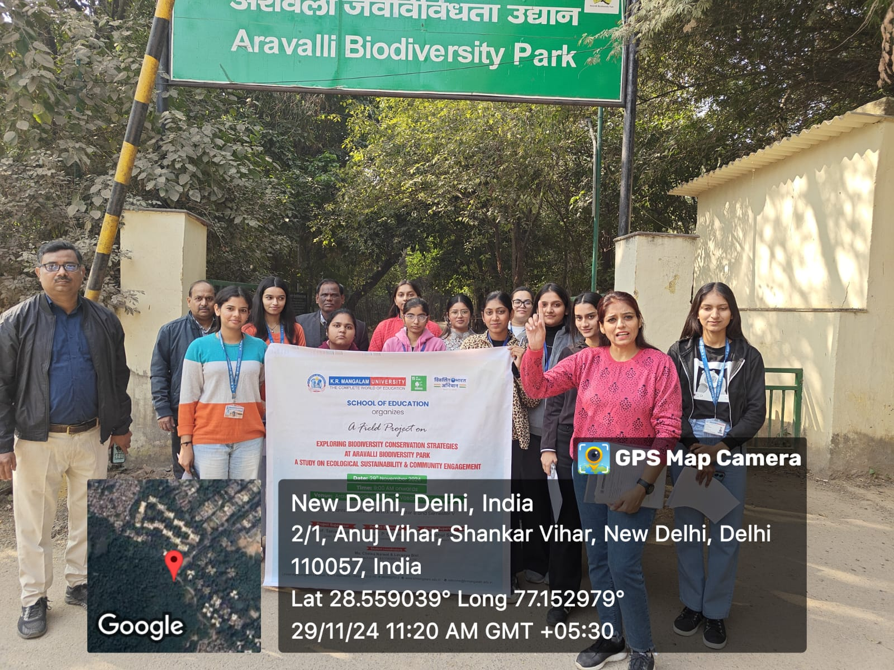
Picture 1: Student-teachers and faculty at the venue of the visit
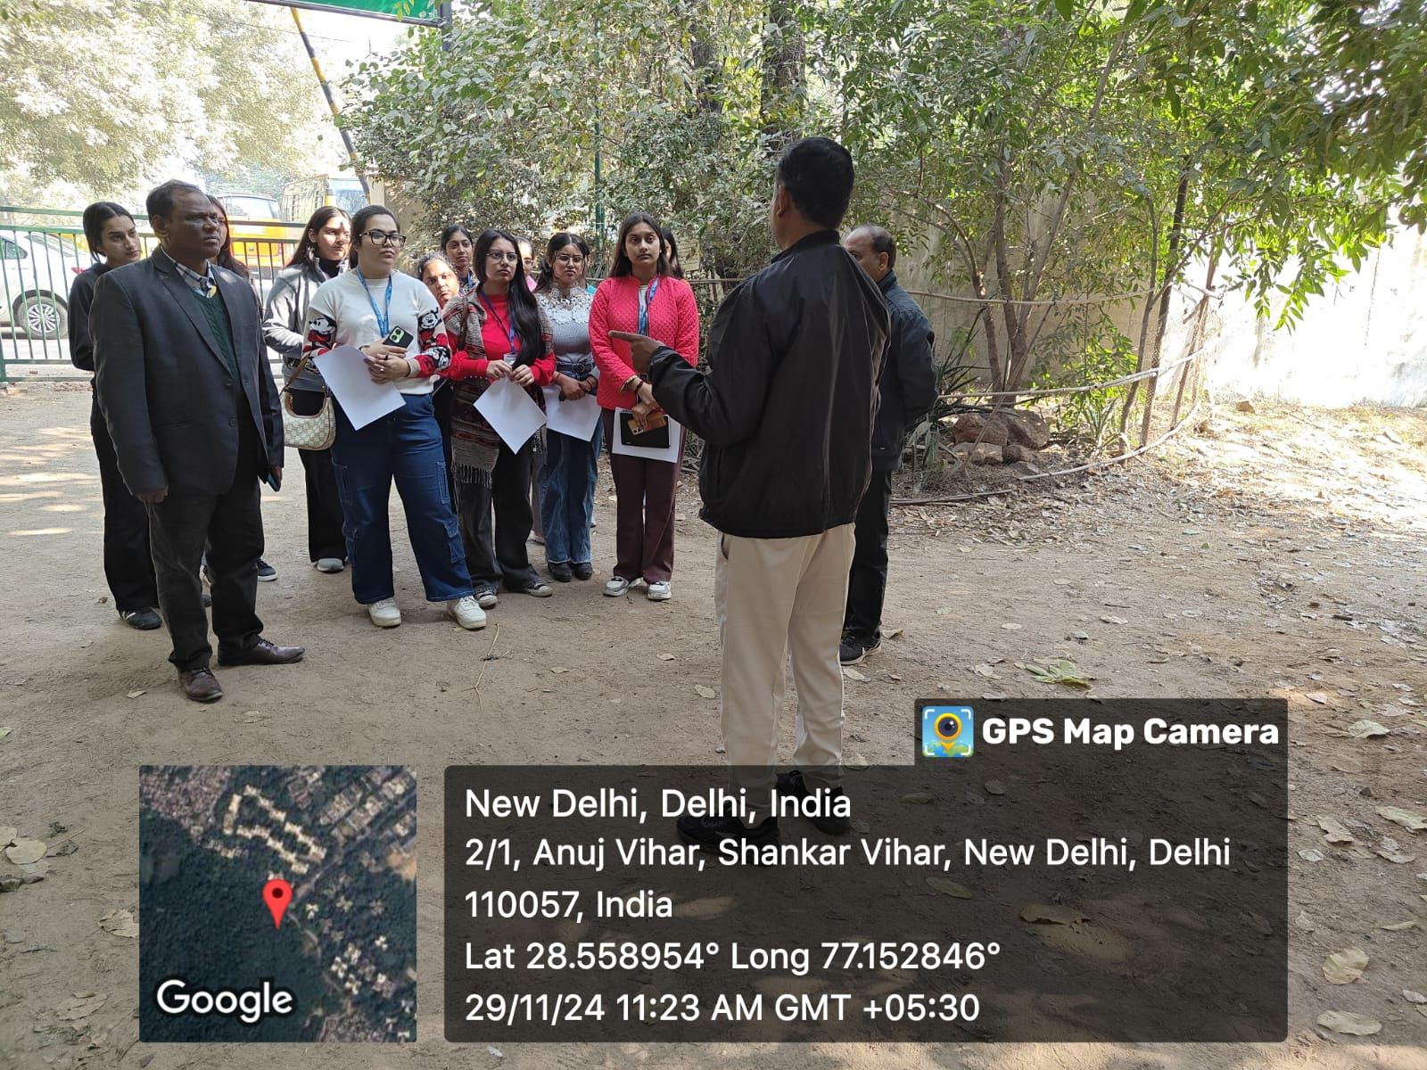
Picture 2: Student-teachers receiving the instructions from the park officials before visit to the park
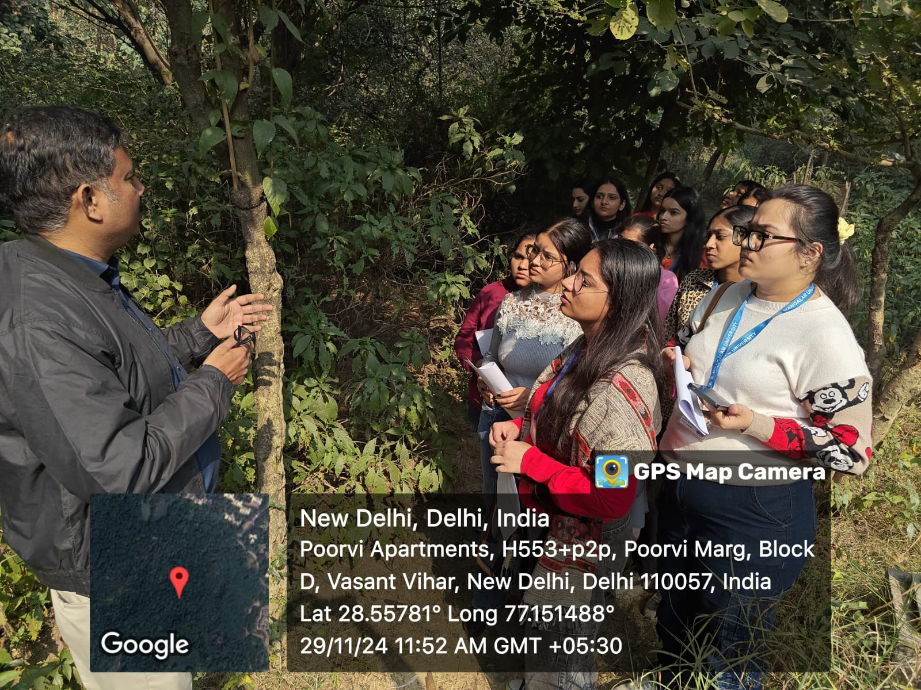
icture 3: Biodiversity Park Officials explaining about the various species of plants to the Student-teachers
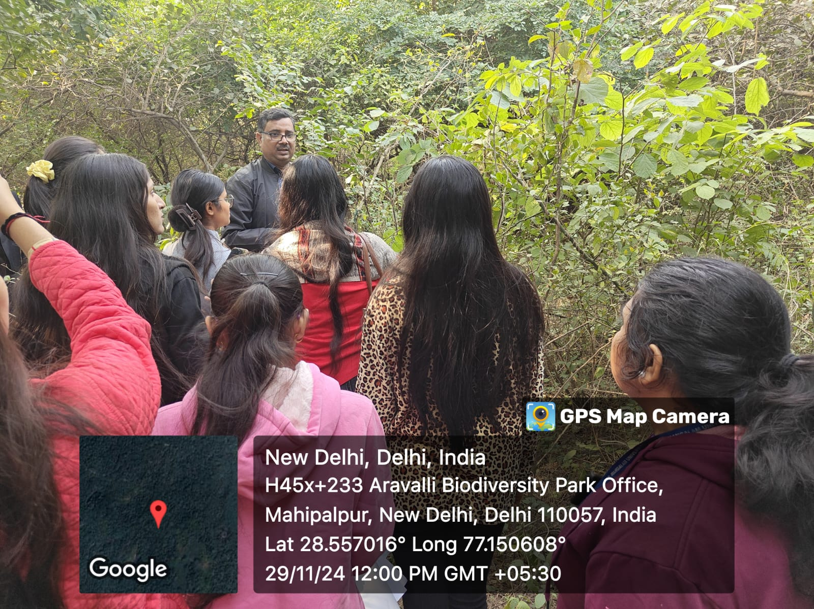
Picture 4: Biodiversity Park Officials explaining about the various species of plants to the Student-teachers
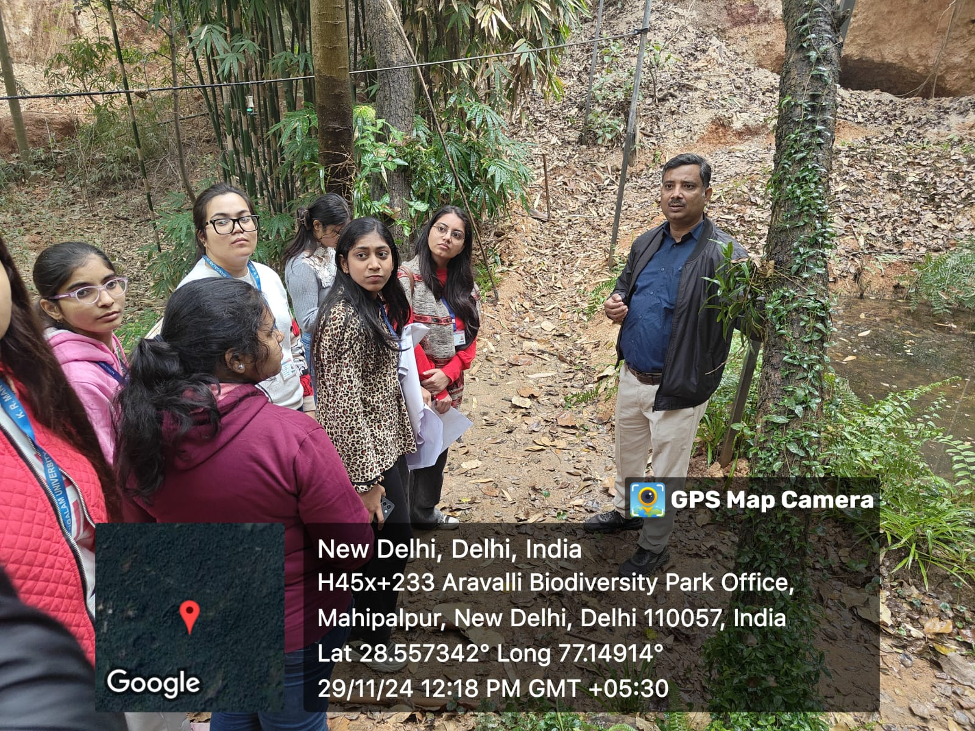
Picture 5: Student-teachers interacting with the officials
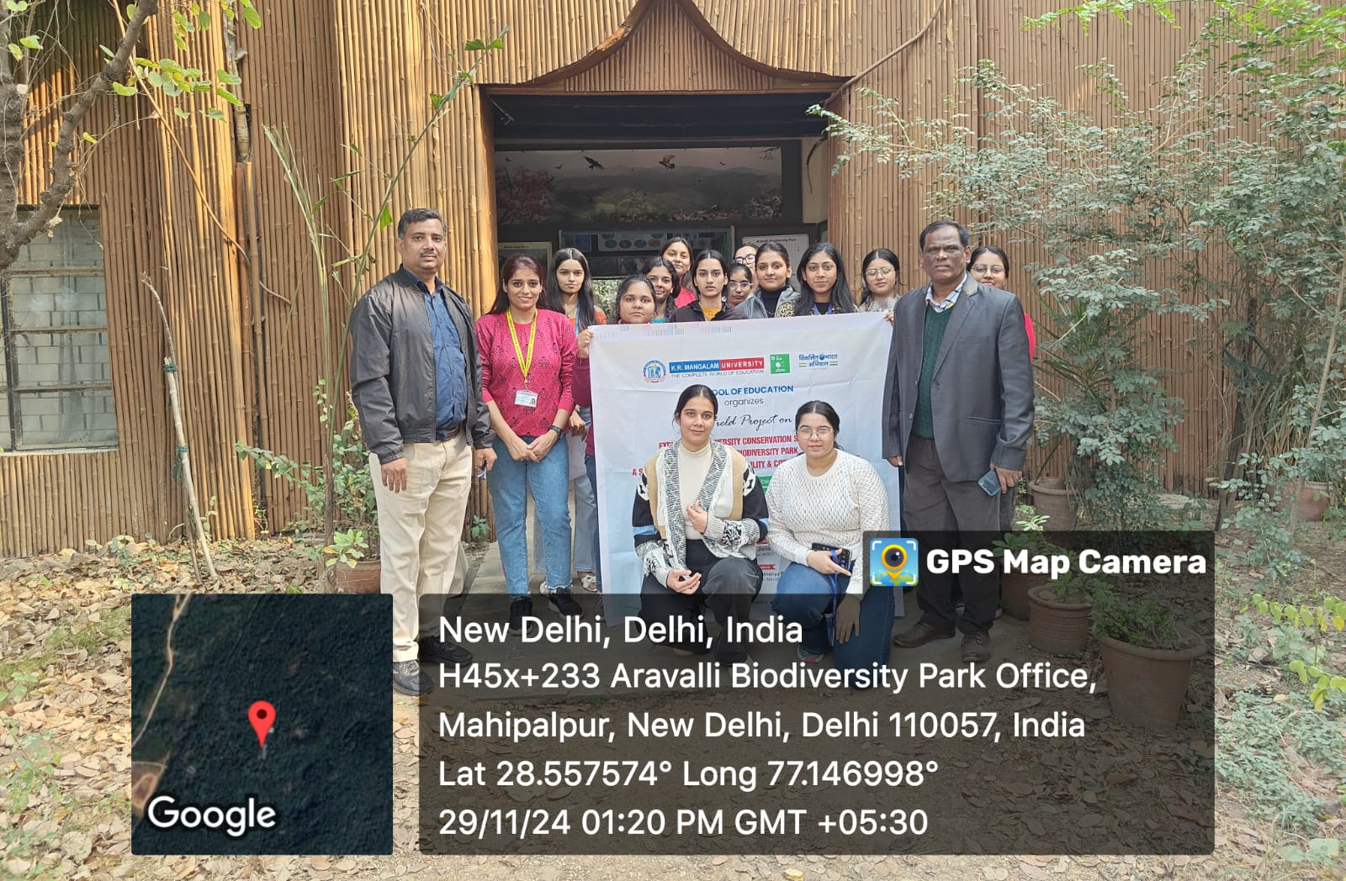
Picture 6: A group photograph of Student-teachers with key officials of Park

