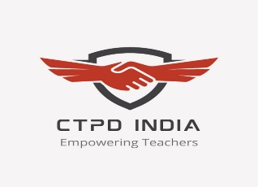

Two-days International E-Conference
CTPDCON ERA 2023
On
‘Educational Reforms & Advancements’

(October 14 – 15, 2023)

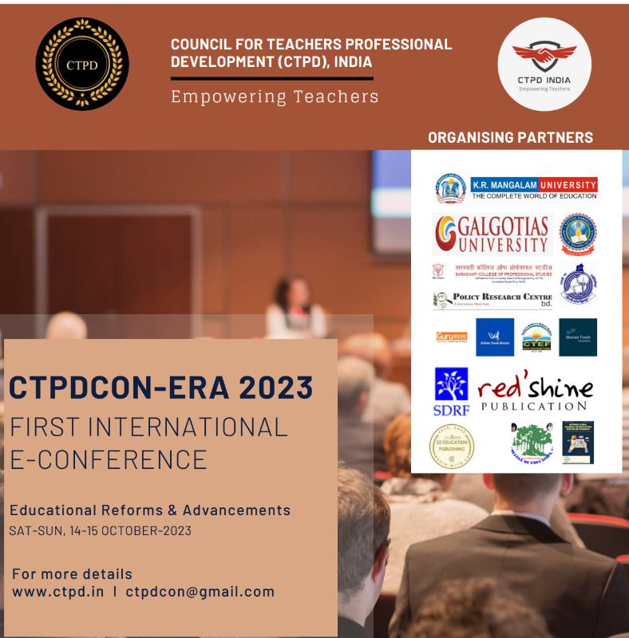

Organized by
SCHOOL OF EDUCATION
K.R. MANGALAM UNIVERSITY
Sohna Road, Gurugram

Venue : ZOOM(Virtual)

A Brief Report

Contents

- Preface and Acknowledgements
- Title and Objective of the Conference
- Themes and Sub-Themes of the Conference
- Inaugural Function
- Address of the Invited Speakers
- Session wise & Track wise Report
- Valedictory Function
- Feedback from the Participants
- Media Coverage
- Recommandations

Preface and Acknowledgements

Education is a powerful catalyst for change, and in our pursuit of excellence, we find ourselves at a pivotal moment in redefining how knowledge is imparted, acquired, and applied. The need for continuous reform and the exploration of innovative advancements have never been more crucial. Educational reforms and advancements are imperative to ensure that our education systems evolve in tandem with the dynamic demands of the contemporary world. In an era characterized by rapid technological progress, globalization, and shifting workforce requirements, traditional educational models risk becoming outdated. Reforms are essential to integrate cutting-edge technologies, foster global awareness, and align curricula with the evolving needs of the job market. Furthermore, educational advancements facilitate innovative teaching methodologies, personalized learning approaches, and the cultivation of critical thinking skills, empowering students to navigate a complex, interconnected, and information-rich environment. By addressing inequalities, emphasizing lifelong learning, and preparing individuals for future challenges, educational reforms contribute to creating a more inclusive, adaptable, and effective education system that equips learners with the skills and knowledge necessary for success in an ever-changing world.
CTPDCON ERA 2023 provided a platform for educators, researchers, policymakers, and visionaries to come together, share insights, and chart a course towards a more inclusive and effective educational paradigm.
This conference was not just a gathering of minds but a collaborative effort to weave the threads of experience, research, and aspirations into a tapestry of educational progress. It was an opportunity to explore groundbreaking ideas, best practices, and evidence-based strategies that can reshape the educational landscape, ensuring that it remains responsive to the needs of a rapidly changing world.
This International Conference, organized by School of Education, K. R. Mangalam University, Gurugram, Haryana, India in collaboration with Council for Teachers Professional Development (CTPD) was conducted from 14 October 2023 to 12 October 2023. The organizing team is thankful to Prof. (Dr.) Sanjay Kumar, Programme Director, CTPD India, for extending all kinds of support for the smooth planning and conduction of the conference. We are further thankful to Mr. Abhishek Gupta and Mr. Rohit Gupta, respected Chairman, K. R. Mangalam University, Prof. C. S. Dubey, hon’ble Vice Chancellor, K. R. Mangalam University for permitting us and supporting us while conducting this conference.
I extend my sincere appreciation to all the participants, presenters, sponsors, and organizers who have invested their time, expertise, and resources in making this conference a reality. We are also indebted to the participants, research scholars and student-teachers for participating and keeping up the spirit.

Regards,

Prof. (Dr.) Tania Gupta
Organizing Secretary, CTPDCON ERA 2023
Dean, School of Education, K.R Mangalam University

Title of the International Conference: EDUCATIONAL REFORMS & ADVANCEMENTS (ERA)

Objectives of the International Conference

- To provide a platform for scholars, researchers, educators, and practitioners from around the world to share their knowledge, insights, and research findings related to emerging trends in higher education with special reference to India.
- To identify and explore the latest emerging trends and developments in higher education in India and discuss implications of these trends for students, institutions, and the broader education community.
- To foster interdisciplinary collaboration, cross-cultural understanding, and the sharing of resources among individuals and institutions.
- To give an opportunity to researchers and innovators to showcase cutting-edge research, innovative practices, and successful initiatives in the field of higher education with special reference to India.
- To present a forum for discussions on policy issues, governance models, and institutional strategies to address the evolving needs of higher education in India in the context of emerging trends.
- To formulate and disseminate to policymakers, educational institutions, and stakeholders, policy recommendations that shall emerge from discussions and insights shared during the conference.

Themes and Sub-Themes of the International Conference

The theme of the Conference: EDUCATIONAL REFORMS & ADVANCEMENTS
Sub-Theme of the Conference:
TRACK 1: INDIAN KNOWLEDGE SYSTEMS (IKS): INTEGRATION AND INTERNATIONALISATION
1.1 IKS as a Living Tradition
- Philosophical aspects of IKS.
- Holistic development and IKS
- Indian Traditional Knowledge System: National Treasure.
- Essence/Components of IKS.
1.2 The Cultural and Spiritual Identity of India
- Role of IKS in building positive cultural identity and self-esteem.
- Role of IKS in National Building.
- Psycho-cultural concerns and Indian Traditional Knowledge.
- Ek Bharat Shrestha Bharat & IKS.
1.3 Relevance of IKS in the Present Knowledge Systems
- Scope of IKS.
- IKS in National Education Policy (NEP) 2020.
- IKS : Innovations & Practices.
- Atmanirbhar Bharat and IKS.
- Modern Society & IKS : Challenges & Remedies.
1.4 Some reflections for Global Integration
- IKS and Sustainable Development.
- Environmental Concerns.
- Peace, Plurality & Universal Fraternity in IKS.
- Human Values and IKS.
- Global Problems & IKS.
TRACK 2: SUSTAINABLE DEVELOPMENT: RESEARCH, PRACTICE AND EDUCATION
2.1 Education in Sustainable Development
- Overview of 17 Sustainable Development Goals.
- Issues, Trends and Patterns.
- History and Global Perspectives.
- Significance of Education in Sustainable Development.
- Quality Education - SDG 4.
2.2 Communities, Governance and Sustainable Practices
- Role of Institutions / Communities in Sustainability.
- Pedagogical Practices and ICT.
- Green Technology.
- Good Governance and Sustainable Entrepreneurship.
- Sustainable Lifestyle.
2.3 Sustainable Education and Global Partnership
- Educational Policy and Curriculum.
- Educational Research and Social Benefits.
- Educational Ecosystem and Management.
- Institutions imparting Education in Sustainable Development.
- Digital Pedagogy for Building Peaceful and Sustainable Societies.
- Peace Education.

TRACK 3: DIGITAL TRANSFORMATION AND ONLINE EDUCATION

3.1 Digital and Online Education for Quality Education
- Ensuring Quality Education in Digital Era.
- Digital Education and Sustainable Development Goals.
- Development of Higher Order Thinking Skills through Digital Education.
- Digital Pedagogies for Quality Education at School Level.
- Digital Pedagogies for Quality Education at HEIs.
- Digital and Online Education for Global Citizen and World Peace.
3.2 Artificial Intelligence in Digital Transformation

- SMART Tools to Enhance Students’ Learning Experiences.
- Machine Learning and Personalized Learning for Education.
- Artificial Intelligence and Digital Pedagogies.
- Untapped AI-Technologies to transform the Education System.
- AI-based Applications for Schools and HEI’s.

3.3 Emerging Trends in Online Education
- Recent Development of Tools and Technologies for Online Education.
- Learners’ Empowerment through Mobile Learning and Microlearning.
- Impact of Remote Work on Online Education.
- Integration of Synchronous and Asynchronous Methods of Education.
- The Power of Gamification in Education.
- Post-COVID Prospects for Massive Open Online Courses.
3.4 Challenges and Benefits of Online Education
- Ubiquitous Learning: Issues and Challenges.
- Issues and Challenges of Digital Education.
- Online Education as Value for Money and Time.
- Digital Pedagogical Challenges for Inclusive Education.
- Online Learning Practices for Traditional Teachers.
TRACK 4: EQUITABLE AND INCLUSIVE HIGHER EDUCATION FOR SUSTAINABLE DEVELOPMENT
4.1 Equitable Access to Quality Higher Education
- Models and Practices of Educational Innovation for Ensuring Equity.
- Gender Equity in Higher Education.
- Accessible and Equitable quality education for the Specially-abled.
- Education in Emergencies: Conflict Zone, Pandemics, Climate Change, Disasters.
- Quality Assurance in Higher Education.
4.2 Policy Perspectives on Inclusive Education
- Towards Inclusion: Past to the Present.
- National and International Framework for Inclusive Education.
- Social Inclusion.
- Creating Inclusive Education Systems: Models and Best Practices.
- Inclusive and Digital Education Policy.
4.3 The Global 2030 Agenda of the UN Sustainable Development Goal (SDG) 4
- Targets and Expected Outcomes.
- Education for Global Citizenship.
- Creating an Effective Environment for lifelong learning for all.
- Training and Education for enhancing the supply of trained quality teachers.
- Community and Partnerships for achieving SDG 4.
4.4 Curriculum, Teaching, Evaluation and Research Paradigms and Methodologies
- Curriculum Changes.
- Good Teaching and Learning.
- Evaluation Approaches for Diverse Learners.
- Outcome-Oriented Research.
- Institutional Change and Transformative Leadership Strategies.

INAUGURAL SESSION
Day 1(14 OCTOBER 2023)
10:00 A.M- 1:05 P.M (IST)

The inaugural session of the CTPDCON ERA 2023, held on Saturday, October 14, 2023, unfolded with a vibrant invocation led by distinguished dignitaries. Dr. Shweta Rani and Dr. Reena Uniyal Tiwari, serving as Conference Organizing Joint Secretaries, moderated the session. As is the tradition of India, we begin everything new by seeking the blessings of goddesses and gods, the blessings of Goddess Saraswati were obtained by e-lighting the lamp along with the Saraswati Vandana. Dr. Sanjay Kumar, the President of CTPD and Conference Convenor, set the tone with a gracious welcome address, emphasizing the significance of the event. Professor Satyendra Gupta, Chief Advisor of CTPD, elucidated on the mission and vision of CTPD, underscoring its commitment to education. Dr. Jugnu Khatter Bhatia, the Conference Organizing Secretary, provided insights into CTPDCON ERA 2023, offering a glimpse into the diverse topics that would be explored. The ceremonial release of the Conference Souvenir marked a momentous occasion, symbolizing the official commencement of the conference. . All the national and international dignitaries were there on board at 10 AM. There were around 75 participants who attended the inaugural session. The keynote address by Professor Gopal Krishna Thakur, Dean of the School of Education at MGAHV and Director, was enlightening, paving the way for subsequent eminent speakers. Padma Shri Prof (Dr.) J.S Rajput, Shri Uday Singh Shankar, Prof. (Dr.) Berinderjeet Kaur, Professor Sunil Kumar Singh, Professor Yashwant Rao Ramma, Professor Nellie Deutsch, and Prof. (Dr.) Dwarika Prasad Uniyal graced the event with their insightful talks on various crucial themes in education. Prof. (Dr.) Tania Gupta, Secretary General CTPD and Conference Organizing Secretary, conveyed a heartfelt vote of thanks, expressing gratitude to all participants. The inaugural session concluded on a patriotic note with the rendition of the National Anthem, leaving a promising aura for the upcoming sessions brimming with knowledge exchange and academic discourse.

ADDRESS OF THE INVITED SPEAKERS

During his Keynote Address, Professor Gopal Krishna Thakur, the Dean of the School of Education at MGAHV and Director, illuminated the audience with his insights on the theme of the conference, "Educational Reforms and Advancements." He provided a comprehensive overview of the current state of education, emphasizing the need for continuous reforms and advancements to meet the evolving demands of the educational landscape. Professor Thakur's address set the stage for the subsequent sessions, instilling a sense of purpose and urgency regarding the transformative journey that education must undertake.
As the Chief Guest, Padma Shri Prof (Dr.) J.S Rajput delivered an impactful address, focusing on the pivotal theme of Educational Reforms and Advancements. Drawing from his vast experience as the Former Director of NCERT, he shed light on the importance of integrating innovative teaching methodologies, technology, and inclusive practices to enhance the quality of education. His address inspired a reflection on the broader implications of educational reforms for a holistic and progressive learning environment.
Shri Uday Singh Shankar, the CEO of Vishwa Yuvak Kendra, contributed to the discourse on educational reforms during his address. Focusing on the role of professional development in teachers, he emphasized its significance as a key factor for achieving equitable, inclusive, and high-quality educational environments. Shankar's insights provided a practical perspective on empowering educators to navigate and lead transformative changes in the educational landscape.
In the segment dedicated to the theme, "Professional Development of Teachers – Key for an Equitable, Inclusive, and Quality Educational Environment", Prof. (Dr.) Berinderjeet Kaur, a distinguished Professor of Mathematics Education from the National Institute of Education, Nanyang Technological University, Singapore, shared her valuable insights. Her address delved into the crucial role of continuous professional development in nurturing teachers who can effectively contribute to creating an inclusive and high-quality educational environment.

The other esteemed speakers, including Professor Sunil Kumar Singh, Professor Yashwant Rao Ramma, Professor Nellie Deutsch, and Prof. (Dr.) Dwarika Prasad Uniyal, similarly offered profound perspectives during their respective sessions, collectively enriching the conference with diverse viewpoints on Educational Reforms and Advancements.

The CTPD First International Conference, CTPDCON-ERA 2023 featured four distinct tracks, each delving into critical areas of education that are central to shaping the future of global learning.

TRACK 1: INDIAN KNOWLEDGE SYSTEMS (IKS): INTEGRATION AND INTERNATIONALISATION
This track is dedicated to exploring the rich tapestry of Indian Knowledge Systems (IKS) and their integration
into the global educational landscape. Attendees can expect in-depth discussions on how IKS can be leveraged
to create a more holistic and culturally inclusive educational experience worldwide.
TRACK 2: SUSTAINABLE DEVELOPMENT: RESEARCH, PRACTICE, AND EDUCATION
Sustainability is a global imperative, and this track will provide a platform for academics, researchers, and
practitioners to share insights into the latest sustainable development practices, research findings, and
educational strategies. Attendees will engage in dialogues aimed at advancing the sustainability agenda in
education.
TRACK 3: DIGITAL TRANSFORMATION AND ONLINE EDUCATION
The digital era has brought about a revolution in education, making online learning a key component of the
modern educational landscape. Track 3 will explore the latest trends in digital transformation and online
education, offering attendees a glimpse into the future of virtual learning environments, digital tools, and
innovative pedagogical approaches.
TRACK 4: EQUITABLE AND INCLUSIVE HIGHER EDUCATION FOR SUSTAINABLE DEVELOPMENT
Inclusivity is at the heart of a progressive education system. This track will focus on addressing disparities in
higher education and exploring strategies to ensure equitable access to quality education for all. Attendees will
engage in discussions about creating educational systems that promote social justice and sustainable
development.

TRACK 1

Track 1 of the International Conference CTPDCON ERA 2023 focused on the theme "Indian Knowledge Systems (IKS): Integration and Internationalisation." Dr. Jugnu Khatter Bhatia served as the Convenor, and Dr. Reena Uniyal Tiwari acted as the Co-Convenor, both playing pivotal roles in orchestrating the discussions and presentations within this track.
PLENARY SESSION 1.1
Day 1(14 OCTOBER 2023)
5:30 P.M-7:30 P.M (IST)

The Plenary Session 1.1 on "IKS as a Living Tradition" during CTPDCON ERA 2023 proved to be a captivating exploration into the rich tapestry of Indian Knowledge Systems. Dr. Khushbu Verma, Assistant Professor at Satyug Darshan Institute of Education and Research, Faridabad, and the Moderator for the session, opened with a warm welcome, setting the tone for an intellectually stimulating discourse. Dr. Jugnu Khatter Bhatia, Conference Organizing Secretary & Principal of Satyug Darshan Institute of Education and Research, provided an insightful overview, emphasizing the significance of the session.
Prof. (Dr.) Mahesh Narayan Dixit, Faculty of Education (IASE), Gujarat Vidyapeeth, Ahmedabad, Gujarat, chaired the session, adding scholarly depth. The paper presentations were a testament to the diversity and depth of the topics covered, including "Indian Traditional Knowledge System" by Dr. Kamna Chaturvedi, "Bhagavad Gita - The Essence of the Philosophy of Life" by Dr. Poonam Dhull, "Upanishadic view of Education" by Anamika Shukla, "Salient Features of Vedic Education in Ancient India" by Dr. Ranjana V. Tijare, "Vedic Mathematics and Calculus: Some Unique Techniques" by Sanjeev Kumar and Prof. (Dr.) Tania Gupta, and "Relevance of IKS: Bhagavad Gita's Perspective on Education" by Dr. Rachna Sharma.
Dr. Sonal Chhabra, Principal of Rawal College of Education, Faridabad, Haryana, provided a comprehensive summary of the session and delivered an insightful address as the Co-Chair. Prof. (Dr.) Mahesh Narayan Dixit offered closing remarks, reflecting on the profound discussions. Prof. (Dr.) Tania Gupta, Dean of the School of Education at K.R. Mangalam University, Gurugram, Haryana, and Secretary General CTPD & Organizing Secretary CTPDCON ERA 2023, extended a gracious vote of thanks, concluding the session on a note of appreciation and anticipation for the continued exploration of Indian Knowledge Systems. The plenary session not only showcased the depth of traditional knowledge but also highlighted its relevance and application in contemporary educational contexts.

PLENARY SESSION 1.2
Day 1(14 OCTOBER 2023)
5:30 P.M-7:30 P.M (IST)
Plenary Session 1.2, focusing on "The Culture and Spiritual Identity of India," unfolded as a captivating exploration of India's rich heritage and knowledge systems during the CTPDCON ERA 2023 conference. Ms. Chetna Thapa, Assistant Professor at D.W.T College, Dehradun, Uttarakhand, skillfully led the session as the Moderator, offering an engaging Opening Address & Welcome. Dr. Shweta Rani, Program Director of BHOO Chetna, CTPD India, and Joint Organizing Secretary of CTPDCON-ERA 2023, provided a comprehensive Overview of the Plenary Session. Prof. (Dr.) Arti Koul Kachroo, the esteemed Dean of the School of Education at Sharda University, Greater Noida, Uttar Pradesh, India, assumed the role of the Chair and delivered an insightful Address.
The session featured diverse and thought-provoking paper presentations. Ms. Aparna Seebaluck and Ms. Monika Talukdar presented a paper titled "Analytical Study of Ecosystems for Learning & Well-being in Indian Education." Dr. Sakshi Vermani Rishi explored "The Living Legacy: Exploring the Indian Knowledge System (IKS)." Dibyangana Biswas delved into "Sketching the Alternative Gender Identities from the Ancient Indian Texts and Indian Knowledge System." Prof. (Dr.) Sunita Bhargava and Dr. Suman Lata Yadav addressed the challenges and solutions in the contemporary society through their paper, "भारतीय ज्ञान प्रणाली एवं आधुननक समाज के समक्ष निक्षा की चुनौनतयां एवं समाधान." Shubham Vats and Dr. Navita Malik discussed "A Study of the Implementation and the Impact of Promoting Entrepreneurship, Vocational Education, and Innovation in School." Finally, Vivek Sharma and Dr. Shweta Rani provided insights into the essence and need of the Indian Knowledge System in the educational landscape.

Dr. Pargat Singh Garcha, Principal of GHG Khalsa College of Education, Gurusar Sadhar, Punjab, India, delivered a comprehensive Summary of the Session and an Address as Co-Chair. Prof. (Dr.) Arti Koul Kachroo offered Closing Remarks, highlighting the significance of the presentations. Prof. (Dr.) Satyendra Gupta, Chief Advisor CTPD & Advisor CTPDCON- ERA 2023, expressed gratitude and appreciation during the concluding Vote of Thanks. The session not only contributed to the academic discourse on India's cultural and spiritual identity but also fostered a deeper understanding of the diverse topics presented by the participants.

PLENARY SESSION 1.3
Day 1(14 OCTOBER 2023)
5:30 P.M-7:30 P.M (IST)
Plenary Session 1.3, focusing on the "Relevance of Indian Knowledge Systems (IKS) in the Present Knowledge System," unfolded as a dynamic exploration of the intersection between traditional wisdom and contemporary educational paradigms during the CTPDCON ERA 2023 conference. Dr. Balbir Kaur, Associate Professor & HOD Post Graduate Studies Department, School of Education, Shri Guru Ram Rai University, Dehradun, Uttarakhand, India, adeptly steered the session as the Moderator, delivering an engaging Opening Address & Welcome. Dr. Parvesh Lata, Program Director of Digital Circle CTPD India and Associate Professor & Head, Department of Education, G D Goenka University, Gurugram, Haryana, India, provided an insightful Overview of the Plenary Session. Dr. Ganesh V. Halade, Associate Professor in the Division of Cardiovascular Sciences, Department of Medicine, University of South Florida, USA, assumed the role of the Chair, offering a unique perspective.

The session featured a series of enlightening paper presentations that delved into various aspects of the relevance of Indian Knowledge Systems in the contemporary educational landscape. Dr. Renu Kumari presented "New Vision for India’s Higher Education System in Context of NEP2020," exploring the transformative possibilities envisioned by the National Education Policy. Girish Chandra Behera and Pranati Priyadarshini discussed "Indian Art of Living - A Strong Message of Science," highlighting the harmonious blend of traditional wisdom and scientific principles. Dharna Malhotra explored "Indian Knowledge System in National Education Policy (NEP) 2020: Scope and Challenges," shedding light on the intricacies of integrating IKS into modern education. Mahak Chhabra and Prof. Mudit Rathore addressed "NEP 2020 and Indian Knowledge Systems: The Spiritual Preparation of Teachers," emphasizing the spiritual dimension in teacher preparation. Shahla Naaz examined "Exploring Intercultural Sensitivity Among Students of Higher Education in India," while Parinka Sharma and Dr. J.N. Baliya presented "Role of Indian Knowledge System in Building Cultural Identity and Self-Esteem - A Pedagogical Perspective." Clement John concluded the presentations with "Is E-learning a Learning? International Students’ View," discussing the effectiveness of e-learning from an international perspective.

Dr. Vandana Shivajirao Nalawade, Principal of Azad College of Education, Satara, Maharashtra, India, delivered a comprehensive Summary of the Session and an Address as Co-Chair. Dr. Ganesh V. Halade provided Closing Remarks, emphasizing the importance of integrating traditional knowledge into global educational frameworks. Prof. (Dr.) Prarthita Biswas, Program Director East Zone CTPD India & Professor & Research Head, Department of Education, Swami Vivekananda University, Kolkata, West Bengal, India, expressed gratitude and appreciation during the concluding Vote of Thanks. The session not only contributed significantly to the ongoing discourse on the relevance of Indian Knowledge Systems but also demonstrated the enthusiasm and commitment of the academic community toward fostering an inclusive and holistic approach to education.

PLENARY SESSION 1.4
Day 1(14 OCTOBER 2023)
5:30 P.M-7:30 P.M (IST)
Plenary Session 1.4, themed "IKS & Some Reflections for Global Integration," unfolded as a thought-provoking exploration of the intrinsic value and global relevance of Indian Knowledge Systems (IKS) during the CTPDCON ERA 2023 conference. Ms. Anita Sahay, Assistant Professor at Satyug Darshan Institute of Education and Research, Faridabad, Haryana, India, adeptly guided the session as the Moderator, delivering an engaging Opening Address & Welcome. Dr. Vinay D Dhondge, Program Director West Zone CTPD India & Professor at Azad College of Education, Satara, Maharashtra, provided an insightful Overview of the Plenary Session. Prof. (Dr.) Savita Rawat, from the Department of Teacher Education, D.A.V (P.G) College, Dehradun, Uttarakhand, India, assumed the role of the Chair, offering valuable perspectives.

The session featured an array of enlightening paper presentations that explored the diverse dimensions of IKS in the context of global integration. Dr. Prerna Vashistha and Dr. Parvesh Lata presented "Indian Knowledge System: Fostering Peace and Value Education for a Sustainable World," emphasizing the potential of IKS in nurturing values for global sustainability. Dr. V.V. Ravi and Smt. V. Bhanumathi discussed "Relevance of Ancient Wisdom on Weather Forecasting for Improving Agro-Advisories," shedding light on the application of traditional knowledge in practical domains. Naina Sharma and Prof. (Dr.) Tania Gupta presented "Indian Knowledge System: Integration and Internationalisation," addressing the integration of IKS into the global educational framework. Prof. Chandrawati Joshi and Dr. Vidhi Dhoundiyal explored "Indian Knowledge System and Sustainable Development," emphasizing its role in promoting sustainable practices. Dr. Sandip Kumar and Dr. Ram Kishor presented "भारतीय ज्ञान परम्परा और साववभौनमक मानवीय मूल्यं का वतवमान निक्षा मेंसमाययजन- एक स्वस्थ नचंतन," highlighting the integration of Indian knowledge traditions for holistic well-being. Shabnam explored "Environmental Concerns: Issues, Impact, Mitigation and Education," and Abhijit Bhattacharya discussed "Education and Values," presenting perspectives on environmental awareness and value-based education, respectively.

Dr. Anita Singh, Director of Saraswati College of Professional Studies, Ghaziabad, Uttar Pradesh, provided a comprehensive Summary of the Session and an Address as Co-Chair. Prof. (Dr.) Savita Rawat delivered Closing Remarks, emphasizing the global significance of integrating IKS into contemporary education. Prof. (Dr.) Sanjay Kumar, Program Director of CTPD India & Convenor CTPDCON ERA 2023, expressed gratitude and appreciation during the concluding Vote of Thanks. The session not only contributed significantly to the ongoing discourse on IKS but also demonstrated the potential for its seamless integration into the global educational landscape.

TRACK 2

Track 2 of the CTPDCON ERA 2023, under the theme "Sustainable Development: Research, Practice, and Education," was convened by Prof. Satyendra Gupta, with Dr. Shweta Rani serving as the Co-Convenor. This track brought together experts, researchers, and practitioners to delve into the multifaceted dimensions of sustainable development within the realms of research, practice, and education.

PLENARY SESSION 2.1
Day 1(14 OCTOBER 2023)
2:00 P.M-4:00 P.M (IST)
Plenary Session 2.1, centered on "Education in Sustainable Development," provided a profound exploration of the critical intersection between education and sustainable global progress during the CTPDCON ERA 2023 conference. Ms. Smita Thakre, Coordinator at Titans Public School, Amravati, Maharashtra, adeptly served as the Moderator, extending a warm Opening Address & Welcome. Prof (Dr.) Tania Gupta, Secretary General CTPD, Organizing Secretary CTPDCON ERA 2023 & Dean, School of Education, K.R Mangalam University, Gurugram, Haryana, delivered an insightful Overview of the Plenary Session. Prof. (Dr.) R. S. Rai, Professor & Director-IQAC at AMITY University, NOIDA, U.P, India, assumed the role of the Chair, offering an Address that set the stage for thought-provoking discussions.

The session featured enlightening paper presentations addressing diverse facets of sustainable development. Dr. Chandra Mohan, Dr. Shah Alam Khan, and Jenifer Robinson presented "Overview of 17 Sustainable Development Goals," offering a comprehensive perspective on the global sustainability agenda. Taorem Romibala Devi explored "Substance Education: An Embodiment of Good Health and Well Being," emphasizing the vital role of education in promoting well-being. Tejal Pramod Nikam delved into "Education in Sustainable Development," highlighting the integral role of education in fostering sustainability. Neha Khaiwal analyzed "Assessing the Impact of Education on Sustainable Development: A Comprehensive Analysis," providing valuable insights into the effectiveness of educational initiatives. Samiha Baig conducted a "Review of Education for Sustainable Education," contributing to a broader understanding of sustainable education. Dr. Pooja Sharma shared insights on "Sustainable Innovations in Global Retailing," illustrating the potential for sustainable practices in the retail sector. Smita Thakare discussed "Professional Growth of Teachers," shedding light on the role of educators in sustainable development.

Prof. (Dr.) Pallavi D Khedkar, Professor & Director Academics at Parul University, Vadodara, Gujarat, provided a comprehensive Summary of the Session and an Address as Co-Chair. Prof. (Dr.) R. S. Rai delivered Closing Remarks, emphasizing the pivotal role of education in fostering sustainable development. Dr. Jugnu Khatter Bhatia, Program Director, Research Circle, CTPD India & Organizing Secretary CTPDCON-ERA 2023, expressed gratitude during the concluding Vote of Thanks. The session not only enriched the discourse on education's role in sustainable development but also underscored the urgency of aligning educational practices with global sustainability goals.
PLENARY SESSION 2.2
Day 1(14 OCTOBER 2023)
2:00 P.M-4:00 P.M (IST)
Plenary Session 2.2, themed "Communities, Governance, and Sustainable Practices," unfolded as a compelling exploration of the intricate relationship between community engagement, governance, and sustainable practices during the CTPDCON ERA 2023 conference. Dr. Pooja Chopra, Assistant Professor at GD Goenka University, Gurugram, efficiently took on the role of Moderator, extending a gracious Opening Address & Welcome. Dr. Reena Uniyal Tiwari, Program Director, Quality Circle, CTPD India & Organizing Joint Secretary CTPDCON-ERA 2023, offered an insightful Overview of the Plenary Session. Prof. Poonam Sharma, Professor in the Department of Geography at Shaheed Bhagat Singh College, University of Delhi, Delhi, served as the Chair, delivering a comprehensive Address that set the stage for the ensuing discussions.

The session featured enlightening paper presentations that addressed various aspects of sustainable practices. Dr. Amit Ahuja and Rajani Upadhyay presented "Green Technology in Education and Sustainable Development," emphasizing the pivotal role of technology in fostering sustainability. Sarishti Joshi explored "The Significance of Education for Sustainable Development (ESD) in Modern-day India," offering insights into the contemporary relevance of sustainable education. Dr. Manjeet Yadav discussed "Embracing Sustainable Lifestyle: The Power of Individual Choices," emphasizing the transformative potential of individual decisions in promoting sustainability. Ms. Soumita Chakraborty and Prof. (Dr.) Prarthita Biswas shared insights on "For The Greener Tomorrow: Storytelling as A Method for Inculcating Sustainability Awareness in Elementary Students," showcasing innovative pedagogical approaches for instilling sustainability values.

Moreover, Dr. Reena Uniyal Tiwari delved into "Role of Lifestyle Choices in Achieving Sustainable Development Goals," emphasizing the need for mindful choices in achieving sustainability. Dr. Joyti Sehrawat explored "Technology-Mediated Collaborative Learning: Exploring Tools and Implementation Concerns," shedding light on the role of technology in collaborative learning for sustainability. Masooda Haseeb presented a "Study on Understanding Intangible Assets for ESD," contributing to a deeper understanding of intangible aspects in the context of sustainable development.

Dr. Sayed Zaheen Alam, Associate Professor in the Department of Geography at Dyal Singh College, University of Delhi, offered a comprehensive Summary of the Session and an Address as Co-Chair. Prof. Poonam Sharma provided Closing Remarks, underscoring the significance of sustainable practices in community development. Prof (Dr.) Tania Gupta, Secretary-General CTPD, Organizing Secretary CTPDCON ERA 2023 & Dean, School of Education, K.R Mangalam University, Gurugram, Haryana, expressed gratitude during the concluding Vote of Thanks. The session not only enriched the discourse on sustainable practices but also highlighted the critical role of communities and governance in fostering a sustainable future.

PLENARY SESSION 2.3
Day 1(14 OCTOBER 2023)
2:00 P.M-4:00 P.M (IST)

Plenary Session 2.3, focused on "Sustainable Education and Global Partnership," unfolded as a significant discourse during the CTPDCON ERA 2023 conference. Dr. Rekha Kaushal, Assistant Professor at GD Goenka University, Gurugram, adeptly moderated the session, welcoming participants and setting the stage for the deliberations. Prof. (Dr.) Vinay D Dhondge, Program Director for West Zone, CTPD India & Professor at Azad College of Education, Satara, Maharashtra, provided an insightful overview of the session, underscoring the importance of sustainable education and global collaboration. Dr. Ajay Surana, Associate Professor at Banasthali Vidyapith, Rajasthan, chaired the session and delivered a comprehensive address, framing the discussions within the broader context of sustainable development in education.

The session featured impactful paper presentations that delved into various facets of sustainable education. Dr. Sasmita Gahan presented "Peace Education: Need in Today's Scenario," highlighting the pressing need for integrating peace education in the contemporary educational landscape. Dr. Amitkumar Shankarrao Gagare discussed the "Sustainable Practices of Rayat Shikshan Sanstha in Rural Development," shedding light on successful rural development initiatives through education. Wahida Rais, a research scholar at Integral University, Lucknow, explored "Identifying Education's Core Problems for Sustainable Development," emphasizing the importance of addressing fundamental challenges for sustainable progress.
The session further delved into the theme of global partnership with Riya and Dr. Parvesh Lata presenting on "Global Partnership and Sustainable Education as a Framework for Peace Education." Dr. Archana Chaudhari shared insights into the impact of a peace education course in the B.Ed program in her presentation titled "Assessing the Impact of Peace Education Course in the B.Ed Program: A Study of Alumni's Implementation in Their School." Dr. G. M. Vijayalakshmi discussed "The Role of Education in Sustainable Development," emphasizing the transformative role education plays in fostering sustainability.
Additionally, Heena Kumar and Garima Chauhan, in collaboration with Dr. Shweta Rani, explored "Social Media in Education and Sustainability in Cybersecurity: Emerging Trends and Mitigation Measures in Palam Colony, NCT Delhi," offering valuable insights into the intersection of education, sustainability, and cybersecurity in the digital age. Dr. Shirin Rais, Assistant Professor at Aligarh Muslim University, provided a comprehensive Summary of the Session and Address as Co-Chair. Dr. Ajay Surana delivered Closing Remarks, reflecting on the key takeaways from the session. Dr. Parvesh Lata, Program Director, Digital Circle, CTPD India, and Associate Professor & Head of the Department of Education, G D Goenka University, Gurugram, Haryana, expressed gratitude in the concluding Vote of Thanks. The session, with its diverse perspectives and rich discussions, significantly contributed to advancing the discourse on sustainable education and global collaboration.

PLENARY SESSION 2.4
Day 1(14 OCTOBER 2023)
2:00 P.M-4:00 P.M (IST)
Plenary Session 2.4, dedicated to "Practices in Sustainability," marked a pivotal discussion at the CTPDCON ERA 2023 conference. Dr. Sweta Bhargava, Assistant Professor at Sanjay TT College, Jaipur, Rajasthan, adeptly guided the session as the moderator. The session commenced with an insightful overview provided by Prof. (Dr.) Umesh Sharma, Advisor Finance at CTPD & Pro-Vice Chancellor, Arni University, Himachal Pradesh. Prof. (Dr.) Jayanta Mete, Professor in the Department of Education at the University of Kalyani, Kalyani, Nadia, West Bengal, assumed the role of the chair and offered valuable perspectives on the subject.

The presentations during this session encapsulated a diverse array of sustainability practices. Jitendra Singh, Assistant Professor at Saraswati College of Professional Studies, Ghaziabad, U.P., shared "Sustainability in Action: Practical Tips for Everyday Life," offering pragmatic insights for individuals to incorporate sustainability in their daily routines. Shabnam, a research scholar at Jamia Millia Islamia, Delhi, presented "Environmental Concerns: Issues, Impact, and Mitigation Through Education," emphasizing the role of education in addressing environmental challenges.

Jitendra Kumar, Assistant Professor at Saraswati College of Professional Studies, Ghaziabad, U.P., focused on "Peace Education," elucidating its significance in fostering harmonious societies. Dr. Kirtikar Yogeshwar Shripal, Assistant Professor at Appasaheb Birnale College of Education, Sangli, Maharashtra, delved into "Sustainable Development: Research, Practice, and Education," providing a comprehensive perspective on the holistic approach towards sustainable development.

Fr. Baiju Thomas, a research scholar at Ramakrishna Mission Vivekananda Educational and Research Institute, Coimbatore, Tamil Nadu, presented a paper titled "Promoting Inclusive Education Ensures Education for All in India: A Review Study," shedding light on the critical aspect of inclusive education. Chitra, an Associate Professor at ICFAI, Baddi, Himachal Pradesh, discussed "Efficient Learning with the Application of e-Technology," exploring the role of technology in enhancing the learning process.

The session also featured Dr. Annu Tomar, Assistant Professor at the Institute of Technology and Science, Mohan Nagar, Ghaziabad, Uttar Pradesh, who presented on "Financial Aspects of Human Resource Development and Change," emphasizing the economic dimensions of sustainable practices. Dr. Shruti Tiwari, Principal at the School of Education, Suresh Gyan Vihar University, Jaipur, Rajasthan, delivered a comprehensive Summary of the Session and Address as Co-Chair. Prof. (Dr.) Jayanta Mete provided insightful Closing Remarks, highlighting the key takeaways from the session. Prof. (Dr.) Sanjay Kumar, Program Director, CTPD India, and Convenor CTPDCON-ERA 2023 expressed gratitude in the concluding Vote of Thanks. This session, with its varied perspectives on sustainable practices, contributed significantly to the overarching theme of the conference.

TRACK 3

Under the leadership of Dr. Sanjay Kumar as the Convenor and Ms. Jenifer Robinson as the Co-Convenor, Track 3 of the CTPDCON ERA 2023 focused on the critical theme of "Equitable and Inclusive Higher Education for Sustainable Development." This track aimed to explore strategies, challenges, and innovations in fostering higher education environments that are not only inclusive but also contribute to sustainable development.

PLENARY SESSION 3.1
Day 2 (15 OCTOBER 2023
10:00 A.M-12:30 P.M (IST)
Plenary Session 3.1, focusing on "Digital Transformation and Online Education" during the CTPDCON ERA 2023 conference, provided a comprehensive exploration of the challenges and opportunities associated with the evolving landscape of online education. Moderated by Ms. Shalini Sharma, Assistant Professor at Saraswati College of Professional Studies, Ghaziabad, Uttar Pradesh, the session began with an insightful overview by Prof. (Dr.) Satyendra Gupta, Chief Advisor CTPD & Advisor CTPDCON- ERA 2023. Dr. Amit Ahuja, Associate Professor at the University School of Education, GGSIP University, Delhi, assumed the role of the chair and offered valuable insights into the digital education domain.

The session featured diverse paper presentations addressing various facets of online education. Dr. Amita Kumari and Dr. Jugnu Khatter Bhatia discussed the "Challenges and Benefits of Online Education," highlighting the multifaceted nature of the digital learning environment. Dr. Anjana Agarwal delved into the "Issues and Challenges" posed by digital education, shedding light on critical aspects that warrant attention in the evolving educational landscape.

Dr. Geeta Dhasmana presented a "Review Report on the Contribution of SWAYAM (MOOCs) in Education," offering insights into the impact of Massive Open Online Courses on the education sector. Dr. Mukesh Sharma explored the "Selection and Solutions of Online Learning Systems," emphasizing the importance of thoughtful choices and effective solutions in digital education.

Dr. Rajesh Dhaka shared insights into the "Benefits and Challenges of Online Education during the COVID-19 Lockdown in India," providing a nuanced understanding of the educational landscape amid the pandemic. Dr. Babu Lal Bunker focused on "New Education Policy - Progress towards E-learning in India in 2020," offering perspectives on the advancements in e-learning under the New Education Policy.

Additional presentations by Ravi Kant Verma, Sangeeta Singh, Rosy Tigga, and Anshuman Srivastava addressed diverse issues, such as causal attribution on digital transformation learning, the influence of online learning on study habits, challenges of digital education, and exploring the impact of digital and online education on quality education in India.

Dr. Sunita Arora, Principal at the Institute of Teacher's Education, Faridabad, Haryana, provided a comprehensive summary of the session and shared her insights as the Co-Chair. Dr. Amit Ahuja delivered closing remarks, emphasizing key takeaways. Dr. Jugnu Khatter Bhatia, Program Director, Research Circle, CTPD India, and Organizing Secretary CTPDCON-ERA 2023 expressed gratitude in the concluding vote of thanks. This session significantly contributed to understanding the dynamics of digital transformation in education.

PLENARY SESSION 3.2
Day 2 (15 OCTOBER 2023
10:00 A.M-12:30 P.M (IST)

Plenary Session 3.2 at the CTPDCON ERA 2023 conference, themed "Digital and Online Education for Quality Education," emerged as a forum for in-depth discussions on the transformative impact of digital technologies on the educational landscape. Dr. Sakshi Vermani Rishi, Associate Professor at Rishihood University, took on the role of moderator, guiding the session with expertise. Dr. Reena Uniyal Tiwari, Program Director, Quality Circle, CTPD India & Joint Organizing Secretary, CTPDCON-ERA 2023, set the stage with an insightful overview. Dr. Sandhya Milind Khedekar, Principal at Gokhale Education Society's College of Education, Sangamner, Maharashtra, India, assumed the role of chair, offering valuable insights.

The session featured a series of impactful paper presentations, each shedding light on different aspects of digital and online education. Teena and Dr. Jugnu Khatter Bhatia presented on the "Challenges and Benefits of Online Education," emphasizing the nuanced nature of this evolving educational paradigm. Archana Singh explored "Digital Competence" as essential 21st-century skills for teachers, highlighting the importance of technological proficiency in the teaching profession.

Other presentations covered diverse topics, including online learning practices for traditional teachers by Dr. Shweta Tyagi, the management of teaching research-extension by an agricultural university during COVID-19 by Dr. V Vijaya Lakshmi, and the role of machine learning in education by Dr. Megha D Gokhe. Karishma Narang discussed "Digital Pedagogies for Quality Education at School Level," while Dr. Chetna Thapa highlighted key aspects of NEP 2020 related to digital transformation.

Tlalane Mosae delved into "The Impact of Digital Transformation on the Future of Teaching and Learning," Dr. Ashish Sharad Gurav explored digital pedagogies for quality education at the school level, and Dr. Bhawna Bisht discussed "Artificial Intelligence and Digital Transformation in Higher Education."

The session concluded with a summary and address by Co-Chair MAM Sameem, a lecturer at the South Eastern University of Sri Lanka. Dr. Sandhya Milind Khedekar provided closing remarks, and Dr. Shweta Rani, Program Director, BHOO Chetna, CTPD India & Joint Organizing Secretary, CTPDCON-ERA 2023, extended a vote of thanks. This session contributed significantly to understanding the pivotal role of digital and online education in shaping the landscape of quality education.

PLENARY SESSION 3.3
Day 2 (15 OCTOBER 2023
10:00 A.M-12:30 P.M (IST)

Plenary Session 3.3 of the CTPDCON ERA 2023 conference, centered around "Emerging Trends and Artificial Intelligence in Digital Transformation," marked a profound exploration into the transformative effects of digital technologies and artificial intelligence (AI) on the educational landscape. Dr. Akanksha Srivastava, Associate Professor at the School of Education, Sharda University, Greater Noida, India, adeptly moderated the session. Prof. (Dr.) S.C. Pachauri, Program Director, North Zone CTPD India, provided an insightful overview, and Dr. Siti Nazuar Sailin, Deputy Dean at the Awang Had Salleh Graduate School of Arts and Sciences, Universiti Utara Malaysia, Kuala Lumpur, Malaysia, chaired the session.

The session showcased several impactful paper presentations. Dr. Shail Dhaka presented a deep dive into the "E-Learning Revolution" and its implications for digital transformation in India. Garima, a research scholar at Amity University, discussed the "Awareness of Disruptive Technology Among B.Ed. Trainees." Payal Mittal shed light on the "Integration of ChatGPT - AI-Powered Tool into Language Education," emphasizing the incorporation of AI in language learning.

Other presentations included insights from Ashish Sharma on "AI-based Applications for Schools and HEIs" and Dr. Alpna Sharma's exploration of the "Concept of Artificial Intelligence in Education in Modern India." Dr. Binti Dua presented on the "Effectiveness of Augmented Reality in Teaching Science Concepts," highlighting the role of augmented reality in enhancing science education. Dr. Deepa Rana concluded the session with her presentation on "Transforming Higher Education Through Digitalization."

Additionally, Mohini Singh, Richa, Pranav Kumar Gahadwal, and Twinkle presented diverse perspectives on AI-driven education, digital education for quality education, ed-tech entrepreneurship, and the future of learning in the digital era. The session, with its comprehensive presentations, significantly contributed to the overarching theme of the conference, providing valuable insights into the evolving landscape of education in the digital age.
Lastly Vote of thanks was presented by Dr. Vinay. D. Dhongde , Program Director, West Zone, CTPD India.

PLENARY SESSION 3.4
Day 2 (15 OCTOBER 2023
10:00 A.M-12:30 P.M (IST)

Plenary Session 3.4 of the CTPDCON ERA 2023 conference, titled "Challenges and Benefits of Online Education," delved into the multifaceted landscape of online learning, expertly moderated by Dr. Parvesh Lata, Associate Professor at the Department of Education, G.D. Goenka University, Gurugram. Prof. (Dr) Tania Gupta, Dean of the School of Education, K.R Mangalam University, Gurugram, provided an insightful overview, and Prof. (Dr.) Madhusudan J. V., Head of the Department of Education and Educational Technology at the School of Social Sciences, University of Hyderabad, presided as the session chair.

The session featured a series of thought-provoking paper presentations addressing the challenges and benefits of online education. Priti Sharma and Prof. (Dr.) Tania Gupta discussed the "Challenges and Benefits of Online Education," providing a comprehensive understanding of the evolving dynamics of online learning. Surbhi Sharma explored the "Adapting Instructional Design Principles for MOOCs in Teacher Education," emphasizing the challenges and opportunities in incorporating Massive Open Online Courses (MOOCs) in teacher training.

Swati Chakraborty investigated "Education in the Digital Era," focusing on students' online learning experiences and challenges during the COVID-19 pandemic. Vijay Parmar discussed "Challenges and Benefits of Online Education: Digital Pedagogical Challenges for Inclusive Education," shedding light on the nuances of inclusive online education.

Further presentations by Dr. Khushbu Verma, Mamta Pasrija, Monika Pasrija, Dr. Balbir Kaur, Dr. Gomti Sankhla, and Aribam Brajita Devi, among others, covered diverse aspects such as issues, challenges, and benefits of digital education for adolescents, the transformation from traditional teaching to online teaching, digitization challenges in education, and trends in modern forms of school.

The session concluded with Akansha Dahiya presenting "Unveiling the Unseen: Challenges and Solutions in the Digital Era of Education." Dr. Paresh Shah, the Co-Chair, offered a comprehensive summary and insightful remarks, emphasizing the significance of addressing challenges while harnessing the benefits of online education. Dr. Madhusudan J. V. provided closing remarks, and Dr. Pooja Verma expressed gratitude in the vote of thanks, encapsulating the enriching discussions and contributions of the session.

TRACK 4

Prof. (Dr.) Tania Gupta, as the Convenor, and Dr. Pooja Verma, as the Co-Convenor, spearheaded Track 4 of the CTPDCON ERA 2023, focusing on "Equitable and Inclusive Higher Education for Sustainable Development." Their visionary leadership and commitment to fostering positive changes in higher education became the driving force behind the success of this track.

PLENARY SESSION 4.1
Day 2 (15 OCTOBER 2023)
01:30 P.M-03:30 P.M (IST)

Plenary Session 4.1 of the CTPDCON ERA 2023 conference, themed "Equitable Access to Quality Higher Education," was skillfully moderated by Mr. Saket Bihari, Assistant Professor at the School of Education, K.R Mangalam University, Gurugram. Prof. (Dr) Umesh Sharma, the Advisor Finance at CTPD and Pro-Vice Chancellor of Arni University, Himachal Pradesh, provided a comprehensive overview of the session. Dr. Kaushal Sharma, Associate Professor & Head of the Department of Hearing Impairment at Dr. Shakuntala Misra National Rehabilitation University, Lucknow, served as the esteemed chair.

The session featured enlightening paper presentations addressing various dimensions of equitable access and quality in higher education. Dr. Sweta Bhargava discussed "Equitable and Inclusive Higher Education for Sustainable Development," shedding light on the crucial intersection of inclusivity and sustainable development in higher education. Dr. Carlus Toppo explored "Today's Need of Birsa Munda's Ulgulan (Agitation) in Tribal People," delving into the contemporary relevance of tribal agitations.

Dr. Sunita Subhash Babhulkar presented on "Gender Equality Issues and Challenges," providing insights into the persistent challenges related to gender equality in higher education. Dr. Shalini Bhardwaj discussed "Equitable Access to Quality Higher Education - Gender Equity in Higher Education," addressing gender equity as a pivotal component of quality education. Rubia Gazala, in her presentation titled "Quality Education in the Era of Digital Technology: A Review," provided a comprehensive review of the intersection of quality education and digital technology.

Additionally, Poorva Chopra and Dr. Parvesh Lata collaborated on the presentation titled "Education for All: Equitable and Inclusive Higher Education for Sustainable Development," emphasizing the imperative of inclusive higher education for sustainable development.

The session was aptly summarized by Dr. Upasana Singh, the Director of Human Touch Foundation, who provided valuable insights. Dr. Kaushal Sharma, the session chair, delivered closing remarks, highlighting key takeaways, and expressing gratitude for the enriching discussions. Dr. Jugnu Khatter Bhatia, the Program Director of the Research Circle at CTPD India and Organizing Secretary of CTPDCON-ERA 2023, extended a vote of thanks, acknowledging the participants' valuable contributions to the session.

PLENARY SESSION 4.2
Day 2 (15 OCTOBER 2023)
01:30 P.M-03:30 P.M (IST)
Plenary Session 4.2 of the CTPDCON ERA 2023 conference, focusing on "Policy Perspectives on Inclusive Education," was expertly moderated by Dr. Rachna Sharma, Associate Professor at KIIT College of Education, Gurugram, Haryana. Dr. Reena Tiwari Uniyal, the Program Director of the Quality Circle at CTPD India and Joint Organizing Secretary of CTPDCON-ERA 2023, provided an insightful overview of the session. Prof. (Dr.) Anupam Ahuja, the former Professor in the Department of Education of Groups with Special Needs (DEGSN) and Head of International Relations Division (IRD) at NCERT, New Delhi, served as the esteemed chair.

The session featured thought-provoking paper presentations, including "Equitable and Inclusive Higher Education for Sustainable Development" by Dr. Poonam, shedding light on the critical intersection of inclusivity and sustainable development in higher education. Hemalatha Srinivas Manchikanti, in her presentation titled "Value Education for an Inclusive Society," explored the role of value education in fostering inclusivity.

Jisna Johnson, a research scholar at Marian College, Kutiikanam, presented "Dear Zindagi: A Cinematic Journey That Redefines Parenting in the Modern World," providing a unique perspective on parenting through the lens of cinema. Dharm Pal Singh and Dr. Deepa Rana collaborated on the presentation "An Analysis Study: Awareness and Knowledge of Learning Disabilities of Children among Primary School Teachers," addressing crucial aspects of learning disabilities awareness among educators.

Meenakshi, a B.Ed. Student-Teacher at G.D Goenka University, presented "A Content Analysis of Genes' Mutations Causing Autism Spectrum Disorder (ASD) in Children Presenting with Delay in Sensory Information Processing," delving into the genetic factors contributing to ASD. Additionally, Gautam Gaurav, a B.A. Honours (Geography) graduate, and Dr. Shweta Rani, Assistant Professor (Senior Grade), presented on "समावेदी निक्षय पर नीति परर्ष्ठ्य," offering insights into policy perspectives on inclusive education.

The session was effectively summarized by Dr. Astrid Schmied, an Education Research Scientist at the OER Centre for Science of Learning in Education, National Institute of Education, Nanyang Technological University, Singapore. Prof. (Dr.) Anupam Ahuja delivered closing remarks, emphasizing the significance of policy perspectives in fostering inclusive education. Dr. Shweta Rani, the Program Director of BHOO Chetna at CTPD India and Joint Organizing Secretary of CTPDCON-ERA 2023, extended a vote of thanks, expressing gratitude for the enriching discussions and valuable contributions by the participants.

PLENARY SESSION 4.3
Day 2 (15 OCTOBER 2023)
01:30 P.M-03:30 P.M (IST)

Plenary Session 4.3 of the CTPDCON ERA 2023 conference, themed "The Global 2030 Agenda of the UN Sustainable Development Goal (SDG) 4," was adeptly moderated by Dr. Binti Dua, Assistant Professor at the School of Education, K.R Mangalam University, Gurugram, Haryana, India. Prof. (Dr) Tania Gupta, Dean of the School of Education at K.R Mangalam University and Convenor Track 4, served as the organizing secretary, providing an insightful overview. The distinguished chair, Prof. (Dr.) Manjula Vithanapathirana, Chair of Educational Psychology at Colombo University, Sri Lanka, addressed the session.

The paper presentations included "Discerning the Differences in Teacher Efficacy in Rural and Urban India" by Dr. Pushkarni Panchamukhi, exploring the nuances of teacher efficacy in diverse settings. Anita Sahay and Dr. Jugnu Khatter Bhatia presented "The Targets and Expected Outcomes of UN Sustainable Development Goal 4 (SDG4) of the Global 2030 Agenda: A Review," offering a comprehensive review of SDG4 objectives. Prasanta Barik presented "A Comprehensive Study About the Effectiveness of Teacher Education in Non-Attending Mode," shedding light on alternative modes of teacher education. Deepa Khatri explored "Career Guidance and Counseling for Global Citizenship Education: A Conceptual Framework," emphasizing the role of guidance in fostering global citizenship.

Swati Tulshan presented "Understanding Various Factors of Lifelong Learning and Its Prevalence among College Students," addressing factors influencing lifelong learning. Shalini Sharma discussed "Creating an Effective Environment for Lifelong Learning For All," emphasizing the importance of a conducive environment. Nupoor Bhandari and Dr. Charu Sharma presented "The Global 2030 Agenda: Vocational Education and Sustainable Development Goals in the Indian Context," highlighting the intersection of vocational education and sustainable development. Kevika Bali, Smrithy K, and Prof. (Dr.) Tania Gupta collaborated on "Sustainable Development in the Pedagogical Space - Bridging the Gaps Between What Is and What Can Be," exploring sustainable development in education.

The session's summary and address were eloquently delivered by Dr. Apoorva Panshikar, an Assistant Professor at the Department of Special Education, SNDT Women’s University, Mumbai, India. Prof. (Dr.) Manjula Vithanapathirana provided closing remarks, emphasizing the significance of SDG4 in the global education agenda. Prof. (Dr.) Tania Gupta extended a vote of thanks, expressing gratitude for the insightful contributions and discussions during the session.

PLENARY SESSION 4.4
Day 2 (15 OCTOBER 2023)
01:30 P.M-03:30 P.M (IST)

Plenary Session 4.4 of the CTPDCON ERA 2023 conference, centered on "Curriculum, Teaching, Evaluation, and Research Paradigms and Methodologies," was skillfully moderated by Dr. Pooja Verma, Assistant Professor at the School of Education, K.R Mangalam University, Gurugram, Haryana, India. Prof. (Dr.) Satyendra Gupta, Chief Advisor at CTPD and Advisor CTPDCON- ERA 2023, provided an insightful overview of the session. The distinguished chair, Dr. Eugene Kowch, an Associate Professor in Leadership, Policy & Governance at the Werklund School of Education, University of Calgary, Alberta, Canada, set the stage with a compelling address.

The paper presentations delved into various aspects of education. "Experiential Learning in Teacher Education" by Dr. Kaushal Yadav and Dr. Dharmendra Bumtaria explored innovative approaches in teacher education. Yuvika Singh presented "Unveiling Employee Engagement: Insights from Higher Education Sector," shedding light on employee engagement in higher education. Saket Bihari discussed "Mobile Learning and Microlearning: Empowering Teachers for 21st Century Education," emphasizing the role of technology in education. Swati Garg's presentation, "A Review on the Importance of Soft Skills in Teaching Profession," highlighted the significance of soft skills for educators. Manmohan presented "Study of Teaching Pedagogies for Mathematics Educators of Integrated B.Sc. B.Ed. Programme in Higher Education Institutes of Gurugram District Haryana," providing insights into effective teaching strategies. Mokshita Sethi and Aditi Verma addressed "Understanding Attention Deficit/Hyperactivity Disorder from Childhood to Adulthood," offering valuable perspectives on ADHD.

Dr. Anusuya Kapoor Yadav, Assistant Dean Students Welfare and Assistant Professor at Amity Institute of Rehabilitation Sciences, Amity University, Uttar Pradesh, provided a comprehensive summary and insightful remarks as the co-chair. Dr. Eugene Kowch delivered closing remarks, emphasizing the importance of the discussed paradigms and methodologies in shaping education. Prof. (Dr.) Sanjay Kumar, Program Director of CTPD India and Convenor of CTPDCON-ERA 2023, expressed gratitude and extended a vote of thanks for the enriching contributions and discussions during the session.

VALEDICTORY SESSION
Day 2 (15 OCTOBER 2023)
01:30 P.M-03:30 P.M (IST)

The Valedictory Session of the International Conference CTPDCON ERA 2023 on Educational Reforms and Advancements was a grand culmination of the two-day event, held on Sunday, 15 October 2023. The session commenced with an invocation led by all dignitaries, setting a solemn tone for the event. Dr. Parvesh Lata, Program Director of Digital Circle, CTPD India, and Associate Professor & Head of the Department of Education, SOHSE, GD Goenka University, Gurugram, Haryana, India, along with Ms. Jenifer Robinson, Associate Program Director of BHOO Chetna Circle, CTPD India, and Assistant Vice Principal of Indian School, Al Wadi Al Kabir, Sultanate of Oman, coordinated the opening segment.

Prof. (Dr.) Vinay D. Dhondge, the Program Director of West Zone CTPD India, delivered the welcome address, extending gratitude to all participants for their active engagement throughout the conference. Subsequently, Prof. (Dr.) Prathitha Biswas, Program Director of East Zone CTPD India, presented a comprehensive report on the proceedings of the Inaugural Session, highlighting key discussions and insights.

The conference's organizing partners for different tracks shared their reports. Dr. Jugnu Khatter Bhatia and Dr. Reena Uniyal Tiwari reported on Track 1, Prof. (Dr.) Satyendra Gupta presented Track 2, Dr. Sanjay Kumar provided insights into Track 3, and Prof. (Dr.) Tania Gupta detailed Track 4.

The Valedictory Session featured esteemed guests who enriched the gathering with their addresses. Prof. (Dr.) Gopal Krishna Thakur, President of the Social Development and Research Foundation (SDRF), India, delivered a special address, emphasizing the importance of social development and research in the educational domain.

Following this, the conference was graced by the presence of international guests of honor. Dr. Nilufar Khodjaeva, Head of Department at Tashkent State University of Oriental Studies, Uzbekistan, shared her insights. Dr. Rekha Koul, Discipline Lead at STEM Research Group & Deputy Head, School of Education, Faculty of Humanities, Curtin University, Australia, addressed the gathering, contributing valuable perspectives from an international standpoint.

The Chief Guest for the Valedictory Session was Prof. (Dr.) Sanjeev Sonawane, Vice-Chancellor of Yashwantrao Chavan Maharashtra Open University, Nashik, Maharashtra, India. His address reflected on the key challenges and opportunities in the field of education, emphasizing the need for continuous advancements and reforms.

The session also included the announcement of awards. The Best Paper Presentation Awards were conducted by Ms. Smita Thakre, Associate Program Director, CTPD India. Prof. (Dr.) S.C Pachauri, Program Director of North Zone, CTPD India, facilitated the CTPD India Fellowship Awards. The Lifetime Achievement Awards, a prestigious recognition, were overseen by Prof. (Dr.) Tania Gupta, Secretary-General of CTPD & Organizing Secretary of CTPDCON ERA 2023.

The distinguished Lifetime Achievement Awardees included Prof. Marmar Mukhopadhyay, Chairman of Educational Technology and Management Academy (ETMA); Prof. Shakuntala Nagpal (Retd.), Former Head, Department of Teacher Education, NCERT, New Delhi, India; Dr. K. M Bhandarkar, President of Council for Teacher Education Foundation (CTEF) India; and Dr. Satinder Dhillon, President, North Zone, Council for Teacher Education Foundation (CTEF), India.

Each awardee shared their valuable experiences and insights, contributing to the academic and professional growth of the attendees. Prof. Marmar Mukhopadhyay, Prof. Shakuntala Nagpal, Dr. K. M Bhandarkar, and Dr. Satinder Dhillon expressed their gratitude for the recognition bestowed upon them.

The Vote of Thanks was extended by Dr. Sanjay Kumar, President of CTPD, Program Director CTPD India, and Conference Convenor. The Valedictory Session concluded with the National Anthem, marking the successful end of the conference and leaving participants inspired and motivated by the wealth of knowledge and perspectives shared during the event.

ANNEXURE – I
BROCHURE

ANNEXURE – II
MINUTE-TO-MINUTE CONFERENCE SCHEDULE
Minute-to-Minute Programme Schedule
INAUGURAL SESSION
14 OCTOBER 2023
10:00 A.M- 1:05 P.M (IST)
Day 1
Saturday, 14 OCTOBER 2023
Joining Link
https://us02web.zoom.us/j/85348651913?pwd=b3F2ZVlidVdTYVJuOGIwNFkyanBKQT09 Password: CTPDCON
Activity | Time | Speaker/Guests | Moderators
Invocation | 10:00 A.M-10:05 A.M | All Dignitaries | Dr. Shweta Rani Conference Organizing Joint Secretary & Assistant Professor (Senior Grade), Department of Geography, Dyal Singh College, University of Delhi, India  Dr. Reena Uniyal Tiwari  Conference Organizing Joint Secretary& Associate Professor, Department of Education, D.A.V. (PG) College, Dehradun, Uttarakhand, India
Welcome Address | 10:05 AM – 10:10 AM | Dr. Sanjay Kumar  President CTPD, Conference Convenor & Principal, Saraswati College of Professional Studies, Ghaziabad, Uttar Pradesh, India
About CTPD | 10:10 A.M-10:15 A.M | Professor Satyendra Gupta  Chief Advisor CTPD, Conference Advisor & Dean School of Education, Galgotias University, Greater Noida, Uttar Pradesh, India
About CTPDCON ERA 2023 | 10:15 A.M-10:20 A.M | Dr. Jugnu Khatter Bhatia  Conference Organizing Secretary& Principal, Satyug Darshan Institute of Education and Research, Faridabad, Haryana, India
Release of Conference  Souvenir | 10:20 A.M-10:25 A.M | All Dignitaries

Keynote Address | 10:25 A.M-10:45 A.M | Professor Gopal Krishna Thakur Dean, School of Education, MGAHV (Central University), Wardha, Maharashtra, India& Director | 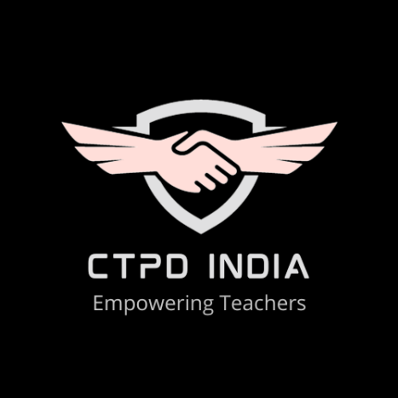
Address by the Chief Guest | 10:45 A.M-11:05 A.M | Padma Shri Prof (Dr.) J.S Rajput Former Director, NCERT, New Delhi, India
Address by Guest Speaker | 11:05 A.M-11:20 A.M | Shri Uday Singh Shankar  CEO, Vishwa Yuvak Kendra, New Delhi, India
Address by the Guest of Honour  Topic: Professional Development of Teachers – Key for an Equitable, Inclusive and Quality Educational Environment | 11:20 A.M-11:40 A.M | Prof. (Dr.) Berinderjeet Kaur Professor of Mathematics Education, National Institute of Education, Nanyang Technological University, Singapore
Address by Guest Speaker  Topic: Indian Knowledge System: Integration and Internationalisation | 11:40 A.M-12:00 P.M | Professor Sunil Kumar Singh Faculty of Education, B.H.U (Central University), Varanasi, Uttar Pradesh, India
Address by Guest Speaker  Topic: Sustainable  Development: Research,  Practice and Education | 12:00 P.M-12:20 P.M | Professor Yashwant Rao Ramma Science Education, Mauritius Institute of Education, Moka, Mauritius
Address by Guest Speaker  Topic: Digital Transformation and Online Education | 12:20 P.M-12:40 P.M | Professor Nellie Deutsch (Ed.D) Instructor in IMT M.Sc in Immersive Technologies, International Hellenic University, Kavala, Greece
Address by Guest Speaker  Topic: Equitable and Inclusive Higher Education for Sustainable Development | 12:40 P.M-1:00 P.M | Prof. (Dr.) Dwarika Prasad Uniyal Pro Vice-Chancellor, R. V. University, Bengaluru, Karnataka, India
Vote of Thanks | 1:00 P.M-1:05 P.M | Prof. (Dr.) Tania Gupta  Secretary General CTPD & Conference Organizing Secretary
National Anthem

TRACK 1: Indian Knowledge Systems (IKS): Integration and Internationalisation
14 OCTOBER 2023
5:30 P.M-7:30 P.M (IST)
Convenor: Dr. Jugnu Khatter Bhatia Co-Convenor: Dr. Reena Uniyal Tiwari
Plenary Session 1.1: IKS as a Living Tradition
Joining Link
https://us06web.zoom.us/j/85973130792?pwd=yVn2HC7p6tR8ZD3rfAVrkojCeJG7c3.1 Password: CTPDCON
Activity | Time | Moderator/Chair/Co-chair/Guest Speaker
Opening Address & Welcome | 5:30 P.M-5:35 P.M | Dr. Khushbu Verma  Assistant Professor, Satyug Darshan Institute of Education and Research, Faridabad  & Moderator, Plenary Session 1.1, CTPDCON ERA 2023
Overview of the Plenary Session | 5:35 P.M-5:40 P.M | Dr. Jugnu Khatter Bhatia  ConferenceOrganizing Secretary & Principal, Satyug Darshan Institute of Education and Research, Faridabad, Haryana, India
Address by Chair | 5:40 P.M-6:00 P.M | Prof. (Dr.) Mahesh Narayan Dixit  Faculty of Education (IASE), Gujarat Vidyapeeth, Ahmedabad, Gujarat, India
Paper Presentation 1  Title: Indian Traditional Knowledge System | 6:00 P.M-6:10 P.M | Dr. Kamna Chaturvedi  Associate Professor, Saraswati College of Professional Studies, Ghaziabad, Uttar Pradesh, India
Paper Presentation 2  Title: Bhagavad Gita -The Essence of the Philosophy of Life | 6:10 P.M-6:20 P.M | Dr. Poonam Dhull  Assistant Professor, RLS College of Education, Sidhrawali, Gurugram, Haryana, India
Paper Presentation 3  Title: Upanishadic view of Education | 6:20 P.M-6:30 P.M | Anamika Shukla  Associate Professor, School of Humanities, Indira Gandhi National Open University, New Delhi, India
Paper Presentation 4  Title: Salient Features of Vedic Education in Ancient India | 6:30 P.M-6:40 P.M | Dr. Ranjana V. Tijare  Assistant Professor, Shri Vasant College of Education, Nagpur, Maharashtra, India
Paper Presentation 5  Title: Vedic Mathematics and Calculus : Some Unique Techniques | 6:40 P.M-6:50 P.M | Sanjeev Kumar  Research Scholar, School of Education, K.R. Mangalam University, Gurugram, Haryana, India  Prof. (Dr.) Tania Gupta  Dean, School of Education, K.R. Mangalam University, Gurugram, Haryana, India
Paper Presentation 6  Title: Relevance of IKS: Bhagavad Gita's Perspective on Education | 6:50 P.M-7:00 P.M | Dr. Rachna Sharma  Associate Professor, KIIT College of Education, Gurugram, Haryana, India

Summary of the Session and Address by Co-Chair | 7:00 P.M-7:20 P.M | Dr. Sonal Chhabra  Principal, Rawal College of Education, Faridabad, Haryana, India
Closing Remarks of the Chair | 7:20 P.M-7:25 P.M | Prof. (Dr.) Mahesh Narayan Dixit  Faculty of Education (IASE), Gujarat Vidyapeeth, Ahmedabad, Gujarat, India
Vote of Thanks | 7:25 P.M-7:30 P.M | Prof. (Dr.) Tania Gupta  Dean, School of Education, K.R Mangalam University, Gurugram, Haryana, India, Secretary General CTPD & Organizing Secretary CTPDCON ERA 2023

Plenary Session 1.2: The Culture and Spiritual Identity of India
Joining Link
https://us06web.zoom.us/j/85972353486?pwd=qk74N0LfrOesetunwJ9YdyTJH4cODV.1 Password: CTPDCON
Activity | Time | Moderator/Chair/Co-chair/Guest Speaker
Opening Address & Welcome | 5:30 P.M-5:35 P.M | Ms. Chetna Thapa  Assistant Professor, D.W.T College, Dehradun, Uttarakhand, India & Moderator, Plenary Session 1.2, CTPDCON ERA 2023
Overview of the Plenary Session | 5:35 P.M-5:40 P.M | Dr. Shweta Rani  Program Director, BHOO Chetna, CTPD India & Joint Organizing Secretary, CTPDCON-ERA 2023
Address by Chair | 5:40 P.M-6:00 P.M | Prof. (Dr.) Arti Koul Kachroo  Dean, School of Education, Sharda University, Greater Noida, Uttar Pradesh, India
Paper Presentation 1  Title: Analytical Study of Ecosystems for learning & well-being in Indian Education | 6:00 P.M-6:10 P.M | Ms. Aparna Seebaluck  Principal K.R Mangalam World School Gurugram, Haryana, India  Ms. Monika Talukdar  Coordinator, K.R Mangalam World School Gurugram, Haryana, India
Paper Presentation 2  Title: The Living Legacy: Exploring the Indian Knowledge System (IKS) | 6:10 P.M-6:20 P.M | Dr. Sakshi Vermani Rishi  Associate Professor, School of Education, Rishihood University, Sonipat, Haryana, India
Paper Presentation 3  Title: Sketching the Alternative Gender Identities from the Ancient Indian texts and Indian Knowledge System | 6:20 P.M-6:30 P.M | Dibyangana Biswas  Assistant Professor, School of Liberal Arts and Humanities, Woxsen University,Hyderabad, Telangana, India
Paper Presentation 4  Title: भारतीय ज्ञान प्रणाली एवं आधुननक समाज के समक्ष निक्षा की चुनौनतयां एवं समाधान | 6:30 P.M-6:40 P.M | Prof (Dr.) Sunita Bhargava  Principal, Sanjay Teacher's Training College, Jaipur, Rajasthan, India  Dr. Suman Lata Yadav  Assistant Professor, Sanjay Teacher's Training College, Jaipur, Rajasthan, India
Paper Presentation 5  Title: A Study of the Implementation and the Impact of Promoting Entrepreneurship, Vocational Education and Innovation in School | 6:40 P.M-6:50 P.M | Shubham Vats  Research Scholar, School of Education, Galgotias University, Greater Noida, Uttar Pradesh, India  Dr. Navita Malik  Associate Professor, School of Education, Galgotias University, Greater Noida, Uttar Pradesh, India

Paper Presentation 6  Title: Indian Knowledge System: It's Essence and Need for Educational Landscape | 6:50 P.M-7:00 P.M | Vivek Sharma  Student MA (Sociology), Dr. B.R. Ambedkar University Delhi  Dr. Shweta Rani  Assistant Professor (Senior Grade), Department of Geography, Dyal Singh College, University of Delhi, India
Summary of the Session and Address by Co-Chair | 7:00 P.M-7:20 P.M | Dr. Pargat Singh Garcha  Principal, GHG Khalsa College of Education, GurusarSadhar, Punjab, India
Closing Remarks of the Chair | 7:20 P.M-7:25 P.M | Prof. (Dr.) Arti Koul Kachroo  Dean, School of Education, Sharda University, Greater Noida, Uttar Pradesh, India
Vote of Thanks | 7:25 P.M-7:30 P.M | Prof. (Dr.) Satyendra Gupta  Chief Advisor CTPD & Advisor CTPDCON- ERA 2023

Plenary Session 1.3: Relevance of IKS in the Present Knowledge System
Joining Link
https://us06web.zoom.us/j/87894242715?pwd=ABGl2NEICCxmgP86y4gj4QsvAhb3tB.1 Password: CTPDCON
Activity | Time | Moderator/Chair/Co-chair/Guest Speaker
Opening Address & Welcome | 5:30 P.M-5:35 P.M | Dr. Balbir Kaur  Associate Professor & HOD Post Graduate Studies Department, School of Education, Shri Guru Ram Rai University, Dehradun, Uttrakhand, India & Moderator, Plenary Session 1.3, CTPDCON ERA 2023
Overview of the Plenary Session | 5:35 P.M-5:40 P.M | Dr. Parvesh Lata  Program Director Digital Circle CTPD India, Associate Professor & Head, Department of Education,G D Goenka University, Gurugram, Haryana, India
Address by Chair | 5:40 P.M-6:00 P.M | Dr. Ganesh V. Halade  Associate Professor, Division of Cardiovascular Sciences, Department of Medicine, University of South, Florida, USA
Paper Presentation 1  Title: New Vision for India’s Higher Education System in Context of NEP2020 | 6:00 P.M-6:10 P.M | Dr. Renu Kumari  Associate Professor, Department of Education, Dr. ZHTT College, L. Sarai, Darbhanga, India
Paper Presentation 2  Title: Indian Art of Living-A Strong Message of Science | 6:10 P.M-6:18 P.M | Girish Chandra Behera  Assistant Professor in Odia (Teacher Education), Shailabala Women’s Autonomous College, Cuttack, India  Pranati Priyadarshini  Assistant Professor in Botany (Teacher Education), Shailabala Women’s Autonomous College, Cuttack, India
Paper Presentation 3  Title: Indian Knowledge System in National Education Policy (NEP) 2020: Scope and Challenges | 6:18 P.M-6:26 P.M | Dharna Malhotra  PhD Scholar, Department of Education, G.D. Goenka University, Gurugram, Haryana, India
Paper Presentation 4  Title: NEP 2020 and Indian Knowledge Systems: The Spiritual Preparation of Teachers | 6:26 P.M-6:34 P.M | Mahak Chhabra  Research Scholar, University of Rajasthan, Jaipur, Rajasthan, India  Prof. Mudit Rathore  Research Supervisor, University of Rajasthan, Jaipur, Rajasthan, India
Paper Presentation 5  Title: Exploring Intercultural Sensitivity Among Students of Higher Education in India | 6:34 P.M-6:42 P.M | Shahla Naaz  Research Scholar, Department of TTI & NFE, IASE Faculty of Education, Jamia Millia Islamia, New Delhi, India

Paper Presentation 6  Title: Role of Indian Knowledge System in Building Cultural Identity and Self-Esteem- A Pedagogical Perspective | 6:42 P.M-6:51 P.M | Parinka Sharma  Research Scholar, Department of Educational Studies, Central University of Jammu, J&K, India  Dr. J.N. Baliya  Professor, Department of Educational Studies, Central University of Jammu, J&K, India
Paper Presentation 7  Title: Is E-learning a Learning? International Students’ View | 6:51 P.M-7:00 P.M | Clement John  PhD Scholar, Galgotias University, Greater Noida, U.P., India
Summary of the Session and Address by Co-Chair | 7:00 P.M-7:20 P.M | Dr. Vandana Shivajirao Nalawade  Principal, Azad College of Education, Satara, Maharashtra, India
Closing Remarks of the Chair | 7:20 P.M-7:25 P.M | Dr. Ganesh V. Halade  Associate Professor, Division of Cardiovascular Sciences, Department of Medicine, University of South, Florida, USA
Vote of Thanks | 7:25 P.M-7:30 P.M | Prof. (Dr.) Prarthita Biswas  Program Director East Zone CTPD India & Professor & Research Head, Department of Education, Swami Vivekananda University, Kolkata, West Bengal, India

Plenary Session 1.4: IKS & Some Reflections for Global Integration
Joining Link
https://us02web.zoom.us/j/85348651913?pwd=b3F2ZVlidVdTYVJuOGIwNFkyanBKQT09 Password: CTPDCON
Activity | Time | Moderator/Chair/Co-chair/Guest Speaker
Opening Address & Welcome | 5:30 P.M-5:35 P.M | Ms. Anita Sahay  Assistant Professor, Satyug Darshan Institute of Education and Research, Faridabad, Haryana, India & Moderator, Plenary Session 1.4, CTPDCON ERA 2023
Overview of the Plenary Session | 5:35 P.M-5:40 P.M | Dr. Vinay D Dhondge  Program Director West Zone CTPD India & Professor, Azad College of Education, Satara, Maharashtra
Address by Chair | 5:40 P.M-6:00 P.M | Prof. (Dr.) Savita Rawat  Department of Teacher Education, D.A.V (P.G) College, Dehradun, Uttrakhand, India
Paper Presentation 1  Title: Indian Knowledge System: Fostering Peace and Value Education for a Sustainable World | 6:00 P.M-6:10 P.M | Dr. Prerna Vashistha  Associate Professor, Delhi Teachers’ Training College (Affiliated to GGSIP University, New Delhi, India)  Dr. Parvesh Lata  Associate Professor & Head Department of Education, SOHSE, GD Goenka University, Gurugram, Haryana, India
Paper Presentation 2  Title: Relevance of Ancient Wisdom on Weather Forecasting for Improving Agro-Advisories | 6:10 P.M-6:18 P.M | Dr. V.V. Ravi  M.A PhD (Astrology), Hyderabad, Telangana, India  Smt. V. Bhanumathi  Hyderabad, Telangana, India
Paper Presentation 3  Title: Indian Knowledge System: Integration and Internationalisation | 6:18 P.M-6:26 P.M | Naina Sharma  Ph.D. Scholar, School of Education, K.R Mangalam University, Gurugram, Haryana, India  Prof. (Dr.) Tania Gupta  Dean School of Education, K.R. Mangalam University, Gurugram, Haryana, India
Paper Presentation 4  Title: Indian Knowledge System and Sustainable Development | 6:26 P.M-6:34 P.M | Prof. Chandrawati Joshi  Assistant Professor, Govt. P.G. College, Gopeshwar , Chamoli, India  Dr. Vidhi Dhoundiyal  Assistant Professor, Govt. P.G. College, Gopeshwar, Chamoli, India
Paper Presentation 5  Title: भारतीय ज्ञान परम्परा और साववभौनमक मानवीय मूल्यं का वतवमान निक्षा मेंसमाययजन- एक स्वस्थ नचंतन | 6:34 P.M-6:42 P.M | Dr. Sandip Kumar  Principal  Dr. Ram Kishor  Assistant Professor

Paper Presentation 6  Title: Environmental Concerns: Issues, Impact, Mitigation and Education | 6:42 P.M-6:51 P.M | Shabnam  JRF (Ph.D. Scholar), Department of TT& NFE, IASE, Faculty of Education, Jamia Millia Islamia, New Delhi, India
Paper Presentation 7  Title: Education and Values | 6:51 P.M -7:00 P.M | Abhijit Bhattacharya  Assistant Professor, Govt. College of Art & Craft, Agartala, Tripura, India
Summary of the Session and Address by Co-Chair | 7:00 P.M-7:20 P.M | Dr. Anita Singh  Director, Saraswati College of Professional Studies, Ghaziabad, Uttar Pradesh, India
Closing Remarks of the Chair | 7:20 P.M-7:25 P.M | Prof. (Dr.) Savita Rawat  Department of Teacher Education, D.A.V (P.G) College, Dehradun, Uttrakhand, India
Vote of Thanks | 7:25 P.M.-7:30 P.M. | Prof. (Dr.) Sanjay Kumar  Program Director, CTPD India & Convenor CTPDCON ERA 2023

TRACK 2: Sustainable Development: Research, Practice and Education
14 OCTOBER 2023
2:00 P.M-4:00 P.M (IST)
Convenor: Prof. Satyendra Gupta Co-Convenor: Dr. Shweta Rani
Plenary Session 2.1: Education in Sustainable Development
Joining Link
https://us06web.zoom.us/j/85973130792?pwd=yVn2HC7p6tR8ZD3rfAVrkojCeJG7c3.1 Password: CTPDCON
Activity | Time | Moderator/Chair/Co-chair/Guest Speaker
Opening Address & Welcome | 2:00 P.M-2:05 P.M | Ms. Smita Thakre  Coordinator, Titans Public School, Amravati, Maharashtra &Moderator, Plenary Session 2.1, CTPDCON ERA 2023
Overview of the Plenary Session | 2:05 P.M-2:10 P.M | Prof (Dr.) Tania Gupta  Secretary General CTPD, Organizing Secretary CTPDCON ERA 2023 & Dean, School of Education, K.R Mangalam University, Gurugram, Haryana, India
Address by Chair | 2:10 P.M-2:30 P.M | Prof. (Dr.) R. S. Rai  Professor & Director-IQAC, AMITY University, NOIDA, U.P, India
Paper Presentation 1  Title: Overview of 17 Sustainable Development Goals | 2:30 P.M-2:40 P.M | Dr. Chandra Mohan  Associate Professor, SBAS, K.R. Mangalam University, Gurugram, Haryana, India  Dr. Shah Alam Khan  Department of Pharmaceutical Chemistry,  College of Pharmacy, National University of Science and Technology, Muscat 620, Sultanate of Oman.  Jenifer Robinson  Research Scholar, SBAS, K.RMangalam University, Gurugram, Haryana, India
Paper Presentation 2  Title: Substance Education: An Embodiment of Good Health and Well Being | 2:40 P.M-2:50 P.M | Taorem Romibala Devi  Research Scholar, Assam University, Assam, India
Paper Presentation 3  Title: Education in Sustainable Development | 2:50 P.M-3:00 P.M | Tejal Pramod Nikam  Assistant Professor, Oriental College of Education, Sanpada, Navi Mumbai, India
Paper Presentation 4  Title: Assessing the Impact of Education on Sustainable Development: A Comprehensive Analysis | 3:00 P.M-3:10 P.M | Neha Khaiwal  Ph.D. Scholar, Galgotias University, Greater Noida, Uttar Pradesh, India
Paper Presentation 5  Title: A Review of Education for Sustainable Education | 3:10 P.M-3:20 P.M | Samiha Baig  Principal, Diamond College of Commerce and Science, Nagpur, India

Paper Presentation 6  Title: Sustainable Innovations in Global Retailing | 3:20 P.M-3:30 P.M | Dr. Pooja Sharma  Associate Professor, BSSS IAS, Bhopal, MP, India
Paper Presentation 7  Title: Professional Growth of Teachers | 3:30 P.M-3:40 P.M | Smita Thakare  Titans' Public School, Badnera, Amravati, Maharashtra, India
Summary of the Session and Address by Co-Chair | 3:40 P.M-3:50 P.M | Prof. (Dr.) Pallavi D Khedkar  Professor & Director Academics, Parul University, Vadodara, Gujarat, India
Closing Remarks of the Chair | 3:50 P.M-3:55 P.M | Prof. (Dr.) R. S. Rai  Professor & Director IQAC, Amity University, NOIDA, U.P, India
Vote of Thanks | 3:55 P.M-4:00 P.M | Dr. Jugnu Khatter Bhatia  Program Director, Research Circle, CTPD India & Organizing Secretary CTPDCON-ERA 2023

Plenary Session 2.2: Communities, Governance and Sustainable Practices
Joining Link
https://us06web.zoom.us/j/85972353486?pwd=qk74N0LfrOesetunwJ9YdyTJH4cODV.1 Password: CTPDCON
Activity | Time | Moderator/Chair/Co-chair/Guest Speaker
Opening Address & Welcome | 2:00 P.M-2:05 P.M | Dr. Pooja Chopra  Assistant Professor, Department of Education, School of Humanities, Social Sciences and Education, GD Goenka University, Gurugram &Moderator, Plenary Session 2.2, CTPDCON ERA 2023
Overview of the Plenary Session | 2:05 P.M-2:10 P.M | Dr. Reena Uniyal Tiwari  Program Director, Quality Circle, CTPD India & Organizing Joint Secretary CTPDCON-ERA 2023
Address by Chair | 2:10 P.M-2:30 P.M | Prof. Poonam Sharma  Professor, Department of Geography, Shaheed Bhagat Singh College, University of Delhi, Delhi
Paper Presentation 1  Title: Green Technology in Education and Sustainable Development | 2:30 P.M-2:40 P.M | Dr. Amit Ahuja  Associate Professor, University School of Education, Guru Gobind Singh Indraprastha University, Delhi  Rajani Upadhyay  Research Scholar, University School of Education, Guru Gobind Singh Indraprastha University, Delhi
Paper Presentation 2  Title: The Significance of Education for Sustainable Development (ESD) in Modern day India | 2:40 P.M-2:50 P.M | Sarishti Joshi  Research Scholar, Department of Sociology, Panjab University, Chandigarh, India
Paper Presentation 3  Title: Embracing Sustainable Lifestyle: The Power of Individual Choices | 2:50 P.M-3:00 P.M | Dr. Manjeet Yadav  Assistant Professor, R. L. S. College of Education, Sidhrawali, Gurugram
Paper Presentation 4  Title: For The Greener Tomorrow: Storytelling as A Method for Inculcating Sustainability Awareness in Elementary Students | 3:00 P.M-3:10 P.M | Ms. Soumita Chakraborty  Swami Vivekananda University, Kolkata, West Bengal, India  Prof. (Dr.) Prarthita Biswas  Professor & Research Head, Department of Education, Swami Vivekananda University, Kolkata, West Bengal, India
Paper Presentation 5  Title: Role of Lifestyle Choices in Achieving Sustainable Development Goals | 3:10 P.M-3:20 P.M | Dr. Reena Uniyal Tiwari  Associate Professor, Department of Education, D.A.V. (P.G) College, Dehradun, Uttarakhand, India

Paper Presentation 6  Title: Technology-Mediated  Collaborative Learning: Exploring Tools and Implementation Concerns | 3:20 P.M-3:30 P.M | Dr. JoytiSehrawat  Assistant Professor, Rao Lal Singh College of Education, Sidhrawali, Gurugram, Haryana, India
Paper Presentation 7  Title: A Study on Understanding Intangible Assets for ESD | 3:30 P.M-3:40 P.M | Masooda Haseeb  Assistant Professor, Janhit Institute of Education and Information, Greater Noida, G.B. Nagar, U.P.
Summary of the Session and Address by Co-Chair | 3:40 P.M-3:50 P.M | Dr. Sayed Zaheen Alam  Associate Professor, Department of Geography, Dyal Singh College, University of Delhi, Delhi
Closing Remarks of the Chair | 3:50 P.M-3:55 P.M | Prof. Poonam Sharma  Professor, Department of Geography, Shaheed Bhagat Singh College, University of Delhi, Delhi
Vote of Thanks | 3:55 P.M-4:00 P.M | Prof (Dr.) Tania Gupta  Secretary General CTPD, Organizing Secretary CTPDCON ERA 2023 & Dean, School of Education, K.R Mangalam University, Gurugram, Haryana, India

Plenary Session 2.3: Sustainable Education and Global Partnership
Joining Link
https://us06web.zoom.us/j/87894242715?pwd=ABGl2NEICCxmgP86y4gj4QsvAhb3tB.1 Password: CTPDCON
Activity | Time | Moderator/Chair/Co-chair/Guest Speaker
Opening Address & Welcome | 2:00 P.M-2:05 P.M | Dr. Rekha Kaushal  Assistant Professor, Department of Education, School of Humanities, Social Sciences and Education, GD Goenka University, Gurugram & Moderator, Plenary Session 2.3, CTPDCON ERA 2023
Overview of the Plenary Session | 2:05 P.M-2:10 P.M | Prof. (Dr.) Vinay D Dhondge  Program Director, West Zone, CTPD India & Professor, Azad College of Education, Satara, Maharashtra, India
Address by Chair | 2:10 P.M-2:30 P.M | Dr. Ajay Surana  Associate Professor, Department of Education, Banasthali Vidyapith, Rajasthan, India
Paper Presentation 1  Title: Peace Education: Need in Today's Scenario | 2:30 P.M-2:40 P.M | Dr. Sasmita Gahan  Shailabala Women's Autonomous College, Cuttack, Odhisa, India
Paper Presentation 2  Title: Sustainable Practices of Rayat Shikshan Sanstha in Rural Development | 2:40 P.M-2:50 P.M | Dr. Amitkumar Shankarrao Gagare  Associate Professor, SSB College of Education,  Shrirampur, Maharashtra, India
Paper Presentation 3  Title: Identifying Education's Core Problems for Sustainable Development | 3:00 P.M-3:10 P.M | Wahida Rais  Research Scholar, Integral University, Lucknow, India
Paper Presentation 4  Title: Global Partnership and Sustainable Education as a Framework for Peace Education | 3:10 P.M-3:20 P.M | Riya  M.Ed. Student, Bhagat Phool Singh Mahila Vishwavidyalaya, Khanpur Kalan, Haryana  Dr. Parvesh Lata  Associate Professor & Head, Department of Education, G D Goenka University, Gurugram, Haryana, India
Paper Presentation 5  Title: Assessing the Impact of Peace Education Course in the B.Ed Program: A Study of Alumni's Implementation in Their School | 3:20 P.M-3:30 P.M | Dr. Archana Chaudhari  HOD, MIT WPU School of Education, Pune, India
Paper Presentation 6  Title: The Role of Education in Sustainable Development | 3:30 P.M-3:40 P.M | Dr. G. M. Vijayalakshmi  Tames College of Education, Gangavati, Karnataka, India

Paper Presentation 7  Title: Social Media in Education and Sustainability in Cybersecurity: Emerging Trends and Mitigation Measures in Palam Colony, NCT Delhi | 3:40 P.M-3:50 P.M | Heena Kumar  B.Ed., Kirorimal College of Education (MDU)  Garima Chauhan  BA Programme, Dyal Singh College, Delhi  Dr. Shweta Rani  Assistant Professor (Senior Grade), Department of Geography, Dyal Singh College, University of Delhi, India
Summary of the Session and Address by Co-Chair | 3:50 P.M-4:00 P.M | Dr. Shirin Rais  Assistant Professor, Department of Economics, Aligarh Muslim University, Aligarh, UP, India
Closing Remarks of the Chair | 4:00 P.M-4:05 P.M | Dr. Ajay Surana  Associate Professor, Department of Education, Banasthali Vidyapith, Rajasthan, India
Vote of Thanks | 4:05 P.M-4:10 P.M | Dr. Parvesh Lata  Program Director, Digital Circle, CTPD India & Associate Professor & Head of Department of Education, G D Goenka University, Gurugram, Haryana, India

Plenary Session 2.4: Practices in Sustainability
Joining Link
https://us02web.zoom.us/j/85348651913?pwd=b3F2ZVlidVdTYVJuOGIwNFkyanBKQT09 Password: CTPDCON
Activity | Time | Moderator/Chair/Co-chair/Guest Speaker
Opening Address & Welcome | 2:00 P.M-2:05 P.M | Dr. Sweta Bhargava  Assistant Professor, Sanjay TT College, Jaipur, Rajasthan & Moderator, Plenary Session 2.4, CTPDCON ERA 2023
Overview of the Plenary Session | 2:05 P.M-2:10 P.M | Prof. (Dr) Umesh Sharma  Advisor Finance, CTPD & Pro-Vice Chancellor, Arni University, Himachal Pradesh, India
Address by Chair | 2:10 P.M-2:30 P.M | Prof. (Dr.) Jayanta Mete  Professor, Department of Education, University of Kalyani, Kalyani, Nadia, West Bengal, India
Paper Presentation 1  Title: Sustainability in Action: Practical Tips for Everyday Life | 2:30 P.M-2:40 P.M | Jitendra Singh  Assistant Professor, Saraswati College of Professional Studies, Ghaziabad, U.P., India
Paper Presentation 2  Title: Environmental Concerns: issues, Impact and Mitigation Through Education | 2:40 P.M-2:50 P.M | Shabnam  Research Scholar, Department of TT & NFE, IASE, Jamia Millia Islamia, Delhi, India
Paper Presentation 3  Title: Peace Education | 2:50 P.M-3:00 P.M | Jitendra Kumar  Assistant Professor, Saraswati College of Professional Studies, Ghaziabad, U.P., India
Paper Presentation 4  Title: िाश्वत नवकास: संियधन, सरावआनण निक्षण  (Sustainable Development: Research, Practice, and Education) | 3:00 P.M-3:10 P.M | Dr. Kirtikar Yogeshwar Shripal  Assistant Professor, AppasahebBirnale College of Education, Sangli, Maharashtra, India
Paper Presentation 5  Title: Promoting Inclusive Education Ensures Education for All in India: A Review Study | 3:10 P.M-3:20 P.M | Fr. Baiju Thomas  Research Scholar, Ramakrishna Mission Vivekananda Educational and Research Institute, Coimbatore, Tamil Nadu, India
Paper Presentation 6  Title: Efficient Learning with the Application of e-Technology | 3:20 P.M-3:30 P.M | Chitra  Associate Professor, ICFAI, Baddi, Himachal Pradesh, India
Paper Presentation 7  Title: Financial Aspects of Human Resource Development and Change | 3:30 P.M-3:40 P.M | Dr. Annu Tomar  Assistant Professor, Institute of Technology and Science, Mohan Nagar, Ghaziabad, Uttar Pradesh, India

Summary of the Session and Address by Co-Chair | 3:40 P.M-3:50 P.M | Dr. Shruti Tiwari  Principal, School of Education, Suresh Gyan Vihar University, Jaipur, Rajasthan, India
Closing Remarks of the Chair | 3:50 P.M-3:55 P.M | Prof. (Dr.) Jayanta Mete  Professor, Department of Education, University of Kalyani, Kalyani, Nadia, West Bengal, India
Vote of Thanks | 3:55 P.M-4:00 P.M | Prof. (Dr.) Sanjay Kumar  Program Director, CTPD India & Convenor CTPDCON-ERA 2023

TRACK 3: Equitable and Inclusive Higher Education for Sustainable Development
15 OCTOBER 2023
10:00 A.M-12:30 P.M (IST)
Convenor: Dr. Sanjay Kumar Co-Convenor: Ms. Jenifer Robinson
Plenary Session 3.1: Digital Transformation and Online Education (Hindi/Bilingual) Joining Link
https://us06web.zoom.us/j/85973130792?pwd=yVn2HC7p6tR8ZD3rfAVrkojCeJG7c3.1 Password: CTPDCON
Activity | Time | Moderator/Chair/Co-chair/Guest Speaker
Opening Address & Welcome | 10:00 A.M -10:05A.M | Ms. Shalini Sharma  Assistant Professor, Department of Education, Saraswati College of Professional Studies, Ghaziabad, Uttar Pradesh, India & Moderator, Plenary Session 3.1, CTPDCON ERA 2023
Overview of the Plenary Session | 10:05 A.M -10:10A.M | Prof. (Dr.) Satyendra Gupta  Chief Advisor CTPD & Advisor CTPDCON- ERA 2023
Address by Chair | 10:10 A.M - 10:30A.M | Dr. Amit Ahuja  Associate Professor, University School of Education, GGSIP University, Delhi, India
Paper Presentation 1  Title: Challenges and Benefits of Online Education | 10:30 A.M -10:38 A.M | Dr. Amita Kumari  Assistant Professor, Satyug Darshan Institute of Education and Research Faridabad, Haryana, India  Dr. Jugnu Khatter Bhatia  Principal, Satyug Darshan Institute of Education and Research, Faridabad, Haryana, India
Paper Presentation 2  Title: Digital Education: Issues and Challenges | 10:38 A.M-10:46 A.M | Dr. Anjana Agarwal  Assistant Professor, Sanjay Teachers Training College Lal Kothi, Jaipur, Rajasthan, India
Paper Presentation 3  Title: A Review Report on Contribution of SWAYAM (MOOCs) in Education | 10:46 A.M-10:54 A.M | Dr. Geeta Dhasmana  Assistant Professor, Fairfield Institute of Management & Technology, New Delhi, India
Paper Presentation 4  Title: ऑनलाइन निक्षण प्रणाली की चुनयनतया एवंसमाधान | 10:54 A.M-11:02 A.M | Dr. Mukesh Sharma  Head of Department, Nathdwara Institute of Biotechnology and Management, Kankroli, Rajasthan, India
Paper Presentation 5  Title: Bharat Mein COVID-19 Lockdown Ke Doran Online Siksha ParnnaliKe Labh aur Chounotiyan | 11:02 A.M-11:10 A.M | Dr. Rajesh Dhaka  Professor, Jagannath University, Bahadurgarh, Haryana, India

Paper Presentation 6  Title: नई निक्षा नीनत - 2020 मेंई लननिंग की ओर भारत के बढ़तेकदम | 11:10 A.M-11:18 A.M | Dr. Babu Lal Bunker  Principal, Tagore Shikshak Prashikshan Sansthan Kuchaman City Nagaur, Kuchaman City, Rajasthan, India
Paper Presentation 7  Title: Effects of Causal Attribution on Digital Transformation Learning in the Senior Secondary School Sector | 11:18 A.M-11:26 A.M | Ravi Kant Verma  Research Scholar, Galgotias University, Greater Noida, Uttar Pradesh, India
Paper Presentation 8  Title: Influence of Online Learning on Study Habits of Senior Secondary School Students | 11:26 A.M-11:34 A.M | Sangeeta Singh  Research Scholar, Galgotias University, Greater Noida, Uttar Pradesh, India
Paper Presentation 9  Title: Issues and Challenges of Digital Education | 11:34 A.M-11:42 A.M | Rosy Tigga  Assistant Professor, Department of Education, Saraswati College of Professional Studies, Ghaziabad, Uttar Pradesh, India
Paper Presentation 10  Title: Exploring the Impact of Digital and Online Education on Quality Education in India | 11:42 A.M-11:50 A.M | Anshuman Srivastava  Research Scholar, University of Allahabad Prayagraj, Uttar Pradesh, India
Summary of the Session and Address by Co-Chair | 11:50 A.M - 12:15 P.M | Dr. Sunita Arora  Principal, Institute of Teacher's Education, Faridabad, Haryana, India
Closing Remarks of the Chair | 12:15 P.M- 12:25 P.M | Dr. Amit Ahuja  Associate Professor, University School of Education, GGSIP University, Delhi, India
Vote of Thanks | 12:25 P.M - 12:30 P.M | Dr. Jugnu Khatter Bhatia  Program Director, Research Circle, CTPD India & Organizing Secretary CTPDCON-ERA 2023

Plenary Session 3.2: Digital and Online Education for Quality Education
Joining Link
https://us06web.zoom.us/j/85972353486?pwd=qk74N0LfrOesetunwJ9YdyTJH4cODV.1 Password: CTPDCON
Activity | Time | Moderator/Chair/Co-chair/Guest Speaker
Opening Address & Welcome | 10:00 A.M- 10:05 A.M | Dr. Sakshi Vermani Rishi  Associate Professor, School of Education, Rishihood University, Sonipat, Haryana, India& Moderator, Plenary Session 3.2, CTPDCON ERA 2023
Overview of the Plenary Session | 10:05 A.M- 10:10 A.M | Dr. Reena Uniyal Tiwari  Program Director, Quality Circle, CTPD India & Joint Organizing Secretary, CTPDCON-ERA 2023
Address by Chair | 10:10 A.M -10:30 A.M | Dr. Sandhya Milind Khedekar  Principal, Gokhale Education Society's, College of Education, Sangamner, Maharashtra, India
Paper Presentation 1  Title: Digital Transformation and Online Education | 10:30 A.M -10:38 A.M | Teena  Assistant Professor, Satyug Darshan Institute of Education and Research, Faridabad, Haryana, India  Dr. Jugnu Khatter Bhatia  Principal, Satyug Darshan Institute of Education and Research, Faridabad, Haryana, India
Paper Presentation 2  Title: Digital Competence: Essential 21st Century Skills for Teachers | 10:38 A.M-10:46 A.M | Archana Singh  Research Scholar, Galgotias University, Greater Noida, Uttar Pradesh, India
Paper Presentation 3  Title: Online Learning Practices for Traditional Teachers | 10:46 A.M-10:54 A.M | Dr. Shweta Tyagi  Assistant Professor, IPEM, Ghaziabad, Uttar Pradesh, India
Paper Presentation 4  Title: Management of Teaching Research - Extension by Agricultural University During COVID-19 | 10:54 A.M-11:02 A.M | Dr. V Vijaya Lakshmi  Professor, College of Community Science, PJTSAU, Hyderabad, Telangana, India
Paper Presentation 5  Title: Machine Learning in Education | 11:02 A.M-11:10 A.M | Dr. Megha D Gokhe  Principal, Thakur Shyamnarayan College of Education & Research, Mumbai, Maharashtra, India
Paper Presentation 6  Title: Digital Pedagogies for Quality Education at School Level | 11:10 A.M-11:18 A.M | Karishma Narang  Research Scholar, G. D. Goenka University, Gurgaon, Haryana, India

Paper Presentation 7  Title: Digital Transformation and Usage of ICT: Key Highlights of NEP 2020 | 11:18 A.M-11:26 A.M | Dr. Chetna Thapa  Assistant Professor, Dayanand Women's Training College, Dehradun, Uttarakhand, India
Paper Presentation 8  Title: The impact of digital transformation on the future of teaching and learning | 11:26 A.M-11:34 A.M | Tlalane Mosae  Research Scholar, GD Goenka University, Gurugram, Haryana, India
Paper Presentation 9  Title: Digital Pedagogies for Quality Education at School Level | 11:34 A.M-11:42 A.M | Dr. Ashish Sharad Gurav  Assistant Professor, AEF's, Ashoka International Centre for Educational Studies and Research, Nashik, India
Paper Presentation 10  Title: Artificial Intelligence and Digital Transformation in Higher Education: Shaping the Future of Learning | 11:42 A.M-11:50 A.M | Dr. Bhawna Bisht  Assistant Professor, NKBMG PG College, Chandausi, Sambhal, Uttar Pradesh, India
Paper Presentation 11  Title: Online Education as Value for Money and Time | 11:50 A.M-12:00 P.M | Dr. Karuna Singh  Assistant Professor, Dhempe College of Arts & Science, Panaji, Goa, India
Summary of the Session and Address by Co-Chair | 12:00 P.M -12:20 P.M | MAM Sameem  Lecturer, Department of English Language Teaching, Faculty of Arts and Culture, South Eastern University of Sri Lanka, Sri Lanka
Closing Remarks of the Chair | 12:20 P.M -12:25 P.M | Dr. Sandhya Milind Khedekar  Principal, Gokhale Education Society's, College of Education, Sangamner, Maharashtra, India
Vote of Thanks | 12:25 P.M 12:30 P.M | Dr. Shweta Rani  Program Director, BHOO Chetna, CTPD India & Joint Organizing Secretary, CTPDCON-ERA 2023

Plenary Session 3.3: Emerging Trends and Artificial Intelligence in Digital Transformation Joining Link
https://us06web.zoom.us/j/87894242715?pwd=ABGl2NEICCxmgP86y4gj4QsvAhb3tB.1 Password: CTPDCON
Activity | Time | Moderator/Chair/Co-chair/Guest Speaker
Opening Address & Welcome | 10:00 A.M -10:05 A.M | Dr. Akanksha Srivastava  Associate Professor, School of Education, Sharda University, Greater Noida, India& Moderator, Plenary Session 3.3, CTPDCON ERA 2023
Overview of the Plenary Session | 10:05 A.M -10:10 A.M | Prof. (Dr.) S.C. Pachauri  Program Director, North Zone CTPD India
Address by Chair | 10:10 A.M -10:30 A.M | Dr. Siti NazuarSailin  Deputy Dean, Awang Had Salleh, Graduate School of Arts and Sciences, Universiti Utara Malaysia, Kuala Lumpur, Malaysia
Paper Presentation 1  Title: E-Learning Revolution A Deep Dive into Digital Transformation in India | 10:30 A.M -10:38 A.M | Dr. Shail Dhaka  Associate Professor, Shobhit Institute of Engineering & Technology Meerut, Uttar Pradesh, India.
Paper Presentation 2  Title: The Awareness of Disruptive Technology Among B.Ed. Trainees. | 10:38 A.M-10:46 A.M | Garima  Research Scholar, Amity University, Noida, Uttar Pradesh, India
Paper Presentation 3  Title: Integration of ChatGPT - AI-Powered Tool into Language Education. | 10:46 A.M-10:54 A.M | Payal Mittal  Research Scholar, G.D. Goenka University, Gurugram, Haryana, India
Paper Presentation 4  Title: AI-based Applications for Schools and HEI’s | 10:54 A.M-11:02 A.M | Ashish Sharma  Research Scholar, Galgotias University, Greater Noida, Uttar Pradesh, India
Paper Presentation 5  Title: Concept of Artificial Intelligence in Education in Modern India. | 11:02 A.M-11:10 A.M | Dr. Alpna Sharma  Assistant Professor, Sanjay T.T. College, Lal Kothi, Jaipur, Rajasthan, India
Paper Presentation 6  Title: Effectiveness of Augmented Reality in Teaching Science Concepts. | 11:10 A.M-11:18 A.M | Dr. Binti Dua  Assistant Professor, School of Education, K.R Mangalam University, Gurugram, Haryana, India
Paper Presentation7  Title: Transforming Higher Education Through Digitalization | 11:18 A.M-11:26 A.M | Dr. Deepa Rana  Assistant Professor, Shobhit Institute of Engineering and Technology Modipuram, Meerut, Uttar Pradesh, India.

Paper Presentation 8  Title: AI-Driven Design and Implementation of Personalized Learning Pathways: A Theoretical Framework for Enhancing Student Success in Secondary Education | 11:26 A.M-11:34 A.M | Mohini Singh  Research Scholar, Swami Vivekanand Subharti University, Meerut, Uttar Pradesh, India
Paper Presentation 9  Title: Digital Education for Quality Education | 11:34 A.M-11:42 A.M | Richa  Assistant Professor, Dewan Institute of Management Studies (College Of Education), Meerut, Uttar Pradesh, India
Paper Presentation 10  Title: Ed-tech Entrepreneurship and Technological role in Digital Transformation and Online Education | 11:42 A.M-11:50 A.M | Pranav Kumar Gahadwal  Student, Department of Geography, Dyal Singh College, University of Delhi, New Delhi, India  Dr. Shweta Rani  Assistant Professor (Senior Grade), Department of Geography, Dyal Singh College, University of Delhi, India
Paper Presentation 11  Title: Unlocking the Future: From Classroom to Digital Era of Learning | 11:50 A.M-12:00 P.M | Twinkle  Student, Central Institute of Education (Department of Education), New Delhi, India  Dr. Shweta Rani  Assistant Professor (Senior Grade), Department of Geography, Dyal Singh College, University of Delhi, India
Summary of the Session and Address by Co-Chair | 12:00 P.M -12:20 P.M | Dr. Yash Paul Sharma  Assistant Professor, Department of Education, Central University of Kerala, Kerala, India
Closing Remarks of the Chair | 12:20 P.M- 12:25 P.M | Dr. Siti NazuarSailin  Deputy Dean, Awang Had Salleh, Graduate School of Arts and Sciences Universiti Utara Malaysia, Kuala Lumpur, Malaysia
Vote of Thanks | 12:25 P.M- 12:30 P.M | Dr. Vinay. D. Dhongde  Program Director, West Zone, CTPD India

24 | P a g e

Plenary Session 3.4: Challenges and Benefits of Online Education
Joining Link
https://us02web.zoom.us/j/85348651913?pwd=b3F2ZVlidVdTYVJuOGIwNFkyanBKQT09 Password: CTPDCON
Activity | Time | Moderator/Chair/Co-chair/Guest Speaker
Opening Address & Welcome | 10:00 A.M -10:05 A.M | Dr. Parvesh Lata  Associate Professor, Department of Education, G.D. Goenka University, Gurugram, India& Moderator, Plenary Session 3.4, CTPDCON ERA 2023
Overview of the Plenary Session | 10:05 A.M-10:10 A.M | Prof. (Dr) Tania Gupta  Dean, School of Education, K.R Mangalam University, Gurugram, Haryana, India & Convenor Track 4, Organizing Secretary, CTPDCON-ERA 2023
Address by Chair | 10:10 A.M- 10:30 A.M | Prof. (Dr.) Madhusudan J. V.  Head of Department, Education and Educational Technology, School of Social Sciences, University of Hyderabad, Hyderabad, Telangana, India
Paper Presentation 1  Title: Challenges and Benefits of Online Education | 10:30 A.M -10:38 A.M | Priti Sharma  Research Scholar, School of Education, K R Mangalam University, Gurugram, Haryana, India  Prof. (Dr.) Tania Gupta  Dean, School of Education, K R Mangalam University, Gurugram, Haryana, India
Paper Presentation 2  Title: Adapting Instructional Design Principles for MOOCs in Teacher Education: Challenges and Opportunities | 10:38 A.M-10:46 A.M | Surbhi Sharma  Research Scholar, University of Lucknow, Lucknow, Uttar Pradesh, India
Paper Presentation 3  Title: Education in the Digital Era: An Inquest of Students' Online Learning Experiences and Challenges during COVID-19 | 10:46 A.M-10:54 A.M | Swati Chakraborty  Research Scholar, GD Goenka University, Gurugram, Haryana, India
Paper Presentation 4  Title: Challenges and Benefits of Online Education: Digital Pedagogical Challenges for Inclusive Education | 10:54 A.M-11:02 A.M | Vijay Parmar  Research Scholar, Galgotias University, G B Nagar, Uttar Pradesh, India
Paper Presentation 5  Title: Issues and Challenges of Digital Education | 11:02 A.M-11:10 A.M | Dr. Khushbu Verma  Assistant Professor, Satyug Darshan Institute of Research & Education Faridabad, Haryana, India

Dr. Jugnu Khatter Bhatia
Principal, Satyug Darshan Institute of Education and Research, Faridabad Haryana, India
Paper Presentation 6  Title: Digital Education: Issues, Challenges, and Benefits for Adolescents | 11:10 A.M-11:18 A.M | Mamta Pasrija  Research Scholar, Galgotias University, Greater Noida, Uttar Pradesh, India.
Paper Presentation 7  Title: Challenges and Benefits of Online Education - Transformation of Learning from Traditional Teaching to Online Teaching | 11:18 A.M-11:26 A.M | Monika Pasrija  Research Scholar, Galgotias University, Greater Noida, Uttar Pradesh, India.
Paper Presentation 8  Title: Challenges in Digitization of Education | 11:26 A.M-11:34 A.M | Dr. Balbir Kaur  Head of Department, School of Education, Shri Guru Ram Rai University, Dehradun, Uttarakhand, India.
Paper Presentation 9  Title: Challenges and Benefits of Online Education | 11:34 A.M-11:42 A.M | Dr. Gomti Sankhla  Assistant Professor, Sanjay Teacher's Training College, Jaipur, Rajasthan, India.
Paper Presentation 10  Title: Digital Education-The New and Modern Form of School: Trends, Challenges and Benefits | 11:42 A.M-11:50 A.M | AribamBrajita Devi  Student, Department of Geography, Dyal Singh College, University of Delhi, New Delhi, India  Yamini Rawat  Student, Dyal Singh College, University of Delhi, New Delhi, India
Paper Presentation 11  Title: Unveiling the Unseen: Challenges and Solutions in the Digital Era of Education | 11:50 A.M-12:00 P.M | Akansha Dahiya  Student, K.R Mangalam University, Haryana, India
Summary of the Session and Address by Co-Chair | 12:00 P.M -12:20 P.M | Dr. Paresh Shah  Former Principal, School of Management Rai University, Ahmadabad, Gujrat, India
Closing Remarks of the Chair | 12:20 P.M- 12:25 P.M | Dr. Madhusudan J. V.  Head of Department, Education and Educational Technology, School of Social Sciences, University of Hyderabad, Hyderabad, Telangana, India
Vote of Thanks | 12:25 P.M- 12:30 P.M | Dr. Pooja Verma  Associate Program Director CTPD India & Co-Convenor CTPDCON-ERA 2023

TRACK 4: Equitable and Inclusive Higher Education for Sustainable Development 15 OCTOBER 2023
1:30 P.M-3:30 P.M (IST)
Convenor: Prof. (Dr.) Tania Gupta Co-Convenor: Dr. Pooja Verma
Plenary Session 4.1: Equitable Access to Quality Higher Education
Joining Link
https://us06web.zoom.us/j/85973130792?pwd=yVn2HC7p6tR8ZD3rfAVrkojCeJG7c3.1 Password: CTPDCON
Activity | Time | Moderator/Chair/Co-chair/Guest Speaker
Opening Address & Welcome | 1:30 P.M-1:35 P.M | Mr. Saket Bihari  Assistant Professor, School of Education, K.R Mangalam University Gurugram, Haryana, India & Moderator, Plenary Session 4.1, CTPDCON ERA 2023
Overview of the Plenary Session | 1:35 P.M-1:40 P.M | Prof. (Dr) Umesh Sharma  Advisor Finance, CTPD & Pro-Vice Chancellor, Arni University, Himachal Pradesh, India
Address by Chair | 1:40 P.M-2:00 P.M | Dr. Kaushal Sharma  Associate Professor & Head, Department of Hearing Impairment, Faculty of Special Education, Dr. Shakuntala Misra National Rehabilitation University, Lucknow, Uttar Pradesh, India
Paper Presentation 1  Title: Equitable and Inclusive Higher Education for Sustainable Development | 2:00 P.M-2:10 P.M | Dr. Sweta Bhargava  Assistant Professor, Sanjay Teachers Training College, Jaipur, Rajasthan, India
Paper Presentation 2  Title: Today's Need of Birsa Munda's Ulgulan (Agitation) in Tribal People | 2:10 P.M-2:20 P.M | Dr. Carlus Toppo  Assistant Professor, Radha Govind University, Ramgarh, Jharkhand
Paper Presentation 3  Title: Gender Equality Issues and Challenges | 2:20 P.M-2:30 P.M | Dr. Sunita Subhash Babhulkar  Assistant Professor, Jyotiba Phule of Education, Nagpur, Maharashtra, India
Paper Presentation 4  Title: Equitable Access to Quality Higher Education- Gender Equity in Higher Education | 2:30 P.M-2:40 P.M | Dr. Shalini Bhardwaj  Assistant Professor, Sharda University Greater NOIDA, Uttar Pradesh, India
Paper Presentation 5  Title: Quality Education in the Era of Digital Technology: A Review | 2:40 P.M-2:50 P.M | Rubia Gazala  Research Scholar, University of Kashmir, Srinagar, Kashmir, India

Paper Presentation 6  Title: Education for All: Equitable and Inclusive Higher Education for Sustainable Development | 2:50 P.M-3:00 P.M | Poorva Chopra  Research Scholar, G.D Goenka University, Gurugram, Haryana, India  Dr. Parvesh Lata  Associate Professor & Head, School of Education, G.D Goenka University, Gurugram, Haryana, India
Summary of the Session and Address by Co-Chair | 3:00 P.M-3:20 P.M | Dr. Upasana Singh  Director, Human Touch Foundation, Greater NOIDA, Uttar Pradesh, India
Closing Remarks of the Chair | 3:20 P.M- 3:25P.M | Dr. Kaushal Sharma  Associate Professor & Head, Department of Hearing Impairment, Faculty of Special Education, Dr. Shakuntala Misra National Rehabilitation University, Lucknow, Uttar Pradesh, India
Vote of Thanks | 3:25 P.M-3:30 P.M | Dr. Jugnu Khatter Bhatia  Program Director, Research Circle, CTPD India & Organizing Secretary CTPDCON-ERA 2023

Plenary Session 4.2: Policy Perspectives on Inclusive Education
Joining Link
https://us06web.zoom.us/j/85972353486?pwd=qk74N0LfrOesetunwJ9YdyTJH4cODV.1 Password: CTPDCON
Activity | Time | Moderator/Chair/Co-chair/Guest Speaker
Opening Address & Welcome | 1:30 P.M-1:35 P.M | Dr. Rachna Sharma  Associate Professor, KIIT College of Education, Gurugram, Haryana, India & Moderator, Plenary Session 4.2, CTPDCON ERA 2023
Overview of the Plenary Session | 1:35 P.M-1:40 P.M | Dr. Reena Tiwari Uniyal  Program Director, Quality Circle, CTPD India & Joint Organizing Secretary, CTPDCON-ERA 2023
Address by Chair | 1:40 P.M-2:00 P.M | Prof. (Dr.) Anupam Ahuja  Former Professor, Department of Education of Groups with Special Needs (DEGSN) & Head International Relations Division (IRD), NCERT, New Delhi
Paper Presentation 1  Title: Equitable and Inclusive Higher Education for Sustainable Development | 2:00 P.M-2:10 P.M | Dr. Poonam  Associate Professor, Jagannath University, Bahadurgar, Haryana, India
Paper Presentation 2  Title: Value Education for An Inclusive Society | 2:10 P.M-2:20 P.M | Hemalatha Srinivas Manchikanti  Faculty, Army Public School, Delhi Cantt.
Paper Presentation 3  Title: Dear Zindagi: A Cinematic Journey That Redefines Parenting in the Modern World | 2:20 P.M-2:30 P.M | Jisna Johnson  Research Scholar  Marian College, Kutiikanam (under Lincoln University Malaysia)
Paper Presentation 4  Title: An Analysis Study: Awareness and Knowledge of Learning Disabilities of Children among Primary School Teachers | 2:30 P.M-2:40 P.M | Dharm Pal Singh  Research Scholar, Shobhit Institute of Engineering and Technology (Deemed to-be-University), Meerut, Uttar Pradesh, India  Dr. Deepa Rana  Assistant Professor, Shobhit Institute of Engineering and Technology (Deemed to-be-University), Meerut, Uttar Pradesh, India
Paper Presentation 5  Title: A Content Analysis of Genes' Mutations Causing Autism Spectrum Disorder (ASD) in Children Presenting with Delay in Sensory Information Processing | 2:40 P.M-2:50 P.M | Meenakshi  B.Ed. Student-Teacher, G.D Goenka University, Gurugram, Haryana, India

Paper Presentation 6  Title: समावेिी निक्षा पर नीनत पररप्रेक्ष्य | 2:50 P.M-3:00 P.M | Gautam Gaurav  B. A. Honours (Geography) Graduated, Department of Geography, Dyal Singh College, University of Delhi, India  Dr. Shweta Rani  Assistant Professor (Senior Grade), Department of Geography, Dyal Singh College, University of Delhi, India
Summary of the Session and Address by Co-Chair | 3:00 P.M-3:20 P.M | Dr. Astrid Schmied  Education Research Scientist, OER Centre for Science of Learning in Education, National Institute of Education, Nanyang Technological University, Singapore
Closing Remarks of the Chair | 3:20 P.M- 3:25P.M | Prof. (Dr.) Anupam Ahuja  Former Professor, Department of Education of Groups with Special Needs (DEGSN) & Head International Relations Division (IRD), NCERT, New Delhi
Vote of Thanks | 3:25 P.M-3:30 P.M | Dr. Shweta Rani  Program Director, BHOO Chetna, CTPD India & Joint Organizing Secretary, CTPDCON-ERA 2023

Plenary Session 4.3: The Global 2030 Agenda of the UN Sustainable Development Goal (SDG) 4 Joining Link
https://us06web.zoom.us/j/87894242715?pwd=ABGl2NEICCxmgP86y4gj4QsvAhb3tB.1 Password: CTPDCON
Activity | Time | Moderator/Chair/Co-chair/Guest Speaker
Opening Address & Welcome | 1:30 P.M-1:35 P.M | Dr. Binti Dua  Assistant Professor, School of Education, K.R Mangalam University Gurugram, Haryana, India & Moderator, Plenary Session 4.3, CTPDCON ERA 2023
Overview of the Plenary Session | 1:35 P.M-1:40 P.M | Prof. (Dr) Tania Gupta  Dean, School of Education, K.R Mangalam University, Gurugram, Haryana, India & Convenor Track 4, Organizing Secretary CTPDCON ERA 2023
Address by Chair | 1:40 P.M-2:00 P.M | Prof. (Dr.) Manjula Vithanapathirana  Chair of Educational Psychology, Faculty of Education Colombo University, Sri Lanka
Paper Presentation 1  Title: Discerning the Differences in Teacher Efficacy in Rural and Urban India | 2:00 P.M-2:08 P.M | Dr. Pushkarni Panchamukhi  Associate Dean, School of Economics, RV University, Bangalore, Karnataka, India
Paper Presentation 2  Title: The Targets and Expected outcomes of UN Sustainable Development Goal 4 (SDG4) of the Global 2030 Agenda: A Review | 2:08 P.M-2:15 P.M | Anita Sahay  Assistant Professor, Satyug Darshan Institute of Education and Research, Faridabad Haryana, India  Dr. Jugnu Khatter Bhatia  Principal, Satyug Darshan Institute of Education and Research, Faridabad Haryana, India
Paper Presentation 3  Title: A Comprehensive Study About the Effectiveness of Teacher Education in Non Attending Mode | 2:15 P.M-2:22 P.M | Prasanta Barik  Panigaon Higher Secondary School,  Lakhimpur, Assam, India
Paper Presentation 4  Title: Career Guidance and Counseling for Global Citizenship Education  A Conceptual Framework | 2:22 P.M-2:30 P.M | Deepa Khatri  Research Scholar, School of Education, K.R Mangalam University, Gurugram, Haryana, India  Prof. (Dr.) Tania Gupta  Dean, School of Education, K.R Mangalam University, Gurugram, Haryana, India
Paper Presentation 5  Title: Understanding various factors of Lifelong Learning and its Prevalence among College Students | 2:30 P.M-2:38 P.M | Swati Tulshan  Research Scholar, Calcutta University, Kolkata, West Bengal, India

Paper Presentation 6  Title: Creating an Effective Environment for Lifelong Learning For All | 2:38 P.M-2:45 P.M | Shalini Sharma  Assistant Professor, Saraswati College of Professional Studies, Ghaziabad, Uttar Pradesh, India
Paper Presentation 7  Title: The Global 2030 Agenda: Vocational Education and Sustainable Development Goals in the Indian Context | 2:45 P.M-2:52 P.M | Nupoor Bhandari  Research Scholar, Himgiri Zee University, Dehradun, Uttarakhand, India  Dr. Charu Sharma  Assistant Professor, Himgiri Zee University, Dehradun, Uttarakhand, India
Paper Presentation 8  Title: Sustainable Development in the Pedagogical Space - Bridging the Gaps Between What Is and What Can Be | 2:52 P.M-3:00 P.M | Kevika Bali  B.Ed. Student-Teacher, School of Education, K.R Mangalam University, Gurugram, Haryana, India  Smrithy K  B.Ed. Student-Teacher, School of Education, K.R Mangalam University, Gurugram, Haryana, India  Prof. (Dr.) Tania Gupta  Dean, School of Education, K.R Mangalam University, Gurugram, Haryana, India
Summary of the Session and Address by Co-Chair | 3:00 P.M-3:20 P.M | Dr. Apoorva Panshikar  Assistant Professor, Department of Special Education, SNDT Women’s University, Mumbai, India
Closing Remarks of the Chair | 3:20 P.M- 3:25P.M | Prof. (Dr.) Manjula Vithanapathirana  Chair of Educational Psychology, Faculty of Education, Colombo University, Sri Lanka
Vote of Thanks | 3:25 P.M-3:30 P.M | Prof. (Dr.) Tania Gupta  Dean, School of Education, K.R Mangalam University, Gurugram, Haryana, India & Convenor Track 4, Organizing Secretary CTPDCON ERA 2023

Plenary Session 4.4: Curriculum, Teaching, Evaluation and
Research Paradigms and Methodologies
Joining Link
https://us02web.zoom.us/j/85348651913?pwd=b3F2ZVlidVdTYVJuOGIwNFkyanBKQT09 Password: CTPDCON
Activity | Time | Moderator/Chair/Co-chair/Guest Speaker
Opening Address & Welcome | 1:30 P.M-1:35 P.M | Dr. Pooja Verma  Assistant Professor, School of Education, K.R Mangalam University Gurugram, Haryana, India & Moderator, Plenary Session 4.3, Convenor Track 4, CTPDCON ERA 2023
Overview of the Plenary Session | 1:35 P.M-1:40 P.M | Prof. (Dr.) Satyendra Gupta  Chief Advisor CTPD & Advisor CTPDCON- ERA 2023
Address by Chair | 1:40 P.M-2:00 P.M | Dr. Eugene Kowch  Associate Professor in the Leadership, Policy & Governance, Werklund School of Education, University of Calgary, Alberta, Canada
Paper Presentation 1  Title: Experiential Learning in Teacher Education | 2:00 P.M-2:10 P.M | Dr. Kaushal Yadav  Principal, A G Teachers College, Ahmedabad, Gujarat, India  Dr. Dharmendra Bumtaria  Assistant Professor, A G Teachers College, Ahmedabad, Gujarat, India
Paper Presentation 2  Title: Unveiling Employee Engagement: Insights from Higher Education Sector | 2:10 P.M-2:20 P.M | Yuvika Singh  Assistant Professor, The ICFAI University, Himachal Pradesh, India
Paper Presentation 3  Title: Mobile Learning and Microlearning: Empowering Teachers for 21stCentury Education | 2:20 P.M-2:30 P.M | Saket Bihari  Research Scholar, School of Education, K.R Mangalam University, Gurugram, Haryana, India  Prof. (Dr.) Tania Gupta  Dean, School of Education, K.R Mangalam University, Gurugram, Haryana, India
Paper Presentation 4  Title: A Review on Importance of Soft Skills in Teaching Profession | 2:30 P.M-2:40 P.M | Swati Garg  Assistant Professor, Mahalakshmi College for Girls, Duhai, Ghaziabad, Uttar Pradesh, India
Paper Presentation 5  Title: Study of Teaching Pedagogies for Mathematics Educators of Integrated B.Sc. B.Ed. Programme in Higher Education Institutes of Gurugram District Haryana | 2:40 P.M-2:50 P.M | Manmohan  Research Scholar, School of Education, K.R Mangalam University, Gurugram, Haryana, India  Prof. (Dr.) Tania Gupta  Dean, School of Education, K.R Mangalam University, Gurugram, Haryana, India

Paper Presentation 6  Title: Understanding Attention Deficit/Hyperactivity Disorder from Childhood to Adulthood | 2:50 P.M-3:00 P.M | Mokshita Sethi  B.El.Ed. Student-Teacher, School of Education, K.R Mangalam University, Gurugram, Haryana, India  Aditi Verma  B.El.Ed. Student-Teacher, School of Education, K.R Mangalam University, Gurugram, Haryana, India  Prof. (Dr.) Tania Gupta  Dean, School of Education, K.R Mangalam University, Gurugram, Haryana, India
Summary of the Session and Address by Co-Chair | 3:00 P.M-3:20 P.M | Dr. Anusuya Kapoor Yadav  Assistant Dean Students Welfare, Assistant Professor, Amity Institute of Rehabilitation Sciences, Amity University, Uttar Pradesh, India
Closing Remarks of the Chair | 3:20 P.M- 3:25P.M | Dr. Eugene Kowch  Associate Professor in the Leadership, Policy & Governance, Werklund School of Education, University of Calgary, Alberta, Canada
Vote of Thanks | 3:25 P.M-3:30 P.M | Prof. (Dr.) Sanjay Kumar  Program Director, CTPD India & Convenor CTPDCON-ERA 2023

VALEDICTORY SESSION
15 OCTOBER 2023
4:30 P.M- 7:30 P.M (IST)
Day 2
Sunday, 15 October, 2023
Joining Link
https://us02web.zoom.us/j/85348651913?pwd=b3F2ZVlidVdTYVJuOGIwNFkyanBKQT09 Password: CTPDCON
Activity | Time | Speaker/Guests | Moderators
Invocation | 4:30 P.M- 4:35 P.M | All Dignitaries | Dr. Parvesh Lata  Program Director, Digital Circle, CTPD India & Associate Professor & Head Department of Education, SOHSE, GD Goenka University, Gurugram, Haryana, India  Ms. Jenifer Robinson Associate Program Director, BHOO Chetna Circle, CTPD India & Assistant Vice Principal, Indian School, Al Wadi Al Kabir Sultanate of Oman
Welcome Address | 4:35 P.M- 4:40 P.M | Prof. (Dr.) Vinay D. Dhondge  Program Director, West Zone CTPD India
Report of the Conference (Inaugural Session) | 4:40 P.M- 4:45 P.M | Prof. (Dr.) Prathitha Biswas  Program Director, East Zone CTPD India
Report of the Conference by Organizing Partner (Track 1) | 4:45 P.M- 4:50 P.M | Dr. Jugnu Khatter Bhatia  Principal, Satyug Darshan Institute of Education and Research, Faridabad, Haryana, India  Dr. Reena Uniyal Tiwari  Associate Professor, Department of Education, D.A.V. (PG) College, Dehradun, Uttrakhand
Report of the Conference by Organizing Partner (Track 2) | 4:50P.M- 4:55 P.M | Prof. (Dr.) Satyendra Gupta  Dean, School of Education, Galgotias University, Greater Noida, Uttar Pradesh, India
Report of the Conference by Organizing Partner(Track 3) | 4:55 P.M- 5:00 P.M | Dr. Sanjay Kumar  Principal, Saraswati College of Professional Studies, Ghaziabad, Uttar Pradesh, India
Report of the Conference by Organizing Partner (Track 4) | 5:00 P.M- 5:05 P.M | Prof. (Dr.) Tania Gupta  Dean, School of Education, K R Mangalam University, Gurugram, Haryana
Special Address | 5:05 P.M- 5:15 P.M | Prof. (Dr.) Gopal Krishna Thakur President, Social Development and Research Foundation (SDRF), India

Address by Guest of Honour | 5:15 P.M- 5:35 P.M | Dr. Nilufar Khodjaeva  Head of Department, Tashkent State University of Oriental Studies,Uzbekistan
Address by Guest of Honour | 5:35 P.M- 5:55 P.M | Dr. Rekha Koul  Discipline Lead at STEM Research Group & Deputy Head, School of Education, Faculty of Humanities, Curtin University, Australia
Address by the Chief Guest | 5:55 P.M- 6:15 P.M | Prof. (Dr.) Sanjeev Sonawane Vice Chancellor, Yashwantrao Chavan Maharashtra Open University, Nashik, Maharashtra, India
Best Paper Presentation Awards | 6:15 P.M- 6:20 P.M | MC: Ms. Smita Thakre  Associate Program Director, CTPD India
CTPD India Fellowship Awards | 6:20 P.M- 6:25 P.M | MC: Prof. (Dr.) S.C Pachauri  Program Director, North Zone, CTPD India
Life Time Achievement Awards | 6:25 P.M- 6:35 P.M | MC: Prof. (Dr.) Tania Gupta  Secretary General CTPD & Organizing Secretary CTPDCON ERA2023
Address by Life Time Achievement Awardees | 6:35 P.M- 6:50 P.M | Prof. Marmar Mukhopadhyay Chairman, Educational Technology and Management Academy (ETMA)
Address by Life Time Achievement Awardees | 6:50 P.M- 7:05 P.M | Prof. Shakuntala Nagpal (Retd.) Former Head, Department of Teacher Education, NCERT, New Delhi, India
Address by Life Time Achievement Awardees | 7:05 P.M- 7:15 P.M | Dr. K. M Bhandarkar  President Council for Teacher Education Foundation (CTEF) India
Address by Life Time Achievement Awardees | 7:15 P.M-7:25 P.M | Dr. Satinder Dhillon  President, North Zone, Council for Teacher Education Foundation (CTEF), India
Vote of Thanks | 7:25 P.M-7:30 P.M | Dr. Sanjay Kumar  President CTPD, Program Director CTPD India & Conference Convenor
National Anthem

ANNEXURE – III
LIST OF INVITED SPEAKERS & SESSION CHAIRS

Sr. No. | Invited Speakers & Session Chairs Name | Organization | Session  Day and Time | Topic
 | Professor Gopal Krishna Thakur | Dean, School of Education, MGAHV (Central University), Wardha, Maharashtra, India& Director | INAUGURAL SESSION | Educational Reforms and Advancements
 | Padma Shri Prof (Dr.) J.S Rajput | Former Director, NCERT, New Delhi, India | INAUGURAL SESSION | Educational Reforms and Advancements
 | Shri Uday Singh Shankar | CEO, Vishwa Yuvak Kendra, New Delhi, India | INAUGURAL SESSION | Educational Reforms and Advancements
 | Prof. (Dr.) Berinderjeet Kaur | Professor of Mathematics Education, National Institute of Education, Nanyang Technological University, Singapore | INAUGURAL SESSION | Professional Development of Teachers – Key for an Equitable, Inclusive and Quality Educational Environment
 | Professor Sunil Kumar Singh | Faculty of Education, B.H.U (Central University), Varanasi, Uttar Pradesh, India | INAUGURAL SESSION | Indian Knowledge System: Integration and Internationalisation
 | Professor Yashwant Rao Ramma | Science Education, Mauritius Institute of Education, Moka, Mauritius | INAUGURAL SESSION | Sustainable Development: Research, Practice and Education
 | Professor Nellie Deutsch (Ed.D) | Instructor in IMT M.Sc in Immersive Technologies, International Hellenic University, Kavala, Greece | INAUGURAL SESSION | Digital Transformation and Online Education
 | Prof. (Dr.) Dwarika Prasad Uniyal | Pro Vice-Chancellor, R. V. University, Bengaluru, Karnataka, India | INAUGURAL SESSION | Equitable and Inclusive Higher Education for Sustainable Development
 | Prof. (Dr.) Mahesh Narayan Dixit | Faculty of Education (IASE), Gujarat Vidyapeeth, Ahmedabad, Gujarat, India | Plenary Session 1.1 | IKS as a living Tradition
 | Prof. (Dr.) Arti Koul Kachroo | Dean, School of Education, Sharda University, Greater Noida, Uttar Pradesh, India | Plenary Session 1.2 | The culture and Spiritual Identity of India
 | Dr. Ganesh V. Halade | Associate Professor, Division of Cardiovascular Sciences, Department of Medicine, University of South, Florida, USA | Plenary Session 1.3 | Relevance of IKS in the present Knowledge sysytem
 | Prof. (Dr.) Savita Rawat | Department of Teacher Education, D.A.V (P.G) College, Dehradun, Uttrakhand, India | Plenary session 1.4 | Some Reflections for Global Integration
 | Prof. (Dr.) R. S. Rai | Professor & Director-IQAC, AMITY University, NOIDA, U.P, India | Plenary Session 2.1 | Education in Sustainable Development
 | Prof. Poonam Sharma | Professor, Department of Geography, Shaheed Bhagat Singh College, University of Delhi, Delhi | Plenary Session 2.2 | Communities, Governance and Sustainable Practices
 | Dr. Ajay Surana | Associate Professor, Department of Education, Banasthali Vidyapith, Rajasthan, India | Plenary Session 2.3 | Sustainable Education and Global Partnership
 | Prof. (Dr.) Jayanta Mete | Professor, Department of Education, University of Kalyani, Kalyani, Nadia, West Bengal, India | Plenary Session 2.4 | Practices in Sustainability
 | Dr. Amit Ahuja | Associate Professor, University School of Education, GGSIP University, Delhi, India | Plenary Session 3.1 | Digital Transformation and Online Education
 | Dr. Sandhya Milind Khedekar | Principal, Gokhale Education Society's, College of Education, Sangamner, Maharashtra, India | Plenary Session 3.2 | Digital and Online Education for Quality Education
 | Dr. Siti Nazuar Sailin | Deputy Dean, Awang Had Salleh, Graduate School of Arts and Sciences, Universiti Utara Malaysia, Kuala Lumpur, Malaysia | Plenary Session 3.3 | Emerging Trends and Artificial Intelligence in Digital
 | Prof. (Dr.) Madhusudan J. V. | Head of Department, Education and Educational Technology, School of Social Sciences, University of Hyderabad, Hyderabad, Telangana, India | Plenary Session 3.4 | Challenges and Benefits of Online Education
 | Dr. Kaushal Sharma | Associate Professor & Head, Department of Hearing Impairment, Faculty of Special Education, Dr. Shakuntala Misra National Rehabilitation University, Lucknow, Uttar Pradesh, India | Plenary Session 4.1 | Equitable Access to Quality Higher Education
 | Prof. (Dr.) Anupam Ahuja | Former Professor, Department of Education of Groups with Special Needs (DEGSN) & Head International Relations Division (IRD), NCERT, New Delhi | Plenary Session 4.2 | Policy Perspectives on Inclusive Education
 | Prof. (Dr.) Manjula Vithanapathirana | Chair of Educational Psychology, Faculty of Education Colombo University, Sri Lanka | Plenary Session 4.3 | The Global 2030 Agenda of the UN Sustainable Development Goal
 | Dr. Eugene Kowch | Associate Professor in the Leadership, Policy & Governance, Werklund School of Education, University of Calgary, Alberta, Canada | Plenary Session 4.4 | Curriculum, Teaching, Evaluation and  Research Paradigms and Methodologies
 | Prof. (Dr.) Gopal Krishna Thakur | President, Social Development and Research Foundation (SDRF), India | VALEDICTORY SESSION | Special Address  Educational Reforms and Advancements
 | Dr. Nilufar Khodjaeva | Head of Department, Tashkent State University of Oriental Studies,Uzbekistan | VALEDICTORY SESSION | Educational Reforms and Advancements
 | Dr. Rekha Koul  Discipline Lead at | STEM Research Group & Deputy Head, School of Education, Faculty of Humanities, Curtin University, Australia | VALEDICTORY SESSION | Educational Reforms and Advancements
 | Prof. (Dr.) Sanjeev Sonawane | Vice Chancellor, Yashwantrao Chavan Maharashtra Open University, Nashik, Maharashtra, India | VALEDICTORY SESSION | Educational Reforms and Advancements

ANNEXURE – IV
LIST of ATEENDEES
Sr. No. | Name of the attendee | Organization | Title of the program | Duration(from-to) (DD-MM-YYYY)
Dr. Kamna Chaturvedi
Associate Professor, Saraswati College of Professional Studies, Ghaziabad, Uttar Pradesh, India

Sr. No. | Name & Organisation | Duration(from-to) (DD-MM-YYYY) | Title of the paper
Plenary Session 1.1: IKS as a Living Tradition
1 | Dr. Kamna Chaturvedi  Associate Professor, Saraswati College of Professional Studies, Ghaziabad, Uttar Pradesh, India | 6:00 P.M-6:10 P.M | Title: Indian Traditional Knowledge System
2 | Dr. Poonam Dhull  Assistant Professor, RLS College of Education, Sidhrawali, Gurugram, Haryana, India | 6:10 P.M-6:20 P.M | Title: Bhagavad Gita -The Essence of the Philosophy of Life
3 | Anamika Shukla  Associate Professor, School of Humanities, Indira Gandhi National Open University, New Delhi, India | 6:20 P.M-6:30 P.M | Title: Upanishadic view of Education
4 | Dr. Ranjana V. Tijare  Assistant Professor, Shri Vasant College of Education, Nagpur, Maharashtra, India | 6:30 P.M-6:40 P.M | Title: Salient Features of Vedic Education in Ancient India
5 | Sanjeev Kumar  Research Scholar, School of Education, K.R. Mangalam University, Gurugram, Haryana, India  Prof. (Dr.) Tania Gupta  Dean, School of Education, K.R. Mangalam University, Gurugram, Haryana, India | 6:40 P.M-6:50 P.M | Title: Vedic Mathematics and Calculus : Some Unique Techniques
5 | Dr. Rachna Sharma  Associate Professor, KIIT College of Education, Gurugram, Haryana, India |  | Title: Relevance of IKS: Bhagavad Gita's Perspective on Education
Plenary Session 1.2: The Culture and Spiritual Identity of India
6 | Ms. Aparna Seebaluck  Principal K.R Mangalam World School Gurugram, Haryana, India  Ms. Monika Talukdar  Coordinator, K.R Mangalam World School Gurugram, Haryana, India | 6:00 P.M-6:10 P.M | Paper Presentation 1  Title: Analytical Study of Ecosystems for learning & well-being in Indian Education
7 | Dr. Sakshi Vermani Rishi  Associate Professor, School of Education, Rishihood University, Sonipat, Haryana, India | 6:10 P.M-6:20 P.M | Paper Presentation 2  Title: The Living Legacy: Exploring the Indian Knowledge System (IKS)
8 | Dibyangana Biswas  Assistant Professor, School of Liberal Arts and Humanities, Woxsen University,Hyderabad, Telangana, India | 6:20 P.M-6:30 P.M | Paper Presentation 3  Title: Sketching the Alternative Gender Identities from the Ancient Indian texts and Indian Knowledge System
9 | Prof (Dr.) Sunita Bhargava  Principal, Sanjay Teacher's Training College, Jaipur, Rajasthan, India  Dr. Suman Lata Yadav  Assistant Professor, Sanjay Teacher's Training College, Jaipur, Rajasthan, India | 6:30 P.M-6:40 P.M | Paper Presentation 4  Title: भारतीय ज्ञान प्रणाली एवं आधुननक समाज के समक्ष निक्षा की चुनौनतयां एवं समाधान
10 | Shubham Vats  Research Scholar, School of Education, Galgotias University, Greater Noida, Uttar Pradesh, India  Dr. Navita Malik  Associate Professor, School of Education, Galgotias University, Greater Noida, Uttar Pradesh, India | 6:40 P.M-6:50 P.M | Paper Presentation 5  Title: A Study of the Implementation and the Impact of Promoting Entrepreneurship, Vocational Education and Innovation in School
11 | Vivek Sharma  Student MA (Sociology), Dr. B.R. Ambedkar University Delhi  Dr. Shweta Rani  Assistant Professor (Senior Grade), Department of Geography, Dyal Singh College, University of Delhi, India | 6:50 P.M-7:00 P.M | Paper Presentation 6  Title: Indian Knowledge System: It's Essence and Need for Educational Landscape
Plenary Session 1.4: IKS & Some Reflections for Global Integration
12 | Dr. Renu Kumari  Associate Professor, Department of Education, Dr. ZHTT College, L. Sarai, Darbhanga, India | 6:00 P.M-6:10 P.M | Paper Presentation 1  Title: New Vision for India’s Higher Education System in Context of NEP2020
13 | Girish Chandra Behera  Assistant Professor in Odia (Teacher Education), Shailabala Women’s Autonomous College, Cuttack, India  Pranati Priyadarshini  Assistant Professor in Botany (Teacher Education), Shailabala Women’s Autonomous College, Cuttack, India | 6:10 P.M-6:18 P.M | Paper Presentation 2  Title: Indian Art of Living-A Strong Message of Science
14 | Dharna Malhotra  PhD Scholar, Department of Education, G.D. Goenka University, Gurugram, Haryana, India | 6:18 P.M-6:26 P.M | Paper Presentation 3  Title: Indian Knowledge System in National Education Policy (NEP) 2020: Scope and Challenges
15 | Mahak Chhabra  Research Scholar, University of Rajasthan, Jaipur, Rajasthan, India  Prof. Mudit Rathore  Research Supervisor, University of Rajasthan, Jaipur, Rajasthan, India | 6:26 P.M-6:34 P.M | Paper Presentation 4  Title: NEP 2020 and Indian Knowledge Systems: The Spiritual Preparation of Teachers
15 | Shahla Naaz  Research Scholar, Department of TTI & NFE, IASE Faculty of Education, Jamia Millia Islamia, New Delhi, India | 6:34 P.M-6:42 P.M | Paper Presentation 5  Title: Exploring Intercultural Sensitivity Among Students of Higher Education in India
16 | Clement John  PhD Scholar, Galgotias University, Greater Noida, U.P., India | 6:51 P.M-7:00 P.M | Paper Presentation 6  Title: Role of Indian Knowledge System in Building Cultural Identity and Self-Esteem- A Pedagogical Perspective
17 | Dr. Vandana Shivajirao Nalawade  Principal, Azad College of Education, Satara, Maharashtra, India | 7:00 P.M-7:20 P.M | Paper Presentation 7  Title: Is E-learning a Learning? International Students’ View
Plenary Session 1.4: IKS & Some Reflections for Global Integration
18 | Dr. Prerna Vashistha  Associate Professor, Delhi Teachers’ Training College (Affiliated to GGSIP University, New Delhi, India)  Dr. Parvesh Lata  Associate Professor & Head Department of Education, SOHSE, GD Goenka University, Gurugram, Haryana, India | 6:00 P.M-6:10 P.M | Paper Presentation 1  Title: Indian Knowledge System: Fostering Peace and Value Education for a Sustainable World
19 | Dr. V.V. Ravi  M.A PhD (Astrology), Hyderabad, Telangana, India  Smt. V. Bhanumathi  Hyderabad, Telangana, India | 6:10 P.M-6:18 P.M | Paper Presentation 2  Title: Relevance of Ancient Wisdom on Weather Forecasting for Improving Agro-Advisories
20 | Naina Sharma  Ph.D. Scholar, School of Education, K.R Mangalam University, Gurugram, Haryana, India  Prof. (Dr.) Tania Gupta  Dean School of Education, K.R. Mangalam University, Gurugram, Haryana, India | 6:18 P.M-6:26 P.M | Paper Presentation 3  Title: Indian Knowledge System: Integration and Internationalisation
21 | Prof. Chandrawati Joshi  Assistant Professor, Govt. P.G. College, Gopeshwar , Chamoli, India  Dr. Vidhi Dhoundiyal  Assistant Professor, Govt. P.G. College, Gopeshwar, Chamoli, India | 6:26 P.M-6:34 P.M | Paper Presentation 4  Title: Indian Knowledge System and Sustainable Development
22 | Dr. Sandip Kumar  Principal  Dr. Ram Kishor  Assistant Professor | 6:34 P.M-6:42 P.M | Paper Presentation 5  Title: भारतीय ज्ञान परम्परा और साववभौनमक मानवीय मूल्यं का वतवमान निक्षा मेंसमाययजन- एक स्वस्थ नचंतन
23 | Shabnam  JRF (Ph.D. Scholar), Department of TT& NFE, IASE, Faculty of Education, Jamia Millia Islamia, New Delhi, India | 6:42 P.M-6:51 P.M | Paper Presentation 6  Title: Environmental Concerns: Issues, Impact, Mitigation and Education
24 | Abhijit Bhattacharya  Assistant Professor, Govt. College of Art & Craft, Agartala, Tripura, India | 6:51 P.M -7:00 P.M | Paper Presentation 7  Title: Education and Values
Plenary Session 2.1: Education in Sustainable Development
25 | Dr. Chandra Mohan  Associate Professor, SBAS, K.R. Mangalam University, Gurugram, Haryana, India  Dr. Shah Alam Khan  Department of Pharmaceutical Chemistry,  College of Pharmacy, National University of Science and Technology, Muscat 620, Sultanate of Oman.  Jenifer Robinson  Research Scholar, SBAS, K.RMangalam University, Gurugram, Haryana, India | 2:30 P.M-2:40 P.M | Paper Presentation 1  Title: Overview of 17 Sustainable Development Goals
26 | Taorem Romibala Devi  Research Scholar, Assam University, Assam, India | 2:40 P.M-2:50 P.M | Paper Presentation 2  Title: Substance Education: An Embodiment of Good Health and Well Being
27 | Tejal Pramod Nikam  Assistant Professor, Oriental College of Education, Sanpada, Navi Mumbai, India | 2:50 P.M-3:00 P.M | Paper Presentation 3  Title: Education in Sustainable Development
28 | Neha Khaiwal  Ph.D. Scholar, Galgotias University, Greater Noida, Uttar Pradesh, India | 3:00 P.M-3:10 P.M | Paper Presentation 4  Title: Assessing the Impact of Education on Sustainable Development: A Comprehensive Analysis
29 | Samiha Baig  Principal, Diamond College of Commerce and Science, Nagpur, India | 3:10 P.M-3:20 P.M | Paper Presentation 5  Title: A Review of Education for Sustainable Education
30 | Dr. Pooja Sharma  Associate Professor, BSSS IAS, Bhopal, MP, India | 3:20 P.M-3:30 P.M | Paper Presentation 6  Title: Sustainable Innovations in Global Retailing
31 | Smita Thakare  Titans' Public School, Badnera, Amravati, Maharashtra, India | 3:30 P.M-3:40 P.M | Paper Presentation 7  Title: Professional Growth of Teachers
Plenary Session 2.2: Communities, Governance and Sustainable Practices
32 | Paper Presentation 1  Title: Green Technology in Education and Sustainable Development | 2:30 P.M-2:40 P.M | Dr. Amit Ahuja  Associate Professor, University School of Education, Guru Gobind Singh Indraprastha University, Delhi  Rajani Upadhyay  Research Scholar, University School of Education, Guru Gobind Singh Indraprastha University, Delhi
33 | Paper Presentation 2  Title: The Significance of Education for Sustainable Development (ESD) in Modern day India | 2:40 P.M-2:50 P.M | Sarishti Joshi  Research Scholar, Department of Sociology, Panjab University, Chandigarh, India
34 | Paper Presentation 3  Title: Embracing Sustainable Lifestyle: The Power of Individual Choices | 2:50 P.M-3:00 P.M | Dr. Manjeet Yadav  Assistant Professor, R. L. S. College of Education, Sidhrawali, Gurugram
35 | Paper Presentation 4  Title: For The Greener Tomorrow: Storytelling as A Method for Inculcating Sustainability Awareness in Elementary Students | 3:00 P.M-3:10 P.M | Ms. Soumita Chakraborty  Swami Vivekananda University, Kolkata, West Bengal, India  Prof. (Dr.) Prarthita Biswas  Professor & Research Head, Department of Education, Swami Vivekananda University, Kolkata, West Bengal, India
36 | Paper Presentation 5  Title: Role of Lifestyle Choices in Achieving Sustainable Development Goals | 3:10 P.M-3:20 P.M | Dr. Reena Uniyal Tiwari  Associate Professor, Department of Education, D.A.V. (P.G) College, Dehradun, Uttarakhand, India
37 | Dr. JoytiSehrawat  Assistant Professor, Rao Lal Singh College of Education, Sidhrawali, Gurugram, Haryana, India | 3:20 P.M-3:30 P.M | Paper Presentation 6  Title: Technology-Mediated  Collaborative Learning: Exploring Tools and Implementation Concerns
38 | Masooda Haseeb  Assistant Professor, Janhit Institute of Education and Information, Greater Noida, G.B. Nagar, U.P. | 3:30 P.M-3:40 P.M | Paper Presentation 7  Title: A Study on Understanding Intangible Assets for ESD
Plenary Session 2.3: Sustainable Education and Global Partnership
39 | Dr. Sasmita Gahan  Shailabala Women's Autonomous College, Cuttack, Odhisa, India | 2:30 P.M-2:40 P.M | Paper Presentation 1  Title: Peace Education: Need in Today's Scenario
40 | Dr. Amitkumar Shankarrao Gagare  Associate Professor, SSB College of Education,  Shrirampur, Maharashtra, India | 2:40 P.M-2:50 P.M | Paper Presentation 2  Title: Sustainable Practices of Rayat Shikshan Sanstha in Rural Development
41 | Wahida Rais  Research Scholar, Integral University, Lucknow, India | 3:00 P.M-3:10 P.M | Paper Presentation 3  Title: Identifying Education's Core Problems for Sustainable Development
42 | Riya  M.Ed. Student, Bhagat Phool Singh Mahila Vishwavidyalaya, Khanpur Kalan, Haryana  Dr. Parvesh Lata  Associate Professor & Head, Department of Education, G D Goenka University, Gurugram, Haryana, India | 3:10 P.M-3:20 P.M | Paper Presentation 4  Title: Global Partnership and Sustainable Education as a Framework for Peace Education
43 | Dr. Archana Chaudhari  HOD, MIT WPU School of Education, Pune, India | 3:20 P.M-3:30 P.M | Paper Presentation 5  Title: Assessing the Impact of Peace Education Course in the B.Ed Program: A Study of Alumni's Implementation in Their School
44 | Dr. G. M. Vijayalakshmi  Tames College of Education, Gangavati, Karnataka, India | 3:30 P.M-3:40 P.M | Paper Presentation 6  Title: The Role of Education in Sustainable Development
Plenary Session 2.4: Practices in Sustainability
45 | Jitendra Singh  Assistant Professor, Saraswati College of Professional Studies, Ghaziabad, U.P., India | 2:30 P.M-2:40 P.M | Paper Presentation 1  Title: Sustainability in Action: Practical Tips for Everyday Life
46 | Shabnam  Research Scholar, Department of TT & NFE, IASE, Jamia Millia Islamia, Delhi, India | 2:40 P.M-2:50 P.M | Paper Presentation 2  Title: Environmental Concerns: issues, Impact and Mitigation Through Education
47 | Jitendra Kumar  Assistant Professor, Saraswati College of Professional Studies, Ghaziabad, U.P., India | 2:50 P.M-3:00 P.M | Paper Presentation 3  Title: Peace Education
48 | Dr. Kirtikar Yogeshwar Shripal  Assistant Professor, AppasahebBirnale College of Education, Sangli, Maharashtra, India | 3:00 P.M-3:10 P.M | Paper Presentation 4  Title: िाश्वत नवकास: संियधन, सरावआनण निक्षण  (Sustainable Development: Research, Practice, and Education)
49 | Fr. Baiju Thomas  Research Scholar, Ramakrishna Mission Vivekananda Educational and Research Institute, Coimbatore, Tamil Nadu, India | 3:10 P.M-3:20 P.M | Paper Presentation 5  Title: Promoting Inclusive Education Ensures Education for All in India: A Review Study
50 | Chitra  Associate Professor, ICFAI, Baddi, Himachal Pradesh, India | 3:20 P.M-3:30 P.M | Paper Presentation 6  Title: Efficient Learning with the Application of e-Technology
51 | Dr. Annu Tomar  Assistant Professor, Institute of Technology and Science, Mohan Nagar, Ghaziabad, Uttar Pradesh, India | 3:30 P.M-3:40 P.M | Paper Presentation 7  Title: Financial Aspects of Human Resource Development and Change
Plenary Session 3.1: Digital Transformation and Online Education
52 | Dr. Amita Kumari  Assistant Professor, Satyug Darshan Institute of Education and Research Faridabad, Haryana, India  Dr. Jugnu Khatter Bhatia  Principal, Satyug Darshan Institute of Education and Research, Faridabad, Haryana, India | 10:30 A.M -10:38 A.M | Paper Presentation 1  Title: Challenges and Benefits of Online Education
53 | Dr. Anjana Agarwal  Assistant Professor, Sanjay Teachers Training College Lal Kothi, Jaipur, Rajasthan, India | 10:38 A.M-10:46 A.M | Paper Presentation 2  Title: Digital Education: Issues and Challenges
54 | Dr. Geeta Dhasmana  Assistant Professor, Fairfield Institute of Management & Technology, New Delhi, India | 10:46 A.M-10:54 A.M | Paper Presentation 3  Title: A Review Report on Contribution of SWAYAM (MOOCs) in Education
55 | Dr. Mukesh Sharma  Head of Department, Nathdwara Institute of Biotechnology and Management, Kankroli, Rajasthan, India | 10:54 A.M-11:02 A.M | Paper Presentation 4  Title: ऑनलाइन निक्षण प्रणाली की चुनयनतया एवंसमाधान
56 | Dr. Rajesh Dhaka  Professor, Jagannath University, Bahadurgarh, Haryana, India | 11:02 A.M-11:10 A.M | Paper Presentation 5  Title: Bharat Mein COVID-19 Lockdown Ke Doran Online Siksha ParnnaliKe Labh aur Chounotiyan
57 | Dr. Babu Lal Bunker  Principal, Tagore Shikshak Prashikshan Sansthan Kuchaman City Nagaur, Kuchaman City, Rajasthan, India | 11:10 A.M-11:18 A.M | Paper Presentation 6  Title: नई निक्षा नीनत - 2020 मेंई लननिंग की ओर भारत के बढ़तेकदम
58 | Ravi Kant Verma  Research Scholar, Galgotias University, Greater Noida, Uttar Pradesh, India | 11:18 A.M-11:26 A.M | Paper Presentation 7  Title: Effects of Causal Attribution on Digital Transformation Learning in the Senior Secondary School Sector
59 | Sangeeta Singh  Research Scholar, Galgotias University, Greater Noida, Uttar Pradesh, India | 11:26 A.M-11:34 A.M | Paper Presentation 8  Title: Influence of Online Learning on Study Habits of Senior Secondary School Students
60 | Rosy Tigga  Assistant Professor, Department of Education, Saraswati College of Professional Studies, Ghaziabad, Uttar Pradesh, India | 11:34 A.M-11:42 A.M | Paper Presentation 9  Title: Issues and Challenges of Digital Education
61 | Anshuman Srivastava  Research Scholar, University of Allahabad Prayagraj, Uttar Pradesh, India | 11:42 A.M-11:50 A.M | Paper Presentation 10  Title: Exploring the Impact of Digital and Online Education on Quality Education in India
Plenary Session 3.2: Digital and Online Education for Quality Education
62 | Teena  Assistant Professor, Satyug Darshan Institute of Education and Research, Faridabad, Haryana, India  Dr. Jugnu Khatter Bhatia  Principal, Satyug Darshan Institute of Education and Research, Faridabad, Haryana, India | 10:30 A.M -10:38 A.M | Paper Presentation 1  Title: Digital Transformation and Online Education
63 | Archana Singh  Research Scholar, Galgotias University, Greater Noida, Uttar Pradesh, India | 10:38 A.M-10:46 A.M | Paper Presentation 2  Title: Digital Competence: Essential 21st Century Skills for Teachers
64 | Dr. Shweta Tyagi  Assistant Professor, IPEM, Ghaziabad, Uttar Pradesh, India | 10:46 A.M-10:54 A.M | Paper Presentation 3  Title: Online Learning Practices for Traditional Teachers
65 | Dr. V Vijaya Lakshmi  Professor, College of Community Science, PJTSAU, Hyderabad, Telangana, India | 10:54 A.M-11:02 A.M | Paper Presentation 4  Title: Management of Teaching Research - Extension by Agricultural University During COVID-19
66 | Dr. Megha D Gokhe  Principal, Thakur Shyamnarayan College of Education & Research, Mumbai, Maharashtra, India | 11:02 A.M-11:10 A.M | Paper Presentation 5  Title: Machine Learning in Education
67 | Karishma Narang  Research Scholar, G. D. Goenka University, Gurgaon, Haryana, India | 11:10 A.M-11:18 A.M | Paper Presentation 6  Title: Digital Pedagogies for Quality Education at School Level
68 | Dr. Chetna Thapa  Assistant Professor, Dayanand Women's Training College, Dehradun, Uttarakhand, India | 11:18 A.M-11:26 A.M | Paper Presentation 7  Title: Digital Transformation and Usage of ICT: Key Highlights of NEP 2020
69 | Tlalane Mosae  Research Scholar, GD Goenka University, Gurugram, Haryana, India | 11:26 A.M-11:34 A.M | Paper Presentation 8  Title: The impact of digital transformation on the future of teaching and learning
70 | Dr. Ashish Sharad Gurav  Assistant Professor, AEF's, Ashoka International Centre for Educational Studies and Research, Nashik, India | 11:34 A.M-11:42 A.M | Paper Presentation 9  Title: Digital Pedagogies for Quality Education at School Level
71 | Dr. Bhawna Bisht  Assistant Professor, NKBMG PG College, Chandausi, Sambhal, Uttar Pradesh, India | 11:42 A.M-11:50 A.M | Paper Presentation 10  Title: Artificial Intelligence and Digital Transformation in Higher Education: Shaping the Future of Learning
72 | Dr. Karuna Singh  Assistant Professor, Dhempe College of Arts & Science, Panaji, Goa, India | 11:50 A.M-12:00 P.M | Paper Presentation 11  Title: Online Education as Value for Money and Time
Plenary Session 3.3: Emerging Trends and Artificial Intelligence in Digital Transformation
73 | Dr. Shail Dhaka  Associate Professor, Shobhit Institute of Engineering & Technology Meerut, Uttar Pradesh, India. | 10:30 A.M -10:38 A.M | Paper Presentation 1  Title: E-Learning Revolution A Deep Dive into Digital Transformation in India
74 | Garima  Research Scholar, Amity University, Noida, Uttar Pradesh, India | 10:38 A.M-10:46 A.M | Paper Presentation 2  Title: The Awareness of Disruptive Technology Among B.Ed. Trainees.
75 | Payal Mittal  Research Scholar, G.D. Goenka University, Gurugram, Haryana, India | 10:46 A.M-10:54 A.M | Paper Presentation 3  Title: Integration of ChatGPT - AI-Powered Tool into Language Education.
76 | Ashish Sharma  Research Scholar, Galgotias University, Greater Noida, Uttar Pradesh, India | 10:54 A.M-11:02 A.M | Paper Presentation 4  Title: AI-based Applications for Schools and HEI’s
77 | Dr. Alpna Sharma  Assistant Professor, Sanjay T.T. College, Lal Kothi, Jaipur, Rajasthan, India | 11:02 A.M-11:10 A.M | Paper Presentation 5  Title: Concept of Artificial Intelligence in Education in Modern India.
78 | Dr. Binti Dua  Assistant Professor, School of Education, K.R Mangalam University, Gurugram, Haryana, India | 11:10 A.M-11:18 A.M | Paper Presentation 6  Title: Effectiveness of Augmented Reality in Teaching Science Concepts.
 | Mohini Singh  Research Scholar, Swami Vivekanand Subharti University, Meerut, Uttar Pradesh, India | 11:26 A.M-11:34 A.M | Paper Presentation 8  Title: AI-Driven Design and Implementation of Personalized Learning Pathways: A Theoretical Framework for Enhancing Student Success in Secondary Education
79 | Richa  Assistant Professor, Dewan Institute of Management Studies (College Of Education), Meerut, Uttar Pradesh, India | 11:34 A.M-11:42 A.M | Paper Presentation 9  Title: Digital Education for Quality Education
80 | Pranav Kumar Gahadwal  Student, Department of Geography, Dyal Singh College, University of Delhi, New Delhi, India  Dr. Shweta Rani  Assistant Professor (Senior Grade), Department of Geography, Dyal Singh College, University of Delhi, India | 11:42 A.M-11:50 A.M | Paper Presentation 10  Title: Ed-tech Entrepreneurship and Technological role in Digital Transformation and Online Education
81 | Twinkle  Student, Central Institute of Education (Department of Education), New Delhi, India  Dr. Shweta Rani  Assistant Professor (Senior Grade), Department of Geography, Dyal Singh College, University of Delhi, India | 11:50 A.M-12:00 P.M | Paper Presentation 11  Title: Unlocking the Future: From Classroom to Digital Era of Learning
Plenary Session 3.4: Challenges and Benefits of Online Education
82 | Priti Sharma  Research Scholar, School of Education, K R Mangalam University, Gurugram, Haryana, India  Prof. (Dr.) Tania Gupta  Dean, School of Education, K R Mangalam University, Gurugram, Haryana, India |  | Paper Presentation 1  Title: Challenges and Benefits of Online Education
83 | Surbhi Sharma  Research Scholar, University of Lucknow, Lucknow, Uttar Pradesh, India |  | Paper Presentation 2  Title: Adapting Instructional Design Principles for MOOCs in Teacher Education: Challenges and Opportunities
84 | Swati Chakraborty  Research Scholar, GD Goenka University, Gurugram, Haryana, India |  | Paper Presentation 3  Title: Education in the Digital Era: An Inquest of Students' Online Learning Experiences and Challenges during COVID-19
85 | Vijay Parmar  Research Scholar, Galgotias University, G B Nagar, Uttar Pradesh, India |  | Paper Presentation 4  Title: Challenges and Benefits of Online Education: Digital Pedagogical Challenges for Inclusive Education
86 | Dr. Khushbu Verma  Assistant Professor, Satyug Darshan Institute of Research & Education Faridabad, Haryana, India  Dr. Jugnu Khatter Bhatia  Principal, Satyug Darshan Institute of Education and Research, Faridabad Haryana, India |  | Paper Presentation 5  Title: Issues and Challenges of Digital Education
87 | Mamta Pasrija  Research Scholar, Galgotias University, Greater Noida, Uttar Pradesh, India. |  | Paper Presentation 6  Title: Digital Education: Issues, Challenges, and Benefits for Adolescents
 | Monika Pasrija  Research Scholar, Galgotias University, Greater Noida, Uttar Pradesh, India. |  | Paper Presentation 7  Title: Challenges and Benefits of Online Education - Transformation of Learning from Traditional Teaching to Online Teaching
88 | Dr. Balbir Kaur  Head of Department, School of Education, Shri Guru Ram Rai University, Dehradun, Uttarakhand, India. |  | Paper Presentation 8  Title: Challenges in Digitization of Education
89 | Dr. Gomti Sankhla  Assistant Professor, Sanjay Teacher's Training College, Jaipur, Rajasthan, India. |  | Paper Presentation 9  Title: Challenges and Benefits of Online Education
90 | AribamBrajita Devi  Student, Department of Geography, Dyal Singh College, University of Delhi, New Delhi, India  Yamini Rawat  Student, Dyal Singh College, University of Delhi, New Delhi, India |  | Paper Presentation 10  Title: Digital Education-The New and Modern Form of School: Trends, Challenges and Benefits
91 | Akansha Dahiya  Student, K.R Mangalam University, Haryana, India |  | Paper Presentation 11  Title: Unveiling the Unseen: Challenges and Solutions in the Digital Era of Education
Plenary Session 4.1: Equitable Access to Quality Higher Education
92 | Dr. Sweta Bhargava  Assistant Professor, Sanjay Teachers Training College, Jaipur, Rajasthan, India | 2:00 P.M-2:10 P.M | Paper Presentation 1  Title: Equitable and Inclusive Higher Education for Sustainable Development
93 | Dr. Carlus Toppo  Assistant Professor, Radha Govind University, Ramgarh, Jharkhand | 2:10 P.M-2:20 P.M | Paper Presentation 2  Title: Today's Need of Birsa Munda's Ulgulan (Agitation) in Tribal People
94 | Dr. Sunita Subhash Babhulkar  Assistant Professor, Jyotiba Phule of Education, Nagpur, Maharashtra, India | 2:20 P.M-2:30 P.M | Paper Presentation 3  Title: Gender Equality Issues and Challenges
95 | Dr. Shalini Bhardwaj  Assistant Professor, Sharda University Greater NOIDA, Uttar Pradesh, India | 2:30 P.M-2:40 P.M | Paper Presentation 4  Title: Equitable Access to Quality Higher Education- Gender Equity in Higher Education
96 | Rubia Gazala  Research Scholar, University of Kashmir, Srinagar, Kashmir, India | 2:40 P.M-2:50 P.M | Paper Presentation 5  Title: Quality Education in the Era of Digital Technology: A Review
97 | Poorva Chopra  Research Scholar, G.D Goenka University, Gurugram, Haryana, India  Dr. Parvesh Lata  Associate Professor & Head, School of Education, G.D Goenka University, Gurugram, Haryana, India | 2:50 P.M-3:00 P.M | Paper Presentation 6  Title: Education for All: Equitable and Inclusive Higher Education for Sustainable Development
98 | Dr.Pooja Verma , Assistant Professor , KR Mangalam University, Gurugram | 3:00 P.M-3:10 P.M | Bridging Horizons: Virtual Classrooms Paving the Way for Equitable Access to Quality Higher Education
Plenary Session 4.2: Policy Perspectives on Inclusive Education
99 | Dr. Poonam  Associate Professor, Jagannath University, Bahadurgar, Haryana, India | 2:00 P.M-2:10 P.M | Paper Presentation 1  Title: Equitable and Inclusive Higher Education for Sustainable Development
100 | Hemalatha Srinivas Manchikanti  Faculty, Army Public School, Delhi Cantt. | 2:10 P.M-2:20 P.M | Paper Presentation 2  Title: Value Education for An Inclusive Society
101 | Jisna Johnson  Research Scholar  Marian College, Kutiikanam (under Lincoln University Malaysia) | 2:20 P.M-2:30 P.M | Paper Presentation 3  Title: Dear Zindagi: A Cinematic Journey That Redefines Parenting in the Modern World
102 | Dharm Pal Singh  Research Scholar, Shobhit Institute of Engineering and Technology (Deemed to-be-University), Meerut, Uttar Pradesh, India  Dr. Deepa Rana  Assistant Professor, Shobhit Institute of Engineering and Technology (Deemed to-be-University), Meerut, Uttar Pradesh, India | 2:30 P.M-2:40 P.M | Paper Presentation 4  Title: An Analysis Study: Awareness and Knowledge of Learning Disabilities of Children among Primary School Teachers
103 | Meenakshi  B.Ed. Student-Teacher, G.D Goenka University, Gurugram, Haryana, India | 2:40 P.M-2:50 P.M | Paper Presentation 5  Title: A Content Analysis of Genes' Mutations Causing Autism Spectrum Disorder (ASD) in Children Presenting with Delay in Sensory Information Processing
104 | Gautam Gaurav  B. A. Honours (Geography) Graduated, Department of Geography, Dyal Singh College, University of Delhi, India  Dr. Shweta Rani  Assistant Professor (Senior Grade), Department of Geography, Dyal Singh College, University of Delhi, India | 2:50 P.M-3:00 P.M | Paper Presentation 6  Title: समावेिी निक्षा पर नीनत पररप्रेक्ष्य
Plenary Session 4.3: The Global 2030 Agenda of the UN Sustainable Development Goal (SDG) 4
105 | Dr. Pushkarni Panchamukhi  Associate Dean, School of Economics, RV University, Bangalore, Karnataka, India | 2:00 P.M-2:08 P.M | Paper Presentation 1  Title: Discerning the Differences in Teacher Efficacy in Rural and Urban India
106 | Anita Sahay  Assistant Professor, Satyug Darshan Institute of Education and Research, Faridabad 107Haryana, India  Dr. Jugnu Khatter Bhatia  Principal, Satyug Darshan Institute of Education and Research, Faridabad Haryana, India | 2:08 P.M-2:15 P.M | Paper Presentation 2  Title: The Targets and Expected outcomes of UN Sustainable Development Goal 4 (SDG4) of the Global 2030 Agenda: A Review
107 | Prasanta Barik  Panigaon Higher Secondary School,  Lakhimpur, Assam, India | 2:15 P.M-2:22 P.M | Paper Presentation 3  Title: A Comprehensive Study About the Effectiveness of Teacher Education in Non Attending Mode
108 | Deepa Khatri  Research Scholar, School of Education, K.R Mangalam University, Gurugram, Haryana, India  Prof. (Dr.) Tania Gupta  Dean, School of Education, K.R Mangalam University, Gurugram, Haryana, India | 2:22 P.M-2:30 P.M | Paper Presentation 4  Title: Career Guidance and Counseling for Global Citizenship Education  A Conceptual Framework
109 | Dr. Pushkarni Panchamukhi  Associate Dean, School of Economics, RV University, Bangalore, Karnataka, India | 2:30 P.M-2:38 P.M | Paper Presentation 5  Title: Understanding various factors of Lifelong Learning and its Prevalence among College Students
110 | Shalini Sharma  Assistant Professor, Saraswati College of Professional Studies, Ghaziabad, Uttar Pradesh, India | 2:38 P.M-2:45 P.M | Paper Presentation 6  Title: Creating an Effective Environment for Lifelong Learning For All
111 | Nupoor Bhandari  Research Scholar, Himgiri Zee University, Dehradun, Uttarakhand, India  Dr. Charu Sharma  Assistant Professor, Himgiri Zee University, Dehradun, Uttarakhand, India | 2:45 P.M-2:52 P.M | Paper Presentation 7  Title: The Global 2030 Agenda: Vocational Education and Sustainable Development Goals in the Indian Context
112 | Kevika Bali  B.Ed. Student-Teacher, School of Education, K.R Mangalam University, Gurugram, Haryana, India  Smrithy K  B.Ed. Student-Teacher, School of Education, K.R Mangalam University, Gurugram, Haryana, India  Prof. (Dr.) Tania Gupta  Dean, School of Education, K.R Mangalam University, Gurugram, Haryana, India | 2:52 P.M-3:00 P.M | Paper Presentation 8  Title: Sustainable Development in the Pedagogical Space - Bridging the Gaps Between What Is and What Can Be
Plenary Session 4.4: Curriculum, Teaching, Evaluation and
Research Paradigms and Methodologies
113 | Dr. Kaushal Yadav  Principal, A G Teachers College, Ahmedabad, Gujarat, India  Dr. Dharmendra Bumtaria  Assistant Professor, A G Teachers College, Ahmedabad, Gujarat, India | 2:00 P.M-2:10 P.M | Paper Presentation 1  Title: Experiential Learning in Teacher Education
114 | Yuvika Singh  Assistant Professor, The ICFAI University, Himachal Pradesh, India | 2:10 P.M-2:20 P.M | Paper Presentation 2  Title: Unveiling Employee Engagement: Insights from Higher Education Sector
115 | Saket Bihari  Research Scholar, School of Education, K.R Mangalam University, Gurugram, Haryana, India  Prof. (Dr.) Tania Gupta  Dean, School of Education, K.R Mangalam University, Gurugram, Haryana, India | 2:20 P.M-2:30 P.M | Paper Presentation 3  Title: Mobile Learning and Microlearning: Empowering Teachers for 21stCentury Education
116 | Swati Garg  Assistant Professor, Mahalakshmi College for Girls, Duhai, Ghaziabad, Uttar Pradesh, India | 2:30 P.M-2:40 P.M | Paper Presentation 4  Title: A Review on Importance of Soft Skills in Teaching Profession
117 | Manmohan  Research Scholar, School of Education, K.R Mangalam University, Gurugram, Haryana, India  Prof. (Dr.) Tania Gupta  Dean, School of Education, K.R Mangalam University, Gurugram, Haryana, India | 2:40 P.M-2:50 P.M | Paper Presentation 5  Title: Study of Teaching Pedagogies for Mathematics Educators of Integrated B.Sc. B.Ed. Programme in Higher Education Institutes of Gurugram District Haryana
118 | Mokshita Sethi  B.El.Ed. Student-Teacher, School of Education, K.R Mangalam University, Gurugram, Haryana, India  Aditi Verma  B.El.Ed. Student-Teacher, School of Education, K.R Mangalam University, Gurugram, Haryana, India  Prof. (Dr.) Tania Gupta  Dean, School of Education, K.R Mangalam University, Gurugram, Haryana, India | 2:50 P.M-3:00 P.M | Paper Presentation 6  Title: Understanding Attention Deficit/Hyperactivity Disorder from Childhood to Adulthood
119 | Dr. Rachna Sharma & Ms. Anupam Bansal  Associate Professor, KIIT College of Education, Gurugram | 3:00 P.M-3:10 P.M | Paper Presentation 7  Effect of Yoga & Meditation: An Intervention Program on the Mental Health of Pre-service Teachers

ANNEXURE – V
CERTIFICATES
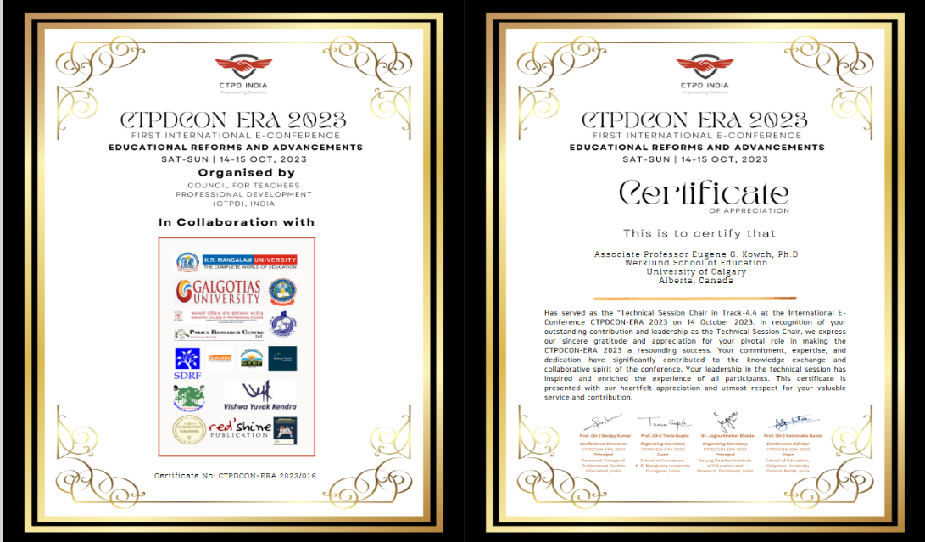

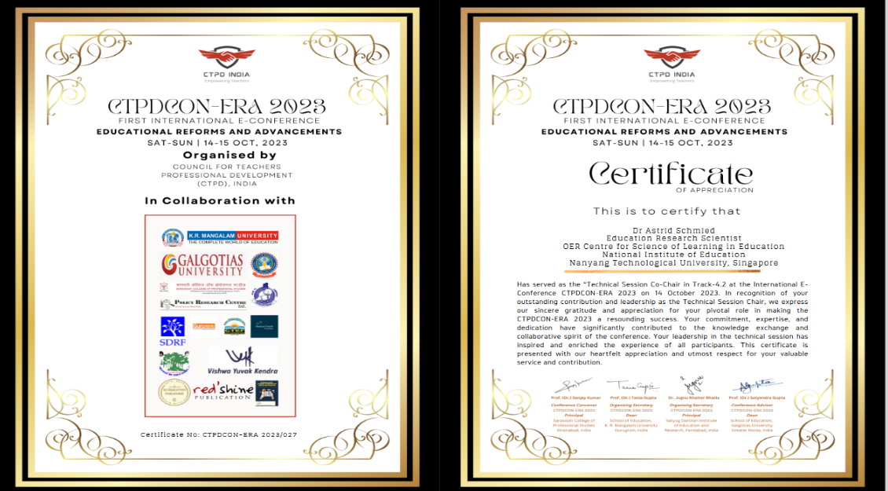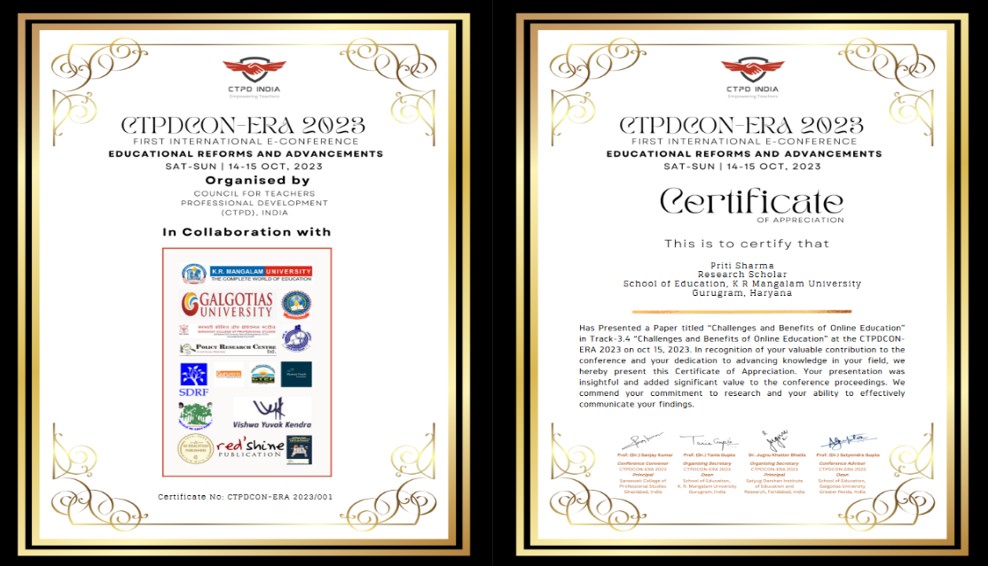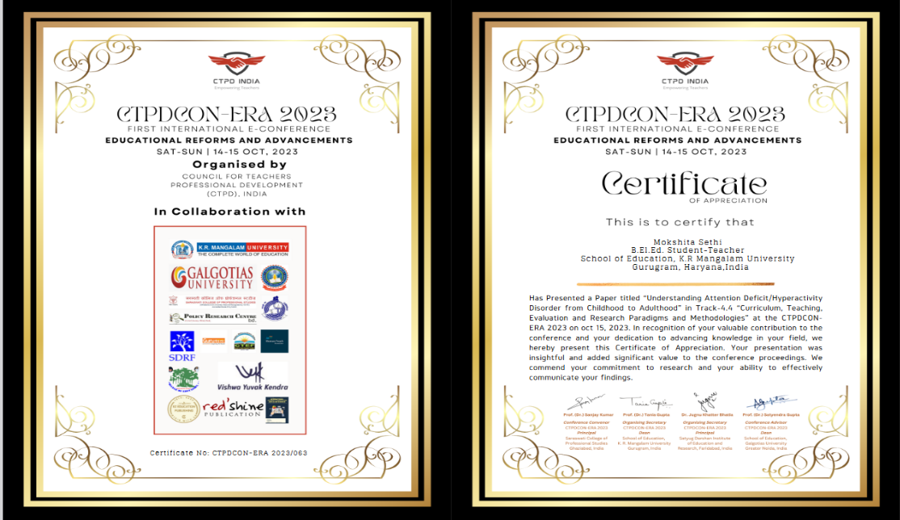
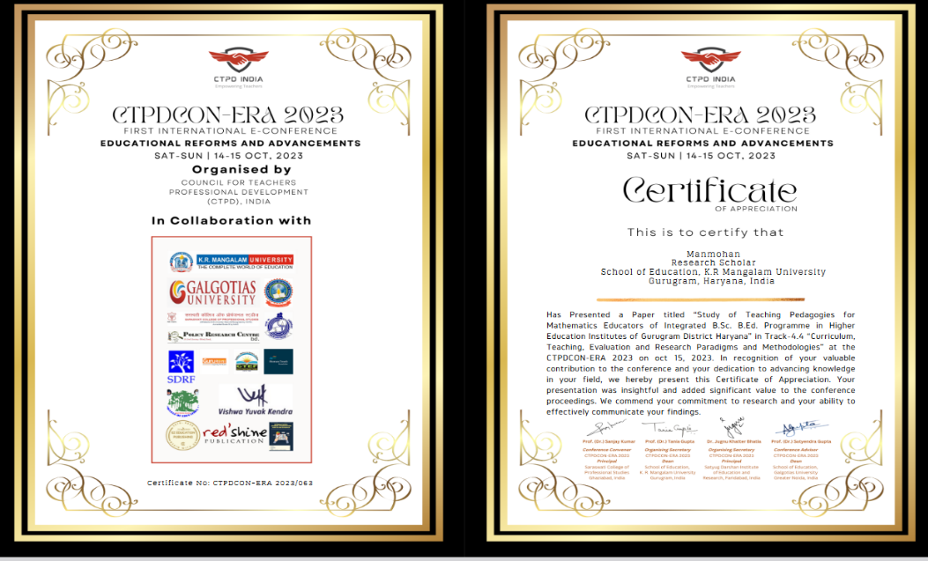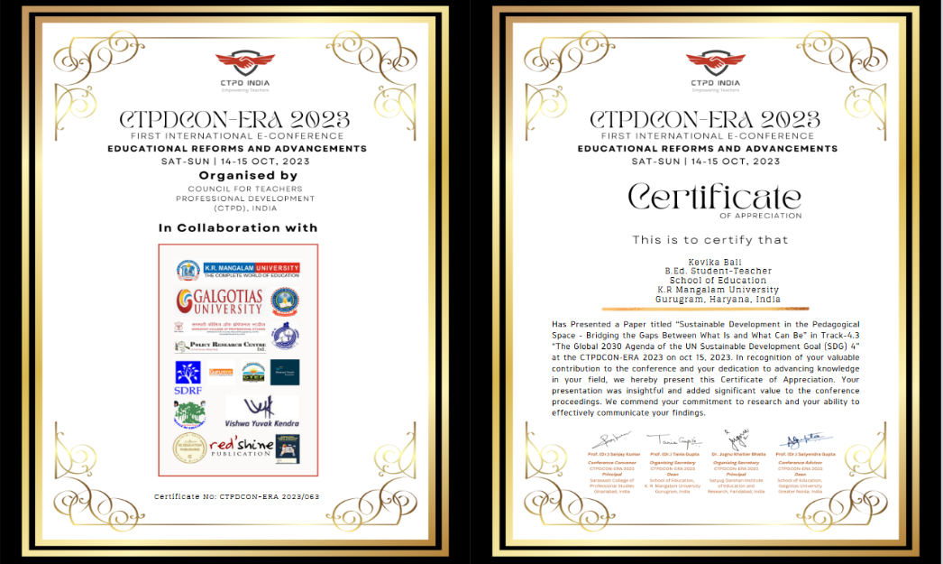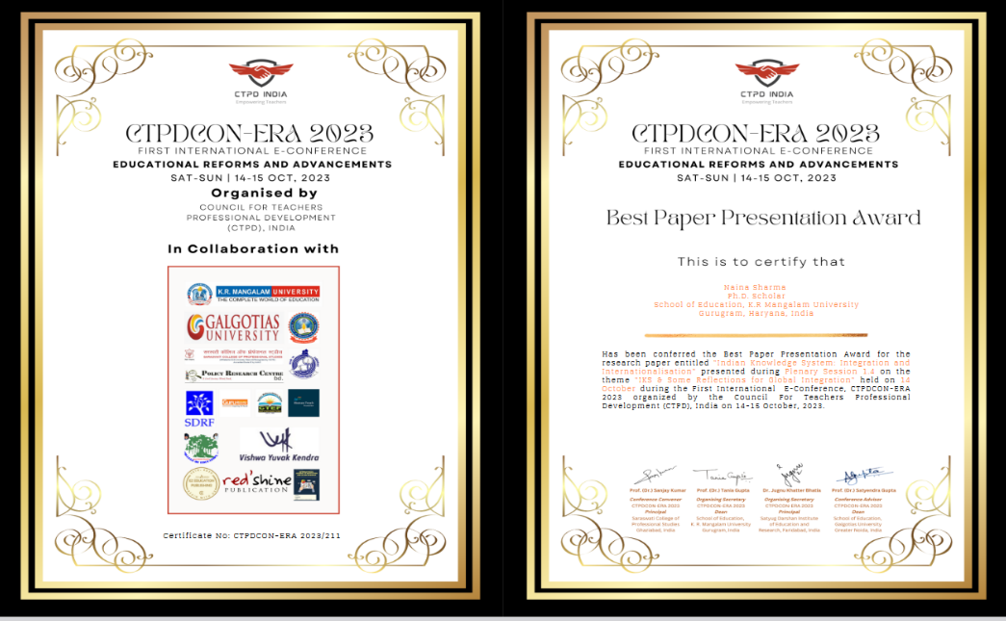

ANNEXURE – VI
PHOTOGRAPHS

INAUGURAL SESSION
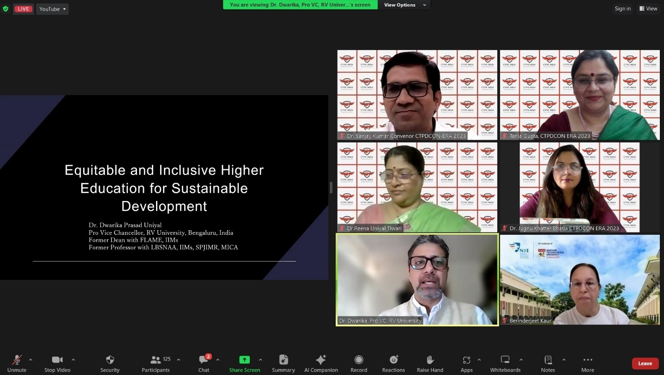
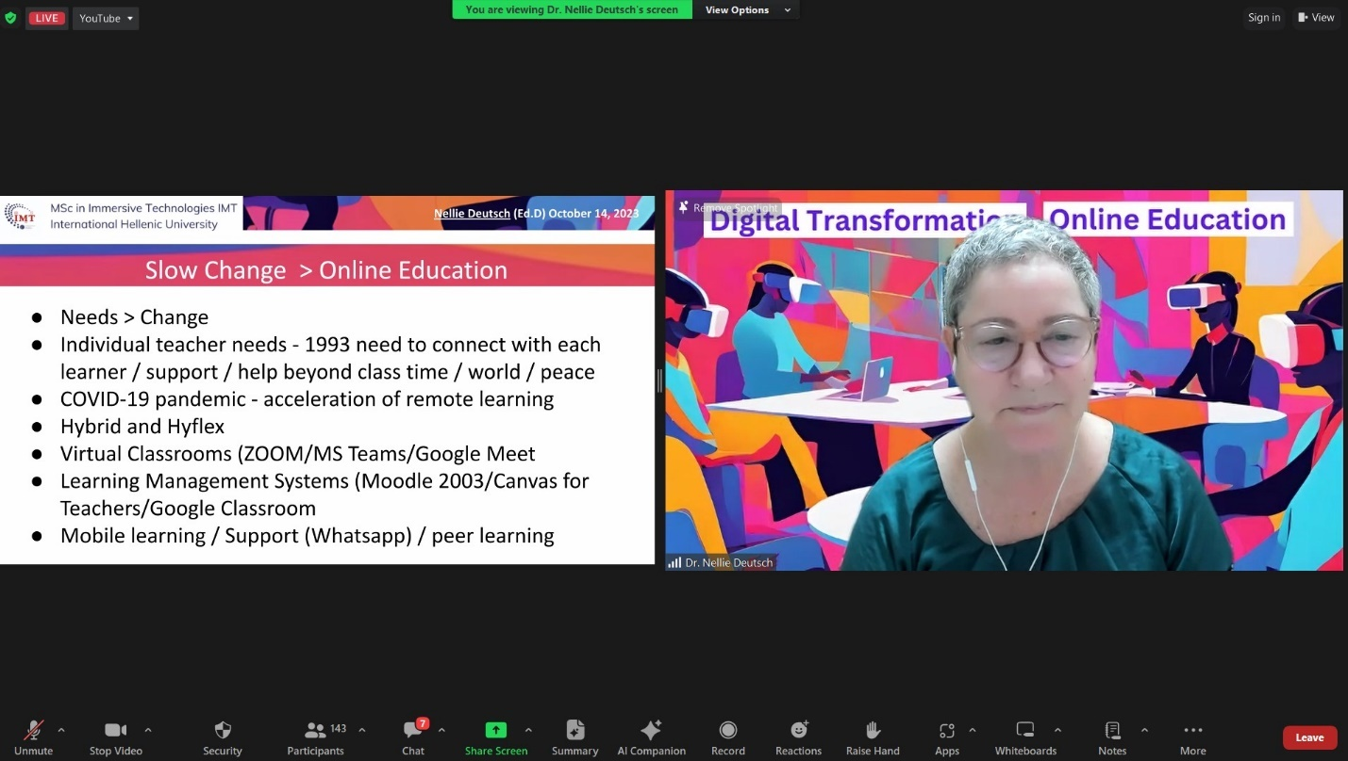

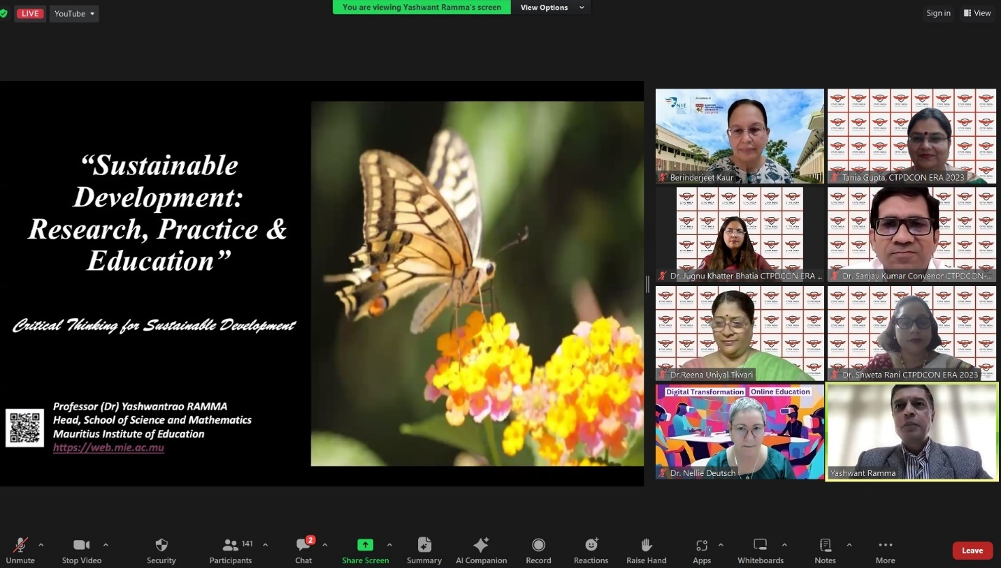
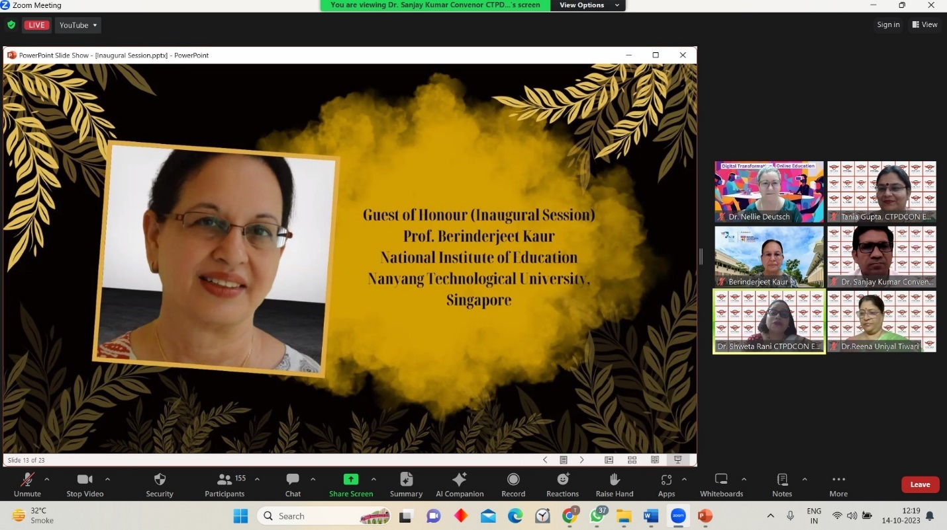

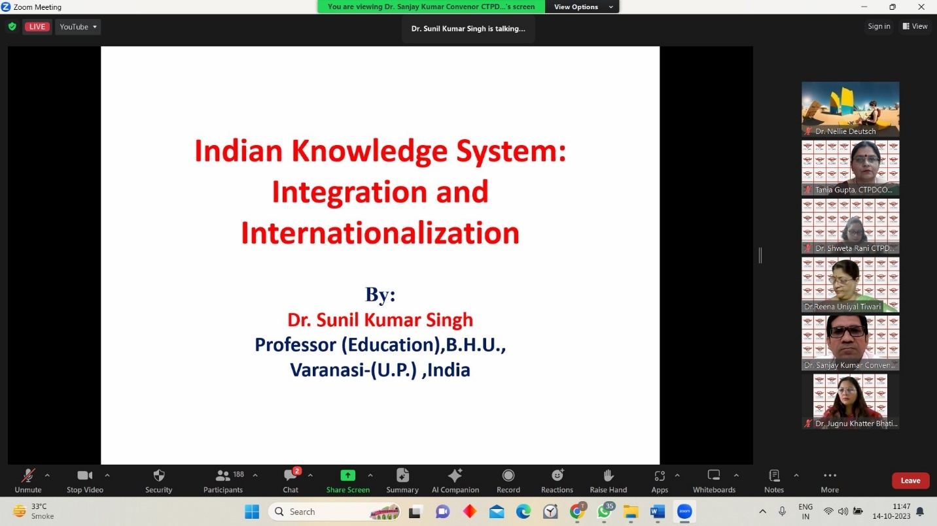
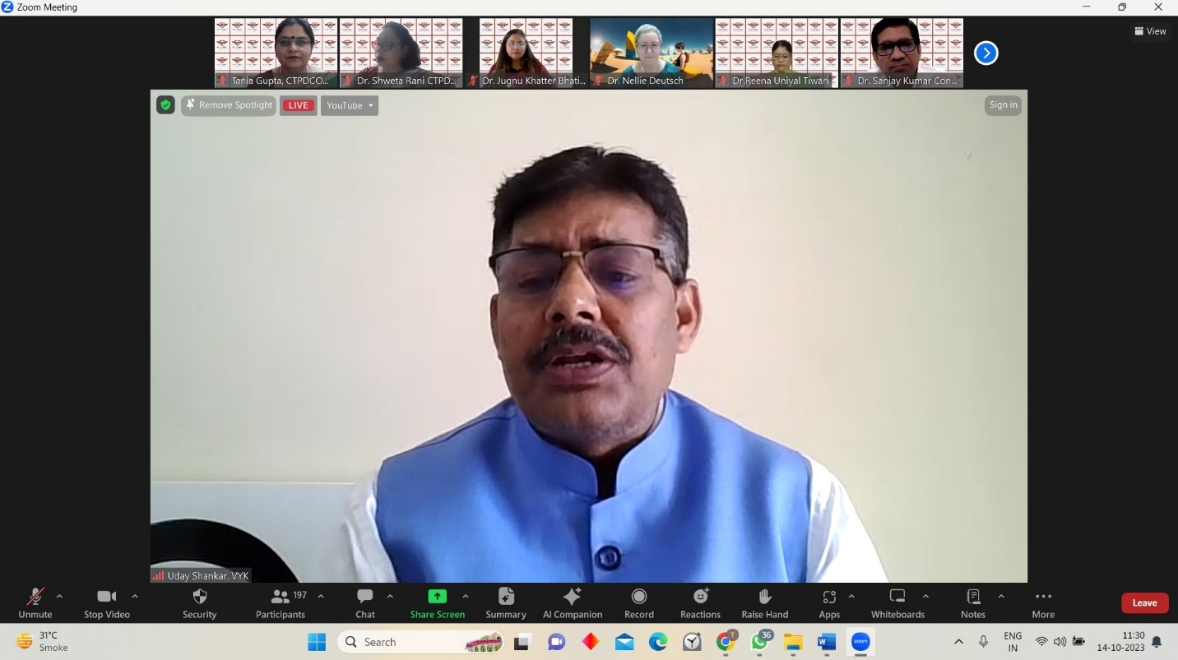
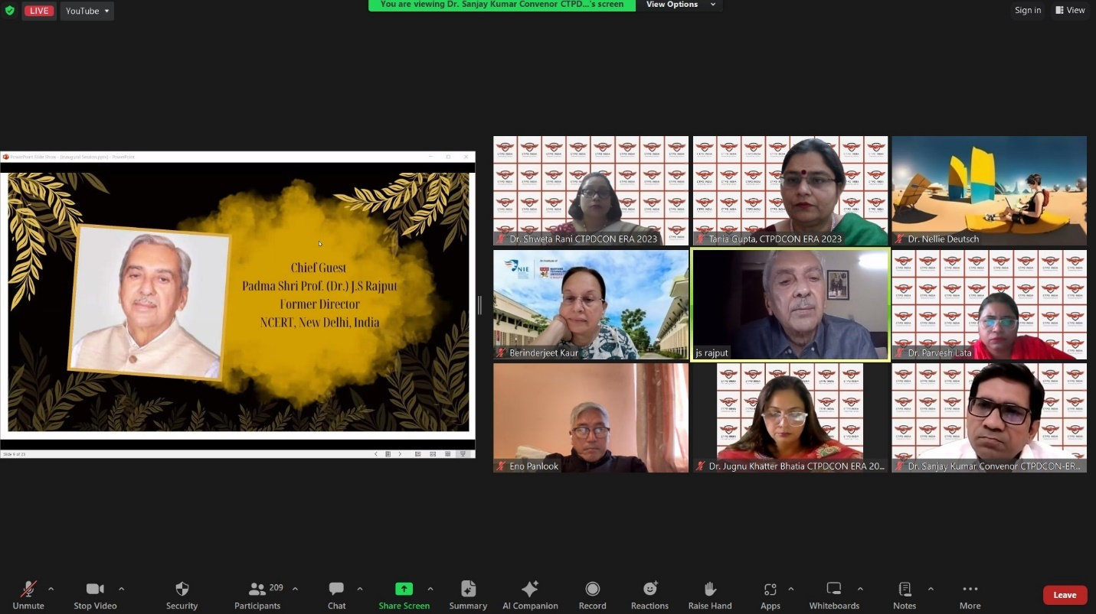
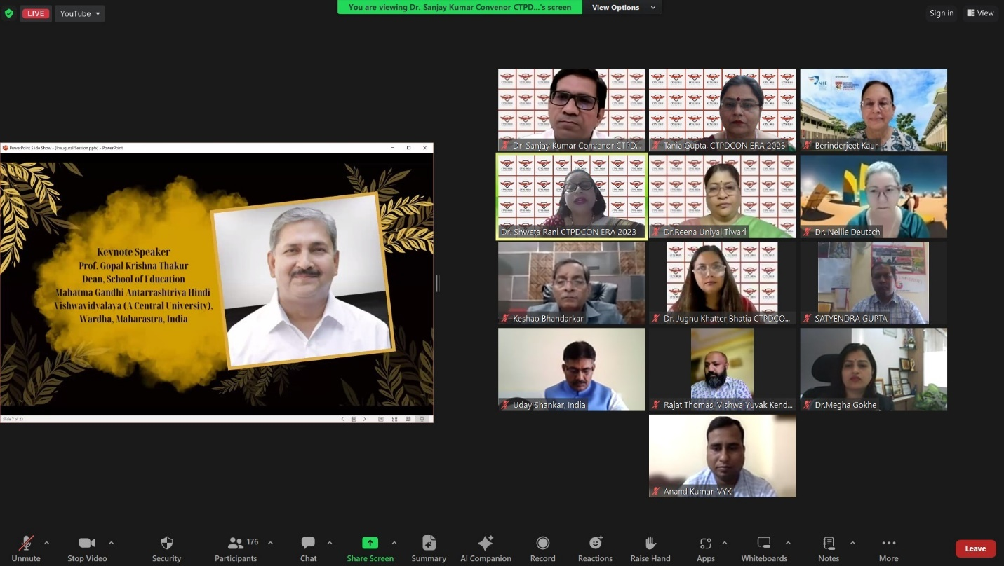

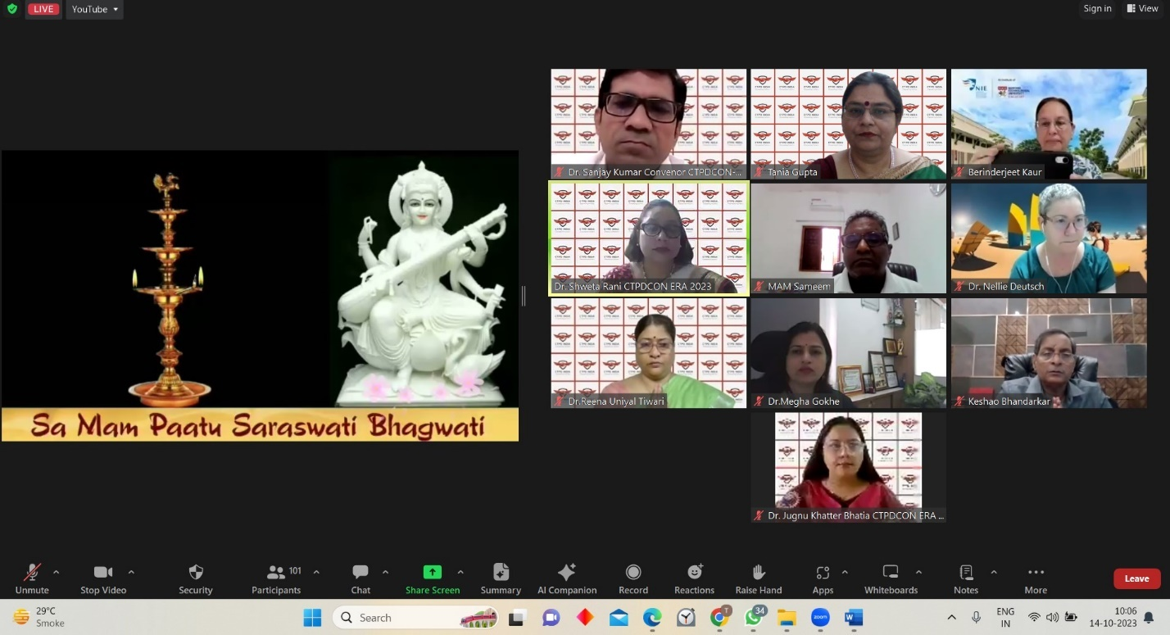
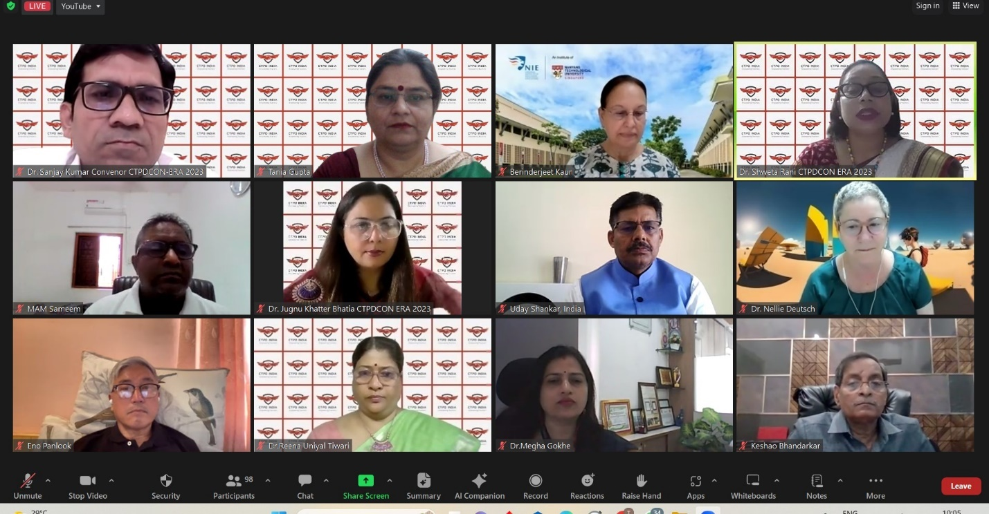

TRACK 1
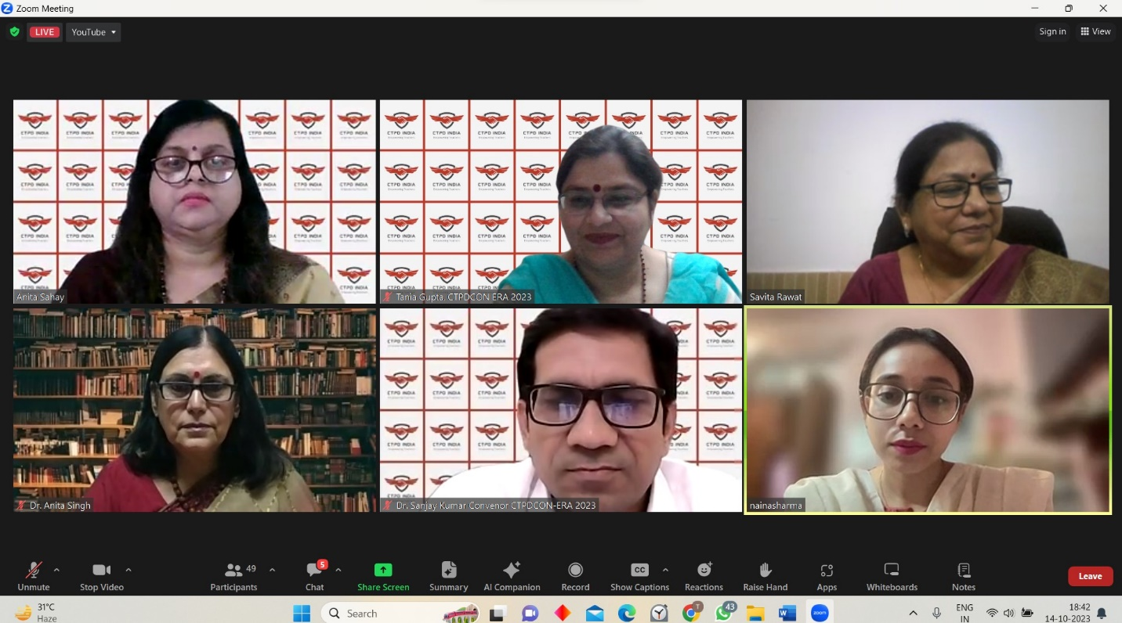
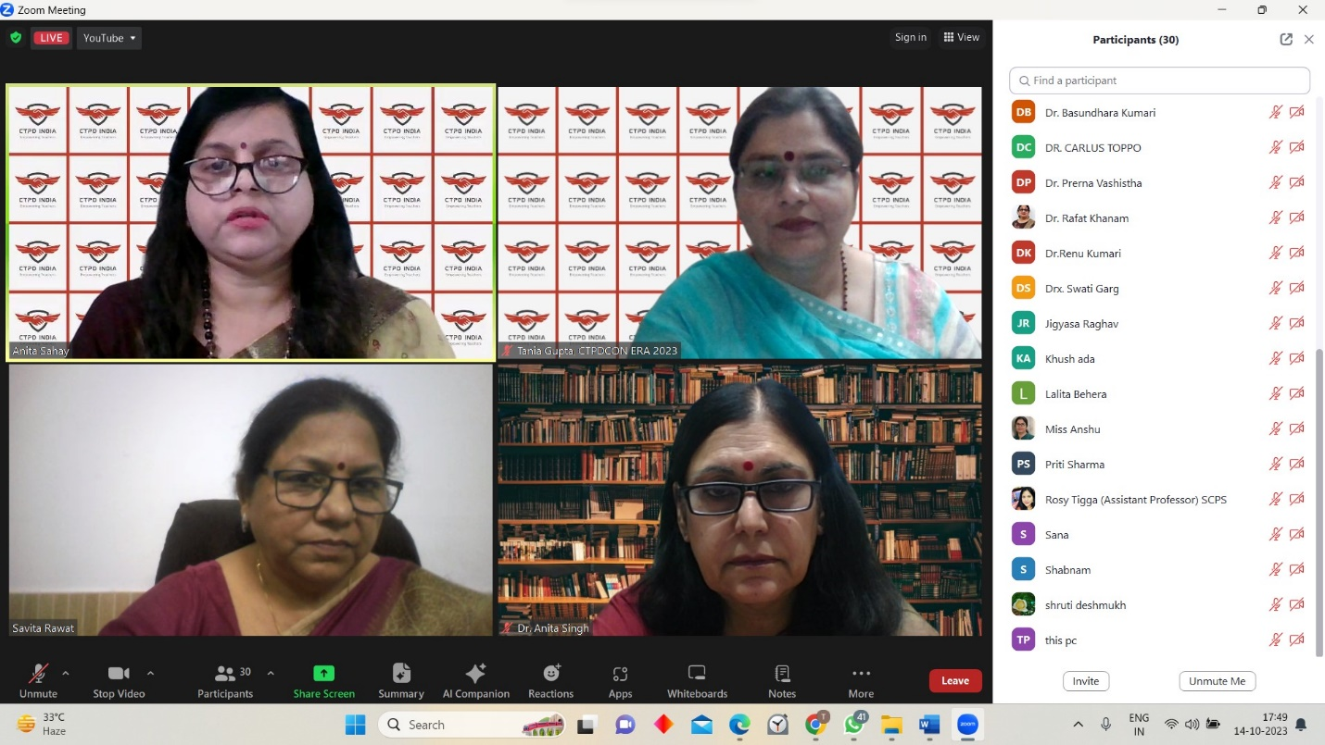
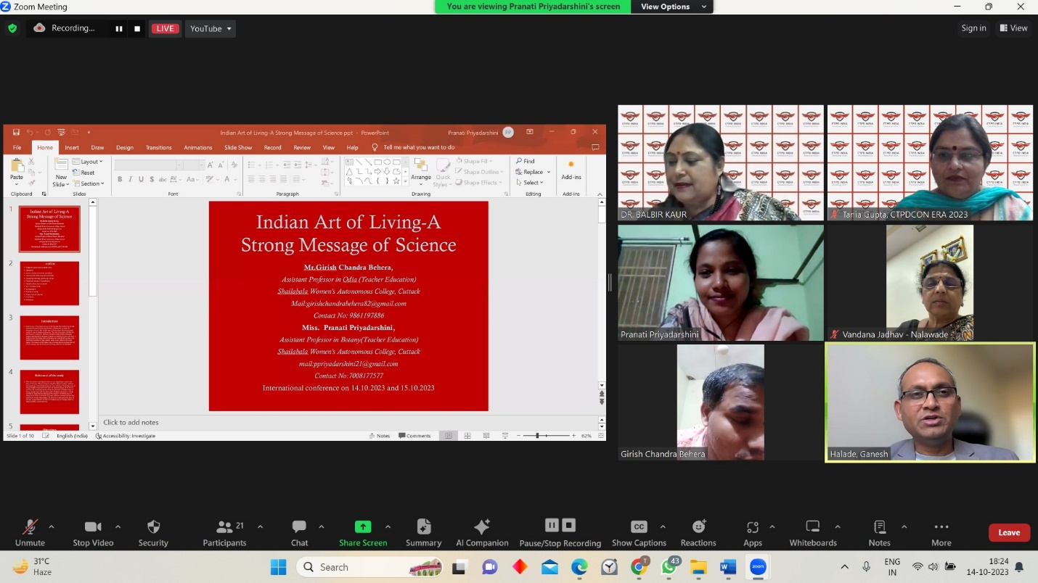
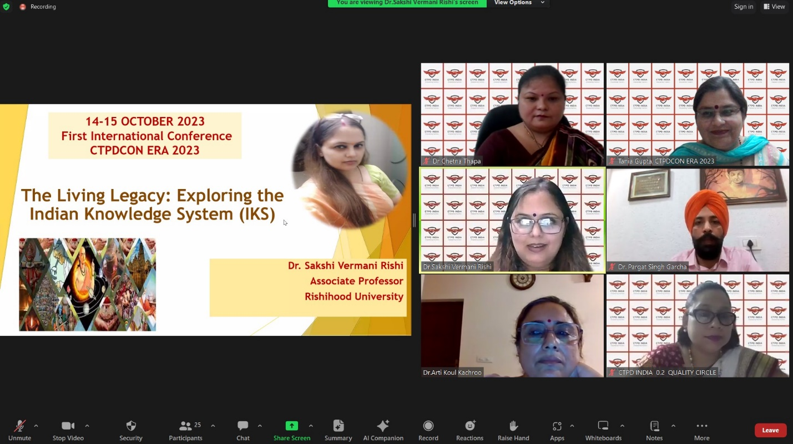
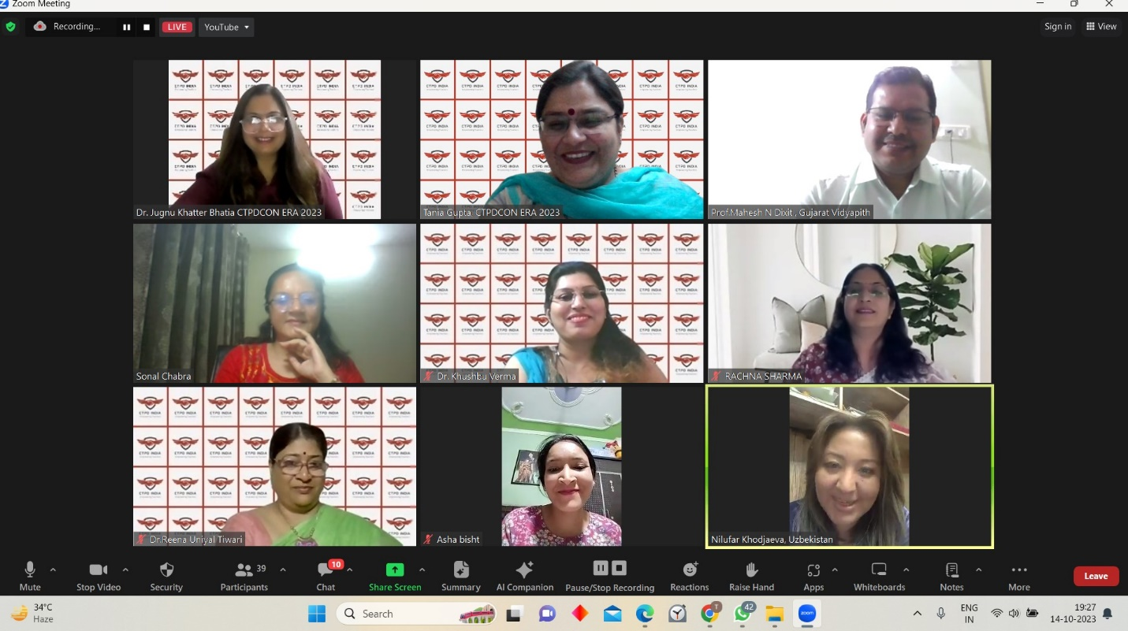
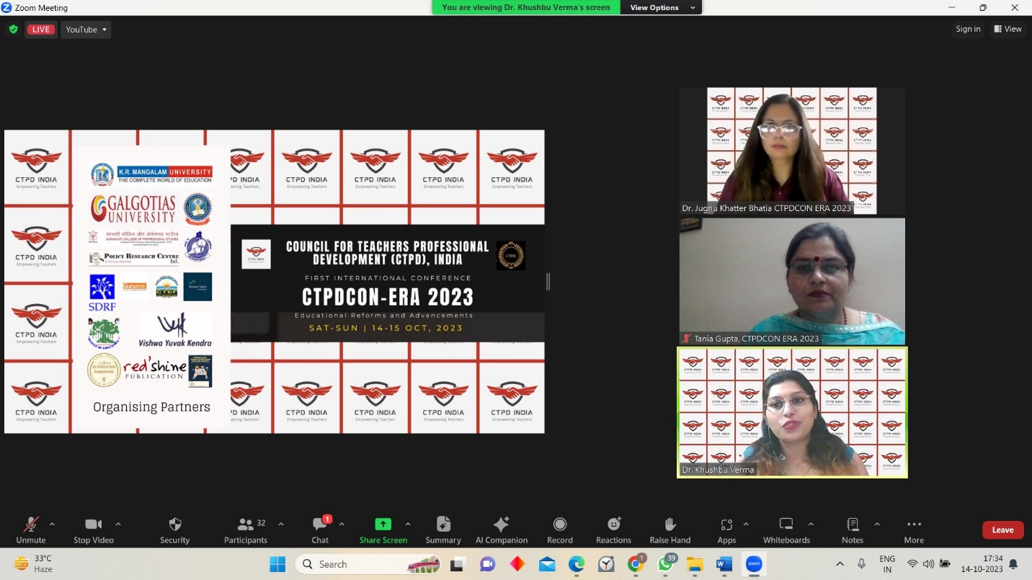

TRACK 2
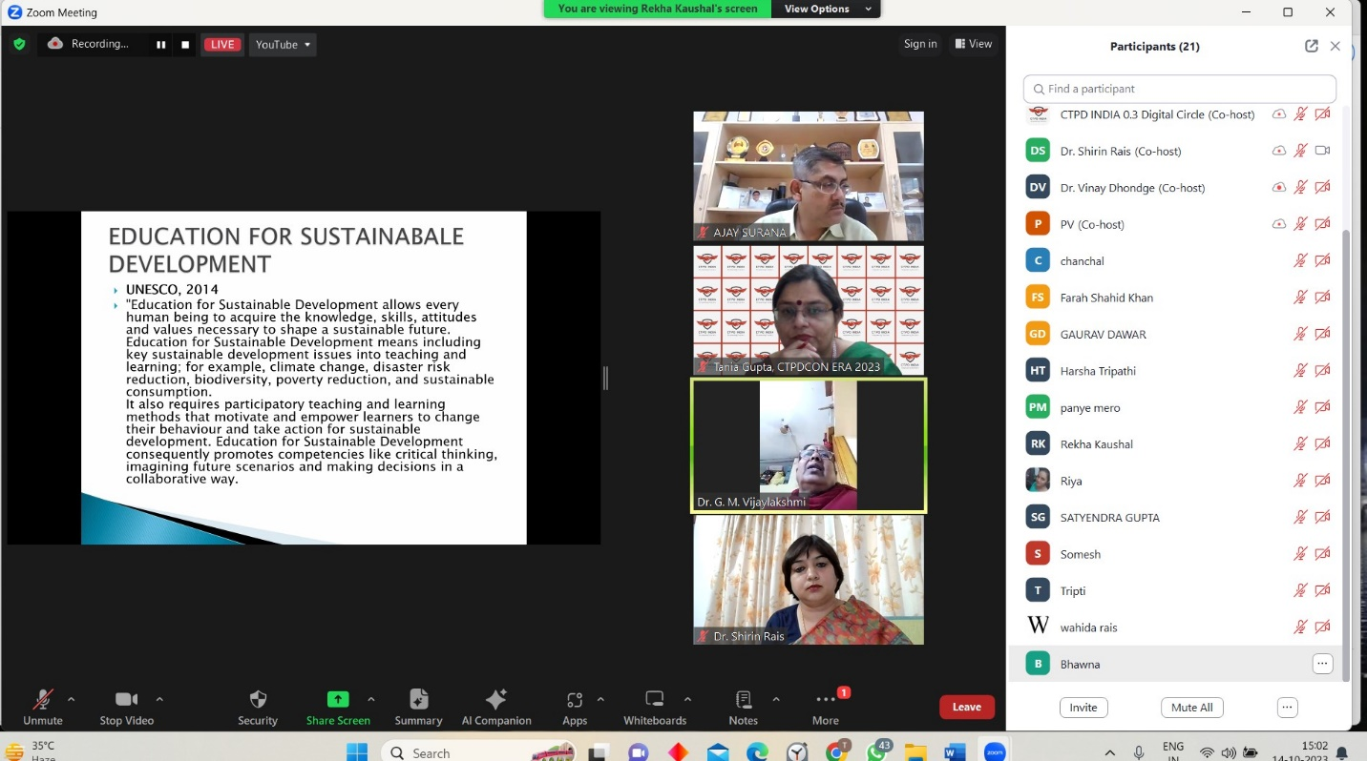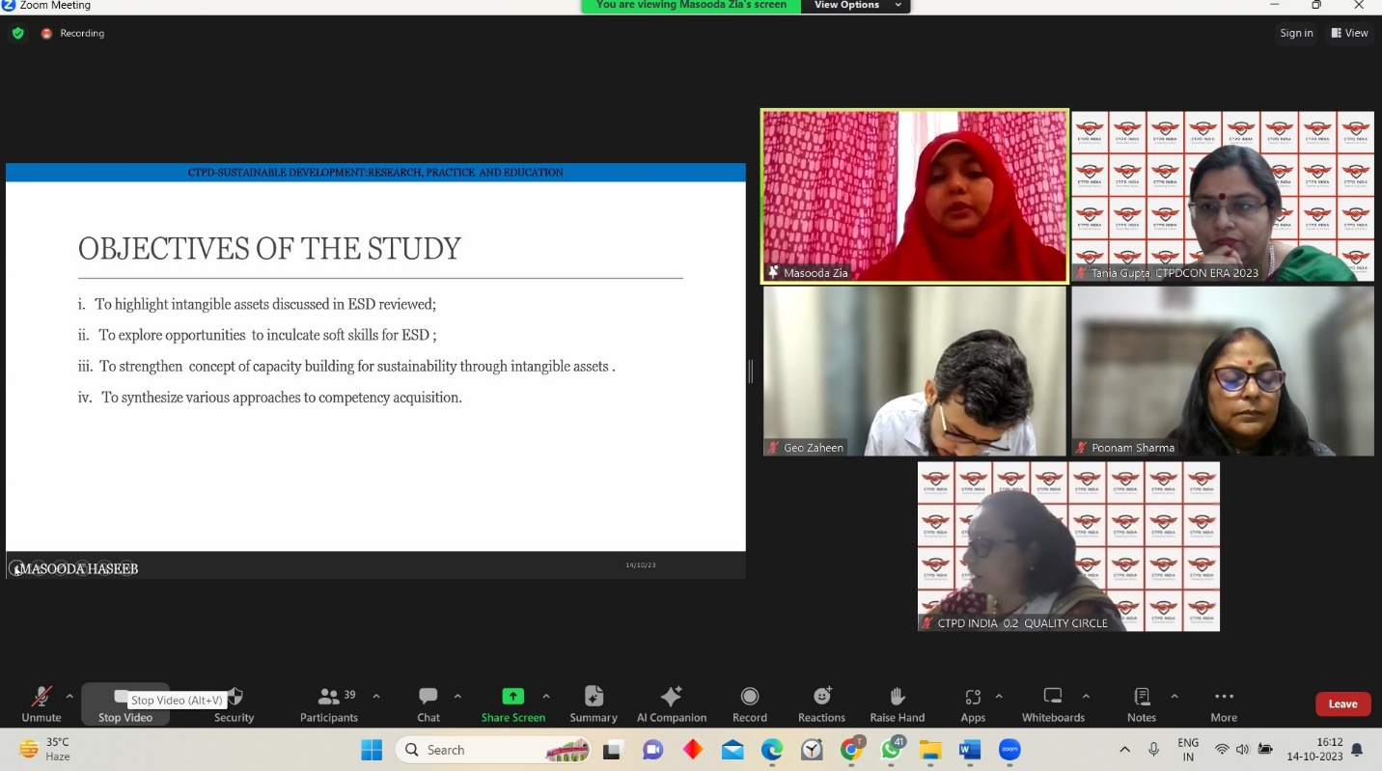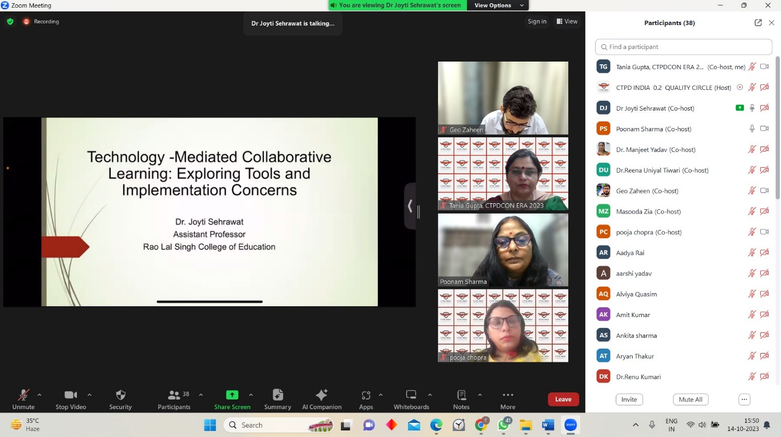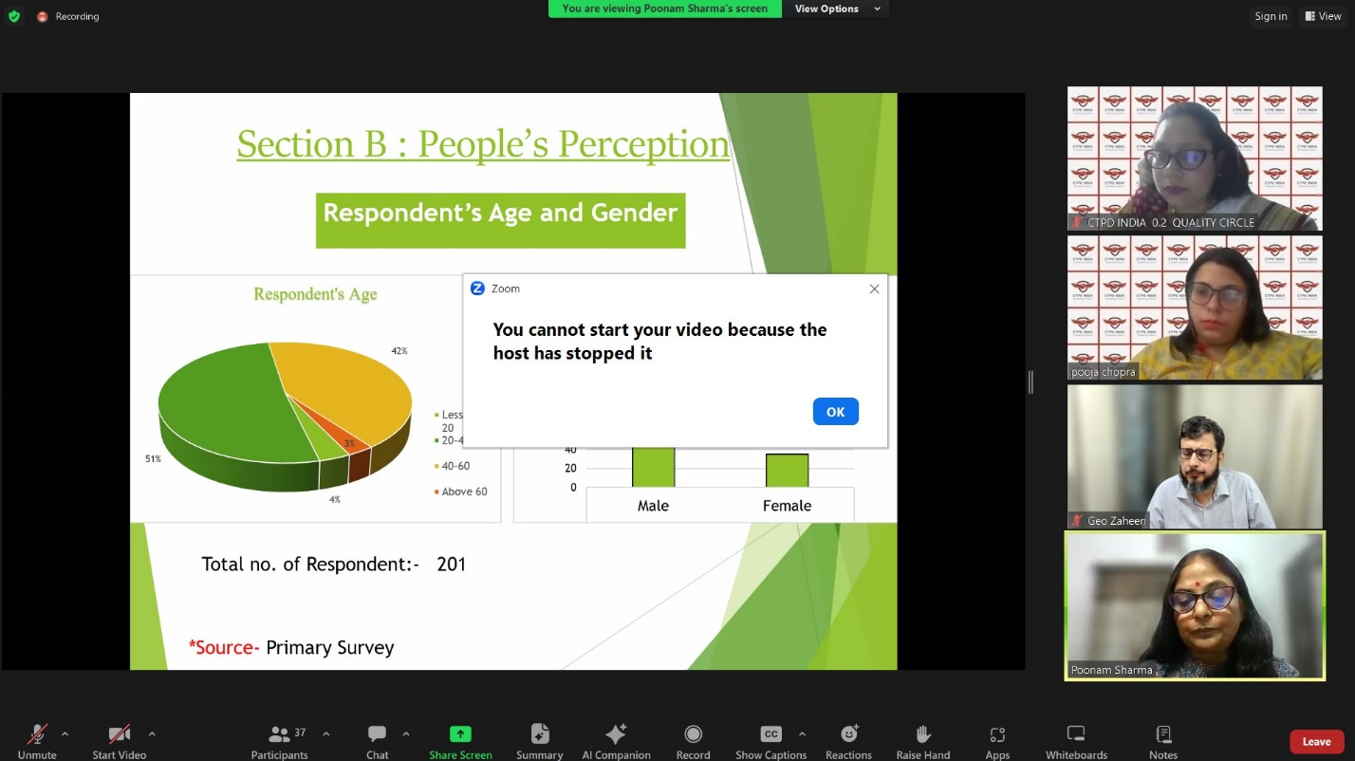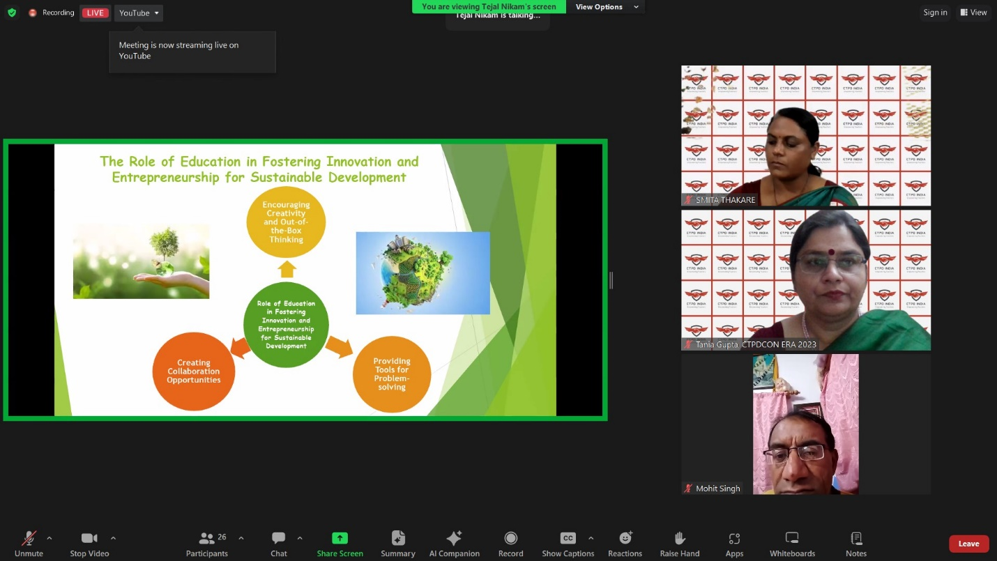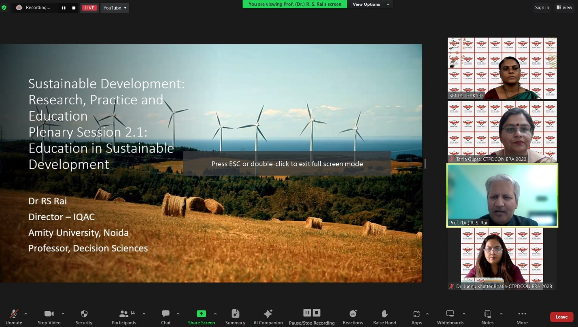

TRACK 3
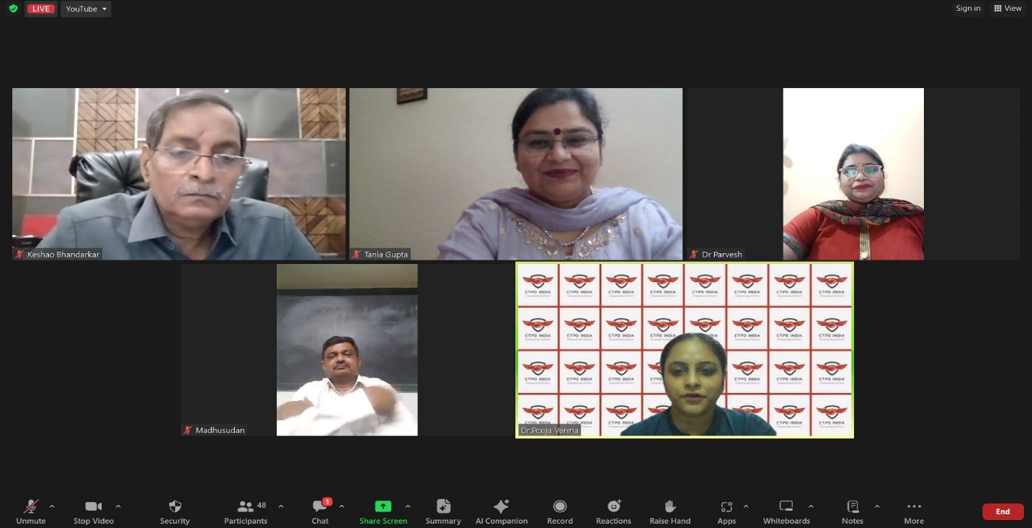
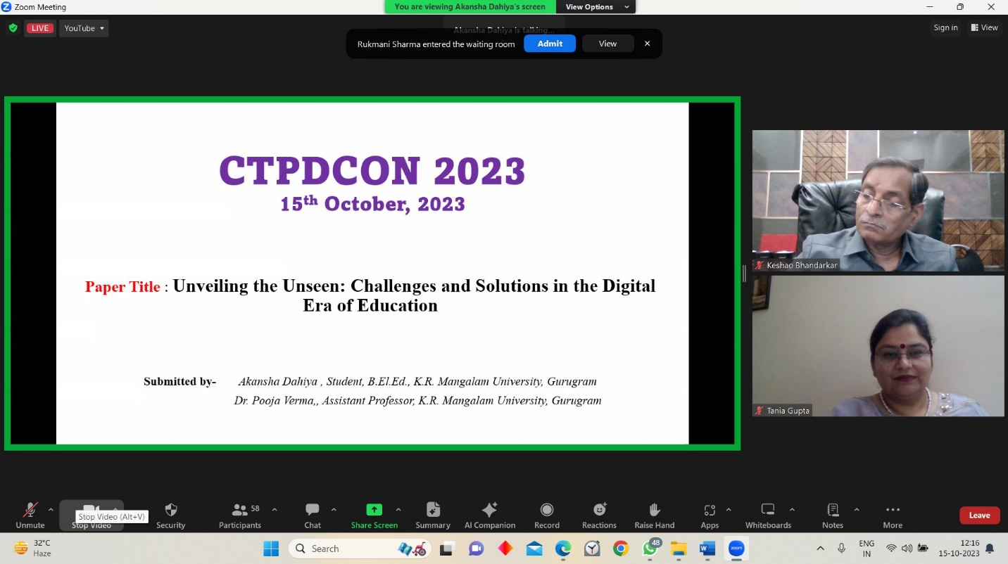
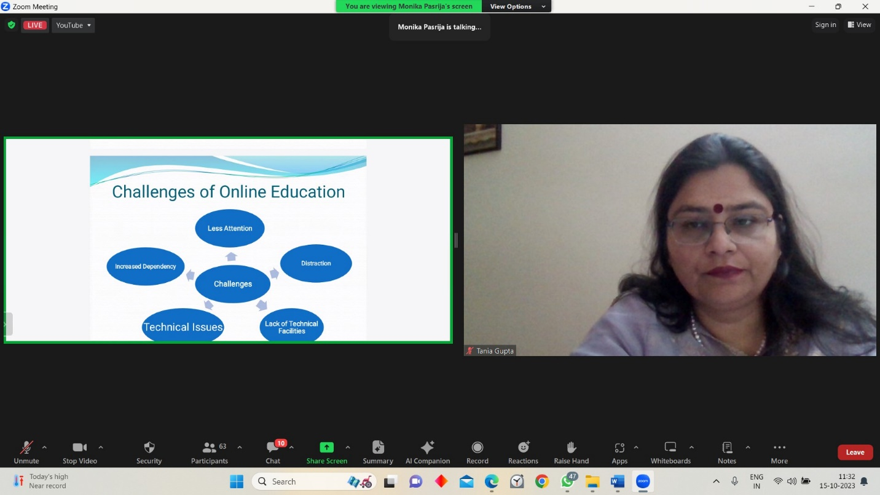

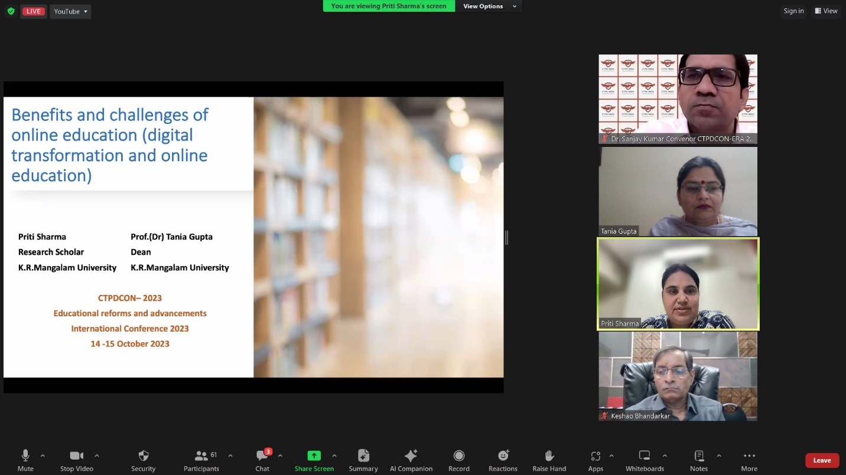

TRACK 4

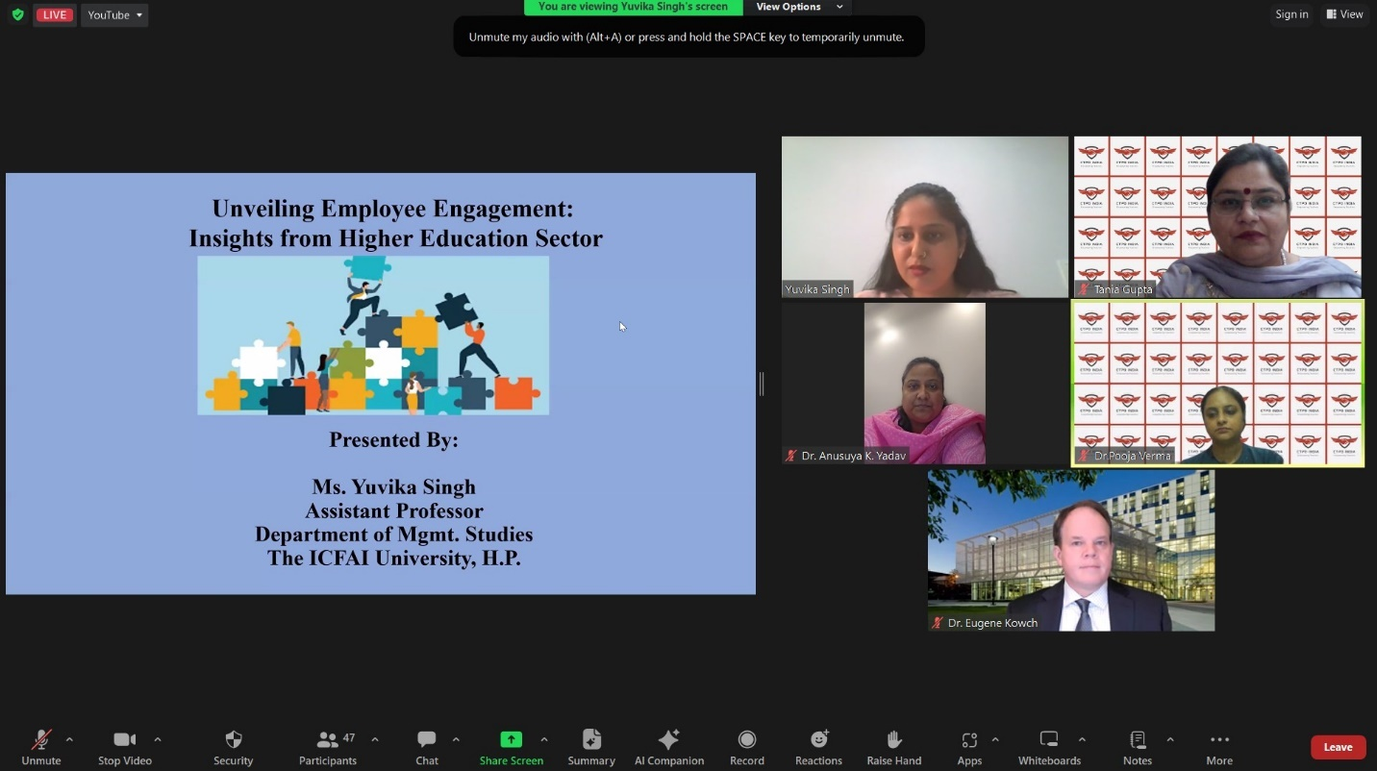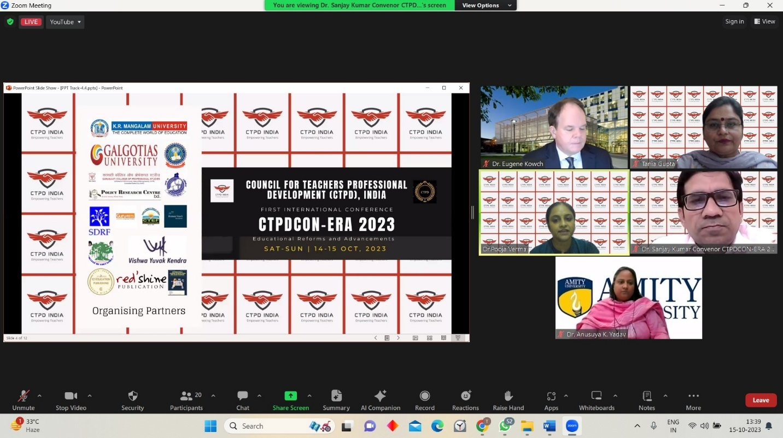
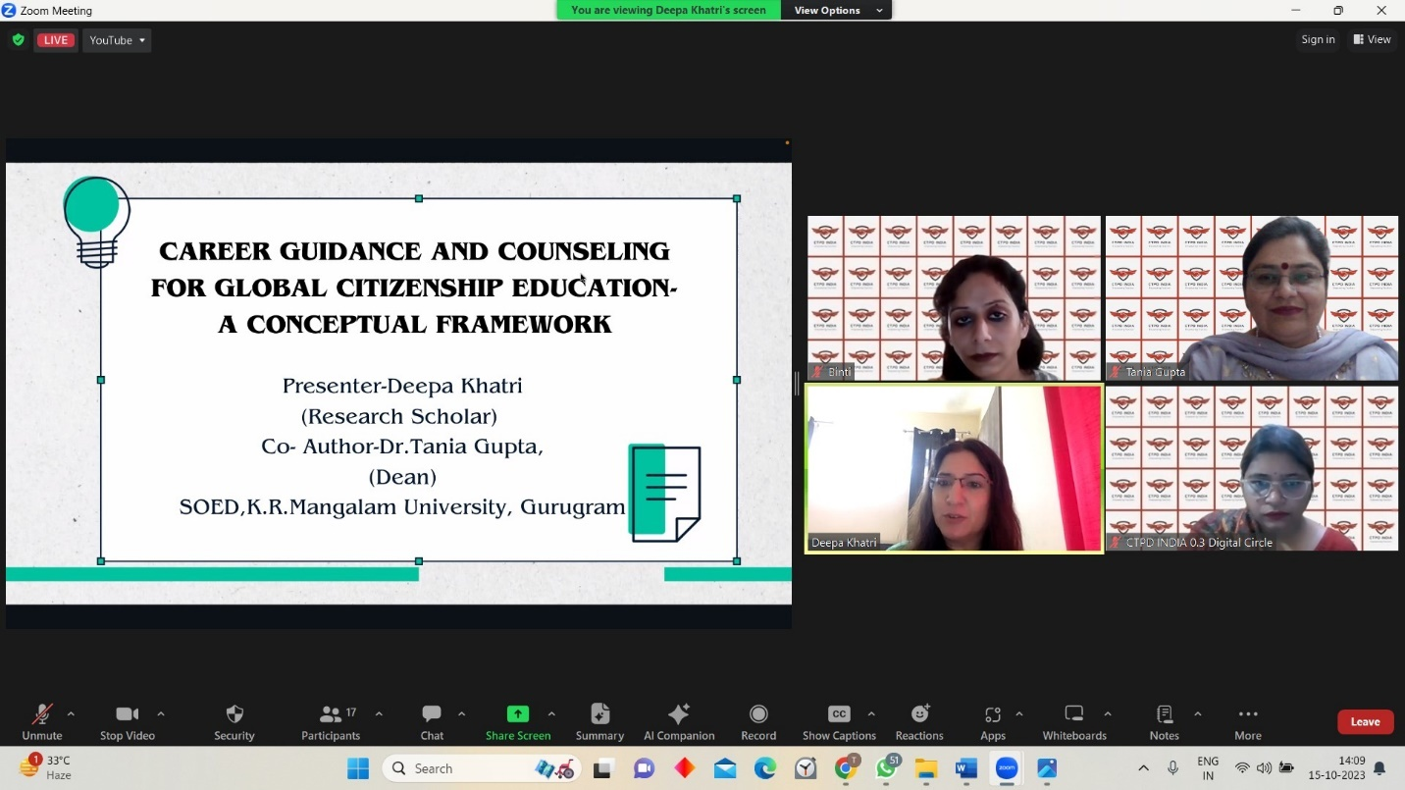

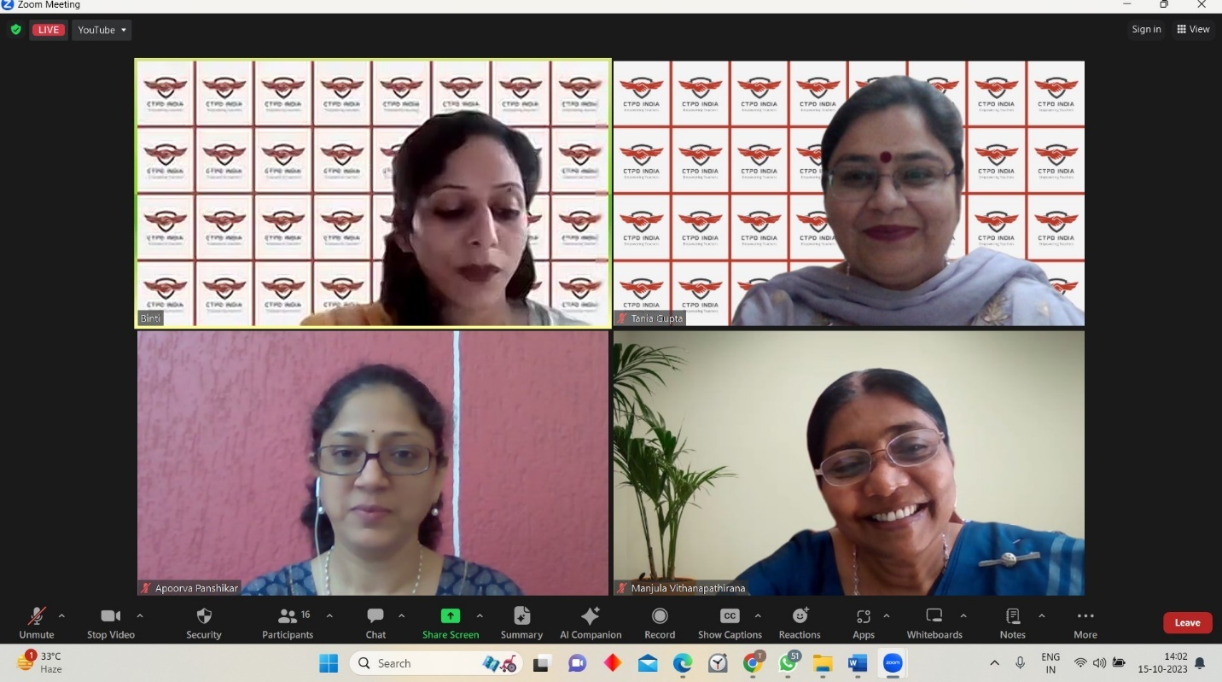
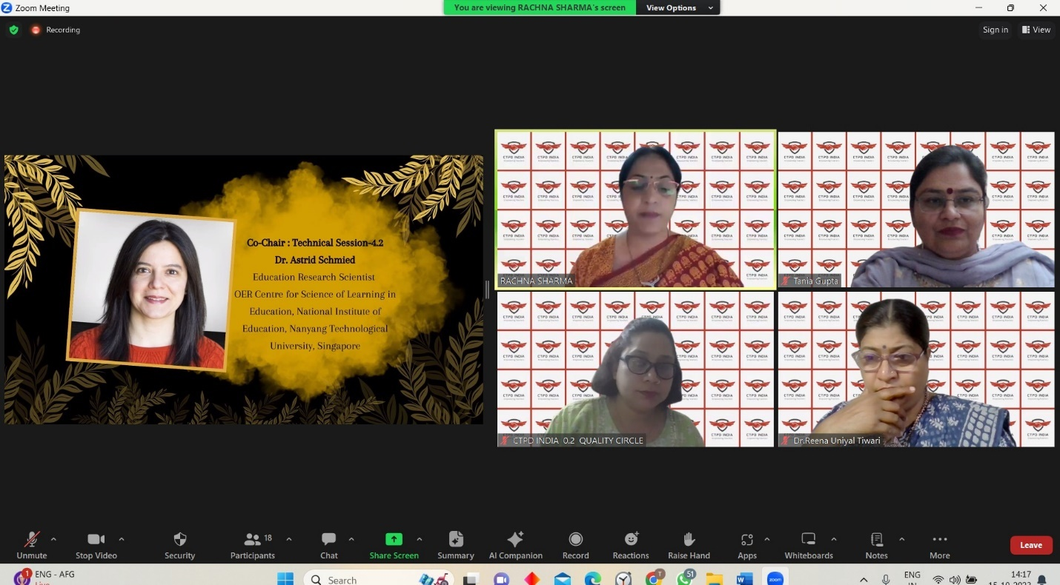

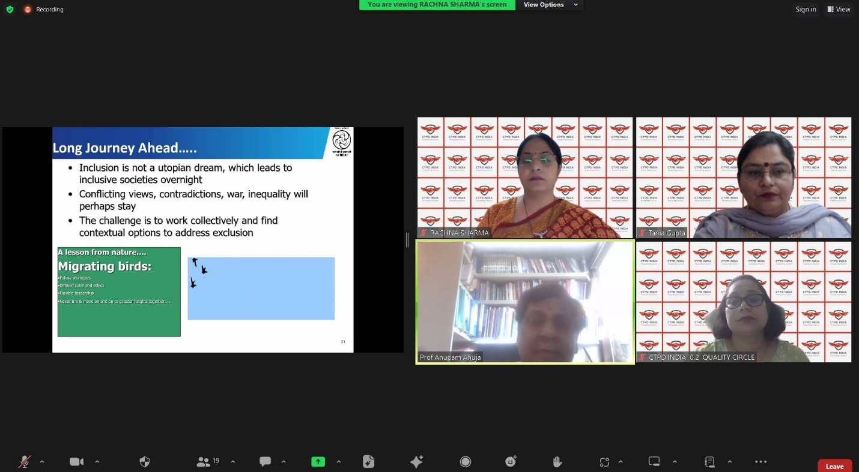

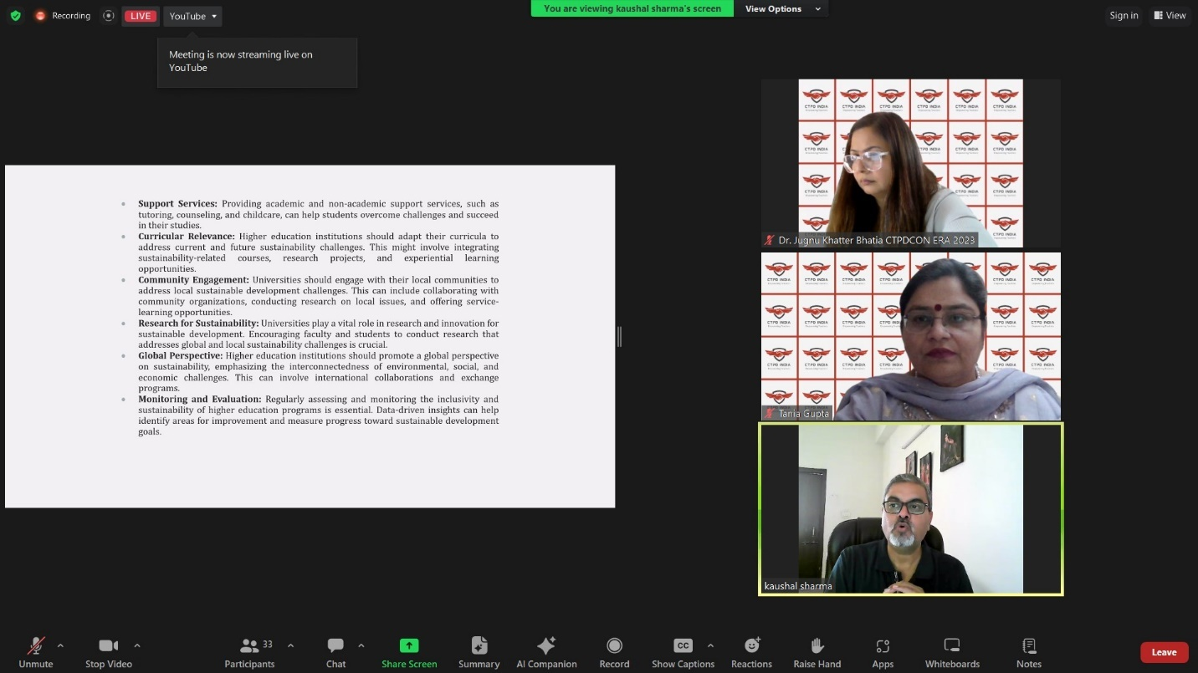

VALEDICTORY SESSION

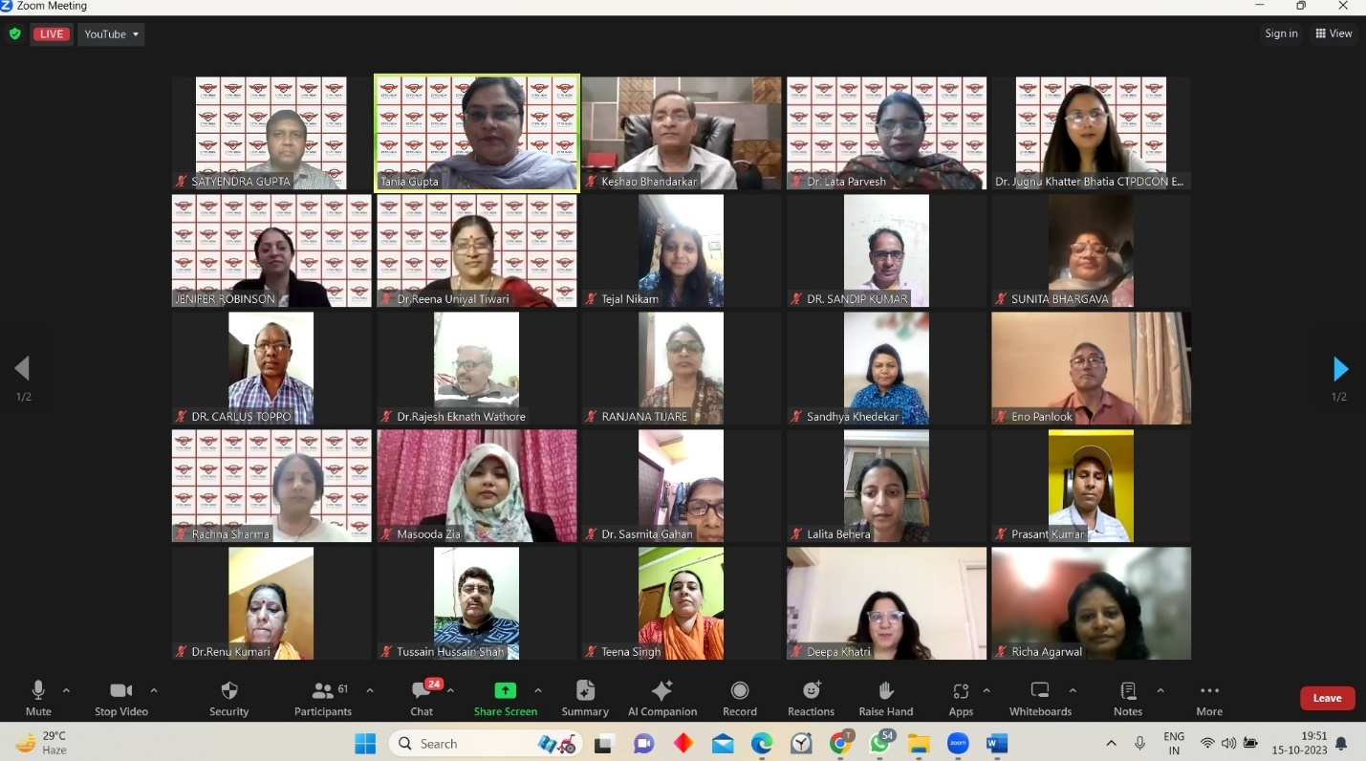
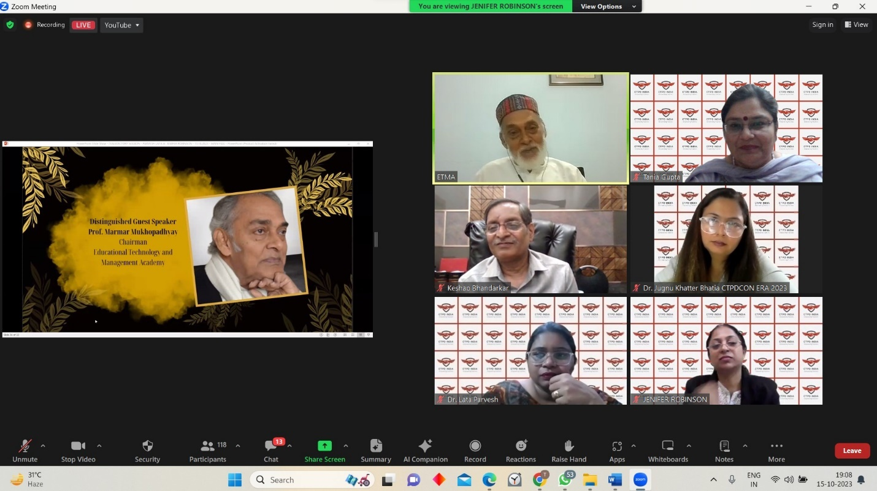
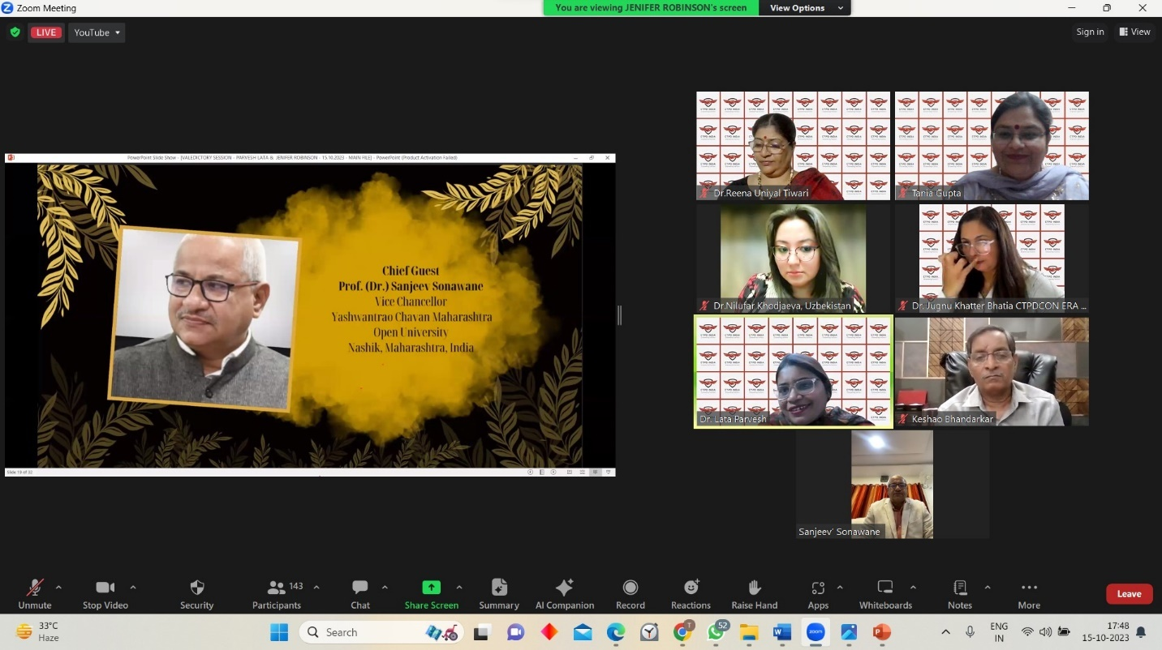

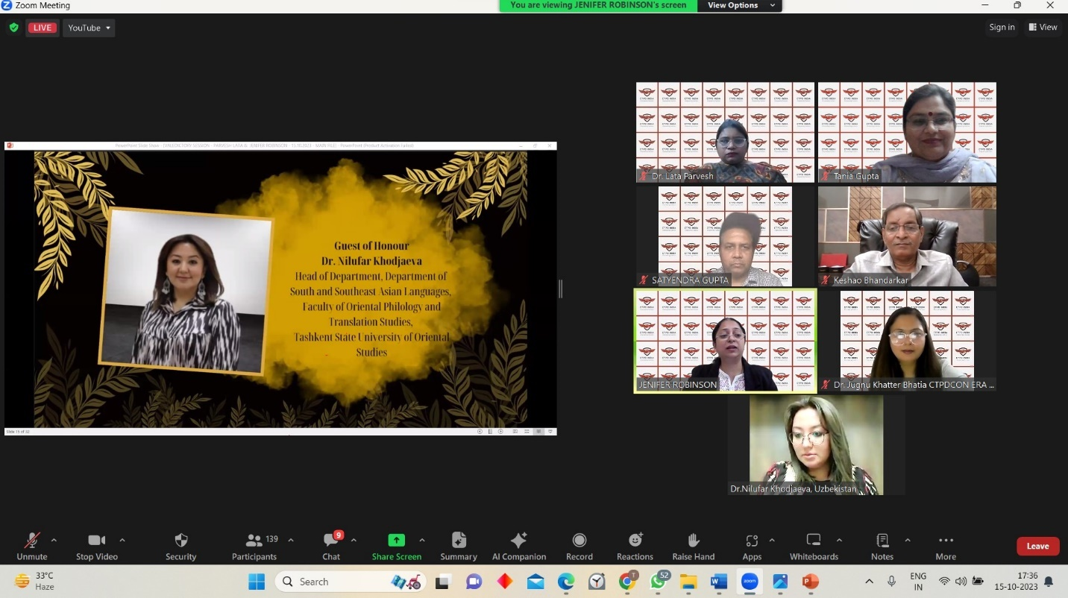

Report prepared by | Dr. Pooja Verma
Report verified by Event Coordinator | Prof. (Dr.) Tania Gupta  Dr. Pooja Verma
Report Seen by Dean SOED | Prof. (Dr.) Tania Gupta
Report Seen by IQAC Coordinator | Dr. Shikha Dutt Sharma

