Report on
A Seminar on “Professional Ethics for Teachers.”

Date and Day: April 24, 2025 and Thursday

Venue: Aryabhatta Block - 210, K. R. Mangalam University.
Event Type: Seminar
Mode of Activity: Offline
Target Group: Faculty of School of Basic and Applied Sciences

Resource Person: Prof. (Dr.) Mehraj Uddin Mir, Motilal Nehru Chair, K. R. Mangalam University

Coordinators: Dr. Ritika Khatri & Ms. Saloni Arora

Organized by: School of Basic and Applied Sciences

Number of Participants: 20

School of Basic and Applied Sciences (SBAS), K. R. Mangalam University, organized a Seminar on “Professional Ethics for Teachers” on April 24, 2025 ,Prof. (Dr.) Mehraj Uddin Mir, Motilal Nehru Chair, K. R. Mangalam University (KRMU) was the resource person. In this Seminar, 20 faculties along with few students were present. The main objective of the program was to raise awareness about professional and behavioral ethics among the faculty.
The event was started by Ms. Saloni Arora, Assistant Professor (SBAS), coordinator of the event, by giving a brief introduction about the speaker. Further, the speaker took over the session and started off by diving right into the topic ‘A faculties’ perspective on personal and professional ethics. He emphasized that professional ethics are an extension of personal ethics. He also mentioned that ethics change from time to time and from situation to situation depending on the frame of reference. Something that is ethical in one industry might absolutely be unethical in the other industry, he added.
Further, speaker extended their talk on research ethics which involves the application of fundamental ethical principles to research activities which include the design and implementation of research, respect towards society and others, the use of resources and research outputs, scientific misconduct and the regulation of research.

The event was concluded by Dr. Ritika Khatri with vote of thanks to the speaker and the audience. The session was very interesting and helpful for the faculties. In the end in a gesture to express our deepest gratitude to Prof. Mir, a memento in the form of a gift was presented to him by Prof. (Dr.) Meena Bhandari, Dean SBAS and Prof. (Dr.) Tania Gupta, Dean School of Education (SOED).

Outcome: The seminar helped faculties to clearly distinguish between personal and professional ethics. They also understand the role of professional codes of ethics, the difference between aspirational and disciplinary codes of ethics, and how professional codes may apply in their career. They learn to think critically about ethical issues, which are encountered firsthand within a career, and apply personal and professional ethics to vexing moral decisions within specific professions.

Conclusion: The seminar concluded with the traditional professional ethics literature, focusing on codes, conduct and rational decision-making in difficult cases. Consideration is then given to what might be the implications for learning shifting emphasis towards a more embedded conception of ethics in professional life, with a focus on the commitment and character of professional practitioners and the specificities of the contexts in which they work

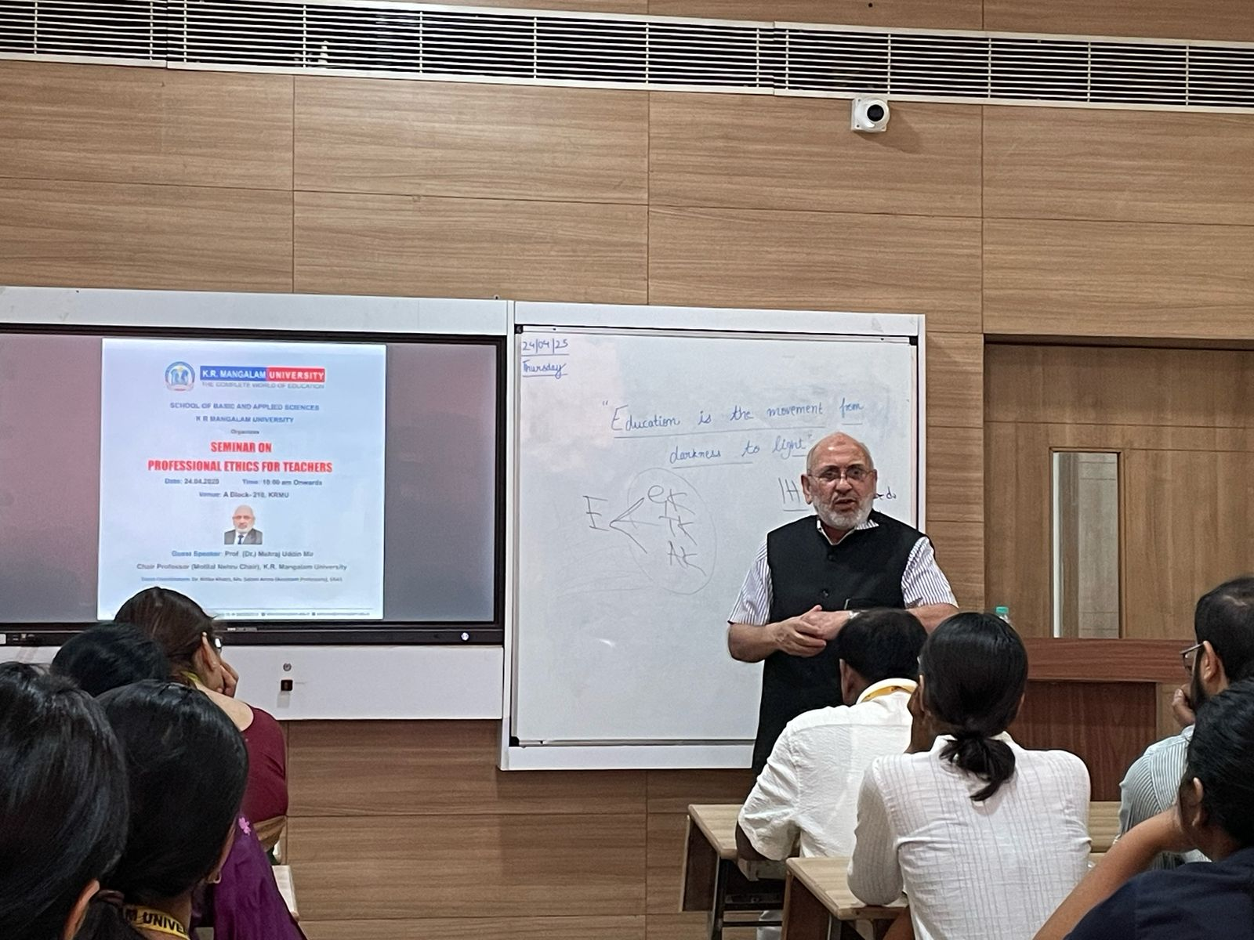
Prof. (Dr.) Mehraj Uddin Mir, Motilal Nehru Chair, K. R. Mangalam University giving insights into "Professional Ethics for Teachers"

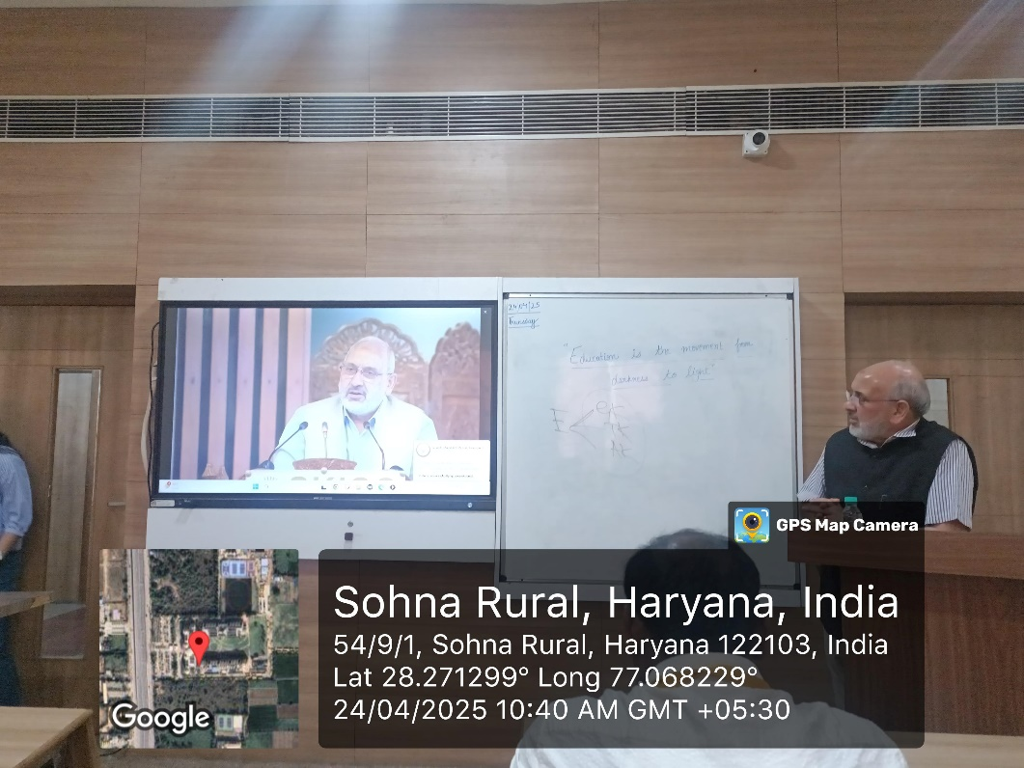

Resource Person Prof. (Dr.) Mehraj Uddin Mir, Motilal Nehru Chair, K. R. Mangalam University sharing his experience with the teachers

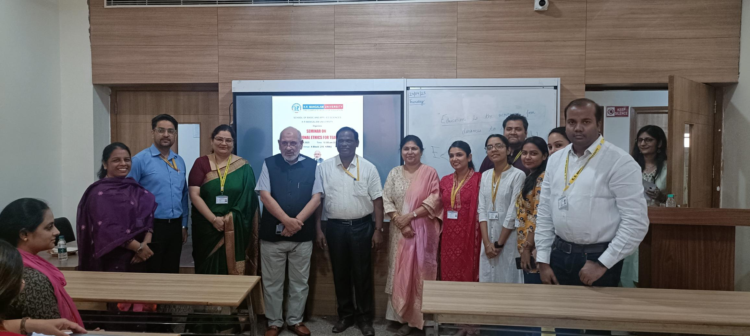

Resource person Prof. (Dr.) Mehraj Uddin Mir, Motilal Nehru Chair, K. R. Mangalam University with Prof. (Dr) Meena Bhandari (Dean SBAS), Prof. (Dr.) Tania Gupta (Dean SOED) and faculty members

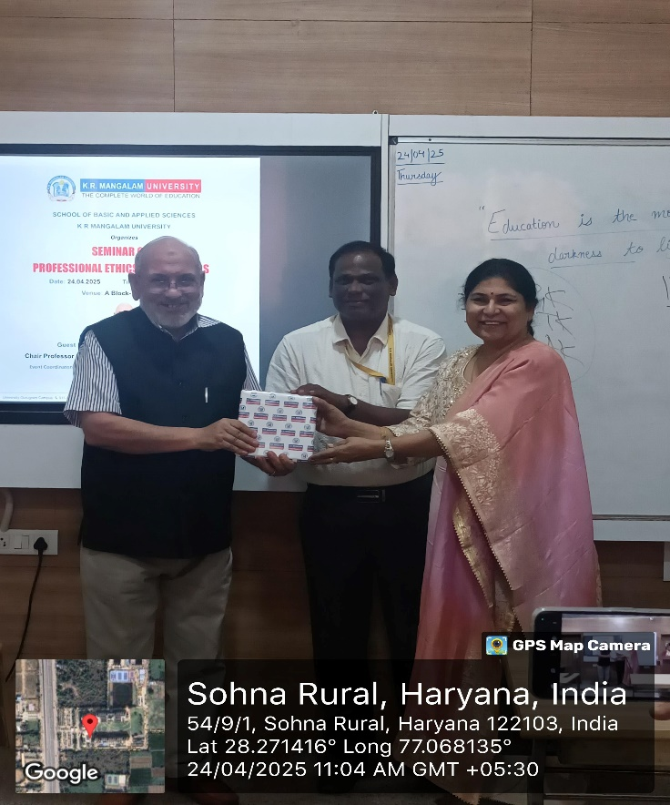
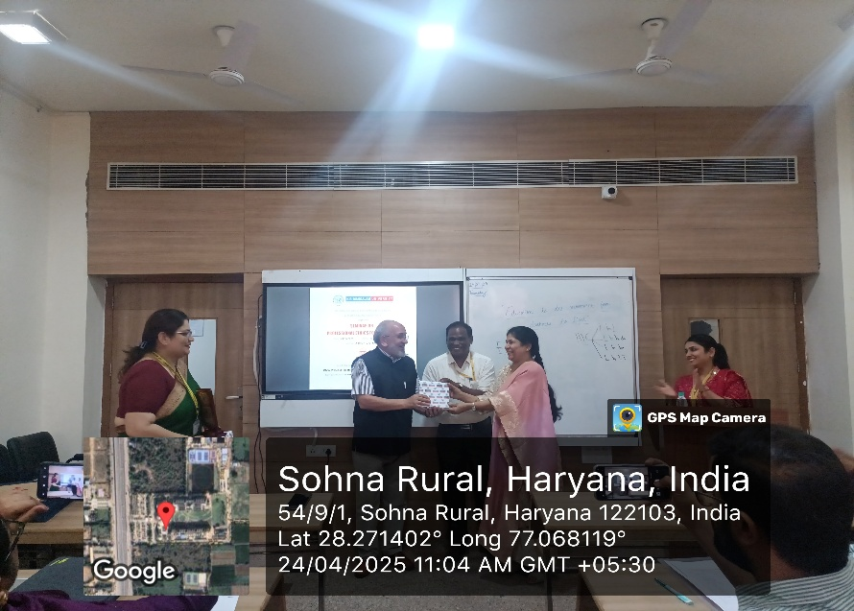
Prof. Meena Bhandari presenting a token of gratitude to our resource person Prof. (Dr.) Mehraj Uddin Mir, Motilal Nehru Chair, K. R. Mangalam University

Report prepared by | Dr. Ritika Khatri and Ms. Saloni Arora
Report Seen by Dean, SBAS | Dr. Meena Bhandari
Report verified by IQAC Coordinator | Dr. Shikha Dutt Sharma

