Seminar on ‘Mastering on Communication skills for Personal and Professional Growth’

Date: 22-04-2025
Venue: B007, K. R. Mangalam University
Event Type: Seminar
Mode of Activity: Offline
Target Group: Students of School of Basic and Applied Sciences
Organized by: School of Basic and Applied Sciences
Participants: Undergraduate students of SBAS
Resource Person: Dr. Tuhina Ray, Career Development Cell, K.R. Mangalam University
Event Coordinators:
- Faculty Coordinators: Dr. Saloni Rathee (Assistant Prof., SBAS), Dr. Kanchan Jangra (Assistant Prof., SBAS)
- Total Participants: 26

Introduction
The seminar titled 'Mastering on Communication Skills for Personal and Professional Growth' was organized to create awareness about the importance of effective communication in everyday life. The seminar aimed to provide students with insights into how strong communication skills can enhance their academic performance, improve interpersonal relationships, and prepare them for successful careers in various professional fields.
The expert lecture aligned with sustainable development goals (SDG) 4.

Objectives
- To help participants understand and improve both spoken and body language for more effective interaction.
- To develop students' ability to express themselves clearly and confidently in front of an audience.
- To teach the importance of listening as a key component of effective communication.
- To provide insights into workplace communication, including emails, presentations, and meetings.
- To encourage self-awareness and empathy by understanding the role of communication in building relationships.

Content
The seminar covered the following key topics:
- Core elements of communication, including clarity, tone, body language, and feedback.
- Common obstacles such as fear, language gaps, and misunderstandings, along with strategies to overcome them.
- Emphasis was placed on understanding emotions—both one’s own and others’—to enhance empathy and relationship-building.

Dr.Tuhina Ray delivered a highly informative and impactful lecture on "Mastering Communication Skills for Personal and Professional Growth." Her session highlighted the significance of clear and confident communication in various aspects of life.

Conclusion
The seminar concluded on a positive and inspiring note, leaving participants motivated to improve their communication skills. Students gained valuable insights into both personal and professional aspects of effective communication. The interactive session encouraged active participation and self-reflection.
The seminar concluded with a note of thanks from the faculty coordinators.

Event Outcome

- Students developed a deeper understanding of the importance of effective communication in both personal and professional contexts.
- Participants gained practical tips and techniques to enhance their speaking, listening, and interpersonal communication skills.
- The session boosted students’ confidence in expressing themselves clearly and professionally in various settings.

Future Prospect

- Strong communication skills can open doors to leadership roles, interviews, and networking success.
- Ongoing practice and learning can lead to better relationships, emotional intelligence, and self-expression.
- Mastery in communication supports effective learning, teaching, and mentoring throughout one’s career.

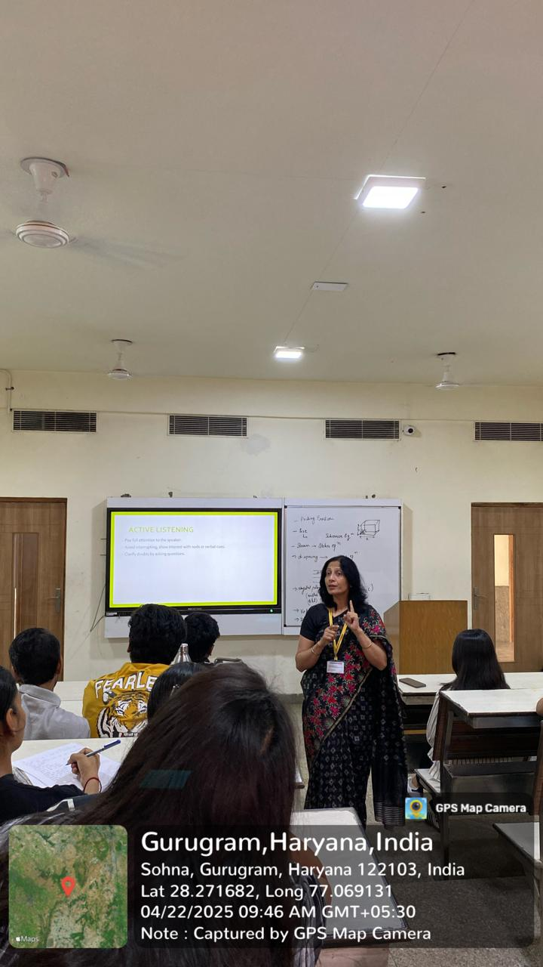

Dr. Tuhina explaining clear and concise Expression

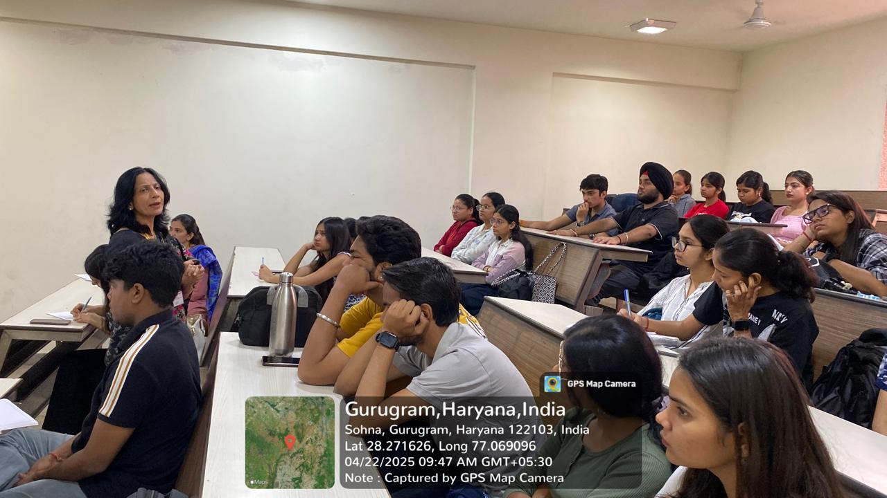

Expert explaining nonverbal communication

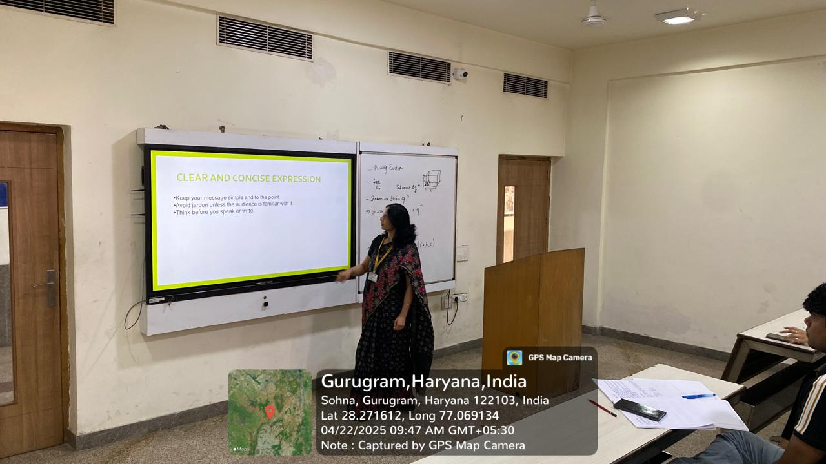
Expert explaining speaking and writing skills to students

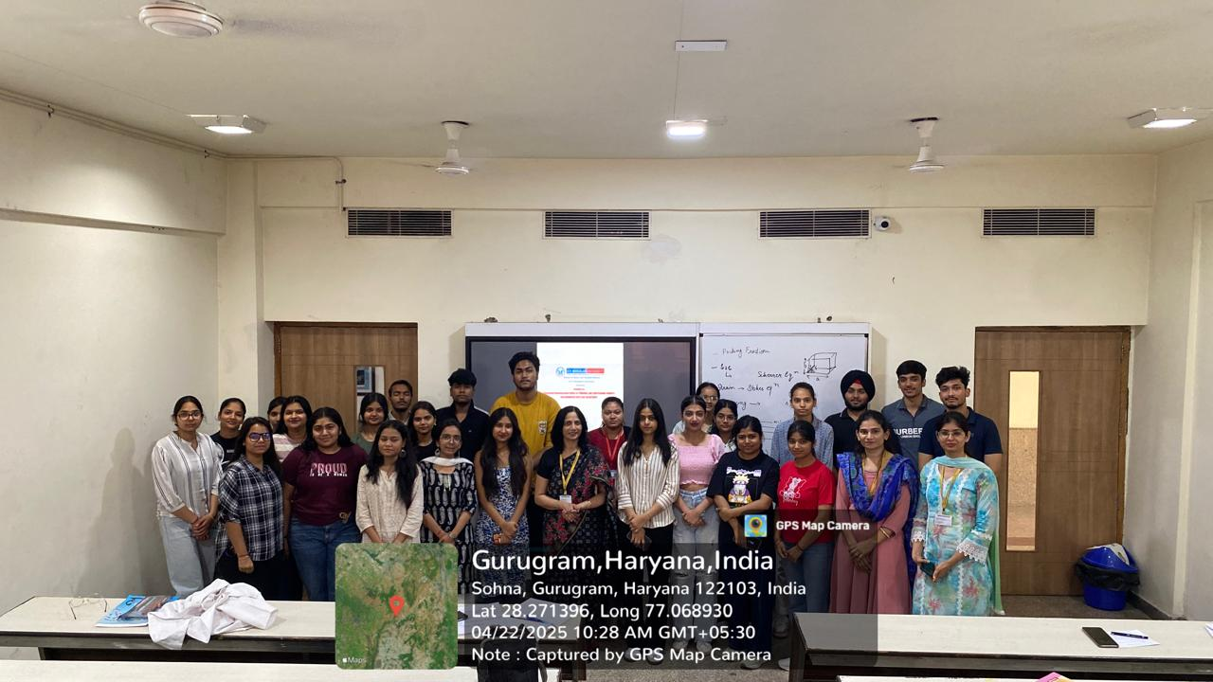

Group photograph

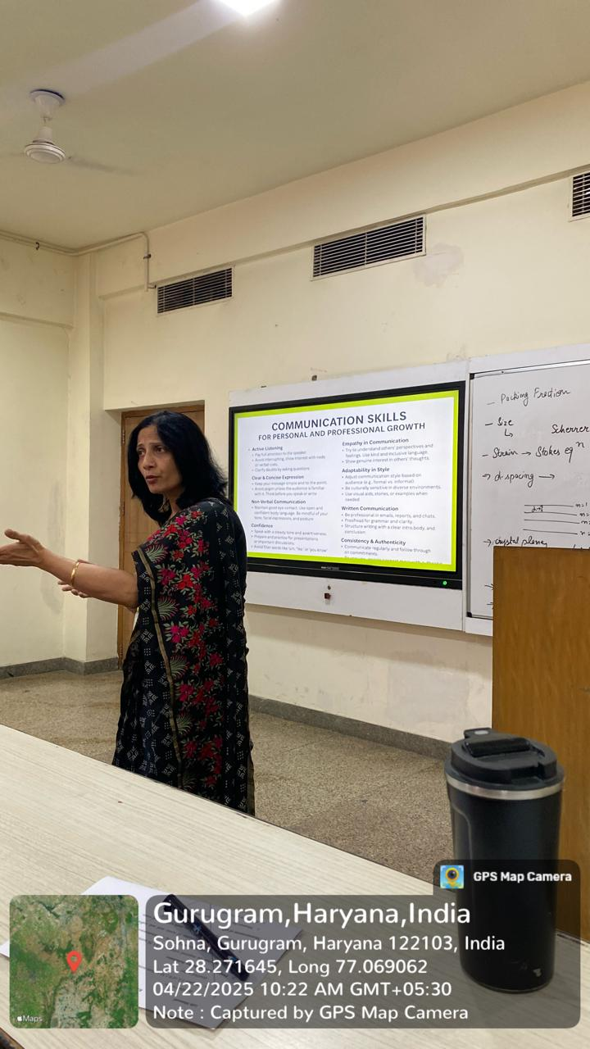

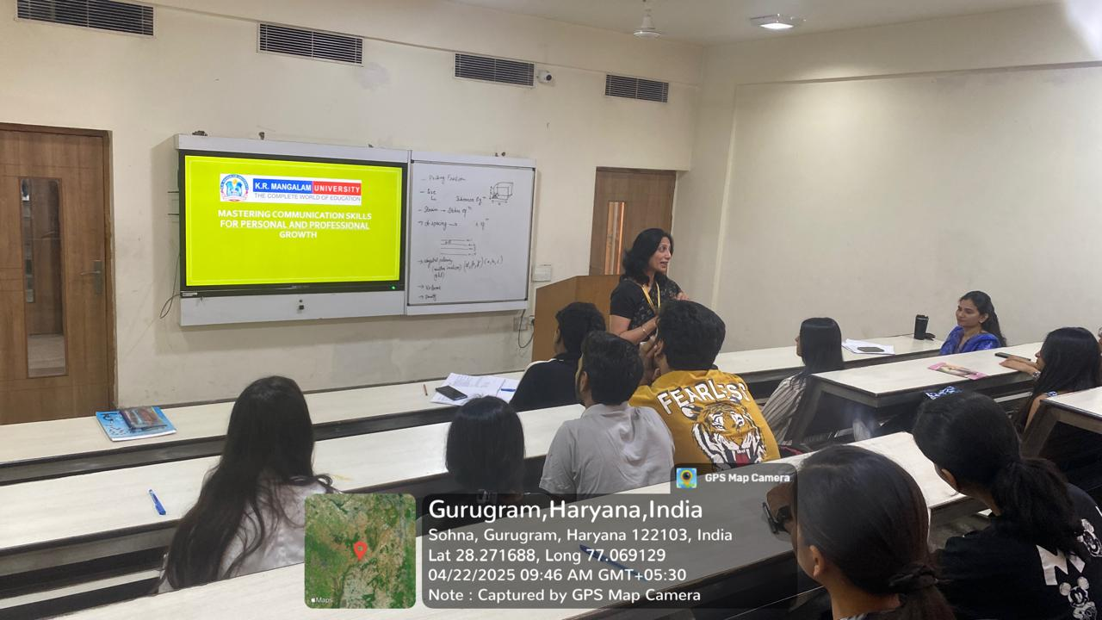

Report Prepared by  Event Coordinator | Dr. Saloni Rathee  Dr. Kanchan Jangra
Report Verified by  Dean, SBAS | Dr. Meena Bhandari
Report Verified by  IQAC Coordinator | Dr Shikha Dutt Sharma

