Event Report
SCHOOL OF EDUCATION
Organizes
COMMUNICATE TO LEAD: Capacity Development Programme on Interpersonal Communication and Team Building Soft Skills for Teacher
in collaboration with Career Development Centre (CDC K.R.M.U)
Date: 27 October 2025 to 17 November 2025
Venue: A210, Second Floor, Aryabhatta Block, K. R. Mangalam University
Event Type: Capacity Development Programme
Mode of Activity: Offline
Target Group: Students and Faculty KRMU
Organized by: School of Education, K. R. Mangalam University.
Resource Person: Mr. Vijay Purohit, Soft-skill Trainer, K. R. Mangalam University.
Number of Participants: 21
Faculty Coordinator: Dr. Kanchan Khatreja, Assistant Professor, SOED
Convenor: Prof. (Dr.) Tania Gupta, Dean, School of Education & Director, IQAC
Event Objectives:
- To develop effective verbal and non-verbal communication skills for classroom and professional settings.
- To foster empathy, assertiveness, and active listening among educators.
- To build confidence in handling difficult conversations and providing constructive feedback.
- To encourage team communication and collaboration in school environments
Introduction
The Capacity Development Programme titled "Communication to Lead: Interpersonal Communication and Team Building Soft Skills for Teachers" was organized by the School of Education in collaboration with CDC, K.R. Mangalam University. Conducted over multiple sessions in October and November 2025, the programme aimed to equip B.Ed. Semester I students with essential verbal and non-verbal communication skills, interpersonal effectiveness, time management, public speaking, and contemporary professional skills such as resume building using AI tools and LaTeX. The programme sought to enhance participants' confidence, empathy, and teamwork abilities, preparing them for effective classroom teaching and professional growth as future educators. It was coordinated by Dr. Kanchan Khatreja, with expert sessions led by Mr. Vijay Purohit.
Capacity Development Programme Session 1 report

The School of Education organized a Capacity Development Programme on " Communication to Lead: Capacity Development Programme on Interpersonal Communication and Team Building Soft Skills for Teachers" in collaboration with CDC, K.R. Mangalam University on

27th October 2025. Expert of the session Mr. Vijay Purohit started with an activity of charades followed by an introduction to the three V Model, and its importance in effective communication. The session also emphasized about how vocal, listening and visual skills are crucial and their application in real life. The session concluded with a revisit to all the theories introduced and the students were briefed about how such interpersonal communication and soft skills are necessary for classroom teaching. The programme was coordinated by Dr. Kanchan Khatreja, Assistant Professor, SOED. Prof. Tania Gupta, Dean, School of Education provides guidance to conduct such programs that are crucial for prospective teachers in classroom teaching.
Capacity Development Programme Session 2 report:
The School of Education organized this session on "Communication to Lead: Capacity Development Programme on Interpersonal Communication and Team Building Soft Skills for Teachers" in collaboration with CDC, K.R. Mangalam University on 3rd November 2025. Expert of the session Mr. Vijay Purohit started with essential strategies for Time Management and Focus to effectively balance academic, practical, and personal demands. The core instruction centered on being Objective-Oriented—defining clear goals for coursework, practical teaching, and personal development—followed by rigorous Prioritisation followed by a specific diagram of Prioritization. This prioritization model guides students in scheduling essential but non-urgent tasks (like lesson planning and studying theory) before they become urgent crises. A crucial skill highlighted was learning how to Say 'NO' to non-essential demands that clutter the schedule (Quadrant III tasks). The session also introduced practical tools for consistency, such as the Tiny Habit and the 5-Minute Rule, to help B.Ed. students overcome procrastination and consistently engage with daily responsibilities like micro-teaching preparation.
Lastly, the speaker also shed light on the stages of learning where he talked about 4 stages of learning which are: learning, reflect, execute and shared. Expert concluded it by stating that learning should not be just kept to itself only it should be reflected through any medium like writing, explaining to other, next by executing that learning in actions or practically. B.Ed. semester 1 attended this session and the program was co-ordinated by Dr. Kanchan Khatreja, Assistant Professor, SOED.

Capacity Development Programme 3 report:
The School of Education organized this session on "Communication to Lead: Capacity Development Programme on Interpersonal Communication and Team Building Soft Skills for Teachers" in collaboration with CDC, K.R. Mangalam University on 10th November 2025. Expert of the session Mr. Vijay Purohit started with emphasis on the the importance of "why?". The core of the session was public speaking, the struggles that people often face when it comes to public speaking and how one can tackle the same. The speaker shared strategies to help one overcome the hurdles in public speaking through the 'Triple R' method (research, rehearse and review) and the 'Triple P' method (prepare, ponder and present), drawing emphasis on understanding the audience, the content and the consequences. The speaker also shared strategies on how to start and conclude a topic in different ways to keep the listeners engaged the whole time.

The Capacity Development Programme concluded with an activity that enables the attendees to apply the methods discussed and how they can be used in everyday interactions. B.Ed. semester 1 attended this session

Capacity Development Programme Session 4 report:
The School of Education organized a session on " Communication to Lead: Capacity Development Programme on Interpersonal Communication and Team Building Soft Skills for Teachers" in collaboration with CDC, K.R. Mangalam University on 17 November 2025. Expert of the session Mr. Vijay Purohit discussed about two relevant things of 21st century: Artificial Intelligence and Resume Building and LinkedIn networking. The session was followed by showing participants videos and use of website where participants can access these

AI tools altogether. The participants can have access to all AI tools for instance can use for photo editing, Video editing etc.the resource person discussed with the participants the process of preparing a resume using LaTeX, a useful platform for writing academic documents such as books and theses. He also highlighted the significance of the Application Tracking System (ATS), which helps filter and organize relevant information in a resume. Furthermore, he demonstrated how coding support for resume creation can be effectively generated using AI tools like ChatGPT, Perplexity, and similar platforms. One website was overleaf.com where students can copy the code and the resume is provided by the website with proper profile and other information required it also saves time. Similarly, Flowcv platform can be used as well for this purpose but it traditional method need to write information manually.
Lastly, the session concluded with a discussion on the growing industry preference for video resumes, driven by the decreasing reliability and authenticity of traditional written resumes. The programme was attended by the students of B.Ed. Semester I and was efficiently co-ordinated by Dr. Kanchan Khatreja, Assistant Professor, School of Education. The session concluded with a feedback session, during which participants shared their reflections and suggestions. The capacity development programme significantly enhanced the interpersonal communication and team-building skills of B.Ed. students, equipping them with practical strategies for effective verbal and non-verbal interactions and professional resume building using modern AI tools. The programme's impact is reflected in improved confidence and readiness among participants to apply these skills in classroom teaching and professional contexts, fostering their overall growth as future educators.
Conclusion: The programme directly contributed to SDG 4: Quality Education and SDG 8: Decent Work and Economic Growth by enhancing future teachers’ interpersonal communication, collaboration, and employability skills. Participants reported increased confidence in verbal and non-verbal communication, better time management, and improved public speaking and feedback skills for classroom settings. They gained hands-on exposure to AI tools, LaTeX, and professional resume-building platforms, strengthening their career preparedness and digital literacy. Overall, the programme nurtured reflective, empathetic, and tech-enabled teachers, ready to lead inclusive and engaging learning environments.

GLIMPSES OF THE EVENT:
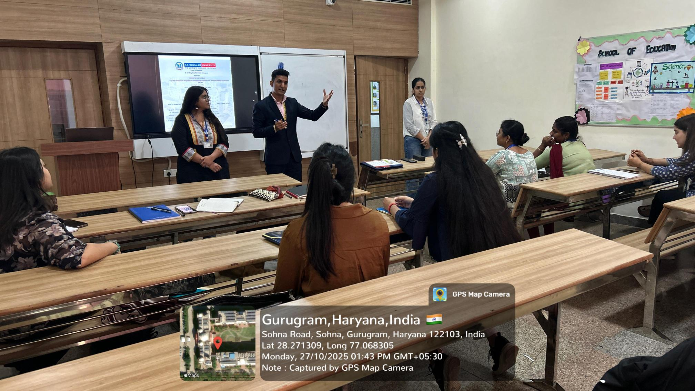
Public speaking strategies that inspire and engage
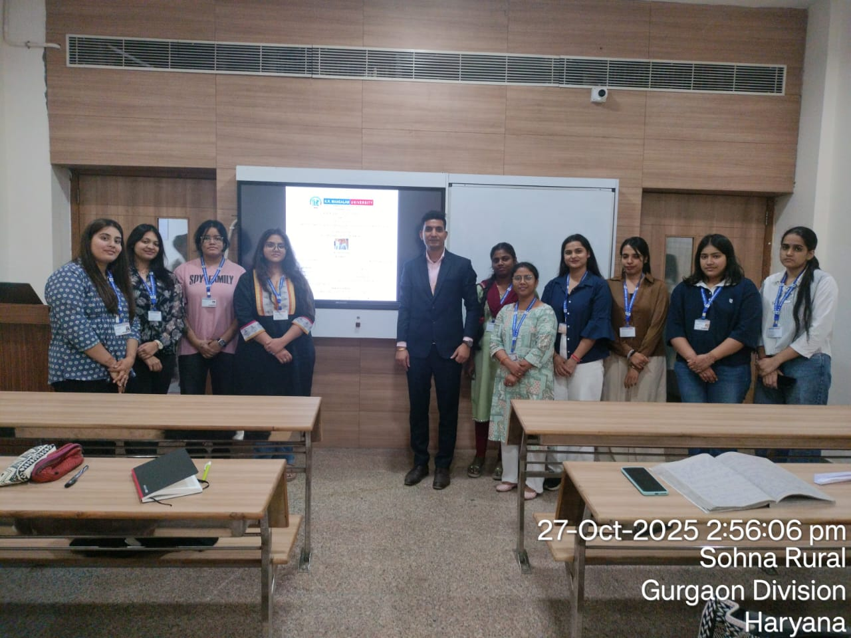
Empowering tomorrow’s teachers with confidence and communication
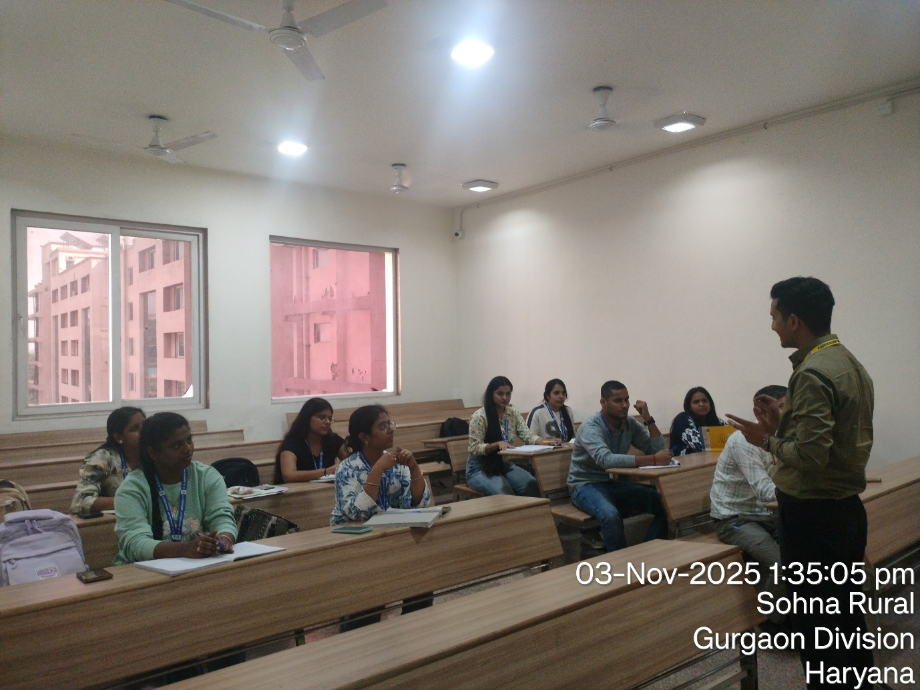
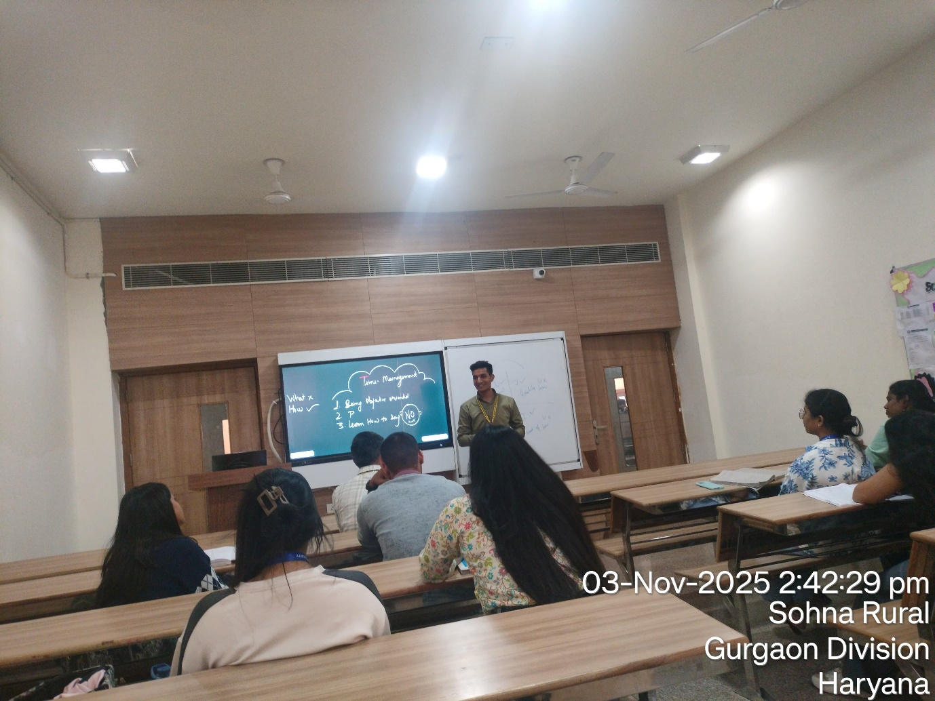
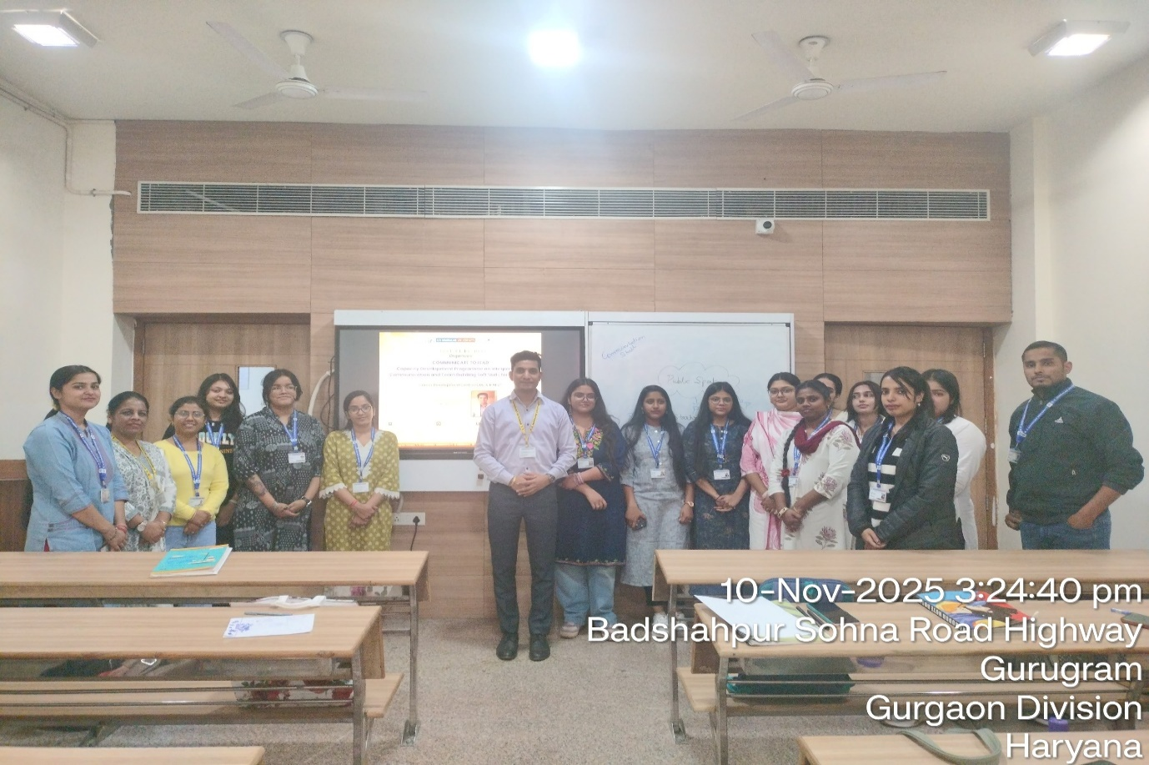
Shaping the future together: empowered educators ready to lead with confidence and purpose
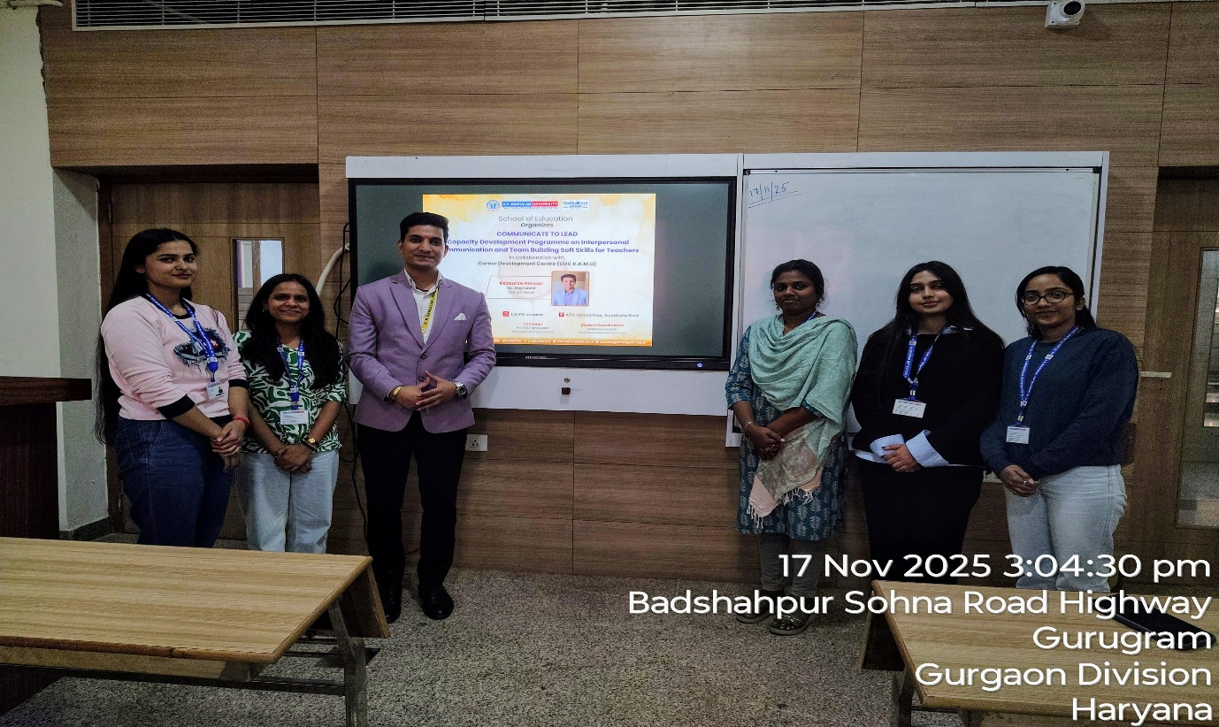

Enthusiastic Participants during capacity development programme with speaker
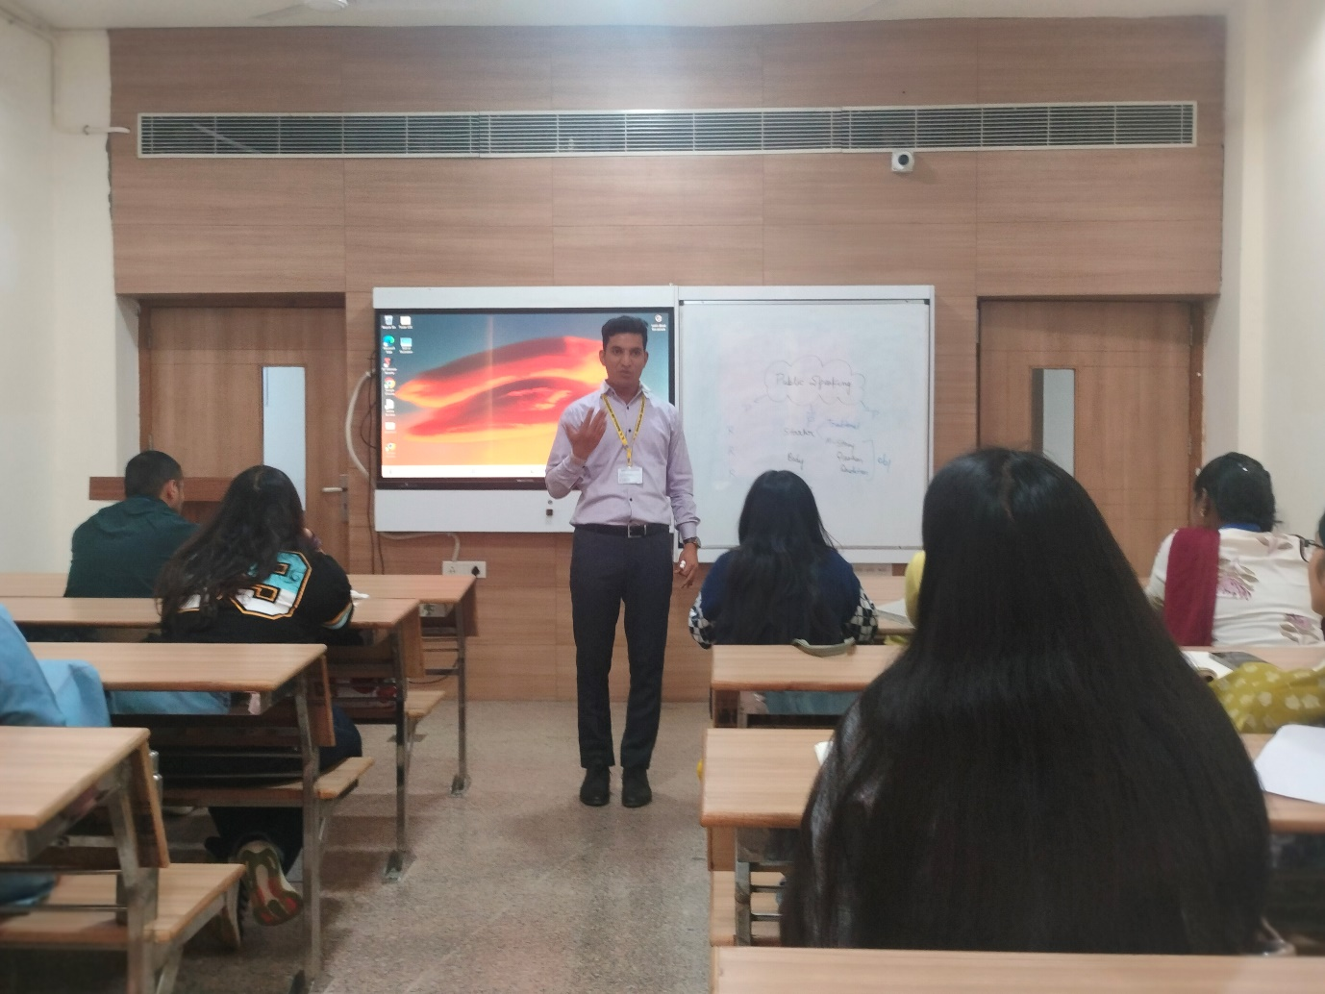
Unlocking the power of communication to lead and inspire

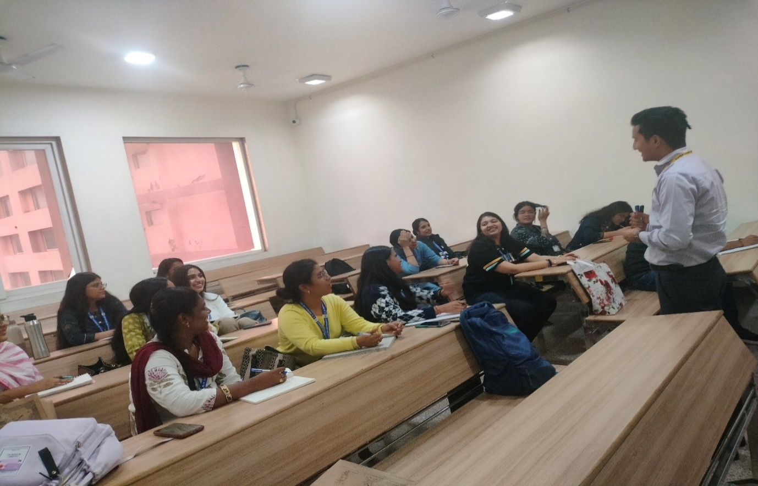
Harnessing AI tools for modern resume building and career growth
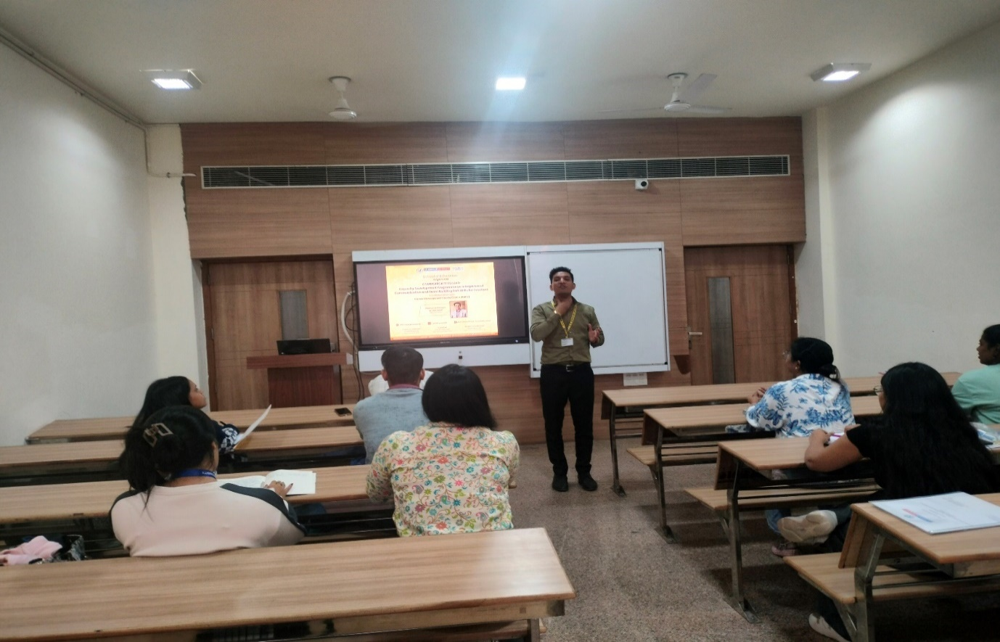
Building soft skills for strong classrooms and beyond

Report prepared by: | Dr. Kanchan Khatreja, Assistant Professor, SOED
Report checked & verified by: | Prof. (Dr.) Tania Gupta  Dean, SOED
IQAC Coordinator: | Dr. Shikha Dutt Sharma

