Knowledge Exchange
S.No. | Event Name | Date | Report Link
1. | Case Study to National Crafts Museum & Hastkala Academy, New Delhi | 26th September 2024 | https://docs.google.com/document/d/1drkbHA614CcpYLHcdIcv41Z8rQgqihw0/edit?usp=drive_link&ouid=115718882834692882101&rtpof=true&sd=true
2. | A Visit to the Aravalli Biodiversity Park and Field Project on “Exploring Biodiversity Conservation Strategies at Aravalli Biodiversity Park: A Study on Ecological Sustainability and Community Engagement” | 29 November 2024 | https://docs.google.com/document/d/1BeCDEDGyK9Cf3Yw0Ya38T3GSsk632CN9/edit?usp=drive_link&ouid=115718882834692882101&rtpof=true&sd=true
3. | Secure Your Digital World: Key Cybersecurity Tips for Everyday Safety | 19 December 2024 | https://docs.google.com/document/d/14wS3wZ1peXoGDXoVOCdIU3e6WxKdNH9P/edit?usp=drive_link&ouid=115718882834692882101&rtpof=true&sd=true
4. | Green Strokes: Draw to Preserve (Drawing Competition) | 28 May 2025 | https://docs.google.com/document/d/1mOUUd1OfgzCgR_LVHssEK16ulyqT7fhs/edit?usp=drive_link&ouid=115718882834692882101&rtpof=true&sd=true
5. | Synergy: Wellness and Development Program | 18 October 2024 | https://docs.google.com/document/d/1RbXxJseMhJzOuPfEcducHEAyOHg6QAZz/edit?usp=drive_link&ouid=115718882834692882101&rtpof=true&sd=true
6. | Nourish & Flourish: A Path to Balanced Nutrition and Health | 20 December 2024 | https://docs.google.com/document/d/1BZz3TDxNHRFQwKnBIhHNiSY1U0_0CTmM/edit?usp=drive_link&ouid=115718882834692882101&rtpof=true&sd=true
7. | Child Safety and Protection | 13 May 2025 | https://docs.google.com/document/d/1u5K9_BZFVs6HIfe_flZ4PtpvL50-1mQU/edit?usp=drive_link&ouid=115718882834692882101&rtpof=true&sd=true
8. | Declamation Contest on Drug Abuse: Its Social, Psychological and Health Consequences | 21 October 2024 | https://docs.google.com/document/d/1JiTi9ewjopid9fgB_zKG6_KbpSoEqx-q/edit?usp=drive_link&ouid=115718882834692882101&rtpof=true&sd=true
9. | Drawing Competition on Save the Water for New Generation | 23 December 2024 | https://docs.google.com/document/d/15I0oZNZ-rDBpxqANplulnJPCnVPeGkHX/edit?usp=drive_link&ouid=115718882834692882101&rtpof=true&sd=true
10. | Save a Life: First Aid Awareness” Training Session on World First Aid Day | 14 September 2024 | https://docs.google.com/document/d/1-bNzQ-Cbl3_kNEEO3SQjuFuZza3gFQoP/edit?usp=drive_link&ouid=115718882834692882101&rtpof=true&sd=true

Case Study to National Crafts Museum & Hastkala Academy, New Delhi

The case study visit to the National Crafts Museum & Hastkala Academy, New Delhi, was conducted on Thursday, 26th September 2024, from 10:00 AM onwards, as an offline academic activity organized by the School of Architecture and Design, K R Mangalam University. The event was coordinated by Ar. Nandit Pastariya, Assistant Professor, SOAD, and was attended by 17 third-year architecture students. The visit aimed to enhance students’ understanding of the integration of traditional Indian crafts with architectural design. Through direct observation of textiles, folk art, and handcrafted materials such as wood and metal, students explored the relationship between cultural heritage, sustainability, and architectural aesthetics. The activity provided experiential learning through on-site sketching, material discussions, and spatial analysis. The case study was further complemented by a site visit to Bhairon Marg, Pragati Maidan, enriching students’ practical exposure to contextual design and traditional craftsmanship in contemporary architectural practice.
Photographs:
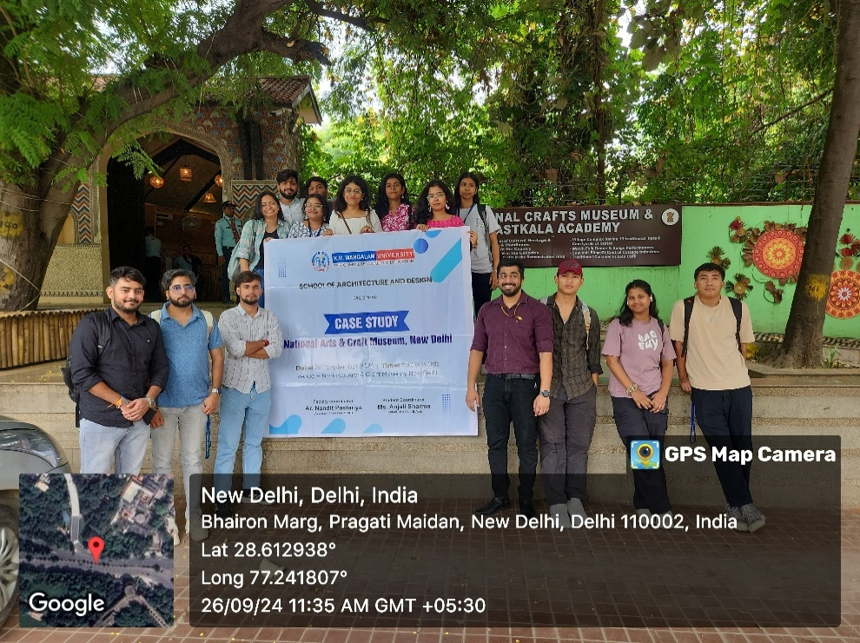
Group photo at the National Crafts Museum & Hastkala Academy, New Delhi

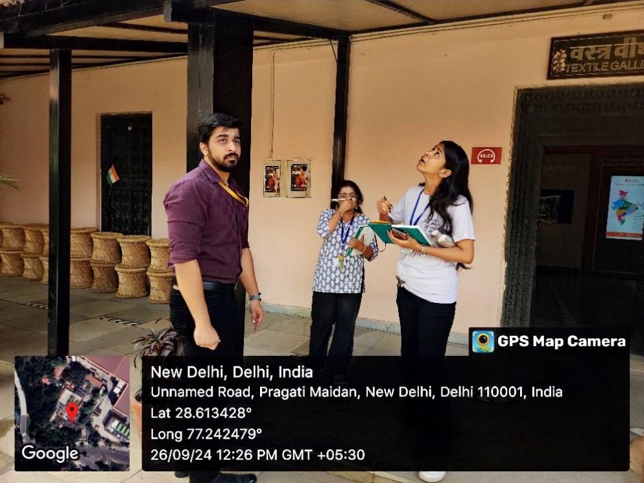
Architectural Material discussion in the form of an interactive session

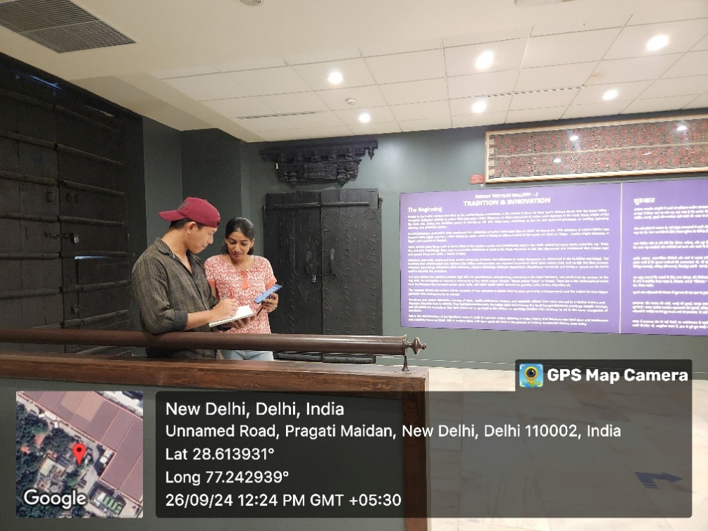
Students sketching on site diagrams for better understanding of spaces

A Visit to the Aravalli Biodiversity Park and Field Project on
“Exploring Biodiversity Conservation Strategies at Aravalli Biodiversity Park: A Study on Ecological Sustainability and Community Engagement”
The field visit and case study to the Aravalli Biodiversity Park, Vasant Vihar, New Delhi, was conducted on 29 November 2024 as an offline academic activity organized by the School of Education, K. R. Mangalam University. The visit involved student-teachers of B.El.Ed. Semester 3 and 5, with a total participation of 48 student-teachers, and was coordinated by Prof. P. C. Jena, Professor, School of Education, and Dr. Anshul Saluja, Assistant Professor, School of Education. The activity focused on exploring biodiversity conservation strategies, ecological sustainability, and community engagement, in alignment with Sustainable Development Goal (SDG) 15: Life on Land. During the visit, participants observed conservation practices related to native flora and fauna, ecological restoration, and habitat sustainability, guided by park officials, reflecting effective collaboration with the Aravalli Biodiversity Park authorities. The visit enhanced experiential learning by integrating theoretical knowledge with real-world ecological practices and highlighted the role of education and community participation in promoting environmental stewardship and sustainable development.
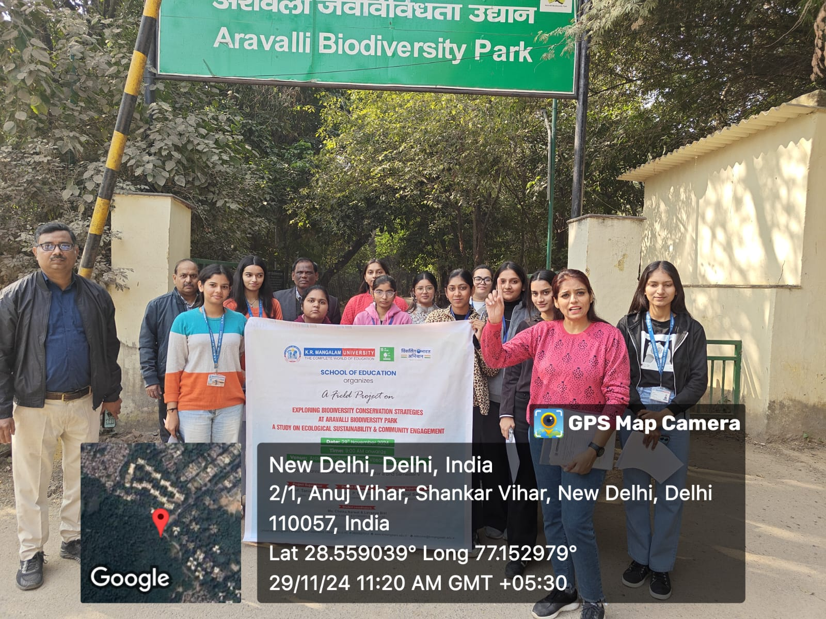
Student-teachers and faculty at the venue of the visit
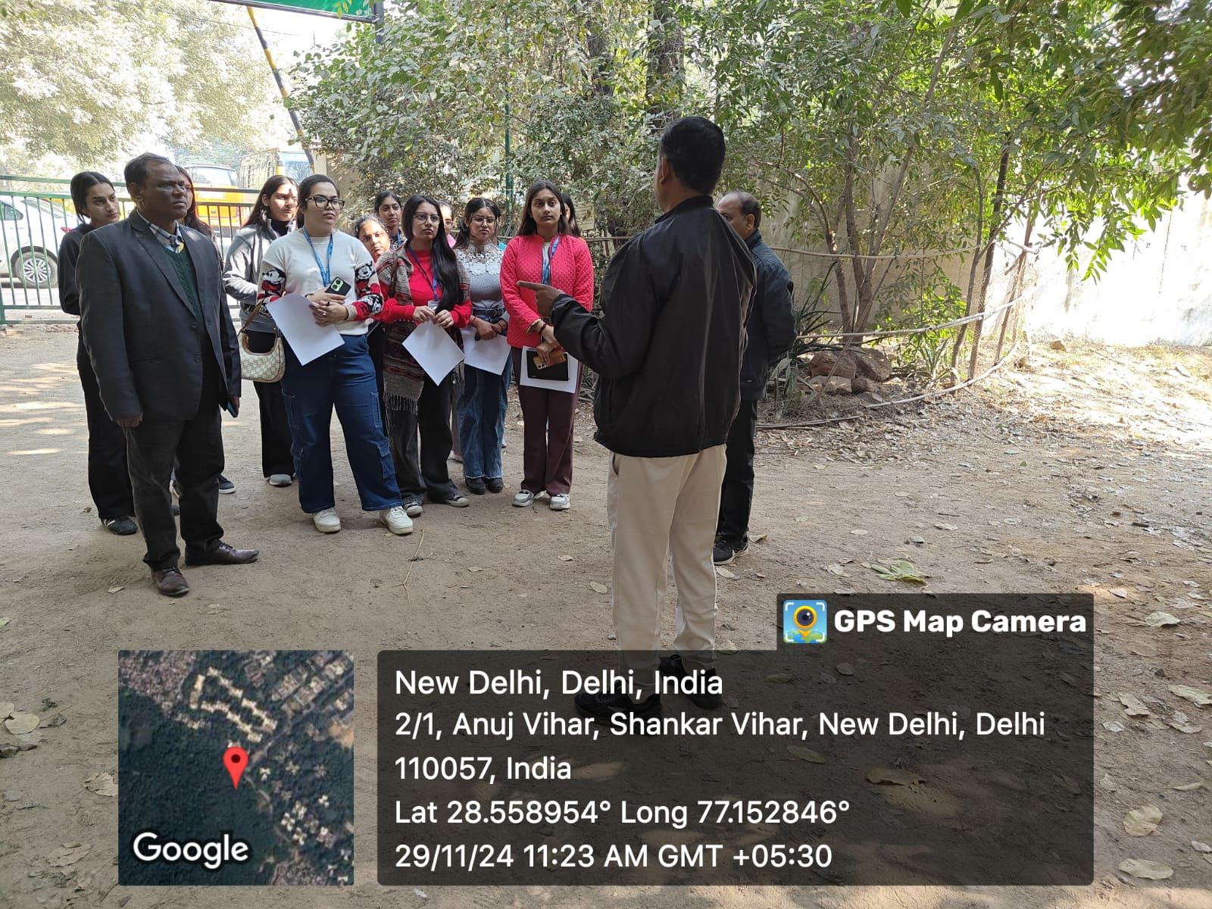
Student-teachers receiving the instructions from the park officials before visit to the park
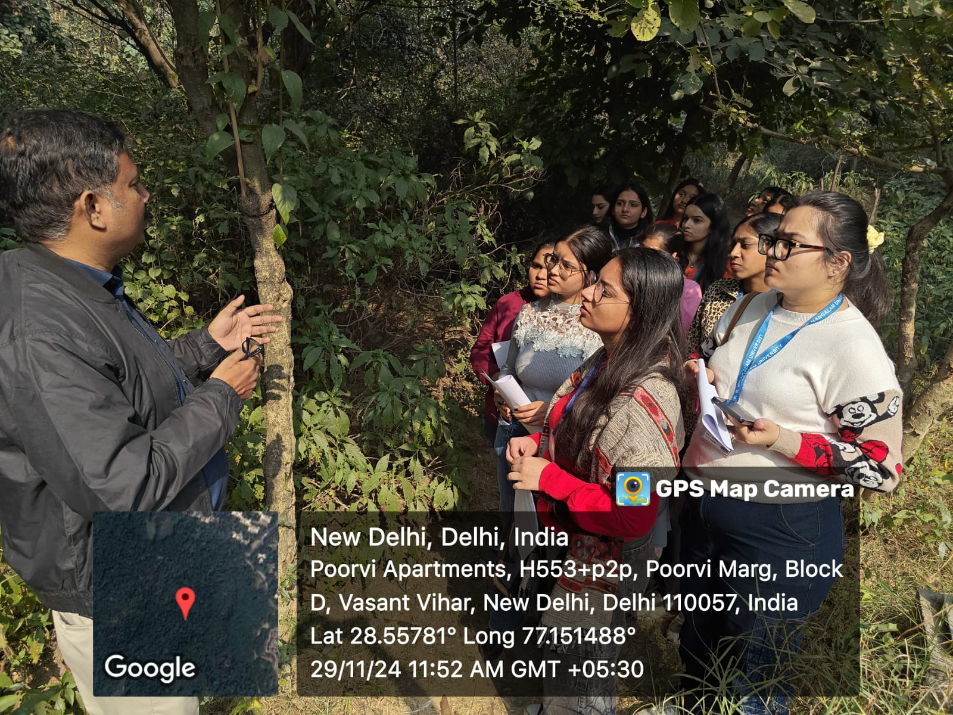
Biodiversity Park Officials explaining about the various species of plants to the Student-teachers

Secure Your Digital World: Key Cybersecurity Tips for Everyday Safety
The lecture session titled “Secure Your Digital World: Key Cybersecurity Tips for Everyday Safety” was organized on 19 December 2024 at Garhi Bazidpur Village as an offline community outreach initiative by the Youth Red Cross Committee, K.R. Mangalam University. The programme targeted villagers of Garhi Bazidpur and Youth Red Cross (YRC) volunteers, with the objective of enhancing awareness about cybersecurity and safe digital practices. The session was delivered by Ms. Kritika Singh, Assistant Professor of Cyber Forensics, and coordinated by Dr. Monika Yadav, Program Coordinator, Youth Red Cross Committee, with support from student coordinators. The lecture focused on common cyber threats such as phishing, malware, and hacking, and emphasized practical measures including strong passwords, two-factor authentication, safe browsing habits, and protection of personal data on social media and email platforms. The interactive discussion enabled participants to clarify doubts through real-life examples of cyber fraud. Overall, the initiative successfully strengthened digital awareness, encouraged safer online behavior, and promoted community empowerment in the digital domain.
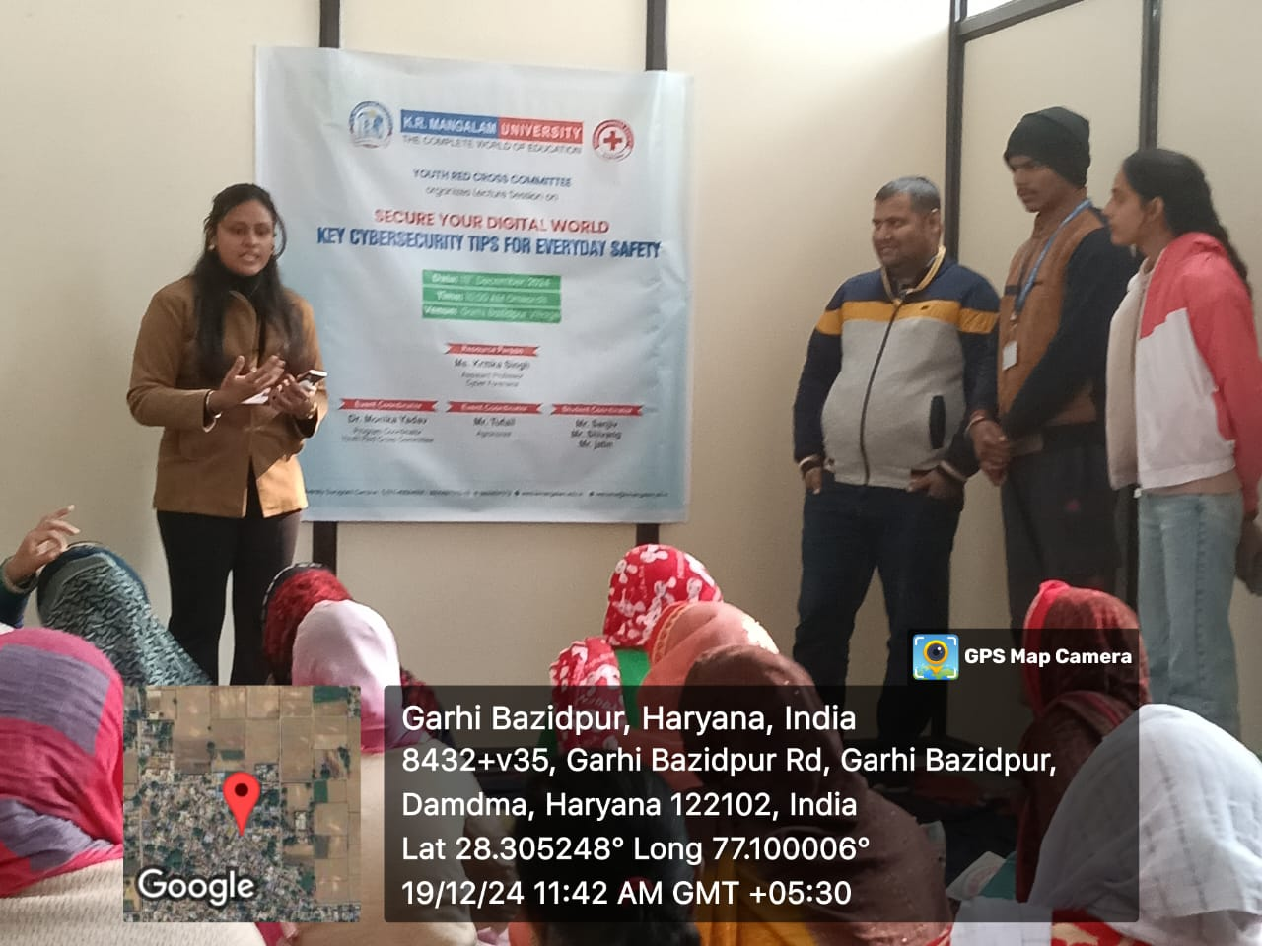
Ms. Kritika Singh delivers a lecture on "Key Cybersecurity Tips for Everyday Safety" at Garhi Bazidpur Village, organized by the Youth Red Cross Committee on 19th December 2024.

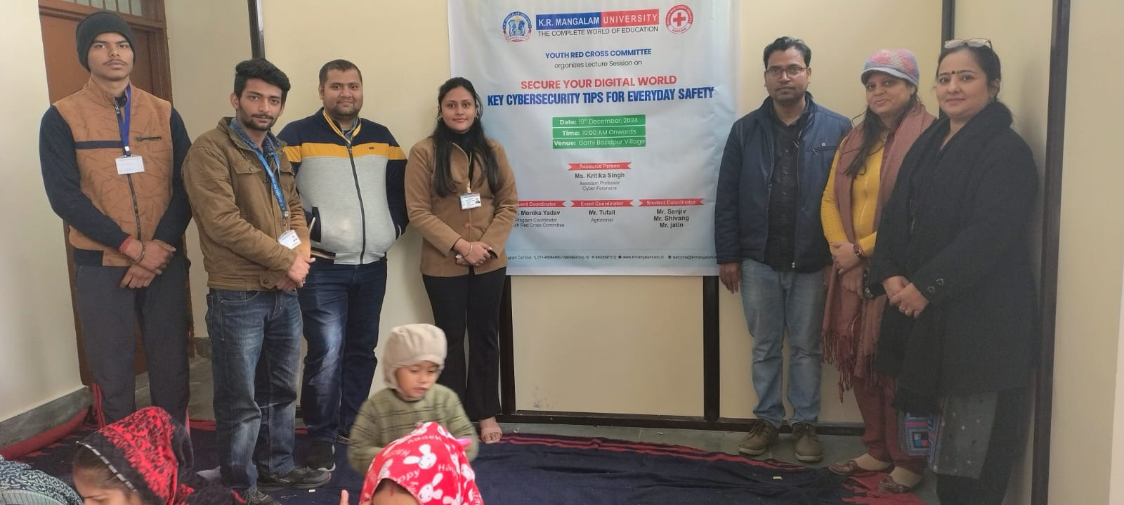

Event coordinators, resource person Ms. Kritika Singh, and participants at the "Key Cybersecurity Tips for Everyday Safety" session

Green Strokes: Draw to Preserve (Drawing Competition)
The drawing competition titled “Green Strokes: Draw to Preserve” was organized on 28 May 2025 at Government Primary School, Daula, as an offline outreach activity by the Youth Red Cross Committee, K. R. Mangalam University. The event was conducted to commemorate Earth Day and to promote environmental awareness among school children. School students of Daula actively participated along with 14 Youth Red Cross volunteers from KRMU, under the coordination of Dr. Monika Yadav, Program Coordinator, YRC, with support from student coordinators. The activity focused on encouraging creative expression on themes such as environmental conservation, sustainability, water conservation, and protection of natural resources. Through art-based learning and guided interaction, the competition successfully sensitized young participants toward eco-friendly practices. The initiative also strengthened community engagement and reinforced the role of educational institutions in fostering environmental responsibility and sustainable values among future generations.
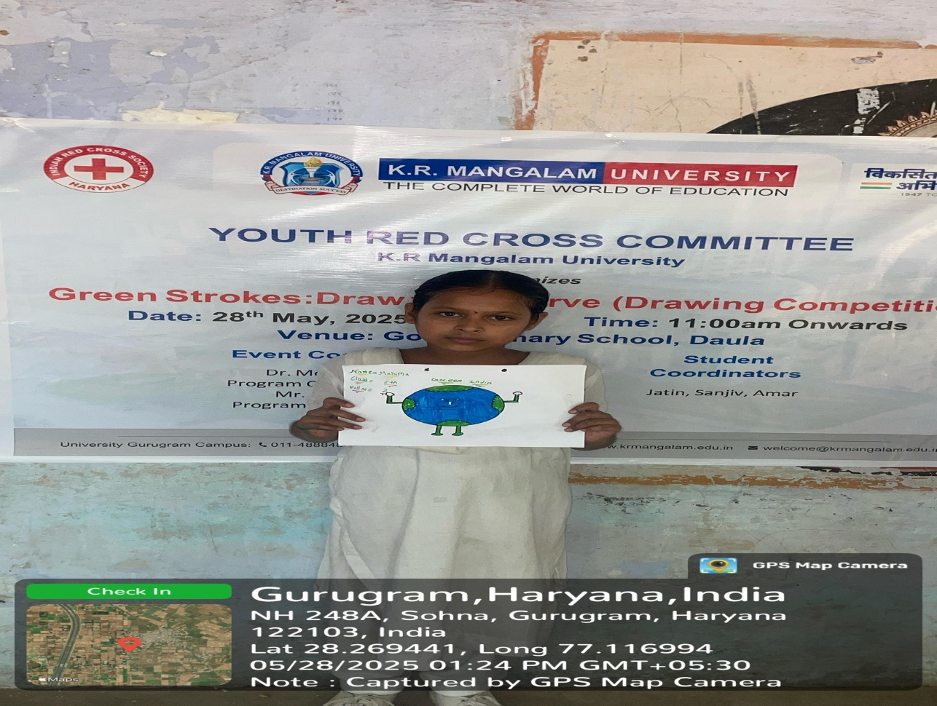

A participant displays her creative artwork promoting environmental conservation during the "Green Strokes: Draw to Preserve" competition at Govt. Primary School, Daula.

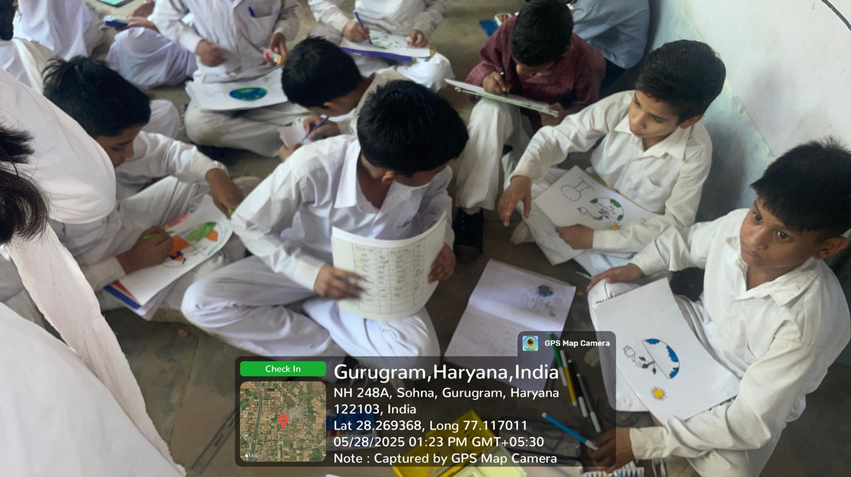

Students enthusiastically express their environmental awareness through art during the "Green Strokes: Draw to Preserve" competition at Govt. Primary School, Daula.

Synergy: Wellness and Development Program
The live seminar titled “Synergy: Wellness and Development Program” was organized on 18 October 2024 at Room A-213, A Block, K.R. Mangalam University as an offline academic and wellness initiative. The programme was conducted by the Youth Red Cross Committee, K.R. Mangalam University, in collaboration with The Kailasa Foundation, reflecting effective institutional–external partnership. A total of 107 university students participated in the seminar, which was coordinated by Dr. Monika Yadav, with student coordinators providing organizational support. The session was led by Mr. Varun Sharma, Founder of The Kailasa Foundation, who delivered an insightful discourse on the interrelationship between physical, digital, and mental well-being. The seminar emphasized practical strategies such as healthy lifestyle practices, responsible digital usage, and mental balance in a fast-paced environment. Overall, the event enhanced awareness of holistic wellness, encouraged balanced living among students, and strengthened collaboration between educational institutions and wellness organizations.
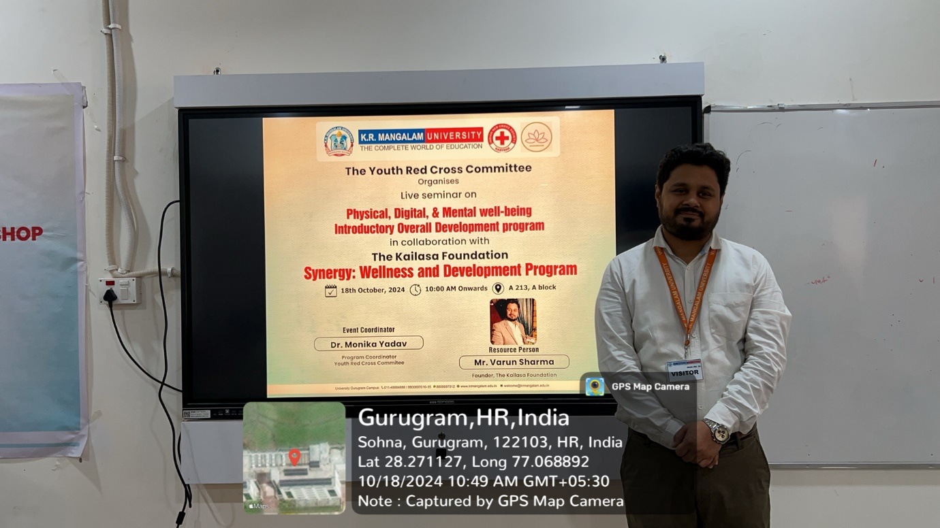

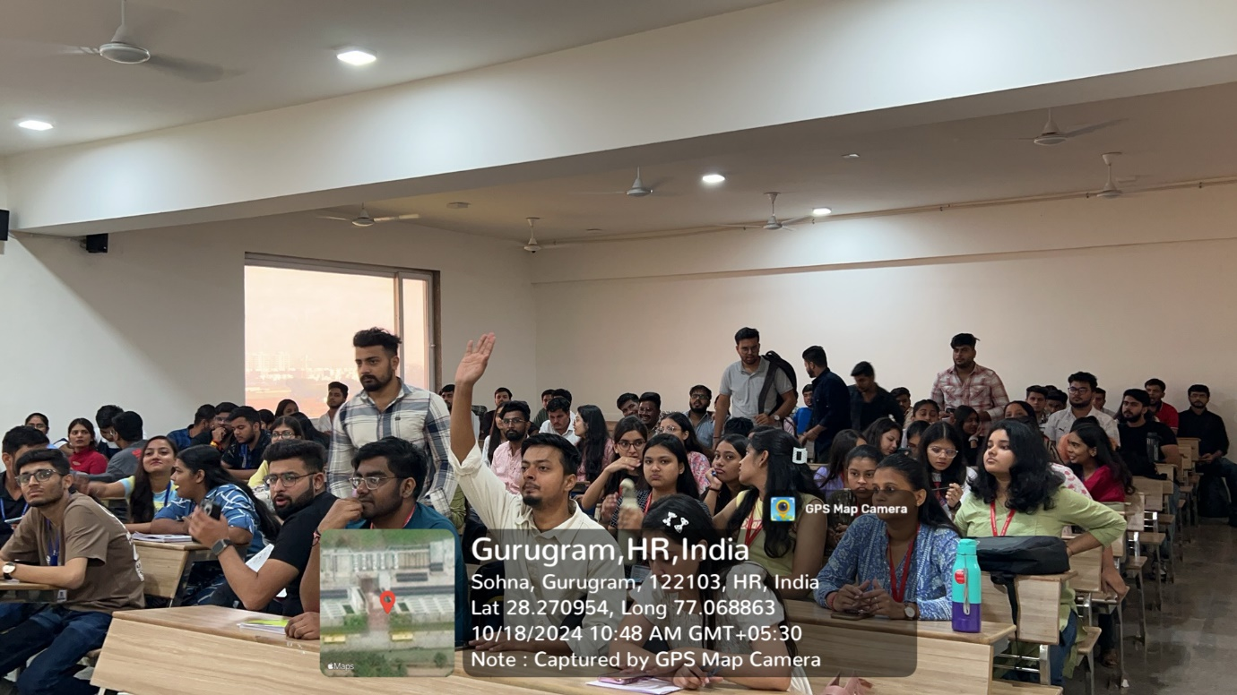

Nourish & Flourish: A Path to Balanced Nutrition and Health
The lecture session titled “Nourish & Flourish: A Path to Balanced Nutrition and Health” was organized on 20 December 2024 at Government Senior Secondary School, Daula, as an offline community outreach initiative by the Youth Red Cross Committee, K.R. Mangalam University. The programme targeted school students of Daula along with Youth Red Cross volunteers and was coordinated by Dr. Monika Yadav, Program Coordinator, YRC. The session was delivered by Dr. J. S. Yadav, Dean, School of Agriculture & Science, who emphasized the importance of balanced nutrition for overall health and prevention of lifestyle-related diseases. The lecture highlighted practical dietary practices, including the consumption of locally available nutritious foods, meal planning, hydration, and mindful eating. Through interactive discussions and clarification of common nutritional misconceptions, the session enhanced health awareness among participants. The initiative also strengthened university–community engagement and encouraged the adoption of healthy dietary habits for sustainable well-being.

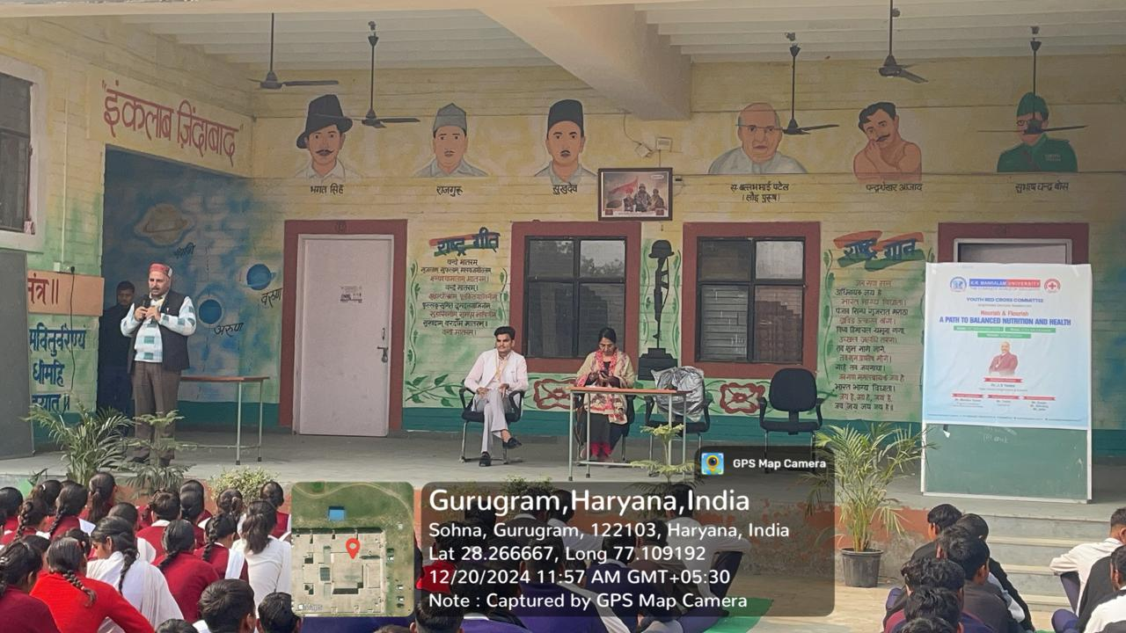

Dr. J.S. Yadav explaining the concept of balanced nutrition.

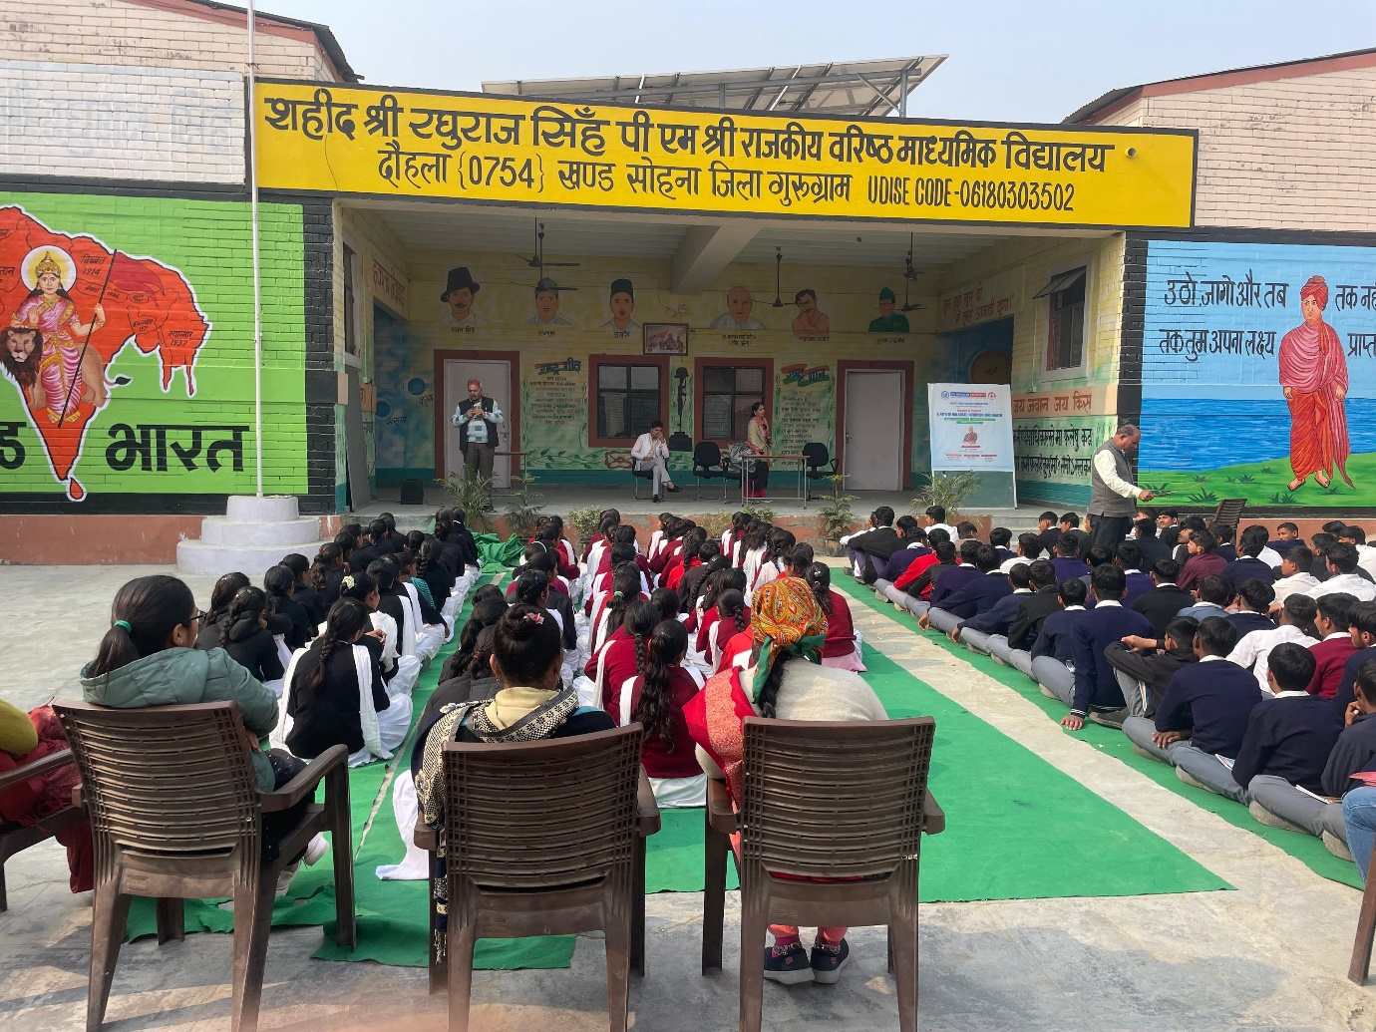

Students engaged in a health awareness program on balanced nutrition.

Child Safety and Protection
The awareness session on “Child Safety and Protection” was conducted on 13 May 2025 at Government Senior Secondary School, Daula, as an offline outreach initiative organized by the Youth Red Cross Committee, K.R. Mangalam University. The programme targeted school students and involved 14 Youth Red Cross volunteers, aiming to enhance awareness of child rights, personal safety, and legal protection mechanisms. The session was coordinated by Dr. Monika Yadav and Mr. Nitin Tyagi, and delivered by Ms. Gargi Singh, Assistant Professor, School of Legal Studies. Through interactive discussions and real-life examples, students were educated on recognizing unsafe situations, understanding legal provisions, and reporting inappropriate behaviour. The session effectively empowered students, strengthened safety awareness, and contributed to building a more informed and confident school community.
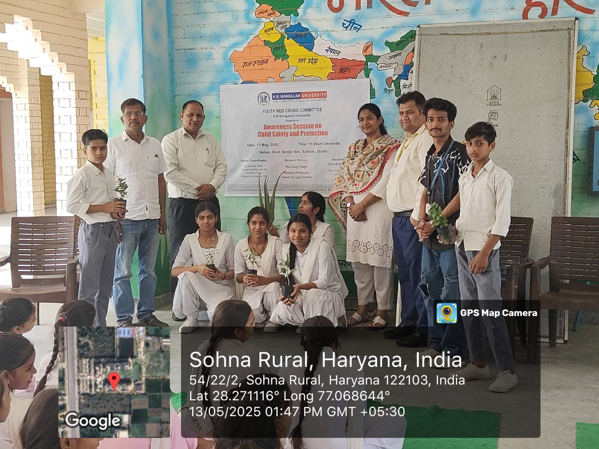

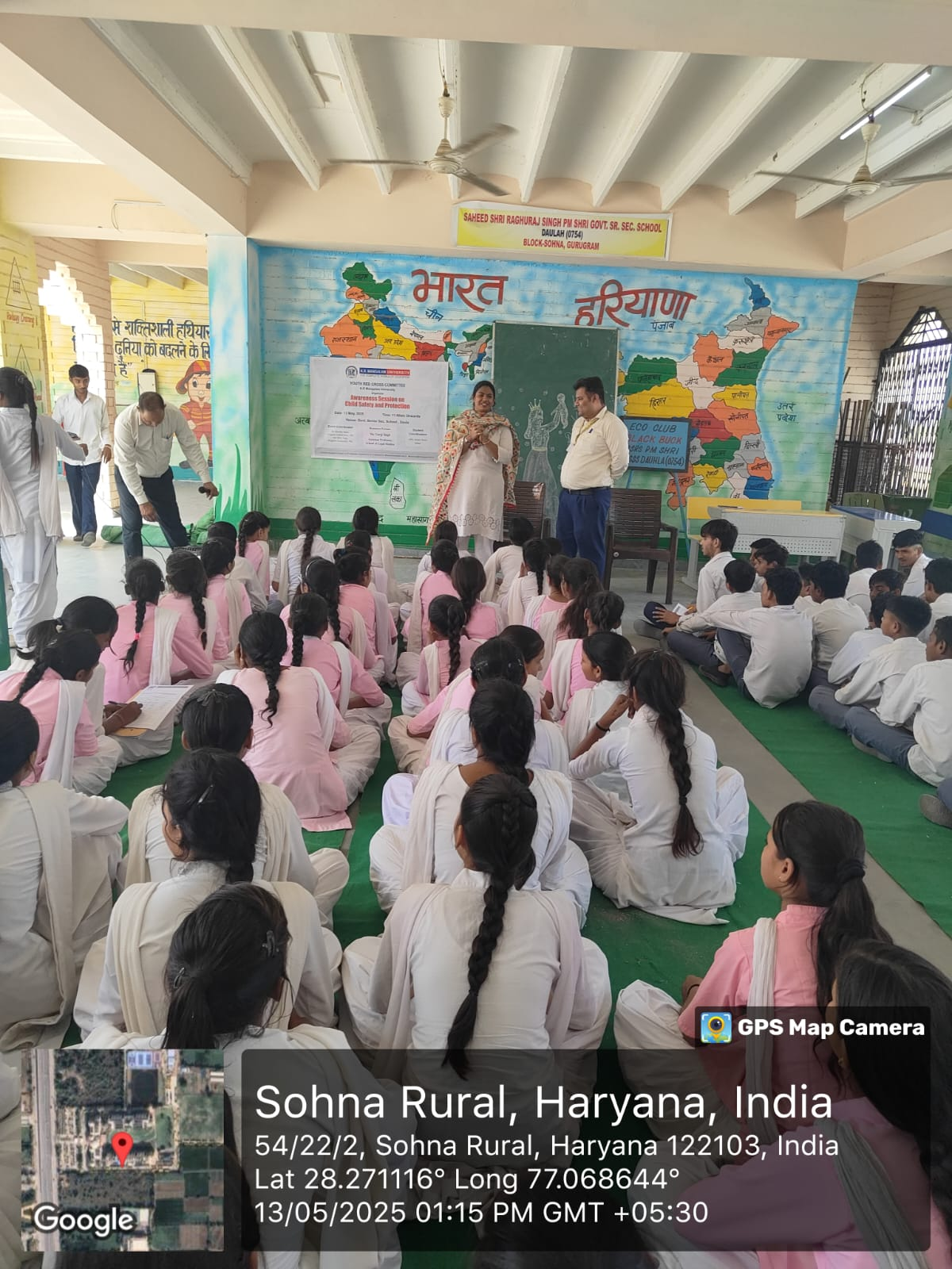
Dr. Gargi Singh addressing students during the awareness session on adolescent health and well-being at Shaheed Shri Raghubir Singh Govt. Sr. Sec. School, Sohna Rural, Haryana.

Declamation Contest on Drug Abuse: Its Social, Psychological and Health Consequences
The declamation contest titled “Drug Abuse: Its Social, Psychological and Health Consequences” was organized on 21 October 2024 at the Multipurpose Hall, 4th Floor, K.R. Mangalam University, as an offline awareness initiative. The event was jointly organized by the Youth Red Cross Committee and the Environment Club of K.R. Mangalam University, in collaboration with the Rotary Club New Gurgaon, reflecting strong institutional–community partnership. A total of 85 students attended the programme, with 20 students actively participating in English and Hindi categories. The contest was evaluated by Rotary Club representatives, including Rtn. Ashok Malik, Rtn. Mini Agarwal, and Rtn. Dr. Ram Kumar Yadav. The activity aimed to sensitize students to the social, psychological, and health impacts of drug abuse and to encourage resistance to peer pressure. The initiative significantly enhanced awareness, promoted responsible decision-making, and strengthened collaboration for future social awareness programmes.
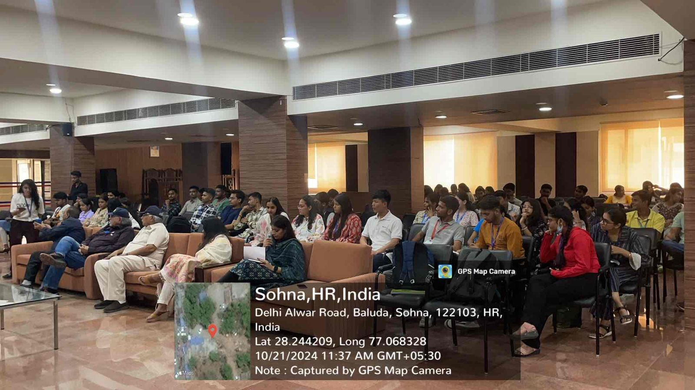

Audience attending the Declamation Contest

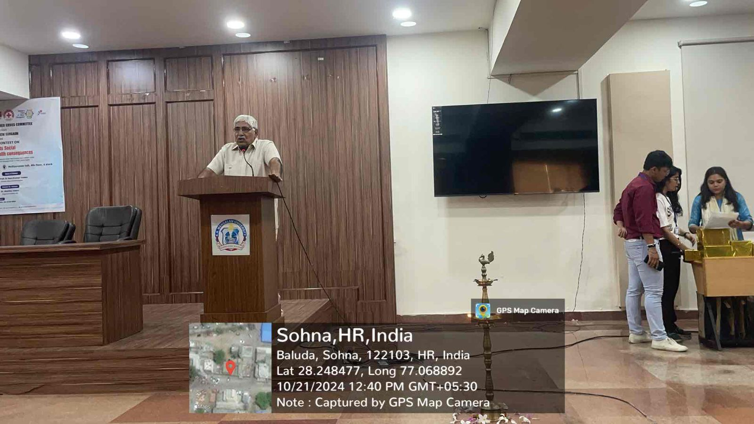

Rtn Dr Ram Kumar Yadav, President Rotary Club New Gurgaon, addresses the audience during the Declamation Contest

Drawing Competition on Save the Water for New Generation
The drawing competition titled “Save the Water for New Generation” was organized on 23 December 2024 at Government Senior Secondary School, Daula Village, as an offline awareness activity by the Youth Red Cross Committee, K.R. Mangalam University. The programme targeted school students and witnessed the participation of 24 students along with 14 Youth Red Cross volunteers, aiming to promote environmental consciousness through creative engagement. The event was coordinated by Dr. Monika Yadav, Programme Coordinator, YRC, with support from student coordinators. The primary objective was to sensitize young learners to the importance of water conservation and to encourage creative expression on sustainable practices. Students produced insightful artworks reflecting the need to preserve water resources for future generations. The competition concluded with the recognition of outstanding entries through certificates and appreciation tokens. Overall, the initiative enhanced environmental awareness, fostered creativity, and strengthened collaboration between the university and the local school community toward sustainable development goals.
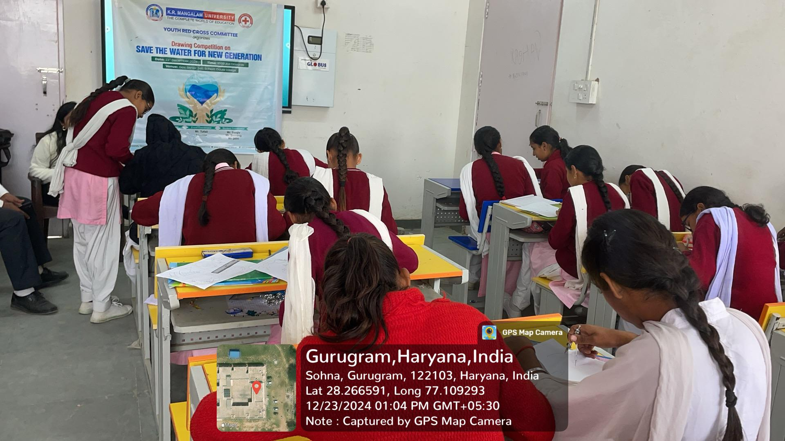

Students participate in a Youth Red Cross drawing competition on "Save the Water for New Generation."

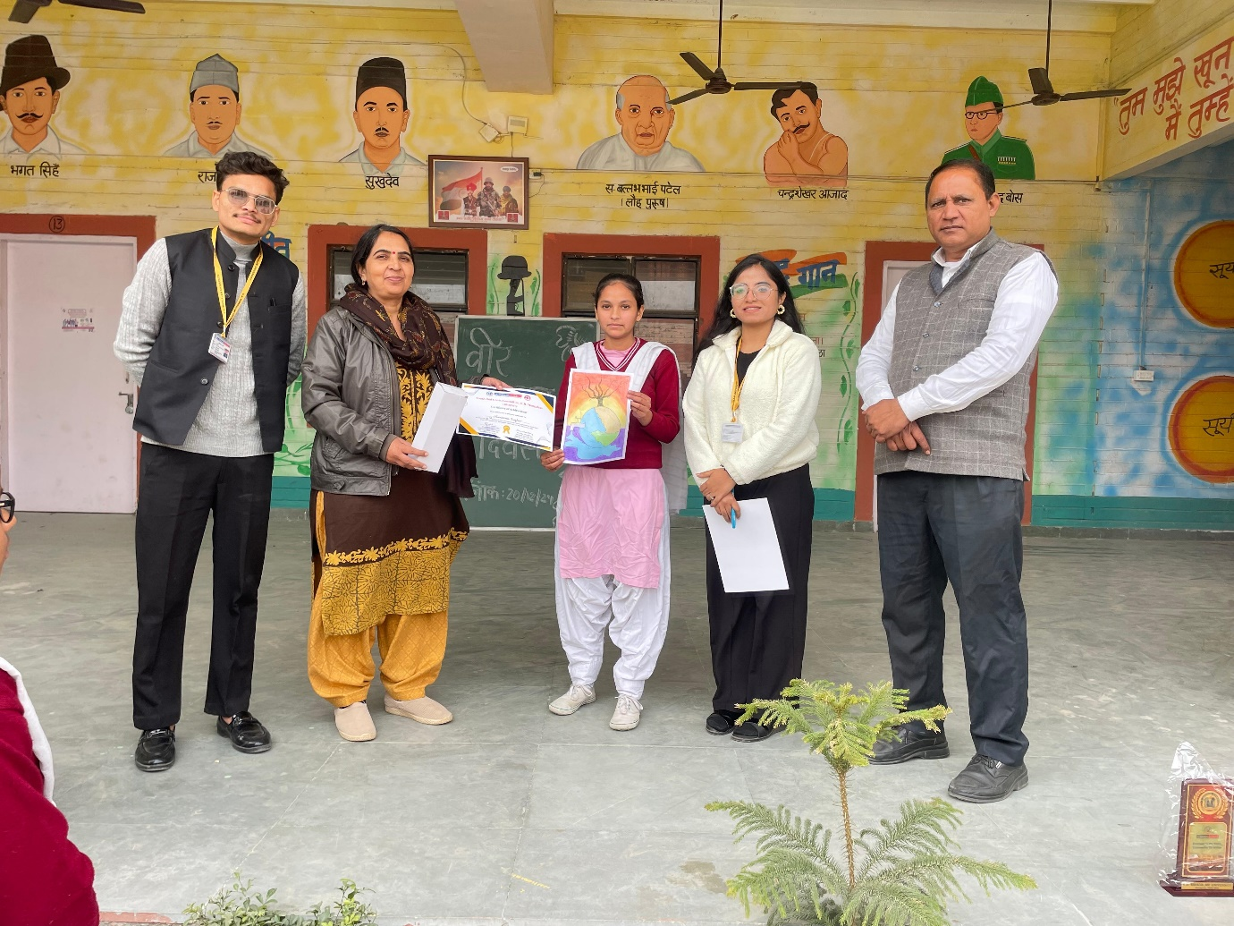

A student is awarded for her artwork on "Save the Water for New Generation" during a Youth Red Cross event in Gurugram, Haryana.

Save a Life: First Aid Awareness” Training Session on World First Aid Day
The training session titled “Save a Life: First Aid Awareness” was conducted on 14 September 2024 at Lakhuwas Village to mark World First Aid Day. The programme was organized by the Youth Red Cross, K.R. Mangalam University, in collaboration with the Indian Red Cross Society, reflecting a strong partnership between academic and humanitarian organizations. Conducted in offline mode, the session targeted residents of Lakhuwas Village along with Youth Red Cross volunteers. The training was led by Mr. Jitin Kaushik, District Training Officer, Gurugram, who provided hands-on demonstrations on essential first aid skills, including CPR, fracture management, burn treatment, and bleeding control. Simulated emergency scenarios further enhanced practical learning and community preparedness. The session significantly improved participants’ knowledge, confidence, and ability to respond effectively to medical emergencies. Overall, the initiative strengthened community resilience and promoted a culture of safety, responsibility, and proactive health care at the grassroots level.
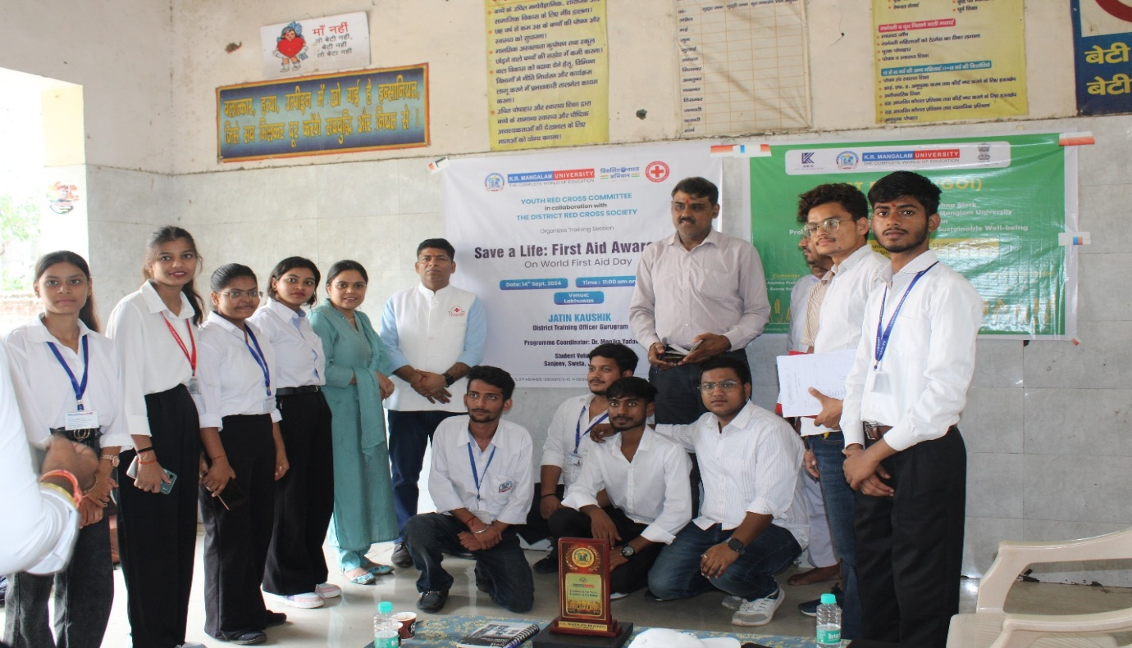
Group photo of participants and organizers during the "Save a Life: First Aid Awareness" event
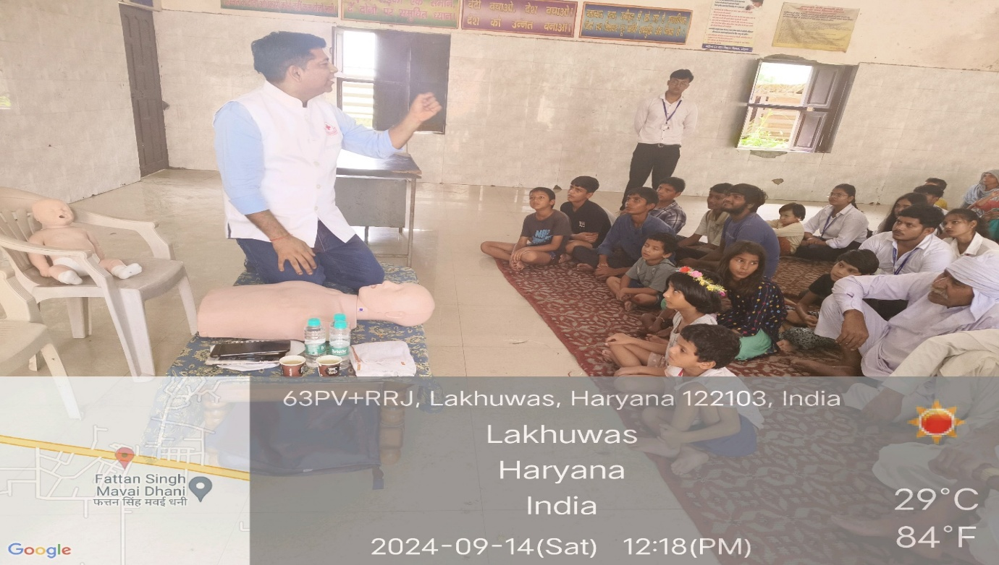
Mr. Jatin Kaushik, District Training Officer, Gurugram, explaining CPR techniques to participants during the First Aid Awareness Training Session

