Report on
‘Journey Beyond Campus: Alumni Insight'

Date: 04-04-2025
Venue: B013, K. R. Mangalam University
Event Type: Alumni Insight Session
Mode of Activity: Offline
Target Group: Undergraduate students SBAS
Organized by: School of Basic and Applied Sciences
Resource Person: Ms. Aarti Gangadhar Shinde, MBA Student at SOIL School of Business Design
Event Coordinators:
- Faculty Coordinators: Dr Sujata Kumari (Assistant Prof., SBAS), Dr. Pratibha Sharma (Assistant Prof., SBAS)
- Student Coordinator: Ms. Ritu, and Ms. Sneha B.Sc. (H) Chemistry, IVth Sem
Participants: 61

Introduction
The alumni insight session "Journey Beyond Campus: Alumni Insight" was organized to bridge the gap between academic learning and professional life. The event featured distinguished alumni who shared their experiences, career challenges, and industry insights to help students prepare for their future careers. This event is aligned with SDG4 offering students valuable career advice and guidance from the alumni.
Objectives
- To provide students with guidance on career prospects and industry expectations.
- To emphasize the importance of skill development and lifelong learning.
- To inspire students through real-life success stories of alumni.
- To facilitate networking opportunities between students and alumni.
Content
The session included insightful discussions on:
- Transition from Campus to Career: Alumni shared her personal journeys, highlighting challenges and key learnings.
- Skill Development: Alumini discussed the importance of technical and soft skills in career success.
- Industry Trends & Expectations: Insights into job market trends and employer expectations.
- Entrepreneurship & Innovation: Story of alumni who ventured into cooperate and academics.
- Work-Life Balance & Career Growth: Strategies to maintain professional and personal well-being.
The interactive Q&A session allowed students to engage with the speakers, seeking advice on career choices, professional development, and future opportunities.
Conclusion
The alumni insight session was highly engaging and informative, providing students with valuable career insights and practical guidance. The key takeaways included the significance of networking, adaptability, and strategic career planning.
Event Outcome
- Enhanced understanding of industry expectations and career pathways.
- Increased motivation to develop necessary skills for professional success.
- Strengthened alumni-student connections for future mentorship and guidance.
Future Prospects
- Organizing more interactive career-oriented workshops and networking sessions.
- Expanding mentorship programs with alumni.
- Conducting hands-on career preparation sessions such as resume-building and interview simulations.

Geotag photos with captions:

Photo 1: A group photographs of participants and the resource person after her interaction.
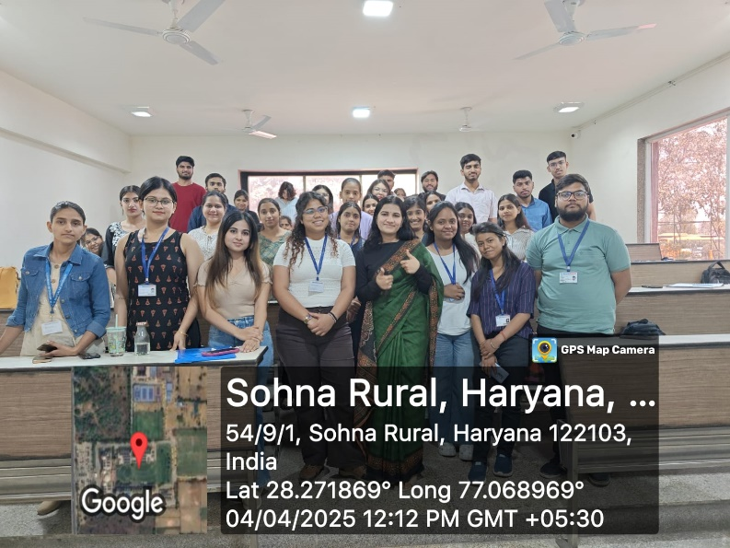

Photo 2: Pictures of resource person during her talk.
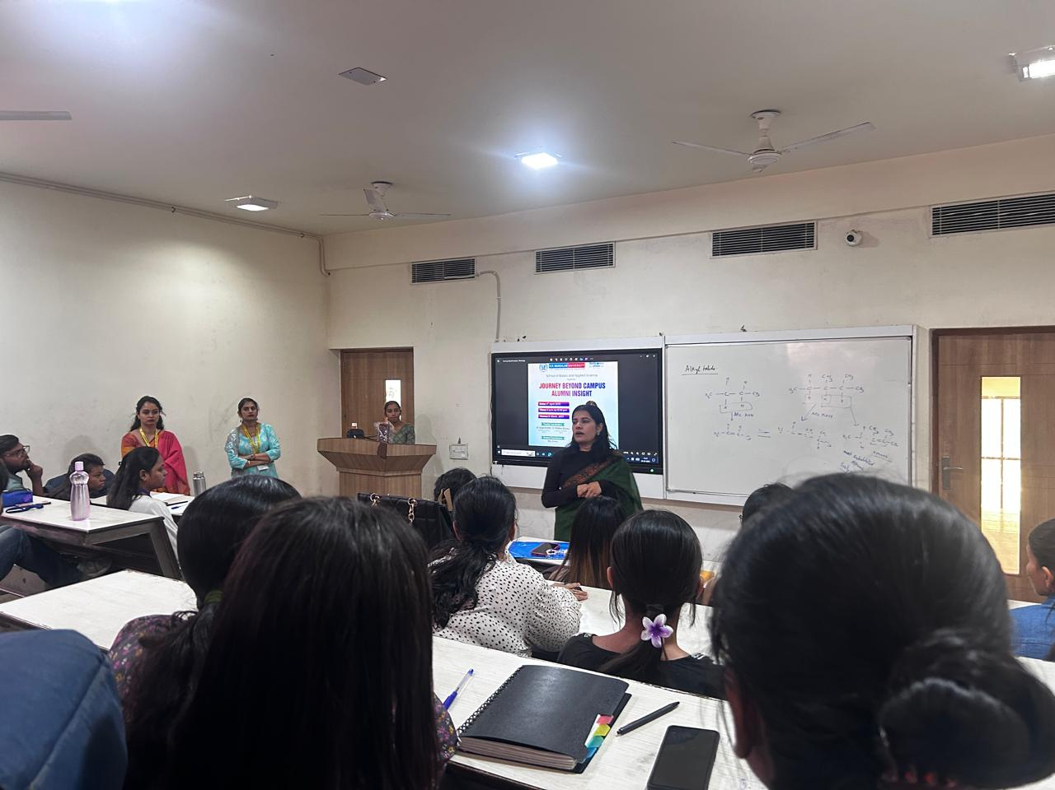 Photo 3: Pictures of resource person during her talk 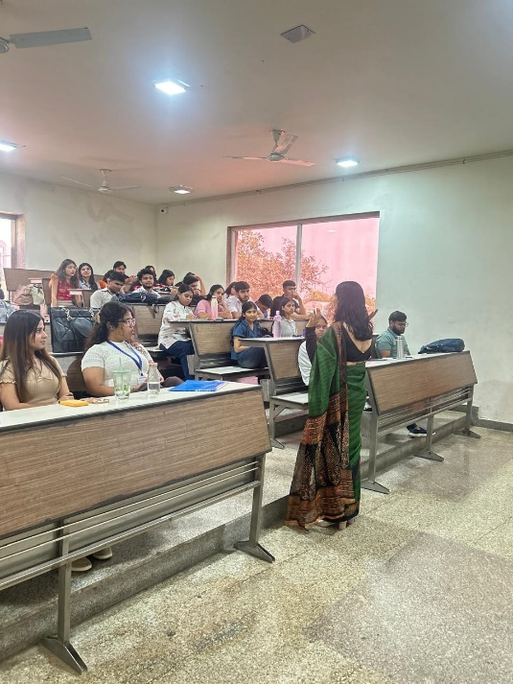

Photo 4: Felicitation of Ms. Aarti Gangadhar Shinde by faculty coordinators
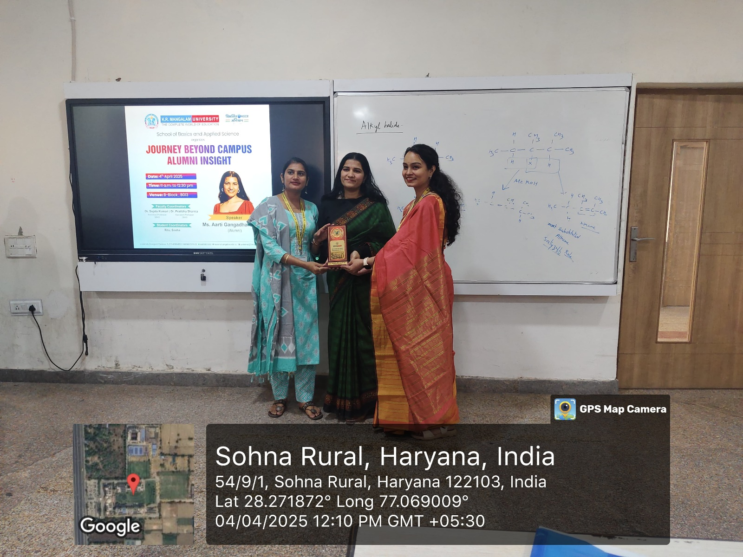

Report Prepared by  Event Coordinator | Dr. Sujata Kumari, Dr. Pratibha Sharma
Report Verified by  Dean, SBAS | Prof.(Dr) Meena Bhandari
Report Verified by  IQAC Coordinator | Dr Shikha Dutt Sharma

