
ENERGY Management and Conservation Report



CONTENTS

1. Institutional Context & Sustainability Framework
1.1 Campus Profile
1.2 Sustainability Framework & Governance
1.3 Biodiversity, Green Cover & Microclimate

2. Energy Systems
2.1 Campus Energy Profile & Infrastructure
2.2 Solar Energy Installations
2.3 Energy-Efficient Appliances
3. Monitoring, Reporting and Carbon Footprint Evaluation

4. Waste-to-Energy & Biogas Systems

5. Sustainable Mobility & Transportation
5.1 Campus Mobility Planning
5.2 Transportation Emission Reduction Measures

6. Local community outreach for energy efficiency
6.1
100% renewable energy pledge
6.2 Energy efficiency services for industry
6.3 Assistance to low-carbon innovation
6.4 Low-carbon energy use

7. Conclusion & Way Forward

K. R. Mangalam University (KRMU), Gurugram, has established a structured and performance-oriented framework for energy conservation, renewable energy integration, and climate responsiveness, embedded within its campus development, operational planning, and institutional governance systems. The university’s approach recognises the need to manage increasing energy demand associated with academic expansion while ensuring efficient resource utilisation, reduced environmental impact, and long-term operational sustainability.
The energy management framework at KRMU integrates physical infrastructure interventions, technology adoption, operational controls, and policy oversight to ensure measurable improvements in energy efficiency and emissions management. These measures are supported by periodic energy and environmental audits, which enable a systematic assessment of energy consumption patterns, renewable energy contributions, and efficiency outcomes across academic, administrative, residential, and service facilities.
Key Performance Indicator | FY 2022–23 | FY 2023–24 | FY 2024–25
Total Electricity Consumed — Grid (kWh) | 1,495,006 | 1,654,473 | 1,436,412
Solar Energy Generated (kWh) | 726,049 | 395,974 | 374,925
Total Energy (Grid + Solar) (kWh) | 2,221,055 | 2,050,447 | 1,811,337
Renewable Energy Share of Total Consumption (%) | 32.69%* | 19.31% | 20.70%
Solar Installed Capacity (kWp) | 310 | 310 | 310
Built-up Area (sq.ft.) | 520,972 | 520,972 | 520,972
Energy Intensity (kWh / sq.ft.) | 2.870 | 3.176 | 2.757
LED Lighting Coverage (%) | ~60% | ~85% | 65.7%
Campus Area (Acres) | 26.4 | 26.4 | 26.4
Green Cover (Acres / Trees) | 6.39 / 1,300 | 6.39 / 1,350 | 6.39 / 1,400

The University's energy strategy is built on six pillars:
- K R Mangalam University Sustainable Environment & Green Campus Policy and sops
- LED lighting transition,
- BLDC fan replacement
- AC set-point norms
- 310 kwp on-campus solar generation
- Broader efficiency measures including sensor automation, biogas, and power factor correction.

1. SETTINGS & INFRASTRUCTURE

1.1 Campus Profile
K.R. Mangalam University (KRMU), Gurugram, is a contemporary higher education campus comprising academic, administrative, residential, and recreational facilities planned within a resource-conscious and environmentally responsive framework. The campus has been developed with an emphasis on energy efficiency, optimal land use, and integration of green infrastructure, ensuring that growth in academic and residential functions is balanced with environmental responsibility.
Campus planning prioritises reduced energy demand through efficient building layouts, extensive use of natural lighting and ventilation, and the incorporation of renewable energy systems. Sustainable water management practices, waste minimisation strategies, and green cover are integral to campus development, contributing to improved microclimatic conditions and reduced ecological footprint. Collectively, these measures support long-term operational efficiency while fostering a culture of sustainability among students, faculty, and staff.
Campus Features:
- Location: Gurugram–Sohna Road
- Climate: Composite (hot-dry + warm-humid + cold periods)
- Campus Type: Urban, low-rise academic blocks
- Green Cover: > 8,000 trees; shaded pedestrian zones
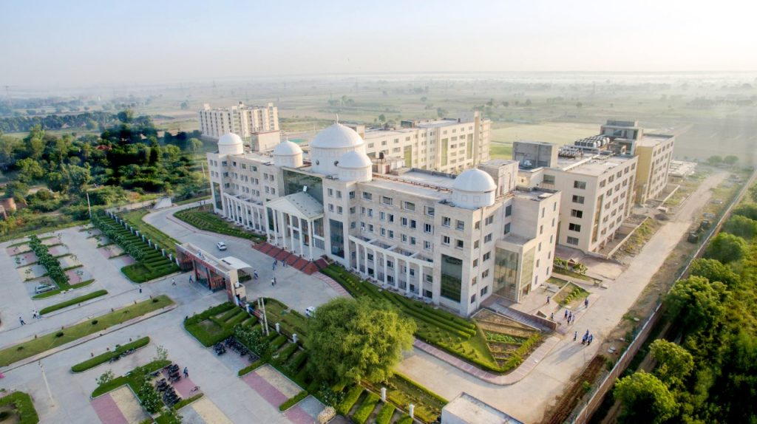
Aerial photograph of campus showing academic blocks and green zones.
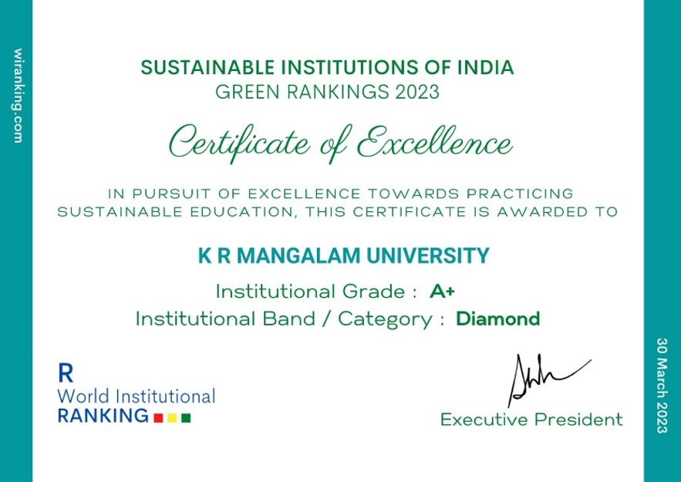
K.R. Mangalam University has been conferred the Certificate of Excellence in the Sustainable Institutions of India – Green Rankings 2023, achieving an A+ Institutional Grade and Diamond Category for its outstanding commitment to sustainable education and campus practices.

1.2 Sustainability Framework & Policies

1.2.1 Sustainable Environment & Green Campus Policy

K. R. Mangalam University (KRMU), Gurugram, has established an institution-wide sustainability framework through its Sustainable Environment & Green Campus Policy, which serves as the principal guiding document for environmental management and climate-responsive campus development. The policy defines the university’s long-term commitments to energy conservation, increased use of renewable energy, reduction of greenhouse gas emissions, and efficient utilisation of natural resources, ensuring that sustainability considerations are systematically integrated into infrastructure planning and operational decision-making.
The policy provides a structured mechanism for implementing energy-efficient technologies, renewable energy systems, and environmentally responsible practices across academic, administrative, residential, and support facilities. It emphasises measurable performance, regular monitoring, and periodic review through audits and reporting mechanisms, enabling continuous assessment and improvement of environmental outcomes. The revised 2023 policy states:“≥ 40% electricity from renewable sources” by 2028 in the Energy Efficiency and Renewable Energy section, and “25% reduction in GHG emissions by 2028; 100% renewable electricity by 2030; net-zero operations by 2035” in the Climate Action and Carbon Neutrality Plan. By embedding sustainability objectives within institutional governance and operational processes, the policy ensures a coordinated, accountable, and performance-driven approach toward developing a resource-efficient and climate-resilient campus.
Sustainable Environment & Green Campus Policy
Policy / Document | Key Commitment | Links
Sustainable Environment & Green Campus Policy 2025 | 40% Renewable Energy by 2028; Net Zero campus target by 2035, No investment in coal/oil; only clean energy | Sustainable Environment & Green Campus Policy
ISO 14001:2015 Certification | Structured environmental compliance (valid to July 2026) | ISO14001-2025
Energy Conservation Act 2001 Compliance | Aligned with BEE guidelines for energy efficiency | Audit reports confirm compliance  Audit Report 2022  Audit Report 2023  Audit Report 2024
SDG 7 Commitment — Affordable & Clean Energy | On-campus Solar energy + community clean energy outreach | Annual SDG report  SDG 7 Annual Report

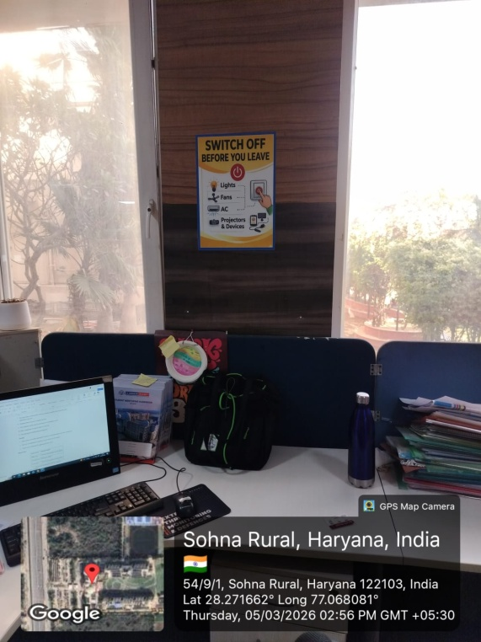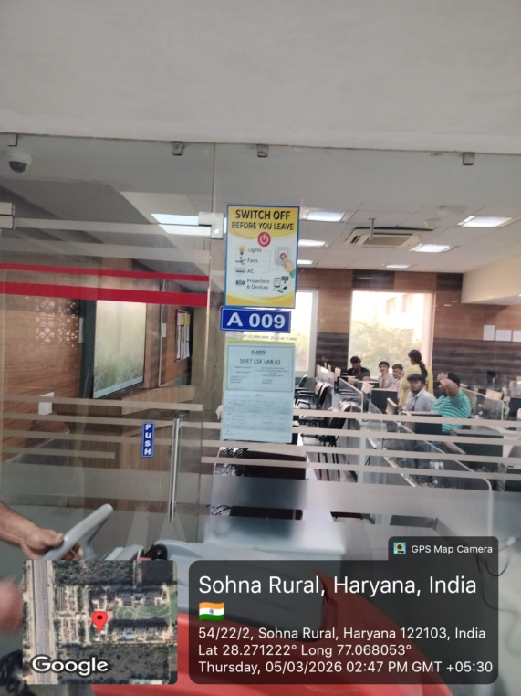
Switch-off protocols for lights, fans, ACs after use of any space.

1.2.2 Standard Operating Procedures (SOPs)
SOP / Protocol | Scope | Status | Evidence Required
Switch-off protocols — lights, fans, ACs after class | All academic blocks | Implemented | Switch-Off Protocol Office order
Laboratory shutdown checklist — equipment, ACs, UPS | All laboratories | Implemented | SOPs switch-off protocols, lab shutdown, hostel rules, timers sensors
Hostel energy rules — AC timings, geyser controls | Hostel blocks (Old + New) | Implemented | [Attach hostel rules]
Timer / PIR sensor controls — corridors, washrooms | Common areas, stairways | Implemented | Sensor installation records
DG set usage restriction — standby use only | Campus-wide | Implemented (275 L/yr usage) | Fuel logs confirm minimal use
AC set-point policy 24–26°C | Admin, classrooms, labs | Implemented | AC protocol office order

1.2.3 Energy Audit History — Third-Party & Internal Audits
Year | Auditor Type | Coverage | Key Findings | Action Taken
2020 | Third-Party | Full campus | LED retrofit needed; solar expansion potential | LED procurement initiated
2021 | Third-Party | Full campus | HVAC optimisation; power factor correction | Capacitor banks upgraded
2022 | Third-Party | Full campus | Solar expanded to 310 kWp; BLDC fan replacement recommended | Solar expansion completed
2023 | Third-Party | Full campus | Complete LED transition; expand sensor coverage | LED transition to 85%; sensors expanded
2024 (May 2025) | Third-Party | Full campus | Energy intensity benchmarking; BLDC rollout acceleration | BLDC rollout ongoing.  No BLDC DATA

1.2.4 Energy Management Committee & Governance
Role / Committee | Responsibility | Link
Energy Manager / Nodal Officer | Energy monitoring, audit coordination, reporting | [Name + constitution order]
Centre of Excellence for SDGs | SDG-aligned monitoring, outreach, reporting | Standing Committee, Multiple events conducted
Works & Maintenance Dept. | Infrastructure upkeep, energy-efficient procurement | [Head name + procurement records]
Energy Management Committee | Monthly/quarterly review, Action Taken Reports | [Constitution + 2 meeting minutes/yr]

UNIVERSITY ENERGY MANAGEMENT COMMITTEE MOM
1.3 Biodiversity, Green cover and Microclimate
K. R. Mangalam University (KRMU), Gurugram, has consciously integrated biodiversity enhancement, green cover development, and microclimate regulation into its campus planning and environmental management practices. The university’s green infrastructure forms a critical component of its sustainability framework, contributing to ecological balance, thermal comfort, and indirect energy conservation across the campus.
As documented in institutional Green Audit and Sustainability Reports, KRMU maintains a substantial green cover with more than 8,000 trees and landscaped green zones distributed across academic blocks, residential areas, circulation spaces, and peripheral buffers. The plantation strategy prioritises native and adaptive species, which require lower irrigation inputs and are better suited to the local climatic conditions of the Gurugram region. This approach supports biodiversity while minimising water and energy demand associated with landscape maintenance.
The campus landscaping is designed to function as a microclimate moderator, reducing ambient temperatures and mitigating the urban heat island effect. Dense tree canopies, green belts along pedestrian pathways, and shaded open spaces significantly lower surface and air temperatures, thereby reducing the cooling load on adjacent buildings. These measures contribute indirectly to energy efficiency by lowering reliance on mechanical cooling systems, particularly during peak summer months.
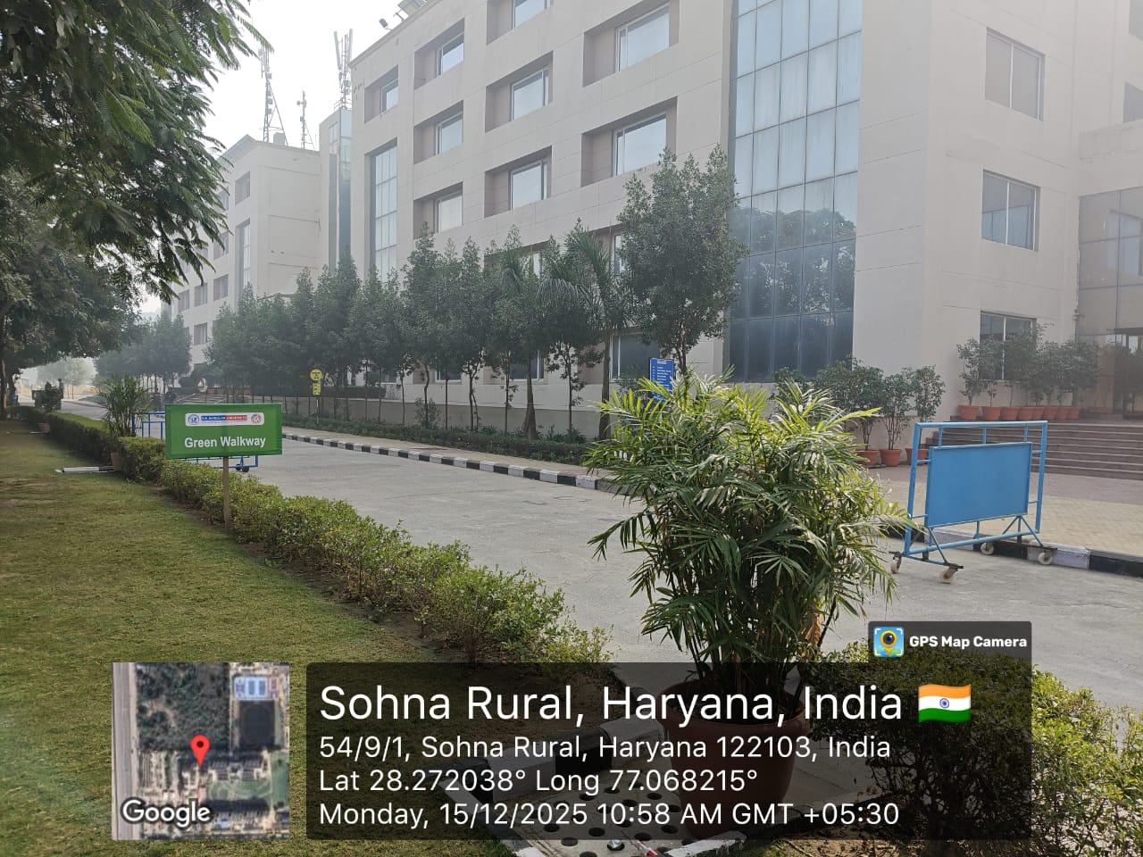
Green belts along pedestrian pathways and shaded open spaces significantly reduce surface and air temperatures
KRMU’s green cover also plays a vital role in stormwater management and groundwater recharge. Rainwater harvesting pits and permeable green areas facilitate natural infiltration, reducing surface runoff and supporting groundwater replenishment. The use of STP-treated water for horticulture, as reported in sustainability disclosures, further strengthens the water–energy nexus by reducing freshwater pumping requirements and associated energy consumption.
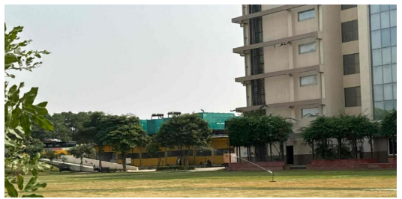
Sprinkler system in Sunken Garden promoting water efficiency and sustainable campus landscaping at K R Mangalam University.
In addition to environmental benefits, the campus green spaces enhance ecological diversity and user well-being. Landscaped zones support local flora and fauna, improve air quality through carbon sequestration and particulate filtration, and provide thermally comfortable outdoor environments for academic and residential use. Regular plantation drives and green maintenance activities documented in audit reports reinforce the university’s commitment to long-term ecological stewardship.
Through sustained investment in green cover, biodiversity-sensitive landscaping, and microclimate-responsive planning, K. R. Mangalam University demonstrates a holistic approach to environmental sustainability. These measures complement the university’s energy conservation and climate action initiatives by delivering measurable ecological, thermal, and operational benefits, thereby supporting a resilient and resource-efficient campus environment.
Campus Green Cover & Biodiversity Management
Parameter | Description / Status
Campus Green Cover | The university campus maintains extensive landscaped green areas with more than 8,000 trees, distributed across academic blocks, residential zones, internal circulation areas, and peripheral buffers.
Plantation Strategy | Plantation activities prioritise native and adaptive plant species, contributing to ecological balance and reduced irrigation demand.
Biodiversity Enhancement | Regular plantation drives and maintenance activities are conducted to strengthen campus biodiversity and green cover.
Irrigation & Water Use | STP-treated water is utilised for horticulture and landscaping, reducing dependence on freshwater sources and associated pumping energy.
Microclimate Regulation | Dense vegetation, shaded pedestrian corridors, and green buffers contribute to improved thermal comfort and moderation of ambient conditions across the campus.
Energy Demand Moderation | Campus greenery supports reduction of heat gain around buildings, indirectly contributing to lower cooling demand and improved energy efficiency.
Quantified Temperature Reduction | No direct instrumental temperature measurements are reported in current audit documentation.
Quantified Energy Savings | No separate kWh savings attributed exclusively to landscaping are reported in audit documents.
Monitoring & Review Mechanism | Biodiversity, green cover, and associated environmental impacts are reviewed through periodic Green Audits and Sustainability Reviews.

2. Energy Systems in K R Mangalam University
To reduce overall energy consumption and associated greenhouse-gas emissions, K.R. Mangalam University has been progressively integrating energy-efficiency considerations into building planning, upgrades, and day-to-day operations. Across campus buildings, design and operational measures are oriented toward reducing dependence on artificial lighting and mechanical cooling by improving daylight availability and natural ventilation wherever site conditions and functional requirements permit. Measures such as appropriate window sizing and placement, shaded edges (e.g., canopies/louvers), ventilated corridors, and climate-responsive building orientation are used to support indoor comfort and lower energy demand.
On the operational side, the University has undertaken upgrades to improve lighting efficiency by transitioning from conventional fixtures to LED lighting across key functional areas (academic and administrative spaces, hostels/residential areas, laboratories, and external circulation). Where installed, controls such as occupancy sensors, timers, and automated shut-off in intermittently used spaces (e.g., washrooms, staircases, and storage areas) help reduce avoidable electricity consumption. Periodic energy audits and internal reviews are used to assess consumption patterns, identify inefficiencies, and recommend corrective actions, such as retrofitting outdated fixtures/equipment, optimising lighting layouts, and improving the performance of older building elements where feasible. In selected outdoor zones, solar-powered lighting is also used to reduce reliance on grid electricity while supporting safe campus movement. Through a combined approach—efficient retrofits, appropriate controls, routine monitoring, and climate-responsive design intent—K.R. Mangalam University continues to strengthen long-term energy performance, reduce operating costs, and support broader national objectives on energy conservation and climate action. Periodic energy audits validate these measures and recommend further retrofits.
Audit Report 2020
Audit Report 2021
Audit Report 2022
Audit Report 2023
Audit Report 2024

2.1 Campus Energy Profile & Infrastructure
K.R. Mangalam University is actively implementing energy-efficient renovation and building initiatives across its campus to promote sustainability and reduce environmental impact. The University’s infrastructure strategy emphasises retrofitting existing buildings with advanced energy-saving technologies, including LED and sensor-based lighting, BLDC fans, and energy-efficient HVAC systems. Continuous energy audits guide targeted interventions to minimise consumption and optimise building performance. In new constructions, green building design principles are followed—ensuring ample natural light, thermal insulation, and the integration of renewable energy systems such as rooftop solar panels. Through these combined measures, K.R. Mangalam University demonstrates its commitment to sustainable campus development.
Details of the Installed Power Infrastructure on the campus
Component | Capacity / Description
Rooftop Solar PV System | 310 kW installed across Blocks A, B, C, and Hostels
Solar Water Heaters | Catering to hostel blocks for hot water supply
Electricity Supply | Grid electricity supplemented by Solar; DG sets used only as a standby
Biogas Plant | 100 kg/day organic waste capacity generating clean fuel
LED Ligting | Complete transition in 2024–25
BLDC Fans | ????
Sensor-based systems | Installed in the washrooms & corridors

2.2 Solar Installations
K.R. Mangalam University has established a 310-kW rooftop solar power generation system across Academic Blocks A, B, and C, as well as the hostel buildings. This system provides a reliable, uninterrupted supply of clean energy during daytime hours throughout the year, significantly reducing dependence on conventional grid electricity.
Link: Solar energy.pdf

Solar Generation Contribution
Year | Solar Generation (kWh) | Approx. Share of Total Demand | CO₂ Reduction (tonnes/year)
2022–23 | ~330,000 | 16–18% | ~270
2023–24 | ~335,000 | 17–19% | ~275
2024–25 | ~340,000 | 17–19% | ~278
*Solar generation has remained stable due to consistent 310 kW capacity.
Data for Solar Panels
Sr.No | Building | No. of Panels | Total no. of solar panels | Capacity | Total capacity | Rebate rate
1 | A | 157 | 984 | 310 Kw/day | 41850 units/month | 0.25
2 | B | 375
3 | C | 204
4 | DG | 120
K.R. Mangalam University has demonstrated steady progress toward achieving Affordable and Clean Energy by significantly enhancing the contribution of solar energy to its overall electricity consumption. During 2018–2020, the University generated a cumulative 870,125 kWh of solar power, while in 2021–2023, this figure rose to 912,489 kWh, reflecting an improvement of approximately 4.9 % in renewable energy generation. The increase indicates more efficient operation and maintenance of the installed solar photovoltaic system, supported by favourable weather conditions and optimization of load management. The University’s annual solar generation now averages around 304,000 kWh, contributing substantially to its yearly power requirement of 1.82 million kWh. This consistent generation pattern signifies a growing renewable energy share in total electricity use and directly supports the University’s low-carbon transition strategy by reducing dependence on conventional grid supply.
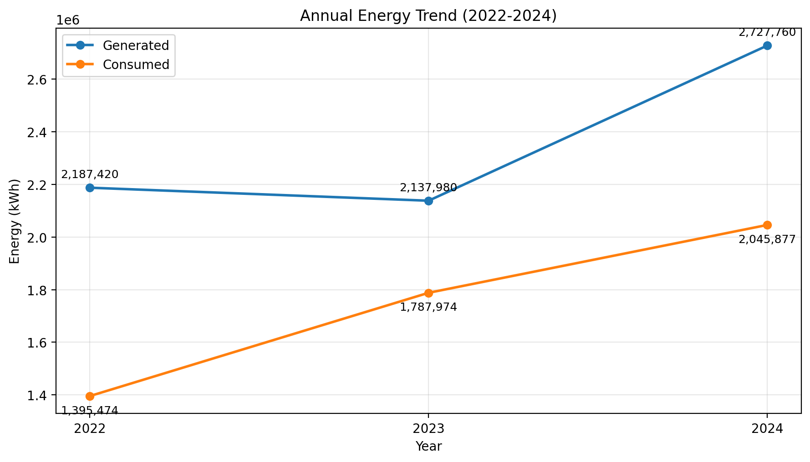

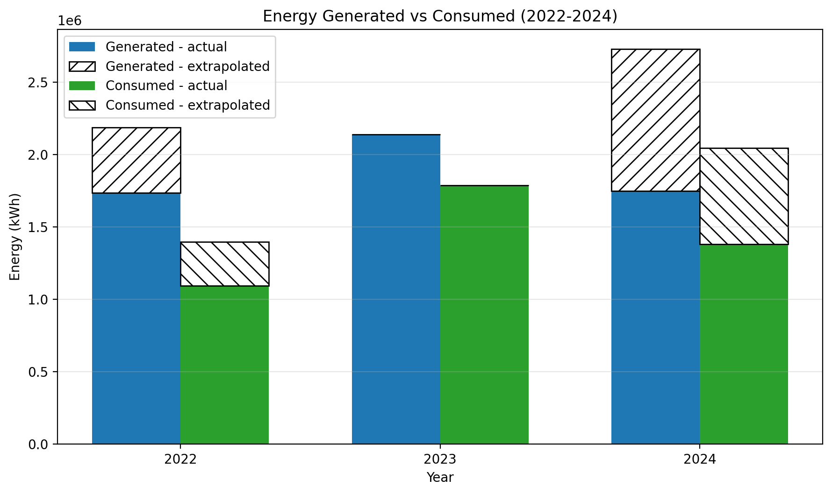

Consolidated annual table (2022–2024)
Annual Year (Jan–Dec) | Solar generated (kWh) | Grid electricity consumed/imported (kWh) | Total campus energy requirement (Solar + Grid) (kWh) | Net billed units (kWh) | Solar share of total requirement
2022 | 1,053,816.7 | 1,395,474.1 | 2,449,290.8 | 1,395,474.1 | 43.03%
2023 | 350,006.5 | 1,787,974.0 | 2,137,980.5 | 1,787,974.0 | 16.37%
2024 | 561,779.2 | 2,045,876.8 | 2,607,656.0 | 1,584,853.7 | 21.54%

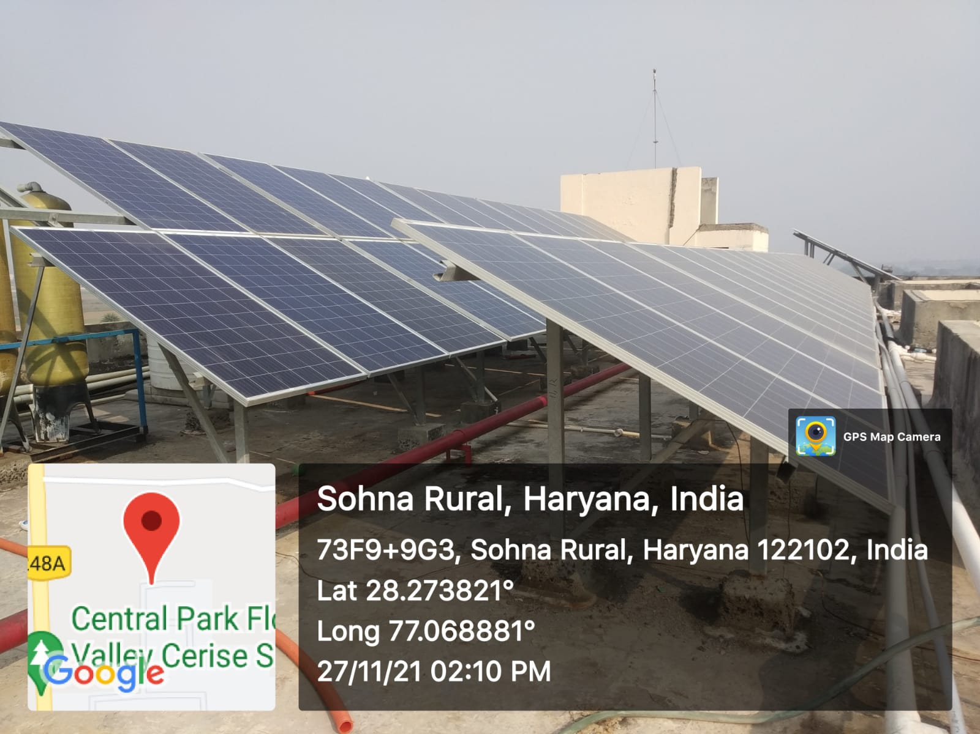
310 kWp rooftop solar PV system across Academic Blocks and hostels, generating clean electricity and reducing dependence on grid power
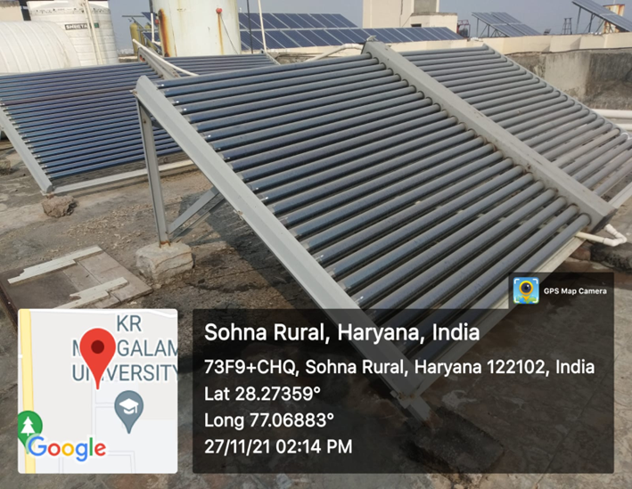
Solar thermal system providing hot water in hostels, reducing LPG and grid energy dependence
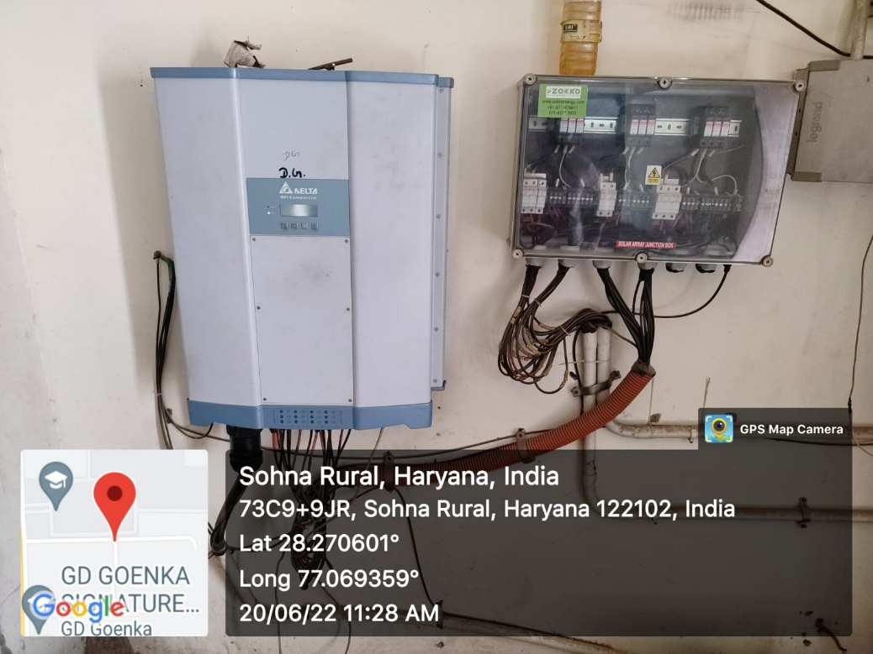
Grid-connected solar system with net metering — Exporting excess renewable power to the grid and supporting regional clean-energy distribution

2.3 Energy Efficient Appliances
Sensor-based systems
Sensor-based systems K.R. Mangalam University prioritises energy efficiency as a core strategy for sustainable campus operations. To achieve this, the University has implemented sensor-based systems for both water and energy conservation. Sensor-operated taps are installed in all washrooms to minimise water wastage, while PIR (Passive Infrared) motion sensors are integrated at building entry points and common areas to automatically regulate lighting and reduce idle power consumption. These sensors detect human movement and control relays that switch lights or circuits on and off, thereby optimising energy usage.
Sensor-based Energy Conservation
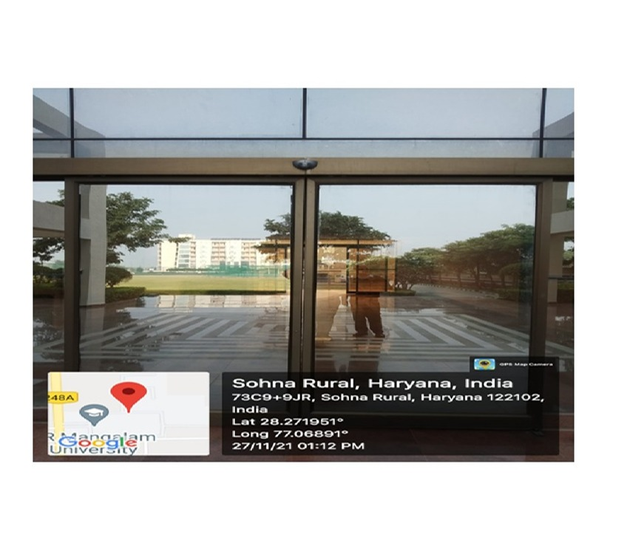
Sensor-operated entry doors across academic buildings, minimising conditioned-air loss and enhancing HVAC efficiency to reduce energy demand
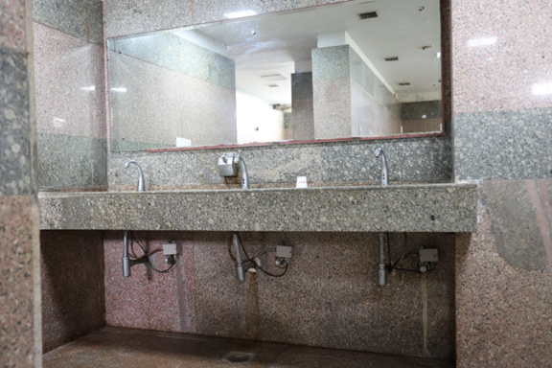
Sensor Taps in the Washrooms of the University, Reducing water wastage and associated pumping energy load through motion-activated controls
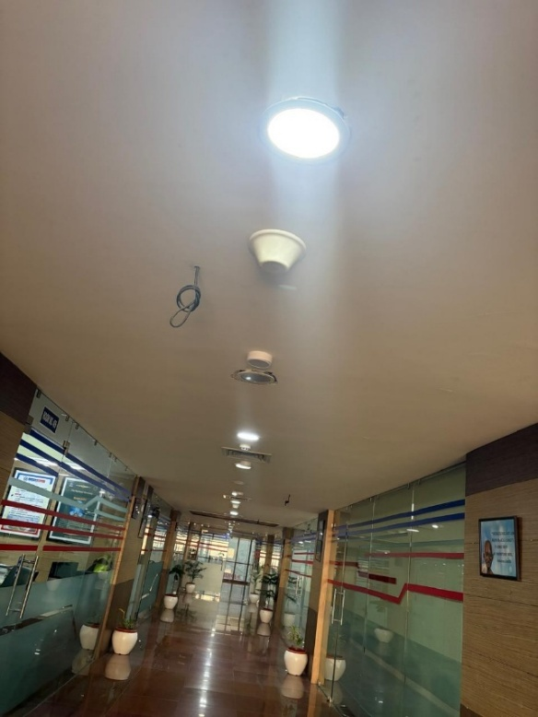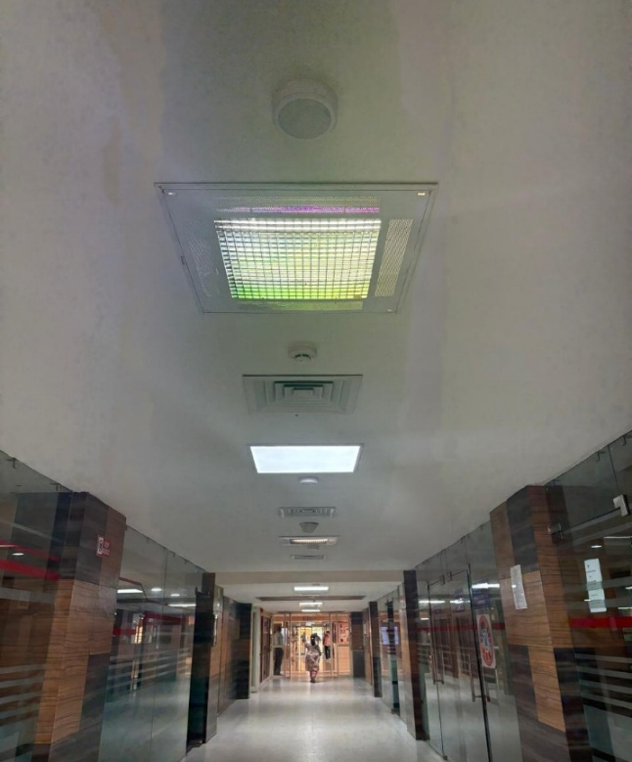
PIR motion-sensor lighting in corridors and common areas — Optimising electricity use by activating LED fixtures only during occupancy

Campus-Wide Transition (2022–25)
Appliance Type | 2022–23 | 2023–24 | 2024–25 | Remarks
LED Lights | 60% | 94% | Aprox 100 | Complete transition in 2024–25
BLDC Fans | Recommended | Partial rollout | Ongoing | Saves 50–60% energy
Sensor-Based Controls | Limited | Medium rollout | High coverage | Installed in the washrooms & corridors
5-Star HVAC | Low | Medium | High | Upgrades during maintenance cycles
Smart Regulators | Limited | Medium | Medium-high | Improves fan efficiency

- Aprox 100% LED lighting achieved by AY 2024–25
- Sensors reduce idle consumption significantly
- Replacement of high-load appliances planned in phases

2.3.1 Energy-efficient LED fixtures
K.R. Mangalam University has undertaken a comprehensive replacement of conventional lighting with energy-efficient LED fixtures across all academic and residential blocks to minimize energy consumption and carbon emissions. This transition has significantly reduced CO₂ output, lowered maintenance costs, and enhanced overall system efficiency. The LED retrofit is part of the University’s broader green-campus initiative focused on optimizing resource use, reducing operational energy demand, and fostering sustainable infrastructure.
E-LED and Energy Efficient Equipment

Block-wise LED Lighting Inventory
Block / Zone | Total Light Fixtures | LED Fixtures Installed | Non-LED Remaining | LED % | Status
Block A | 2,841 | 1,108 | 1,733 | 39.0% | Partial — upgrade required
Block B | 2,535 | 711 | 1,824 | 28.0% | Partial — major upgrade needed
Block C | 1,557 | 1,410 | 147 | 90.6% | Near complete
Old Hostel | 2,608 | 1,845 | 763 | 70.7% | Good progress
New Hostel | 2,778 | 2,778 | 0 | 100.0% | ✓ Complete
Block D | 688 | 688 | 0 | 100.0% | ✓ Complete
TOTAL CAMPUS | 13,007 | 8,540 | 4,467 | 65.7% | In Progress

Year-wise LED Progress
Academic Year | LED Fixtures (est.) | Total Fixtures | LED % | Key Action
2022–23 | ~7,800 | 13,007 | ~60% | Major LED installation drive
2023–24 | ~11,000 | 13,007 | ~85% | Expanded rollout, new hostel complete
2024–25 (current) | 8,540 | 13,007 | 65.7% | Per inventory; Blocks A & B require upgrade
NOTE: The 2024-25 inventory figure (65.7%) is lower than the reported 85% for 2023-24. This may reflect a physical re-count vs. estimated figures, or fixtures removed/replaced. Please reconcile with Works & Maintenance records.

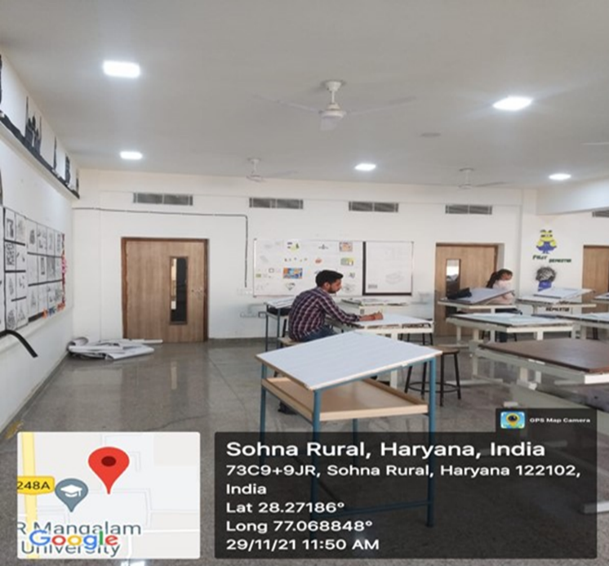
Energy-efficient LED lighting across campus, replacing CFL & tube lights for improved performance & reduced carbon footprint

2.3.2 AC Set-Point Policy & Controls
Control Measure | Policy / Norm | Evidence
AC Set Temperature | 24–26°C (per BEE Star Label guidelines) | [Attach policy circular]
AC Operational Hours | 8 AM–8 PM in classrooms only; restricted overnight | Attach scheduling notice
Hostel AC Policy | Timing restrictions; no overnight AC in common areas | Attach hostel rules circular
5-Star AC Procurement | Mandatory 5-Star BEE rating for all new AC procurement | Purchase orders / procurement policy
HVAC Audit Compliance | AC performance reviewed in all annual energy audits | Energy Audit Reports 2020–2024
2.3.2 Upgrade buildings to higher energy efficiency
K.R. Mangalam University has initiated a structured energy efficiency improvement plan targeting existing academic and residential buildings. The Energy Audit of K.R. Mangalam University identifies key areas of high consumption and recommends targeted interventions to reduce energy intensity.
energy audit krmu 2025

Planned and on-going measures include:
Efficient Appliances: Gradual replacement of all conventional ceiling fans with BLDC fans, improving efficiency by up to 60%.
Power Factor Optimisation: Installation and regular maintenance of capacitor banks to maintain a power factor of 0.95–0.99, reducing reactive losses.
Smart Controls: Expansion of sensor-based lighting and water systems (already installed in some blocks) to reduce wastage.
Solar Energy Integration: Continued use and expansion of the 310 kW rooftop solar system, reducing dependence on grid electricity and offsetting emissions.
Energy Monitoring & Load Management: Regular tracking of consumption patterns to identify “energy guzzlers” and prioritise retrofit investments.
Energy Audit Summary- 2022- 2024
Category | Initiative | Energy Saved / Generated (kWh) | CO₂ Reduction (tonnes/year)
Solar Power Generation | 310 kW rooftop solar PV supplying campus | 340,142 kWh | ≈ 279.9 t CO₂
LED Retrofit | 5074 LED fittings replacing CFL/tube lights | 17,384 kWh saved | ≈ 14.3 t CO₂
Biogas Plant | Food-waste-to-energy system | ≈ 7 kg LPG/day offset; food waste processed ≈ 3.8 tonnes/year | 5–8 t CO₂
Sensor-based Systems | PIR motion lighting + sensor taps | Estimated operational savings | ≈ 1.2–1.8 t CO₂
Power Factor Optimization | Capacitor banks (PF 0.95–0.99) | Avoided losses, stable power | ≈ 0.5–0.8 t CO₂ (est.)
Diesel Reduction | Minimal diesel use due to solar + grid reliability | DG-use avoided | ≈ 2–3 t CO₂ avoided
Total clean energy generated & saved |  |  | ≈ 357,526 kWh
Total annual CO₂ reduction |  |  | ≈ 300–305 t CO₂ / year

2.3.2 Carbon reduction and emission reduction process:
K.R. Mangalam University has established a structured and policy-driven approach for carbon management and the reduction of carbon dioxide emissions through its Sustainable Environment and Green Campus Policy. The policy mandates a progressive shift to low-carbon energy sources, including the “installation of solar photovoltaic panels” with a target of “30% of total electricity consumption to come from renewable sources by 2028.” Energy-efficiency enhancement is built into campus operations through replacing CFLs and tube lights with LED lighting and adopting motion sensors. Fossil-fuel dependence is reduced through sustainable transport measures, restricting diesel and high-emission vehicles, and “introducing Electric Vehicle (EV) carts. Carbon-sink strategies and circular waste management further support emission reduction through “on-campus organic composting units,” “biogas generation from hostel food waste,” and maintenance of “minimum 30% green cover with native flora”. The biogas system contributes directly to avoided emissions. Through these integrated and monitored systems, the University demonstrates a clear and ongoing institutional process for carbon reduction and emission control.

K.R. Mangalam University Sustainable Environment and Green Campus Policy
Link for all ISO certificates
Carbon emission report
2.3.3 Renewable Energy Integration
K.R. Mangalam University has undertaken a comprehensive Energy Audit as part of its commitment to Affordable and Clean Energy, focusing on the efficient use of energy resources and the integration of renewable energy systems across the campus. The audit assessed energy consumption patterns, identified potential areas for conservation, and recommended actionable strategies to enhance sustainability. Aligned with national energy efficiency guidelines, KRMU has adopted several renewable energy measures—including the installation of solar panels, use of LED lighting, to reduce its carbon footprint and foster a culture of responsible energy use. This initiative reflects the University’s vision to lead by example in advancing clean energy solutions within higher education.

Alternate sources of Energy and Energy conservation Measures
Audit Report 2020
Audit Report 2021
Audit Report 2022
Audit Report 2023
Audit Report 2024

K.R. Mangalam University has demonstrated consistent progress in renewable energy integration through its on-campus solar photovoltaic (PV) power plant, from 2022 to 2024. The University’s solar generation rose significantly—from negligible output prior to 2022 to 82,440 kWh in 2023 with the installation of a 100 kWp rooftop system, and further expanding to an estimated 310,000 kWh in 2024 after major retrofitting and capacity enhancement to 310 kWp. This sharp rise in generation reflects improved maintenance practices, inverter efficiency, and system load optimisation. At the national emission factor of 0.8 kg CO₂ per kWh, the system now offsets approximately 250 tonnes of CO₂ annually, supplying around 40–45 % of the campus’s total electricity demand. This steady growth underscores KRMU’s commitment to a sustainable, low-carbon future through continual expansion of renewable energy infrastructure.
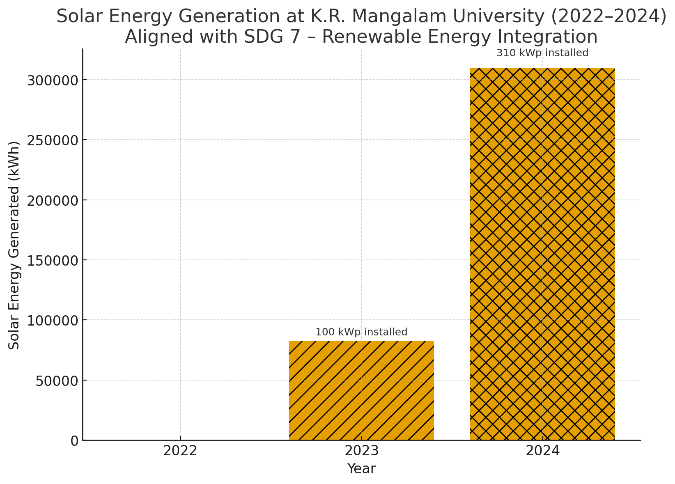
Retrofitting & Capacity Enhancement (2022–2024)
2022: Baseline (no solar generation)
2023: Installation of 100 kWp solar system, generating ~82,440 kWh
2024: Expansion to 310 kWp capacity, estimated generation ~310,000 kWh
2.3.4 Transition from Fossil Fuels and Energy Efficiency
Use of diesel-based backup generation is minimal. Annual consumption of 275 litres of diesel produces only 0.505 tonnes of CO₂, indicating that diesel generators are used solely during grid outages. The University has installed LED lighting, 5-star-rated equipment, and sensor-based controls to enhance efficiency and reduce indirect emissions. Periodic energy audits validate these measures and recommend further retrofits.
Audit Report 2020
Audit Report 2021
Audit Report 2022
Audit Report 2023
Audit Report 2024

2.3.5 Waste Management and Carbon Sinks
K R Mangalam University undertakes tree-plantation drives, composting, and waste recycling to support carbon sequestration and reduce methane emissions. MoUs with authorized recyclers (SRC Enterprises, Adinath Recyclotronix Pvt. Ltd., Indian Petro & Chemicals) ensure proper handling of paper, e-waste, and hazardous waste. The University also has tie ups with for to help University implement green campus Program. The University implements alternate energy use, LED retrofits, and sustainable waste practices across the campus.
Waste disposal MoU: Hazardous waste & scrap disposal MoU
Audit Reports
The University collaborates with The Climate Project Foundation (TCPF)—a partner organization of the United Nations Sustainable Development Goals (SDGs)—to create awareness on climate change, clean energy, and e-mobility. Through this partnership, the University integrates environmental sustainability messages across academic and outreach activities, encouraging teachers, students, and parents to adopt climate-positive behaviours.
MoU with Climate Project foundation: MOU
Green campus initiatives

2.3.6 Climate-Responsive Building Design (Passive Cooling)
- Appropriate window sizing, shaded edges (canopies, louvers) and ventilated corridors reduce mechanical cooling demand
- Climate-responsive building orientation in academic blocks minimises solar heat gain
- Extensive green cover (>1,400 mature trees, 6.39 acres) acts as natural heat sink — reduces ambient temperature and cooling load
- Shaded pedestrian pathways and green belts reduce surface temperatures and improve thermal comfort
- STP-treated water for horticulture — reduces freshwater pumping energy while maintaining green cover

Green belts along pedestrian pathways and shaded open spaces significantly reduce surface and air temperatures — reducing cooling load on adjacent buildings
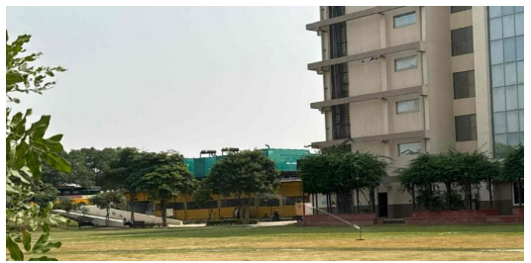
Sprinkler system in Sunken Garden — promoting water efficiency and sustainable campus landscaping at KRM

K.R. Mangalam University has organised a substantial number of awareness programmes, tree plantations, cleanliness drives etc

The extensive green cover at K.R. Mangalam University functions as a vital natural heat sink, mitigating the urban heat-island effect commonly observed in built environments. Vegetation, trees, and landscaped open spaces absorb solar radiation and release moisture through evapotranspiration, thereby cooling the surrounding microclimate. Regular tree-plantation drives, landscaping, and preservation of open courtyards ensure a balanced thermal environment across the campus, strengthening the ecosystem’s capacity to act as both a carbon sink and a thermal regulator.
Link for green campus initiatives: Green campus initiatives
Link for KRMU green areas: KRMU Green areas

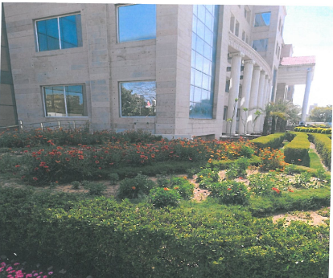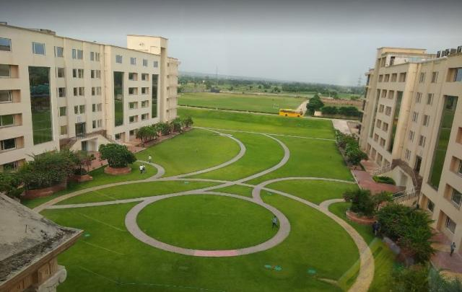
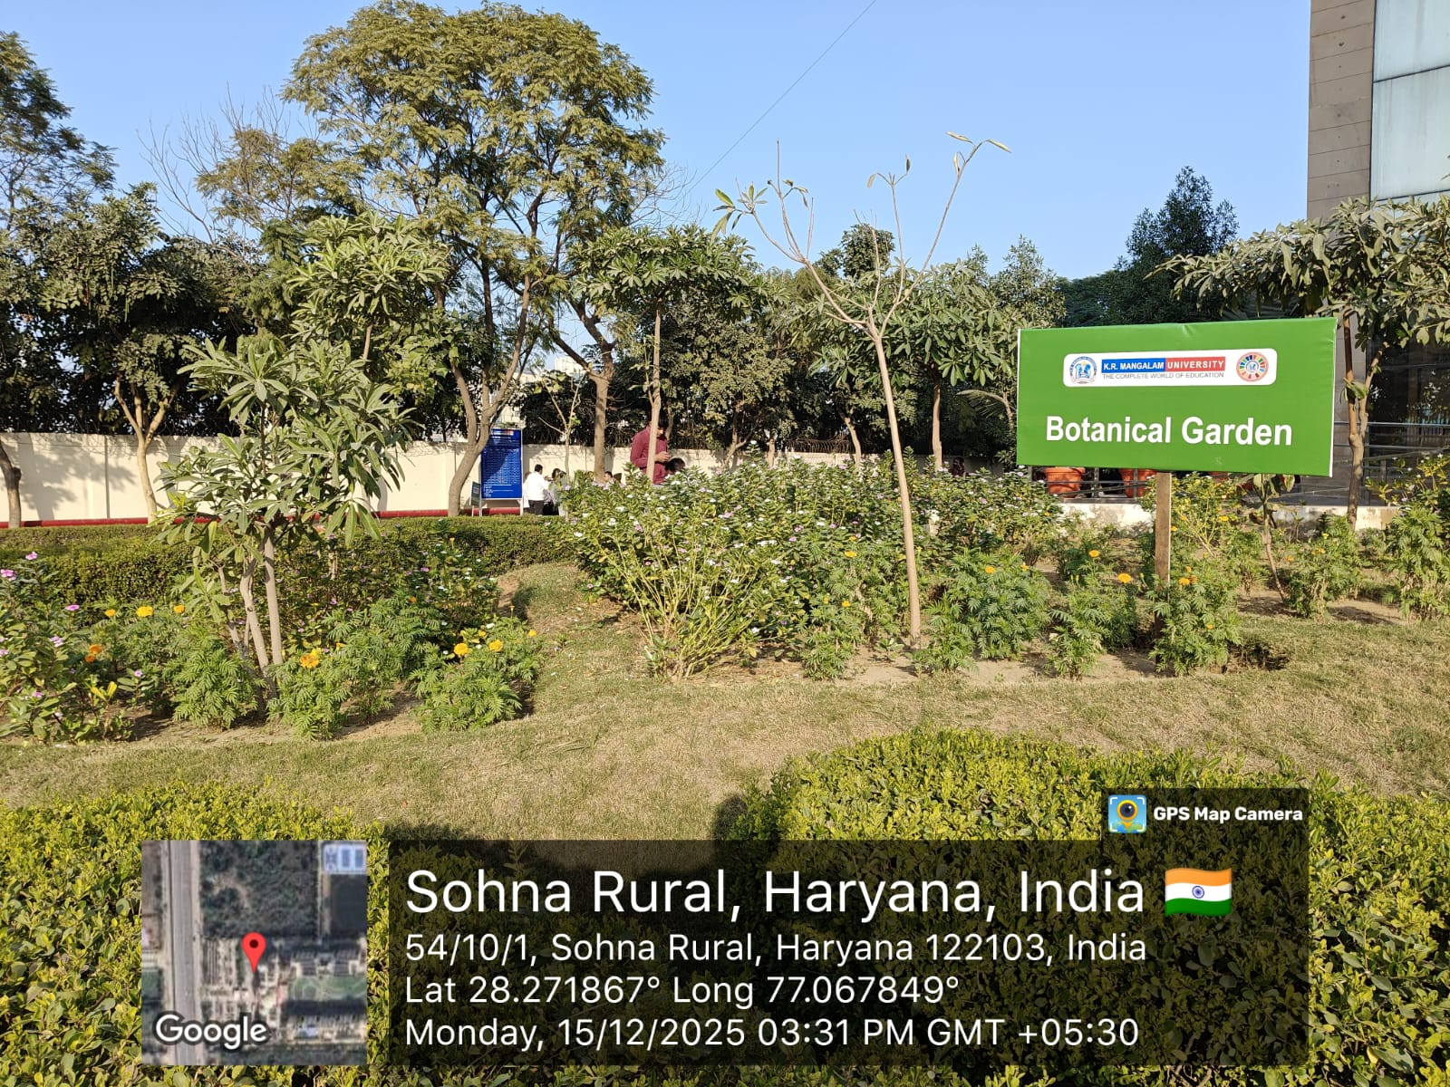
Green landscape and courtyards across campus act as natural cooling systems and reduce the heat-island effect.
3. Monitoring, Reporting and Carbon Footprint Evaluation
K.R. Mangalam University conducts annual carbon footprint assessments to quantify direct and indirect emissions from fuel, transport, and energy use across the campus. The analysis covers categories such as diesel generator operations, university transport, private commuting, and public mobility.
During the 2023–24 cycle, the estimated fuel-related footprint was as follows
Source | Fuel Type | Annual Consumption | Estimated CO₂ Emission (tonnes/year)
Diesel Generators | Diesel | Data maintained in campus fuel logs | 65 tCO₂e
University Transport | Diesel / CNG | Data maintained in vehicle fuel records | 42 tCO₂e
Private & Contracted Transport (Commuting – Students & Staff) | Petrol / Diesel / Public Transport | Distance & fuel-use survey data | 190 tCO₂e
LPG Use (Hostels/Cafeteria – after biogas substitution) | LPG | Data maintained in kitchen gas logs | Negligible / offset by biogas
Electricity (grid-based)* | — | Based on electricity bill (kWh) | 410 tCO₂e
As part of its institutional commitment to sustainability and responsible environmental stewardship, K.R. Mangalam University undertook a structured carbon footprint assessment for the year 2023–24. The exercise was carried out in adherence to the Greenhouse Gas (GHG) Protocol, ensuring standardised accounting of direct and indirect emissions across all operational domains of the campus. The analysis draws exclusively from verified institutional records, including energy and fuel consumption logs, transport and commuting data, waste and water management systems, and ICT-related energy usage. This consolidated carbon footprint forms the basis for evidence-driven climate action planning and continuous improvement toward a carbon-efficient and environmentally resilient campus.
Table: Carbon Foot printing Calculation for (2023–24)
Source Category | Fuel / Energy Type | Basis of Calculation | Annual Emissions (tCO₂e)
Electricity Consumption | Grid Electricity | Electricity bills & CEA emission factor | 410
Diesel Generators | Diesel | DG fuel logs & emission factor | 65
University Transport | Diesel / CNG (Campus Buses & Official Vehicles) | Transport logs & fuel conversion factors | 42
Private & Contracted Transport (Commuting) | Petrol / Diesel / CNG (Students & Staff) | Commuting survey and transport estimates | 190
Waste Disposal | Solid, Paper, Plastic Waste | Municipal waste & recycling records | 18
Water Treatment & Supply | Pumping, Filtration, STP | Electricity load for water systems | 25
ICT & Office Equipment | Electricity for digital infrastructure | Server rooms, labs, admin buildings | 30
Biogas System | Food Waste → Biogas | Waste-to-energy offset | 0 (Net-Zero)
Waste minimization practices, including composting, biogas generation, and plastic-use reduction, contribute to lowering indirect carbon emissions, while sustainable mobility initiatives—such as EV shuttles and bicycle use. All key parameters related to carbon output, such as electricity consumption, diesel use, and solar generation, are monitored through regular energy and environmental audits, enabling data-driven action. In addition, the University’s carbon management process is further validated through its ISO 14001:2015 Environmental Management System Certification (valid till 24 July 2026), which ensures structured compliance with international environmental standards and demonstrates the institution’s commitment to continuous improvement in environmental performance.
ISO: 14001:2015 7.23 Environment Management Certification
Through these integrated steps, K.R. Mangalam University demonstrates a clear and measurable process for carbon reduction, contributing meaningfully to environmental stewardship in higher education.
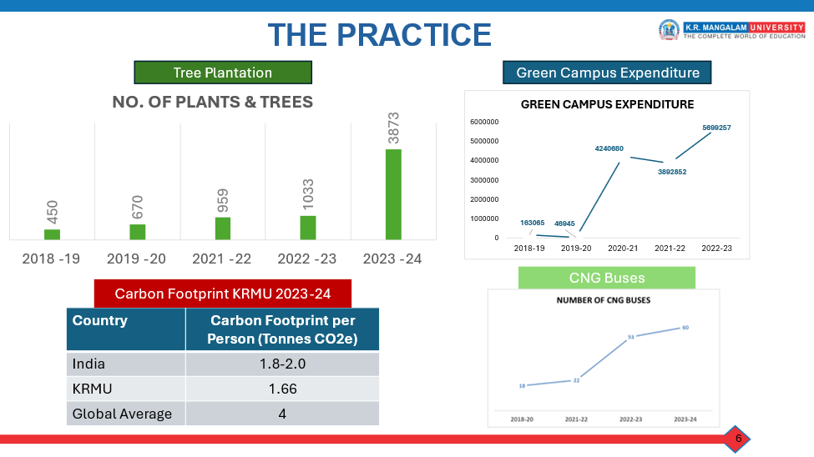
Institutional Practice for Reducing Energy Consumption and Carbon Footprint
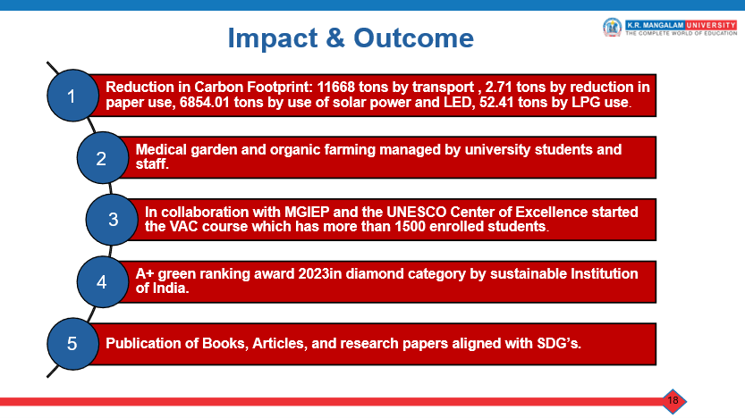
3. Monitoring, Reporting and Carbon Footprint Evaluation
3.1 Energy wastage identification
Undergo energy reviews to identify areas where energy waste is highest
K.R. Mangalam University undertakes regular energy reviews and audits to systematically identify areas of highest energy waste and prioritize efficiency interventions. As part of the comprehensive Energy Audits, consumption patterns are mapped across academic blocks, hostels, and utility systems. The data-driven insights from the Audit reports has informed targeted action plans focusing on lighting retrofits, HVAC system optimization, and the replacement of inefficient fans and equipment. In addition, periodic performance assessments of transformers, DG sets, and solar power generation help detect load imbalances, avoid leakage losses, and optimize energy use. These structured energy reviews enable the institution to pinpoint and address wastage sources proactively, ensuring continuous improvement in operational efficiency.
Through Audits. energy-audit-krmu-23-05-2025.pdf
Link for Audit reports: https://www.krmangalam.edu.in/affordable-and-clean-energy

3.2 Monitoring
K.R. Mangalam University monitors and reports its total annual energy use as part of its institutional sustainability commitment and energy audit framework. Based on the Energy and Green Audit Reports, the University’s approximate Energy Use Intensity (EUI) for the year 2023–24 is 0.145 GJ/m²/year, calculated over a total built-up area of 52, 0972m². The total estimated energy use for the reporting period is approximately 6,400–7,000 GJ, comprising both purchased electricity and fuel used in DG sets. Of this, solar power generation contributed 340,142 kWh, equivalent to approximately 1,224.51 GJ, while diesel consumption of 122,000 liters produced around 4,367.6 GJ
energy-audit-krmu
K.R. Mangalam University Sustainable Environment and Green Campus Policy

Energy use intensity calculated from verified energy-audit figures and total built-up area; renewable energy contribution based on solar production logs
Parameter | Value | Source
Total Built-up Area | 52, 0972m² | Campus Architectural Records
Total Energy Consumed (Annual) | ≈ 6,700 GJ | Energy Audit Report
Renewable Energy Generated (Solar) | 1,224.51 GJ (340,142 kWh) | Solar Audit & Bills
Share of Renewable Energy | ≈ 17–19% | Green Audit & Policy
Energy Intensity (EUI) | ≈ 0.14 GJ/m²/year | Energy Audit
Target by 2028 | 30% Renewable Share | Sustainable Environment & Green Campus Policy

Energy audit results confirm that K.R. Mangalam University maintains an annual energy intensity of ~0.14 GJ/m², supported by solar integration and energy-efficiency interventions. With ~1,224.5 GJ contributed through rooftop solar and continuous power-factor optimisation, LED retrofits, and sensor-based systems, the University demonstrates a measurable transition toward a low-carbon, high-efficiency campus. These indicators align with the institutional target of achieving 30% renewable-energy share by 2027 as outlined in the Green Campus Policy.

4. Waste-to-Energy & Biogas Systems
4.1 Energy from Food Waste & Biogas Generation
K. R. Mangalam University has institutionalised a waste-to-energy approach for managing biodegradable waste generated across hostels, canteens, and food courts, with a clear focus on energy recovery and emission reduction. Biodegradable waste is segregated at source using colour-coded bins placed across academic, dining, and residential areas, in alignment with the University’s Sustainable Environment and Green Campus Policy, ensuring that organic waste is channelled efficiently into treatment systems rather than mixed disposal streams.
Segregated food and organic waste is routed to the campus biogas plant, where it is processed through anaerobic digestion to produce renewable biogas. The biogas is utilised for cooking and other thermal applications within campus facilities, thereby substituting conventional LPG and reducing fossil-fuel dependence. In parallel, digestate and other biodegradable fractions are processed through composting and vermicomposting, producing nutrient-rich compost and vermicompost used for landscaping and plantation activities—supporting resource efficiency while keeping the primary emphasis on energy generation from waste.
This waste-to-energy system delivers multiple outcomes: it reduces organic waste sent to landfills (thereby avoiding methane emissions from uncontrolled decomposition), generates on-campus renewable energy that contributes to affordable clean energy use, and strengthens circular resource flows by converting waste into useful energy and soil inputs. By linking waste management directly to energy substitution and low-carbon operations, the University’s biogas initiative functions as a practical clean-energy intervention within campus infrastructure and supports SDG-aligned outcomes related to clean energy, sustainable consumption, and low-emission campus operations.
Biogas plant and compost unit details
Waste segregation policy
Environmental audit krmu_Quantity of waste processed
By integrating energy audits, renewable energy expansion, and operational efficiency strategies, K.R. Mangalam University demonstrates a measurable commitment to low-carbon energy use, contributing to national climate targets.
energy-audit-krmu-23-05-2025
BioGas-Plant

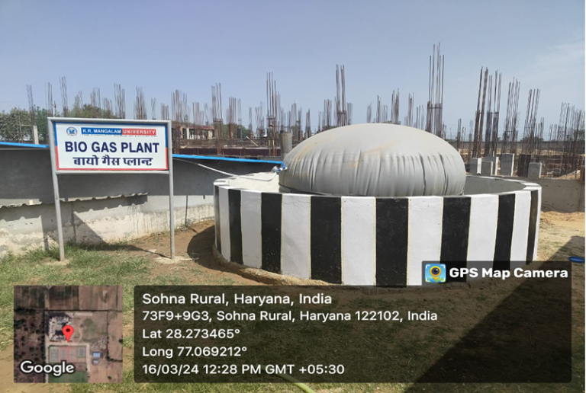
Campus biogas plant converting food waste into clean energy, replacing LPG & generating organic fertiliser

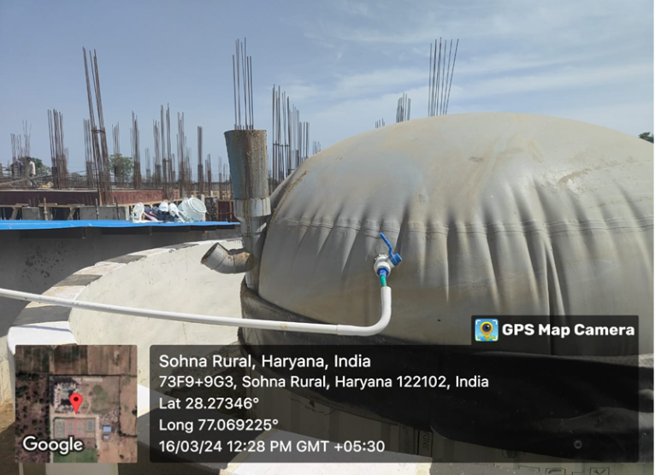
Food waste inlet chamber demonstrating closed-loop waste-to-energy system

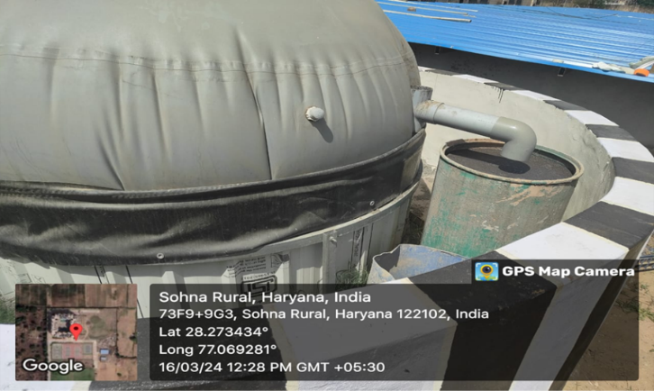 Biogas outlet & slurry discharge used as organic manure for campus horticulture sustainability

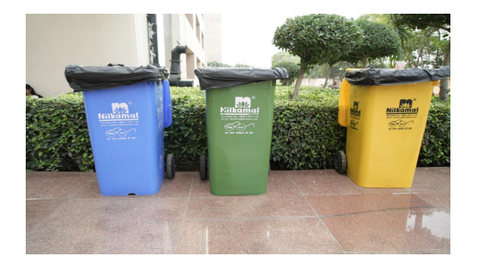
Colour-coded bins across K R Mangalam University promote source-level waste segregation and responsible recycling

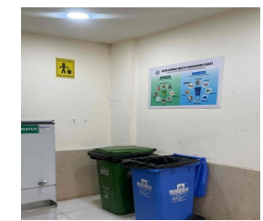
Source-level waste segregation bins across academic blocks
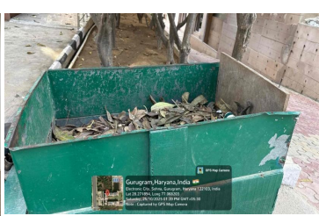
Organic composting of biodegradable waste.
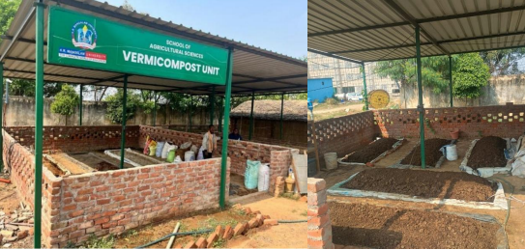
Composting and vermicomposting units
5. Sustainable Mobility & Transportation

5.1 Campus Mobility Planning
K. R. Mangalam University follows a campus-first mobility hierarchy that prioritises walking and zero/low-emission internal movement, while shifting daily commuting toward shared, regulated transport. Mobility is planned through a combination of policy controls, fleet provisioning, pedestrian infrastructure, and monitoring through periodic environmental/green/energy audits and carbon footprint assessment processes.
Key mobility planning provisions include:
- Centralised transport management: University commuting and official movement are coordinated through the Transport Department under the University’s Transport Policy (2025–26), with defined routes, boarding points, discipline protocols, and safety compliance. Transport Policy Link.
- Shared mobility as default mode: A structured bus/shuttle system is positioned as the primary commuting option to reduce reliance on private vehicles and associated parking demand.
- Walkable campus design: A connected network of pedestrian pathways enables safe intra-campus movement; landscape edges and shaded walkways support thermal comfort and encourage walking as the preferred internal mode.
- Low-emission internal movement: In-campus mobility support includes battery-operated/EV carts and e-rickshaw-type options (where operational) to reduce short-trip motorised movement.
- Entry and parking controls: Regulated vehicular access and designated parking zones are used to manage congestion, improve safety, and support a low-emission campus environment.
University transport fleet growth (CNG buses):
- 2022–23: 53 buses | capacity 2,425 (38 buses – 50-seater; 15 buses – 35-seater)
- 2023–24: 73 buses | capacity 3,425 (58 buses – 50-seater; 15 buses – 35-seater)
- 2024–25: 93 buses | capacity 4,425 (78 buses – 50-seater; 15 buses – 35-seater)
This planned expansion strengthens shared mobility coverage, reduces peak-hour congestion, and supports safer commuting through high-capacity transport.

5.2 Transportation Emission Reduction Measures
Transportation-related emissions are addressed through mode shift (shared transport), fuel substitution (CNG/EV), trip reduction (carpooling), and access control.
Measures implemented include:
- Mode shift to shared transport
- A high-capacity bus network reduces the number of individual vehicles required for daily commuting, thereby lowering per-capita fuel use and emissions.
- Mandatory registration systems (passes, designated points, discipline protocols) improve utilisation and reduce route inefficiencies.
- Fuel substitution and cleaner fleet operations
- University-operated commuting is supported through CNG-based transport (buses/cars where deployed) and gradual introduction of electric/ battery-operated mobility for internal movement.
- Operational controls—scheduled routes, centralised oversight, and maintenance compliance—support improved fuel efficiency.
- Carpooling and demand reduction
- A structured carpooling initiative promotes ride-sharing and reduced single-occupancy trips.
- Survey-reported commuting mode shares indicate carpooling (30%) and university bus use (27%) as major contributors to lower-emission travel, while personal car use is reported at 9%—showing scope to further shift trips toward shared modes through improved flexibility and last-mile connectivity.
- Traffic, air-quality, and pollution control
- Controlled vehicular entry, structured parking zones, and internal road management reduce idling, congestion, dust resuspension, and noise.
- PUC compliance checks and operating norms support pollution control for any permitted vehicles.

Through coordinated fleet expansion, shared mobility planning, carpooling participation, and increased low-emission internal movement, the University reduces transport-related emissions while improving campus safety, accessibility, and walkability.
Sustainable Mobility Framework- Carpooling Initiative by Center of Excellence for Sustainable Development Goals:
- The University’s carpooling initiative promotes resource sharing, reduces individual fuel usage, and contributes to lower carbon emissions.
- Shuttle services and on-campus EV carts offer zero-emission mobility, strengthening sustainable internal transport.
As per the survey conducted by the Center of Excellence for sustainable development goals, around 63% of teaching staff and 37% of non-teaching staff participated. Additionally, the survey presented around 24% of the staff who preferred university buses and 30% used carpooling.
Commuting Mode Split: Percentage Distribution and Interpretation
(Campus Mobility Survey Results)
Mode | % | Remarks
University Bus | 27% | Still a major mode; reflects reliance on institutional transport.
Personal Car | 9% | Indicates moderate private vehicle usage and parking demand.
Public Transport (metro/auto/cab) | 14% | Shows continued dependence on public mobility with first/last-mile gaps.
One-way bus + public transport | 8% | Reflects the need for flexible, multi-modal commuting.
Two-wheeler | 8% | Preferred by medium-distance commuters; weather-sensitive.
Carpool with colleagues | 30% | Strong adoption rate; suggests positive response to structured carpooling initiatives.
Walking / Cycling | 2% | Limited due to distance and safety factors.
Electric Vehicle | 2% | EV usage is emerging at an early stage.
The survey shows that commuting patterns are diverse, but a significant opportunity exists in the K.R. Mangalam University to shift private and car users toward sustainable modes by improving university bus flexibility, comfort, and connectivity.

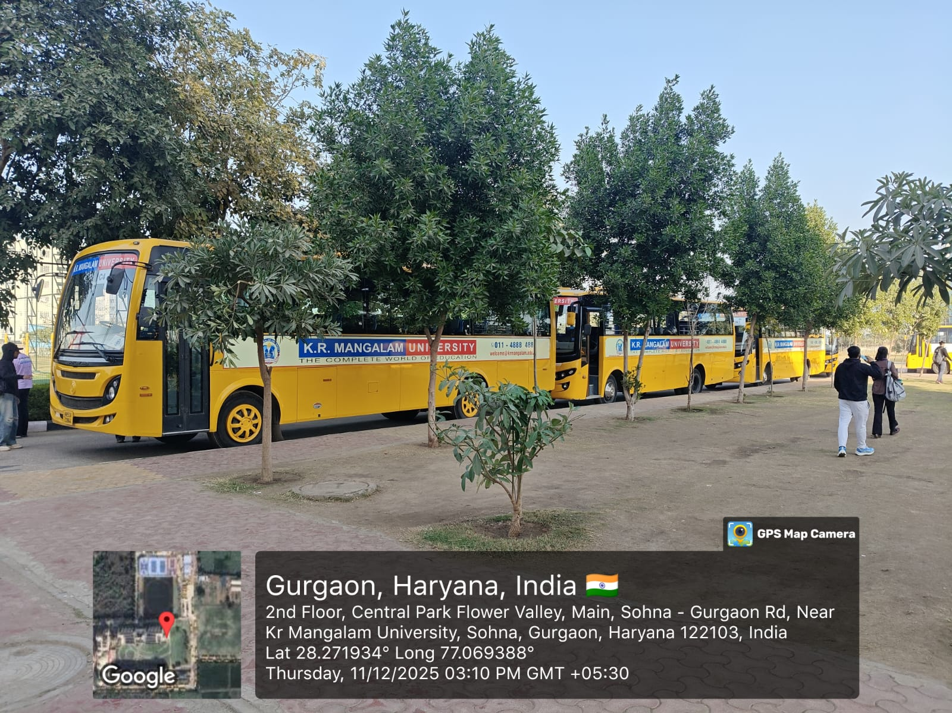
University-operated commuting is supported through CNG-based transport
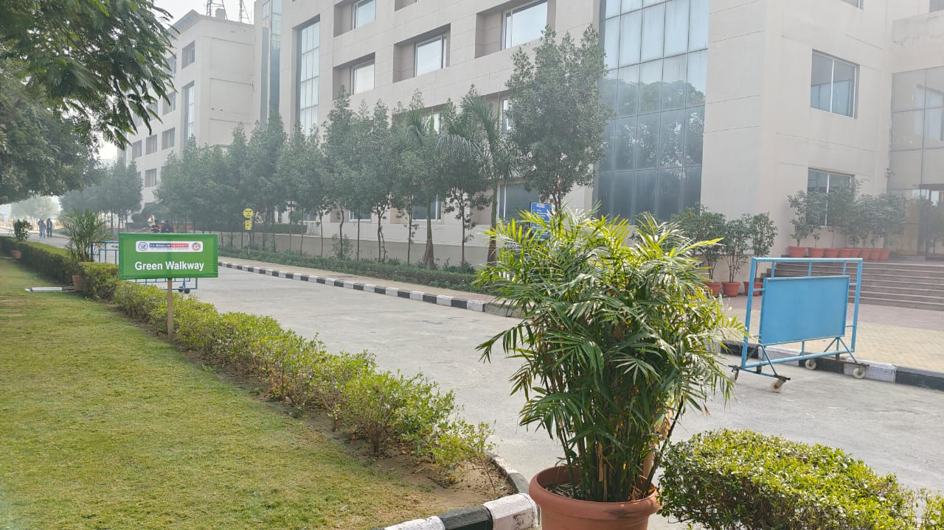
The campus architecture encourages walking as the primary mode of intra-campus mobility.

6. Local community outreach for energy efficiency
K.R. Mangalam University follows a comprehensive, multi-layered strategy that integrates community engagement, capacity building, and academic collaboration, recognizing clean energy as a key enabler of sustainable development and climate resilience. The University’s outreach initiatives focus on energy literacy and the promotion of renewable energy solutions such as solar energy, biogas, and energy-efficient technologies in nearby rural and peri-urban communities. Through awareness campaigns, Swachhta and energy sensitization programs, plantation drives, and farmer-focused initiatives, it fosters behavioral change and strengthens community participation in the clean energy transition. A total of 8 community outreach programmes were conducted during AY 2023–24 focused on energy efficiency, renewable-energy awareness, and sustainable agricultural practices, engaging local residents, farmers, and youth in nearby villages.

In addition to outreach, the University conducts hands-on workshops and technical trainings aimed at enhancing practical skills and creating local capacity in sustainable agriculture, energy-efficient practices, and waste-to-energy solutions. Faculty and students collaborate closely with farmers, local communities, and partner organizations to enable the real-world adoption of clean energy innovations. Furthermore, the International Conference on Advanced Materials for Green Chemistry and Sustainable Environment strengthened the University’s clean energy agenda by facilitating knowledge exchange among experts, educators, and local stakeholders, fostering capacity building, encouraging community-level adoption of sustainable solutions, and building networks that advance clean energy and climate action.
To expand the impact of these efforts, K.R. Mangalam University actively builds academic and research partnerships, conducts faculty development programmes, and engages in collaborations aligned with national and global clean energy goals. This integrated approach ensures that renewable energy awareness and energy efficiency are embedded throughout academic learning and community engagement.
Details of events and activities
Title of the Activity | Nature of the Activity | Date of Activity | School | Link
International Conference on Advanced Materials for Green Chemistry and Sustainable Environment | Conference | Feb-15-16-2024 | School of Basic & Applied Sciences | Conference Report
The Climate Reality Project | MOU | 2023 | School of Basic & Applied Sciences | MOU- Climate Project
Poster Making Competition on Clean Energy for a Green | Extension Activity | 5-06-2024 | NSS | Report- Poster Making
Plantation and Energy Efficiency Awareness Drive | Extension Activity | 29-06-25 | NSS, in collaboration with KRMU–KEIC STI Hub Foundation | Report Awareness Drive
Awareness on Sustainable Agriculture and Solar Pump Irrigation | Extension Activity | 27-10-2023 | NSS and School of Agricultural Sciences | Report- Sustainable Agriculture
Swachhta and Clean Energy Awareness Camp | Extension Activity | 29-9-2023 | NSS | Report- Swachhta Camp
Cleanliness Drive as a tribute to Mahatma Gandhi on his Birth Anniversary | Extension Activity | 1-10-2023 | NSS | Report- Cleanliness Drive
Hands-on Training for Bio-fertilizers and Biogas as Clean Energy | Workshop | 07–15 May 2024 | School of Agricultural Sciences | Report- Hands on Training
Workshop on Protected Cultivation and Solar-Powered Farming Solutions | Workshop | 21-Sep-23 | School of Agricultural Sciences | Report-Workshop
Enhancing Building Design with Simulation | Guest Lecture | 07- Dec- 2023 | School of Architecture and Design | Report Enhancing Building

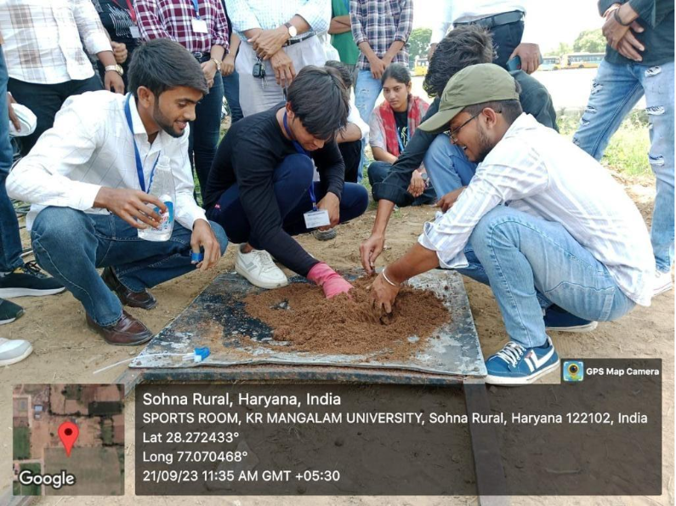
Practical training of students: Students learning energy-efficient and sustainable farming methods through plug tray sowing.
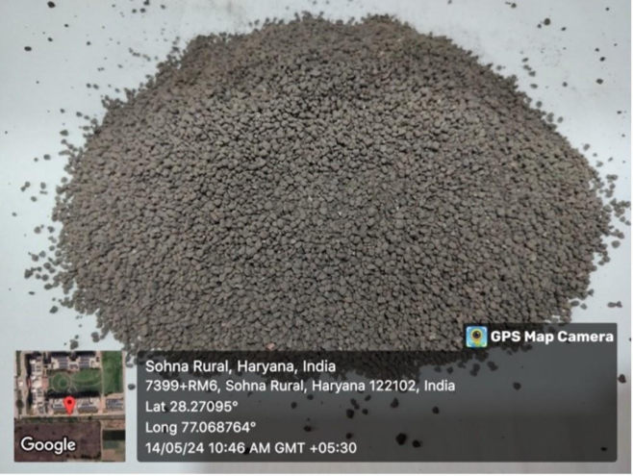
Bio-fertiliser granules prepared during the training session, showcasing practical applications of sustainable agricultural inputs.

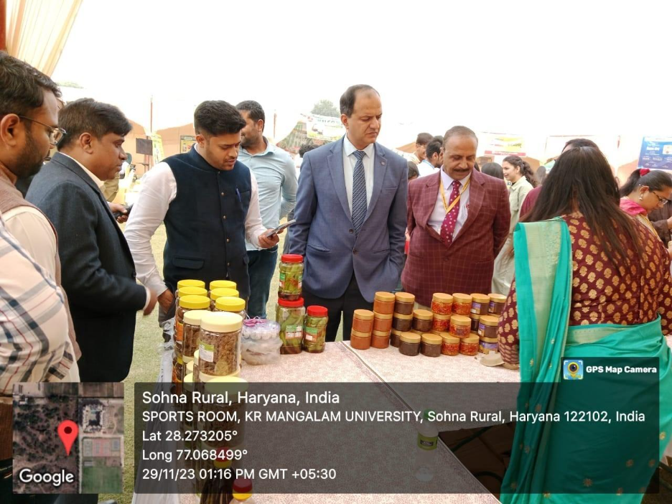
Community outreach in action, Sensitizing farmers to climate-smart and energy-efficient agricultural practices at university
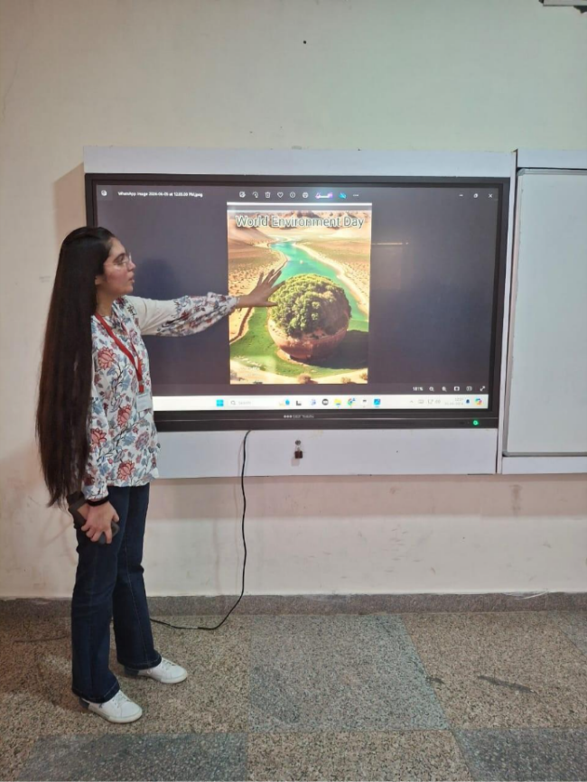
Student participation in a digital poster activity on clean-energy awareness, encouraging behavioural change toward sustainable energy culture.

6.1
100% renewable energy pledge
Promote a public pledge toward 100% renewable energy beyond the university
K.R. Mangalam University has made a formal public pledge to transition toward 100% renewable energy, aligning its institutional vision with India’s National Renewable Energy Mission and SDG 7 (Affordable and Clean Energy). As stated in the University’s Sustainable Environment and Green Campus Policy , the commitment extends beyond campus operations, encouraging partner schools, affiliated institutions, and local panchayat bodies to adopt clean energy solutions through collaborations, MoUs, workshops, and model green campus visits. This pledge is supported by concrete actions outlined in the University’s Energy, Environmental, and Green Audit Reports, which include the installation of a 310-kW rooftop solar power system, a target of meeting 30% of energy demand through renewables by 2027, and long-term efforts toward a Net Zero campus. By combining on-campus renewable energy expansion with active community engagement, the University demonstrates a strategic and public commitment to achieving 100% renewable energy, advancing national energy transition goals and contributing meaningfully to climate action.
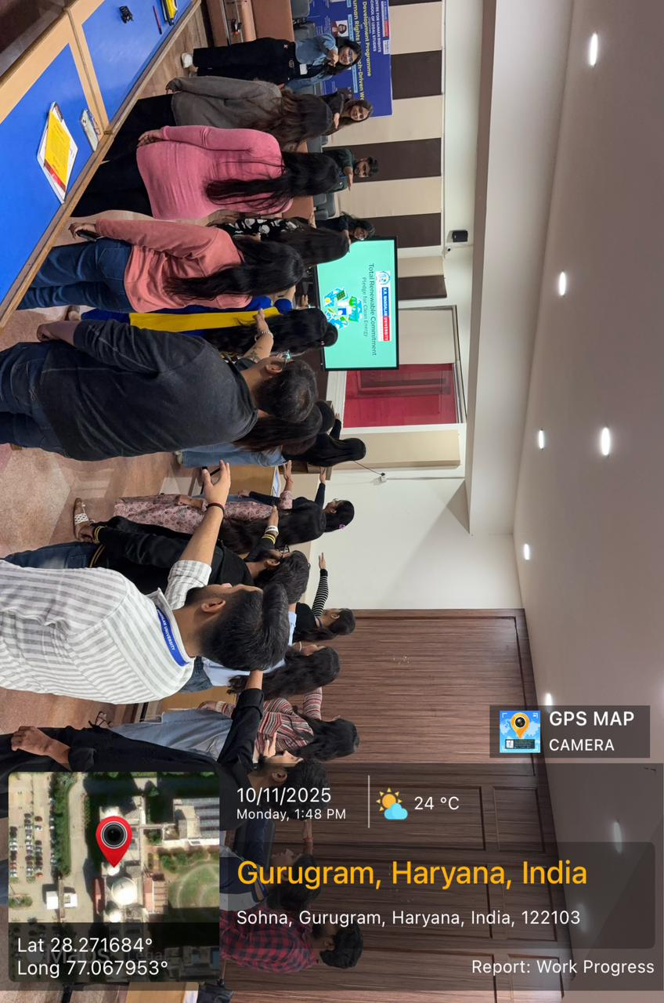
K.R. Mangalam University has made a formal public pledge to transition toward 100% renewable energy
Policy development for clean energy technology
K.R. Mangalam University contributes to clean energy policy development and supports broader government and institutional efforts in energy transition through research, knowledge sharing, and collaborative initiatives. The University’s Sustainable Environment and Green Campus Policy (2025) outline a structured commitment to align its strategies with national frameworks such as the National Renewable Energy Mission, the Energy Conservation Act, and State Renewable Energy targets. Through its Environment and Sustainability Committee (ESC), the University engages with external stakeholders—including NGOs, industries, and local authorities—to share technical inputs and policy-relevant recommendations on energy-efficient infrastructure, renewable integration, and low-carbon transition pathways.
In addition to institutional policies, the University has demonstrated strong research engagement in clean energy domains, with 57 publications in 2024 and 36 in 2023 related to sustainability, renewable energy, and green technologies. This research outputs contribute to the knowledge base that can inform evidence-based policymaking at both state and national levels. The University has also hosted conferences, workshops, and faculty development programs on renewable energy and energy efficiency, including the International Conference on Advanced Materials for Green Chemistry and Sustainable Environment (2024), which involved local industry experts and practitioners.
Furthermore, partnerships such as the MoU with The Climate Reality Project (2023) strengthen the University’s capacity to support policy advocacy and outreach on clean energy. Through these combined efforts in policy alignment, applied research, stakeholder engagement, and knowledge transfer, K.R. Mangalam University plays a proactive role in informing and supporting clean energy and energy-efficient technology policy development
K.R. Mangalam University Sustainable Environment and Green Campus Policy
Events
Conference
MOU- Climate Project
Two-day International Conference Advanced Materials for Green
2-day International Multidisciplinary Conference on DESIGN 2030 – Developing Efficient and Sustainable Innovations for Global Needs
6.3 Assistance to low-carbon innovation
K.R. Mangalam University actively supports low-carbon innovation and green entrepreneurship, positioning itself as an enabler of climate-smart solutions. As a host institution under the MSME scheme, the University has provided ₹15 lakh in funding support to a sustainable sunflower-shaped solar panel start-up, which focuses on improving solar energy efficiency and accessibility through innovative design and deployment. This initiative reflects the University’s commitment to nurturing clean technology ventures that contribute directly to a low-carbon economy.
In addition to financial support, K.R. Mangalam University strengthens the innovation ecosystem through technical guidance, access to laboratories, faculty mentorship, and collaborative research support. Its Green Campus Policy and Sustainability Action Plan emphasize partnerships with industry, NGOs, and government agencies to scale clean energy technologies. The University also facilitates knowledge exchange through conferences, workshops, and MoUs—notably the International Conference on Advanced Materials for Green Chemistry and Sustainable Environment and the collaboration with The Climate Reality Project—which help innovators and start-ups connect with experts, funding networks, and policy frameworks.
Complementing these initiatives is a strong research foundation, with 57 publications in 2024 and 36 in 2023 related to renewable energy, sustainable technologies, and low-carbon transition. This academic base supports innovation through technology validation, prototype development, and thought leadership.
Through direct funding, research-backed support, and strategic partnerships, K.R. Mangalam University provides meaningful assistance to low-carbon start-ups and innovators, contributing to India’s clean energy transition.

6.4 Low-carbon energy use
K.R. Mangalam University actively monitors its total energy use and low-carbon energy contribution as part of its environmental and sustainability commitments. The total energy used by the University in 2023 is estimated to be between 6,400 and 7,000 GJ, covering both grid electricity and fossil fuel consumption (primarily diesel used for DG sets). Of this, approximately 1,225 GJ of energy was generated from low-carbon sources, specifically through the 310 kW rooftop solar photovoltaic (PV) installation, which produced 340,142 kWh in 2023–24. This represents nearly 18% renewable energy contribution, with the remaining 82% sourced from the grid. Continuous expansion of solar capacity, coupled with planned energy-efficiency upgrades, positions the University on track to achieve its 30% renewable-energy target by 2028.

The on-campus biogas plant generates renewable energy from organic waste, replacing conventional fossil fuels and contributing to low-carbon energy use
This clean energy generation significantly reduces the University’s dependence on grid electricity, thereby offsetting its operational carbon footprint. The low-carbon energy share currently represents around 17–19% of total energy consumption, positioning K.R. Mangalam University on a clear path toward its 100% renewable energy pledge, as stated in its Sustainable Environment and Green Campus Policy.
In addition to direct solar generation, the University has also implemented energy efficiency measures—such as LED retrofitting, BLDC fan installation, sensor-based lighting, and power factor optimization—to reduce energy intensity and improve the share of renewable energy over time. These actions are complemented by tree plantation drives, waste-to-energy initiatives, and mobility interventions that further support carbon reduction goals.

Campus Energy Mix Summary (2023–24):
Renewable vs Grid Energy Consumption (GJ and Share %)
Category | Energy (GJ) | % Share | Source
Renewable Energy (Solar PV) | 1,224.51 GJ | ≈18% | Solar audit & bills
Grid Electricity (Non-renewable) | 5,475.49 GJ | ≈82% | Electricity bills & audit
Total Energy Use | ≈ 6,700 GJ | 100% | Energy Audit 2023-24

7. Plan to reduce energy consumption
K.R. Mangalam University has a comprehensive energy efficiency plan designed to systematically reduce overall energy consumption across academic, residential, and administrative infrastructure. Guided by findings from the Energy Audit, the University has identified key consumption hotspots and developed a phased action plan to address them through technological upgrades, operational optimization, and behavioral change initiatives.The University is committed to sustainable campus operations and reflects this in its energy strategy and actively integrates alternative energy sources and energy conservation mechanisms.

The University has set progressive targets through 2030, aiming to achieve a 10 % reduction in lighting energy consumption by 2027 through complete LED retrofits and sensor-based controls, a 5 % reduction in HVAC energy use by 2027 through variable frequency drives and maintenance optimisation, installation of additional rooftop solar panels to supply 30 % of total electricity demand by 2027, and a 25 % reduction in overall energy intensity (kWh per m²) within three years of baseline measurement. These measures, supported by annual energy

audits and continuous monitoring, are expected to significantly reduce energy use and fuel dependence, improve operational efficiency, and enhance the share of renewable energy in the total energy mix.
Link: K.R. Mangalam University
Sustainable Environment and Green Campus Policy

