School of Medical and Allied Sciences (SMAS)
Report
on
Outreach Activity: " Clean Living, Healthy Life: A Life Skill Drive"
Date: 01/05/2025
Venue: Govt School and Village Govt Library, Village Abheypur
Event Type: Awareness Drive-and Dental Check up-Outreach Activity
Mode of Activity: Offline
Target Group: - SMAS Students ,NSS Volunteers, Students of Govt School Abheypur
Course: Social Pharmacy (ER 20-15T) & Social and Preventive Pharmacy (BP802T)
Resource Person: Dr Jubaid, Dentist Clove Hospital, Gurugram and
Dr Yukti, SPRS K R Mangalam University
Event Coordinator: Ms.Manisha Singh, Mr. Prashant and Ms Garima Goyal write designation
Organized by: School of Medical and Allied Sciences In collaboration with Center of Excellence for Sustainable Development Goals (SDGs)and NSS, KRMU
Number of Participants: 155 Govt School Students and Villagers + 8 KRMU Students
INTRODUCTION
The School of Medical and Allied Sciences, K R Mangalam University in collaboration with the National Service Scheme (NSS) and the Centre of Excellence for Sustainable Development Goals (SDGs) organized a community outreach event titled “Clean Living, Healthy Life: A Life Skill Drive” on May 1, 2025, at Village Abheypur. The primary aim of the event was to promote awareness and educate the rural population on the importance of personal hygiene, dental care, and menstrual health, while empowering them with essential life skills to lead healthier and more informed lives. The initiative focused on delivering accessible healthcare services through on-site dental check-ups, sensitizing adolescent girls and women about menstrual hygiene management, and encouraging preventive healthcare practices. The event also sought to strengthen community engagement by mobilizing NSS volunteers to promote the importance of personal and

environmental cleanliness, thereby contributing to long-term behavioral change and improved public health outcomes in the rural setting.
OBJECTIVES
- To raise awareness about the importance of personal hygiene and promote preventive healthcare practices among the rural population.
- To provide free dental check-ups and oral health consultations for villagers, including children, through professional healthcare support.
- To educate adolescent girls and women on menstrual hygiene management, dispel myths, and encourage safe sanitary practices.
- To empower the community with essential life skills and involve NSS volunteers in mobilizing and spreading health awareness through active participation.
METHODOLOGY
The methodology adopted for the event “Clean Living, Healthy Life: A Life Skill Drive” involved a well-coordinated approach beginning with pre-event planning by the School of Medical and Allied Sciences in collaboration with the NSS Unit and the Center of Excellence. Prior to the event, NSS student volunteers carried out door-to-door mobilization in Village Abheypur to inform and encourage villagers to participate, using posters and verbal communication to generate awareness. On the day of the event, a free dental check-up camp was set up at the Village Abheypur, where Dr. Jubaid Dentist, Clove Dental conducted oral examinations, offered consultations, and guided patients for further care if needed. Simultaneously, an awareness session on menstrual hygiene was conducted at the Government School by Dr. Yukti from SPRS, focusing on educating adolescent girls and women about menstrual health, busting myths, and promoting the proper use of sanitary products. Throughout the event, volunteers promoted personal hygiene, clean living habits, and essential life skills through interactive discussions and educational outreach. The entire event was carried out under the supervision of Dr. (Prof.) Hema Chaudhary, with seamless coordination by Ms. Manisha Singh, Mr. Prashant Sharma, and Ms. Garima Goyal to ensure impactful execution and maximum community engagement.

To assess the effectiveness and impact of the event, feedback was collected from participants through informal interactions and structured response forms, which helped in understanding the relevance of the activities conducted and provided insights for future improvement.

OUTCOMES
The outcomes of the event “Clean Living, Healthy Life: A Life Skill Drive” were highly impactful, leading to positive changes in the community. Firstly, the dental check-up camp successfully provided free oral health examinations to the villagers, including school children, leading to improved awareness of oral hygiene and proper dental care practices. Many participants received guidance on maintaining good oral health and were referred for further treatment where necessary. Secondly, the awareness session on menstrual hygiene effectively educated adolescent girls and women about the importance of menstrual health, proper use of sanitary products, and dispelled common myths surrounding menstruation. This created a safe space for open discussions, empowering women with the knowledge to manage menstrual health confidently. Thirdly, the community mobilization efforts led by NSS student volunteers ensured widespread participation and engagement, with many villagers gaining valuable insights into the significance of personal hygiene and preventive healthcare. Feedback from participants reflected a greater understanding of clean living habits, and many expressed gratitude for the valuable information provided. Overall, the event achieved its goal of raising health awareness, fostering open dialogue on taboo topics, and empowering the rural population with life skills that promote better health and well-being.

SDG 4.4: Increa
SDG 8.6: Promotion of youth employment, education, and training.
CONCLUSION
The Outreach Activity: Clean Living, Healthy Life: A Life Skill Drive” successfully achieved its goals of raising awareness about personal hygiene, dental care, and menstrual health in Village Abheypur. The event not only provided essential healthcare services, including free dental check-ups and education on menstrual hygiene, but also empowered the community by promoting healthier living habits and breaking taboos around sensitive topics. Through the

active participation of NSS volunteers, healthcare professionals, and coordinators, the event facilitated open discussions, creating lasting awareness among villagers, particularly women and children. The positive feedback and enthusiastic response from the community highlighted the significance of such initiatives in rural areas. Overall, the event served as a significant step toward improving health awareness, fostering community engagement, and equipping individuals with the knowledge and skills necessary for a healthier, more informed lifestyle.
IMAGES:

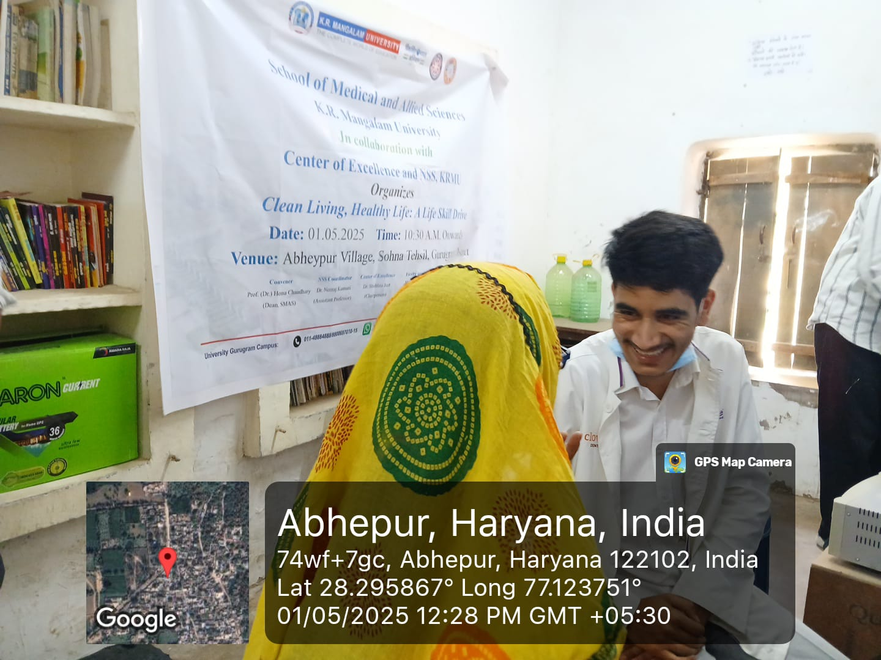
Image 1: Dr. Junaid providing expert dental care to the villagers of Abheypur.

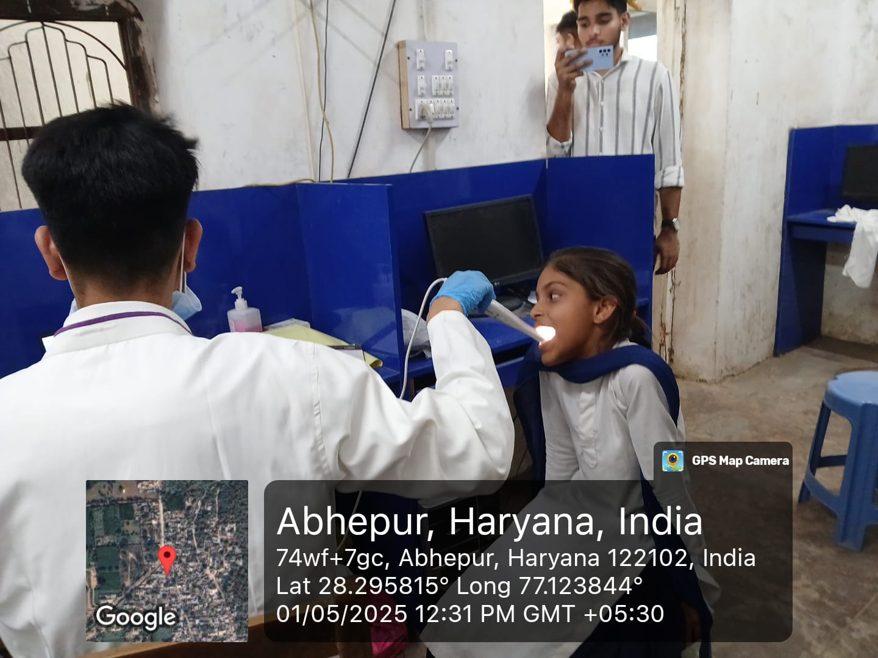
Image 2: Dr. Junaid conducting dental check-ups for the bright smiles of Abheypur’s school children
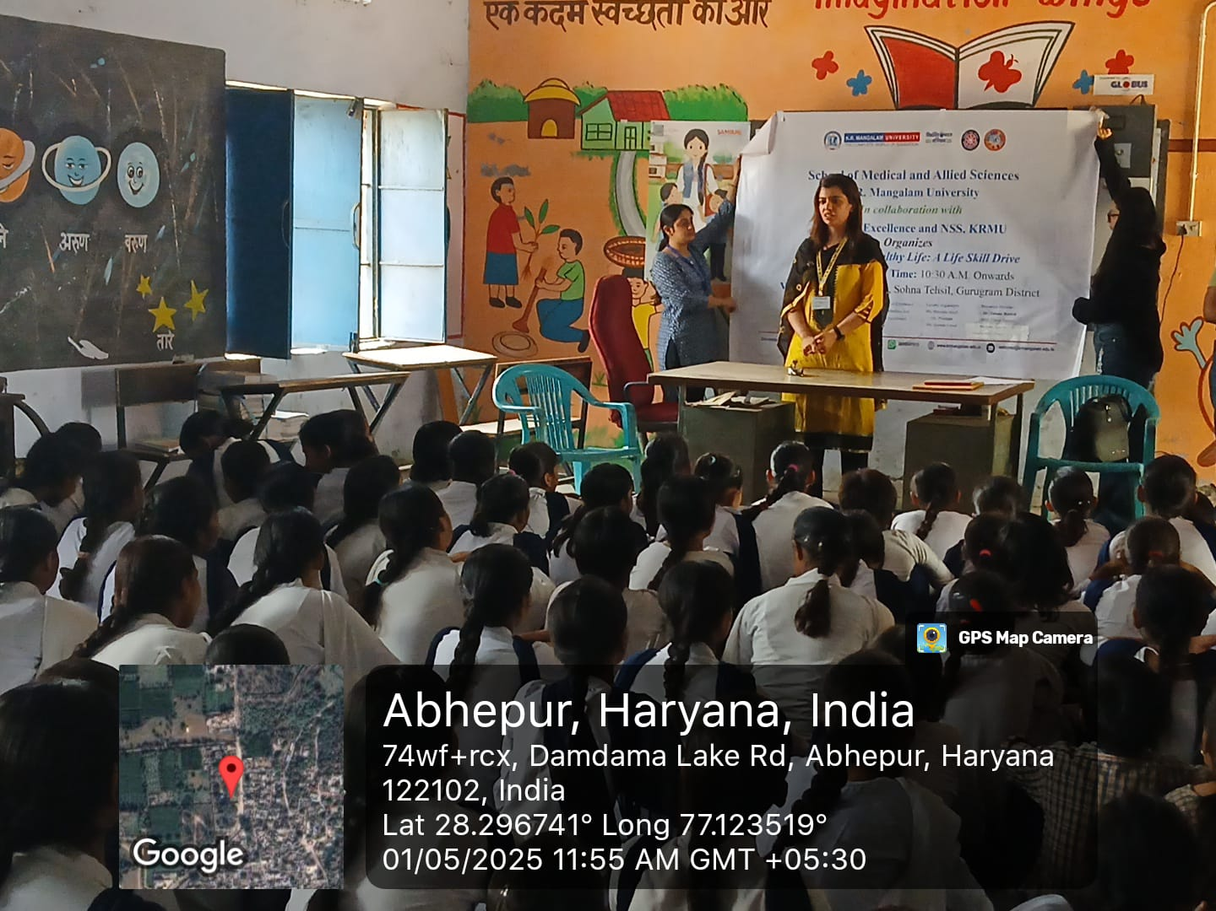Image 3: Dr. Yukti leading an impactful session on menstrual hygiene awareness for women and girls.

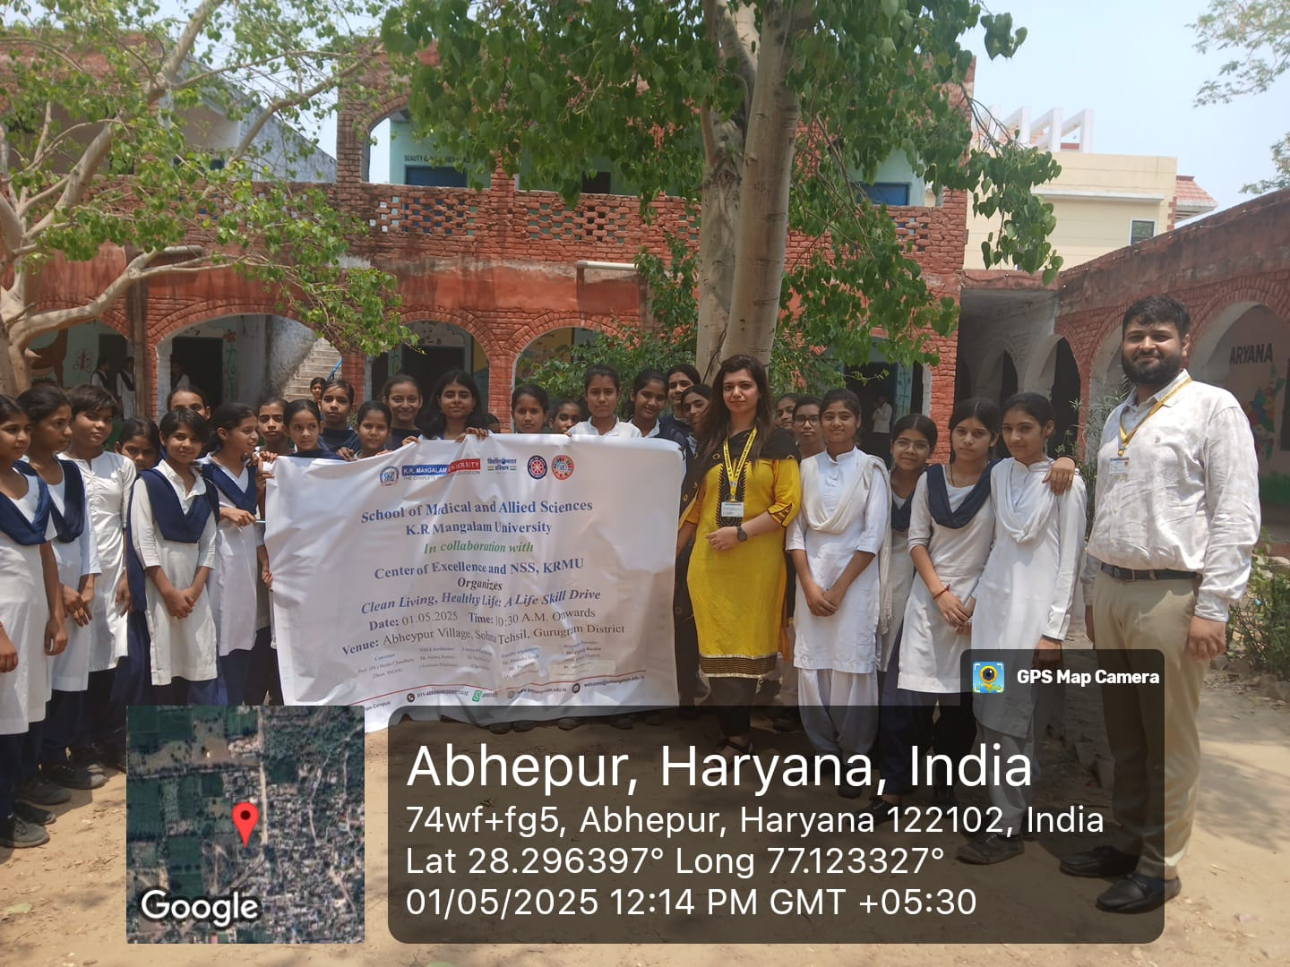
Image 4: Dr. Yukti and event coordinators with the schoolgirls after an insightful session on menstrual hygiene.
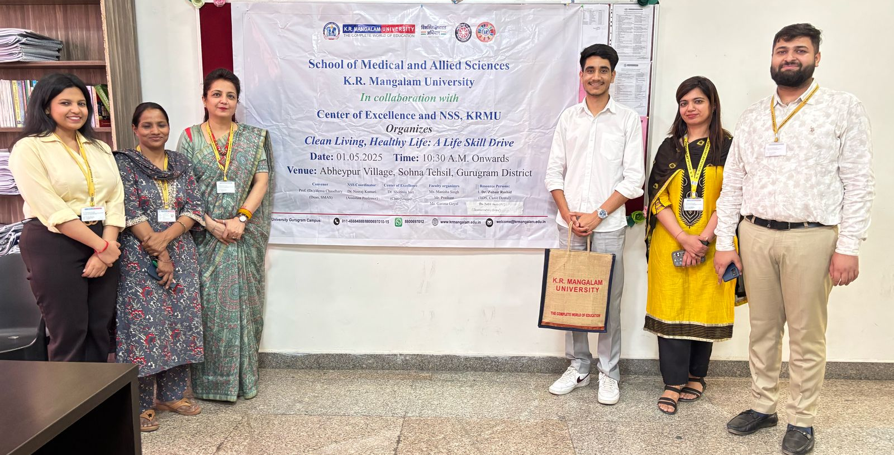
Image 5: Dr. Junaid, Dr. Yukti, Dean SMAS, and event coordinators together after the impactful session.

Report prepared by | Ms. Manisha Singh  Mr Prashant Sharma  Ms Garima Goyal
Report seen by Dean | Prof. (Dr.) Hema Chaudhary
Report verified by IQAC Coordinator | Dr. Shikha Dutt Sharma

