
Water Conservation Initiative Report

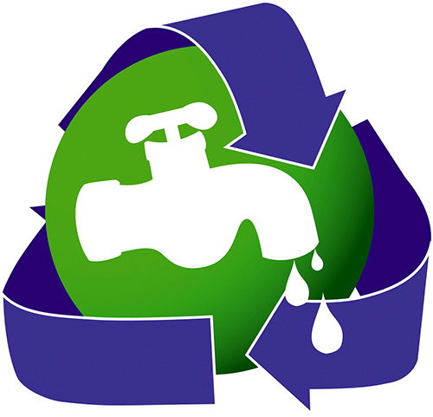

Water Conservation Report (2022–2025)

Contents
1. Overview and Institutional Commitment
1.1 Alignment with National Priorities
1.2 Integrated Approach: Operations, Academics and Community Engagement
2. Campus Water Profile and Supply Sources
2.1 Municipal Supply, Borewell Extraction and Storage Systems
2.2 Water Use Areas: Hostels and Academic Blocks
3. Water Storage and Distribution Infrastructure
3.1 Key Water Storage Facilities (Underground and Overhead Tanks)
3.2 Pump Room and Tank Capacity Details (Block A and Campus Network)
3.3 Borewell Infrastructure and Specifications
3.4 Maintenance and Cleaning Protocols
4. Water Consumption Performance (2022–2025)
4.1 Year-wise Total and Daily Water Consumption (2022–23 to 2024–25)
4.2 Hostel and Academic Block Consumption Split (Daily Estimates)
4.3 Water Consumption per Person (June 2022 – June 2025)
5. Water Consumption Tracking and Source-wise Monitoring
5.1 Monthly Tracking Table: 2022–23 (Water Received, Used, Recycled)
5.2 Monthly Tracking Table: 2023–24 (Water Received, Used, Recycled)
5.3 Monthly Tracking Table: 2024–25 (Water Received, Used, Recycled)
6. Water Management Infrastructure and Evidence Matrix
6.1 Campus Infrastructure Summary (Area, Sources, RO Units, RWH, Tanks)
6.2 Water Conservation Measures (Sensor Taps, Low-flow Fixtures, Audits)
7. Wastewater Treatment, Water Reuse and Pollution Prevention
7.1 STP Infrastructure (100 KLD Operational + 300 KLD Under Installation)
7.2 STP Operations, Treatment Volumes and Reuse Applications
7.3 Effluent Quality Monitoring and CPCB Compliance
7.4 Preventing Water System Pollution (Drainage, Grease Traps, Lab Practices)
7.5 Water Reuse Policy and Measurement Methodology
7.6 Water Reuse Data and Performance Summary
8. Drinking Water Access and Hygiene
8.1 RO Drinking Water Network and Free Access Provisions
8.2 AMC Maintenance and Quarterly Water Quality Testing
8.3 Public RO Facility at Main Gate (Equity and Community Access)
9. Water-Conscious Buildings and Sustainable Landscaping
9.1 Rainwater Harvesting Information Systems and Signage
9.2 Drip Irrigation Coverage and Sprinkler Systems
9.3 Native, Medicinal and Low-Water Planting Practices
9.4 Composting Linkage to Irrigation and Soil Health
10. Water Stewardship in the Community and Education
10.1 Awareness and Outreach Initiatives (NSS, Schools, Villages)
10.2 Academic Courses Supporting Water Governance
10.3 Off-Campus Water Conservation Support and Free Water Stations
10.4 Sustainable Water Extraction and Groundwater Recharge Practices
10.5 Cooperation on Water Security (MoU: National Mission for Clean Ganga)
10.6 Promoting Conscious Water Usage on Campus and Beyond
10.7 Events and Activity Log (2023–2024 / 2024)
11. Consolidated Summary and Conclusion (2022–2025)
11.1 Three-Year Progress Summary: Reduced Freshwater Dependency
11.2 Key Outcomes, Impact and Way Forward

1. Overview and Institutional Commitment
K.R. Mangalam University integrates sustainable water stewardship into campus operations, academics, and community engagement. The University remains committed to ensuring efficient water usage, wastewater treatment, and groundwater conservation, aligned with national environmental priorities. The campus operates multiple water supply sources, on-site storage infrastructure, rainwater harvesting systems, and a Sewage Treatment Plant (STP) to promote efficient water use and recycling. In addition to campus initiatives, student-driven awareness programs and community outreach reinforce responsible water behavior in and beyond the University. K.R. Mangalam University monitors water through a combination of municipal supply, borewell extraction and on-campus storage and recycling systems.
The campus draws water primarily for hostel and academic block operations, supplemented by rainwater harvesting and treated wastewater reuse. Water is stored through underground and overhead tanks with dedicated firefighting reserves.

Key Water Storage Facilities
- Underground tanks – Four units (2 for domestic, 2 for fire-fighting)
- Overhead storage tanks – One on each academic block and hostel building (Block A, B, C, and Hostel)
- Dedicated firefighting tank capacity
- Regular maintenance and tank cleaning cycles
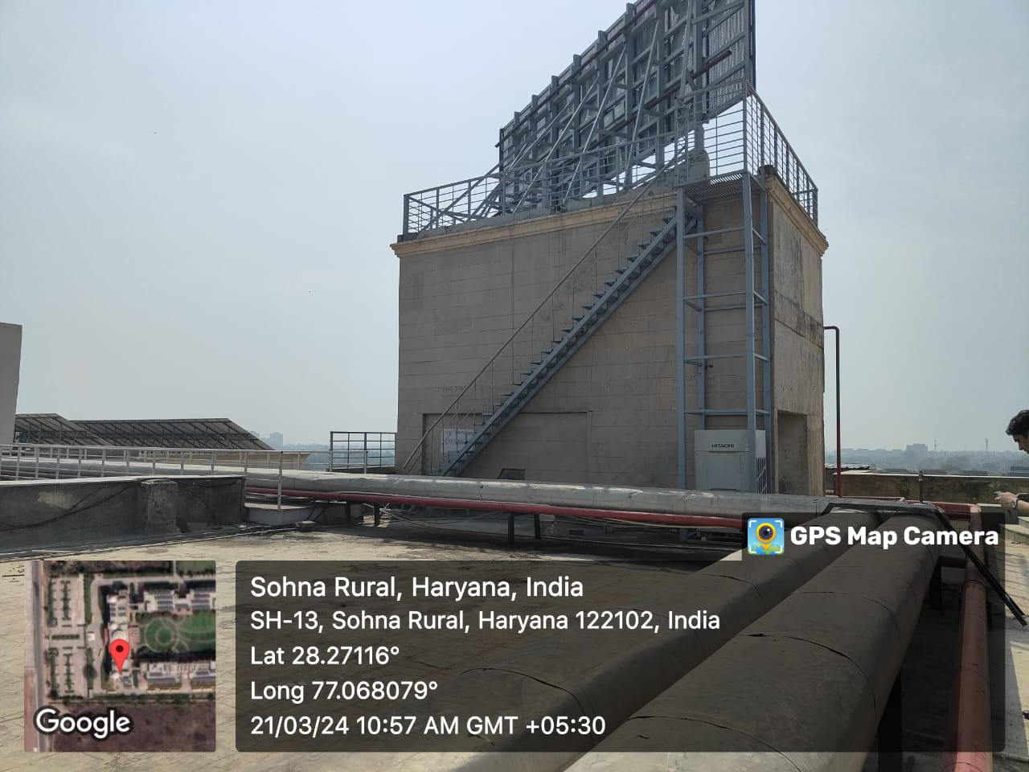
Overhead water tank in university for potable water storage
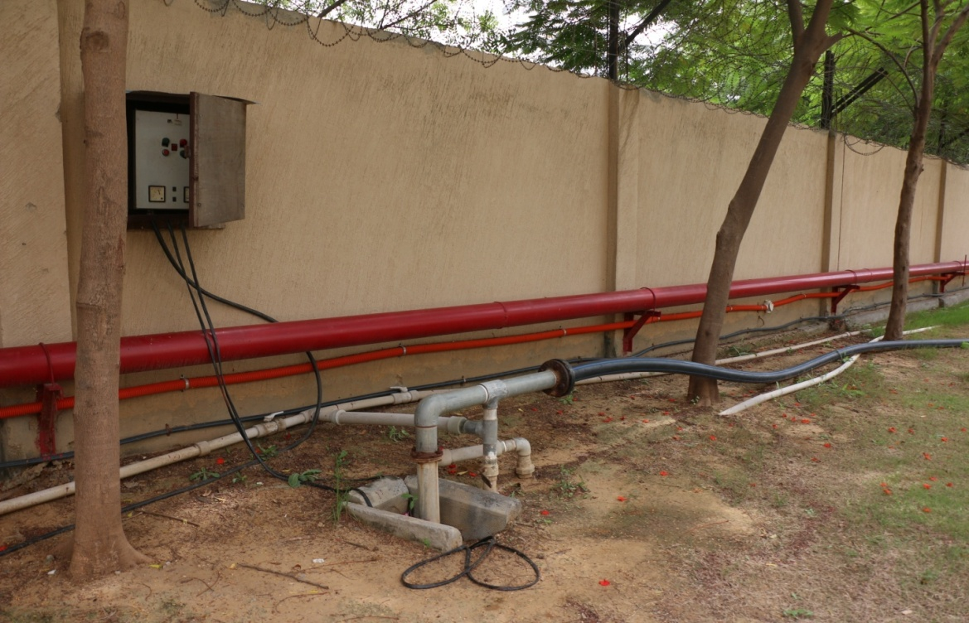
Bore wells are also one of the major water resources in the University. It is 3 inches wide & 220 feet. Deep

The University campus consists of underground tank (Pump Room) of total capacity 4 lakh liters near Block A (Pump Room) wherein underground tanks no.1 & no.2 have a capacity of 1 lakh liters each for domestic use and underground tanks no.3 & no.4 have a capacity of 1 lakh liters each for Fire Fighting purpose & overhead tanks on block A, B, C & hostel building

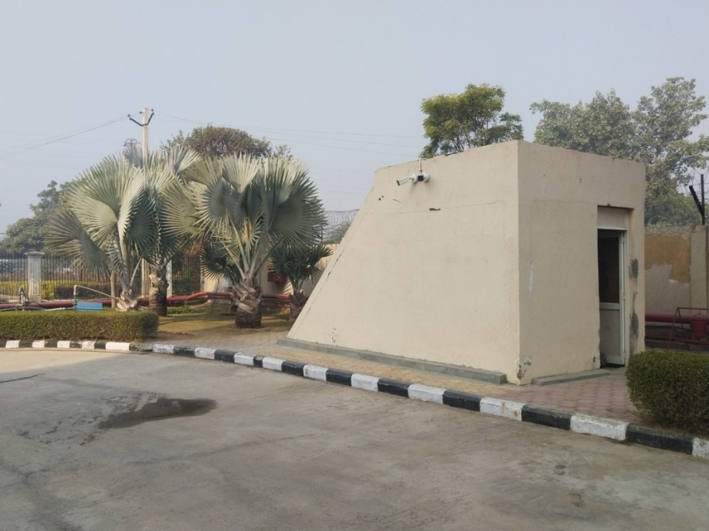
Underground Domestic Tank 2 nos. and Fire Fighting Tanks 2 nos.

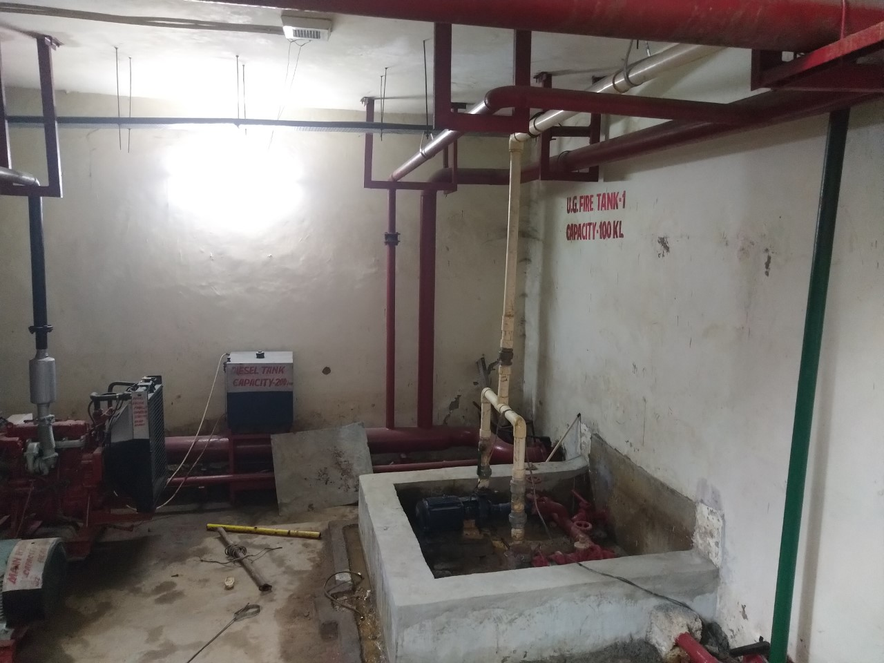
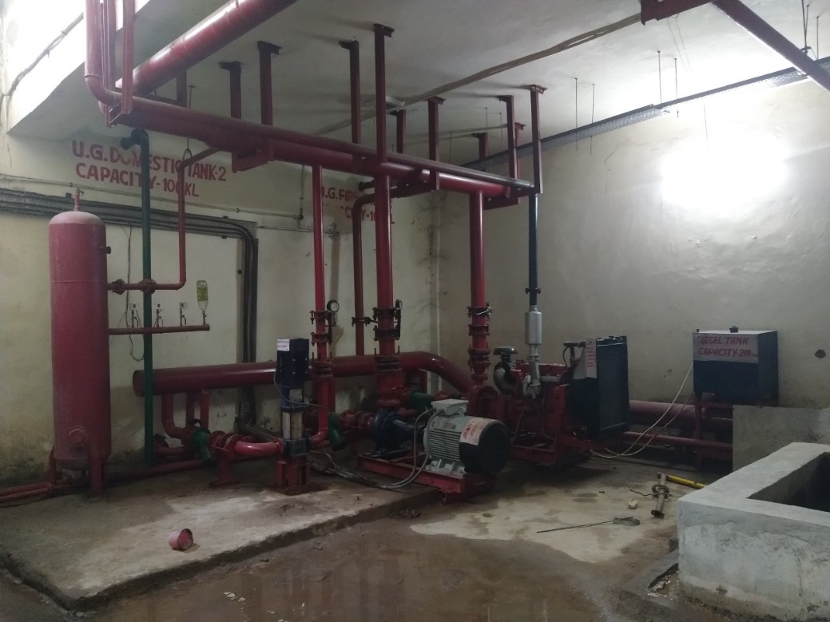
Each block has two tanks for domestic water supply as well as for the firefighting system with a capacity of 50,000 litres each. In hostel building 25,000 liters capacity tank is provided. Maintenance and cleaning of overhead water tanks are done periodically.

As per the university's internal data:

Academic Year | Total Water Consumption (per year) | Daily Water Consumption
2022–23 | 6.02 crore litres/year approx. | 1,65,000 L/day
2023–24 | 3.76 crore litres/year approx. | 1,03,000 L/day
2024–25 | 1.92 crore litres/year approx. | 53,333 L/day

- ~65,000 litres/day of water is used in hostels
- ~36,000 litres/day in Academic Blocks A, B & C (approximation due to non-installed meters)
- Total approx. daily usage ≈ 95,000 litres/day (~95 m³/day)
On an average 65,000 Ltr water per day is used in hostel and approx 30,000 Ltrs water is consumed in A, B & C block.

Water Consumption Tracking
Assessment of Water Usage Measurement: Monitoring Total Water Volume from Various Sources 2022-23

Water received | Water used | Water recycled
Months | Municipal piped supply (KL) | Borewell (KL) | Water brought by tanker (KL) | Total water received (KL) | Water used (Academic) | Water used (Hostel) | Water recycled (STP)
June ‘22 | 2900 | 2000 | 0 | 4900 | 2050 | 2450 | 400
July ‘22 | 3000 | 1900 | 0 | 4900 | 2100 | 2450 | 400
Aug ‘22 | 2900 | 2000 | 0 | 4900 | 2050 | 2450 | 400
Sept ‘22 | 2800 | 2000 | 0 | 4800 | 2000 | 2400 | 380
Oct ‘22 | 3000 | 1900 | 0 | 4900 | 2050 | 2450 | 400
Nov ‘22 | 3100 | 1800 | 0 | 4900 | 2100 | 2450 | 400
Dec ‘22 | 2900 | 1800 | 0 | 4700 | 1950 | 2350 | 380
Jan ‘23 | 2800 | 1700 | 0 | 4500 | 1850 | 2250 | 350
Feb ‘23 | 2900 | 1800 | 0 | 4700 | 1950 | 2350 | 380
Mar ‘23 | 3000 | 1800 | 0 | 4800 | 2000 | 2400 | 380
Apr ‘23 | 3100 | 1900 | 0 | 5000 | 2100 | 2500 | 380
May ‘23 | 3200 | 1900 | 0 | 5100 | 2200 | 2550 | 380
June ‘23 | 3100 | 1900 | 0 | 5000 | 2150 | 2500 | 380

Assessment of Water Usage Measurement: Monitoring Total Water Volume from Various Sources 2023-24

Water received |  |  |  |  | Water used |  | Water recycled
Months | Municipal piped supply (KL) | Borewell (KL) | Water brought by tanker (KL) | Total water received (KL) | Water used (Academic blocks) | Water used (Hostel blocks) | Water recycled (Through STP)
June ‘23 | 2,000 | 1,500 | 0 | 3,500 | 1,400 | 1,800 | 300
July ‘23 | 2,200 | 1,400 | 0 | 3,600 | 1,500 | 1,900 | 350
Aug ‘23 | 2,100 | 1,400 | 0 | 3,500 | 1,400 | 1,800 | 300
Sept ‘23 | 2,000 | 1,300 | 0 | 3,300 | 1,300 | 1,700 | 300
Oct ‘23 | 2,300 | 1,200 | 0 | 3,500 | 1,400 | 1,700 | 400
Nov ‘23 | 2,400 | 1,100 | 0 | 3,500 | 1,400 | 1,700 | 400
Dec ‘23 | 2,100 | 1,100 | 0 | 3,200 | 1,200 | 1,600 | 400
Jan ‘24 | 2,000 | 1,000 | 0 | 3,000 | 1,100 | 1,500 | 400
Feb ‘24 | 2,100 | 1,100 | 0 | 3,200 | 1,200 | 1,600 | 400
March ‘24 | 2,300 | 1,200 | 0 | 3,500 | 1,400 | 1,800 | 400
April ‘24 | 2,400 | 1,300 | 0 | 3,700 | 1,500 | 1,900 | 400
May ‘24 | 2,600 | 1,400 | 0 | 4,000 | 1,600 | 2,000 | 400
June ‘24 | 2,500 | 1,400 | 0 | 3,900 | 1,500 | 2,000 | 400

Assessment of Water Usage Measurement: Monitoring Total Water Volume from Various Sources 2024-25

Water received | Water used | Water recycled
Months | Municipal piped supply (KL) | Borewell (KL) | Water brought by tanker (KL) | Total water received (KL) | Water used (Academic) | Water used (Hostel) | Water recycled (STP)
June ‘24 | 900 | 700 | 0 | 1600 | 650 | 800 | 150
July ‘24 | 920 | 680 | 0 | 1600 | 660 | 800 | 150
Aug ‘24 | 900 | 700 | 0 | 1600 | 650 | 800 | 150
Sept ‘24 | 880 | 680 | 0 | 1560 | 630 | 780 | 150
Oct ‘24 | 940 | 660 | 0 | 1600 | 660 | 800 | 150
Nov ‘24 | 960 | 640 | 0 | 1600 | 660 | 800 | 150
Dec ‘24 | 900 | 640 | 0 | 1540 | 630 | 760 | 150
Jan ‘25 | 880 | 620 | 0 | 1500 | 610 | 740 | 150
Feb ‘25 | 900 | 640 | 0 | 1540 | 630 | 760 | 150
Mar ‘25 | 940 | 640 | 0 | 1580 | 650 | 780 | 150
Apr ‘25 | 960 | 660 | 0 | 1620 | 660 | 800 | 150
May ‘25 | 980 | 660 | 0 | 1640 | 670 | 820 | 150
June ‘25 | 960 | 660 | 0 | 1620 | 660 | 810 | 150

6.2.2 Water consumption per person (June 2022 – June 2025)
From June 2022 to June 2025, K. R. Mangalam University adopted a progressively strengthened and data-driven approach to water management, reflecting its sustained commitment to environmental stewardship and responsible resource use in alignment with SDG 6 (Clean Water and Sanitation). During the academic year 2022–23, the University recorded an average daily freshwater consumption of approximately 96,000 litres per day (about 30 litres per capita per day) for an estimated campus population of 3,200 persons, resulting in an annual freshwater intake of approximately 35,040 m³ (about 6.02 crore litres) and a per-capita freshwater consumption of 10.95 m³ per person per year. Building on this baseline, the 2023–24 period saw enhanced operational controls, improved monitoring, and increased reuse of treated wastewater, leading to a reduction in daily freshwater consumption to approximately 1,03,000 litres per day, corresponding to an annual intake of about 3.76 crore litres and demonstrating early gains in water-use efficiency across academic and residential facilities. This positive trend was further consolidated during 2024–25, when daily freshwater consumption reduced significantly to approximately 53,333 litres per day, translating into an annual consumption of around 19,200 m³ (approximately 1.92 crore litres) and an estimated per-capita freshwater consumption of about 6.0 m³ per person per year, marking a substantial improvement over the three-year period. These reductions were achieved through a combination of robust infrastructure and behavioral interventions, including the operation of a 100 KLD Sewage Treatment Plant with reuse provisions, reuse of treated wastewater for landscaping and flushing, rainwater harvesting through 17 recharge pits, borewell recharge structures, underground water storage tanks, installation of sensor-based taps, efficient plumbing fixtures in hostels, and sustained awareness initiatives promoting mindful water use among students and staff. Importantly, the reported per-capita figures represent freshwater intake only, as treated wastewater reuse forms an integral part of the University’s circular water management strategy. Overall, the period from June 2022 to June 2025 reflects a clear and measurable transition towards lower freshwater dependency, improved reuse, and strengthened water stewardship, positioning K. R. Mangalam University as an institution committed to long-term sustainability and responsible water governance.

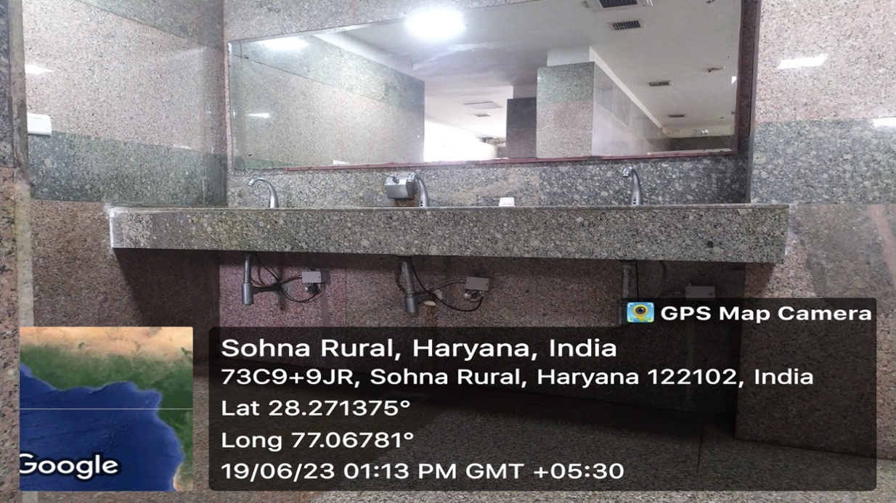
Water-efficient washbasins installed at K.R. Mangalam University, Sohna — equipped with sensor-based taps to minimise water wastage and promote responsible water usage across campus

Water Management Infrastructure
Component | Details | Evidence
Total campus area | 26.4 acres | Campus layout
Water supply sources | Municipal Water, Borewell; earlier tanker supply discontinued | Utility bills / Logs
RO Drinking Units | 29 units installed | Photos + AMC
Rainwater Harvesting Pits | 17 pits (3 × 3 m each, 3 m deep) | RWH layout & photos
Overhead water tanks | 4 tanks, 100,000 L each (academic & hostel blocks) | Photos
OH1- Location (Block A) | Capacity 100,000 L litres | Cleaning logs
OH2- Location (Block B) | Capacity 100,000 L litres | Cleaning logs
OH3- Location (Block C) | Capacity 100,000 L litres | Cleaning logs
OH4- Location (Hostel Block) | Capacity 100,000 L litres | Cleaning logs
Underground water tanks | 4 UG tanks, including firefighting reserve ≈ 200,000 L total | Photos
UG1- Location (Block A) | Capacity 50,000 litres, | Cleaning logs
UG2- Location (Block B) | Capacity 50,000 litres | Cleaning logs
UG3- Location (Block C) | Capacity 50,000litres | Cleaning logs
UG4- Location (Hostel Block) | Capacity 50,000 litres | Cleaning logs
Sewage Treatment Plant (STP) | 100 KLD operational + new 300 KLD under installation | STP Purchase order + photos
Sprinkler / Drip irrigation | Yes, 100 % coverage | Photos
Water Conservation Measures
Indicator | Status | Evidence
Sensor-based taps | Yes | Photos
Dual flush + Low-flow fixtures | Yes | BOQ
Leak detection system | Manual inspection and audit each semester | Maintenance logs
Plumbing audits | Bi-annual (2 per year) | Audit log
Hygiene signage | Displayed in the washrooms and canteen areas | Photos
Wastewater Treatment & Pollution Prevention
Parameter | Value | Evidence
STP Capacity | 100 KLD (existing) + 300 KLD (new) | STP PO
Average operation/day | 24 hours | STP log
Wastewater treated/day | 50 KL | Log sheet
Effluent reused | 80 % (for gardening & bus washing) | Reuse register
TDS/pH values | Within CPCB limits (pH 7.7 / BOD 2.3 / COD 19.6 mg/L) | Lab reports
Rainwater drains covered | Yes | Photo
Grease traps / Lab waste segregation | Yes – canteen & labs | Photo

Drinking Water & Hygiene

Indicator | Details | Evidence
Free drinking water access | Yes – RO points in each  building & public RO at main gate | Photos
RO maintenance | AMC maintained quarterly | AMC
Water quality checks | Quarterly testing from ISO  Lab | Test reports
Public RO facility at main  Gate | Yes | Photo

Water-Conscious Buildings & Landscaping

Indicator | Value / Status | Evidence
RWH pits | 17 | Photos
Drip irrigation | Installed – 72,000 sq m  Coverage | Photos
Native & medicinal plant  Species | 1,409 trees (Pipal, Ashok,  Coro carpus etc.) | Horticulture register
Organic composting for  Irrigation | Yes – wet waste converted to  Compost | Compost logs

Water Reuse Data

Metric | Value | Evidence
STP treated | 18,000 m³ / year | STP log
Recycled water used | 14,000 m³ / year | Reuse log
Reuse applications | Irrigation and flushing | Photos
Reuse % of total demand | 75–80 % | Calculation sheet

Water-Conscious Buildings & Landscaping

Water Reuse Data
Metric | Value | Evidence
STP treated | 18,000 m³ / year | STP log
Recycled water used | 14,000 m³ / year | Reuse log
Reuse applications | Irrigation and flushing | Photos
Reuse % of total demand | 75–80 % | Calculation sheet

K.R. Mangalam University provides free access to purified drinking water for all students, faculty, staff, and visitors across the campus. Drinking-water points equipped with RO purification units and water coolers are installed in all academic blocks, administrative buildings, hostel areas, cafeterias, and public corridors to ensure uninterrupted availability. Water quality is monitored through periodic testing, and RO units are maintained under annual service contracts with scheduled filter replacement and sanitation checks. These measures ensure that safe, hygienic drinking water is consistently supplied. The University also encourages the campus community to use personal refill bottles to reduce dependence on disposable packaged drinking water and support waste-free hydration practices. K R MANGALAM UNIVERSITY remains committed to strengthening access, improving monitoring systems, and maintaining transparency in drinking-water safety and delivery through regular maintenance, quality checks, and awareness initiatives.

Sewage Treatment & Water Reuse

Between June 2022 and June 2025, K. R. Mangalam University strengthened its wastewater management and reuse practices as an integral component of its sustainable water governance framework. The University operates an on-campus 100 KLD Sewage Treatment Plant (STP) that treats wastewater generated from academic buildings, hostels, and common facilities, thereby reducing dependence on freshwater sources. Throughout the reporting period, treated wastewater was primarily reused for landscape irrigation and toilet flushing, supporting a circular water-use approach and contributing to the conservation of potable water resources. To ensure consistent and compliant operation, the STP was supported by routine operational checks, scheduled maintenance activities, and systematic repair records, with periodic laboratory testing of treated effluent conducted to monitor key water quality parameters in accordance with applicable regulatory standards. Complementing the STP, the University’s rainwater harvesting systems and borewell recharge structures functioned in tandem to enhance groundwater recharge and promote long-term water sustainability across the campus. In parallel, the University reinforced responsible water-use behaviour through awareness initiatives and facility-level interventions, including the installation of sensor-based taps in washrooms, regular plumbing inspections to prevent leakages, and student-led campaigns encouraging mindful water consumption. Over the period from 2022 to 2025, K. R. Mangalam University remained committed to progressively enhancing wastewater monitoring, strengthening reuse practices, and maintaining transparent documentation, thereby supporting efficient resource management and sustained groundwater conservation aligned with national and global sustainability objectives.

Wastewater treatment

Between 2022 and 2025, K. R. Mangalam University demonstrated a strong institutional commitment to environmental stewardship and sustainable water management through the installation and continuous operation of an on-campus 100 KLD Sewage Treatment Plant (STP). The STP ensures that wastewater generated from academic buildings, hostels, and common facilities across the campus is effectively treated prior to reuse, thereby significantly reducing the University’s dependence on freshwater sources and minimising environmental discharge. During the reporting period, the operational STP achieved an average treatment of approximately 50 KLD, functioning for about 12 hours per day, resulting in an estimated annual treated wastewater volume of approximately 18,250 m³.

The University recorded a wastewater treatment coverage of approximately 4.6%, with an enhanced water reuse efficiency of about 1.2%, reflecting systematic efforts to integrate wastewater reuse into campus operations and maintain ecological balance. Treated wastewater was reused at a rate of approximately 75–80%, primarily for landscaping irrigation, toilet flushing, cleaning activities, and vehicle washing, thereby supporting a circular and resource-efficient water-use model. To further strengthen wastewater management capacity and future readiness, an additional 300 KLD Sewage Treatment Plant is under installation, which will substantially enhance treatment capacity and reuse potential in line with campus expansion and sustainability goals.

The functioning of the STP is supported by routine operational monitoring, scheduled maintenance, and quality checks to ensure compliance with applicable environmental standards. Through these sustained interventions from 2022 to 2025, K. R. Mangalam University has reinforced its commitment to responsible wastewater management, reduced freshwater dependency, and long-term environmental sustainability, in alignment with SDG 6 (Clean Water and Sanitation) and national sustainability benchmarks.

Sewage Treatment Facility

K. R. Mangalam University has consistently demonstrated a strong and growing commitment to environmental stewardship between 2022 and 2025 through the effective operation and continuous strengthening of its on-campus wastewater treatment infrastructure. The University operates a 100 KLD Sewage Treatment Plant (STP), ensuring that wastewater generated from academic buildings, hostels, and common facilities is systematically treated before being reused. This proactive approach reflects the University’s dedication to sustainable campus operations and responsible water governance.
Through the efficient functioning of the Sewage Treatment Plant, K. R. Mangalam University achieved a wastewater treatment coverage of approximately 4.6%, along with an enhanced water reuse efficiency of about 1.2%, underscoring continuous efforts to maintain ecological balance and improve the sustainability of campus water systems. These outcomes highlight the University’s steady progress in integrating treated wastewater reuse into everyday campus activities.
Sewage Treatment Facility
- STP Capacity: 100 KLD (operational)
- Additional STP: 300 KLD (under installation, to enhance future capacity)
- Average Treated Water: ~50 KLD (operational for approximately 12 hours per day)
- Annual Treated Water: ~18,250 m³
- Reuse Rate: Approximately 75–80%
- Reuse Applications: Landscaping irrigation, toilet flushing, cleaning activities, and vehicle washing
Throughout the period from 2022 to 2025, the University maintained regular monitoring, operational checks, and maintenance protocols to ensure reliable STP performance and compliance with environmental standards. The treated wastewater reuse practices significantly reduced freshwater demand while supporting a circular and resource-efficient water management model. With the planned addition of a 300 KLD STP, K. R. Mangalam University is well-positioned to further strengthen its wastewater treatment capacity and advance its long-term sustainability objectives, reinforcing its commitment to SDG 6 (Clean Water and Sanitation) and responsible environmental management.

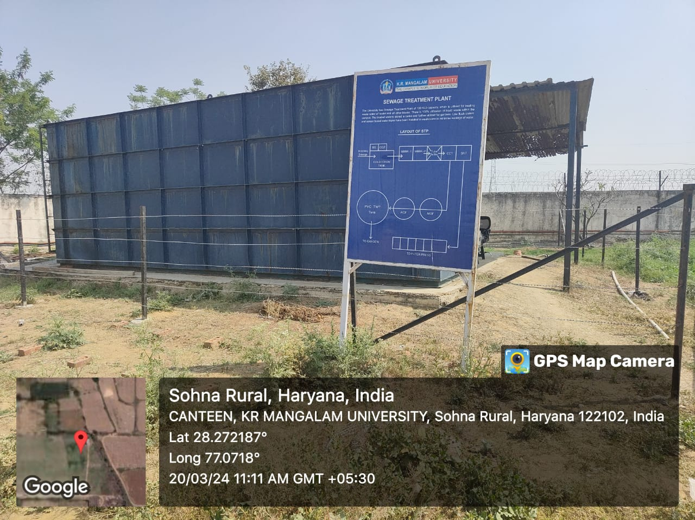
STP infrastructure at K R Mangalam University — enabling efficient wastewater treatment and reuse, contributing to campus water sustainability.
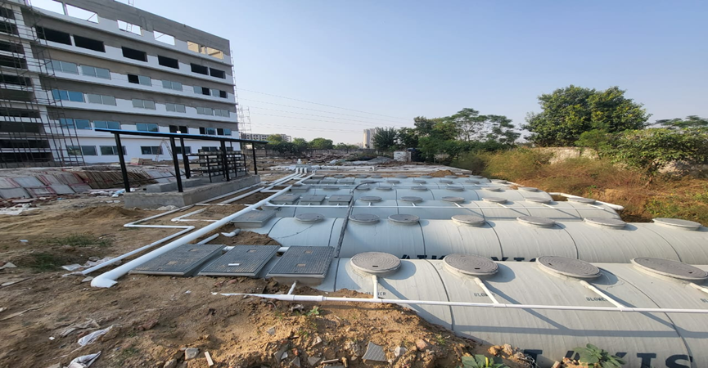
Sewage Treatment Plant (STP) at K.R. Mangalam University, Sohna — designed for efficient wastewater treatment and reuse for landscaping and non-potable purposes

Waste Management and Carbon Sinks
K R Mangalam University undertakes tree-plantation drives, composting, and waste recycling to support carbon sequestration and reduce methane emissions. MoUs with authorized recyclers (SRC Enterprises, Adinath Recyclotronix Pvt. Ltd., Indian Petro & Chemicals) ensure proper handling of paper, e-waste, and hazardous waste. The University also has tie ups with for to help University implement green campus Program. The University implements alternate energy use, LED retrofits, and sustainable waste practices across the campus.
MOU
Audit Reports

Green Campus Initiative
The University collaborates with The Climate Project Foundation (TCPF)—a partner organization of the United Nations Sustainable Development Goals (SDGs)—to create awareness on climate change, clean energy, and e-mobility. Through this partnership, the University integrates environmental sustainability messages across academic and outreach activities, encouraging teachers, students, and parents to adopt climate-positive behaviours.

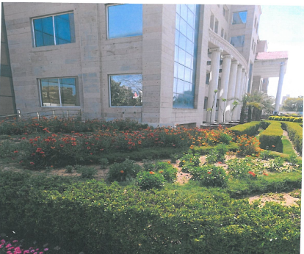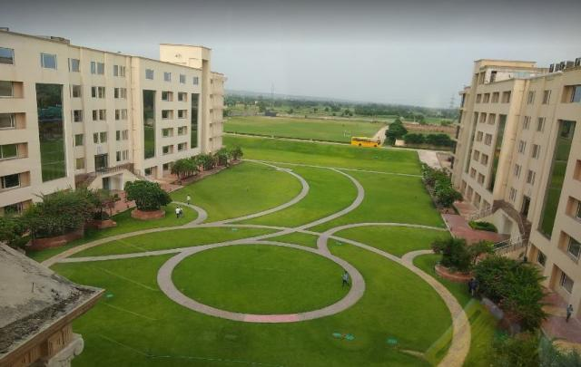
Green landscape and courtyards across campus act as natural cooling systems and reduce the heat-island effect.
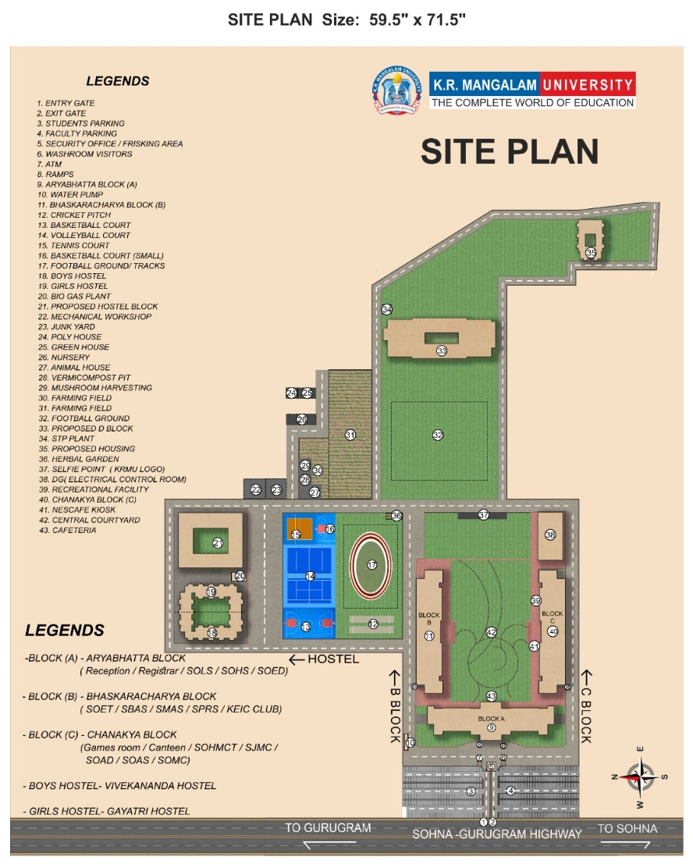
K.R. Mangalam University features a predominantly green campus with vast open spaces, gardens, and eco-friendly zones promoting sustainability. Water Conservation facilities
Preventing water system pollution
K.R. Mangalam University has implemented an effective mechanism wherein polluted water cannot come into the main water supply and drainage system to maintain environmental sustainability and campus safety. The University has a 100 KLD STP that treats all generated wastewater from hostels, academic blocks, and cafeterias before it is discharged or reused. Treated effluent is reused for non-potable applications such as landscaping and toilet flushing, reducing environmental burden and preventing wastewater contamination of soil and groundwater.
For this purpose, strict wastewater management protocols are followed to avoid the accidental discharge of chemical or contaminated water. Rainwater harvesting structures and borewell recharge pits are monitored to ensure that only clean rainwater enters recharge systems. Routine plumbing maintenance helps prevent leakages and contamination risks. In addition, awareness messages are periodically shared across campus to promote responsible disposal practices and discourage littering or waste discharge into storm-water drains.
The University also undertakes periodic checks in the drainage pipeline, tanks, and storage areas to locate and prevent leakages or blockages. The University remains committed to strengthening monitoring processes and continuing to improve pollution-prevention practices in alignment with sustainable campus operations.
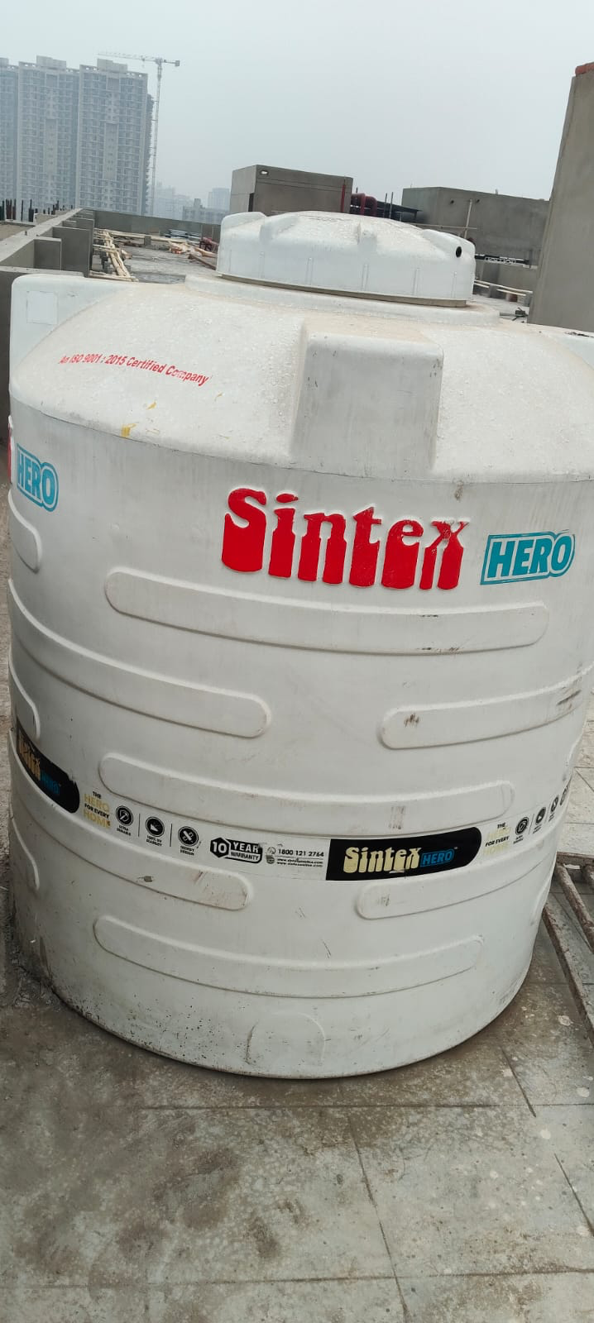
On-campus water storage tank ensures safeguard against waterborne pollutants, and support sustainable water management practices.

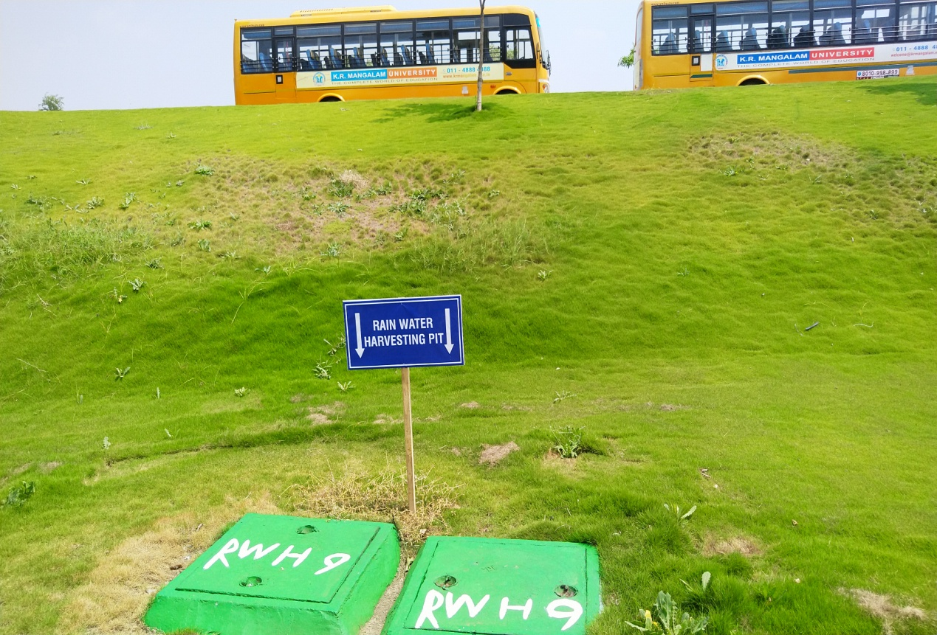

Rainwater harvesting structures are monitored to ensure that only clean rainwater enters recharge systems.
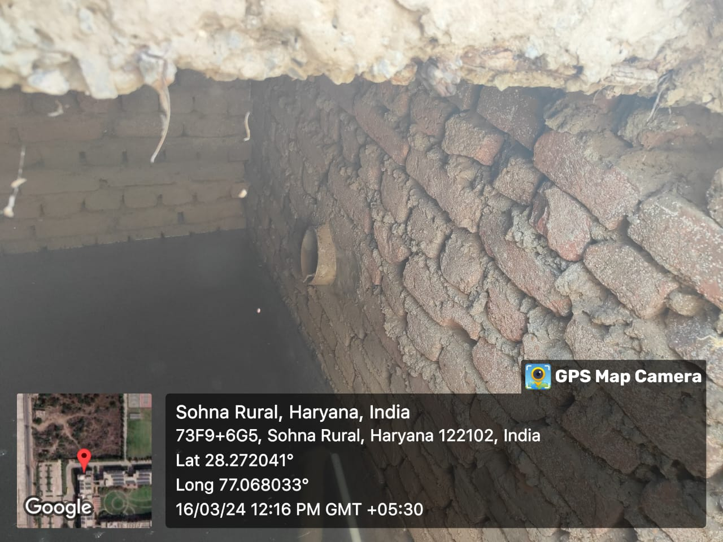
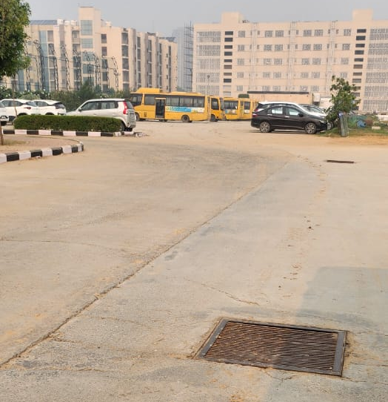

All stormwater drain openings are covered to curtail waste and debris from entering the drainage system
Drinking Water Access & Hygiene
K.R. Mangalam University provides free access to purified drinking water for all students, faculty, staff, and visitors across the campus. Drinking-water points equipped with RO purification units and water coolers are installed in all academic blocks, administrative buildings, hostel areas, cafeterias, and public corridors to ensure uninterrupted availability.
Water quality is monitored through periodic testing, and RO units are maintained under annual service contracts with scheduled filter replacement and sanitation checks. These measures ensure that safe, hygienic drinking water is consistently supplied. The University also encourages the campus community to use personal refill bottles to reduce dependence on disposable packaged drinking water and support waste-free hydration practices.
K R MANGALAM UNIVERSITY remains committed to strengthening access, improving monitoring systems, and maintaining transparency in drinking-water safety and delivery through regular maintenance, quality checks, and awareness initiatives.

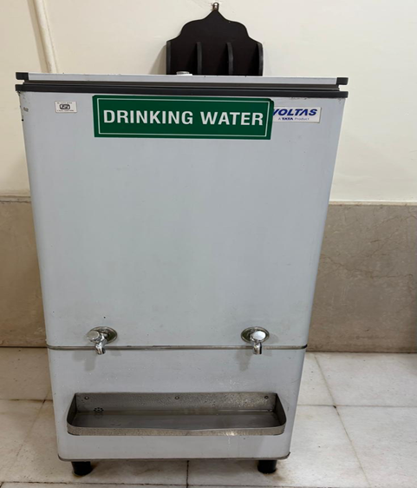
RO-based drinking water facility installed in academic block to ensure safe and free water access.

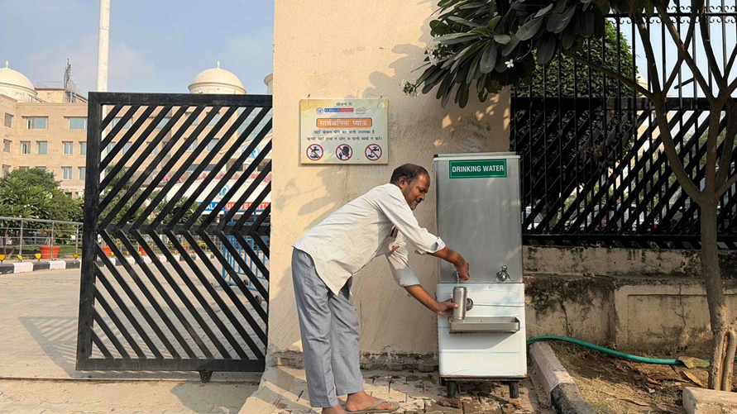

Public drinking water facility at the entrance of K.R. Mangalam University, ensuring free and safe access to potable water for visitors, campus workers, and community members.

Water-conscious building standardsK.R. Mangalam University is committed to ensuring access to safe and free drinking water to all its students, faculty, staff, and visitors within the 28-acre campus of the university, aligning with SDG 6 - Clean Water and Sanitation. The University has installed a network of RO systems and water Coolers in every academic block, hostel, cafeteria, administrative office, and public area to ensure uninterrupted availability of potable water.
During the assessment period, around 15,00,000 litres of purified drinking water were supplied across the campus. All RO units are maintained on annual service contracts that include routine cleaning, replacement of filters, and testing to check whether they conform to health and safety standards. Water quality is tested on a regular basis through accredited laboratories for TDS and purity monitoring, thus ensuring water is fit for human consumption. Besides these contributions, K.R. Mangalam University reaffirms its commitment to sustainability and community health by ensuring safe, clean, and free drinking water is a basic right for all within the campus ecosystem.
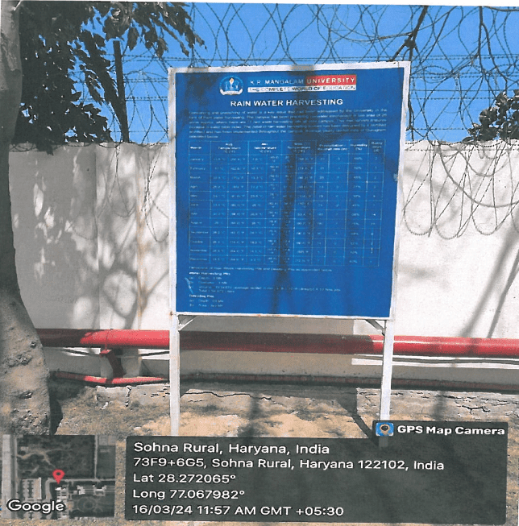
Rainwater Harvesting Information Board installed at K.R. Mangalam University, displaying details of recharge pits and collection systems
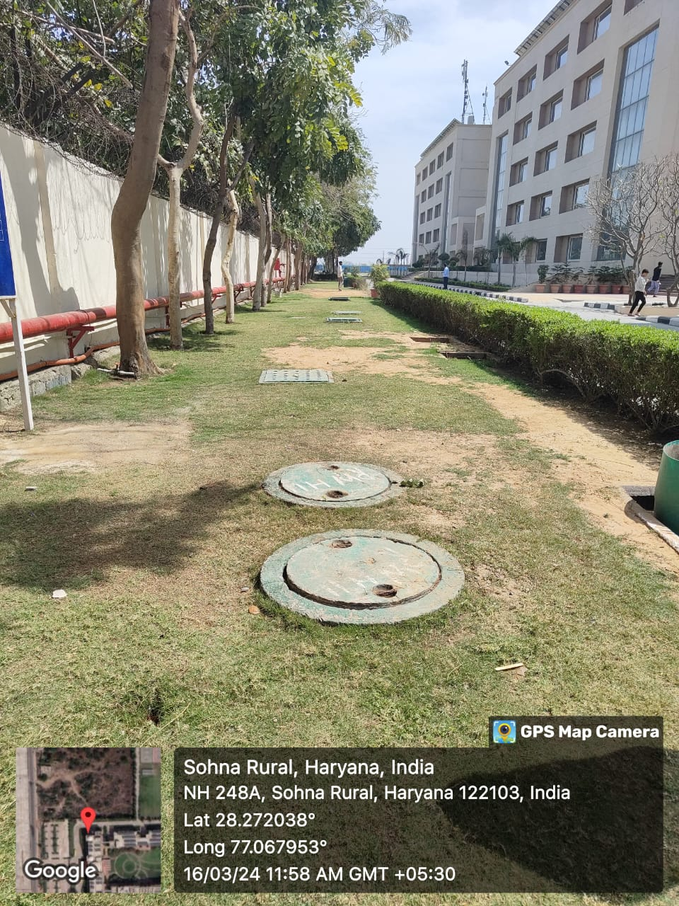
Rainwater Harvesting Pits at K.R. Mangalam University, Sohna — constructed to collect and recharge rainwater into the groundwater table, promoting sustainable water conservation practices
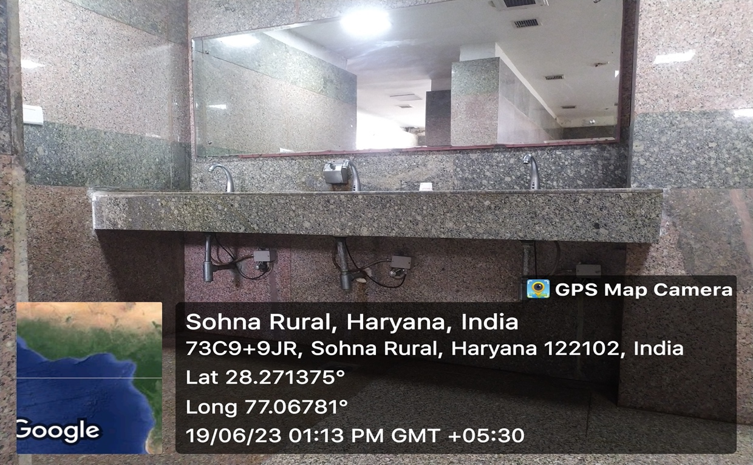
Water-efficient washbasins installed at K.R. Mangalam University, Sohna — equipped with sensor-based taps to minimize water wastage and promote responsible water usage across campus

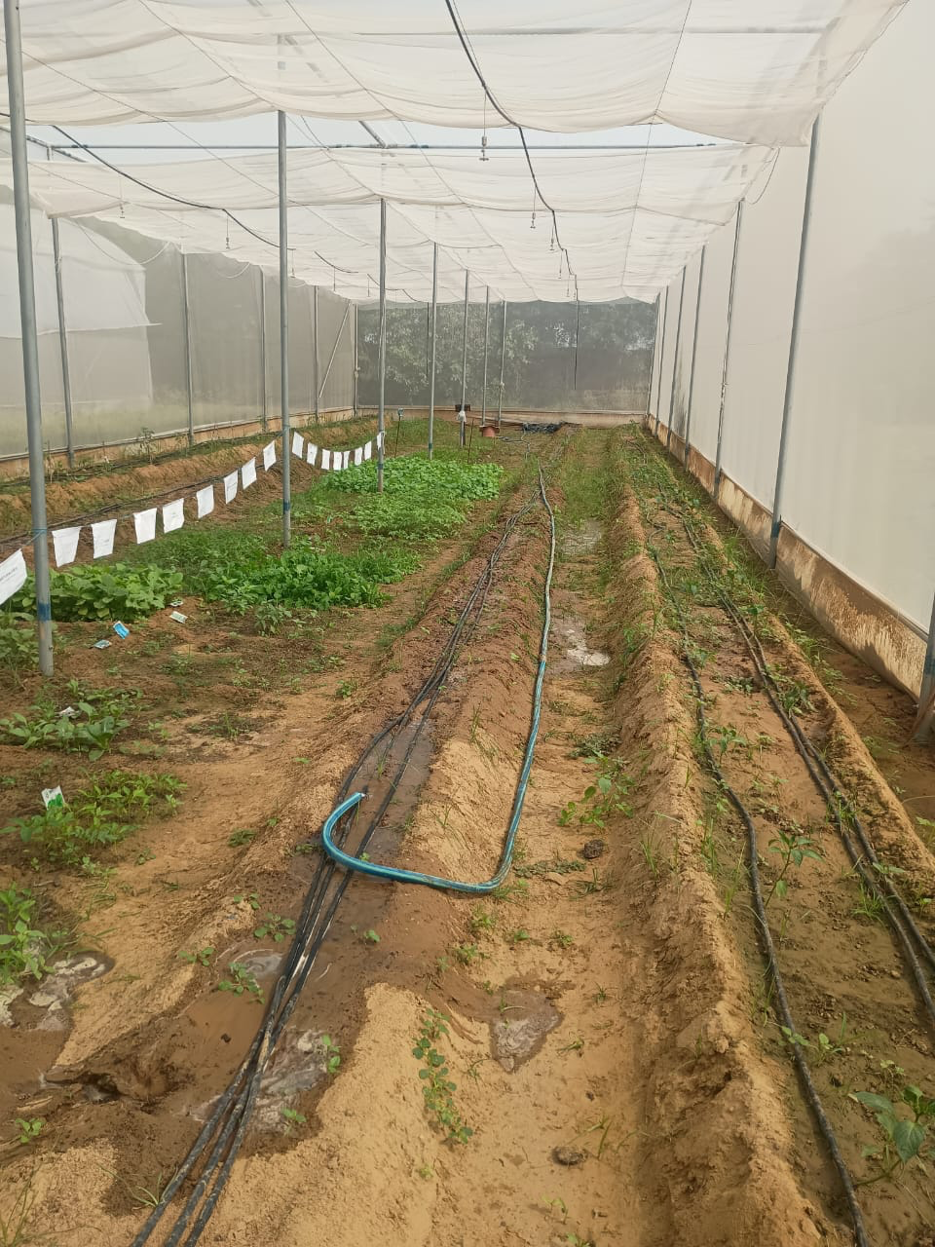
Drip irrigation system under protected cultivation at K.R. Mangalam University, promoting efficient water use in agriculture by minimizing wastage and ensuring sustainable farming practices

Water-conscious planting
K.R. Mangalam University follows water-conscious landscape practices to support long-term ecological balance and reduce the demand on freshwater resources. The campus landscaping programme prioritizes native and climate-appropriate plant species that can thrive in local conditions with lower irrigation needs. Treated wastewater from the 100 KLD Sewage Treatment Plant (STP) is utilised for horticulture, reducing reliance on potable water for maintaining green areas. Along the campus perimeter, two-tier plantations have been completed. Shade-bearing and fruit-bearing plants such as Ashok, Sondana, Kusum, Vismarkya, Kachnar, Pilkan, Sashut, Champa, and others are planted. There is a nursery, a fully operational greenhouse, a composting unit to supply organic manure, and skilled labour to perform horticultural tasks. Numerous horticultural plant varieties are housed in an organic orchard. The university is ecologically sound and is home to many birds and butterflies because of its natural vegetation patches. During the biodiversity survey, 40 butterflies and 120 birds were recorded on campus.

List of medicinal and aromatic plants at K.R. Mangalam University requiring low water for cultivation
S. No. | Plant (Common Name) | Botanical Name | Family | Qty. | Uses
1 | Ajwain | Trachyspermum ammi | Umbelliferae | 10 | Stimulant, Carminative
2 | Curry-patta | Murraya koenigii | Rutaceae | 8 | Treatment of diarrhoea & gastrointestinal diseases
3 | Datura | Datura metel | Solanaceae | 10 | Antiasthmatic and Anticholinergic
4 | Amla | Emblica officinalis | Phyllanthaceae | 7 | Antiscorbutic, Antioxidant
5 | Ashwagandha | Withania somnifera | Solanaceae | 7 | Glaucoma, Diuretic
6 | Brahmi | Bacopa monnieri | Scrophulariaceae | 10 | Memory enhancer, Antipyretic
7 | Tulsi | Ocimum sanctum | Lamiaceae | 8 | Immunity Booster, antipyretic Astringent
8 | Lemon Grass | Cymbopogon flexuosus | Graminae | 10 | Flavouring agent, Carminative
9 | Neem | Azadirachta índica | Meliaceae | 10 | Antimalarial, Antimicrobial

Water reuse
K.R. Mangalam University has established an effective water reuse system that reflects a strong commitment to SDG 6, Clean Water and Sanitation, through sustainable campus management. The Sewage Treatment Plant (STP) at the University has a pivotal role in recycling wastewater coming from hostels, academic blocks, and cafeterias. Then, this treated water is used safely for gardening purposes, landscaping, and flushing toilets to ensure that untreated wastewater is not disposed of into the environment.
A well-designed sprinkler irrigation network has been installed across the campus gardens and green areas, utilizing treated wastewater efficiently while preventing waterlogging and wastage. The sprinklers work on a scheduled system to retain moisture at an optimum level without overutilizing the resources.
Further, to minimize the wastage of water, sensor-based taps are fitted in restrooms and public wash areas. The automatic taps help in controlling the unnecessary flow of water, thereby using water only when needed. Regular maintenance checks are conducted by the facilities team to ensure all systems—STP, pipelines, and sensors—are working efficiently and sustainably.
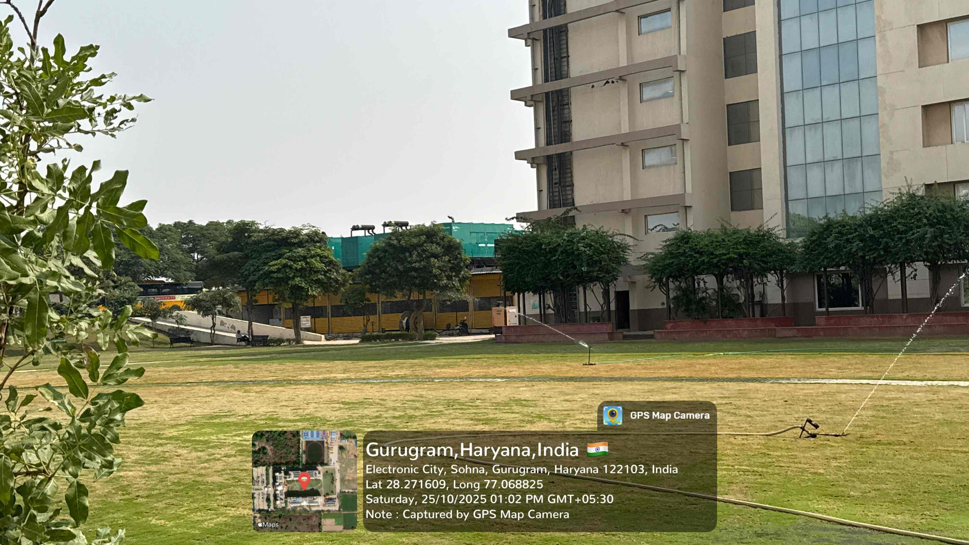
On-campus sprinkler irrigation system at K.R. Mangalam University utilizing treated wastewater for landscape maintenance.

6.4.1 Water reuse policy
K.R. Mangalam University follows a structured approach through its Sustainable Environment and Green Campus policy to treat and reuse water as part of its campus water management and conservation efforts. The University operates an on-site 100 KLD Sewage Treatment Plant (STP) that enables recycling of wastewater generated from hostels, academic blocks, and common facilities. Treated water is used primarily for landscape irrigation and toilet flushing, reducing dependence on freshwater resources and supporting a circular-use model.
Water distribution pipelines are connected from the STP to designated irrigation zones, and sprinkler-based watering systems are deployed in selected areas to minimise wastage. Routine plant checks, maintenance work, and scheduled desludging support continuous operation.
The University continues to enhance reuse system efficiency by improving piped distribution, strengthening monitoring practices, and promoting the conscious use of recycled water as part of sustainable campus operations.
Sustainable Environment and Green Campus Policy

6.4.2 Water reuse measurement
Between 2022 and 2025, K. R. Mangalam University consistently maintained and strengthened its on-campus wastewater treatment and reuse practices as part of its integrated water sustainability framework. The University operates a 100 KLD Sewage Treatment Plant (STP) and systematically measures, monitors, and reuses treated wastewater to reduce dependence on freshwater sources. Treated wastewater from the STP is reused primarily for campus horticulture, landscape irrigation, and flushing, thereby supporting non-potable water needs and promoting a circular approach to water management.
Throughout the reporting period, recycled water was utilised for gardening, landscape irrigation, and sanitation purposes, significantly reducing the demand on freshwater sources. Regular monitoring records and reuse logs were maintained to track treated wastewater volumes and ensure consistent and sustainable water reuse practices across the campus. The STP has a maximum treatment capacity of 100 KLD, while operationally the plant runs for approximately 12 hours per day, treating an average of about 50 KLD of wastewater.
Based on this operational performance, the University achieved an estimated treated wastewater reuse volume of approximately 18,250 m³ per year, calculated as follows:

- Average treated wastewater: 50,000 litres per day
- Annual treated volume:
50,000 litres/day × 365 days = 18,250,000 litres/year
= 18,250 m³/year

This level of reuse was consistently maintained across the period from 2022 to 2025, with treated wastewater supporting key non-potable campus functions. The upper-bound reuse capacity, based on the full design capability of the STP operating at 100 KLD, is estimated at 36,500 m³ per year, demonstrating significant scope for future expansion of wastewater reuse as campus requirements increase.
By maintaining reliable wastewater treatment operations, documenting reuse volumes, and prioritising non-potable applications, K. R. Mangalam University has reinforced its commitment to responsible water stewardship, efficient resource utilisation, and long-term sustainability in alignment with SDG 6 (Clean Water and Sanitation) and national sustainability benchmarks.

6.5 Water in the community
K.R. Mangalam University undertakes initiatives to promote water awareness, conservation practices, and responsible resource use in the surrounding community. Campus activities include student-led outreach through NSS and schools of the university, plantation and maintenance drives, and sensitisation programmes on wastewater reuse, rainwater harvesting, and mindful water consumption.
The University provides free drinking-water access at the main entrance, supporting visitors, daily commuters, and campus labourers. Signage encouraging refillable bottles and reduced single-use plastic supports responsible hydration practices. Campus gardeners are guided in efficient irrigation methods, particularly through the use of treated water from the on-site STP.
Awareness sessions, group discussions, and observation days such as and Environment Day are conducted annually. Students participate in neighbourhood sensitisation efforts, including visits to nearby communities and interaction with school students and campus staff, promoting the importance of water conservation and clean-water hygiene. These initiatives help foster a culture of water responsibility, extending University values beyond the campus boundary.

6.5.1 Water management educational opportunities
The K.R. Mangalam University integrates education on sustainable water resources into various programs for inspiring a culture of environmental stewardship and responsible management of natural resources. Several academic courses under Clean Water and Sanitation are specifically designed to familiarize students with scientific, technical, and practical details related to water management systems, groundwater sustainability, and water-efficient infrastructure design.
List of Academic courses
Program | Batch | Period | Course Code | Course Name
B.Sc. (H) Agriculture | 2021-2025 | Semester-V | SAAG311A | RAINFED AGRICULTURE AND WATERSHED MANAGEMENT
B.Sc. (H) Chem (Research) | 2023-2027 | Semester-I | SEC007 | GROUNDWATER MODELING
B.Tech Civil | 2020-2024 | Semester-VII | ETCE417A | GROUND WATER DEVELOPMENT
B.Arch | 2022-2027 | Semester-IV | APCE230A | BUILDING SERVICES-I (WATER SUPPLY & SANITATION)
B.Sc. (H) Agriculture | 2023-2027 | Semester-II | SAAG114A | SOIL AND WATER CONSERVATION ENGINEERING

Also, the NSS conducts many extension activities and programs for educating the people from the nearby areas of the University. The extension activities taken by the various schools of the university conduct awareness sessions to inculcate knowledge and understanding of good water management.
6.5.3 Off-campus water conservation support
K.R. Mangalam University extends its commitment to environmental sustainability beyond campus boundaries through a range of community-oriented water conservation initiatives. In tune with SDG 6, Clean Water and Sanitation, the University actively supports nearby villages and local communities in promoting responsible usage of water, safe drinking practices, and sustainable resource management.
Key initiatives include setting up free drinking-water stations at and around the campus premises for use by the general public, daily commuters, and visitors from surrounding communities. Such stations ensure available safe, purified RO water is free of cost to reduce dependency on single-use bottled water and minimize plastic wastes.
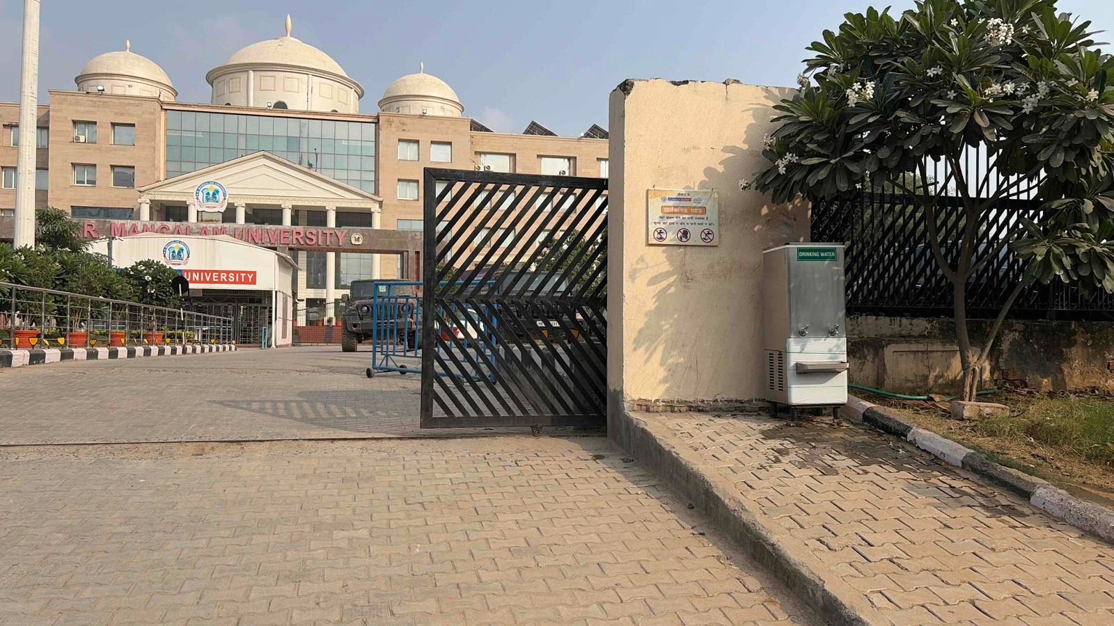
Free purified drinking water facility at K.R. Mangalam University promoting community welfare and sustainable water use.
6.5.4 Sustainable water extraction on campus
K.R. Mangalam University follows sustainable water extraction and management throughout its 28-acre campus to help achieve the goals of SDG 6: Clean Water and Sanitation. The University ensures that the water drawn from underground sources, such as through bore wells, is managed through eco-friendly, regulated extraction systems that ensure the prevention of overexploitation and the maintenance of the groundwater balance.

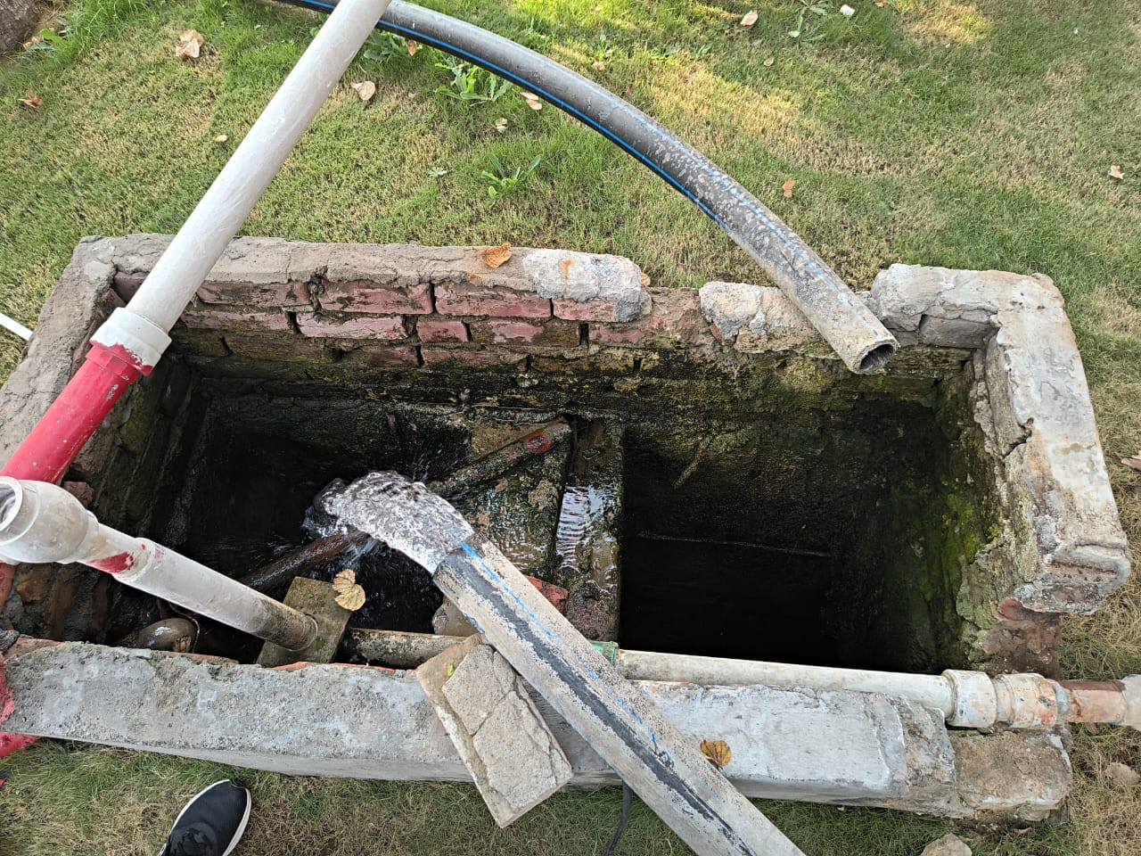
Groundwater extraction and recharge inspection point at K.R. Mangalam University
6.5.5 Cooperation on water security
A Memorandum of Understanding was signed between K.R. Mangalam University and the National Mission for Clean Ganga, under the Ministry of Jal Shakti, Government of India, on 12th April 2023. This MoU focuses on collaborative efforts in river rejuvenation, water conservation, and environmental sustainability. It centers around research, awareness campaigns, student internships, and the establishment of ‘Ganga Activity Centres’ to support the Namami Gange Programme. The initiative encourages students to become ‘Ganga Champions,’ adopt ghats, and integrate river studies into academics. This partnership strengthens the university’s commitment to sustainable development and environmental stewardship in alignment with national priorities.
MoU with Ministry of Jal Shakti

6.5.6 Promoting conscious water usage on campus
K.R. Mangalam University has pledged to ensure that water is used in a very responsible manner on campus. Sensor-based taps, efficient plumbing systems, and recycling of wastewater are in place to minimize wastage and utilize the resource judiciously. Continuous education, participatory activities, and visible signage on sustainability have helped in integrating responsible behavior and collective action, conforming to the spirit of Promotion of Conscious and Sustainable Water Use towards a greener and water-secure future.

6.5.7 Promoting conscious water usage in the wider community
K.R. Mangalam University supports the wider community through the provision of free drinking water facilities, provided at several points near the campus and accessible to local residents, visitors, and commuters. These purified RO water stations promote responsible use of water and ensure equity in access to safe drinking water, contributing to community water responsibility.
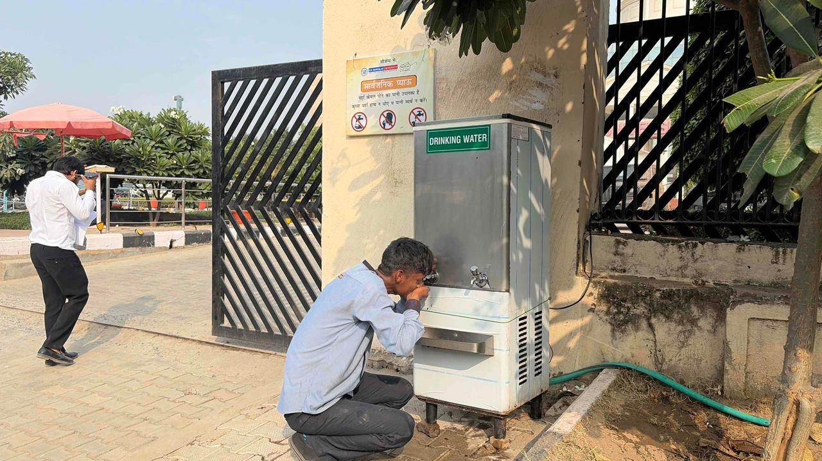
Save water signage at drinking water facility at the campus entrance, promoting mindful water use and responsible hydration for community members and visitors.
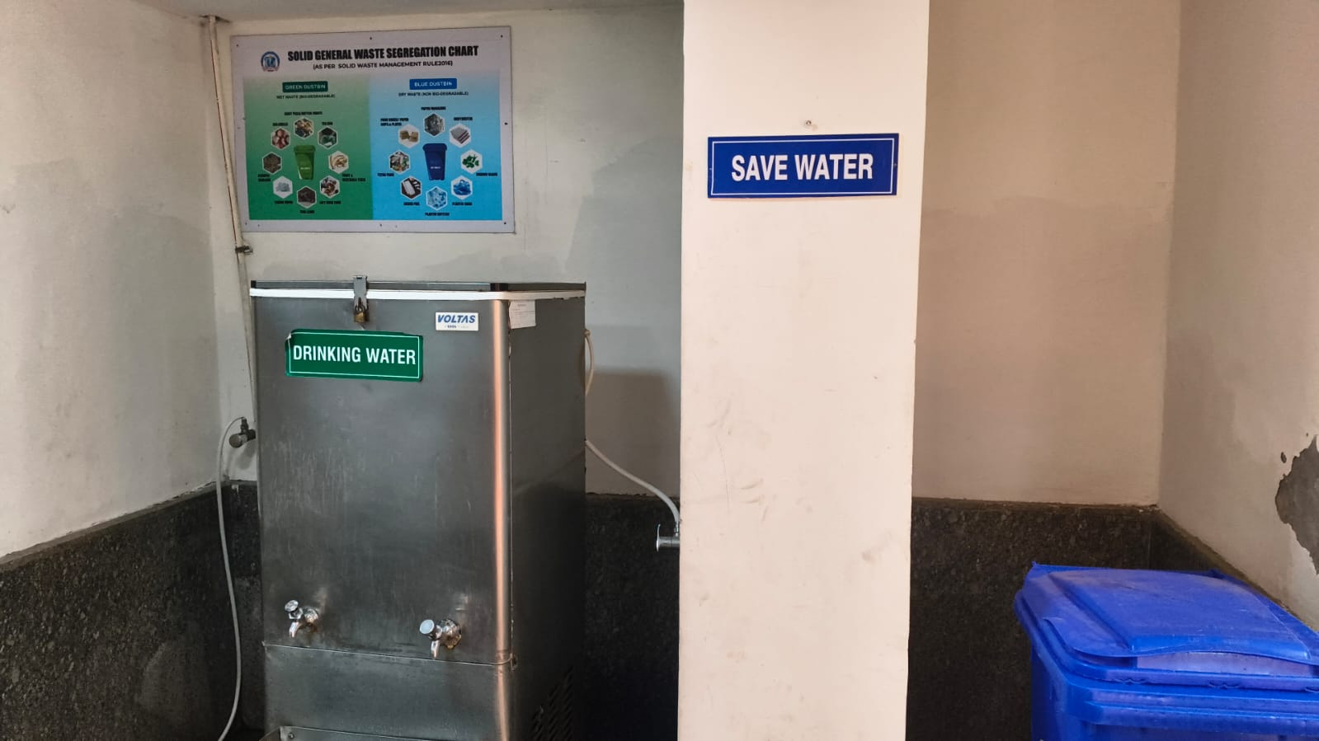
Drinking water station with ‘Save Water’ signage, promoting responsible water use and sustainable campus hygiene practices.
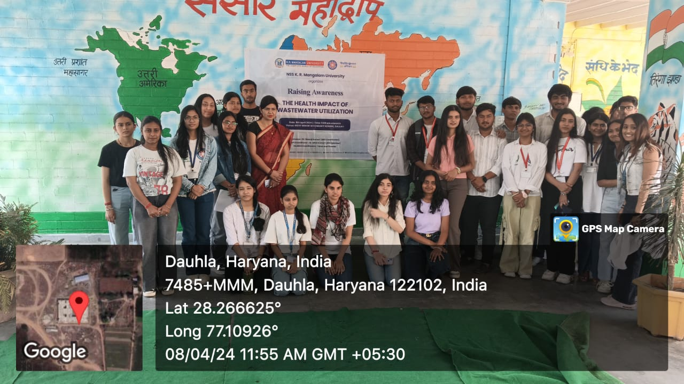
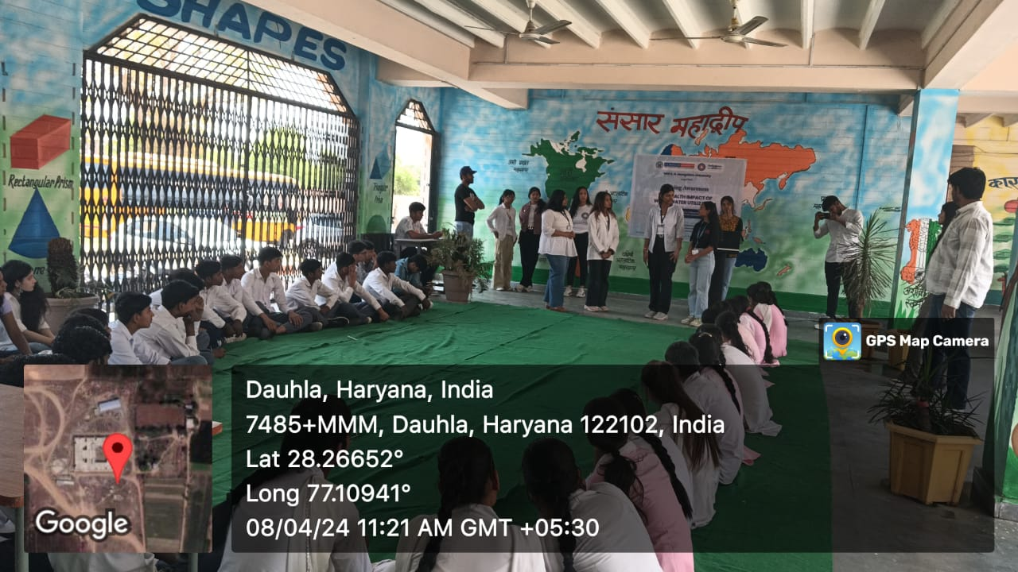
Awareness session conducted at Government Senior Secondary School, Daulah, where K R MANGALAM UNIVERSITY volunteers sensitized students on wastewater health impacts, safe water practices, and hygiene through interactive discussions and street theatre.

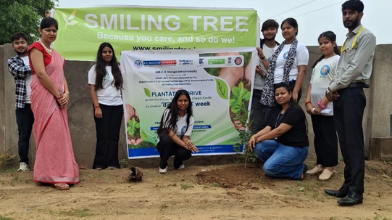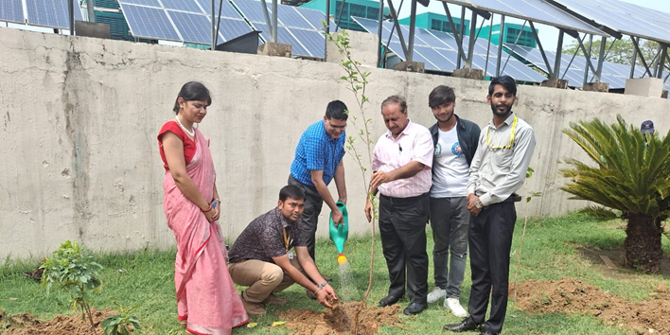
NSS Coordinator with NSS volunteers and members during plantation drive
These initiatives reflect K R MANGALAM UNIVERSITY’s continued efforts to build awareness on clean water, safe sanitation, and green campus values, while fostering responsible citizenship and community participation in sustainable water and environmental practices.

The University will continue to strengthen its community partnerships, expand practical demonstrations of sustainable water-use systems, and enhance awareness through academic-community collaboration and student leadership programs.
S.No. | Title | Date | Organisor | Link
1 | Sewage Treatment Visit | 01/03/2024 | School of Medical and Allied Sciences | Report
2 | Cleanliness Drive at Lakhuwa Village | 01/10/2023 | NSS | Report
3 | Field Visit for the Collection and Survey of Wild Flora Diversity – supports ecosystem conservation and watershed health | 7/03/2024 | School of Agricultural Sciences | Report
4 | Exploring Nature's richness & medicinal plant potential to broaden understanding of Pharmacognosy & sustainable healthcare practices | 28/02/2024 | School of Medical and Allied Sciences | Report
5 | Vriksha Ropan with NSS | 29/10/2023 | School of Agricultural Sciences | Report
6 | Plantation Drive Under the Theme ‘‘Green Earth Clean Earth’’ | 29/06/2024 | NSS | Report
7 | Poster Making Competition on World Environment Day | 05/06/2024 | NSS | Report
8 | Field Visit Report on Sultanpur Lake at Sultanpur Lake Gurugram | 14/09/2023 | School of Agricultural Sciences | Report

Between 2022 and 2025, K. R. Mangalam University’s initiatives under Clean Water and Sanitation reflected a robust, integrated, and future-focused water management ecosystem grounded in strong infrastructure, systematic monitoring, and active community engagement. Throughout this period, the University operated a 100 KLD Sewage Treatment Plant, enabling the reuse of approximately 18,250 m³ of treated wastewater per year, thereby significantly reducing freshwater demand and promoting circular water-use practices. These efforts were complemented by rainwater harvesting through 17 recharge structures and the installation of sensor-based fixtures across the campus to minimise wastage and improve water-use efficiency. The University ensured free access to potable drinking water, conducted periodic water-quality testing, and maintained strategic tank-based water storage systems, underscoring its commitment to public health, equity, and responsible consumption. Beyond infrastructure, water sustainability was actively embedded into academic and outreach activities through curricular integration, NSS-led awareness initiatives, school-level outreach programmes, and collaborative engagements, including MoUs with agencies such as the National Mission for Clean Ganga, thereby extending the impact of water stewardship beyond the campus. Collectively, the initiatives undertaken between 2022 and 2025 demonstrate the University’s continued progress towards inclusive, efficient, and climate-responsive water governance, reinforcing its role as a responsible institution and a leader in long-term water sustainability.

