REPORT
ON
CODE OF CONDUCT FOR STUDENTS

Date: 28th August, 2024
Venue: C005, C Block, Ground Floor
Event Type: Training Program
Mode of activity: Offline
Target group: Students of SBAS
Organized by: School of Basic and Applied Sciences, K R Mangalam University, Gurugram
Resource Person: Dr Seema Raj, Associate Professor, School of Basic and Applied Sciences and
Dr. Pawan Kumar, Professor, School of Basic and Applied Sciences
Participants: 54
The training program on the code of conduct serves as a guiding framework for students, outlining the behavioral expectations within the university/college premises. It aims to foster a safe, respectful, and inclusive environment that supports both academic and personal growth. A well-defined code of conduct enhances the institution's reputation and helps build a harmonious community.
This session on the code of conduct was organized for the students of the School of Basic and Applied Sciences, where they were informed about the standards of discipline and appropriate behavior both on and off campus. Dr. Seema Raj, Associate Professor at the School of Basic and Applied Sciences, introduced the session with a brief overview.
The primary goal of the session was to acquaint students with the behavioral expectations on campus and emphasize the importance of responsible and ethical conduct within the university community. Dr. Seema began by explaining that understanding the institution's rules and regulations is essential to maintaining discipline and ensuring a smooth learning environment. She informed the students about campus timings, emphasizing that classes would run for five days a week from 9:00 am to 4:00 pm, and that students must be punctual. She highlighted that foul or offensive language, littering, bullying, aggression, or violence are strictly prohibited, with disciplinary action taken if necessary. Dr. Seema further stressed that the use of

narcotics on campus is strictly forbidden, with serious consequences for violations. She also mentioned that attending seminars, competitions, and workshops in their entirety is mandatory for all students.
Additionally, Prof. Pawan Kumar covered topics such as the importance of wearing ID cards on campus and outlined various actions that violate the code of conduct and their potential punishments. These include:
- Ragging
- Cheating in examinations
- Acts of violence or intimidation, including sexual harassment or discrimination based on race, color, religion, nationality, sex, age, language, social class, or disability.
He reminded the students that they are free to use university facilities such as the library, labs, and canteen, but that the use of laptops and mobile phones is strictly prohibited during classes. In closing, Dr. Seema and Prof. Pawan Kumar wished all the freshmen and senior students success in their academic journey.

Photographs:
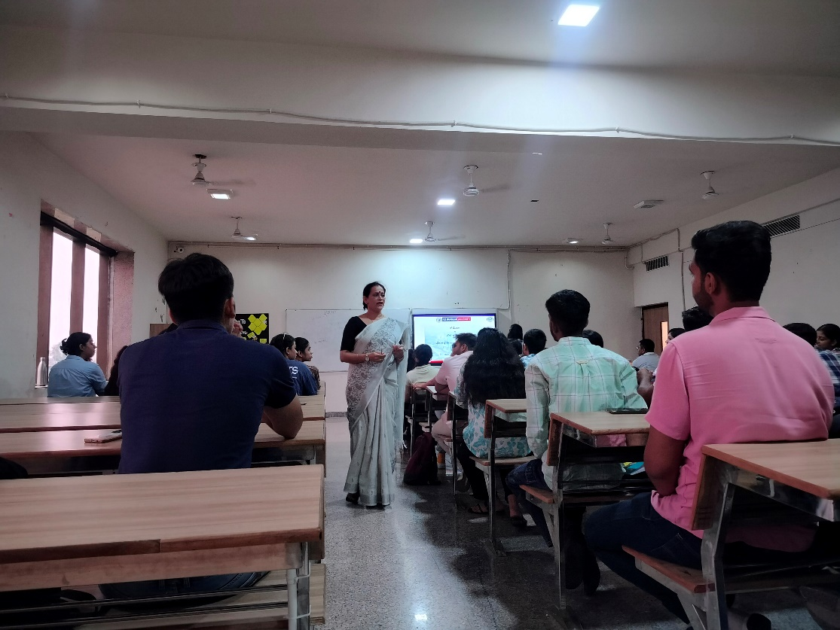

Photo 1: Dr Seema addressed the audience about code of conduct

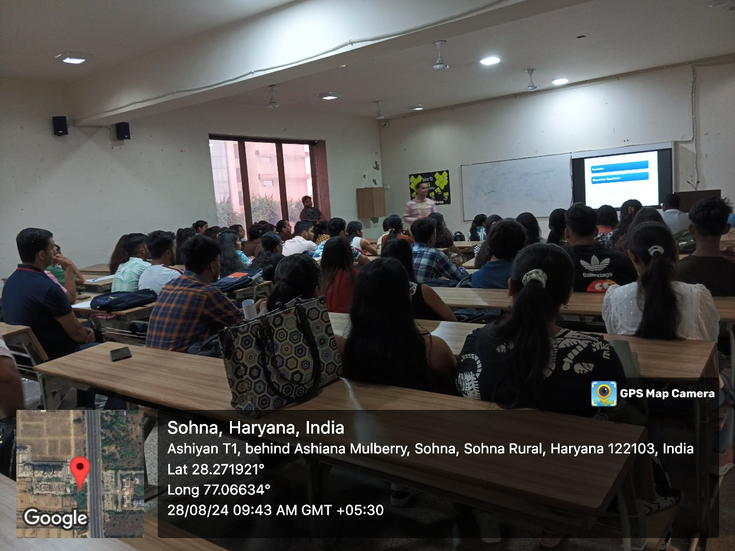

Report prepared by | Dr Seema Raj, Associate Professor, SBAS  Dr. Neeraj Kumari, Assistant Professor, SBAS
Report verified by | Prf. Meena Bhandari, Dean, SBAS
Report Verified by IQAC Coordinator | Dr Shikha Dutt Sharma

Photo 2: Prof. Pawan Kumar addressed the audience about various actions that violate the code of conduct

