REPORT

Case Study to National Crafts Museum & Hastkala Academy, New Delhi

Date: Thursday, 26th September 2024, 10 AM onwards
Venue: National Crafts Museum & Hastkala Academy, New Delhi
Event Type: Case Study
Mode of Activity: offline
Target Group: Students of 3rd Year architecture
Resource Persons: NA
Coordinators: Ar. Nandit Pastariya, Assistant Professor, SOAD, K R Mangalam University
Organized by: School of Architecture and Design
Number of Participants: 17

During their visit to the National Crafts Museum & Hastkala Academy in New Delhi, the architecture students gained valuable insights into traditional Indian crafts and their integration with architectural design. The museum's rich collection of textiles, folk art, and handcrafts provided a unique opportunity to study the intricate relationship between art and architecture, reflecting India's cultural heritage. Students observed the craft techniques, materials, and structural forms, which deepened their understanding of how local artistry influences architectural aesthetics and functionality. This hands-on experience fostered creativity and an appreciation for sustainable design rooted in craft traditions.
Students explored the relationship between traditional Indian crafts and architectural design, observing how local artistry influences building aesthetics and functionality. The museum's exhibits showcased diverse materials such as textiles, wood, and metal, offering insights into sustainable design approaches. Students learned about the cultural significance of Indian crafts, gaining a deeper appreciation for how heritage and craftsmanship are preserved through design. Observations of handcrafted objects provided inspiration for incorporating intricate detailing and structural forms into modern architectural designs. This event was further succeeded by Site visit to Bhairon marg, Pragati Maidan, New Delhi.

Photographs:
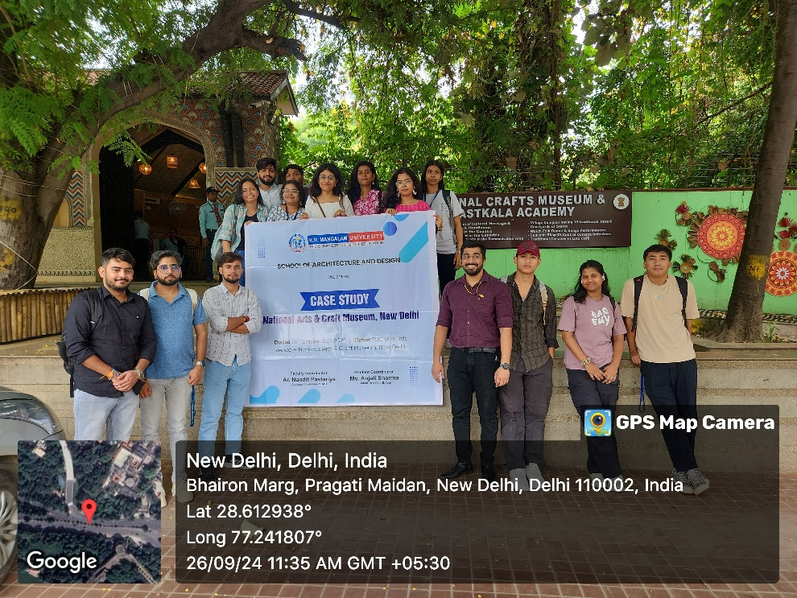
Photo 1: Group photo at the National Crafts Museum & Hastkala Academy, New Delhi

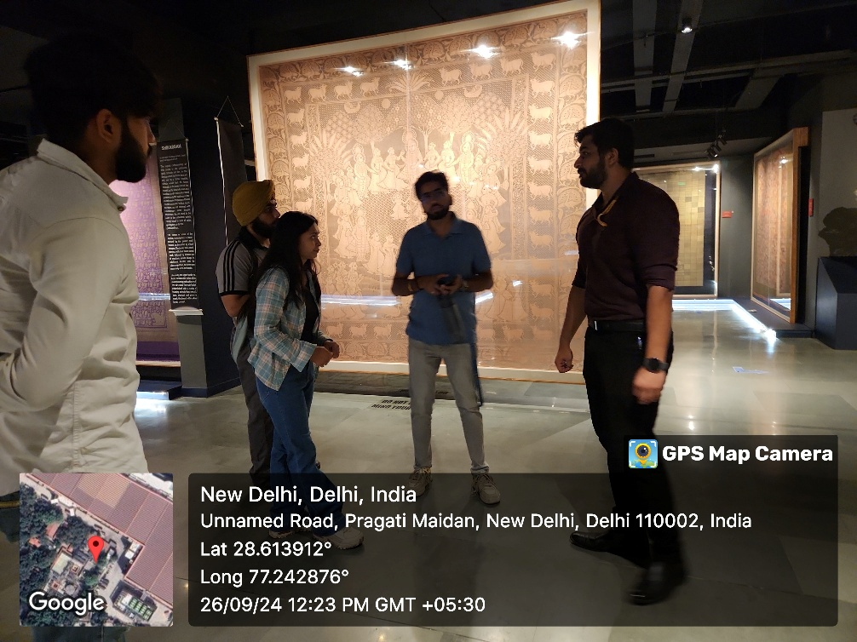
Photo 2: Understanding the showcase spaces, materials and their utilization
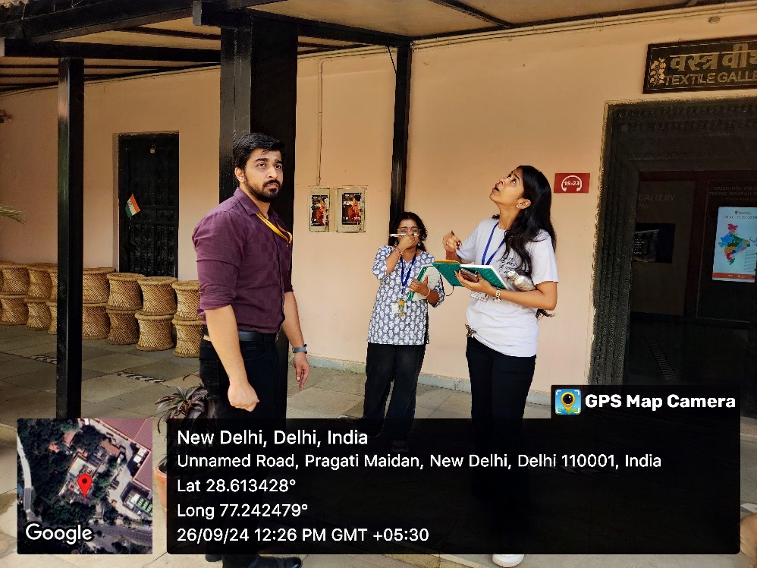
Photo 3: Architectural Material discussion in the form of an interactive session

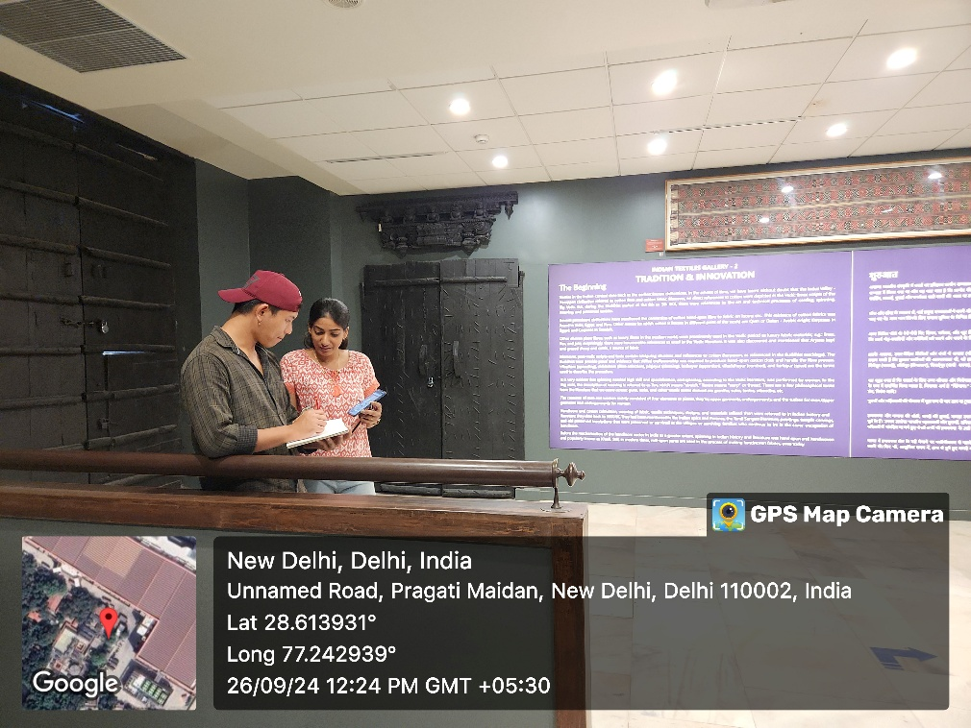
Photo 4: Students sketching on site diagrams for better understanding of spaces

Report prepared by | Ar. Nandit Pastariya, Assistant Professor SOAD
Report Verified by Dean | Prof. Tanaya Verma, Dean SOAD
Report Verified by IQAC Office | Dr. Shikha Dutt

Feedback:
