CAPACITY DEVELOPMENT OF GOVT. SCHOOL TEACHERS ON THE USE OF EDUCATIONAL TECHNOLOGY IN PEDAGOGY AND ASSESSMENT IN GHAMROJ AND ALIPUR VILLAGES

- Introduction
In the rapidly evolving landscape of education, the integration of educational technology has become a cornerstone of modern teaching practices. This shift is particularly significant in rural areas, where access to quality education has historically been limited due to infrastructural constraints and resource shortages. Educational technology, encompassing tools like digital learning platforms, interactive whiteboards, and online resources, has the potential to bridge the gap between urban and rural education. By enabling personalized learning, enhancing student engagement, and providing access to a vast array of resources, technology has revolutionized how education is delivered. In rural areas, where traditional methods often fall short in addressing diverse learning needs, educational technology offers a lifeline, helping to ensure that students in these regions are not left behind in the global pursuit of knowledge and skills.
Despite the promise of educational technology, its successful implementation in rural schools hinges on the capacity of teachers to effectively integrate these tools into their pedagogy. Government school teachers, who often work in resource-limited environments, face significant challenges in adopting and utilizing technology due to a lack of training, support, and infrastructure. The need for capacity development among these teachers is critical, as their ability to harness the potential of educational technology directly impacts the quality of education provided to students. By equipping teachers with the necessary skills and knowledge to use technology in teaching and assessment, educational outcomes can be significantly improved, leading to a more equitable and inclusive education system.

- Demography of the Study Area
Berka is a medium size village located in Sohna Tehsil of Gurgaon district, Haryana with total 209 families residing. The Berka village has population of 1437 of which 743 are males while 694 are females as per Population Census 2011. In Berka village population of children with age 0-6 is 228 which makes up 15.87 % of total population of village. Average Sex Ratio of Berka village is 934 which is higher than Haryana state average of 879. Child Sex Ratio for the Berka as per census is 839, higher than Haryana average of 834. Berka village has higher literacy rate compared to Haryana. In 2011, literacy rate of Berka village was 78.99 % compared to 75.55 % of Haryana. In Berka Male literacy stands at 88.85 % while female literacy rate was 68.64 %. As per constitution of India and Panchayati Raj Act, Berka village is administrated by Sarpanch (Head of Village) who is elected representative of village..
Table 1: Census report
Particulars | Total | Male | Female
Total No. of Houses | 209 | - | -
Population | 1,437 | 743 | 694
Child (0-6) | 228 | 124 | 104
Schedule Caste | 419 | 218 | 201
Schedule Tribe | 0 | 0 | 0
Literacy | 78.99 % | 88.85 % | 68.64 %
Total Workers | 465 | 332 | 133
Marginal Worker | 17 | 14 | 3
Source: 2011 Censes
Alipur
Alipur is a village situated in Sohna tehsil of Gurgaon district in Haryana. As per the Population Census 2011, there are a total of 591 families residing in the village Alipur. The total population of Alipur is 3,398 out of which 1,789 are males and 1,609 are females thus the Average Sex Ratio of Alipur is 899.
The population of Children aged 0-6 years in Alipur village is 414 which is 12% of the total population. There are 250 male children and 164 female children between the age 0-6 years. Thus, as per the Census 2011 the Child Sex Ratio of Alipur is 656 which is less than Average Sex Ratio (899) of Alipur village.
As per the Census 2011, the literacy rate of Alipur is 82.2%. Thus Alipur village has a higher literacy rate compared to 73.4% of Gurgaon district. The male literacy rate is 92.4% and the female literacy rate is 71.35% in Alipur village.
Table 2: Census report
 | Total | Male | Female
Children | 414 | 250 | 164
Literacy | 82.21% | 92.4% | 71.35%
Scheduled Caste | 574 | 304 | 270
Scheduled Tribe | 0 | 0 | 0
Illiterate | 945 | 367 | 578
Main Workers | 780 | 87 |  | 867
Cultivators | 217 | 37 |  | 254
Agriculture Labourer | 62 | 5 |  | 67
Household Industries | 8 | 6 |  | 14
Other Workers | 493 | 39 |  | 532
Census: 2011, India.
- Importance of Educational Technology
Educational technology has become an indispensable component of modern education, transforming how teachers instruct and how students learn. Its importance lies in its ability to enhance learning experiences, making education more interactive, personalized, and accessible. Educational technology, which includes digital tools such as computers, tablets, educational software, and online resources, allows for a dynamic and engaging learning environment that can cater to diverse learning styles and needs. By integrating technology into the classroom, teachers can present complex concepts in more understandable and visually appealing ways, thereby improving student comprehension and retention.
One of the primary benefits of educational technology is its ability to provide personalized learning experiences. Traditional teaching methods often follow a one-size-fits-all approach, which may not address the varying paces and styles of different learners. Educational technology enables the creation of customized learning paths, allowing students to progress at their own speed and revisit challenging concepts as needed. This adaptability helps in addressing individual learning gaps and promotes a more inclusive learning environment where all students have the opportunity to succeed.
Moreover, educational technology plays a crucial role in fostering collaboration and communication among students and teachers. With the advent of online platforms, students can easily collaborate on projects, share ideas, and receive instant feedback from their peers and instructors. This collaborative approach not only enhances learning outcomes but also prepares students for the increasingly digital and interconnected world. In addition, technology facilitates continuous assessment, enabling teachers to monitor student progress in real time and provide targeted interventions when necessary.
In rural areas, where educational resources and qualified teachers are often scarce, the importance of educational technology becomes even more pronounced. It can bridge the gap between urban and rural education by providing access to high-quality educational content and resources that would otherwise be unavailable. Through digital learning platforms, students in remote areas can access the same educational materials as their urban counterparts, helping to level the playing field. Furthermore, technology can supplement the efforts of teachers who may be overburdened with large class sizes or multiple grade levels, ensuring that students receive the attention and support they need to thrive.
The educational technology is a powerful tool that can significantly enhance the quality of education. It promotes personalized learning, fosters collaboration, and ensures that students in all regions have access to the same educational opportunities. As the education landscape continues to evolve, the integration of technology into teaching and learning processes will be essential in preparing students for the future.
- Importance of Technological Competence Among Teachers
Technological competence among teachers is crucial in the modern educational landscape, where the integration of technology into teaching and learning processes is rapidly becoming the norm. As educational technology transforms traditional classrooms into dynamic, interactive, and student-centered learning environments, the ability of teachers to effectively use these tools has a direct impact on the quality of education provided. Technological competence empowers teachers to enhance their instructional strategies, engage students more effectively, and ultimately improve learning outcomes.
One of the key reasons technological competences is essential for teachers is that it enables them to adapt to the diverse learning needs of students. Today’s classrooms are increasingly diverse, with students possessing varying levels of ability, learning styles, and interests. Technologically competent teachers can leverage digital tools to differentiate instruction, providing personalized learning experiences that cater to the unique needs of each student. This adaptability not only helps in addressing individual learning gaps but also fosters an inclusive learning environment where all students can thrive.
Moreover, technological competence allows teachers to create more engaging and interactive lessons. Digital tools such as interactive whiteboards, multimedia presentations, and educational software enable teachers to present complex concepts in visually appealing and easily understandable ways. This not only captures students' attention but also enhances their comprehension and retention of the material. In an era where students are constantly exposed to digital media outside the classroom, teachers who are proficient in using technology can make learning more relevant and engaging, thereby increasing student motivation and participation.
In addition to enhancing instructional methods, technological competence is vital for teachers to effectively assess and monitor student progress. Technology offers various tools for formative and summative assessment, enabling teachers to track student performance in real time and provide timely feedback. This ongoing assessment helps in identifying areas where students may be struggling, allowing teachers to intervene early and adjust their teaching strategies accordingly. Furthermore, technology facilitates data-driven decision-making, enabling teachers to use analytics to inform their instructional practices and improve student outcomes.
In rural and resource-limited settings, the importance of technological competence among teachers is even more pronounced. In such areas, access to quality educational resources is often limited, and teachers may face challenges in delivering comprehensive instruction. Technologically competent teachers can overcome these challenges by using digital resources to supplement their teaching, providing students with access to a broader range of learning materials and opportunities. This not only enhances the learning experience for students but also helps bridge the educational gap between urban and rural schools.
The technological competence is essential for teachers to effectively integrate technology into their teaching practices, enhance student engagement, and improve learning outcomes. As the role of technology in education continues to grow, equipping teachers with the necessary technological skills and knowledge will be critical in preparing students for success in the 21st century.
- Review of the Study
Sharma & Sharma (2021) conducted study on “Techno-pedagogical skills of teacher trainees belonging to arts and science academic streams.” The goal of this research was to determine the techno-pedagogical abilities of teacher trainees of science and arts streams. The study’s findings confirm that teacher trainees in the arts have lower techno-pedagogical skills than science stream teacher trainees. Anand, S. (2019) conducted study on “Techno pedagogical competency of faculty members: The present need of higher education.” The current study examines the techno-pedagogical abilities of faculty members who teach in higher education. According to the study’s findings, faculty members had above-average techno-pedagogical competency. Also, there was no significant difference in Techno pedagogical competency between male and female faculty members, as well as between social-science and science faculty members. According to the findings faculty members should use platforms such as SWAYAM and NPTEL to keep themselves and their students up to date. Beri & Sharma (2019) conducted “A study of technological -pedagogical and content knowledge among teacher- educators in Punjab region.” The purpose of this research was to assess the teacher-educator’s techno-pedagogical and content (subject) knowledge abilities (competencies) at Punjab’s teaching training colleges The results demonstrated that Punjab region’s teacher- educators have strong techno-pedagogical and content (subject) knowledge abilities (competencies). The study revealed statistically significant differences in teacher-educator techno-pedagogical and content (subject) knowledge abilities (competencies) based on gender, location of colleges, stream and types of colleges. Bala, P., & Tao, I. (2018) conducted study on “An examination of techno pedagogical competence and anxiety towards the use of instructional aids in teaching among senior secondary school teachers.” The study’s goal was to investigate the determinants of techno-pedagogical competence in teachers of senior secondary schools. The study’s findings revealed that: 1) Six senior secondary school teachers showed low, 43 showed average, 51 showed high level of techno-pedagogical competency. 2) With respect to Anxiety towards the use of instructional aids, 27 senior secondary school teachers displayed an average level and the 73 remaining senior secondary school teachers displayed a low level and not a single senior secondary school teacher displayed a high level of anxiety towards the use of instructional aids. 3) With respect to techno-pedagogical competence and anxiety towards the use of instructional aids in teaching male and female teachers senior secondary school teachers didn’t differ significantly. Sibichen (2018) conducted survey on “Techno-pedagogical skills of secondary teacher education students.” The goal of this study was to evaluate secondary teacher education student’s techno-pedagogical abilities. The findings also demonstrated that secondary teacher education students who have completed a computer course had significantly better evaluation, learning and techno-pedagogical skills than those who have not. Prakash & Hooda (2018) conducted “A study on techno pedagogical competency among teachers of government and private schools of Haryana state.” The study’s goal was to determine the techno-pedagogical competency of teachers in Haryana’s private and government schools. The findings demonstrated that teachers in private senior secondary schools have a higher techno-pedagogical competency than teachers in govt. senior secondary schools since private schools have better facilities than public schools. Male teachers of private and government senior secondary schools have higher techno-pedagogical competency than females. Teachers in urban private and government senior secondary schools have higher mean scores of techno-pedagogical competencies than teachers in rural private and government senior secondary schools. Sathiyaraj & Singaravelu (2013) conducted study on “Techno-pedagogical competency of higher secondary school teachers in Cuddalore district.” By using the normative survey method, the investigators studied higher secondary school teacher’s techno-pedagogical competency. According to the findings of the survey, teachers in most of the higher secondary schools have an average level of perceived techno-pedagogical competency. Furthermore, there is insignificant difference in perceived techno-pedagogical competency between (i) female and male school teachers, (ii) urban and rural school teachers, (iii) government & private school teachers, &(iv) married and unmarried teachers. Gonzalo (2011) studied “Training needs of teachers in ICT: training profiles and elements of complexity.” This study intends to create teacher training profiles that can be linked to their ICT competencies and usage, as well as personal and personal aspects. The findings showed that teachers require more personal-professional training, as well as greater classroom teaching and ICT integration. There was a strong relationship between these training needs profiles and ICT abilities, particularly technology; as well as ICT use, primarily in the personal-professional realm. These profiles were also seen influenced by frequency of computer use and teacher’s age.
- Significance of the Study
The significance of this study lies in its potential to bridge the digital divide in rural education by enhancing the technological competence of teachers. With the growing emphasis on integrating educational technology into teaching, learning, and assessment processes, this study plays a crucial role in assessing and improving the preparedness of teachers in rural areas like Ghamroj and Alipur villages. This research is significant in multiple ways, including its potential to impact educational outcomes, contribute to policy development, and provide valuable insights for future interventions.
- Addressing the Digital Divide in Rural Education
One of the most significant aspects of this study is its focus on rural schools, which often lag behind their urban counterparts in terms of access to and use of technology in education. The digital divide between rural and urban schools is a well-documented issue, and this study seeks to address that gap by evaluating and improving the technological competence of teachers in rural settings. By providing teachers with the necessary skills to integrate technology into their teaching practices, this study contributes to reducing the educational inequalities between rural and urban areas. The intervention program empowers teachers with digital tools that can enhance student engagement and learning outcomes, thereby contributing to the overall quality of education in rural schools.
- Enhancing Teacher Competence in Educational Technology
The study’s primary focus on evaluating and improving the technological competence of teachers is highly significant in today’s educational landscape. The rapid advancements in educational technology have transformed the way knowledge is imparted and assessed, and teachers need to keep pace with these changes to remain effective in the classroom. This study provides a structured approach to enhancing teacher competence by assessing their baseline skills through a pre-test, delivering targeted interventions through hands-on training, and measuring progress through a post-test assessment. By doing so, the study ensures that teachers are not only exposed to new technologies but also equipped with the practical skills to implement them in real-world teaching scenarios. This increased competence can lead to more effective teaching practices, improved student outcomes, and a more dynamic learning environment.
- Impact on Teaching, Learning, and Assessment
The integration of technology into teaching, learning, and assessment has the potential to transform traditional educational practices. This study highlights the importance of using digital tools to enhance these core components of education. For example, the training sessions on tools like Google Forms, Canva, and online learning platforms provide teachers with innovative ways to assess student learning, create engaging lesson plans, and track student progress. This shift from traditional methods to technology-driven approaches can lead to more personalized learning experiences for students, as teachers can use data and analytics to identify individual student needs and tailor their instruction accordingly. Additionally, the use of digital assessment tools enables more efficient and accurate tracking of student performance, providing teachers with valuable insights into their students’ strengths and areas for improvement.
- Contributing to Policy Development
The findings of this study have important implications for policymakers, particularly in the context of rural education. By identifying the gaps in technological competence among teachers and the challenges they face in integrating technology into their teaching practices, the study provides policymakers with valuable data to inform future education policies. For example, the study’s findings can guide decisions on allocating resources for technology infrastructure in rural schools, developing teacher training programs focused on digital literacy, and creating supportive environments for the adoption of educational technology. Furthermore, the study underscores the need for ongoing professional development and technical support for teachers, which can be integrated into national education policies to ensure that teachers have the necessary tools and knowledge to thrive in a technology-enhanced educational landscape.
- Providing a Model for Future Interventions
This study serves as a model for future interventions aimed at improving the technological competence of teachers in rural areas. The structured approach, which includes pre-test assessments, targeted training, and post-test evaluations, can be replicated in other rural communities to achieve similar outcomes. Additionally, the study’s focus on hands-on training and practical application of digital tools ensures that the interventions are directly relevant to the teachers’ day-to-day work. By documenting the process and outcomes of the intervention program, this study provides valuable insights for other researchers, educators, and policymakers looking to implement similar programs in different contexts.
- Empowering Teachers and Enhancing Student Outcomes
Ultimately, the significance of this study lies in its potential to empower teachers and improve student outcomes. Teachers are the backbone of the education system, and by equipping them with the skills to effectively use technology in the classroom, this study contributes to their professional growth and development. As teachers become more confident and competent in using digital tools, they can create more engaging and effective learning experiences for their students. This, in turn, can lead to improved student motivation, higher academic achievement, and better preparation for the demands of the 21st-century workforce.
The significance of this study is multi-faceted, with its potential to bridge the digital divide, enhance teacher competence, transform teaching practices, inform policy development, and provide a model for future interventions. By focusing on rural education, the study addresses a critical area of need and contributes to the broader goal of improving the quality of education in underserved communities. Through its comprehensive approach to evaluating and improving technological competence, this study has the potential to create lasting positive change for both teachers and students in rural areas.
- Research Questions
- What is the current level of technological competence among government school teachers in Ghamroj and Alipur villages?
- How effective are capacity development programs in enhancing the use of educational technology among government school teachers?
- What challenges do teachers face when integrating technology into their teaching and assessment practices in rural schools?
- Are there any significant differences in technological competence between male and female teachers in rural schools?
- Objectives
- To evaluate the current level of technological competence among government school teachers in Ghamroj and Alipur villages.
- To assess the impact of capacity development programs on the use of educational technology among government school teachers.
- To analyse the learning levels of Teachers on the basis of gender and how these levels correlate with the technological competence of their teachers.
- To analyse the learning levels of Teacher on the basis of Locale School wise.
- To identify the challenges faced by teachers in integrating technology into their pedagogy and assessment in rural schools.
- To explore the differences in technological competence between male and female teachers in the context of rural education.

- Methodology
The case study will utilize a mixed-method approach, combining both quantitative and qualitative research methods. This approach allows for a comprehensive analysis of the technological competence of teachers, the effectiveness of the intervention program, and the challenges faced in rural settings.
9.1 Sample Selection
Government school teachers from Ghamroj and Alipur villages in Gurugram.
9.2 Sample Size: A purposive sampling method was used to select 20 teachers from both School and 10 from each. The sample will include an equal representation of male and female teachers to ensure a gender-based analysis.
Table 3: Sample selection form the Alipur and Ghamroj, Sohna Gurugram.
S. No. | Village/School | No of Teachers | Male | Female | Total
1 | Alipur | 10 | 5 | 5 | 20
2 | Ghamroj | 10 | 5 | 5 | 20
Source: Field Survey 2024
Data Collection Methods
9.3 Pre-Test Questionnaire: A structured questionnaire consisting of 15 questions will be developed to assess the current level of technological competence among teachers. This questionnaire will focus on their knowledge and use of educational technology, familiarity with digital tools, and confidence in integrating technology into their teaching practices.
9.4 Post-Test Questionnaire: After the intervention, the same questionnaire will be administered to the teachers to measure any improvement in their technological competence. The post-test results will be compared with the pre-test results to evaluate the effectiveness of the training.
9.5 Focus Group Discussions (FGDs): To identify the challenges faced by teachers in integrating technology into their pedagogy and assessment, focus group discussions will be conducted with a selected group of teachers. These discussions will explore the practical difficulties teachers’ encounter, such as infrastructure limitations, lack of technical support, and resistance to change.
9.6 Observation and Gender-Based Analysis: In addition to the questionnaire and FGDs, classroom observations was conducted to assess the practical application of technology in teaching.
9.7 Data Analysis
9.7.1 Quantitative Analysis: The pre-test and post-test data will be analyzed using statistical methods to measure changes in technological competence. Descriptive statistics (mainly mean, are employed to compare the results based on gender and assess the effectiveness of the intervention program.
9.7.2 Qualitative Analysis: The data from FGDs and classroom observations will be analyzed thematically to identify recurring challenges and patterns in the integration of technology. The qualitative analysis will provide context to the quantitative findings and offer insights into the barriers faced by teachers.
9.8 Ethical Considerations
Informed consent will be obtained from all participants before conducting the study. Confidentiality and anonymity of the participants will be maintained throughout the research process.
- Intervention Programme and Data Collection
Phase 1: Pre-Test Assessment (Baseline Assessment) Date: 02.05.2024
The first phase of the intervention program focused on evaluating the technological competence of teachers from Ghamroj and Alipur villages. The goal was to assess their existing knowledge and use of educational technology through a baseline pre-test assessment.
On May 2, 2024, a pre-test questionnaire consisting of 10 questions was administered to the teachers. These questions covered their familiarity with basic digital tools like Gmail, Canva, Google Meet, Learning Management Systems (LMS), PowerPoint, and other relevant educational applications. The primary objective was to establish a clear understanding of the teachers' current proficiency levels, thereby identifying areas where they were already competent and areas requiring improvement.
The results of this pre-test assessment painted a clear picture of the technological gaps among the teachers. A significant number of teachers lacked proficiency in using basic digital tools for teaching, learning, and assessment. Female teachers, in particular, were found to be less familiar with technology compared to their male counterparts. In both Ghamroj and Alipur, male teachers demonstrated slightly higher levels of technological competence, though the gap between the two genders was relatively small in Alipur compared to Ghamroj.
These findings helped inform the design of the upcoming intervention, which was tailored to address the specific weaknesses identified. With this baseline data, a focused training program was devised to enhance the digital skills of the teachers, ensuring that they could effectively integrate educational technology into their daily teaching practices.
Phase II: Hands-On Training and Demonstrations (Dates: 08.05.2024 to 14.05.2024)
After identifying the technological gaps in the pre-test assessment, a hands-on training program was initiated in Ghamroj village, spanning four days. The training aimed to equip teachers with the necessary skills to use educational technology for teaching, learning, and assessment.
Day 1: Hands-On Training (08.05.2024)
On May 8, 2024, the first day of the intervention focused on hands-on training. Teachers were introduced to essential digital tools, such as Gmail, Canva, Outlook, and various educational apps that support teaching in rural settings. The objective was to build foundational knowledge by teaching the teachers how to create email accounts, manage classroom communications, and explore different online resources. Teachers participated in practical sessions that demonstrated the relevance of each tool in real classroom scenarios, allowing them to grasp the importance of technology integration.
Day 2: Demonstration on Online Resources (09.05.2024)
On May 9, 2024, the second day was dedicated to demonstrating the use of online resources for teaching. Teachers were shown how to access various educational websites, online textbooks, and open educational resources (OERs) that they could utilize for content delivery. The session also highlighted how to use YouTube educational channels and platforms like Coursera or Khan Academy to supplement classroom teaching. A particular emphasis was placed on how these resources can help rural teachers enhance their subject matter knowledge and engage students more effectively.
Day 3: Training on Educational Software (13.05.2024)
On May 13, 2024, the third day of the intervention targeted the use of software programs that support teaching and learning. Teachers were introduced to educational software like PowerPoint, Google Forms, and Learning Management Systems (LMS). Teachers learned to create interactive presentations and assessments through PowerPoint and Google Forms. They were also trained on how to use LMS platforms to manage and deliver online content, track student performance, and engage in distance learning practices, especially useful in rural settings where physical resources may be limited.
Day 4: Integrating Technology into Pedagogy (14.05.2024)
The final day of the hands-on training, held on May 14, 2024, focused on integrating technology into everyday pedagogical practices. Teachers learned to design lessons that incorporated digital tools for classroom teaching and student assessment. The goal was to ensure that teachers could effectively implement what they had learned over the previous three days into their own teaching methods. They practiced how to create technology-enhanced lesson plans, focusing on making learning more interactive and engaging for students.
Throughout the hands-on training sessions, the teachers were encouraged to practice what they had learned in real time, allowing for immediate feedback and improvement. The interactive nature of the training allowed teachers to become more confident in their use of technology. By the end of the training, teachers were not only able to use the tools but were also able to adapt these tools for their specific classroom needs, enhancing both their teaching effectiveness and their student’s learning experiences.
Phase III: Post-Test Assessment and Evaluation (Date: 17.05.2024)
Upon the completion of the training program, a post-test assessment was conducted on May 17, 2024, to evaluate the effectiveness of the intervention. The same questionnaire used during the pre-test was administered, allowing for a direct comparison of the teachers' technological competence before and after the training.
The results of the post-test showed significant improvement in the teachers’ ability to use digital tools. A comparative analysis of the pre-test and post-test results revealed that teachers had gained a more comprehensive understanding of educational technology. For instance, teachers who had previously struggled to set up basic tools like Gmail or Canva were now able to use them effectively. Additionally, they demonstrated a better grasp of how to integrate technology into their lesson planning and assessment processes.
Although the majority of teachers showed marked improvement, the results indicated that some areas still required further development. For instance, the use of more advanced digital tools, such as LMS and Google Meet for interactive learning, still presented a challenge for some teachers. These findings highlighted the need for ongoing support and follow-up training sessions to ensure sustained improvement.
Challenges and Focus Group Discussions (FGDs)
Following the post-test, focus group discussions were held with the teachers to identify the challenges they faced in integrating educational technology into their teaching practices. Teachers reported a range of obstacles, including infrastructure limitations, such as a lack of reliable internet access and limited availability of digital devices in rural schools. Some teachers also expressed concerns about their ability to maintain the momentum of technology use without continuous technical support.
In particular, female teachers highlighted gender-specific challenges, such as a lack of confidence in using technology and limited exposure to digital tools during their own education. These discussions provided valuable insights into the contextual barriers faced by teachers in rural areas and emphasized the need for ongoing professional development and infrastructural support.
The findings from these focus group discussions were documented and analyzed, forming the basis for future interventions aimed at overcoming these challenges. Recommendations included providing technical support to teachers, enhancing the availability of digital resources in rural schools, and organizing follow-up training sessions to address the remaining gaps.
The intervention program aimed to enhance the technological competence of teachers in Ghamroj and Alipur villages, starting with a baseline pre-test, followed by hands-on training sessions, and culminating in a post-test assessment. The pre-test revealed significant gaps in teachers’ knowledge of educational technology, which were addressed through focused training modules. The post-test demonstrated notable improvement, though some challenges remained, particularly in more advanced digital tools and infrastructure limitations. Focus group discussions provided valuable insights into the barriers teachers faced, particularly female teachers, and these findings will inform future interventions aimed at continuing to build capacity in rural schools.

Glimpses of the Case study
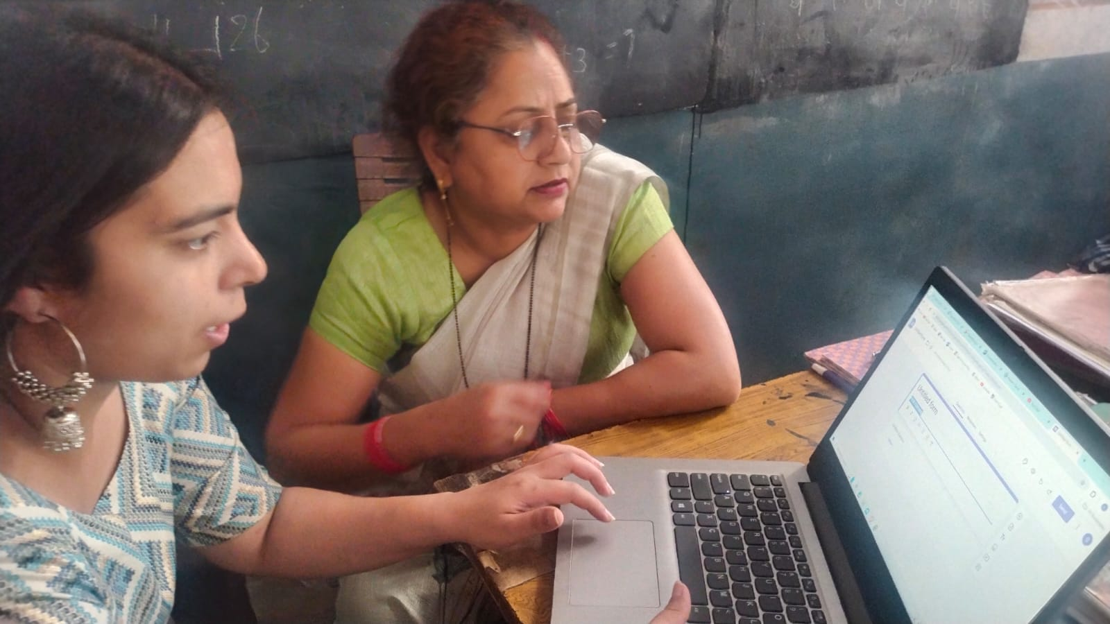
Photo 1: Teachers Engaged in Pre-Test Assessment: Evaluating Technological Competence.
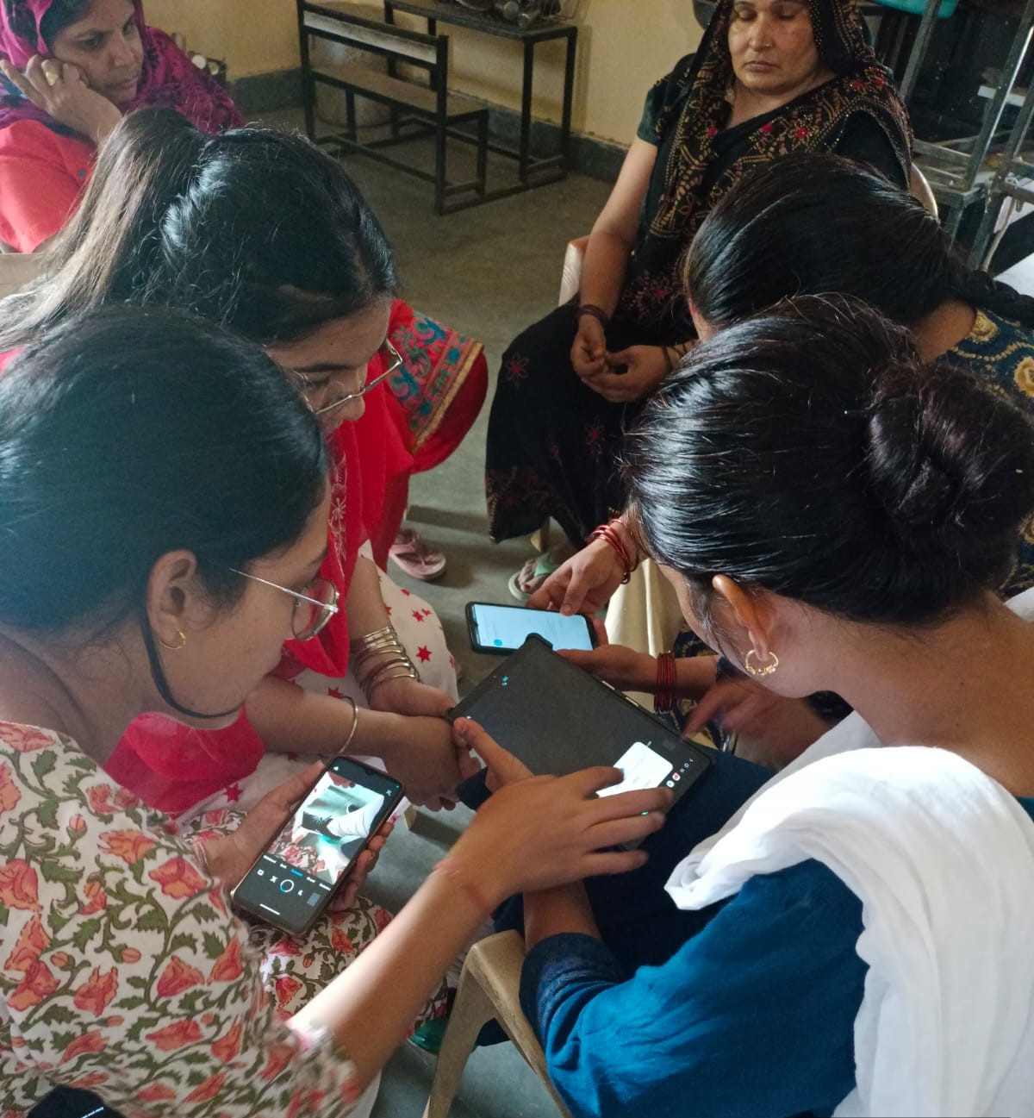
Photo 2: Post-Training Evaluation: Teachers Demonstrate Enhanced Technological Skills.
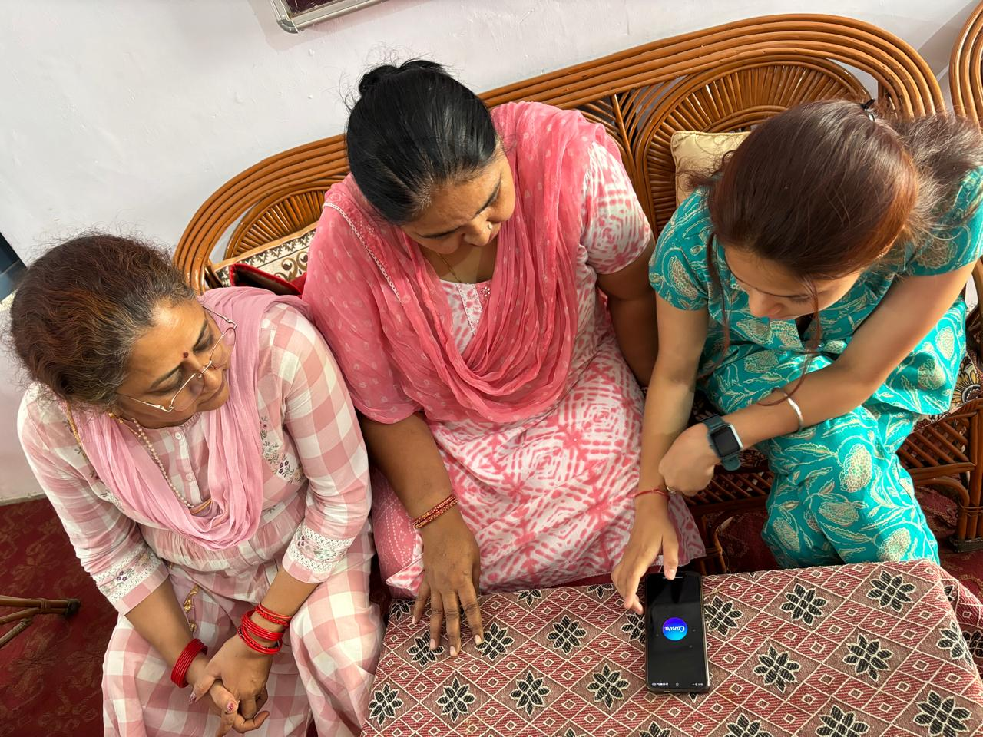
Photo 3: Photo Heading: Interactive Learning in Action: Teachers Participate in Hands-On Training Sessions.
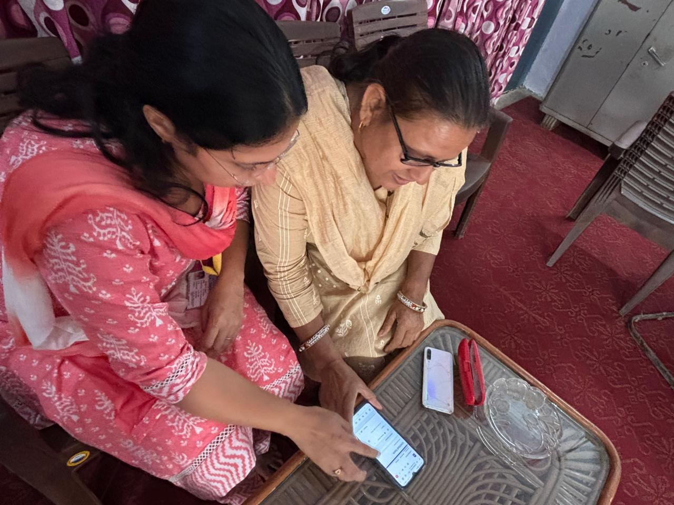
Photo 4: Hands-On Training Session on Educational Tools for Teachers.
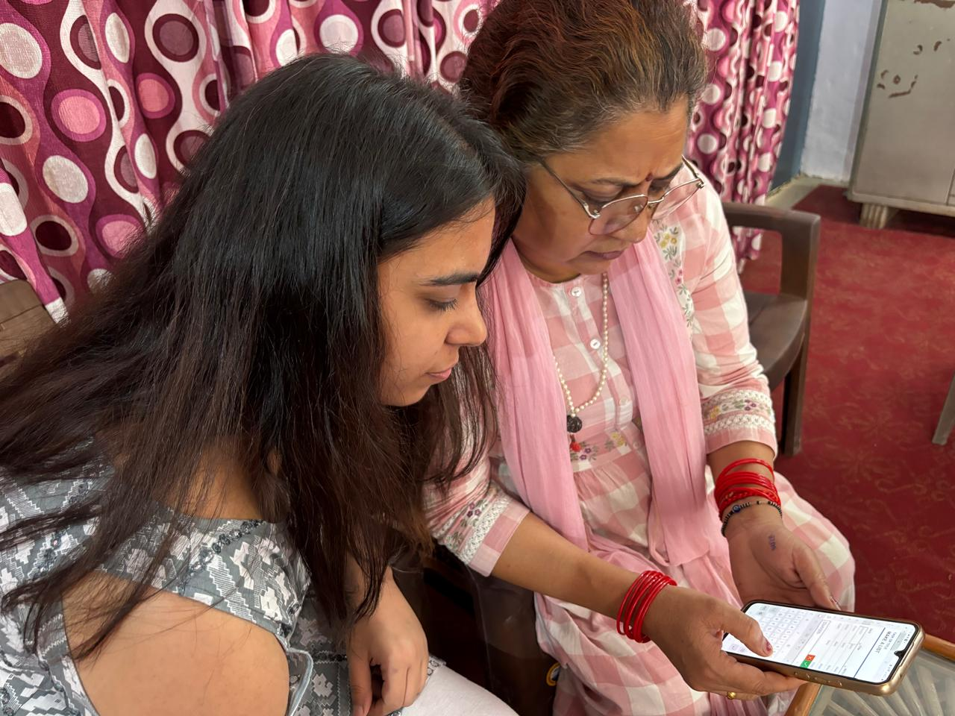
Photo 5: Exploring Online Learning Resources During Intervention.
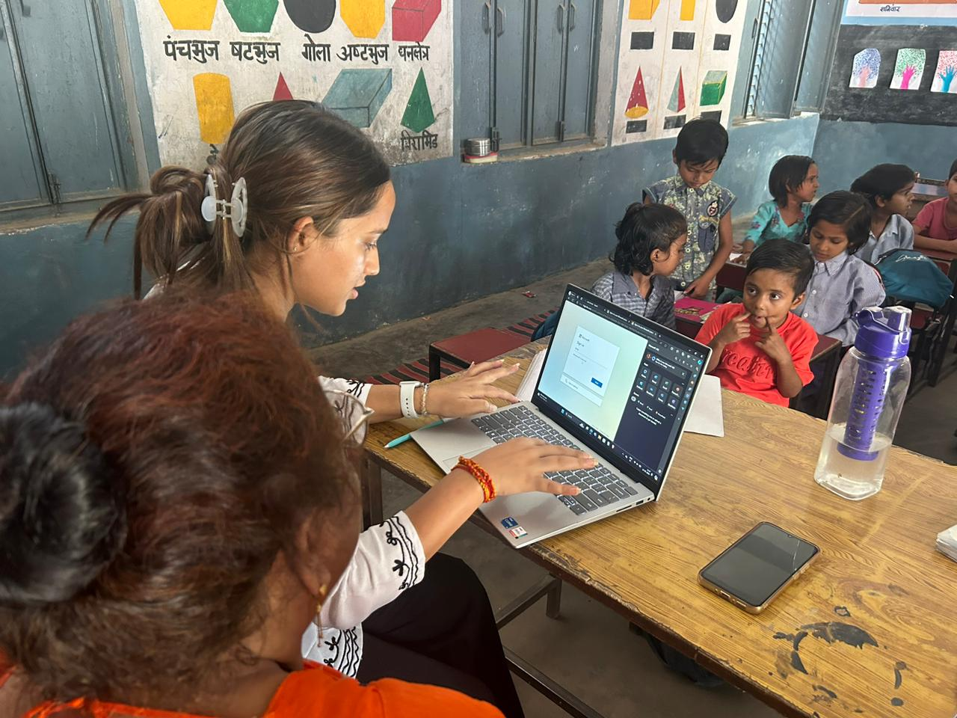
Photo 6: Hands-On Experience: Conducting Online Assessments.
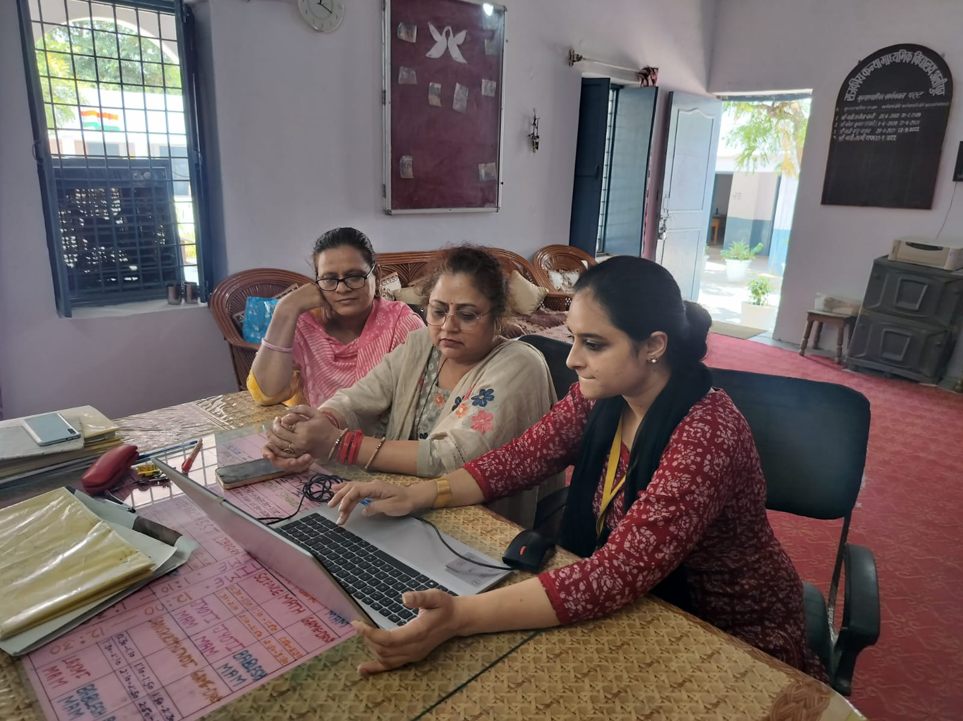
Photo 7: Teachers Learning to Use Google Forms During Intervention Program.
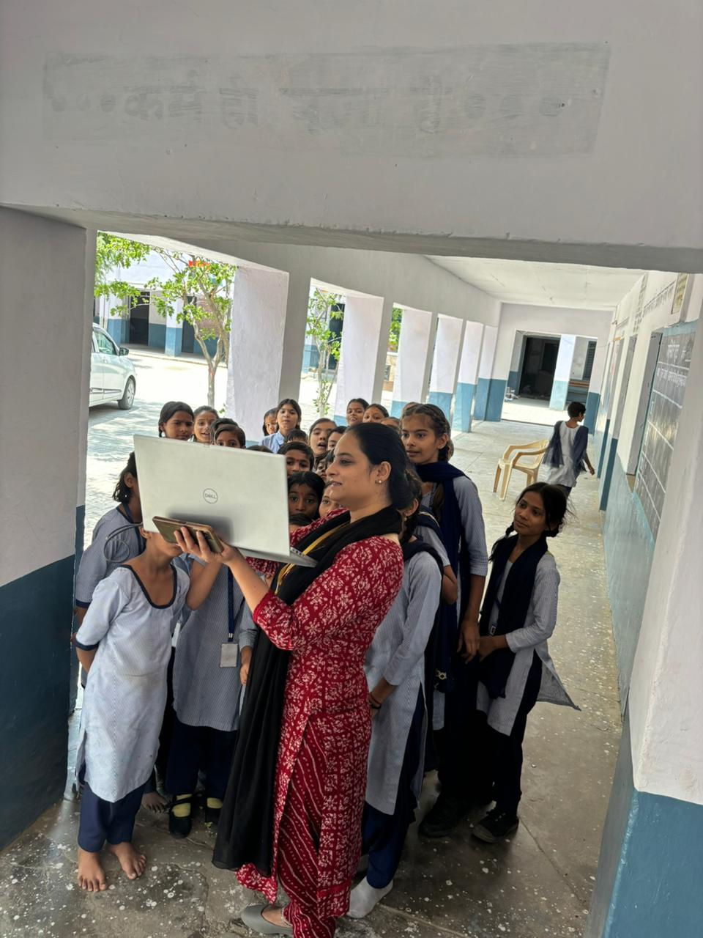Photo 8: Demonstration on Google Meet for Virtual Classrooms.
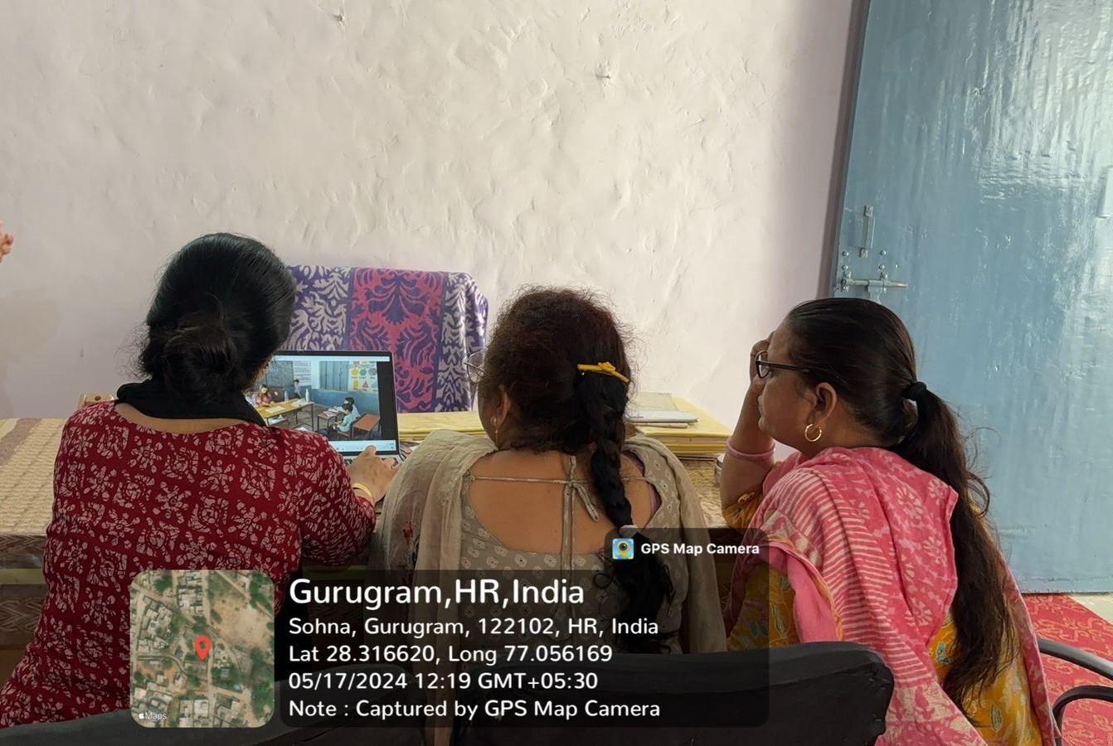
Photo 9: Interactive Session on Online Assessment Tools.
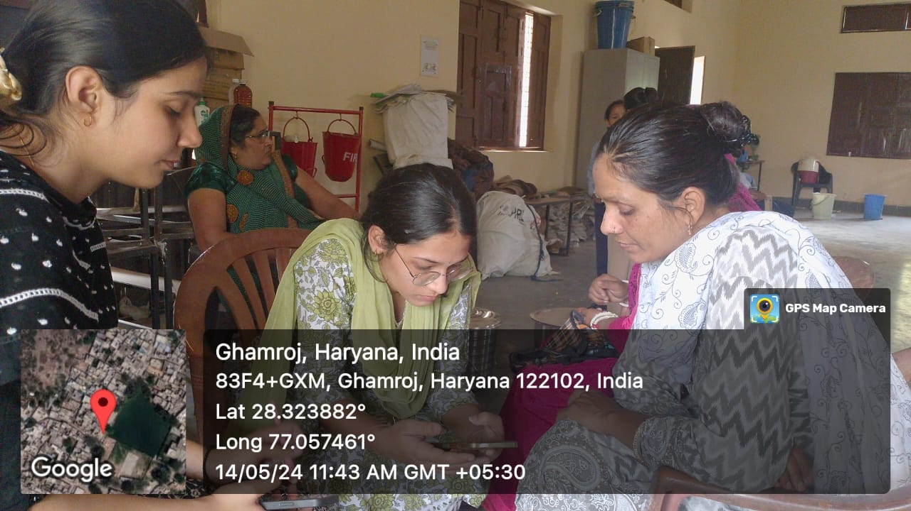
Photo10: Teachers Practicing Digital Lesson Planning Using Educational Software.
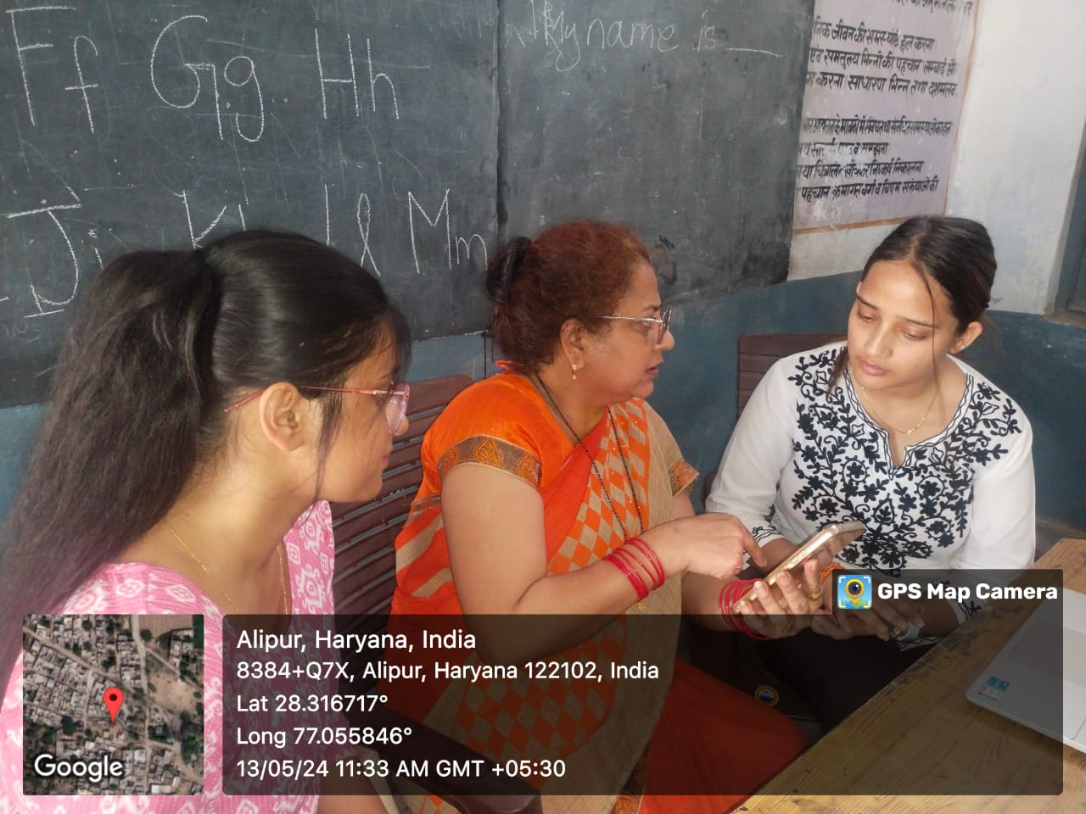
Photo11: Teachers Engaging in Gmail and Canva Training.
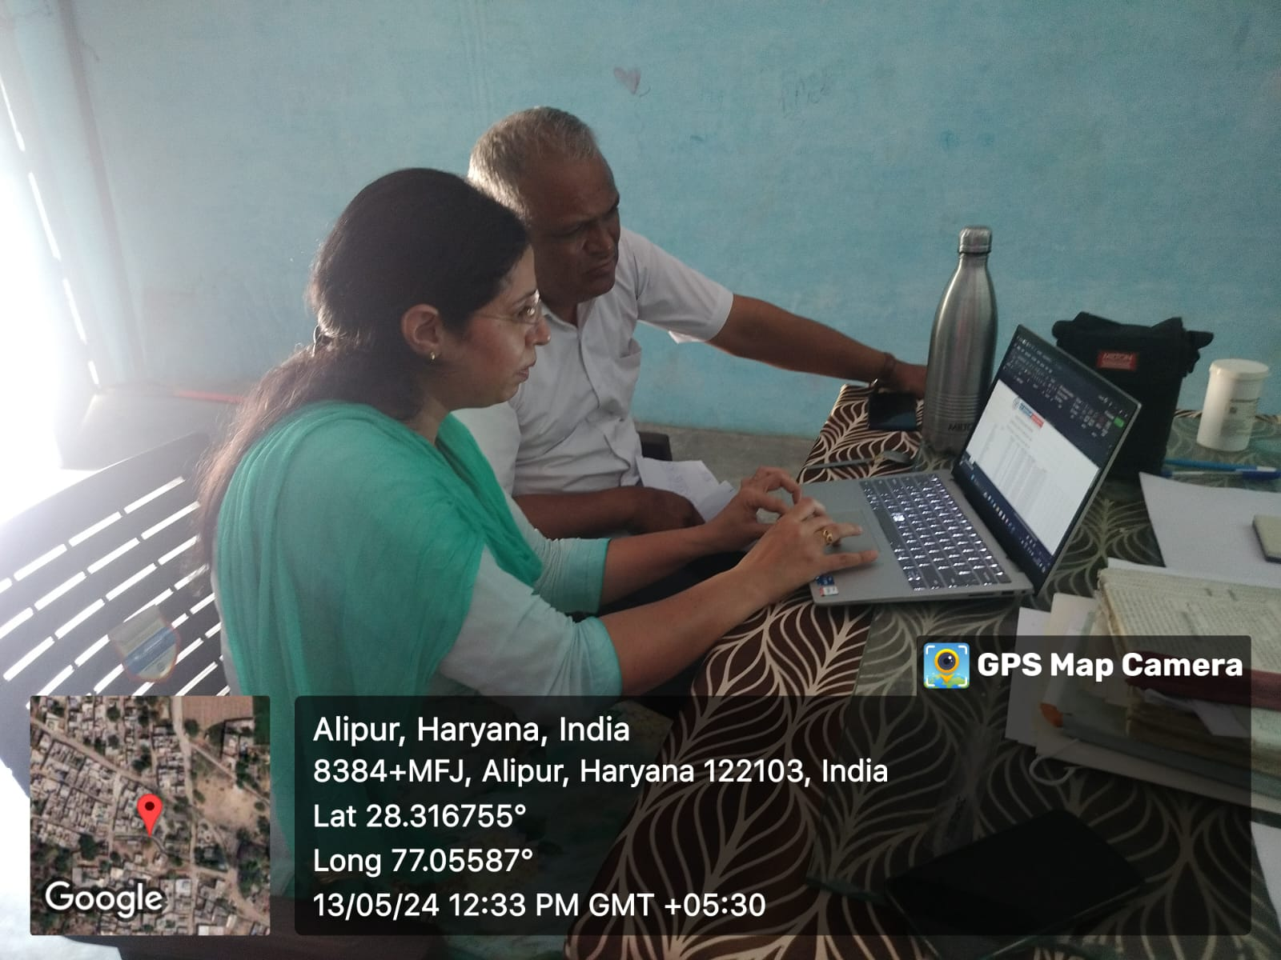
Photo12: Practical Demonstration of Digital Resources for Classroom Use.

- Analysis and Interpretation of the Data
Graph 1: Teacher’s Awareness and Use of Educational Technology in Teaching, Learning, and Assessment.

Source: Field Work 2024
The graph illustrates the responses of teachers regarding their familiarity with and use of various educational technologies in teaching, learning, and assessment. The data shows that a significant majority (90%) of teachers are not utilizing these technological tools, while only a small fraction (10%) are aware of or using them. Most teachers have not conducted or participated in online classes (Google Meet, Zoom), and a similar pattern is seen with the use of digital learning resources like DIKSHA and e-pathshala. Teachers rarely use interactive tools (like Kahoot! or Quizizz) that can enhance student engagement and learning outcomes. This indicates a missed opportunity for interactive teaching practices. Learning management systems (LMS) like Google Classroom, which are designed to organize class materials and manage assignments, are largely unused by teachers, suggesting a gap in modern educational techniques. A vast majority of teachers do not create or share presentations and educational content using tools like Google Slides or PowerPoint, which are essential for delivering engaging and organized lessons. The use of digital tools for assessment, such as Google Forms for quizzes and tests, is also minimal. This lack of technological integration hinders effective online evaluations and feedback mechanisms. There is little evidence of participation in online professional development programs or webinars, indicating that teachers are not upgrading their skills through available digital learning opportunities.
The graph demonstrates an urgent need for capacity development among teachers to improve their technological competence. Most of the teachers are unfamiliar with basic digital tools necessary for effective teaching, learning, and assessment in the modern educational context. This highlights the critical requirement for intervention programs and hands-on training to bridge this knowledge gap, especially in rural areas.
Graph 2: Gender-Wise Level of Educational Technology Awareness Among Teachers in Alipur and Ghamroj Schools.

Source: Field Study 2024
In Alipur, male teachers show moderately higher awareness (60%) compared to female teachers (40%). This suggests a noticeable gap in educational technology competency between male and female teachers. Female teachers in Alipur may require targeted training to bridge this gap.
The gap is more significant in Ghamroj. Male teachers demonstrate a much higher level of awareness (70%) compared to female teachers (30%). This indicates that female teachers in Ghamroj may face even greater challenges or lack access to resources compared to their male counterparts, highlighting a critical need for focused intervention programs to improve technological competency among female teachers. In both villages, male teachers are more aware of educational technology than female teachers.
The disparity is more significant in Ghamroj (70% vs. 30%) compared to Alipur (60% vs. 40%). The data reflects a gender-based disparity in the awareness and use of educational technology. This emphasizes the need for specific training and capacity-building interventions, particularly for female teachers, to ensure equitable access to technology and its integration into teaching practices. Special focus should be given to Ghamroj, where the gap is more pronounced.
Graph 3: School wise comparison of awareness among the two Schools.

Source: Field Survey 2024
From the above graph it has been found that In Alipur School the Teacher has more Awareness about the educational technology which is being used in teaching and learning process as compared to the Ghamroj village.

Graph 4: Post Test Assessment of Technological Competence among Teachers.

Source: Field Study 2024
Graph 4 presents the results of the post-test assessment conducted among teachers following the intervention program. The post-test was administered on May 17, 2024, to measure improvements in the teachers’ technological competence after completing the hands-on training sessions. The purpose of this assessment was to gauge the effectiveness of the training and identify areas where the teachers showed progress.
The graph reveals a noticeable improvement in the technological competence of teachers compared to their baseline performance in the pre-test. For example, prior to the intervention, many teachers struggled with using basic digital tools like Gmail, Canva, and Google Meet. However, after the training, a significant number of teachers were able to demonstrate proficiency in these areas.

Skill Areas: Specific improvements were seen in areas such as:
Email Management: Nearly all teachers were able to create, send, and manage emails via platforms like Gmail.
Digital Presentation: Teachers displayed competence in creating and using PowerPoint presentations for classroom teaching.
Digital Assessment: There was an increase in the teachers’ ability to create and administer quizzes via Google Forms, which was emphasized during the training sessions.
This upward trend in technological skills demonstrates the impact of the intervention program. However, the graph also indicates that while a majority of teachers made significant progress, a few still exhibited challenges with more advanced tools such as Learning Management Systems (LMS) and online meeting platforms like Google Meet, particularly in rural areas where technological infrastructure remains limited.
The post-test assessment confirms the success of the intervention in enhancing the teachers’ digital literacy. However, it also highlights the need for follow-up training sessions, particularly in advanced educational technology, to bridge the remaining gaps.
Graph 4 showcases the overall improvement in technological competence, demonstrating the effectiveness of the training. However, there are still areas requiring further development, particularly in advanced technology use.

Graph 5: Gender Wise learning Levels of the teachers in Post Test.

Source: Field Survey 2024
Graph 5 illustrates the learning levels of teachers in both Ghamroj and Alipur villages after completing the intervention program. This graph is critical in understanding how much the teachers absorbed from the training and how effectively they can apply the learned technological tools in their classrooms. The graph demonstrates a significant overall improvement in the teachers’ learning levels. Most teachers transitioned from low to medium or high levels of competence after participating in the intervention program.
Low-Level Learners: The number of low-level learners, who initially had little to no exposure to educational technology, drastically reduced by the end of the program. This indicates that even those with minimal prior knowledge benefited greatly from the hands-on training.
Medium-Level Learners: Many teachers, especially from Alipur village, showed moderate gains in competence. They were able to effectively integrate tools like Google Forms for assessments, PowerPoint for presentations, and online resources into their lesson plans.
High-Level Learners: A select group of teachers emerged as high-level learners, demonstrating the ability to integrate various digital tools seamlessly into their teaching. These teachers not only mastered the tools provided during the training but also began experimenting with more complex platforms such as LMS and advanced assessment tools.
This graph provides a clear indication that the intervention program had a substantial impact on improving the learning levels of the teachers. The shift from low to medium and high levels highlights the effectiveness of the program, though there is still room for improvement, particularly in providing continued support for teachers to maintain and further develop their skills.
Graph 5 offers a clear understanding of the general progression in teachers' learning levels. Most teachers were able to move from low to medium or high levels of competence, indicating that the intervention succeeded in raising the baseline of technological literacy. Still, the graph points to the need for follow-up programs to help teachers achieve and sustain higher levels of competence.
Graph 6: School wise Learning Levels of the teachers.

Graph 6 compares the learning levels of teachers on a school-by-school basis in Ghamroj and Alipur villages after the intervention program. This graph offers a more granular look at how different schools performed and helps identify specific areas that may need further attention.
Alipur Village: Teachers from Alipur village showed the highest improvement in learning levels post-intervention. Many of them progressed from low to medium or high competence in using educational technology. This suggests that the infrastructure or baseline exposure to technology in Alipur might have been slightly better than in Ghamroj, allowing the teachers to grasp the tools more effectively.
Ghamroj Village: While teachers in Ghamroj also showed improvement, their learning levels remained lower than those in Alipur. A larger proportion of teachers in Ghamroj were still at the medium level, with fewer progressing to high competence. This disparity could be attributed to several factors:
Infrastructure Challenges: Ghamroj might face more significant technological barriers, such as limited access to devices or unreliable internet connections, which could hinder the teachers’ ability to fully integrate digital tools into their classrooms.
Prior Exposure: Teachers in Ghamroj may have had less exposure to technology before the intervention, making it harder for them to reach the same learning levels as their counterparts in Alipur within the same time frame.
School-Specific Learning: The graph also highlights that schools within the same village may have different levels of technological advancement among their teachers. Some schools, particularly those with younger or more digitally literate staff, saw more rapid improvement in their teachers’ skills. On the other hand, schools with older or less tech-savvy staff required additional support to achieve the same learning outcomes.
This school-wise breakdown emphasizes the need for targeted interventions tailored to the specific needs of individual schools. For instance, schools in Ghamroj may benefit from additional support in terms of infrastructure and continuous technical training. The higher performance of Alipur schools shows that with the right resources and sustained effort, teachers can significantly improve their technological competence.
Finally, Graph 8 provides a more detailed look at the school-wise differences in learning outcomes. Teachers in Alipur generally performed better than those in Ghamroj, likely due to better infrastructure and prior exposure to educational technology. The variation between schools within the same village suggests that interventions should be tailored to the specific needs and contexts of individual schools.
In conclusion, the intervention program made significant strides in enhancing the technological competence of teachers in rural villages. However, the analysis of these graphs underscores the importance of continued support, tailored interventions, and addressing infrastructural limitations to ensure that all teachers, regardless of their starting point, can fully integrate technology into their teaching practices.
- Findings of the Study (Objective-wise)
Objective 1: Evaluate the current level of technological competence among teachers in Ghamroj and Alipur Villages
Baseline Competence: The pre-test assessment revealed that the majority of teachers in both villages had limited exposure to educational technology. Most teachers were unfamiliar with basic digital tools such as Gmail, Google Forms, Canva, and other online resources. A large percentage of teachers, especially in Ghamroj village, lacked the technical skills necessary to integrate technology into their teaching practices.
Alipur Teachers More Proficient: The pre-test results indicated that teachers in Alipur village had a slightly higher level of baseline competence in using educational technology compared to their counterparts in Ghamroj. This could be attributed to better infrastructure and prior exposure to digital tools in Alipur schools.
Identified Gaps: Across both villages, teachers struggled the most with using technology for assessments, digital collaboration, and online teaching platforms. These gaps formed the basis for the intervention program, which was designed to improve these specific areas of technological competence.
Objective 2: Assess the impact of the capacity development program on the use of educational technology by teachers.
Post-Test Improvements: The post-test assessment conducted after the intervention program showed a significant improvement in the teachers’ technological competence across both villages. Teachers demonstrated better command over tools like Gmail, Google Forms, PowerPoint, and online resources for teaching. Most teachers advanced from low to medium competence, with some progressing to high competence in using educational technology.
Hands-On Training Success: The success of the intervention can be attributed to the hands-on nature of the training program, which allowed teachers to practice using educational tools in real-time classroom scenarios. This practical approach was particularly effective in boosting teachers’ confidence and competence in integrating technology into their pedagogy.
Strong Performance: Teachers in Alipur village, who had a better baseline, showed the greatest improvement post-intervention. A large number of Alipur teachers moved to a high level of competence, successfully incorporating digital tools into their lesson plans and assessments.
Challenges in Ghamroj: While teachers in Ghamroj also showed significant progress, their post-test results indicated that many remained at a medium level of competence. This suggests that additional training and support are needed in Ghamroj to achieve the same level of technological integration as in Alipur.
Objective 3: Identify the challenges teachers face in integrating technology into their pedagogy and assessment practices
Infrastructure Barriers: One of the key challenges identified during Focus Group Discussions (FGDs) and classroom observations was the lack of adequate infrastructure, particularly in Ghamroj. Teachers reported issues such as unreliable internet connections, limited access to computers or devices, and power outages, which hindered their ability to fully implement the technological skills they had learned during the training.
Resistance to Change: Another challenge highlighted by teachers, especially those with more traditional teaching backgrounds, was resistance to adopting new technological methods. Some teachers were hesitant to move away from established teaching practices and expressed concerns about the time and effort required to learn and implement digital tools.
Need for Ongoing Support: Many teachers expressed the need for continuous technical support and follow-up training to help them sustain and further develop their technological skills. Without ongoing professional development, there is a risk that teachers will revert to traditional methods due to a lack of confidence in using new technologies.
Objective 4: Identify learning levels on the basis of gender.
Gender-Based Differences: The study found no significant differences in learning levels based on gender. Both male and female teachers showed similar levels of improvement following the intervention program. This suggests that gender does not play a major role in the teachers' ability to learn and apply educational technology, provided they have access to the necessary training and resources.
Equal Participation: Both male and female teachers actively participated in the hands-on training sessions, and their progress was relatively consistent across all skill areas, including the use of digital tools for assessments and classroom management. This finding is important for ensuring that future capacity development programs are designed to be inclusive and equitable for all teachers, regardless of gender.
Objective 5: Evaluate the impact of the intervention program on the teacher’s ability to use educational technology effectively
Improved Classroom Integration: One of the key outcomes of the intervention was the noticeable improvement in the teachers’ ability to integrate educational technology into their classrooms. Teachers reported that they were more confident in using tools such as PowerPoint for presentations, Google Forms for assessments, and online platforms for student engagement.
Increased Student Engagement: Teachers also reported that their use of digital tools led to increased student engagement in the classroom. The ability to create interactive quizzes, multimedia presentations, and online discussions helped make lessons more engaging and accessible for students, particularly in rural schools where traditional teaching methods may not always capture students’ interest.
Sustained Knowledge Retention: The post-test results, combined with classroom observations, indicate that the hands-on nature of the training helped teachers retain the technological skills they learned. Teachers were able to implement these tools in their daily teaching practices, which suggests that the knowledge and skills acquired during the intervention will likely have a lasting impact.
Objective 6: Provide recommendations for future interventions based on the findings.
Ongoing Professional Development: Based on the findings, it is recommended that future interventions include ongoing professional development programs for teachers. These should provide continuous support, refresher courses, and advanced training in educational technology to ensure that teachers can continue to develop their skills over time.
Addressing Infrastructure Gaps: The study highlighted the need for improvements in the technological infrastructure in rural schools, particularly in Ghamroj. Schools should be provided with reliable internet access, sufficient devices, and technical support to enable teachers to fully implement the digital tools they have learned to use.
Tailored Interventions for Low-Level Learners: Future interventions should offer additional support and differentiated instruction for teachers who remain at a low or medium level of competence. Tailoring the training to address their specific challenges will help ensure that all teachers, regardless of their starting point, can reach a high level of proficiency in using educational technology.
Promoting a Culture of Technological Adoption: To overcome resistance to technological change, it is recommended that schools and education authorities promote a culture of innovation and adoption of digital tools. This can be achieved through incentives, recognition programs, and creating a supportive community of practice among teachers who can share their experiences and strategies for integrating technology into the classroom.
The findings from this study demonstrate the significant impact of the intervention program on improving teachers' technological competence, particularly in rural areas like Ghamroj and Alipur. While the program was largely successful, there are still challenges related to infrastructure and resistance to change that must be addressed in future interventions. Continuous support, tailored training, and improvements in school infrastructure will be key to ensuring the sustained and effective use of educational technology by teachers.
- Recommendations for Policymakers
- Investment in Technological Infrastructure
To support the integration of educational technology in rural schools, policymakers should prioritize investment in infrastructure. This includes ensuring reliable internet connectivity, providing digital devices (computers, tablets), and equipping schools with the necessary technological tools. In areas like Ghamroj, where infrastructure gaps hindered the effective implementation of digital tools, bridging this divide is essential. Establishing government-supported technology hubs in rural schools will also provide students and teachers with greater access to these resources.
- Continuous Professional Development Programs for Teachers
Policymakers should implement continuous professional development (CPD) programs focused on educational technology. Such programs should not only be part of the initial teacher training but also integrated into ongoing professional learning schedules. Policymakers should promote teacher technology upskilling initiatives that are hands-on and practical, and these programs should include follow-up sessions to ensure sustained use of the technology. Additionally, offering certification and career advancement incentives for teachers who excel in using educational technology can motivate participation.
- Customization of Training to Local Needs
A one-size-fits-all approach may not work for diverse regions. Training programs should be tailored to address the specific needs and challenges of rural and urban teachers. For example, schools in Alipur may require more advanced training, while Ghamroj teachers may benefit from foundational courses in digital literacy. Policymakers should advocate for context-specific interventions that align with local realities and learning gaps. Differentiating the levels of professional development programs based on a teacher’s existing competence and needs will lead to more impactful outcomes.
- Incentivizing the Adoption of Technology in Classrooms
Policymakers should consider creating incentive schemes that encourage schools and teachers to adopt technology-based learning methods. This could involve recognizing and rewarding innovative teachers and schools that excel in integrating educational technology into their classrooms. Government grants, public recognition, or awards for teachers who demonstrate creative and effective uses of technology can serve as strong motivation for other educators to follow suit.
- Addressing Barriers to Technology Adoption
Policymakers should consider the social and cultural resistance to educational technology, especially in rural areas where traditional teaching methods are deeply entrenched. Strategies should include raising awareness of the benefits of digital tools for teaching and learning, addressing misconceptions, and providing ongoing support to reduce resistance to change. Establishing peer-mentoring programs where tech-savvy teachers help guide others can also ease the transition into adopting technology.
- Developing a National Digital Curriculum
Policymakers should aim to develop a standardized national digital curriculum that integrates the use of technology into regular teaching practices. This curriculum should include digital pedagogy strategies, as well as specific learning outcomes tied to technological competence. A digital curriculum will not only ensure uniformity across different regions but will also promote consistency in the use of technology in education, bridging the digital divide between urban and rural schools.

- Monitoring and Evaluation of Technological Integration
Continuous monitoring and evaluation of technology integration in schools should be a priority for policymakers. Setting up assessment frameworks and data collection tools to track the progress of teachers’ technological competencies is essential. Monitoring the effectiveness of technological interventions through post-training evaluations and long-term follow-ups will help refine future programs. Policymakers should also use data-driven approaches to allocate resources and support based on the specific needs of each region.
- Public-Private Partnerships for Technological Advancements
Policymakers can foster partnerships between the government, private tech companies, and NGOs to bring advanced educational technology to schools, especially in rural and under-resourced areas. Private-sector organizations can offer technical support, software solutions, and training expertise, while the government can ensure equitable access and facilitate adoption. Such collaborations can accelerate the deployment of digital tools and help schools overcome financial and logistical barriers.
- Digital Literacy Programs for Students and Teachers Alike
While teacher training is critical, policymakers must also consider the need for digital literacy programs targeted at students. The focus should be on equipping students with the necessary skills to navigate digital learning platforms, ensuring that they can take full advantage of educational technology. Integrating digital literacy into the school curriculum will enhance student engagement and complement the teachers’ use of technology in the classroom.
- Incorporating Technology in Pedagogical Assessments
Policymakers should push for reforms that incorporate educational technology into teacher performance evaluations and school assessments. Teachers’ ability to effectively use digital tools in pedagogy and assessments should be a key criterion in evaluating their performance. Additionally, making technology proficiency part of standardized teacher certifications will encourage more educators to prioritize skill development in this area.
- Budget Allocation for Educational Technology
Governments must allocate specific budget lines for educational technology in rural and urban schools alike. Policymakers should ensure that a portion of education budgets is dedicated to acquiring digital resources, upgrading technological infrastructure, and supporting teacher training. This will ensure that the long-term integration of educational technology is not subject to resource constraints and that all schools have equal access to technological tools and training.
- Strengthening Technical Support Systems
To ensure the successful adoption and continued use of educational technology, policymakers must establish technical support systems for schools, particularly those in rural areas. This includes setting up dedicated helplines, online troubleshooting resources, and on-ground IT support teams to assist teachers in maintaining and using digital tools effectively. Continuous technical assistance will help alleviate teachers' concerns and provide them with the confidence to use technology consistently in their classrooms.
Policymakers play a crucial role in fostering the effective use of educational technology in rural and urban schools. By addressing infrastructure gaps, promoting continuous professional development, incentivizing adoption, and ensuring ongoing support, policymakers can empower teachers to use technology to its full potential. These recommendations will help bridge the digital divide and create an inclusive, technologically advanced education system that benefits both teachers and students across India.
- Recommendations for Further Study
Future research should focus on a broader exploration of how various levels of technological competence among teacher’s impact student outcomes, particularly in rural settings. It would be beneficial to conduct longitudinal studies to assess the long-term effectiveness of technology training programs and their sustained impact on teaching practices. Additionally, further study is needed to examine the role of socio-cultural factors, such as gender and community attitudes, in influencing teachers’ adoption of educational technology.
Another area of research could explore the comparative effectiveness of different training models (e.g., face-to-face versus online) and their adaptability in diverse school environments. Investigating the potential of mobile learning tools and low-cost technological solutions in resource-constrained areas would provide valuable insights into how technology can be scaled up in rural schools.
Moreover, future studies should also consider the perspectives of students, focusing on how their digital literacy levels and access to technology at home influence the success of educational technology initiatives. This will help create a more comprehensive understanding of the ecosystem necessary for successful technology integration in education.
- Challenges Faced During the Study
The case study encountered several challenges that impacted the smooth execution of the intervention program and the overall research process. These challenges highlight the difficulties faced in implementing educational technology training in rural areas and underline the need for comprehensive strategies to overcome them.
1. Lack of Support from Community Members
One of the most significant challenges was the lack of support from community members, including parents and local authorities. In rural areas like Ghamroj and Alipur, there is often resistance to new initiatives, especially those related to technology. Many community members did not fully understand the importance of integrating educational technology into teaching and were skeptical about the program’s relevance. Some parents and community leaders were indifferent or even opposed to the use of digital tools in education, seeing them as unnecessary or too complicated for rural schools. This resistance made it difficult to create a supportive environment for the teachers participating in the training sessions.
2. Lack of Infrastructure
Infrastructure issues were another major obstacle. In both Ghamroj and Alipur, schools lacked basic technological infrastructure, such as reliable internet access, sufficient digital devices, and modern classrooms equipped to handle technological advancements. The lack of computers, laptops, projectors, and smart boards made it challenging to conduct the hands-on training effectively. Moreover, many schools experienced frequent power outages, disrupting the training sessions and affecting the teachers' ability to practice using the digital tools they were being introduced to.
3. Time Constraints and Scheduling Conflicts
Timing was another significant challenge during the study. The teachers had busy schedules, with many of them handling multiple classes throughout the day. Finding suitable times for training sessions that did not disrupt their regular teaching duties was difficult. The intervention program required considerable time for both the hands-on training and follow-up discussions, and many teachers struggled to balance this with their teaching responsibilities. Additionally, the training sessions often had to be scheduled on weekends or after regular school hours, leading to fatigue and reduced engagement among some participants.
4. Teacher Absenteeism
Teacher absenteeism was another issue encountered during the intervention program. Due to personal commitments, health issues, or other responsibilities, some teachers were unable to attend all the sessions. This absenteeism affected the overall progress of the intervention, as certain teachers missed critical training and practice opportunities, making it harder for them to catch up later. Their absence also affected the post-test assessment, as not all participants could demonstrate consistent progress from the pre-test phase.
5. Limited Follow-Up and Ongoing Support
After the initial intervention program, many teachers expressed the need for ongoing support to consolidate their learning. However, due to limited resources and time, follow-up sessions were minimal. Without continued guidance, some teachers found it difficult to fully integrate the newly acquired technological tools into their regular teaching practices. The absence of a structured follow-up mechanism led to a situation where some of the benefits gained during the training were not sustained over the long term.
6. Cultural Resistance to Change
Rural schools often have deep-rooted traditional teaching methods, and many teachers were resistant to the idea of changing their pedagogy to incorporate technology. This cultural resistance was particularly prevalent among older teachers, who had been using traditional methods for decades and were hesitant to embrace new digital tools. Some teachers also felt that the training was an additional burden rather than an opportunity, which led to reduced enthusiasm and engagement during the sessions.
7. Logistical Issues
The rural location of Ghamroj and Alipur posed logistical challenges for the research team and trainers. Poor transportation infrastructure made it difficult for trainers and researchers to reach the schools, and this affected the punctuality and duration of the sessions. Moreover, the limited availability of necessary equipment like laptops and digital devices during the intervention required resource-sharing among the teachers, slowing down the learning process.
8. Lack of Technological Awareness and Prior Exposure
Many teachers had little to no prior exposure to educational technology, which made the training more challenging. Their unfamiliarity with basic tools like Google Forms, Canva, and online educational platforms required more time for foundational learning before moving on to advanced applications. This steep learning curve meant that some teachers struggled to keep up with the pace of the training sessions, affecting their overall progress.
These challenges demonstrate the complex environment in which the intervention program was implemented. Overcoming these barriers will require a coordinated effort from schools, communities, and policymakers to ensure that rural teachers receive the necessary support and resources to successfully integrate educational technology into their classrooms.
Conclusion
The case study aimed to evaluate the technological competence of teachers in the rural villages of Ghamroj and Alipur, assess the impact of an intervention program designed to improve their skills, and identify the challenges faced in integrating educational technology into teaching, learning, and assessment practices. With a focus on improving the professional capacity of teachers in these villages, the study unfolded through a systematic pre-test, intervention, and post-test approach, each phase aligned with specific objectives to ensure comprehensive insights.
The study began by assessing the current technological competence of teachers through a pre-test questionnaire designed to gauge their familiarity with digital tools and educational technology. A questionnaire consisting of 15 questions was administered to the teachers, with a focus on basic tools and platforms like Canva, Google Forms, Google Meet, LMS, Gmail, PPT, and other educational applications. The results revealed that approximately 90% of teachers, both in Ghamroj and Alipur, were largely unaware of these tools and techniques. This gap in knowledge highlighted the need for targeted interventions to enhance their digital literacy and ensure that teachers are well-equipped to leverage technology in their classrooms. Gender-based analysis revealed that female teachers in both villages had even lower levels of technological competence compared to their male counterparts, making it clear that gender dynamics must be considered in future training programs.
The intervention program, spread over several days, aimed to address the gaps identified in the pre-test by providing hands-on training on educational technology tools. The training was designed to be practical, with sessions on creating and using digital content through Gmail, Canva, Google Forms, and Google Meet, among others. Teachers were also trained on digital assessment tools and methods for integrating technology into their pedagogy. During the training, teachers practiced using the tools in real-time, gaining confidence and enhancing their competence. The hands-on approach ensured that the teachers not only learned the theoretical aspects of using technology but also developed the practical skills necessary to implement these tools in their classrooms. This practical learning was a key element of the intervention program, as it bridged the gap between theoretical knowledge and classroom application.
After the intervention program, a post-test assessment was conducted to evaluate the impact of the training. The same questionnaire from the pre-test was administered, and the results showed significant improvement across all categories. Teachers demonstrated greater familiarity with educational technology tools, and their confidence in using these tools for teaching and assessment had notably increased. The gender gap persisted but was less pronounced, indicating that while both male and female teachers benefited from the training, female teachers may require additional support or more personalized training approaches to fully catch up with their male counterparts.
Throughout the study, it became evident that gender played a significant role in the adoption and use of educational technology. Female teachers in both Ghamroj and Alipur showed lower levels of competence in the pre-test, and while they improved following the intervention, the gender gap remained. This suggests that gender-specific challenges, such as lower access to technology or lesser confidence in using digital tools, could be impacting female teachers’ ability to integrate technology into their pedagogy. Further research is needed to understand these challenges better and to design targeted interventions that address the unique needs of female teachers in rural areas.
The focus group discussions (FGDs) and classroom observations conducted after the post-test assessment revealed a number of challenges that teachers faced in integrating educational technology into their classrooms. The primary challenges included lack of infrastructure, such as unreliable internet access, inadequate technical support, and insufficient access to digital devices in schools. Many teachers also cited resistance to adopting new teaching methods as a significant barrier. Cultural attitudes towards technology, particularly in more traditional and rural settings, often hinder the full integration of digital tools into pedagogy.
Teachers also reported a lack of ongoing professional development opportunities to sustain the skills they had learned during the intervention program. The short duration of the training sessions was not sufficient to cover the full range of digital tools available, and teachers expressed a desire for continuous learning opportunities to keep up with the rapidly changing landscape of educational technology.
The findings of this case study offer several recommendations for future interventions and policymaking. First, a more sustained and continuous approach to teacher training is necessary, one that goes beyond a one-time intervention and offers ongoing support and professional development. This could include follow-up sessions, peer-to-peer learning opportunities, and the creation of a support network for teachers to share resources and experiences.
Second, gender-specific interventions should be considered to close the technology competence gap between male and female teachers. Tailored programs addressing the specific needs and challenges of female teachers, such as targeted confidence-building sessions and greater access to technology, would help bridge this divide.
Third, infrastructure challenges must be addressed at a policy level to ensure that schools in rural areas have the necessary tools to support technology integration. This includes reliable internet access, sufficient digital devices, and technical support for teachers. Policymakers should also consider integrating digital literacy as a mandatory part of teacher education and professional development programs.
Lastly, more research is needed to explore the long-term impact of such intervention programs on both teachers and students. Understanding how improved technological competence among teachers translates into student outcomes will be key to designing effective education policies and programs in the future.
In conclusion, this case study highlights both the challenges and opportunities of integrating educational technology into rural classrooms. While the intervention program successfully improved the technological competence of teachers, it also underscored the need for more comprehensive and sustained efforts to ensure that technology can be effectively utilized in education. Addressing infrastructure gaps, providing ongoing professional development, and focusing on gender-specific challenges will be critical in ensuring the long-term success of educational technology initiatives in rural schools.
References
Brown, G. T. (2004). Teachers' conceptions of assessment: Implications for policy and professional development. Assessment in Education: Principles, Policy & Practice, 11(3), 301-318.
Chenoy, D. (2016). Skill Development in India A Transformation in the Making. In India Infrastructure Report 2012 (pp. 199-207). Routledge India.
Christie, P., & Lingard, B. (2020). Teachers and schooling making a difference: Productive pedagogies, assessment and performance. Routledge.
Dalal, M., Archambault, L., & Shelton, C. (2017). Professional development for international teachers: Examining TPACK and technology integration decision making. Journal of Research on Technology in Education, 49(3-4), 117-133.
Dalal, M., Archambault, L., & Shelton, C. (2017). Professional development for international teachers: Examining TPACK and technology integration decision making. Journal of Research on Technology in Education, 49(3-4), 117-133.
Gaible, E., & Burns, M. (2005). Using Technology to Train Teachers: Appropriate Uses of ICT for Teacher Professional Development in Developing Countries. Online Submission.
Hew, K. F., & Brush, T. (2007). Integrating technology into K-12 teaching and learning: Current knowledge gaps and recommendations for future research. Educational technology research and development, 55, 223-252.
Kihoza, P. D., Zlotnikova, I., Bada, J. K., & Kalegele, K. (2016). An assessment of teachers’ abilities to support blended learning implementation in Tanzanian secondary schools. Contemporary Educational Technology, 7(1), 60-84.
Law, N., Pelgrum, W. J., & Plomp, T. (Eds.). (2008). Pedagogy and ICT use in schools around the world: Findings from the IEA SITES 2006 study (Vol. 23). Springer Science & Business Media.
Mishra, P., & Koehler, M. J. (2006). Technological pedagogical content knowledge: A framework for teacher knowledge. Teachers college record, 108(6), 1017-1054.
Mumtaz, S. (2000). Factors affecting teachers' use of information and communications technology: a review of the literature. Journal of information technology for teacher education, 9(3), 319-342.
Qurashi, G. U. D., & Jan, T. (2022). Techno-pedagogical competence of private and government secondary school teachers of Kashmir-a comparative study. International Journal of Indian Psychȯlogy, 10(3), 944-953.
Qurashi, G. U. D., & Jan, T. (2022). Techno-pedagogical competence of private and government secondary school teachers of Kashmir-a comparative study. International Journal of Indian Psychȯlogy, 10(3), 944-953.
Watson, D. M. (2001). Pedagogy before technology: Re-thinking the relationship between ICT and teaching. Education and Information technologies, 6, 251-266.
Yan, Y., & Saguin, K. (2021). Policy capacity matters for capacity development: Comparing teacher in-service training and career advancement in basic education systems of India and China. International Review of Administrative Sciences, 87(2), 294-310.

