

Report on
“Secure Your Digital World: Key Cybersecurity Tips for Everyday Safety”

Date: 19th December, 2024
Venue: Garhi Bazidpur Village
Total No. of Participants:
Event Type: Lecture Session
Mode of Activity: Offline
Target Group: Villagers of Garhi Bazidpur Village and YRC Volunteers
Organized by: Youth Red Cross Committee, K.R. Mangalam University
Resource Person: Ms. Kritika, Assistant Professor, Cyber Forensics
Event Coordinator: Dr. Monika Yadav, Program Coordinator, Youth Red Cross Committee
Student Coordinators: Mr. Sanjiv, Mr. Shivang, And Mr. Jatin

Introduction:
The Youth Red Cross Committee of K.R. Mangalam University organized a lecture session on “Secure Your Digital World: Key Cybersecurity Tips for Everyday Safety” on 19th December 2024, at Garhi Bazidpur Village. The event aimed to create awareness about cybersecurity practices and how to ensure everyday safety in a digitally connected world.

Objectives:
Objectives of the event are as follows:

- To educate participants about the importance of cybersecurity in daily life.
- To provide actionable tips to protect personal information online.
- To empower participants with knowledge of preventing cyber threats.
- To build awareness about safe internet usage practices.

Content:
The lecture session was delivered by Ms. Kritika Singh, Assistant Professor in Cyber Forensics. She highlighted various aspects of cybersecurity, focusing on practical strategies for everyday safety.
Ms. Singh began by explaining common cyber threats such as phishing, malware, and hacking. She emphasized the importance of recognizing these risks and understanding how they can impact personal and professional lives. Participants were advised on simple yet effective practices, such as creating strong passwords and enabling two-factor authentication, to enhance their online security.
The session also addressed safe browsing habits and the significance of protecting sensitive data. Ms. Singh elaborated on how to recognize and avoid suspicious links and websites that may lead to data breaches or cyber fraud. Additionally, she provided guidance on securing social media and email accounts, highlighting best practices to ensure personal information remains private and protected.
During the interactive segment, Ms. Singh engaged with the participants, answering their queries about personal online security. She shared real-life examples of cyber fraud to illustrate the importance of staying vigilant and adopting proactive measures to counteract cyber threats. Her insights and practical advice empowered the participants to take necessary precautions for safeguarding their digital presence.

Outcome:
- The participants gained practical knowledge about cybersecurity measures.
- Community members became more aware of how to safeguard their online presence.
- The session inspired proactive behavior among the participants to adopt safer digital habits.
- The local youth were motivated to further explore the field of cybersecurity.

Conclusion:

The event was a great success, with active participation from the local community and students. The lecture effectively raised awareness about cybersecurity challenges and solutions for everyday safety. The participants expressed their gratitude for the valuable insights shared and requested more such sessions on technology-related awareness.

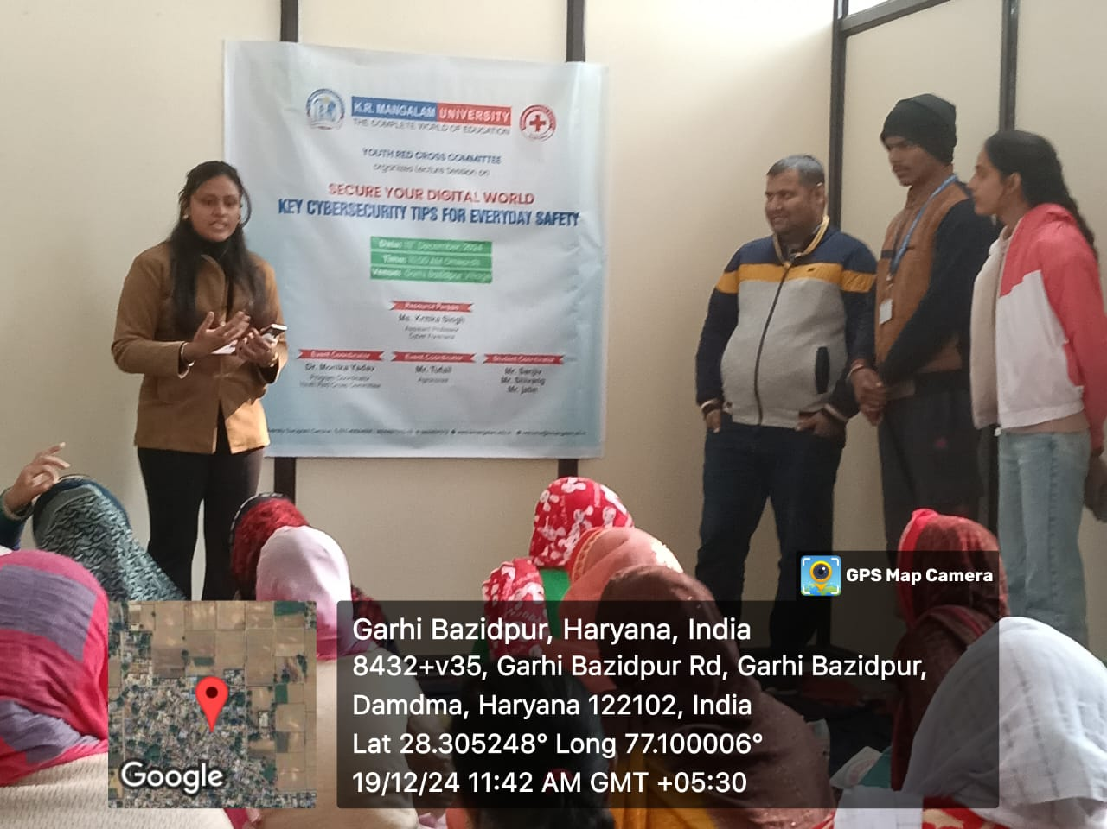
Ms. Kritika Singh delivers a lecture on "Key Cybersecurity Tips for Everyday Safety" at Garhi Bazidpur Village, organized by the Youth Red Cross Committee on 19th December 2024.

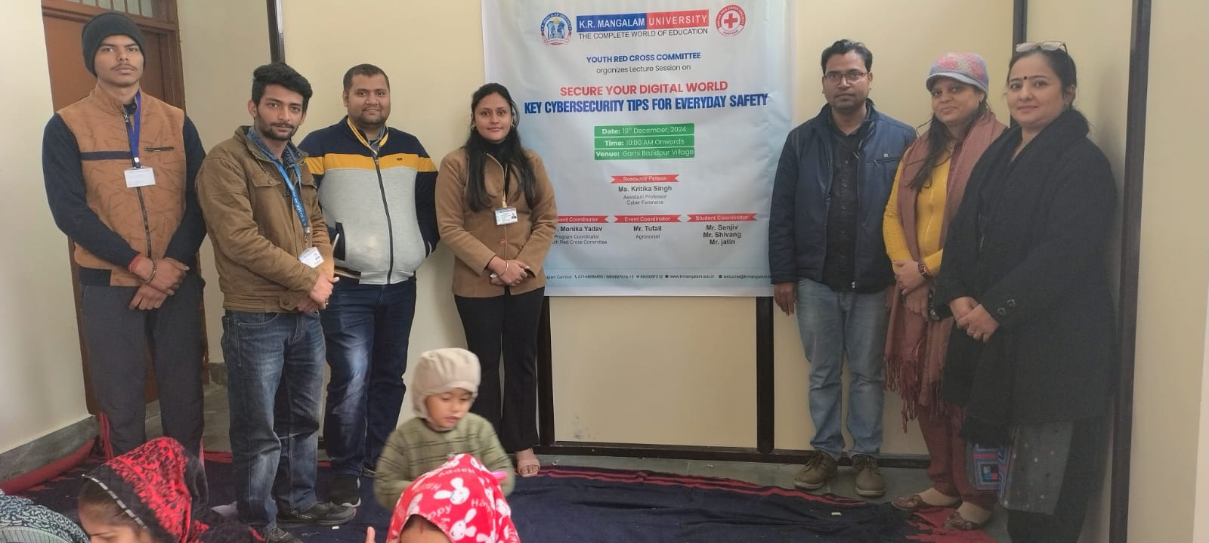

Event coordinators, resource person Ms. Kritika Singh, and participants at the "Key Cybersecurity Tips for Everyday Safety" session.

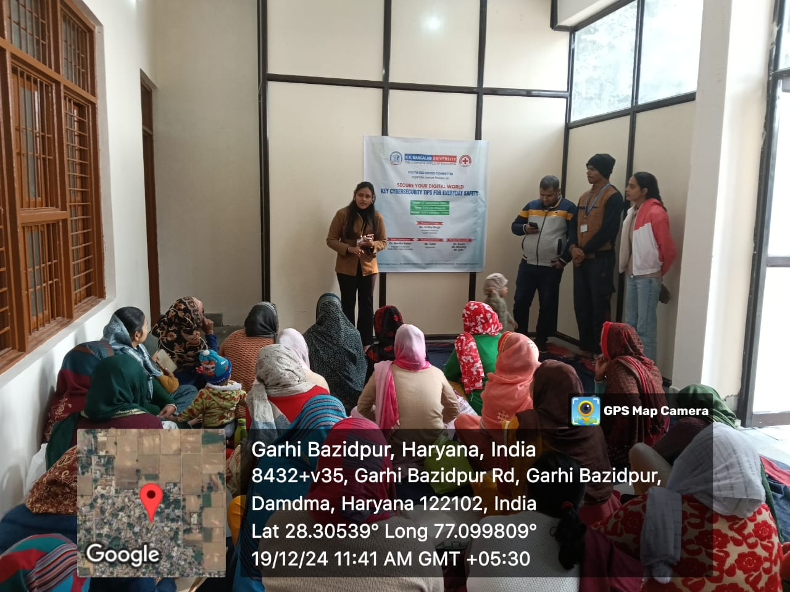

Ms. Kritika Singh, the resource person, answering participants' questions during the interactive session on "Key Cybersecurity Tips for Everyday Safety" at Garhi Bazidpur Village.

Report prepared by | Dr. Monika Yadav
Report verified by Event Coordinator | Dr. Monika Yadav
Report Seen by Red Cross Coordinator | Dr. Monika Yadav
Report seen by IQAC Coordinator | Dr. Shikha Dutta Sharma

