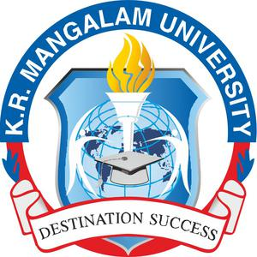

Campus Health, Wellness and Well-Being Ecosystem
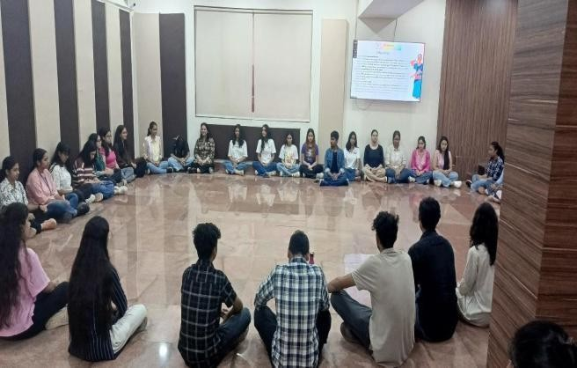

Campus Health, Wellness and Well-Being Ecosystem
Contents
1. Institutional Vision for Health, Wellness and Well-Being
1.1 Commitment to Holistic Campus Well-Being
1.2 Integration with Sustainable Development Goal (SDG-3)
2. Healthy and Low-Pollution Campus Environment
2.1 Smoke-Free Campus Policy
2.2 Anti-Burning and Air Quality Protection Measures
2.3 Laboratory Safety and Chemical Handling Protocols
2.4 Environmental Safety Practices and Awareness
3. Sustainable Waste and Environmental Health Management
3.1 Solid Waste Segregation and Composting Practices
3.2 Liquid Waste Management and STP Reuse System
3.3 E-Waste and Biomedical Waste Disposal Mechanism
4. Safe and Active Campus Mobility
4.1 Internal Road Safety and Speed Regulation
4.2 Pedestrian-Friendly Campus Planning
4.3 Walking and Cycling Promotion Initiatives
5. Physical Fitness and Sports Infrastructure
5.1 Outdoor Sports Facilities and Recreational Spaces
5.2 Synthetic Athletics Track and Professional Training Support
5.3 Promotion of Active Lifestyle among Students and Staff
6. Yoga, Meditation and Preventive Wellness Programmes
6.1 Institutional Wellness Activities and Expert Sessions
6.2 Role of Chetna Society in Holistic Development
6.3 Mindfulness, Emotional Balance and Lifestyle Awareness Initiatives
7. Mental Health Support and Counselling Ecosystem
7.1 WE DOST Counselling and Mental Well-Being Centre
7.2 Individual and Group Counselling Services
7.3 Stress Management Workshops and Awareness Campaigns
7.4 Impact of Mental Wellness Interventions
8. Holistic Healthcare Infrastructure on Campus
8.1 Campus Medical Rooms and Health Support Facilities
8.2 Availability of Medical Professionals and Emergency Care
8.3 Preventive Healthcare and Wellness Check-ups
9. Community Health Outreach and Social Responsibility
9.1 Health Awareness Campaigns in Rural and Urban Communities
9.2 Blood Donation, Hygiene and Nutrition Initiatives
9.3 Student Participation in Public Health Engagement
10. Institutional Collaborations with Healthcare Organisations
10.1 MoUs with Hospitals and Clinical Training Opportunities
10.2 Skill Development and Medical Exposure for Students
11. Participation Trends in Wellness and Fitness Activities
11.1 Pedestrian Zone and Sports Infrastructure Utilisation
11.2 Annual Participation Data and Growth Indicators
12. Alignment with National Policies and Professional Standards
12.1 Compliance with UGC Guidelines
12.2 Mental Healthcare Act and National Mental Health Policy Linkages
13. Outcomes and Impact on Campus Well-Being
13.1 Enhancement of Physical Health and Active Lifestyle
13.2 Improvement in Emotional Resilience and Stress Management
13.3 Contribution towards Sustainable and Healthy Campus Culture
14. Conclusion

Health & Well-Being
K.R. Mangalam University is committed to ensuring a safe, healthy, and inclusive campus environment that promotes the physical, mental, emotional, and social well-being of students, faculty members, and staff. The University adopts a holistic approach to wellness through infrastructure support, preventive healthcare, counselling services, recreational facilities, and awareness initiatives.
The University’s wellness ecosystem integrates environmental sustainability, preventive healthcare, physical fitness, and mental health support into everyday campus life.
Non-Toxic and Low-Pollution Practices
K.R. Mangalam University follows several institutional practices to ensure a safe, healthy, and pollution-free campus environment. The university maintains a smoke-free campus policy, prohibiting smoking in all indoor and outdoor spaces including classrooms, hostels, cafeterias, and open areas. “No Smoking” signage is displayed prominently across the campus to reinforce awareness and compliance.
Smoke Free Campus Policy
To reinforce this initiative ‘No Smoking’ boards have been thoughtfully placed at visible points, reminding everyone—students, staff, and visitors alike—of their shared responsibility to keep the campus air fresh and the environment healthy. This step not only supports the well-being of the University community but also nurtures a culture of collective awareness and respect for health and sustainability.

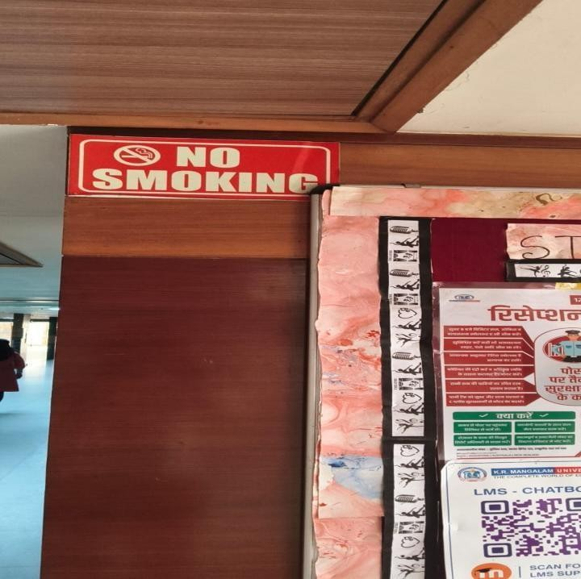 | 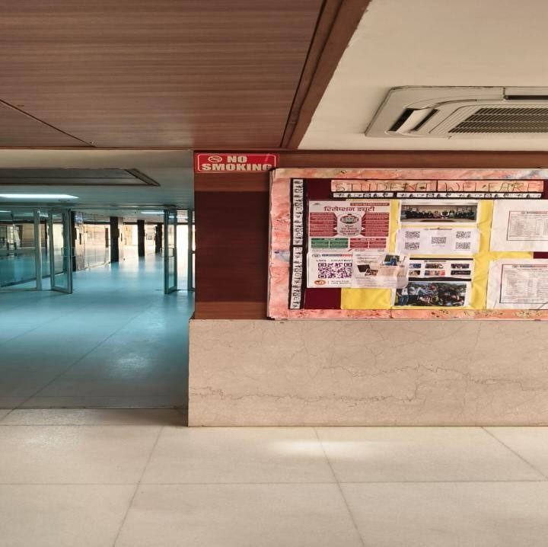

No Smoking Sinages displayed across the University Campus
Anti-Burning Policy
The Anti-Burning Policy at K.R. Mangalam University forms part of the institution’s Health & Wellbeing Compliance framework given under umbrella policy Revised Sustainable Environment and Green Campus Policy.
In accordance with this policy, the university strictly prohibits the burning of leaves, waste, or any combustible material within the campus premises. This measure helps prevent air pollution, maintain a clean and healthy environment, and safeguard the well-being of students, faculty, staff, and visitors. The university instead promotes responsible waste management practices such as waste segregation, composting of organic waste, and recycling through authorized vendors.
The institution also promotes environmentally responsible practices, including safe chemical handling procedures in laboratories through Standard Operating Procedures (SOPs), proper waste management systems, and controlled disposal of laboratory chemicals. It ensures a safe and secure laboratory environment by implementing strict laboratory safety protocols for students, faculty members, and staff. The university follows structured laboratory safety guidelines to minimize risks associated with chemicals, electrical equipment, and laboratory apparatus. All students are required to follow safety instructions, standard operating procedures, and laboratory conduct rules while performing experiments.
Safety Precautions
- The first rule is to always behave responsibly in the laboratory. Please follow all precautions and safety guidelines the laboratory instructor gives.
- When your teacher shows you lab equipment, listen carefully as some of the equipment can be dangerous, highly sensitive and expensive.
- Follow standard operating procedures (SOPs) and safety data sheets (SDS) for all chemicals and equipment.
- Be careful when operating electrical equipment. The lab working surface, equipment, and your hands should be dry.
- It is important to note that all electrical equipment must be turned off and unplugged before leaving your workplace.
- Use extreme care when handling sharp and sensitive apparatus.
- Never leave them unattended when working with an open flame or heating materials. Hot plates remain hot for several minutes after they are turned off. Never touch the surface of a hot plate/MUFFLE.
- Always wear a lab coat, safety goggles, and gloves.
- Direct or reflected laser rays should never be pointed into the eyes as this might cause permanent damage to the eye.
- Use fume hoods when working with volatile substances or toxic fumes.
Do’s
- Teachers expect students to be calm and disciplined. The safety of you and other people depends on it.
- Always wear lab coats, safety goggles, and gloves to protect against chemical spills and splashes.
- Read and follow all lab instructions and safety guidelines carefully.
- Read your lab assignments before coming to class. Prepare your pre-lab write-up before entering the lab.
- Familiarise yourself with all lab procedures before doing the lab exercise. Perform only those experiments on which you have been instructed.
- Get your teacher's signature in your observation notebook before leaving the lab.
- Clearly label all containers with their contents and any associated hazards.
- Clean your lab work area at the close of the lab period. Return equipment and materials to the proper place.
- Dispose of chemical waste properly in designated containers.
- Store chemicals properly, segregating incompatible substances.
- Know the procedures for dealing with chemical spills, fires, and other emergencies.
Don’ts
- Only leave the lab with the prior permission of the instructor/teacher in charge.
- Only attempt to touch the equipment or do the experiment independently once your teacher demonstrates it.
- Switch off your mobile phone before entering the lab.
- Never consume food or beverages or smoke in the laboratory to avoid contamination and chemical exposure.
- Check equipment before use and report any damage or malfunctions.
- In case of any difficulty, approach your teacher. Do not take your own decision.
- Use pipette bulbs or automated pipetting devices to avoid ingestion of hazardous substances.
- Handle grating and other sensitive equipment with care to avoid contamination and damage.
- Monitor experiments continuously to prevent accidents and uncontrolled reactions.
- Adhere to all posted warnings and instructions in the lab.
These measures contribute to maintaining low pollution levels and ensuring occupational safety for students, staff, and visitors.
K.R. Mangalam University follows a comprehensive waste management and environmental safety system to maintain a clean and sustainable campus environment. The university implements solid waste management practices through the use of colour-coded waste bins (green, blue, and yellow) placed across the campus to facilitate proper waste segregation. Organic waste generated from gardens and cafeterias is processed in compost pits, where green waste is converted into manure for landscaping and horticulture purposes. Additionally, recyclable waste is collected and managed through authorized vendors to ensure responsible disposal and recycling.
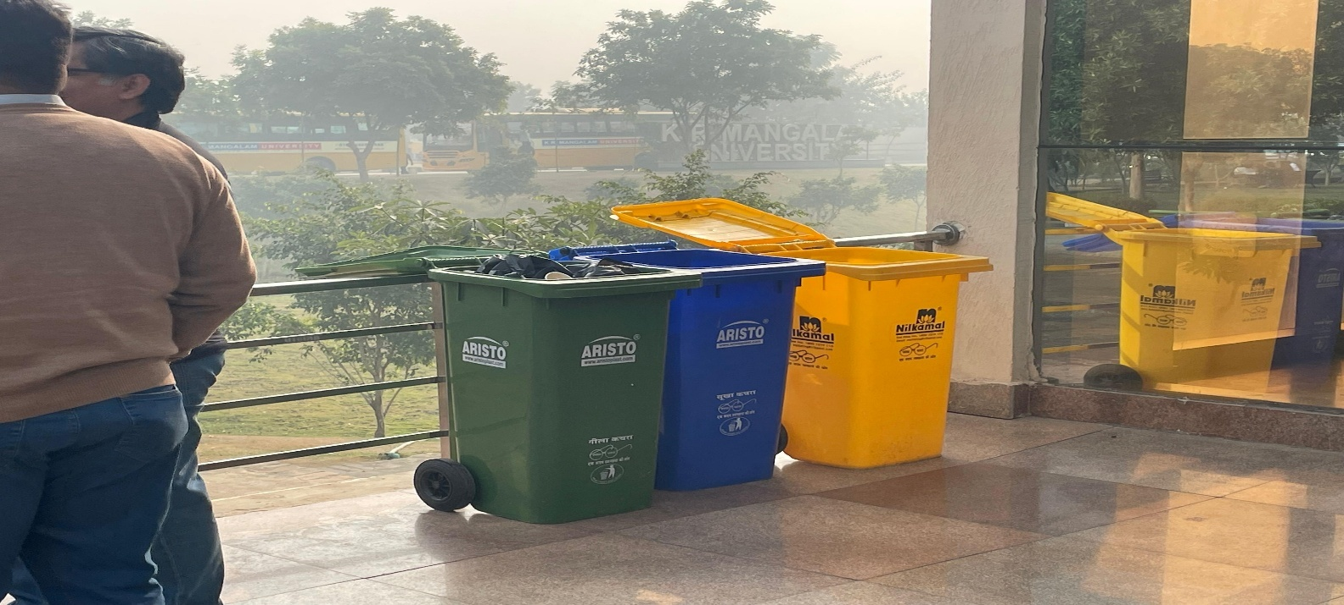
Solid waste management practices through the use of colour-coded waste bins (green, blue, and yellow)
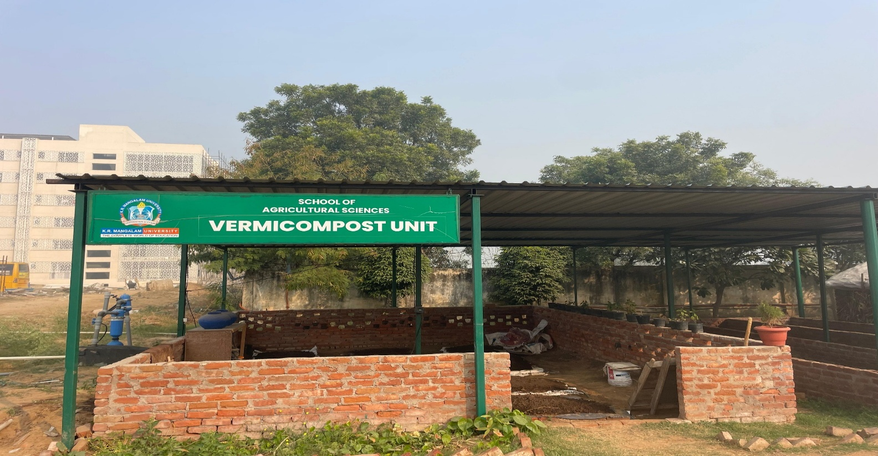
The University implements a structured waste management system that segregates organic and inorganic waste. Organic waste is collected from dining facilities and converted into compost, which is then used in campus gardens—promoting circular economy and sustainable resource use.
The institution also practices effective liquid waste management through a Sewage Treatment Plant (STP) with a capacity of approximately 1 lakh litres, where wastewater is treated and reused for gardening and landscaping activities. Water conservation is further supported through rainwater harvesting systems and other water management initiatives across the campus.
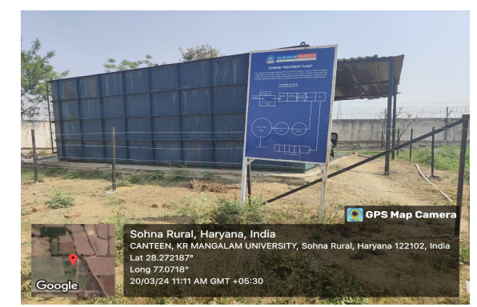
STP infrastructure at K R Mangalam University — enabling efficient wastewater treatment and reuse, contributing to campus water sustainability.
To address technological waste, the university maintains a structured e-waste management system, where electronic waste is centrally collected and disposed of through certified recycling vendors, preventing environmental harm. Furthermore, biomedical and hazardous waste generated in laboratories and medical facilities is carefully handled through separate collection systems and disposed of through authorized biomedical waste management agencies, ensuring safe and environmentally compliant disposal of chemicals, batteries, and biomedical materials. These integrated practices demonstrate the university’s commitment to environmental sustainability and responsible waste management.
https://www.krmangalam.edu.in/centre-for-sustainable-development-goals/
Speed Limit and Road Safety
To ensure safe movement within the campus, K.R. Mangalam University has installed speed limit and traffic regulation signage across internal roads. These signs guide drivers to maintain low vehicle speeds and prioritize pedestrian safety within academic and residential zones.
The presence of visible traffic signage helps regulate vehicular movement, reduce accidents, and maintain a safe and student-friendly campus environment.
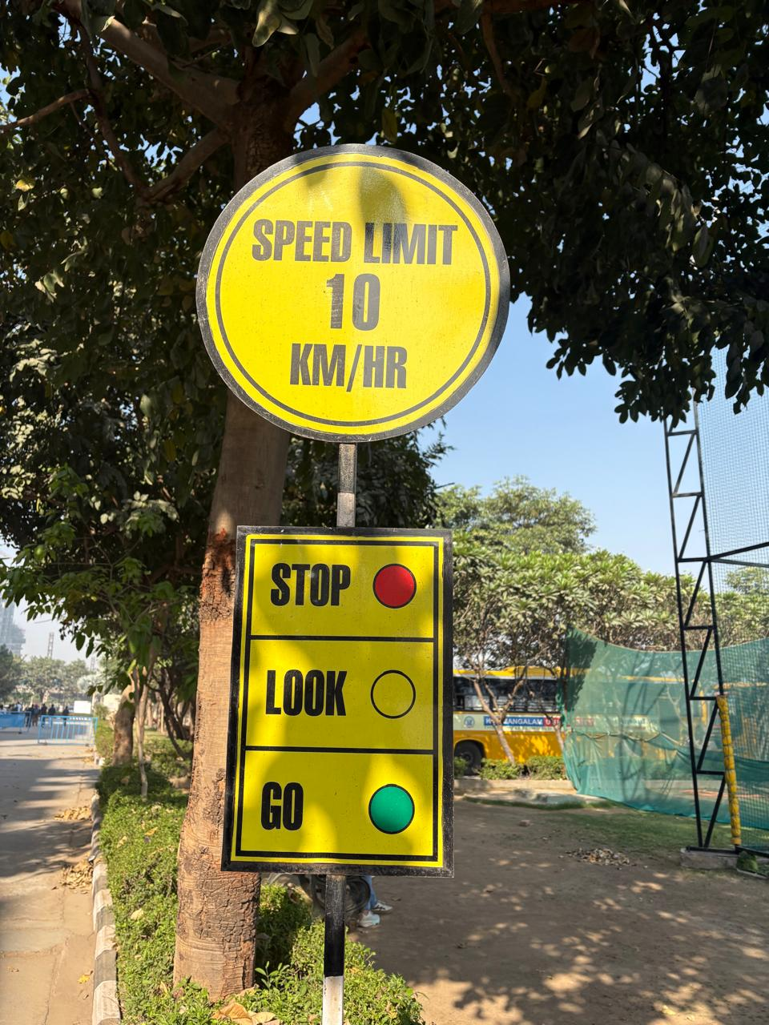 | 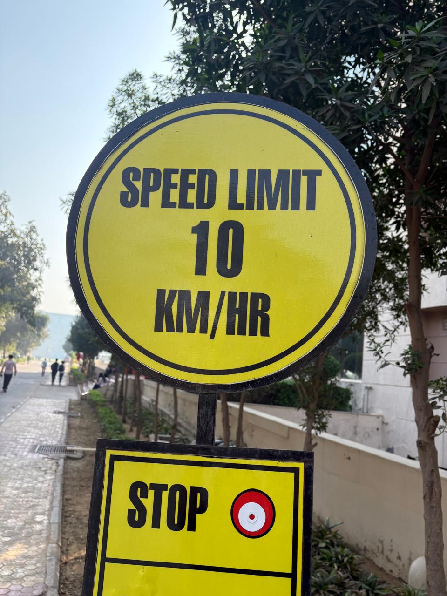
Speed limit and road safety signage installed across K.R. Mangalam University campus to regulate vehicle movement and ensure pedestrian safety.
The University maintains a clean and eco-friendly campus and follows strict environmental safety protocols to minimize pollution and health hazards.
Walking / Cycling Encouragement
The campus of K.R. Mangalam University is designed to promote active mobility and healthy lifestyles among students and staff. The eco-friendly campus located in the Aravalli foothills of Gurugram provides a green and pedestrian-friendly environment that encourages walking across academic and residential zones.
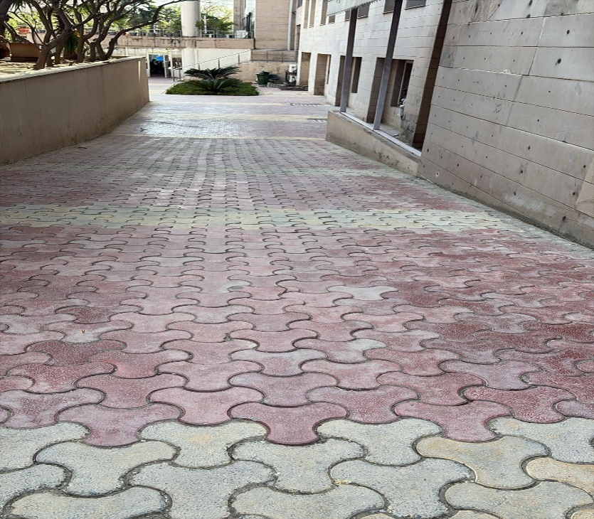 | 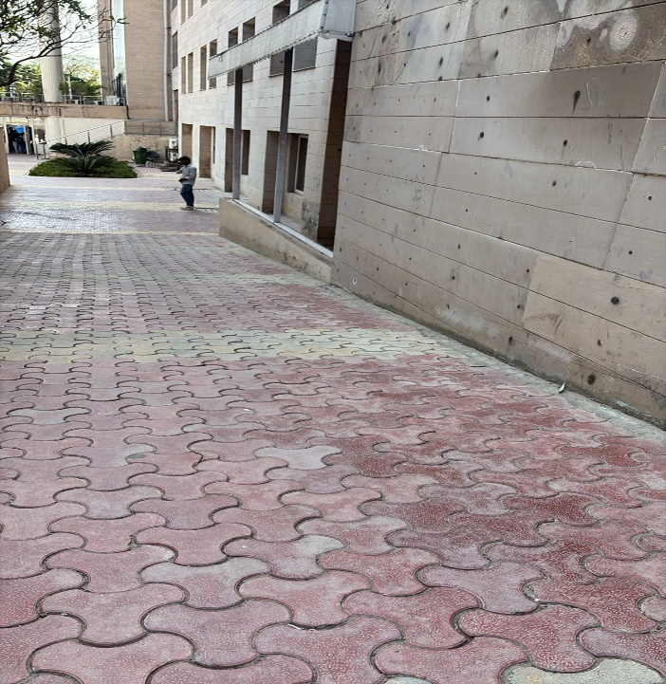
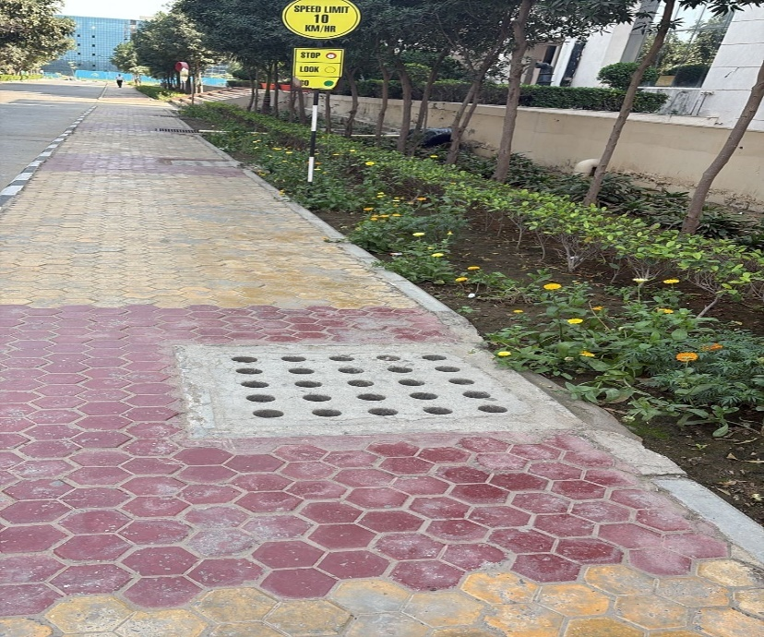 | 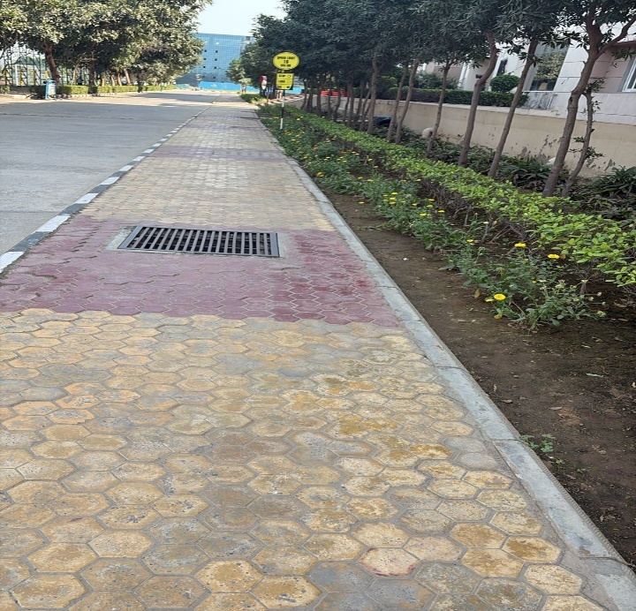
The images depict well-maintained pedestrian pathways with landscaped surroundings and safety signage across the K.R. Mangalam University campus. These walkways promote walking, ensure safe movement of students and staff, and support a healthy and sustainable campus environment.
Sports fields, open recreational areas, and landscaped spaces promote daily physical activity. The presence of extensive outdoor sports infrastructure such as the cricket ground, football field, athletics track, and courts for basketball, volleyball, tennis, and badminton further encourages students to engage in regular movement and outdoor exercise.

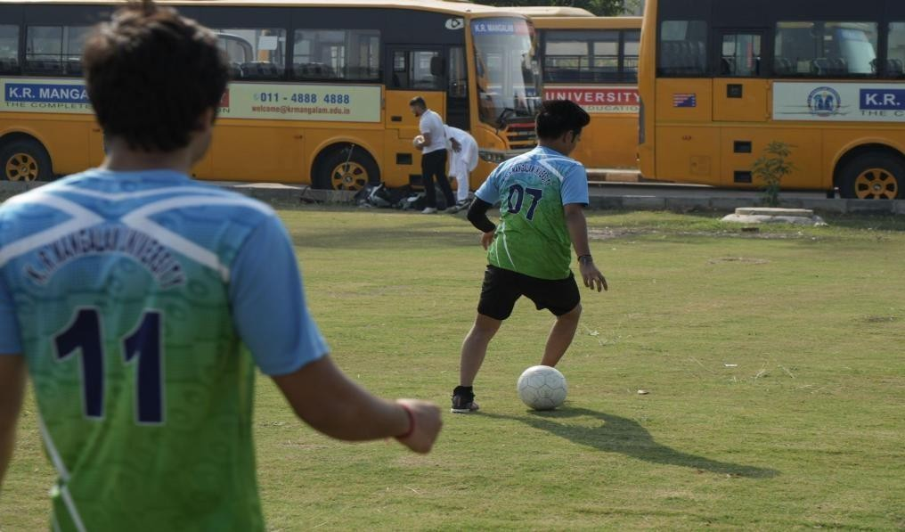
Kicking Goals for Fitness and Unity — Building a Healthier, Happier Campus Community in the Football Court
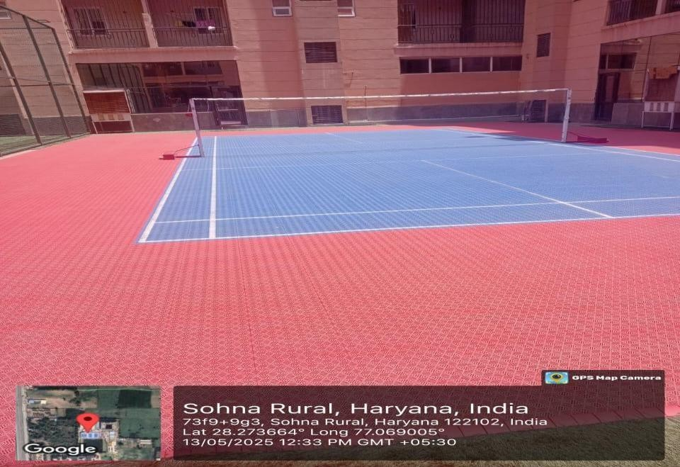
Badminton Court: Promoting Agility, Focus, and Well-Being through Every Serve

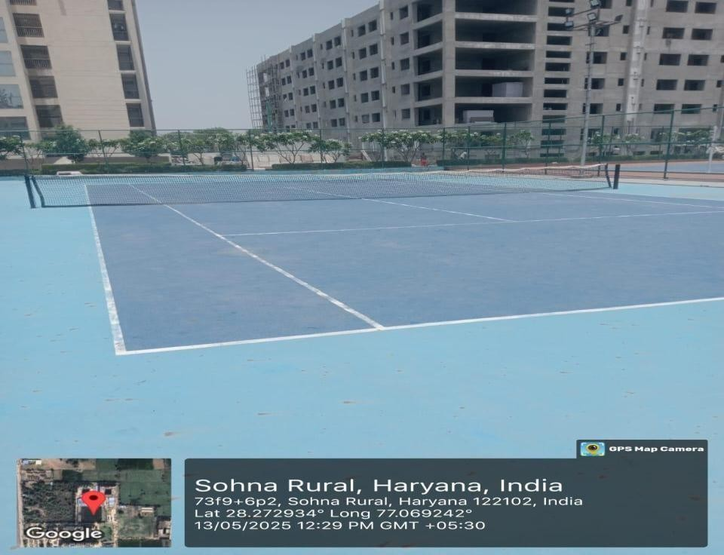
Tennis Court: Cultivating Fitness, Focus, and Fair Play
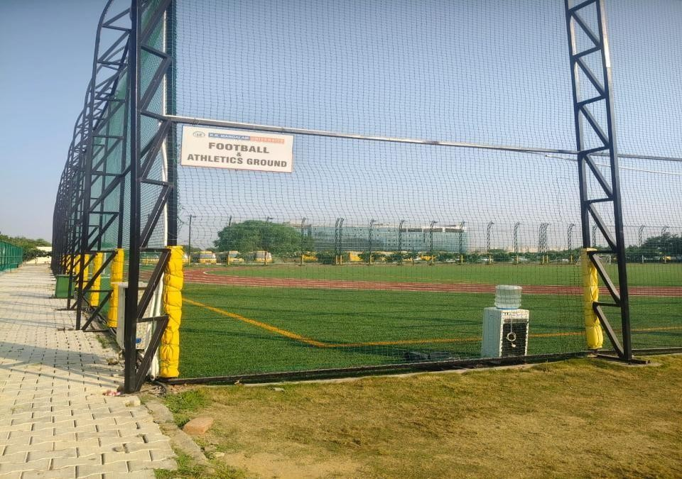
Football and Athletic Ground: Nurturing Strength, Stamina, and Sportsmanship at K.R. Mangalam University

Synthetic Athletics Track
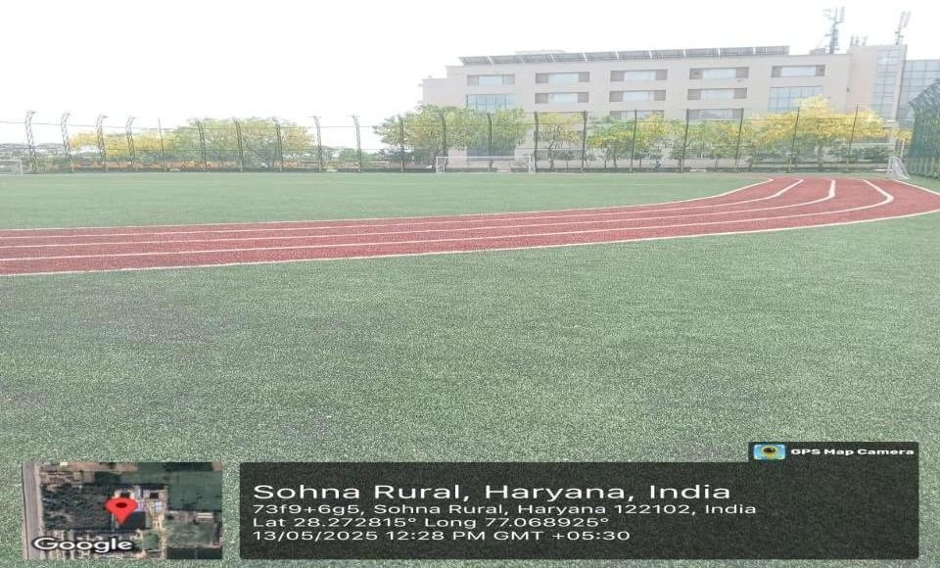
The university boasts synthetic athletics track that meets professional standards. It supports daily training, athletics coaching, and preparation for state and national-level competitions.
Every Step Towards Strength - K. R. Mangalam University’s Athletic Track Inspires Endurance, Energy, and Excellence
Yoga / Meditation Encouragement
K.R. Mangalam University places strong emphasis on promoting holistic health and well-being among students, faculty, and staff through regular yoga, meditation, and mindfulness initiatives. In alignment with Sustainable Development Goal 3 (Good Health and Well-Being), the university organizes structured wellness programmes that focus on improving physical fitness, emotional balance, and mental resilience.
These initiatives are primarily conducted through the Chetna Society and the WE DOST Counselling and Mental Well-Being Centre, which work collaboratively to create a supportive environment for stress management, emotional wellness, and mindful living. Through expert-led sessions, workshops, and awareness activities, the university encourages the campus community to adopt healthy lifestyle practices that enhance both physical and mental health.

Chetna Society:
While the academic system of our country excels in preparing young minds for a competitive future, there is an increasing need for learners to cultivate essential qualities such as values, attitudes, and right conduct. To address this, K.R. Mangalam University has established the Chetna Society. This pioneering initiative aims to imbue students with a set of aspirational values, guiding them towards a balanced and focused life across material, ethical, and spiritual dimensions.
The Chetna Society provides a platform for students to connect with their inner wisdom through heartfulness meditation, helping them calm and guide their minds. By fostering inner growth and balance, society addresses the challenges faced by today’s youth, who often struggle to prioritize amidst numerous goals. Through its various programs, Chetna Society seeks to inspire a sense of well-being and joy, nurturing a generation of mindful and well- rounded individuals. From time to time, expert sessions by IAS Officers are conducted who discuss various aspects of the student’s life including managing time and stress, overcoming fear etc. The society also partners with the International Society for Krishna Consciousness (ISKCON) which conducts various sessions.

Objectives of Chetna Society:
- To foster values, attitudes, and conduct that support balanced and ethical living among students.
- To help students connect with their inner wisdom and use it to guide their personal and academic journeys.
- To introduce students to meditation practices that facilitate mental calmness and clarity.
- To assist students in finding a balance between material, ethical, and spiritual aspects of their lives.
- To inspire and support inner change and personal growth, helping students manage competing goals and pressures effectively.
Evidence Link: Chetna Society

Activities conducted by Chetna Society
Throughout the academic year 2023-24 and 2024-25, Chetna Society coordinated a
number of meaningful sessions and workshops on mental health, emotional well-being, and creative outlets. They organized workshops like Developing Healthy Relationships, Building Mental Toughness, Dealing with Thoughts, Organizational Health, and various activities such as Laugh Therapy, Vision Board Creation, and Technology Detox Retreat. The activities promoted awareness, stress management, and proactive mental health in students and helped create a positive environment on campus.
List of events organized by Chetna Society for Students in AY 2023-24
S.No | Name of the Activity | Date | Evidence Link
1 | Building Mental Toughness to Overcome Challenges in College Life | 31.10.2023 | Awareness Session Report
2 | Expert Lecture: Creativity under Pressure | 15.12.2023 | Expert Lecture Report
3 | Expert Lecture: How the Environmental Movement Can Find Its Way Again | 18.12.2023 | Expert Lecture Report
4 | Dealing with Thoughts | 19.12.2023 | Expert Lecture Report
5 | Expert session on ‘Organizational Health' | 20.12.2023 | Expert Session Report
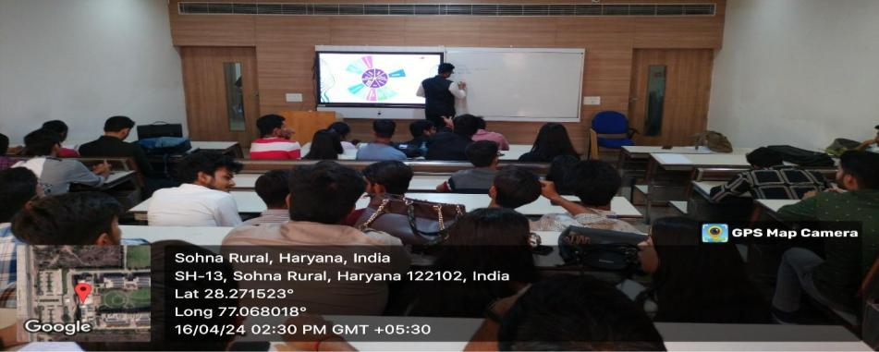  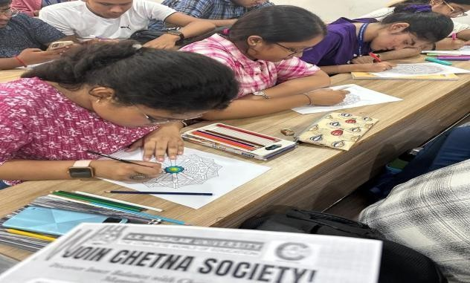  6 | Cultivating Mental Wellbeing and Conscious Living | 16.01.2024 | Competition Report
7 | Skill-Based Activity on Dream Vision Board | 20.02. 2024 | Skill Based Activity Report
8 | Laugh Therapy Session: A Joyful Path to  Better Health | 02 .04.2024 | Laugh Therepy Session Report
9 | From Margins to Mainstream: Navigating  Eco-Anxiety, Intersectionality, and Community Centric Climate Communication | 16 .04.2024 | Expert Session Report
10 | Nourish the Mind, Feed the Body: Unveiling  the Benefits of Mindful Eating | 07. 05. 2024 | Expert Session Report
11 | Embracing Tranquillity: A Technology Detox  Retreat | 21.05. 2024 | Expert Session Report
List of events organized by Chetna Society for Students in AY 2024-25
S.No | Name of the Activity | Date | Evidence Link
1 | Trust Trek: The Blindfold Adventure. | 29 July 2024 | Expert Session Report
2 | Krishna's Cosmic Canvas: Explore and Create the Art of Mandala and Rangoli | 10 September 2024 | Skill Based Activity Report
3 | Harmonizing Frequencies: A Journey into Therapeutic Movement | 17 September 2024 | Meditation Report
4 | The Dangers of Self-Medication: Understanding its Effects on Health and Consciousness | 01 October 2024 | Expert Lecture Report
5 | Expert Session On “Building Emotional Intelligence (Ei) And The Art And Science Of Emotional Brilliance” | 15 September 2024 | Expert Session Report
6 | Dreams on Display : Create Your Own Vision Board | 03 September, 2024 | Skill Based Activity Report
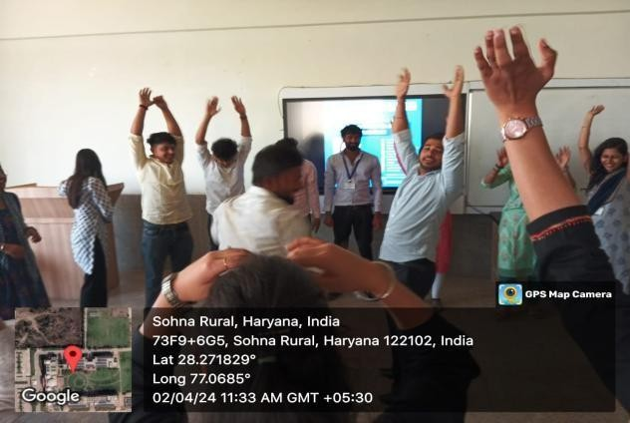
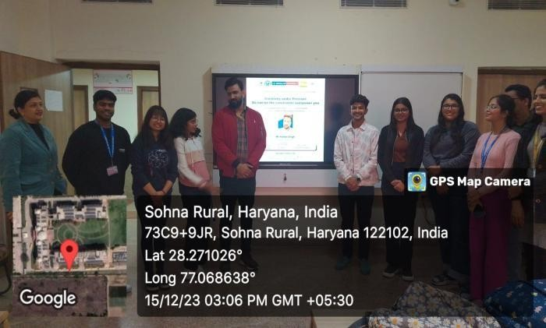
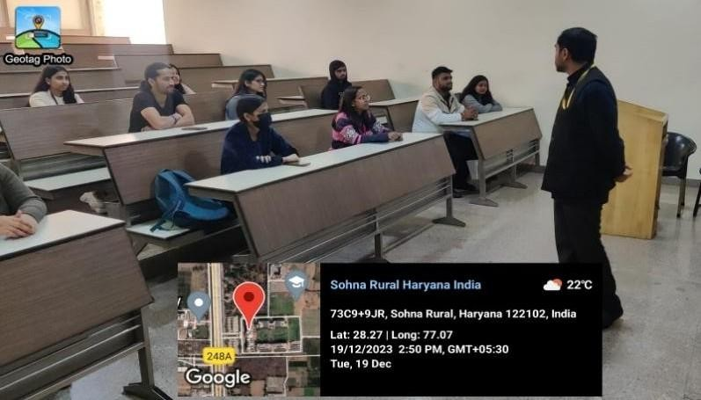
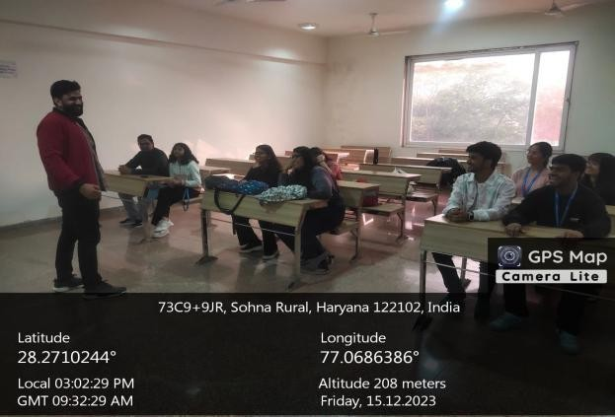
Students engaging in mindfulness and peer-support sessions under the Chetna Society- fostering mental wellness and emotions
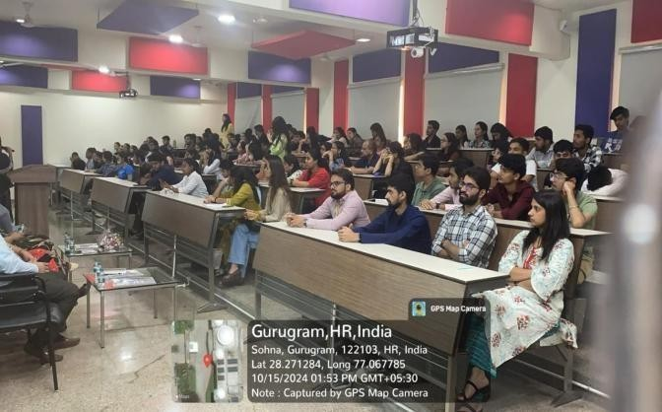

Chetna Society initiatives promoting holistic growth through counselling, self-awareness workshops, and community well-being programmes
The initiatives undertaken by the Chetna Society at K.R. Mangalam University exemplify the institution’s unwavering commitment to promoting mental health, holistic growth, and emotional well-being among students. Through a variety of programs spanning expert-led workshops on Building Mental Toughness, Organizational Health, and Mindful Eating to innovative and therapeutic activities such as Laugh Therapy and Technology Detox Retreats the society has effectively fostered a culture of mindfulness, self-awareness, and positivity within the campus.
The university regularly organizes yoga and stretching sessions where trained instructors guide participants through various yoga postures, breathing techniques, and relaxation practices. These sessions help improve flexibility, concentration, and overall physical fitness while reducing stress and fatigue. Yoga sessions are conducted for both students and staff to promote balance between academic responsibilities and personal well-being.

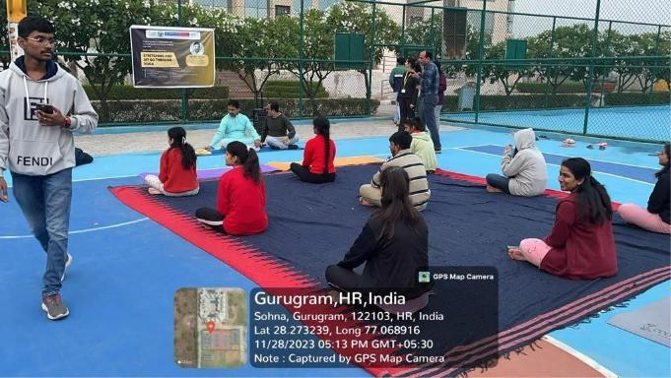
Yoga Session conducted by Experts for Health and Well Being
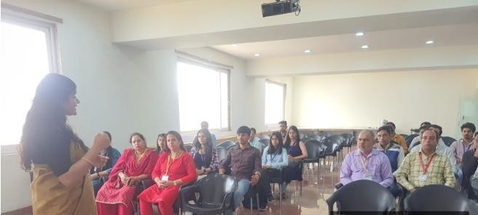
In addition to physical yoga practices, the university promotes meditation and heartfulness programmes that help participants develop inner calmness, clarity of thought, and emotional stability. Meditation sessions conducted under the guidance of wellness experts allow students to cultivate mindfulness, manage anxiety, and maintain focus in their academic and personal lives.
Heartfulness Wellness Expert Conducting Session on Living a Life Full of Purpose
To further support mental well-being, the university organizes technology detox retreats and mindfulness activities that encourage participants to disconnect from digital distractions and reconnect with their inner selves. These programmes focus on self-awareness, emotional regulation, and the development of healthy coping mechanisms for stress.
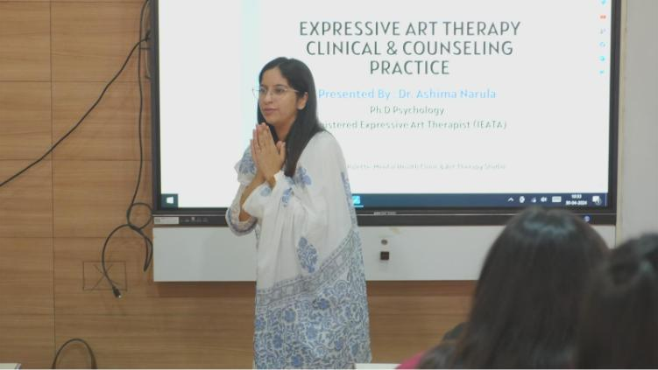
Session on Expressive Art Therapy Being Conducted by the Expert
The university also celebrates International Yoga Day with great enthusiasm each year. On this occasion, large-scale yoga sessions are organized across the campus where students, faculty, and staff actively participate in yoga demonstrations and wellness activities. These events highlight the importance of yoga as an integral part of India’s traditional knowledge system and promote awareness about its benefits for physical and mental health.
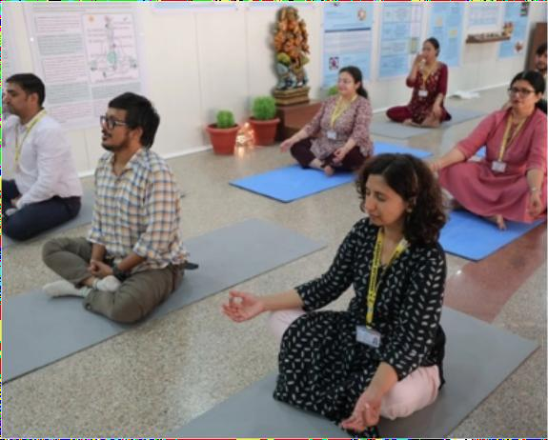

Yoga for Wellness is being conducted for Staff
These initiatives have not only bolstered students’ mental resilience and interpersonal connections but have also closely aligned with the goals of SDG 3 (Good Health and Well- being).

We Dost (Mental Health Wellness Centre) Evidence Link: We Dost
In today’s fast-paced and competitive life, individuals face various issues in their life at different levels. Considering this as biggest challenge Counselling and Mental Wellbeing Centre (We Dost) established in K.R. Mangalam University addressing the emotional, social and behavioural issues of the students/staff members. K.R. Mangalam University, through its Chetna Society and We Dost Counselling Cell, has been organized a series of awareness programmes to promote mental and emotional health among students. These initiatives aimed to improve understanding of healthy relationships, stress management, mindfulness, and overall mental well-being.
Objectives of Counselling & Mental Wellbeing Centre
- To provide quality mental health care to the students and staff.
- To help the students solve their personal, educational, social, and psychological problems.
- To help students and staff develop coping skills.
- To enhance the self-esteem of weaker /slow learners / physically challenged students and staff.
- To help the students and staff members to overcome examination stress, anxiety, or phobia.
- To assist the student in planning for educational and vocational choices.
- To help the students know themselves regarding their interests, abilities, aptitude, passion, and opportunities.
- To create awareness, prepare, and motivate to make success stories and decipher plans to overcome life challenges.
- To establish a feeling of mutual understanding between student and teacher.
- To provide Guidance and Counselling services to individual outside the campus with nominal charges.

Services for Students
The Centre provided a variety of services to students and staff, including individual counseling, group counseling, crisis intervention, and workshops and training. This year, most of the services were delivered in-person, with only two cases being handled through tele-counseling.
- Counselling and Therapy Services
- Wellness and Stress Management Workshops
- Mental Health Awareness Campaigns
- Peer Support Groups
- Health and Wellness Check-ups
- 24x7 Helpline or Online Support
- Recreational and Relaxation Facilities
- Recognition and Motivation Initiatives

Services for Staff
- Counseling and Therapy Services
- Wellness and Stress Management Workshops
- Mental Health Awareness Campaigns
- Peer Support Groups
- Health and Wellness Check-ups
- 24x7 Helpline or Online Support
- Recreational and Relaxation Facilities
- Training for Supervisors and Administrators
- Recognition and Motivation Initiatives Link for We Dost
- In summary, K.R. Mangalam University’s proactive strategy through the Chetna Society and We Dost Centre has transformed the university atmosphere into a nurturing and empathetic community—one that promotes mental wellness, encourages personal development, and equips students to confront life’s challenges with assurance and clarity.
Mental Well-Being and Counselling Support
K.R. Mangalam University places strong emphasis on promoting the mental health and emotional well-being of its students and staff. To ensure a supportive and healthy academic environment, the University has established the WE DOST – Counselling and Mental Well-Being Centre, which provides structured psychological support services and wellness initiatives across the campus. The centre serves as a safe and confidential space where students and employees can seek professional guidance for personal, academic, and emotional concerns.
Initiatives Link for We Dost
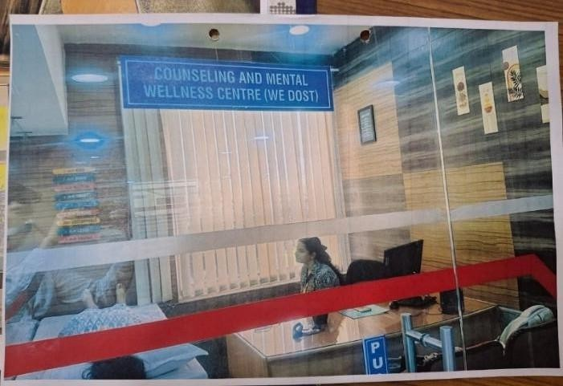
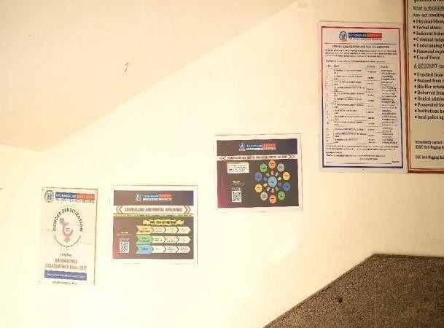
The WE DOST Centre is staffed by qualified counsellors and psychology professionals who offer a wide range of services aimed at improving emotional resilience, stress management, and overall mental health. The counselling services are provided through individual sessions as well as group-based interventions to address different psychological and social challenges faced by students in a competitive academic environment.
We Dost Counselling and Mental Wellbeing Centre
Key Services Provided by the Centre
The Counselling and Mental Well-Being Centre provides the following services:
- Individual Counselling Sessions: One-to-one confidential counselling for students and staff dealing with stress, anxiety, depression, adjustment issues, academic pressure, and personal concerns.
- Group Therapy and Peer Support Programmes: Interactive sessions that help individuals share experiences, develop coping strategies, and build emotional support networks.
- Stress Management Workshops: Training sessions focusing on mindfulness, relaxation techniques, time management, and coping strategies to manage academic and personal stress.
- Mental Health Awareness Campaigns: Awareness drives, seminars, and interactive sessions conducted across the campus to promote understanding of mental health issues and reduce stigma associated with seeking psychological help.
- Crisis Intervention Support: Immediate psychological assistance and counselling support in cases of emotional distress, trauma, or urgent mental health concerns.
A series of well-being initiatives were organized for staff to promote mental and emotional health. Participants engaged in activities designed to reduce tension, enhance mindfulness, and foster relaxation through guided physical and mental exercises. Sessions focused on developing self-awareness, emotional regulation, empathy, and interpersonal skills, equipping staff to manage their emotions effectively. Practical strategies for stress management were also provided to help handle work-related pressures, improve productivity, and maintain a supportive work environment. Collectively, these initiatives reinforced the importance of holistic well-being and emotional resilience among the staff.
The We Dost Counselling and Mental Wellbeing Centre at K.R. Mangalam University has achieved significant progress in promoting a campus environment that is mentally healthy, emotionally resilient, and supportive.
Through its organized counselling services, awareness initiatives, and wellness workshops, the centre has made a substantial impact on enhancing the psychological well-being of both students and staff. The university’s programs, which include individual and group counselling sessions, peer support initiatives, and crisis intervention strategies, have effectively addressed a variety of challenges such as stress, anxiety, depression, and relationship difficulties.
By providing 24x7 helpline support, conducting mental health awareness campaigns, and fostering mindfulness and self-reflection, K.R. Mangalam University has successfully cultivated a culture of openness regarding mental well-being. These efforts not only empower students to manage academic and personal stress effectively but also align with the objectives of SDG 3 – Good Health and Well-being, highlighting the university’s comprehensive approach to education that values both intellectual and emotional development. In summary, the We Dost Centre, in partnership with the Chetna Society, has been instrumental in establishing a compassionate, inclusive, and mentally robust university community that emphasizes wellness, empathy, and self-awareness.

List of Events Organized for Mental Health Support for Staff
S.No. | Name of the Activity | Date | Evidence Link
1 | Peer Pressure and Stress Management” in collaboration with ISCKON | 25 September 2023 | Stress-Management-  Session Report
2 | Expert Session on 'Developing Healthy Relationships | 31 October 2023 | Expert Session Report
3 | Healthy Lifestyle practices for K. R.Mangalam University guards and housekeeping staff | 09 November 2023 | Training Session Report
4 | Stress Management Session for Staff | 21 November 2023 | Expert Session Report
5 | Stretching and Let Go through Yoga | 28 November 2023 | Yoga session Report
6 | Heartful Leadership: Inspiring  Educators to Lead with Morality and Humanity | 03 August 2023 | Expert Session Report
7 | Session on Living a Life Full of Purpose | 28 December 2023 | Expert Session Report
8 | Expressive Arts as an Intervention for  Clinical & Counselling Practice | 30 April 2024 | Clinical & Counselling Session Report
9 | Building Emotional Intelligence (EI) and the Art and Science of Emotional Brilliance | 15 March 2024 | Expert Session Report

Impact of Counselling and Mental Wellness Initiatives
During the academic year 2023–2024, the WE DOST Counselling Centre handled 36 counselling cases, addressing various psychological concerns including anxiety, stress, depression, emotional conflicts, and relationship-related issues. These counselling interventions provided timely support and helped students manage their academic and personal challenges effectively.
In addition to individual counselling, the centre organized multiple mental health awareness programmes, workshops, and well-being sessions throughout the year. Through these initiatives, approximately 65–70% of the university’s student population benefited from mental wellness activities, which significantly contributed to improving emotional resilience, promoting healthy coping mechanisms, and creating a more supportive campus culture.
Alignment with National Policies and Professional Standards
The functioning of the Counselling and Mental Well-Being Centre is aligned with national mental health policies and professional guidelines to ensure ethical and effective psychological support. The centre operates in accordance with:
- University Grants Commission (UGC) guidelines for student counselling services
- The Mental Healthcare Act, 2017, which promotes accessible and rights-based mental healthcare services
- The National Mental Health Policy, 2014, focusing on preventive mental health care and psychological well-being
Through these structured initiatives and services, K.R. Mangalam University demonstrates its commitment to fostering a healthy, inclusive, and emotionally supportive academic environment, thereby contributing to the achievement of Sustainable Development Goal 3 – Good Health and Well-Being. The WE DOST Centre continues to play a vital role in strengthening students’ mental health, promoting awareness, and ensuring that psychological well-being remains an integral part of campus life.
Holistic Health Care Facilities
K.R. Mangalam University is committed to promoting holistic health and well-being for its students, faculty, staff, and the surrounding community. In alignment with Sustainable Development Goal 3 (Good Health and Well-Being), the university has developed a comprehensive healthcare support system that integrates on-campus medical facilities, preventive health awareness programmes, and collaborations with reputed healthcare institutions. These initiatives aim to ensure timely medical assistance, promote preventive healthcare practices, and encourage community health engagement.
Campus Medical Facilities
The University maintains dedicated medical rooms and health check-up centres within the campus to provide immediate medical support and basic healthcare services to students and staff. These facilities operate under the supervision of trained healthcare professionals and are equipped to handle routine medical needs as well as minor emergencies.
The campus health centre is supported by three resident nurses and two on-call doctors, ensuring the availability of qualified medical assistance whenever required. The centre offers a range of healthcare services, including first aid, routine health consultations, basic medical treatment, and emergency support. Students and staff can seek medical guidance and treatment for common health issues, thereby ensuring a safe and supportive campus environment. These facilities play an important role in maintaining the physical well-being of the university community and ensuring quick medical response during health-related situations.
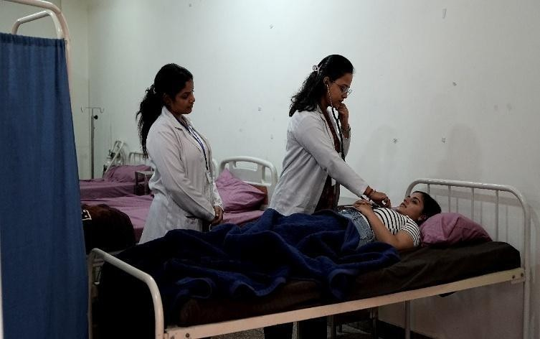
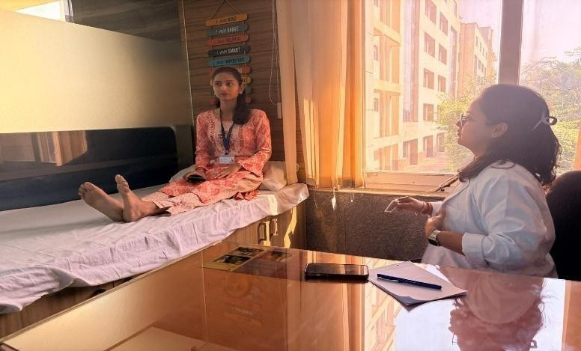

Medical Consultation in University Health Centre
Health Awareness and Outreach Programmes
In addition to providing medical services within the campus, K.R. Mangalam University actively involved in providing community services with a vision towards better health, hygiene & well-being, especially for the underprivileged society. The knowledge of the prevailing disease and its prevention is being taken to the public through schemes such as Malaria Prevention Awareness, Cancer Prevention & Healthy Lifestyles Awareness Campaigns and PCOD/PCOS Awareness Workshop. The Blood Donation Camps and Self-Medication Awareness helped popularize the importance of blood donation, dangers associated with unsupervised intake of medicines, etc. In addition, the programme of Drug De-addiction Seminar and Life Skills for Drug Awareness was initiated to promote a healthy living style and minimize drug abuse. The University has been focusing on hygiene and nutrition-based programs, under which it initiated the Menstrual Hygiene Awareness, workshops for Improving Hygiene Practices in School. Such efforts highlighted the significance of personal hygiene and proper waste management in order to avoid the spread of pathogens. The Women's Health Issues in Rural Haryana project aimed to address the health needs of rural women, while Food Quality Testing in Anganwadi ensured that children in their rural region received healthy food. These initiatives reflect K. R. Mangalam University’s commitment to social responsibility and offer real-world solutions to health problems that bring immense improvements in the lives of marginalized people, contributing significantly towards the betterment of society at large.

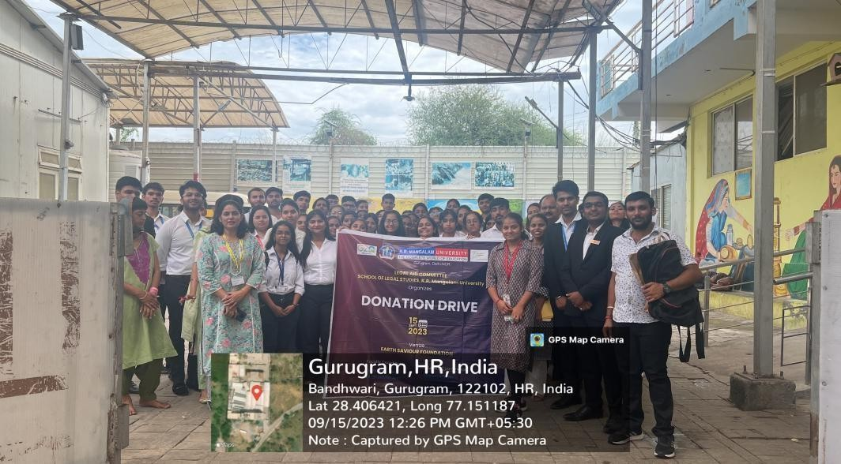
Students of K.R. Mangalam University actively participating in a Donation Drive, contributing essential items to support underprivileged communities and promote the spirit of social responsibility.

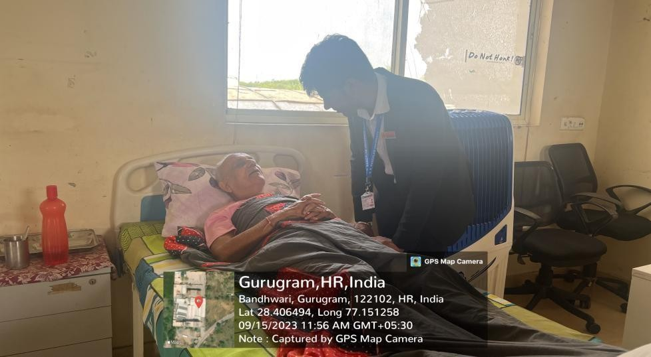
A student of K.R. Mangalam University interacting with an elderly person during the community visit, fostering empathy, understanding, and intergenerational connection as part of the outreach initiative.

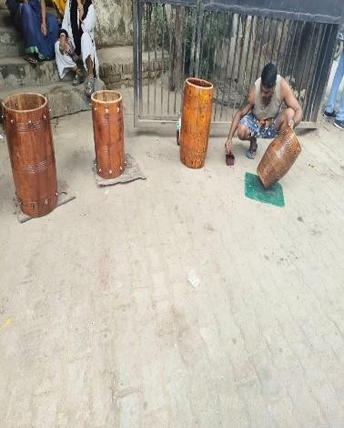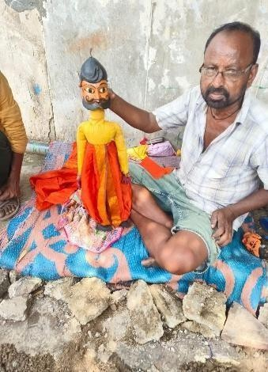
Empowering Communities, Enriching Lives — an initiative by K.R. Mangalam University students and faculty working together to promote health, well-being, and inclusive community development through active engagement and service.
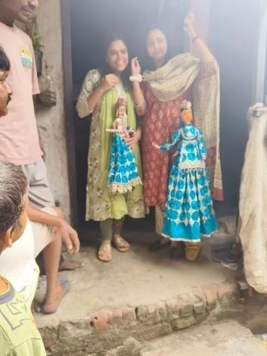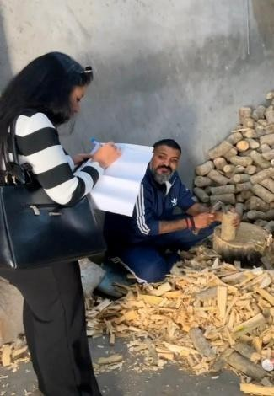
Transforming Lives through Knowledge, Kindness, and Well-Being — K.R. Mangalam University students embodying the spirit of compassion and learning by contributing to community welfare and holistic development.
Health Outreach Programme Conducted by K.R. Mangalam University
Sr. No. | Activity Name | Date | Organised by | Links
1 | Awareness of Social Issues (Women's Health and Hygiene Young Age Challenges | 2024-25 | School of Engineering & Technology | Case Study Report
2 | Promoting Environmental Awareness and Sustainable Waste Management in Alipur Village | 2024-25 | School of Education | Case Study Report
3 | Plantation & Plant Donation Drive | 05-06-2025 | School of Engineering & Technology & NSS | Plant Donation Drive
4 | Awareness Session on Cancer Prevention | 07-05-2025 | Youth Red Cross | Awareness Session
5 | Session: "Eat Right, Move More"- Wellness Workshop For Children | 21-04-2025 | NSS | Workshop Report
6 | Health Checkup Camp | 15-04-2025 | NSS | Health Checkup Camp
7 | Health Checkup Camp | 09-04-2025 | Youth Red Cross | Health Checkup Camp Report
8 | Blood Donation Camp | 09-04-2025 | Youth Red Cross | Blood Donation Camp
9 | Menstrual Health Awareness Session | 07-04-2025 | NSS | Awareness Session Report
10 | Blood Donation Camp | 05-03-2025 | Youth Red Cross | Blood Donation Camp
11 | Guest lecture: Digital Mental Health | 21-02-2025 | School of Journalism & Mass Communication | Guest lecture Report
12 | Poster Making Competition On "Say No To Drugs" | 04-02-2025 | NSS | Poster Making Competition
13 | Breath, Balance, Thrive: Life Skill through Yoga" | 04-02-2025 | School of Humanities | Yoga Session Report
14 | Drawing Competition on Save the Water for New Generation | 23-12-2024 | Red Cross Society | Drawing Competition Report
15 | Nourish & Flourish A Path to Balanced Nutrition and Heaith | 20-12-2024 | Red Cross Society | Session Report
16 | Wellness and Development Program | 18-10-2024 | Red Cross Society | Wellness and Development Program
17 | Cleanline Drive and Rally under Swachhate Hi Seva Campaign | 25-09-2024 & 27-09-2024 | NSS | Cleanline Drive Report
18 | Blood Donation Camp Give Blood Give Life | 24.09.2024 | Red Cross Society | Blood Donation Camp
19 | Save a Life First Aid Awareness Trainnig Session on World First Aid Day | 14-09-2024 | Red Cross Society | World First Aid Day
20 | Workshop on PCOD/PCOs | 28-02-2024 | National Service Scheme (NSS) | Workshop Report
21 | Awareness session on Raising  Awareness: Health Impact of Wastewater Utilization | 08-04-2024 | School of Engineering & Technology | Awareness Session Report
22 | Awareness on Cancer Prevention and Healthy  Lifestyles | 05-04-2024 | School of Management & Commerce & Youth  Red Cross | Awareness Session Report
23 | Awareness session on Prevention of Malaria | 23-04-2024 | School of Medical & Allied Science & NSS | Awareness Session Report
24 | Quiz on “World No Tobacco  Day” | 30-05-2024 | School of Medical & Allied Science & NSS | Quiz Report
25 | Survey on TB Mukt Bharat | 01-03-2024 | NSS | Survey Report
26 | Blood Donation Camp | 19-05-2024 | NSS | Blood Donation Camp
27 | Seminar on Drug De-addiction | 13-03-2024 | School of Engineering  & Technology | Seminar Report
28 | Extension Activity on Awareness on “Health and Hygiene” with NSS | 29-12-2023 | School of Management & Commerce & Youth  Red Cross Society | Extension Activity Report
29 | Life skills for awareness adverse effects of Drugs | 30-10-2023 | School of Medical & Allied Sciences &  NSS | Awareness Camp Report
30 | Drug Addiction: The Menace of Youth's Future | 17-10-2023 | School of Medical & Allied Sciences &  NSS | Awareness Camp Report
31 | Self-Medication: A Challenge in Healthcare Management | 28-11-2023 | School of Humanities & NSS | Extension Activity Report
32 | Major Health Problems among Females | 25-10-2023 | NSS | Extension Activity Report
33 | An Awareness Session: Menstrual Cycles: Let's talk  about it | 23-11-2023 | NSS | Awareness Session Report
34 | Nukkad Natak on the occasion of National Voluntary Blood  Donation Day | 03-10-2023 | School of Engineering & Technology & NSS | Nukkad Natak Report
35 | Development of Cookery Skills and Hygiene Practices among Students in the Government School at Village Garhi Bazidpur, Sohna, Gurugram | 23-02-2024 -  15-03-2024 | School of Hotel Management and Catering Technology | Extension Activity Report
36 | Case Study of Deaddiction Activity | 29-09-23 to  10-11-23 | School of Basic and Applied Science | Case Study Report
37 | Ensuring Drug Safety Insight on Pharmacovigilance | 09 -02-2024 | School of Medical & Allied Science | Awareness Session Report
38 | Pharma Avenshan-2024 | 11-03-2024 | School of Medical & Allied Science | National Pharmacy Education Day Report
39 | World Physiotherapy Day | 08-09- 2023 | School of Physiotherapy & Rehabilitation  Sciences | World Physiotherapy Day Report
40 | International Women's Day | 07-03- 2024 | School of Physiotherapy & Rehabilitation  Sciences | International Women's Day Report
41 | Health Plus "Monitoring Wellness in Our Neighbourhood” | 30-03-24- 13-  04-2024 | School of Medical and Allied Sciences | Health Camp Report
42 | Report On ‘A Visit To Old Age  Home’ | 30-01-2024 | NSS | Visit to Old Age Home Report
43 | Donation Drive at Earth Saviour Foundation | 15-09-2023 | Legal Aid Committee, School of Legal Studies | Donation Drive Report
44 | Health Survey | 19-05-2023 | Legal Aid Committee,  School of Legal Studies | Health Survey Report
45 | Supporting Sustainable Livelihoods through Education and Cultural Entrepreneurship | 23-03-2024 | Supporting- Sustainable- Livelihoods-through- Education-and-Cultural Entrepreneurship.pdf | ICSSR Report
These outreach initiatives were not limited to the campus community but also extended to nearby villages and local communities, reflecting the university’s commitment to social responsibility and public health promotion.
Hospital Collaborations
To strengthen healthcare education, research, and practical exposure for students, K.R. Mangalam University has established 23 Memorandums of Understanding (MoUs) with reputed hospitals and healthcare institutions. These collaborations create opportunities for students to gain hands-on clinical training, internships, and professional exposure in real healthcare environments.
Some of the key partner hospitals include Polaris Hospital, Fortis Memorial Research Institute, C.K. Birla Hospital, Medox Hospital, and Sarvodaya Hospital. Through these collaborations, students from health-related programmes receive opportunities to interact with healthcare professionals, observe clinical practices, and participate in healthcare training programmes. The partne35rships also support joint workshops, medical camps, and skill development initiatives that enhance 36the practical learning experience of students.
Link for MoUs: https://www.krmangalam.edu.in/mou-on-good-health-and-well-being/
Through its well-equipped medical facilities, extensive health awareness initiatives, and strong partnerships with healthcare institutions, K.R. Mangalam University ensures that healthcare support and wellness remain integral components of campus life. These efforts contribute significantly to the promotion of physical, mental, and social well-being among students and staff, while also supporting community health development in alignment with SDG 3: Good Health and Well-Being.

Financial Year | Pedestrian / Vehicle Restricted Zones (Acres) | Sports Facilities Area (Acres) | Total Campus Area (Acres) | Participants at Least Twice a Year (No.) | Participants Once per Week (No.)
2021–22 | 5.8 | 6.09 | 26 | 1,450 | 520
2022–23 | 6.0 | 6.09 | 26 | 1,620 | 610
2023–24 | 6.3 | 6.09 | 26 | 1,850 | 720

Conclusion
K.R. Mangalam University promotes health and well-being through a preventive, participatory, and supportive campus ecosystem. The University not only provides healthcare infrastructure but also actively builds a culture of wellness by encouraging sustainable practices, physical fitness, mental health awareness, and community participation.
The institutional approach ensures that students develop healthy lifestyles, emotional resilience, and work-life balance, aligning with national education priorities and NIRF well-being indicators.

