Report on
" Breath, Balance, Thrive: Life Skill through Yoga "
Event Timings: 10:00 AM onwards
Date: 04-02-2025
Venue: Yoga Lawn, Hostel, KRMU
Event Type: Training Progamme (Skill-Based Activity)
Mode of Activity: Offline
Target Audience: Pan-University Students
Resource Person: Ms Jyoti Sharma, Yoga Instructor, Department of Ayush, Gurugram
Faculty Coordinators: - Dr Manju Rani, Dr Madhurima Mukherjee,
Organized by: School of Humanities

Number of Participants: 51
School of Humanities, in collaboration with the Chetna Society, organized a yoga activity titled Breath, Balance, Thrive: Life Skills through Yoga on February 4, 2025. The event was conducted under the Har Ghar Parivaar- Suryanamaskar initiative by Haryana Yog Aayog and AYUSH. This initiative was designed to promote physical, mental, and emotional well-being through the classical practice of Surya Namaskar and aimed at encouraging individuals to incorporate yoga into their daily lives for holistic health and wellness.

Objective of the Event
The primary objective of the event was to create awareness about the importance of yoga in daily life, enhance the participants' understanding of its benefits, and encourage them to develop resilience, balance, and overall well-being through consistent practice. Yoga, as an ancient discipline, has proven benefits in improving flexibility, boosting immunity, reducing stress, and enhancing focus. Through this initiative, the School of Humanities and the Chetna Society sought to foster a culture of holistic fitness among students and faculty members at K.R. Mangalam University.

Event Proceedings
The event commenced with a warm welcome and an introductory speech by Dr. Manju Rani, who emphasized the significance of yoga in modern-day life and its alignment with Indian cultural heritage. She highlighted the relevance of the Har Ghar Parivaar- Suryanamaskar initiative and encouraged students and faculty members to embrace yoga as a lifelong practice for overall well-being.
Following the welcome note, Ms. Jyoti Sharma, an Yoga Instructor from the Department of AYUSH, Gurugram, took charge of the session. She introduced participants to the foundational aspects of yoga, explaining the various physical, mental, and emotional benefits associated with the practice. She then guided participants through the step-by-step execution of Surya Namaskar, demonstrating proper posture alignment, breathing techniques, and the synchronization of movements with breath.
Throughout the session, Ms. Sharma also provided insights into the physiological and psychological effects of each asana, elaborating on how yoga enhances concentration, reduces stress, and improves flexibility. Additionally, she conducted a brief meditation and mindfulness session, allowing participants to experience inner calm and self-awareness.
The participants actively engaged in the session, following the instructor’s guidance with enthusiasm and dedication. Many expressed their appreciation for the initiative and showed a keen interest in incorporating yoga into their daily routines. The interactive nature of the session allowed students to ask questions and clarify their doubts about yoga and its long-term impact on physical and mental well-being.

Impact and Participation
The event saw an overwhelming response from students, faculty members, and staff across various disciplines. Participants found the session highly beneficial and expressed their gratitude for the opportunity to engage in a structured and guided yoga session. The session successfully reinforced the significance of yoga as a life skill, promoting health, mindfulness, and emotional stability.
In addition, the initiative aligned with the broader goals of the Har Ghar Parivaar- Suryanamaskar project, which aims to create a healthier and more aware society by encouraging families across Haryana to adopt yoga as a daily practice. The event also fostered a sense of community and collective well-being among the participants, making them more conscious of their health and fitness routines.

Closing Ceremony
The event concluded with a heartfelt token of appreciation presented to Ms. Jyoti Sharma by Prof. Renu Verma, acknowledging her valuable contribution and expertise. Faculty coordinators, along with the organizing team, extended their gratitude to all participants for their enthusiastic involvement.
Prof. Renu Verma delivered the closing remarks, emphasizing the importance of continuity in yoga practice and encouraging students to integrate these teachings into their everyday lives. She also expressed gratitude to the university administration for their support in facilitating such impactful events.

Conclusion
The Breath, Balance, Thrive event proved to be a resounding success, reinforcing the importance of yoga as a holistic life skill. The collaboration between the School of Humanities and the Chetna Society, with the guidance of Haryana Yog Aayog and AYUSH, resulted in a well-structured, engaging, and impactful session. The event not only educated participants about the benefits of yoga but also inspired them to make mindful choices towards a healthier and more balanced lifestyle. The event was coordinated under the guidance of Prof. (Dr.) Tania Gupta, Dean, School of Humanities & Director IQAC, whose support and leadership played a vital role in ensuring its success.

Acknowledgment
The School of Humanities extends its sincere gratitude to Prof. (Dr.) Tania Gupta for her unwavering support and encouragement. Special thanks to the organizing team, volunteers, and participants for their dedication and enthusiasm in making this event a memorable and fruitful experience.

Glimpse:

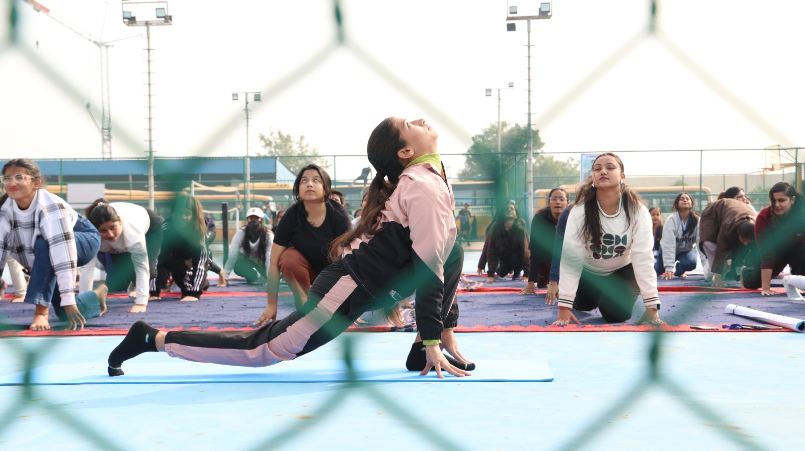

Students practicing Surya Namaskar.

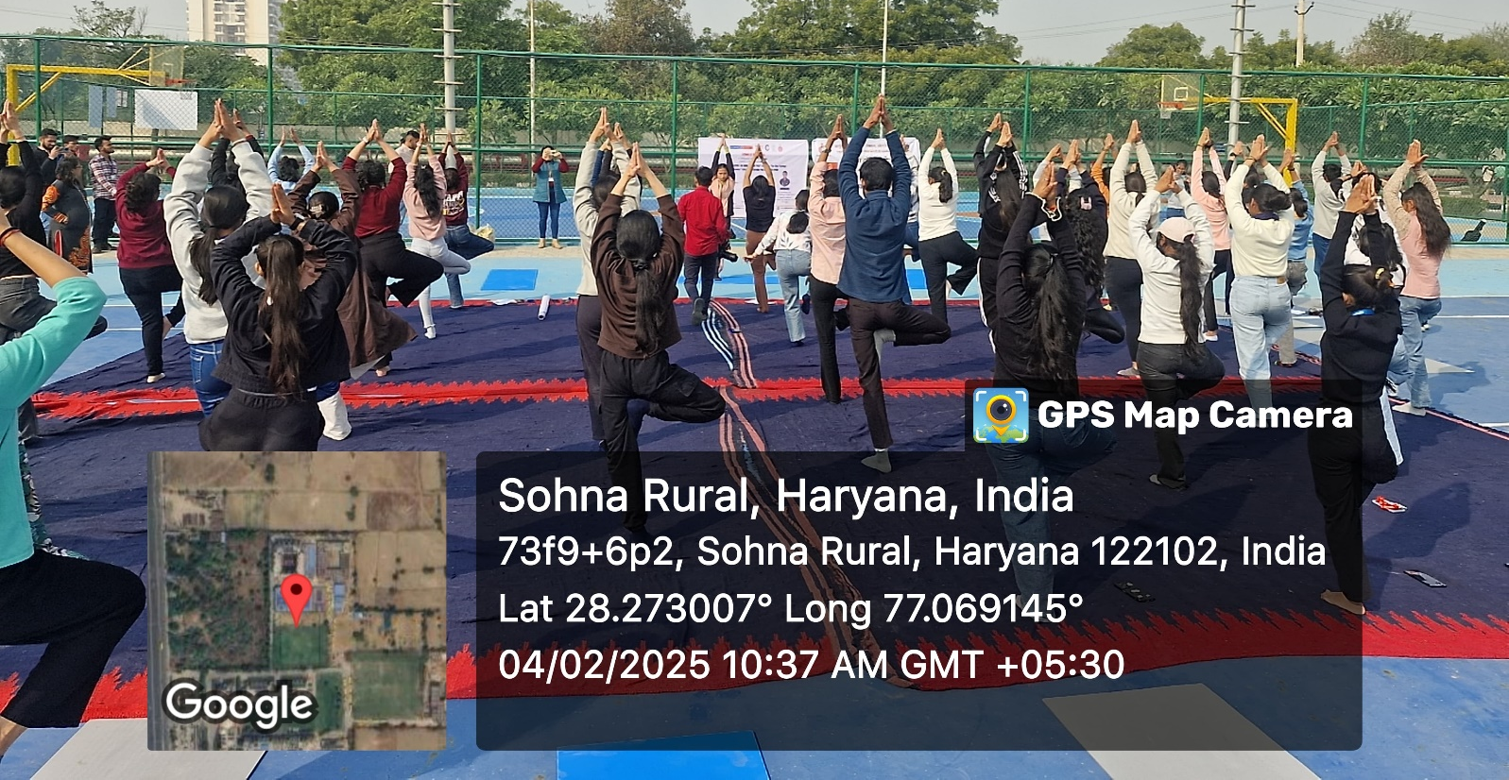During Yoga Session

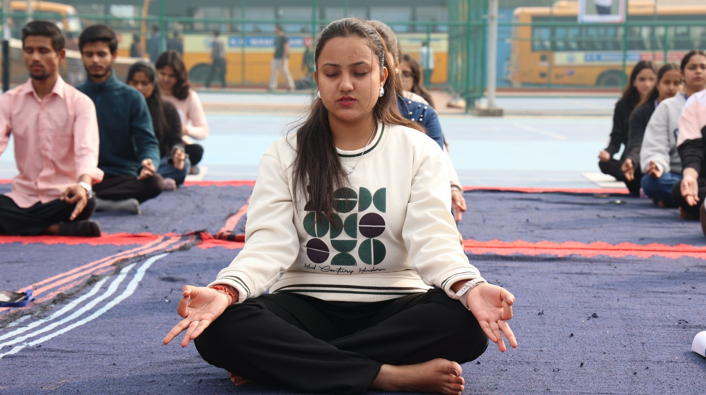Students Practicing Meditation

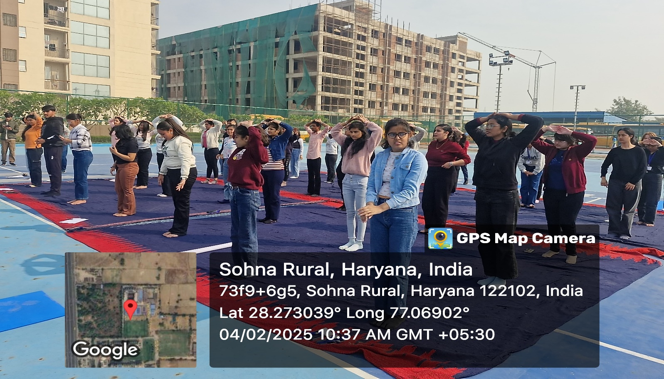

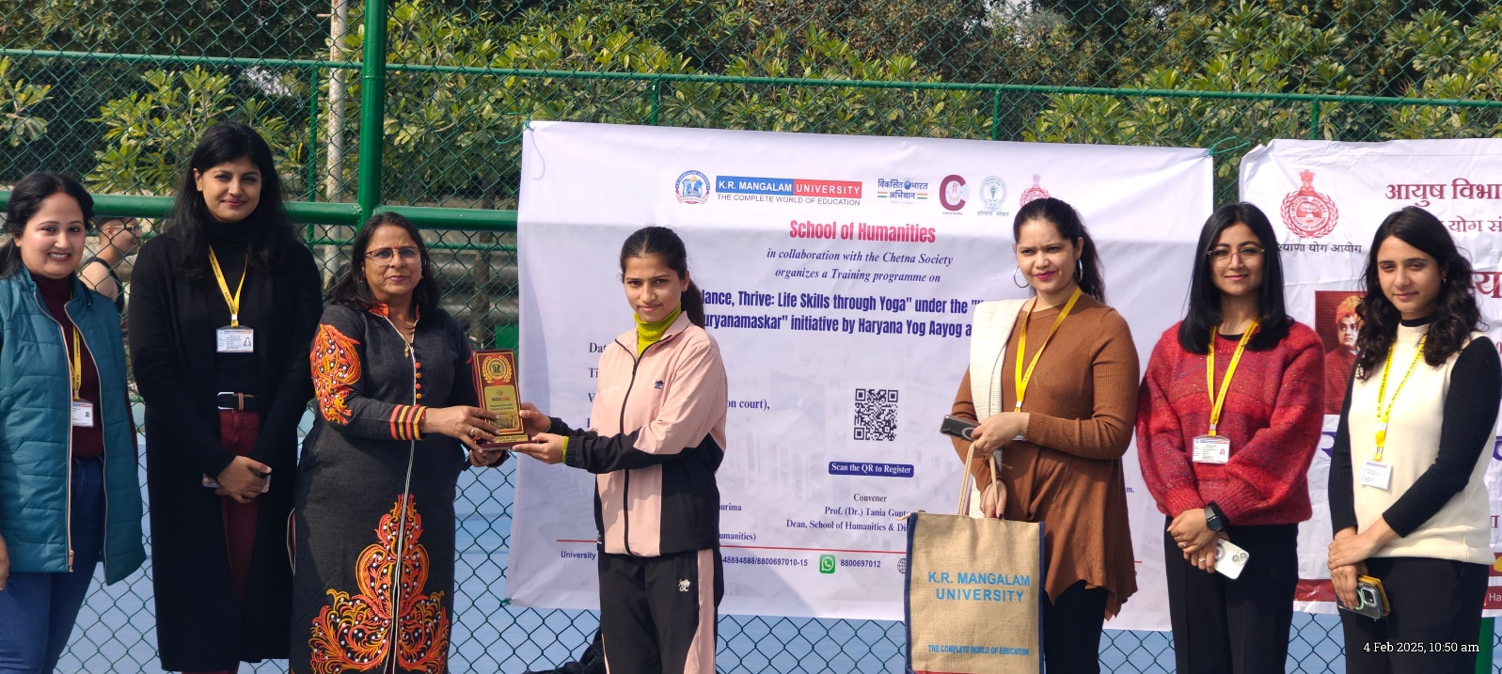Token of appreciation presented to Ms. Jyoti Sharma by Prof. Renu Verma, acknowledging her valuable contribution and expertise

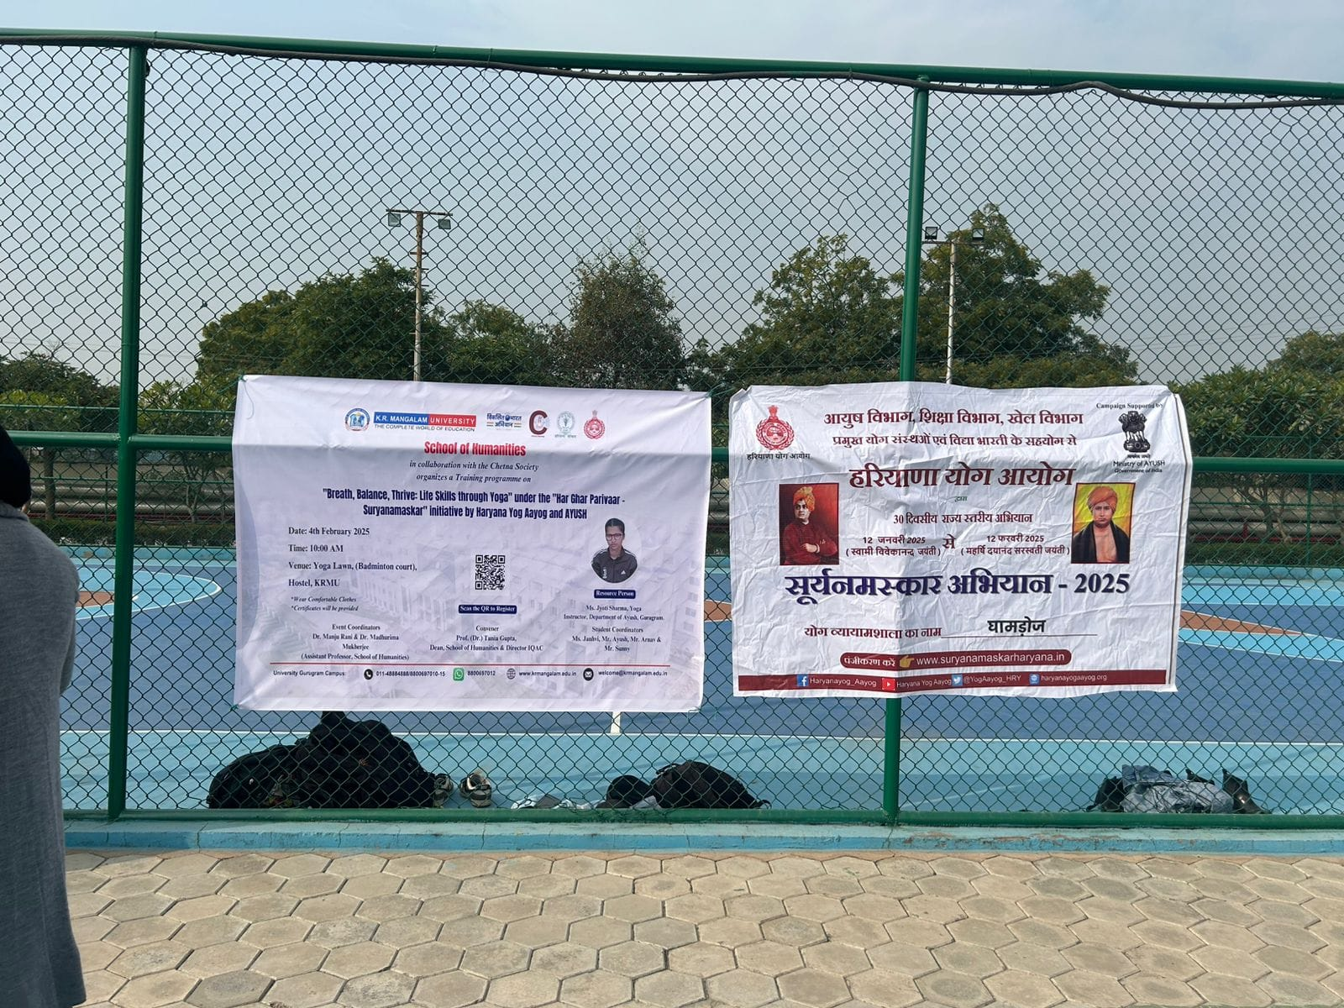

Banners Of The Event

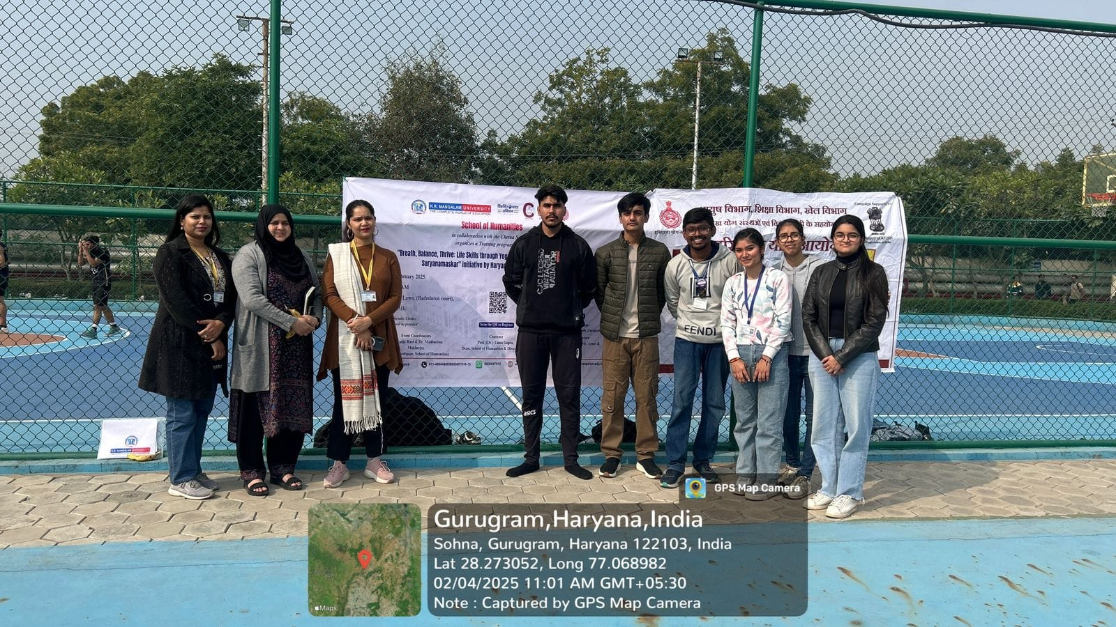

Picture with banner

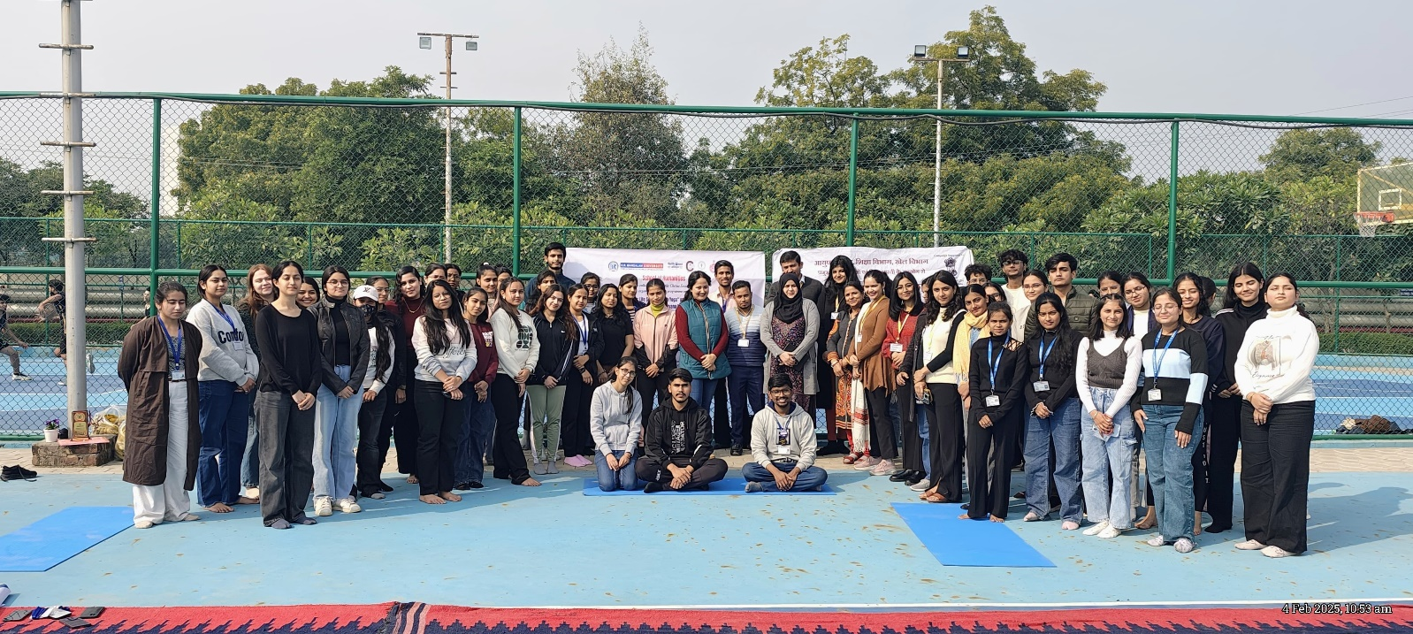Group photo

Report prepared by | Dr Manju Rani (Assistant Professor, SOHS)
Report verified by SOHS Event Coordinator | Ms. Rohini Jha (Assistant professor, SOHS)
Report Seen by Dean | Dr. Tania Gupta (Dean, SOHS)
Report Verified by IQAC | Dr. Shikha Dutt Sharma (IQAC Coordinator)

