REPORT
on
Lecture on Fostering Future Minds: Alumni Perspectives on the Evolving Role of Science in Education
Date: 29-11-2024
Venue: B009 , K. R Mangalam University
Event Type: Lecture
Mode of activity: Offline
Target group: Students of SBAS
Organized by: SBAS, K.R. Mangalam University
Participants: 25
Resource Person: Mr. Agnivesh Tiwari (Alumni of B.Sc. (H) Mathematics), currently working as Operations Manager at Retina India.
Event Coordinators: Dr. Mina Kumari and Dr. Rajni Gautam (School of Basic and Applied Sciences)
Introduction: The lecture titled "Fostering Future Minds: Alumni Perspectives on the Evolving Role of Science in Education" was organized by the School of Basic and Applied Sciences (SBAS) at K. R Mangalam University on November 29, 2024. The lecture aimed to offer valuable insights into the role of science education in shaping the future, through the perspectives of alumni who have successfully transitioned from academia to the professional world. The lecture provided a platform for current students of B.Sc. (H) Mathematics, Physics, and Chemistry to engage with the experiences of an alumnus and understand how science education is evolving to meet the challenges of the modern world.
Objectives:
- To provide students with real-world insights on how science education impacts careers.
- To discuss the evolving role of science in addressing contemporary global challenges.
- To inspire students to think critically about the application of scientific knowledge in various fields.

- To foster a greater understanding of the relationship between academic learning and professional growth.
Content:
The session was led by Mr. Agnivesh Tiwari, an alumnus of the B.Sc. (H) Mathematics program, who shared his journey from being a student at K. R Mangalam University to his current role in the scientific field. He discussed the shifting landscape of science education and its importance in developing critical thinking, problem-solving, and innovation skills. Mr. Tiwari highlighted the growing importance of interdisciplinary knowledge and how students can leverage their scientific background to succeed in diverse career paths.
Additionally, the lecture addressed the integration of emerging technologies like Artificial Intelligence, Data Science, and Biotechnology into traditional science education. Mr. Tiwari emphasized how these fields are reshaping the role of science in education, urging students to stay updated with the latest advancements and embrace lifelong learning.
The lecture also featured interactive discussions where students shared their views on the evolving role of science in education and how they perceived their prospects in the field.
Conclusion:
The lecture concluded with an interactive Q&A session where students had the opportunity to ask questions and clarify their doubts. Mr. Tiwari’s insights on how science is transforming and its potential to solve real-world problems resonated deeply with the students. He encouraged them to approach science education with an open mind and adaptability, preparing them for an ever-changing world.
The event was a success, providing students with a deeper understanding of the importance of their scientific education and how it can shape their future careers. The insights shared by Mr. Tiwari were invaluable in broadening their perspectives on science education and its impact on society.
Event Outcome:
- The lecture successfully provided students with an understanding of the evolving role of science in education.
- Students gained practical advice on career opportunities and how to align their academic pursuits with industry needs.
- The event fostered a sense of community among current students and alumni, strengthening the university's network.
- The session sparked meaningful discussions on integrating new technologies into scientific education.
Future Prospect:
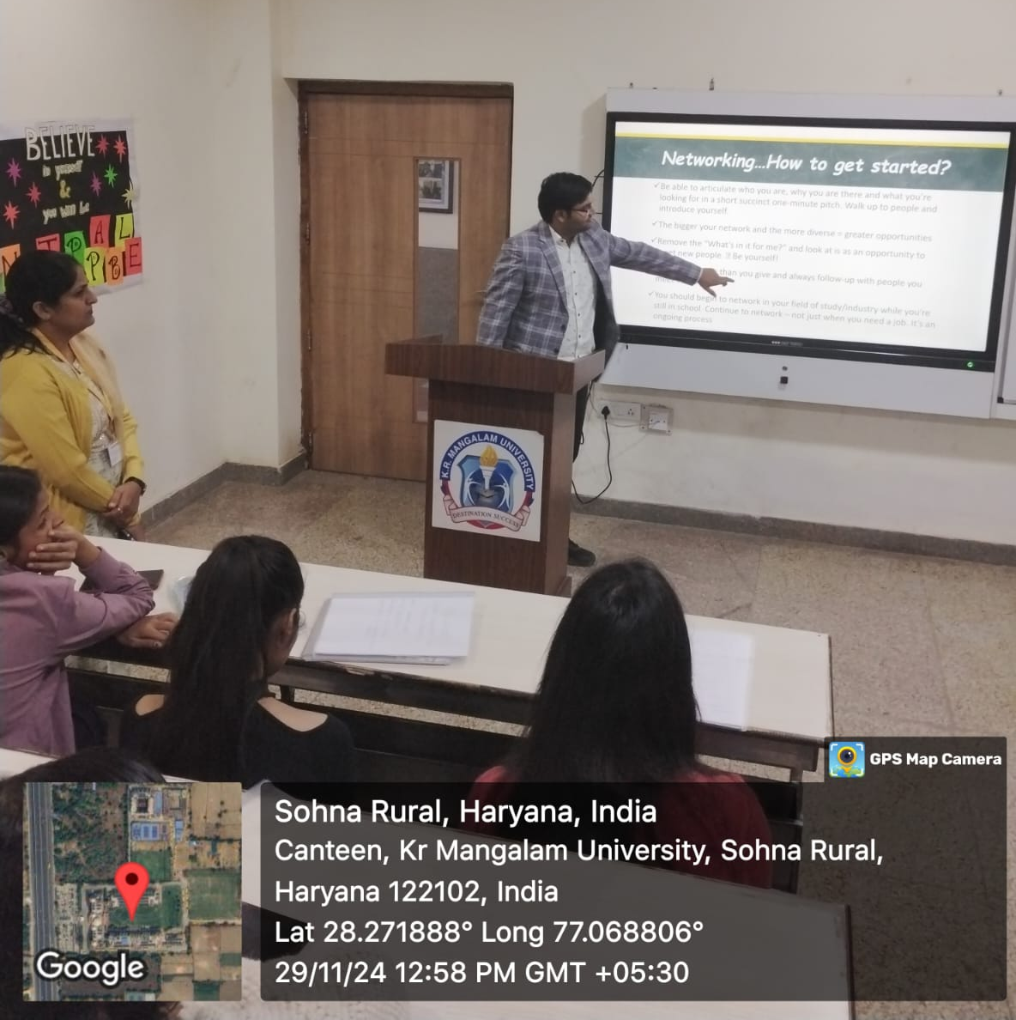
This lecture has set a precedent for future alumni interaction events, and it is hoped that similar sessions will be organized to continue fostering an exchange of ideas between alumni and current students. The event also highlighted the importance of keeping the curriculum dynamic and relevant to the latest trends in science and technology. Going forward, SBAS plans to organize more such events that will not only address academic aspects but also focus on the practical implications of science in society, ensuring that students are well-prepared for the challenges of the future.

Photo 1: Mr Agnivesh Tiwari explained various career options after graduation

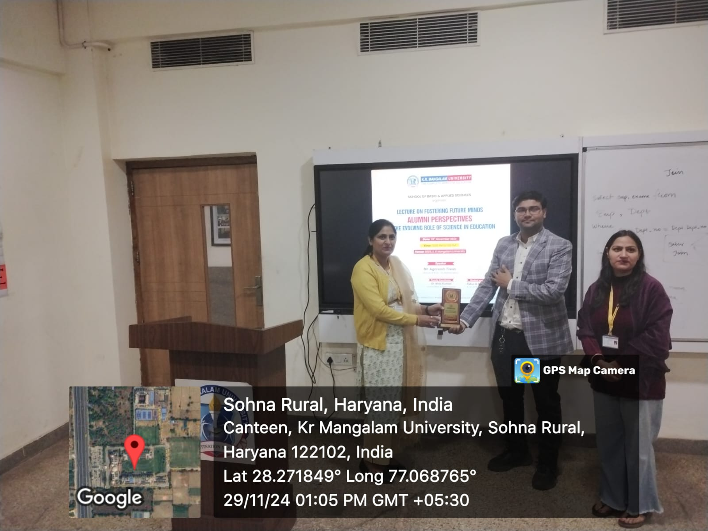

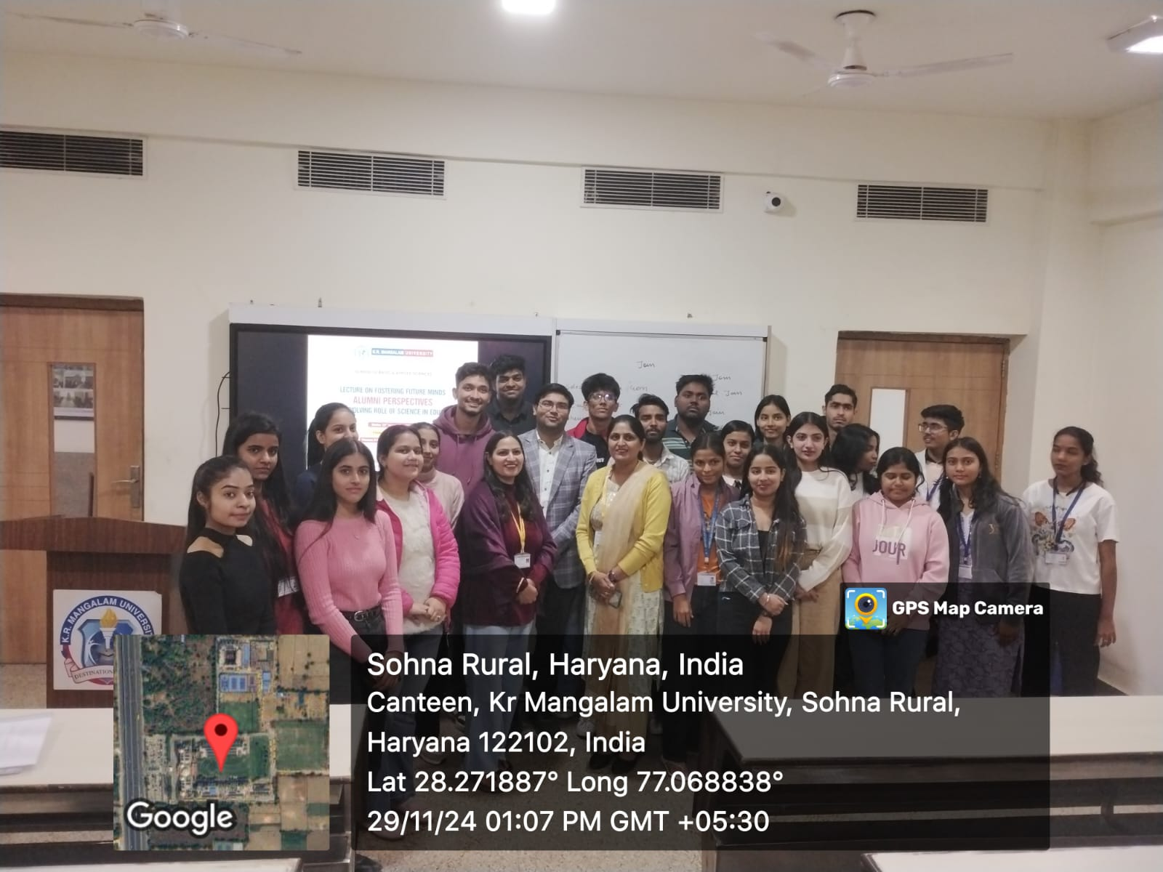
Photo 2: The event coordinator facilitated alumni, Mr Agnivesh Tiwari

Photo 3: A group photograph with students, alumni, and event coordinators

Report Prepared by  Event Coordinator | Dr. Mina Kumari and Dr. Rajni Gautam (School of Basic and Applied Sciences)
Report Verified by  Dean, SBAS | Dr. Meena Bhandari
Report Verified by  IQAC Coordinator | Dr Shikha Dutt Sharma

