Report on Educational Visit to All India Forensic Science Summit 2025

Date: 14th April 2025 and 15th April 2025
Venue: Vigyan Bhawan, New Delhi
Event Type: Attendee National-Level Conference on Forensic Science
Mode of Activity: Offline
Target Group: Students of B.Sc. (H) Forensic Science, K.R. Mangalam University
Organized by: National Forensic Sciences University (NFSU), New Delhi
Coordinated by: Ms. Kritika Singh, Ms. Saloni Arora, and Dr. Shivani Sehgal (Assistant Professors, SBAS) School of Basic and Applied Sciences, K.R. Mangalam University, Gurugram
Participants:
Total Student Participants: 60
Oral Presentations Delivered: 5
Poster Presentations Displayed: 4
Abstracts Published: 5

Introduction:
On April 14th, 2025, the Department of Forensic Science, under the School of Basic and Applied Sciences (SBAS), K.R. Mangalam University, Gurugram, organized a dynamic and knowledge-enriching educational visit to Vigyan Bhawan, New Delhi, to attend the All-India Forensic Science Summit 2025. The summit was hosted by the National Forensic Sciences University (NFSU), New Delhi, and brought together a diverse group of leading experts, academicians, and budding forensic professionals from across the nation. The visit was conducted under the guidance of faculty members Ms. Kritika Singh, Ms. Saloni Arora, and Dr. Shivani Sehgal, ensuring a smooth and productive experience for the student participants.
Objective:
The primary objectives of the educational visit were:
- To expose students to real-time applications and recent advancements in forensic science.
- To encourage active student participation in national-level conferences through poster presentations and oral presentations.
- To promote interaction with domain experts, enhancing networking opportunities for future academic and career prospects.
- To inspire students through exposure to multidisciplinary forensic topics and current technological trends.
- To develop scientific temperament and motivation for research and innovation in forensic practices.
Summit Highlights and Proceedings:
The All-India Forensic Science Summit 2025 featured several keynote addresses, panel discussions, technical presentations, and a student poster competition. Students of B.Sc. (H) Forensic Science from K.R. Mangalam University actively participated in the event and showcased their research through poster presentations and oral presentations, receiving appreciation for their innovative approaches and scientific curiosity.
Key highlights included:
- Technical Sessions: Eminent forensic experts and government officials delivered sessions on crime scene investigation techniques, digital forensics, toxicology, forensic psychology, and emerging areas
- Poster Presentation: Students enthusiastically participated by presenting their research work on diverse topics like Integrating Advanced Techniques in Forensics with the New Investigative Procedures under the New Criminal Laws, Strengthening the Legal Framework for Forensic Evidence: Formulating Comprehensive Guidelines and Standards for Investigation, Forensic Science in the Courtroom: Redefining Expert Investigative Capabilities Against Terrorism Through Advanced Forensic Technologies in ‘Digital India’, Forensic Science in the Service of Justice: Building Indigenous Forensic Infrastructure for ‘Make in India’ and gaining valuable feedback from experts in the field.
- Panel Interactions: Students had the opportunity to interact with professionals from NFSU, law enforcement agencies, and research institutions, fostering a deeper understanding of forensic applications in crime-solving and justice delivery.
Learning Outcomes and Conclusion:
The visit significantly enhanced the academic and professional horizons of the participating students. Through engaging sessions and interactive discussions, students gained firsthand exposure to the workings of India’s forensic science ecosystem. The opportunity to present posters and attend expert-led discussions empowered students with:
- Broader knowledge of national forensic trends and innovations.
- Improved confidence in scientific communication and presentation.
- Increase awareness of academic and career pathways within forensic science.
- Stronger connections with experts and fellow learners across the country.
This event served as a practical extension of classroom learning, deepening the students' understanding of the discipline and reaffirming their passion for forensic science.
Acknowledgements:
The School of Basic and Applied Sciences sincerely thanks the National Forensic Sciences University (NFSU), New Delhi, for organizing such a meaningful summit. Heartfelt appreciation is extended to faculty coordinators Ms. Kritika Singh, Ms. Saloni Arora, and Dr. Shivani Sehgal for their meticulous planning and encouragement. Their efforts played a crucial role in providing students with this valuable platform for academic enrichment and professional growth.
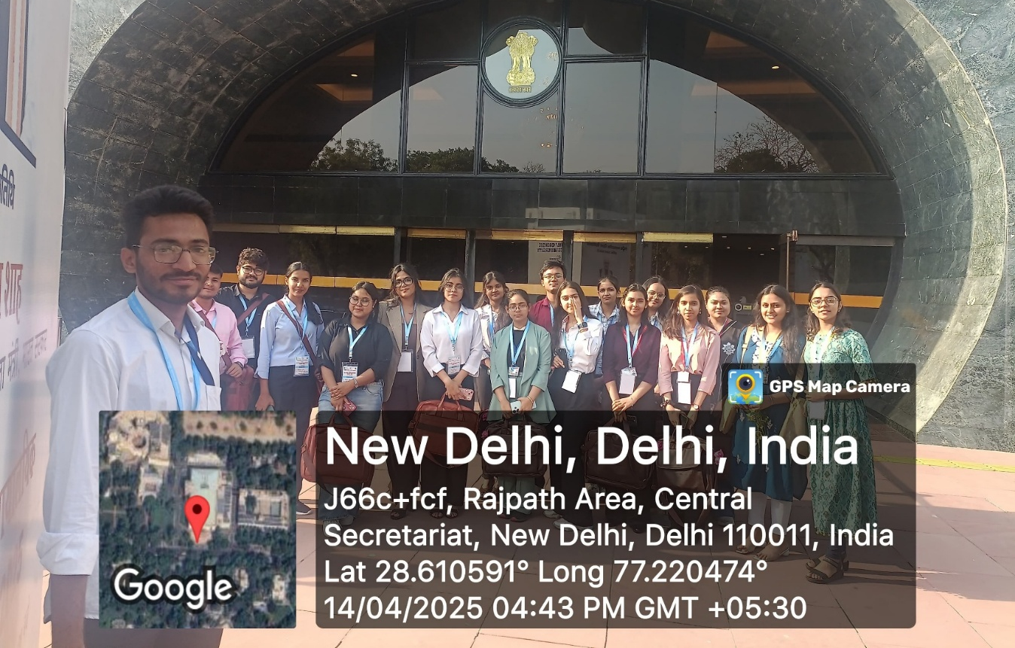

Figure 1: Day 1 (14/04/2025) at All India Forensic Science submit 2025
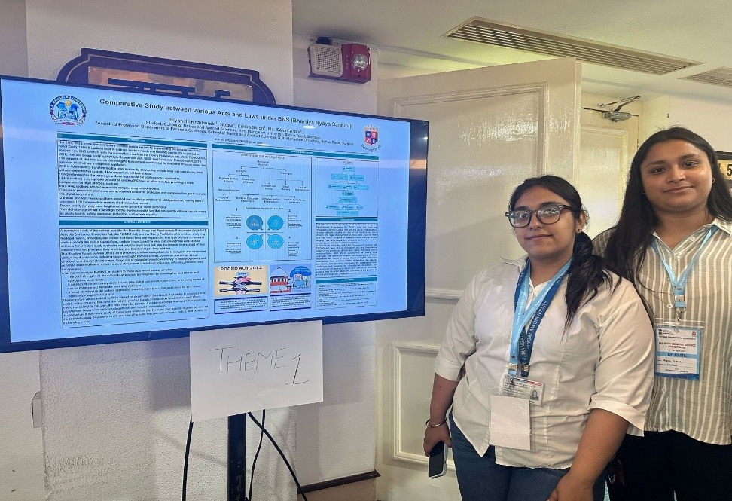
Figure 2 Poster Presented by Priyanshi and Nupur (B.Sc. Forensic Science) of K.R. Mangalam University on 14/04/2025 at Vigyan Bhawan in AIFSS
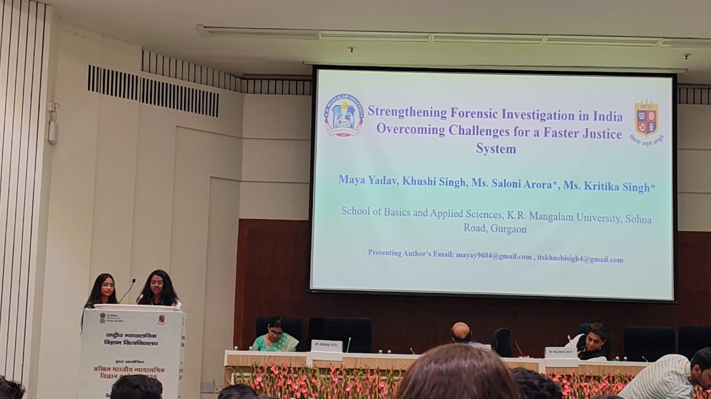
Figure 3: Oral Presentation given by Khushi Singh Pal and Maya Yadav (B.Sc. Forensic Science) of K.R. Mangalam University at Vigyan Bhawan

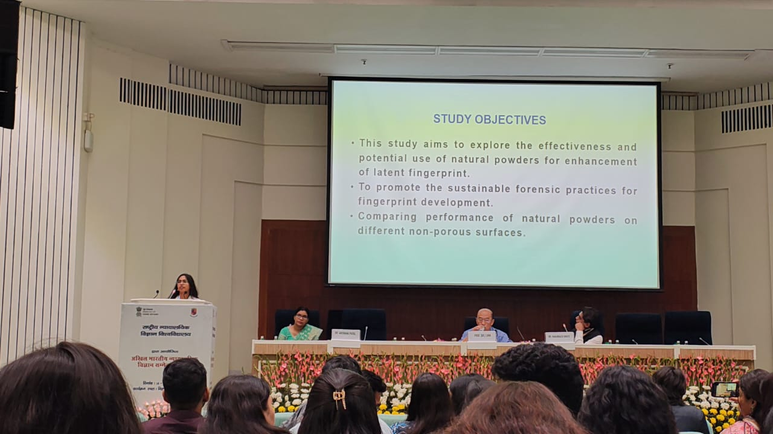
Figure 4: Oral Presentation given by Student Kritika Choudhary (B.Sc. Forensic Science), K.R. Mangalam University at Vigyan Bhawan
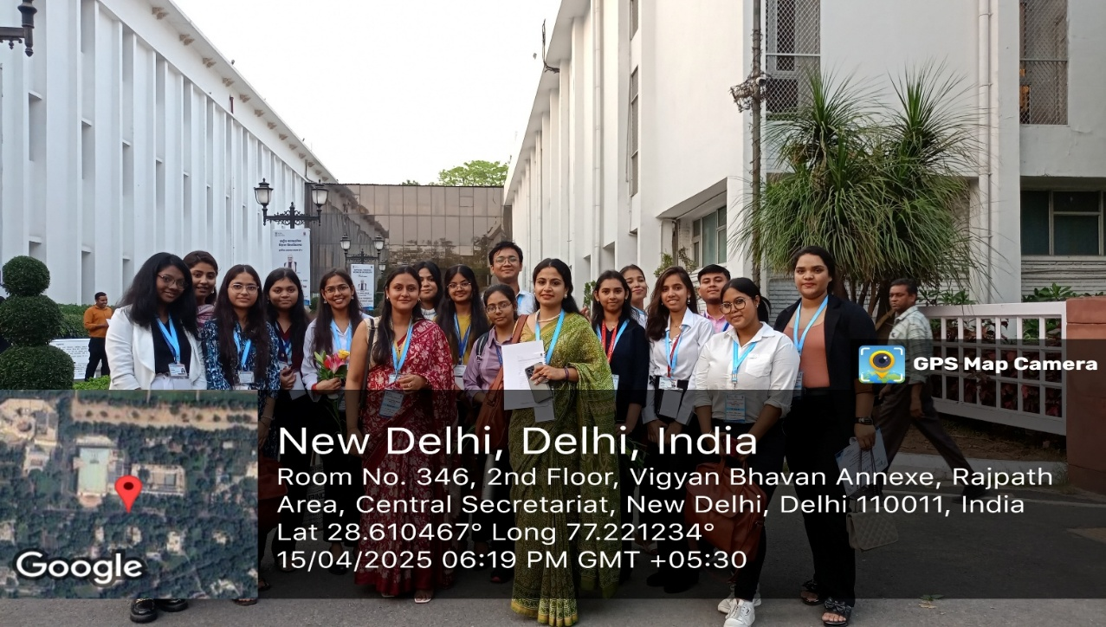

Figure 5 - Day 2 at Vigyan Bhawan (15/04/2025)

