Report on Autopsy Visit to AIIMS

Date: 27th March 2025

Venue: AIIMS, New Delhi
Event Type: Autopsy Visit
Mode of Activity: Offline
Target Group: B.Sc. (H) Forensic Science, Semester-II, Group-1 Students of KRMU
Coordinators: Dr. Baljeet Yadav (Assistant Professor III, SBAS), Dr. Sourabh Kumar Singh (Assistant Professor, SBAS) and Ms. Saloni Arora (Assistant Professor, SBAS)
Organized by: School of Basic and Applied Sciences, K R Mangalam University, Gurugram
Participants: 48
Introduction:
The industrial visit facilitated on March 27th, 2025, by the Department of Forensic Science at KRMU for its undergraduate students to the All India Institute of Medical Sciences (AIIMS), New Delhi, under the guidance of Dr. Baljeet Yadav, Dr. Sourabh Kumar Singh, and Ms. Saloni Arora, represents a significant pedagogical initiative. This experiential learning opportunity, involving 48 B.Sc. (H) Forensic Science Semester-2 students in observing post-mortem examination procedures, directly contributes to Sustainable Development Goal 4: Quality Education. Specifically, it addresses the target of ensuring inclusive and equitable quality education and promoting lifelong learning opportunities for all. By providing practical exposure to real-world forensic investigations, this visit moves beyond theoretical knowledge, fostering a deeper understanding of crucial forensic techniques and ultimately enhancing the quality and relevance of their education in forensic science. This aligns with the broader aim of SDG 4 to equip learners with the knowledge and skills needed to promote sustainable development.
Objective:
The primary objectives of this visit were:
- To allow students to witness firsthand the procedures involved in conducting medico-legal autopsies.
- To enhance students' understanding of the practical application of forensic pathology in determining the cause and manner of death.
- To familiarize participants with the environment, protocols, and significance of a hospital mortuary and forensic medicine department.
- To bridge the gap between theoretical classroom learning and real-world forensic practices.
- To observe the documentation and evidence collection processes during post-mortem examinations.
Content:
The visit to AIIMS was made possible through the cooperation and guidance of Dr. Ashok Kumar Jaiswal, Senior Chemist P.S.O. at AIIMS, who served as the point of contact and facilitator for the student group. Dr. Jaiswal graciously permitted the students access to observe the autopsy proceedings, ensuring a structured and informative learning experience.
During their time at the facility, the students had the unique opportunity to witness three distinct autopsy cases under expert supervision. The cases observed provided a diverse learning spectrum:
  - Case 1: An autopsy performed on a deceased individual who had suffered extensive third-degree burns. This allowed students to observe the specific challenges and findings associated with burn-related fatalities.
  - Cases 2 & 3: Two separate autopsies related to deaths by hanging. These cases provided insights into the examination procedures specific to asphyxial deaths and ligature marks.
Throughout the observation, students could contextualize their academic knowledge regarding human anatomy, injury patterns, and pathological changes associated with different causes of death.
Conclusion:
The Autopsy Visit to AIIMS proved to be an profoundly impactful learning experience for the Forensic Science students. Observing the meticulous process of post-mortem examination, particularly in diverse cases like burns and hanging, provided unparalleled practical insight that transcends textbook learning. The visit successfully demystified the autopsy procedure and highlighted its critical role in the administration of justice. Students gained a deeper appreciation for the complexities of forensic pathology and the skills required of forensic professionals.
This experiential learning opportunity significantly contributed to the students' understanding of forensic medicine and reinforced their career aspirations in the field.
Acknowledgements:
The Department of Forensic Science extends its sincere appreciation to the All India Institute of Medical Sciences (AIIMS), New Delhi, and especially to Dr. Ashok Kumar Jaiswal, for accommodating our students and providing such a valuable educational opportunity. The willingness to share knowledge and allow observation is instrumental in shaping the next generation of forensic scientists.
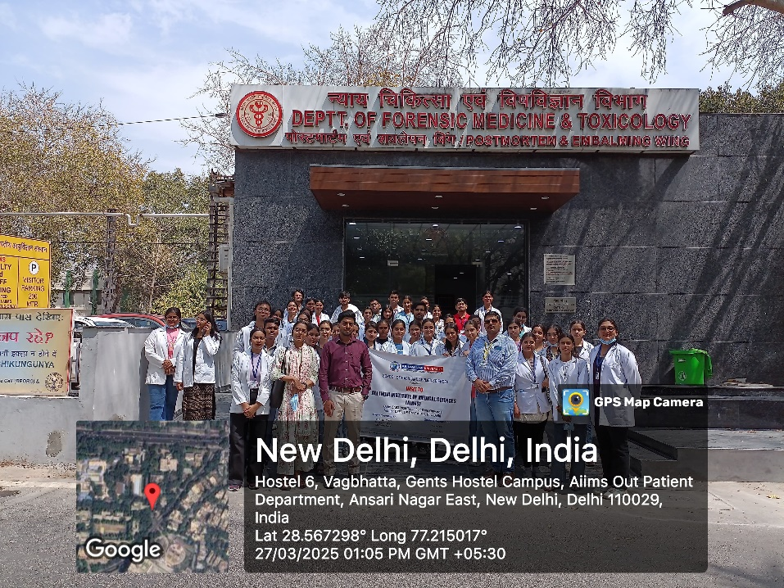
Figure 01. All students at the main gate of Forensic Medicine & Toxicology dept. of AIIMS, New Delhi
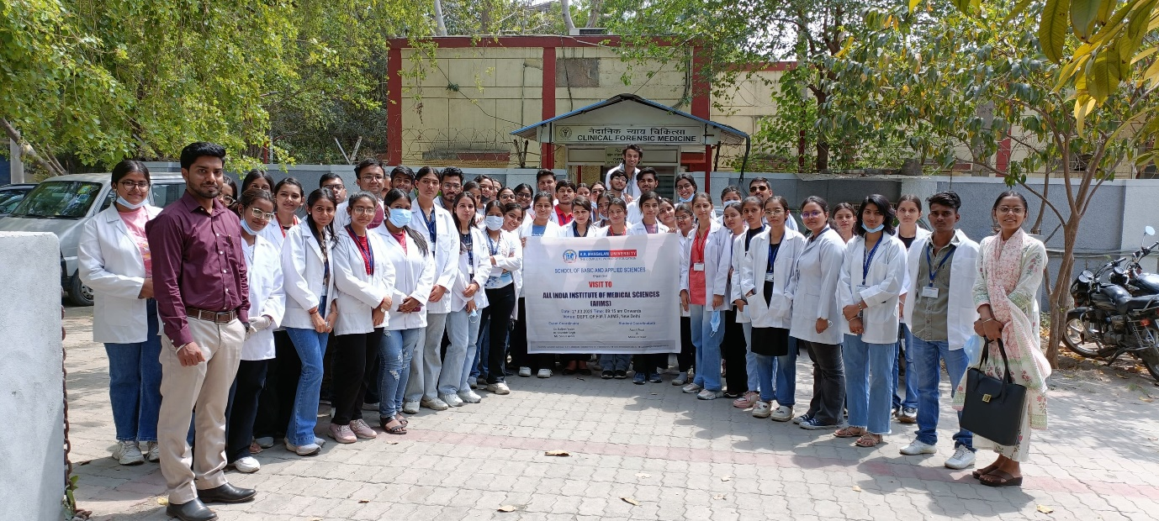
Figure 02. All Students after visiting the Autopsy in the mortuary of FMT Dept. of A.I.I.M.S.
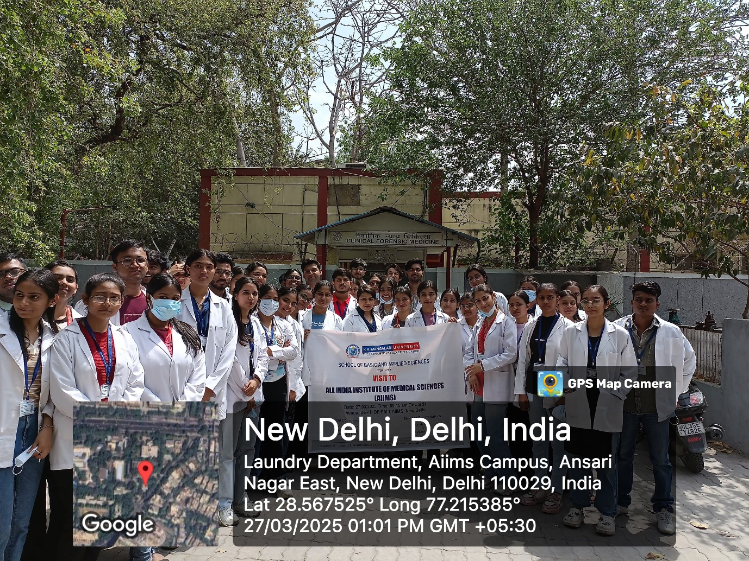
Figure 03. All students of B.Sc 2nd semester & M.Sc. 1st semester Forensic Science at FMT, A.I.I.M.S

Report Prepared by  Event Coordinator | Dr. Baljeet Yadav, Assistant Professor, SBAS
Report Verified by  Dean, SBAS | Prof. (Dr.) Meena Bhandari, Dean, SBAS
Report Verified by  IQAC Coordinator | Dr. Shikha Dutta Sharma, IQAC Coordinator

